Update _2_0_297

Clinical Reminders

VA-AGE-FRIENDLY 4MS

Install Guide

September 2022

Product Development
Office of Information Technology
Department of Veterans Affairs

Table of Contents
Introduction 1
Install Details 3
Install Example 3
Post Installation 6

Introduction
Age Friendly Health Systems is an initiative of The John A. Hartford Foundation and the Institute for Healthcare Improvement (IHI), in partnership with the American Hospital Association (AHA) and the Catholic Health Association of the United States (CHA).

The Age-Friendly 4Ms Note Template (Version 1.0) is for any member of the care team (including MD, DO, NP, PA, RN, SW, PharmD, PT, OT, Psychology etc.) providing care consistent with the 4Ms - What Matters, Medication, Mentation, and Mobility. In an Age-Friendly Health System, each "M" is assessed and acted on to improve care for older adults. Any care setting may add this template to local documentation to support Age-Friendly 4Ms care. The template has been designed to abstract data for quality improvement.

What is the value of this template?
  - Eliminate chart reviews for Committed to Care Excellence
  - Standardize documentation across Age-Friendly care settings
  - Ensure care is consistent with What Matters to older Veterans
What is the benefit of 4Ms care?
  - Increases the effectiveness of care and time spent with Veterans
What is the benefit of a dashboard? (to be developed)
  - Monitor 4Ms care provided (dashboard updated nightly)

++Add this template to existing documentation to facilitate 4Ms tracking ++

Please Note:
For questions or feedback on the template please utilize the REDACTED e-mail contact. For training material please go to REDACTD. Be sure and bookmark the *new and improved* Age Friendly health Systems (URL REDACTED) currently in development which should be fully functional in August 2022.

UPDATE_2_0_297 contains 1 Reminder Exchange entry:
UPDATE_2_0_297 VA-AGE-FRIENDLY 4MS

The exchange file contains the following components:

REMINDER GENERAL FINDINGS
VIEW PROGRESS NOTE TEXT

TIU TEMPLATE FIELD
VA-VANOD BLANK
BLANK SPACE1
VA-GEC AGE-FRIENDLY 4M RESOURCES

HEALTH FACTORS
VA-REMINDER UPDATES [C]
VA-UPDATE_2_0_297
VA-HEALTH AND WELL BEING [C]
VA-WHS-AFHS-PATIENT PRIORITIES FOLLOW-UP
VA-WHS-AFHS-IDENTIFY PATIENT PRIORITIES
VA-WHS-AGE-FRIENDLY-MOBILITY
VA-GEC AGE-FRIENDLY MOBILITY NO
VA-VAAES MOB [C]
VA-VAAES MOB GS 8 WALK 250
VA-VAAES MOB GS 7 WALK 25 FT
VA-VAAES MOB GS 6 WALK 10 STEPS
VA-VAAES MOB GS 5 STANDING
VA-VAAES MOB GS 4 TRANSFERRED
VA-VAAES MOB GS 3 SAT AT EDGE
VA-VAAES MOB GS 2 TURNED SELF
VA-VAAES MOB GS 1 LYING IN BED
VA-GEC AGE-FRIENDLY DELIRIUM NO
VA-WHS-AGE-FRIENDLY-MENTATION-DELIRIUM
VA-VAAES NEURO [C]
VA-VAAES NEURO BCAM POSITIVE
VA-VAAES NEURO BCAM NEGATIVE
VA-GEC AGE-FRIENDLY DEMENTIA NO
VA-WHS-AGE-FRIENDLY-MENTATION-DEMENTIA
VA-GEC AGE-FRIENDLY DEPRESSION NO
VA-WHS-AGE-FRIENDLY-MENTATION-DEPRESSION
VA-GEC AGE-FRIENDLY MEDICATION NO
VA-WHS-AGE-FRIENDLY-MEDICATION
VA-GEC AGE-FRIENDLY WHAT MATTERS NO
VA-WHS-AGE-FRIENDLY-WHAT MATTERS
VA-GEC AGE-FRIENDLY 4MS NOTE TEMPLATE VERSION [C]
VA-GEC AGE-FRIENDLY 4MS NOTE TEMPLATE V1.2

REMINDER SPONSOR
OFFICE OF GERIATRIC EXTENDED CARE

REMINDER TERM
VA-REMINDER UPDATE_2_0_297

HEALTH SUMMARY TYPE
VA-GEC MOBILITY SCALE JH
VA-GEC 4MS MOBILITY GOAL
VA-GEC AGE-FRIENDLY 4MS BCAM
VA-WHS-AGE-FRIENDLY MHA MINI
VA-WHS-AGE-FRIENDLY MHA PHQ2/9
VA-GEC 4MS MEDICATION
VA-GEC 4MS WHAT MATTERS

HEALTH SUMMARY OBJECTS
VA-GEC MOBILITY SCALE JH (TIU)
VA-GEC 4MS MOBILITY GOAL (TIU)
VA-GEC AGE-FRIENDLY 4MS BCAM (TIU)
VA-WHS-AGE-FRIENDLY MHA MINI (TIU)
VA-WHS-AGE-FRIENDLY MHA PHQ2/ (TIU)
VA-GEC 4MS MEDICATION (TIU)
VA-GEC 4MS WHAT MATTERS (TIU)

TIU DOCUMENT DEFINITION
VA-GEC MOBILITY SCALE JH
VA-GEC 4MS MOBILITY GOAL
VA-GEC AGE-FRIENDLY 4MS BCAM
VA-WHS-AGE-FRIENDLY MHA MINI
VA-WHS-AGE-FRIENDLY MHA PHQ2/
VA-GEC 4MS MEDICATION
VA-GEC 4MS WHAT MATTERS

REMINDER DIALOG
VA-AGE-FRIENDLY 4MS

Install Details

This update is being distributed as a web host file. The address for the host file is: https://REDACTED /UPDATE_2_0_297.PRD

The file will be installed using Reminder Exchange, programmer access is not required.

This update can be loaded with users on the system. Installation will take less than 5 minutes.

Install Example
To Load the exchange file, use LWH. The URL is https://REDACTED /UPDATE_2_0_297.PRD

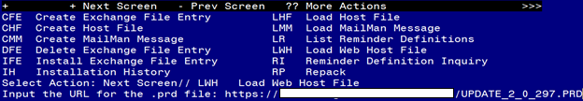

You should see a message that the file was successfully loaded.

Search and locate an entry titled UPDATE_2_0_297 VA-AGE-FRIENDLY 4MS in reminder exchange.
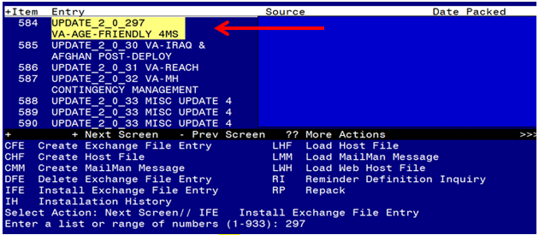
At the Select Action prompt, enter IFE for Install Exchange File Entry
Enter the number that corresponds with your entry titled UPDATE_2_0_297 VA-AGE-FRIENDLY 4MS (in this example it is entry 584, it will vary by site) that is dated 08/09/2022.

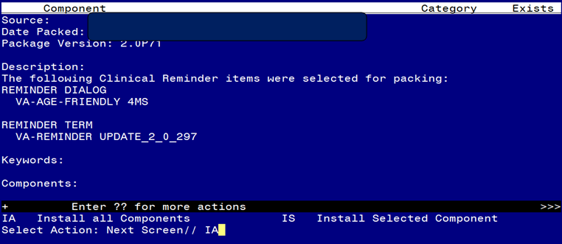
At the Select Action prompt, type IA for Install all Components and hit enter.
For all new entries in any category you will choose I to Install
Skip any items in any category you are prompted to overwrite

You will then be prompted to install the dialog component.
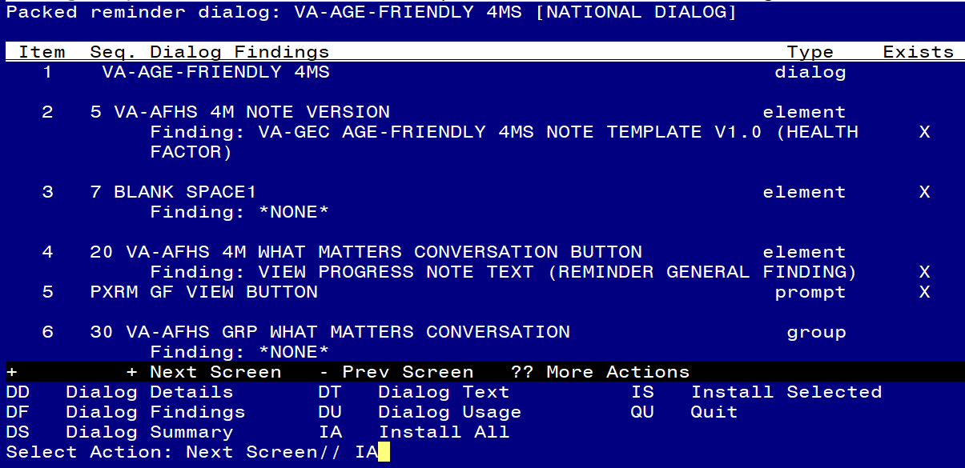
At the Select Action prompt, type IA to install the dialog – VA-AGE-FRIENDLY 4MS
Install reminder dialog and all components with no further changes: Y//ES

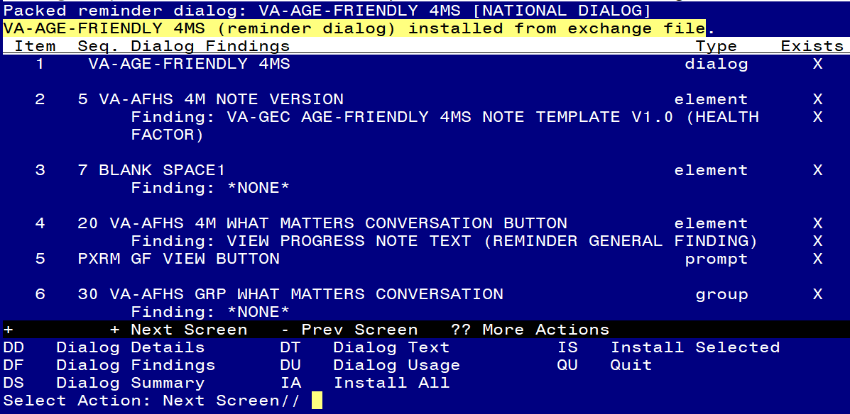
When the dialog has completed installation, you will then be returned to this screen. At the Select Action prompt, type Q.

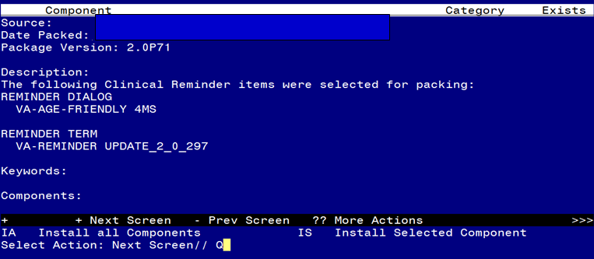
You will then be returned to this screen. At the Select Action prompt, type Q.

Install complete.

Post Installation

- Make the Dialog templates available to be attached to a Personal or Shared templates or to be able to attach the dialog to a progress note title.
Select Reminder Managers Menu <TEST ACCOUNT> Option: CP CPRS Reminder Configuration
CA Add/Edit Reminder Categories
CL CPRS Lookup Categories
CS CPRS Cover Sheet Reminder List
MH Mental Health Dialogs Active
PN Progress Note Headers
RA Reminder GUI Resolution Active
TIU TIU Template Reminder Dialog Parameter
DEVL Evaluate Coversheet List on Dialog Finish
DL Default Outside Location
PT Position Reminder Text at Cursor
LINK Link Reminder Dialog to Template
TEST CPRS Coversheet Time Test
NP New Reminder Parameters
GEC GEC Status Check Active
WH WH Print Now Active
Select CPRS Reminder Configuration <TEST ACCOUNT> Option: TIU TIU Template Reminder Dialog Parameter
Reminder Dialogs allowed as Templates may be set for the following:
1 User USR [choose from NEW PERSON]
3 Service SRV [choose from SERVICE/SECTION]
4 Division DIV [SALT LAKE CITY]
5 System SYS [NATREM.FO-SLC.MED.VA.GOV]
Enter selection: 5 Choose the appropriate number for your site. Your site may do this by System or other levels. The example below uses SYSTEM level.
Setting Reminder Dialogs allowed as Templates for System: NATREM.FO-SLC.MED.VA.GOV
Select Display Sequence: ?
388 VA-COVID-19 TELEPHONE FOLLOW-UP
389 VA-SRA-CONSULT RESPONSE (D)
When you type a question mark above, you will see the list of #’s (with dialogs) that are already taken. Choose a number NOT on this list. For this example, 390 is not present so I will use 390.
Select Display Sequence: 390
Are you adding 390 as a new Display Sequence? Yes// YES
Display Sequence: 390// <Enter> 390
Clinical Reminder Dialog: VA-AGE-FRIENDLY 4MS reminder dialog NATIONAL
...OK? Yes// <Enter> (Yes)

- Associate the reminder dialogs to a shared template folder in CPRS
- In CPRS, open the Template Editor, expand Shared Templates, select the appropriate folder (if applicable), then click New Template (top right-hand corner).
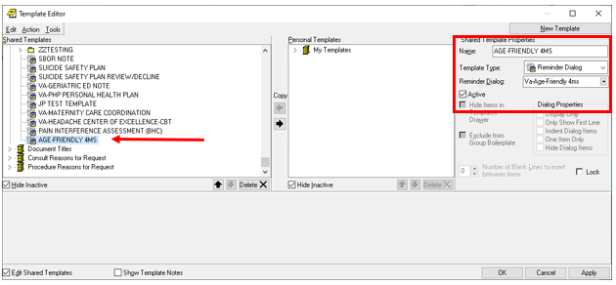

Type in the following information:
Name: AGE-FRIENDLY 4MS
Template Type: Reminder Dialog
Reminder Dialog: VA-AGE-FRIENDLY 4MS

