Update _2_0_298

Clinical Reminders

VA-OSP TH DISCHARGE SUMMARY UPDATE
Install Guide

July 2022

Product Development
Office of Information Technology
Department of Veterans Affairs

Table of Contents
Introduction 1
Install Details 3
Install Example 3
Post Installation 6

Introduction
The Discharge Summary was developed by the OMHSP in collaboration with Evidence Based Psychotherapy subject matter experts and is utilized by therapists providing all SP 2.0 interventions including DBT, Cognitive Behavioral Therapy for Suicide Prevention (CBT-SP) and Problem Solving Therapy for Suicide Prevention (PST-SP).

Based on user feedback, the following changes are being made:
- The template is being updated to include an updated title “Suicide Prevention Telehealth Program Discharge Summary/Treatment Transition” and a description of use.
- 4 health factors were added to existing options within the template.
- Existing fields in the Planned Discharge and Unplanned Discharge sections were made required.

UPDATE_2_0_298 contains 1 Reminder Exchange entry:
UPDATE_2_0_298 VA-OSP TH DISCHARGE SUMMARY UPDATE

The exchange file contains the following components:

REMINDER GENERAL FINDINGS
VIEW PROGRESS NOTE TEXT

TIU TEMPLATE FIELD
WP 2/50
DATE
VA-OSP SP RISK MGMT
VA-OSP SRM CONSULT EMAIL
EB 20/240
DISPLAY TEXT SP OPTIONAL

HEALTH FACTORS
VA-REMINDER UPDATES [C]
VA-UPDATE_2_0_298
VA-OSP TH DISCHARGE [C]
VA-OSP TH DC REFERRED TO SPI
VA-OSP TH DC REFERRED TO DBT
VA-OSP TH DC REFERRED TO PST-SP
VA-OSP TH DC REFERRED TO CBT-SP
VA-OSP TH DC DATE MOST RECENT SUICIDE RISK ASSESSMENT
VA-SUICIDE RISK EVALUATION TYPE [C]
VA-SUICIDE RISK UPDATE EVALUATION
VA-SUICIDE RISK NEW EVALUATION
VA-OSP TH CHRONIC RISK LOW
VA-OSP TH CHRONIC RISK INTERMEDIATE
VA-OSP TH CHRONIC RISK HIGH
VA-OSP TH ACUTE RISK LOW
VA-OSP TH ACUTE RISK INTERMEDIATE
VA-OSP TH ACUTE RISK HIGH
VA-SUICIDE RISK MANAGEMENT [C]
VA-SRM FU LOW ACUTE RISK
VA-SRM FU INTERMEDIATE ACUTE RISK
VA-SRM FU HIGH ACUTE RISK
VA-SUICIDE RISK ASSESSMENT [C]
VA-SUICIDE RISK ACUTE LOW
VA-SUICIDE RISK ACUTE INTERMEDIATE
VA-SUICIDE RISK ACUTE HIGH
VA-OSP TH DC REASON OTHER
VA-OSP TH DC REASON CRISIS
VA-OSP TH DC REASON UNABLE TO REACH
VA-OSP TH DC REASON NOT GOOD FIT OTHER
VA-OSP TH DC REASON INTERFERING SYMPTOMS NEED ADDRESSING
VA-OSP TH DC REASON NOT GOOD FIT AT THIS TIME
VA-OSP TH DC REASON REQUESTED TO END OTHER
VA-OSP TH DC REASON UNABLE TO ATTEND OTHER PRIORITIES
VA-OSP TH DC REASON FEELS NO LONGER NEED TREATMENT
VA-OSP TH DC REASON UNCOMFORTABLE DISCUSSING SUICIDE
VA-OSP TH DC REASON REQUESTED TO END TREATMENT
VA-OSP TH DC SPI NUMBER SESSIONS
VA-OSP TH DC SPI UNPLANNED
VA-OSP TH DC DBT NUMBER MONTHS
VA-OSP TH DC DBT NUMBER IND SESSIONS
VA-OSP TH DC DBT PARTIAL PROTOCOL
VA-OSP TH DC DBT FULL PROTOCOL
VA-OSP TH DC DBT UNPLANNED
VA-OSP TH DC PST-SP NUMBER SESSIONS
VA-OSP TH DC PST-SP PARTIAL PROTOCOL
VA-OSP TH DC PST-SP FULL PROTOCOL
VA-OSP TH DC PST-SP UNPLANNED
VA-OSP TH DC CBT-SP NUMBER SESSIONS
VA-OSP TH DC CBT-SP PARTIAL PROTOCOL COMPLETED
VA-OSP TH DC CBT-SP FULL PROTOCOL COMPLETED
VA-OSP TH DC CBT-SP UNPLANNED
VA-OSP TH DC SPI PLANNED
VA-OSP TH DC DBT AGREED EARLY TERMINATION
VA-OSP TH DC DBT PLANNED
VA-OSP TH DC PST-SP AGREED EARLY TERMINATION
VA-OSP TH DC PST-SP PLANNED
VA-OSP TH DC CBT-SP AGREED EARLY TERMINATION
VA-OSP TH DC CBT-SP PLANNED
VA-OSP TH DC NOTE

REMINDER SPONSOR
VHA OFFICE OF MENTAL HEALTH AND SUICIDE PREVENTION

REMINDER TERM
VA-REMINDER UPDATE_2_0_298

HEALTH SUMMARY TYPE
VA-CSRE MOST RECENT
VA-OSP TH ACUTE RISK LEVELS 6M

HEALTH SUMMARY OBJECTS
VA-CSRE MOST RECENT
VA-OSP TH ACUTE RISK LEVELS 6M

TIU DOCUMENT DEFINITION
VA-CSRE MOST RECENT
VA-OSP TH ACUTE RISK LEVELS 6M

REMINDER DIALOG
VA-OSP TH DISCHARGE

Install Details
This update is being distributed as a web host file. The address for the host file is: https://Redacted /UPDATE_2_0_298.PRD
The file will be installed using Reminder Exchange, programmer access is not required.

Installation:
=============
This update can be loaded with users on the system. Installation will take less than 2 minutes.

Install Example
To Load the Web Host File. Navigate to Reminder exchange in Vista

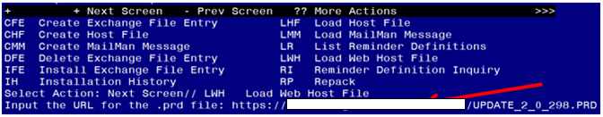

At the Select Action: prompt, enter LWH for Load Web Host File
At the Input the url for the .prd file: prompt, type the following web address:
https://Redacted /UPDATE_2_0_298.PRD
You should see a message at the top of your screen that the file successfully loaded.

Search and locate an entry titled UPDATE_2_0_298 VA-OSP TH DISCHARGE SUMMARY UPDATE in reminder exchange.
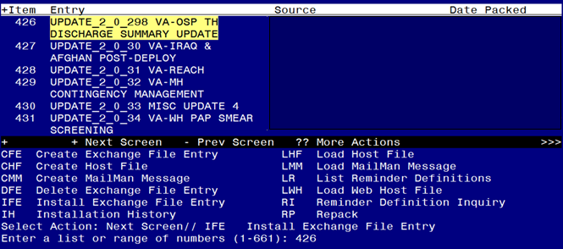

At the Select Action prompt, enter IFE for Install Exchange File Entry
Enter the number that corresponds with your entry UPDATE_2_0_298 VA-OSP TH DISCHARGE SUMMARY UPDATE (in this example it is entry 426. It will vary by site). The date of the exchange file should be 07/06/22.
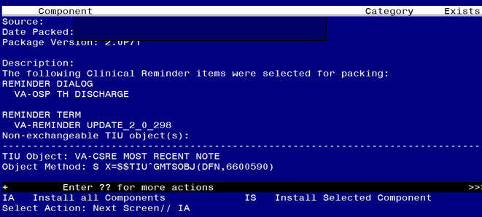

At the Select Action prompt, type IA for Install all Components and hit enter.
Select Action: Next Screen// IA Install all Components
You will see several prompts, for all new entries you will choose I to Install
For ANY components that already exists but the packed component is different, choose S to SKIP
You will be promped to install the reminder dialog component (VA-OSP TH DISCHARGE). You will choose to install all even though some components may have an X to indicate that they exist.

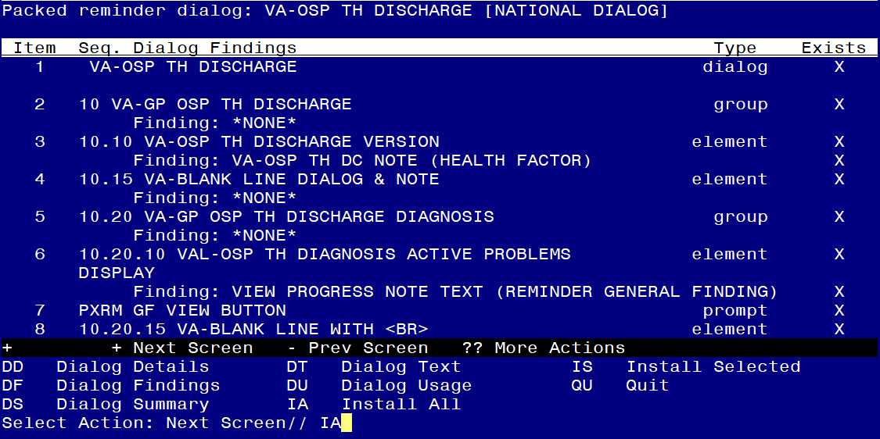
At the Select Action prompt, type IA to install the dialog: VA-OSP TH DISCHARGE
Select Action: Next Screen// IA Install All
Install reminder dialog and all components with no further changes: Y// Yes
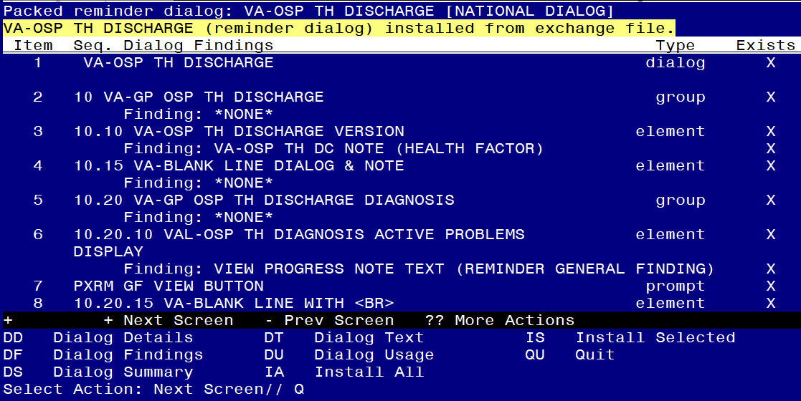

After completing this dialog install, you will type Q.

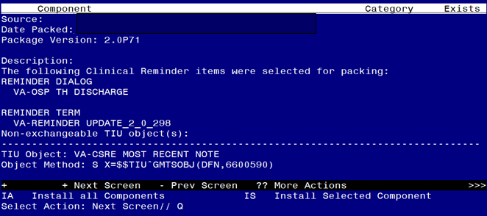

You will then be returned to this screen. At the Select Action prompt, type Q.

Install complete.

Post Installation

- Open the note titled SUICIDE PREVENTION TELEHEALTH DISCHARGE SUMMARY (reminder dialog VA-OSP TH DISCHARGE) and confirm that the version displays as 2.1.

