

**Update \_2\_0\_300**

Clinical Reminders

VA-TH-VVC TEMPLATE UPDATES

Install Guide

**July 2022**

Product Development

Office of Information Technology

Department of Veterans Affairs

Table of Contents

[Introduction 1](#_Toc109891245)

[Pre-Install 5](#_Toc109891246)

[Install Details 5](#_Toc109891247)

[Install Example 6](#_Toc109891248)

[Post Installation 9](#_Toc109891249)

# Introduction

Description:

Guidance from the telehealth program office was recently released updating the required synchronous telehealth disclosure statement:

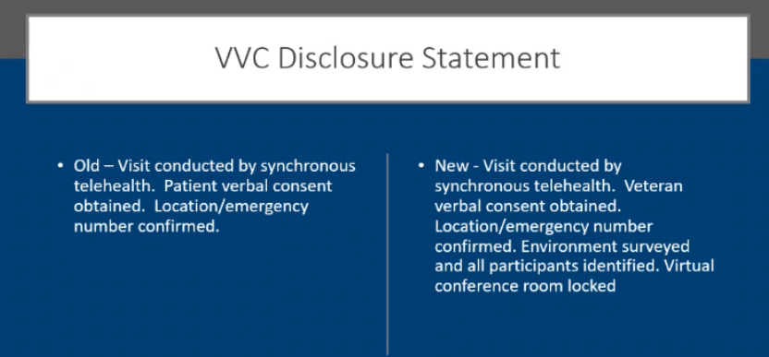

Templates that included one of the following statements:

Before:

EXAMPLE 1

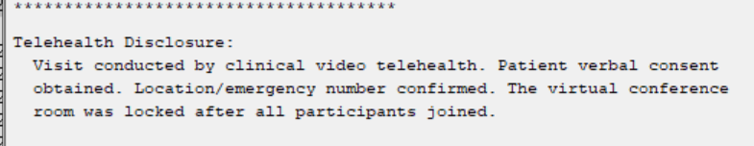

EXAMPLE 2

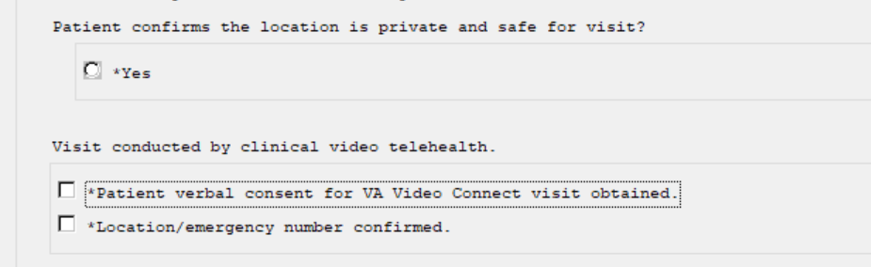

After:

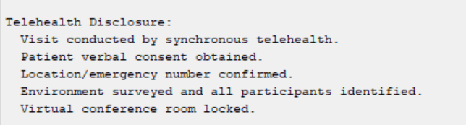

These are the dialogs that are impacted by this change:

VA-TH VVC HYPERTENSION

VA-COVID-19 PROVIDER FOLLOW-UP

VA-CSP VETERAN WELLNESS CONTACT

VA-PGCSS VETERAN INTAKE

VA-SAH GENERAL NOTE

VA-SAH GROUP NOTE

VA-TH VVC EM CASE MANAGEMENT

VA-TH VVC EM CLINICAL PHARMACY

VA-TH VVC EM MENTAL HEALTH

VA-TH VVC EM PROVIDER

VA-CSP CAREGIVERS FIRST NOTE

VA-CSP PCAFC APP INTAKE SECONDARY CG

VA-CSP PGCSS INTERMITTENT NOTE

VA-CSP CAREGIVER ASSESSMENT REV

VA-CSP CAREGIVER WELLNESS CONTACT

VA-CSP PCAFC INTAKE

VA-CSP PCAFC RE-ASSESSMENT

VA-CSP PGCSS CAREGIVER ASSESSMENT

In the reminder dialog VA-TELE URGENT CARE NOTE:

Before:

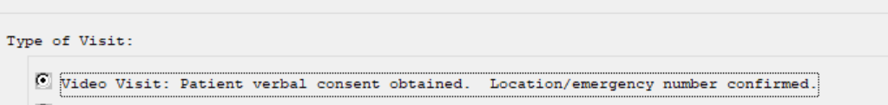

After:

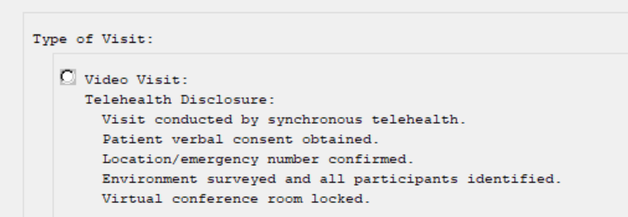

UPDATE\_2\_0\_300 contains 1 Reminder Exchange entry:

**UPDATE\_2\_0\_300 VA-TH-VVC TEMPLATE UPDATES**

**The exchange file contains the following components:**

**REMINDER GENERAL FINDINGS**

VIEW PROGRESS NOTE TEXT

**TIU TEMPLATE FIELD**

VA-BLANK SP

VA-EDIT 12+

VA-BLANK IN PN TEXT

VA-EDIT 7+

VA-HTN GUIDANCE

VA-BLANK

VA-OTHER TEXT

VA-WORD PROCESS 65

VA-EDIT 20

VA-PROVIDER NOTIFIED

VA-HTN FALL PREVENTION

VA-WORD

**EDUCATION TOPICS**

VA-HTN MEDICATION ADHERENCE

VA-HTN NUTRITION EDUCATION

VA-HTN EXERCISE

VA-BP CUFF USE

VA-SAFETY/HOME/FALLS

**HEALTH FACTORS**

VA-REMINDER UPDATES [C]

VA-UPDATE\_2\_0\_300

HYPERTENSION [C]

HTN LIFESTYLE MODIFICATIONS RECOMMENDED

VA-HTN SELF-RECORDED DIASTOLIC BLOOD PRESSURE

VA-HTN SELF-RECORDED SYSTOLIC BLOOD PRESSURE

VA-HTN REFERRED OTHER

VA-HTN REFERRED TO TELEHEALTH

HTN REFERRED TO MOVE

HTN REFERRED TO DIETICIAN

HTN REFERRED TO PACT PHARMACIST

VA-VIDEO CONNECT [C]

VA-VVC BP FOLLOW-UP APPOINTMENT OTHER

VA-VVC BP FOLLOW-UP APPOINTMENT NA

VA-VVC BP FOLLOW-UP APPOINTMENT RTC

VA-VVC BP FOLLOW-UP APPOINTMENT

VA-PERSONAL HEALTH INVENTORY [C]

VA-PHI DAY TO DAY LIFE WHY

VA-PHI DAY TO DAY LIFE

VA-PHI PHYSICAL WELL BEING WHY

VA-PHI PHYSICAL WELL BEING

VA-PHI MENTAL/EMOTIONAL WELL BEING WHY

VA-PHI MENTAL/EMOTIONAL WELL BEING

VA-PHP [C]

VA-PHP MAP

HTN REFUSAL OF MED INTERVENTION

HTN NO MED CHANGE - LIMITED LIFE EXP

HTN NO MED CHANGE - SIDE EFFECTS FROM RX

HTN NO MED CHANGE - NONCOMPLIANCE

HTN NO MED CHANGE - COMORBID ILLNESS

HTN NO MED CHANGE - BP CONTROLLED

HTN MEDICATIONS ADJUSTED

FALL [C]

FALL INJURY DID NOT CHANGE FUNCTIONALITY

FALL INJURY CHANGED FUNCTIONALITY

FALL CAUSED AN INJURY

FALL DID NOT CAUSE INJURY

FALL-MORE THAN 1 IN PAST 12 MONTHS

FALL-NONE IN PAST 12 MONTHS

FALL-ONE IN LAST 12 MONTHS

FALL IN LAST YEAR

TELE URGENT CARE [C]

TELE URGENT TYPE VIDEO HF

**REMINDER SPONSOR**

VHA OFFICE OF CONNECTED CARE (10P8)

OFFICE OF QUALITY & PERFORMANCE

**REMINDER TAXONOMY**

VA-HT ENCOUNTER PHONE 21

VA-HT ENCOUNTER PHONE 11

VA-HT ENCOUNTER PHONE 5

**REMINDER TERM**

VA-REMINDER UPDATE\_2\_0\_300

**HEALTH SUMMARY TYPE**

VA-FALLS

**HEALTH SUMMARY OBJECTS**

VA-FALLS (TIU)

**TIU DOCUMENT DEFINITION**

VA-FALLS

**REMINDER DIALOG**

VA-GP TH VVC UPDATE JUL 22

# Pre-Install

You should have installed Update 249 VA-STRENGTH AT HOME TEMPLATES and UPDATE 226 VA-VVC BLOOD PRESSURE TEMPLATE UPDATE prior to installing this update.

Using the menu Reminder Dialog Management, Reminder Dialogs, change your view to Element, search for and save the inquiry for the following reminder dialog elements. You will need to update these in the post install.

VAL-TH VVC HYPERTENSION DISCLOSURE LAB OBJECT

VAL-TH VVC HYPERTENSION DISCLOSURE MED AND ALLERGY OBJECT

VAL-TH VVC HYPERTENSION PHONE NUMBER OBJECT

VAL-TH VVC HYPERTENSION LOCATION HOME

Identify any orders that you have as additional findings on the following elements, you will add any orders back in the post install. In the post-install they will be named VAL-.

VA-TH VVC HTN REFERRAL PHARM

VA-TH VVC HTN REFERRAL DIETITIAN

VA-TH VVC HTN REFERRAL MOVE

VA-TH VVC HTN REFERRAL OTHER

VA-TH VVC HTN REFERRAL HT

VA-TH VVC HYPERTENSION BP CUFF SIZE

# Install Details

Installation:

=============

This update can be loaded with users on the system. Installation will take less than 5 minutes. This update is being distributed as a web host file.

The address for the host file for sites that have not upgraded to CPRS VERSION 32B is:

**https://Redacted /UPDATE\_2\_0\_300.PRD**

The address for sites that HAVE upgraded to CPRS VERSION 32B is:

**https://Redacted /UPDATE\_2\_0\_30032B.PRD**

The file will be installed using Reminder Exchange, programmer access is not required.

**You will only need to install ONE of these two files. Depending on your 32B install status.**

# Install Example

To Load the Web Host File. Navigate to Reminder exchange in Vista

At the **Select Action:** prompt, enter **LWH** for Load Web Host File

**FOR SITES THAT HAVE NOT INSTALLED 32B**:

At the **Input the url for the .prd file:** prompt, type the following web address

**https://vaww.va.gov/reminders/docs/UPDATE\_2\_0\_300.PRD**

**For 300:
Screen shot of the Reminder Exchange terminal window from the terminal window with LWH for "Load Web Host File" entered and a URL for PRD file downloads filled in (that is only active from inside the VA firewall and some of the URL has been redacted for use outside of the VA.**

**FOR SITES THAT HAVE INSTALLED 32B:**

At the **Input the url for the .prd file:** prompt, type the following web address

**https://vaww.va.gov/reminders/docs/UPDATE\_2\_0\_30032B.PRD**

**For 300B:
Screen shot of the Reminder Exchange terminal window from the terminal window with LWH for "Load Web Host File" entered and a URL for PRD file downloads filled in (that is only active from inside the VA firewall and some of the URL has been redacted for use outside of the VA.**

You should see a message at the top of your screen that the file loaded successfully

**FOR SITES THAT HAVE NOT INSTALLED 32B**

Search and locate an entry titled **UPDATE\_2\_0\_300 VA-TH-VVC TEMPLATE UPDATES** in reminder exchange. For UPDATE_2_0_300:
Screen shot of the terminal window with IFE for the Select Action for Install Exchange File Entry indicating the correct name of the Reminder Exchange File entry and the number of that entry entered at the "Enter a list or range of numbers" Prompt.  This number varies by site.  You can search for the text name of the entry by entering SL at the prompt and then enter the number when you find it.

At the **Select Action** prompt, enter **IFE** for Install Exchange File Entry

Enter the number that corresponds with your entry **UPDATE\_2\_0\_300 VA-TH-VVC TEMPLATE UPDATES** *(in this example it is entry 301 it will vary by site).* The date of the exchange file should be 07/27/2022.

**FOR SITES THAT HAVE INSTALLED 32B**

Search and locate an entry titled **UPDATE\_2\_0\_30032B VA-TH-VVC TEMPLATE UPDATES** in reminder exchange. For Update_2_0_30032B:
Screen shot of the terminal window with IFE for the Select Action for Install Exchange File Entry indicating the correct name of the Reminder Exchange File entry and the number of that entry entered at the "Enter a list or range of numbers" Prompt.  This number varies by site.  You can search for the text name of the entry by entering SL at the prompt and then enter the number when you find it.

At the **Select Action** prompt, enter **IFE** for Install Exchange File Entry

Enter the number that corresponds with your entry **UPDATE\_2\_0\_30032B VA-TH-VVC TEMPLATE UPDATES** *(in this example it is entry 434 it will vary by site).* The date of the exchange file should be 07/27/2022.

The following instructions apply to all sites (including CPRS 32B sites)

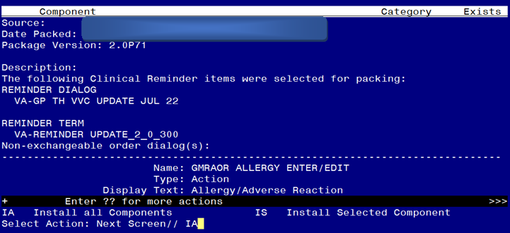

At the **Select Action** prompt, type **IA** for Install all Components and hit enter.

Select Action: Next Screen// IA Install all Components

You will see several prompts, for all new entries you will choose **I to Install**

*For components that already exists but the packed component is different, you will choose* ***S to SKIP.***

**You will be prompted to install the reminder dialog component – You will choose to install all even though some components may have an X to indicate that they exist.**

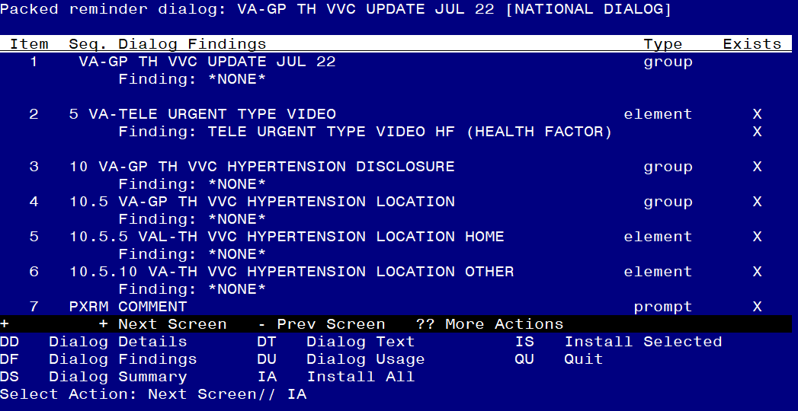

At the **Select Action** prompt, type **IA** to install the dialog – VA-GP TH VVC UPDATE JUL 22

Select Action: Next Screen// IA Install All

Install reminder dialog and all components with no further changes: Y// Yes

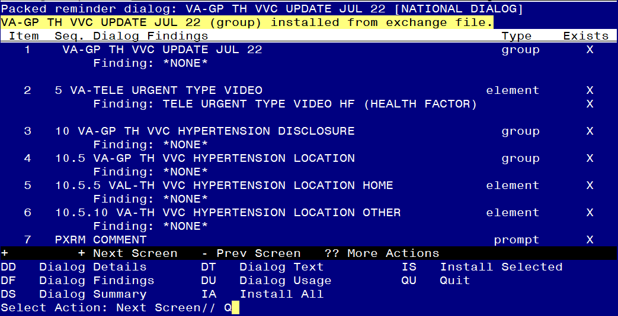

After completing this dialog install, you will type Q.

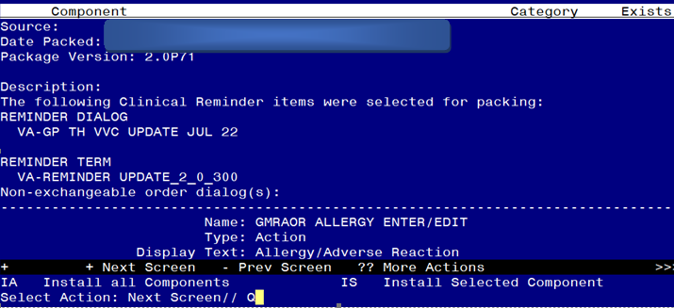

You will then be returned to this screen. At the **Select Action** prompt, type **Q.**

Install complete.

# Post Installation

1. Add your local DATA OBJECT FOR PATIENT ADDRESS to the following element: VAL-TH VVC HYPERTENSION LOCATION HOME

Using the menu Reminder Dialog Management, Reminder Dialogs, change your view to Element.

Search for and edit the following element: VAL-TH VVC HYPERTENSION LOCATION HOME.

1. Add your local DATA OBJECT FOR PATIENT PHONE NUMBER to the following element: VAL-TH VVC HYPERTENSION PHONE NUMBER OBJECT

Using the menu Reminder Dialog Management, Reminder Dialogs, change your view to Element.

Search for and edit the following element: VAL-TH VVC HYPERTENSION PHONE NUMBER OBJECT

1. Add your local DATA OBJECTS FOR MEDICATIONS AND ALLERGIES to the following element: VAL-TH VVC HYPERTENSION DISCLOSURE MED AND ALLERGY OBJECT

Using the menu Reminder Dialog Management, Reminder Dialogs, change your view to Element.

Search for and edit the following element: VAL-TH VVC HYPERTENSION DISCLOSURE MED AND ALLERGY OBJECT

1. Add a local DATA OBJECT FOR BMP WITHIN THE LAST 2 YEARS to the following element: VAL-TH VVC HYPERTENSION DISCLOSURE LAB OBJECT

Using the menu Reminder Dialog Management, Reminder Dialogs, change your view to Element.

Search for and edit the following element: VAL-TH VVC HYPERTENSION DISCLOSURE LAB OBJECT

1. Add referral orders identified in the pre-install to the following reminder dialog elements as an additional finding. Using the menu Reminder Dialog Management, Reminder Dialogs, change your view to Element.

VAL-TH VVC HTN REFERRAL PHARM

VAL-TH VVC HTN REFERRAL DIETITIAN

VAL-TH VVC HTN REFERRAL MOVE

VAL-TH VVC HTN REFERRAL OTHER

VAL-TH VVC HTN REFERRAL HT

VA-TH VVC HYPERTENSION BP CUFF SIZE