Update_2_0_301

Clinical Reminders

VA-VCL Update

Install Guide

August 2022

Product Development
Office of Information Technology
Department of Veterans Affairs

Table of Contents
Introduction 1
Pre-Installation 3
Install Details 4
Install Example 4
Post Installation 7

Introduction
Guidance from the SECVA was released to update the Veterans Crisis Line (VCL) contact information (see screenshot excerpt below).

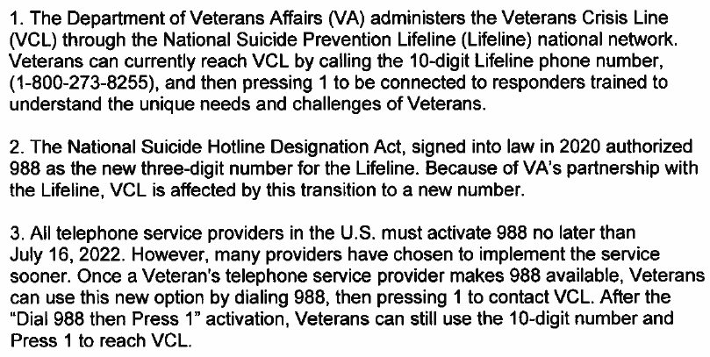

This update includes national reminder dialog groups and elements that contain text for the Veterans Crisis Line (VCL). Each group and element have been updated with the new VCL contact (i.e. Dial 988 then Press 1). A PDF containing the list of each updated reminder dialog is available in the link below.

REDACTED URL

One item (example) from the PDF is below:

Reminder ELEMENT: VA-EL RH&S - VETERANS CRISIS LINE
Change Made: Veterans Crisis Line reference number changed to “Dial 988 then Press 1”.
Resides in the VA-RELATIONSHIP HEALTH AND SAFETY ASSESSMENT reminder dialog.

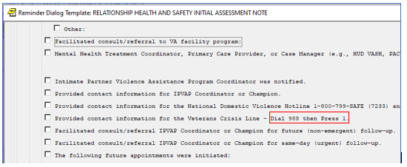

UPDATE_2_0_301 contains 1 Reminder Exchange entry:
UPDATE_2_0_301 VA-VCL UPDATE

The exchange file contains the following components:

REMINDER GENERAL FINDINGS
VIEW PROGRESS NOTE TEXT

TIU TEMPLATE FIELD
VA-SAH IA HEAD INJURY TEXT
YES -OR- NO
GEN WORD PROCESSING
VA-SAH IA CURRENT MH TX
EDIT 60
VA-ONC OTHERS PRESENT
VA-ONC VVC VERBAL
BLANK TEXT FIELD FOR DIALOGS
WORD PROCESSING 10-2-02
VA-TELE URGENT CRISIS LINE
VA SP EB25
VA SP EB30 IND
VA SP CITY ST
VA SP EB40
VA SP CRISIS CHAT
VA SP 3 LINES
VA-OSP SAFETY PLAN BLANK CLINICIAN
VA-OSP SAFETY PLAN BLANK

HEALTH FACTORS
VA-REMINDER UPDATES [C]
VA-UPDATE_2_0_301
VA-SUICIDE RISK ASSESSMENT [C]
VA-SUICIDE ACTION PROVIDE CRISISLINE
TELE URGENT CARE [C]
TELE URGENT TYPE CHAT HF
TELE URGENT TYPE PHONE HF
TELE URGENT TYPE VIDEO HF
TELE URGENT PLAN NEAREST ER HF
TELE URGENT PLAN URGENT CARE HF
TELE URGENT PLAN LESS THAN 72 HRS HF
TELE URGENT PLAN PACT HF
TELE URGENT PLAN TELE URGENT HF
TELE URGENT RFR OTHER HF
TELE URGENT RFR EYE HF
TELE URGENT RFR CV HF
TELE URGENT RFR NEURO HF
TELE URGENT RFR URINARY HF
TELE URGENT RFR GI HF
TELE URGENT RFR SKIN HF
TELE URGENT RFR ENT HF
TELE URGENT RFR MUSCULO HF
VA-SUICIDE BEHAVIOR AND OVERDOSE REPORT [C]
VA-SBOR OD EDUCATION TO CAREGIVER/OTHER
VA-SBOR OD EDUCATION TO PATIENT
DOMESTIC/INTERPERSONAL VIOLENCE SCREEN [C]
VA-IPVAP/A - PROVIDED CRISIS NUMBER

REMINDER SPONSOR
MENTAL HEALTH SERVICES

REMINDER TERM
VA-REMINDER UPDATE_2_0_301

TIU DOCUMENT DEFINITION
VA-WRIISC ACTIVE PROBLEMS
ALLERGIES/ADR

REMINDER DIALOG
VA-GP VCL UPDATE AUG 22

Pre-Installation

Prior to installing this Update:

- Check Reminder Exchange Install History (IH) and ensure your facility has installed the following (previously released) Updates:

  - UPDATE_2_0_249 VA-STRENGTH AT HOME TEMPLATES

- From the Reminder Dialog Management menu, Inquire/Print (INQ) and capture/save the following ELEMENT:

Identify data objects mapped to the dialog text. Re-mapping steps of these data objects are outlined in the Post-Installation steps.

- Element: VAL-TELE URGENT DEMOGRAPHICS

Install Details

This update is being distributed as a web host file. The address for the host file is: https://REDACTED/UPDATE_2_0_301.PRD

The file will be installed using Reminder Exchange, programmer access is not required.

Installation:
=============
This update can be loaded with users on the system. Installation will take less than 15 minutes.

Install Example
To Load the Web Host File. Navigate to Reminder exchange in Vista
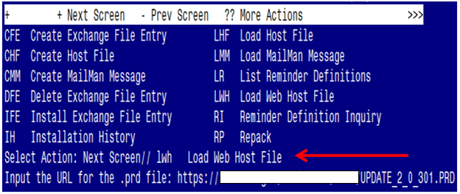

At the Select Action: prompt, enter LWH for Load Web Host File
At the Input the url for the .prd file: prompt, type the following web address:
https://redacted/UPDATE_2_0_301.PRD
You should see a message at the top of your screen that the file successfully loaded.

Search for and locate the reminder exchange entry titled UPDATE_2_0_301 VA-VCL UPDATE.

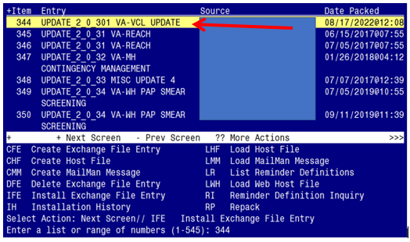

At the Select Action prompt, enter IFE for Install Exchange File Entry
Enter the number that corresponds with your entry titled UPDATE_2_0_301 VA-VCL UPDATE (in this example it is entry 344, it will vary by site). The exchange file date should be 08/17/2022@12:08.

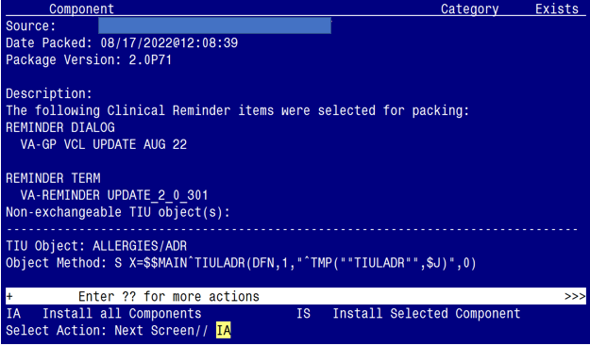

At the Select Action prompt, type IA for Install all Components and hit enter.
Select Action: Next Screen// IA Install all Components

You will see several prompts:
1 - For all new components, choose I to Install
2 - For existing components, choose O to Overwrite.
You will be promped to install the dialog component:

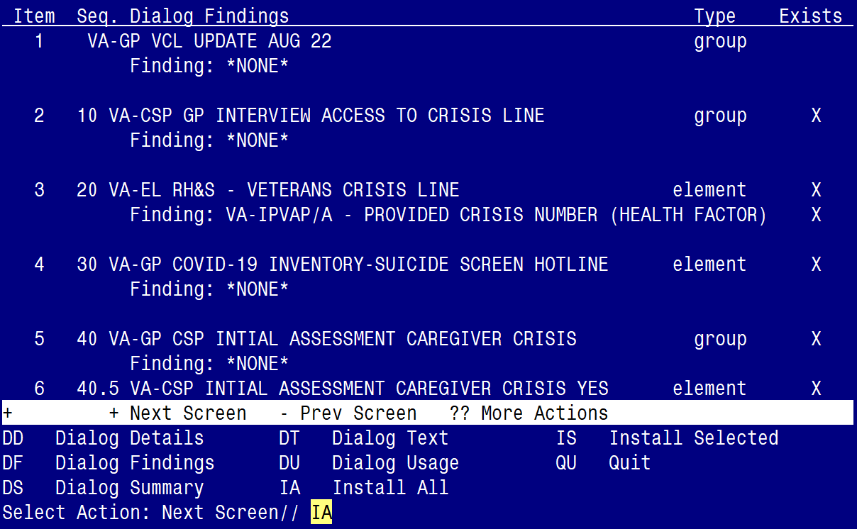

At the Select Action prompt, type IA to install the dialog – VA-GP VCL UPDATE AUG 22
Select Action: Next Screen// IA Install All
Install reminder dialog and all components with no further changes: Y// ES

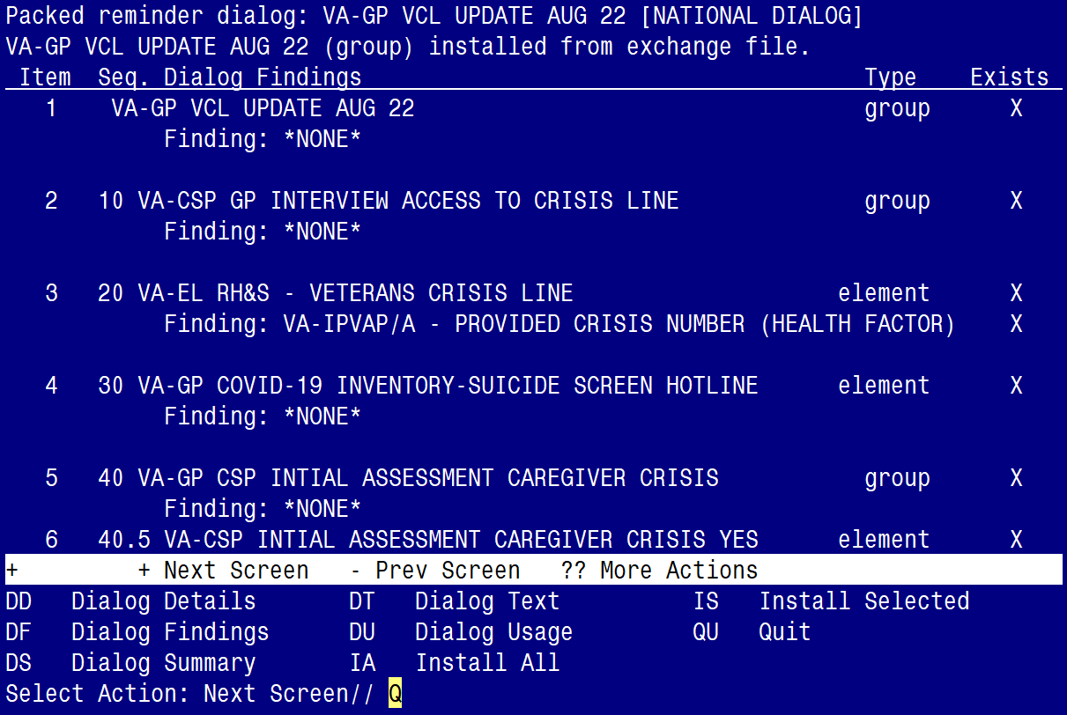

When the dialog has completed installation, you will then be returned to this screen. At the Select Action prompt, type Q.
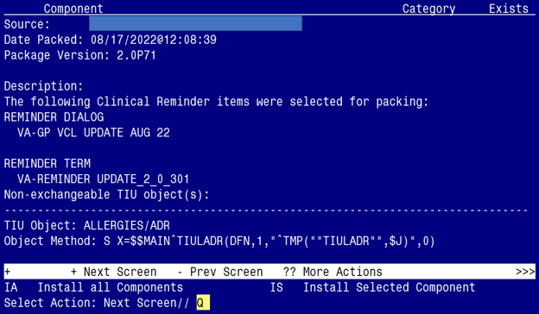

You will be returned to this screen. Type Q to quit.

Install Completed

Post Installation

- Refer to the Inquire/Print (INQ) you saved during the Pre-Installation steps for the following ELEMENT:

Re-map the address, phone number data objects to the following element:

Element: VAL-TELE URGENT DEMOGRAPHICS

Text: Patient's current address **insert data object here for address

Patient's Phone Number: **insert data object here for phone
**insert data object here for cell phone

**insert data object here for patient emergency contact

- Confirm the highlighted data objects are mapped to the dialog text in the following ELEMENTS:

Element: VAL-TELE URGENT PROBLEM LIST
Text:
***************************************************
ACTIVE PROBLEMS: |VA-WRIISC ACTIVE PROBLEMS|

Element: VAL-TELE URGENT ALLERGIES
Text:
***************************************************
ALLERGIES/ADR: |ALLERGIES/ADR|

Element: VAL-TELE URGENT ACTIVE MEDS
Text:
***************************************************
|ACTIVE MEDS COMBINED|

