Update _2_0_302

Clinical Reminders

VA-SEXUAL HEALTH

Install Guide

August 2022

Product Development
Office of Information Technology
Department of Veterans Affairs

Table of Contents
Introduction 1
Install Details 3
Install Example 3
Post Installation 7

Introduction
Description:
This template will be used to evaluate and document a patient’s sexual health history, general health, concerns, risks, well-being and goals. Every patient should have an annual sexual health review, consistent with VHA Directive 1340. The users of this template would be clinical providers who see patients for routine health care. This template is a voluntary tool to aide assessment. The three sections below may be completed at different visits depending on time constraints and the Veteran’s needs or completed by different clinicians on the treatment team. An annual update should review the last assessment and note changes.

UPDATE_2_0_302 contains 1 Reminder Exchange entry:
UPDATE_2_0_302 VA-SEXUAL HEALTH

The exchange file contains the following components:

TIU TEMPLATE FIELD
VA-SEXUAL HEALTH LINK
VA-WORDR

HEALTH FACTORS
VA-REMINDER UPDATES [C]
VA-UPDATE_2_0_302
VA-SEXUAL HEALTH [C]
VA-LGBTQ+HP SXL HLTH SCRN PREVENT STI OTHER
VA-LGBTQ+HP SXL HLTH SCRN PREVENT STI BARRIER METHOD
VA-LGBTQ+HP SXL HLTH SCRN PREVENT STI MONOGAMOUS RELATIONSHIP
VA-LGBTQ+HP SXL HLTH SCRN PREVENT STI REDUCE SEXUAL PARTNERS
VA-LGBTQ+HP SXL HLTH SCRN PREVENT STI ABSTINENT
VA-LGBTQ+HP SXL HLTH SCRN LAST 12 MOS TRANSACTIONAL SEX YES
VA-LGBTQ+HP SXL HLTH SCRN LAST 12 MOS TRANSACTIONAL SEX NO
VA-LGBTQ+HP SXL HLTH SCRN LAST 12 MOS SEXUAL PARTNERS INJ DRUG N
VA-LGBTQ+HP SXL HLTH SCRN LAST 12 MOS SEXUAL PARTNERS INJ DRUG Y
VA-LGBTQ+HP SXL HLTH SCRN LAST 12 MOS SEXUAL PARTNERS HIV NO
VA-LGBTQ+HP SXL HLTH SCRN LAST 12 MOS SEXUAL PARTNERS HIV YES
VA-LGBTQ+HP SXL HLTH SCRN LAST 12 MOS SEXUAL PARTNERS DX STI NO
VA-LGBTQ+HP SXL HLTH SCRN LAST 12 MOS SEXUAL PARTNERS DX STI YES
VA-LGBTQ+HP SXL HLTH SCRN EVER SEXUALLY ACTIVE NO
VA-LGBTQ+HP SXL HLTH SCRN EVER SEXUALLY ACTIVE YES
VA-LGBTQ+HP SXL HLTH SCRN LAST 12 MOS SEXUALLY ACTIVE NO
VA-LGBTQ+HP SXL HLTH SCRN LAST 12 MOS SXLY ACTIV 2 OR MORE PPL
VA-LGBTQ+HP SXL HLTH SCRN LAST 12 MOS SXLY ACTIV 1 PERSON
VA-LGBTQ+HP SXL HLTH SCRN LAST 12 MOS SEXUAL PARTNERS FEMALE
VA-LGBTQ+HP SXL HLTH SCRN LAST 12 MOS SEXUAL PARTNERS MALE
VA-LGBTQ+HP SXL HLTH SCRN LAST 12 MOS NEW SEXUAL PART 1 OR MORE
VA-LGBTQ+HP SXL HLTH SCRN LAST 12 MOS NEW SEXUAL PARTNERS NONE
VA-LGBTQ+HP SXL HLTH SCRN LAST 12 MOS SEXUALLY ACTIVE YES
VA-LGBTQ+HP SXL HLTH SCRN ANYTHG ABT SXL ACT WLD LIKE TO CHG NO
VA-LGBTQ+HP SXL HLTH SCRN ANYTHG ABT SXL ACT WLD LIKE TO CHG YES
VA-LGBTQ+HP SXL HLTH SCRN DIFFICULTY W EJACULATION NA
VA-LGBTQ+HP SXL HLTH SCRN DIFFICULTY W EJACULATION NO
VA-LGBTQ+HP SXL HLTH SCRN DIFFICULTY W EJACULATION YES
VA-LGBTQ+HP SXL HLTH SCRN DIFFICULTY W ERECTION NA
VA-LGBTQ+HP SXL HLTH SCRN DIFFICULTY W ERECTION NO
VA-LGBTQ+HP SXL HLTH SCRN DIFFICULTY W ERECTION YES
VA-LGBTQ+HP SXL HLTH SCRN DIFFICULTY ACHIEVING ORGASM NO
VA-LGBTQ+HP SXL HLTH SCRN DIFFICULTY ACHIEVING ORGASM YES
VA-LGBTQ+HP SXL HLTH SCRN DIFFICULTY W LUBRICATION NA
VA-LGBTQ+HP SXL HLTH SCRN DIFFICULTY W LUBRICATION NO
VA-LGBTQ+HP SXL HLTH SCRN DIFFICULTY W LUBRICATION YES
VA-LGBTQ+HP SXL HLTH SCRN PAIN W INTERCOURSE NO
VA-LGBTQ+HP SXL HLTH SCRN PAIN W INTERCOURSE YES
VA-LGBTQ+HP SXL HLTH SCRN USE DEV OR SUBST FOR SXL PLSR NO
VA-LGBTQ+HP SXL HLTH SCRN USE DEV OR SUBST FOR SXL PLSR YES
VA-LGBTQ+HP SXL HLTH SCRN CHG IN YOUR/PART DESIRE OR FREQ FR TXT
VA-LGBTQ+HP SXL HLTH SCRN HOW SATISF W YOUR/PART SXL FXN FR TXT

REMINDER SPONSOR
LGBTQ+ HEALTH PROGRAM

REMINDER TERM
VA-REMINDER UPDATE_2_0_302

REMINDER DIALOG
VA-SEXUAL HEALTH

Install Details
This update is being distributed as a web host file. The address for the host file is: https://REDACTED /UPDATE_2_0_302.PRD

The file will be installed using Reminder Exchange, programmer access is not required.

Installation:
=============
This update can be loaded with users on the system. Installation will take less than 5 minutes.

Install Example
To Load the exchange file, use LWH. The URL is https://REDACTED/reminders/docs/UPDATE_2_0_302.PRD
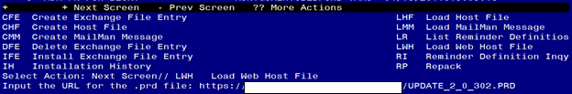

You should see a message that the file was loaded successfully.
Search and locate an entry titled UPDATE_2_0_302 VA-SEXUAL HEALTH in reminder exchange.
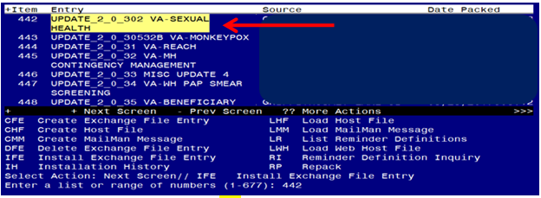
At the Select Action prompt, enter IFE for Install Exchange File Entry
Enter the number that corresponds with your entry titled UPDATE_2_0_302 VA-SEXUAL HEALTH (in this example it is entry 442, it will vary by site) that is dated 08/23/2022.

***There is a new reminder sponsor associated with this install. You will need to do an IS to selectively install reminder sponsor LGBTQ+ HEALTH PROGRAM. If you don’t install this first, you will receive errors when installing the health factors. Please do this step prior to continuing!

YOU NEED TO INSTALL SELECT THE NEW REMINDER SPONSOR ENTRY ONLY (ITEM 59):
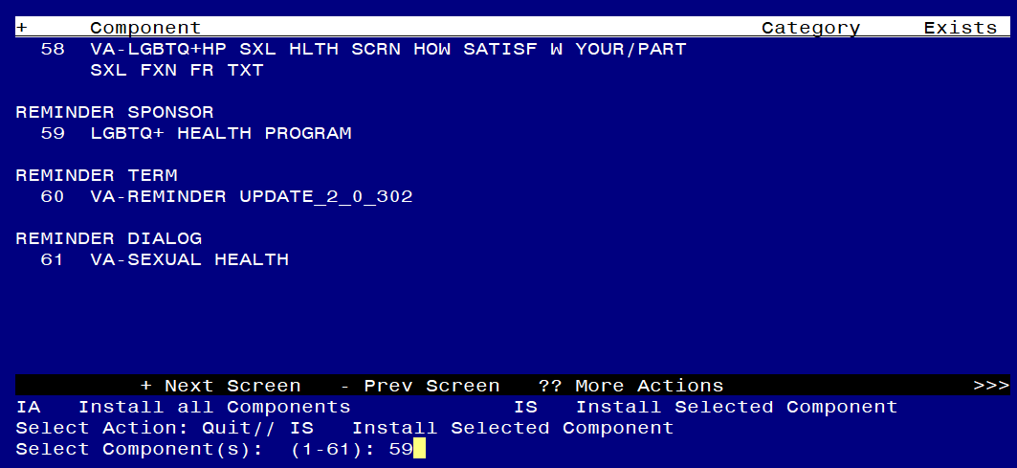
At the Select Action prompt, type IS for Install Selected Component and hit enter.
At the Select Component, type 59 and hit enter
Select Action: Quit// IS Install Selected Component
Select Component(s): (1-61): 59
REMINDER SPONSOR entry LGBTQ+ HEALTH PROGRAM is NEW, what do you want to do?
Select one of the following:
C Create a new entry by copying to a new name
I Install
Q Quit the install
S Skip, do not install this entry
Enter response: I// nstall

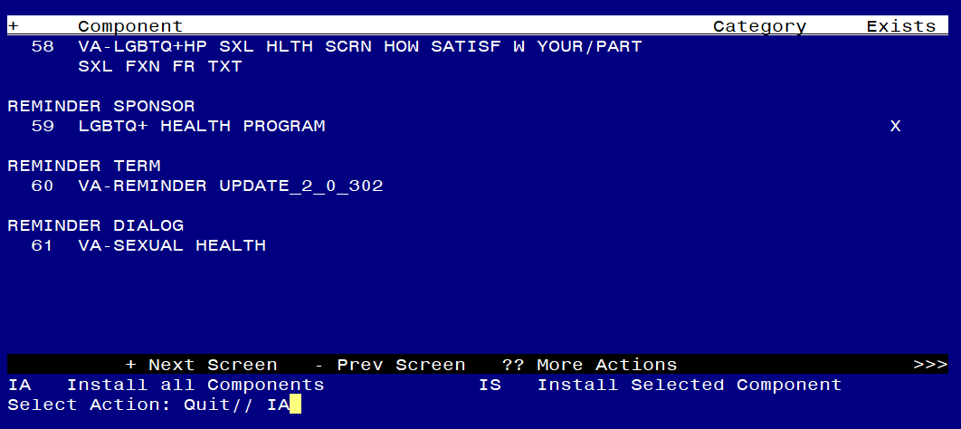
At the Select Action prompt, type IA for Install all Components and hit enter.
For all new entries in any category you will choose I to Install
Skip any items in any category you are prompted to overwrite

You will then be prompted to install the dialog component.
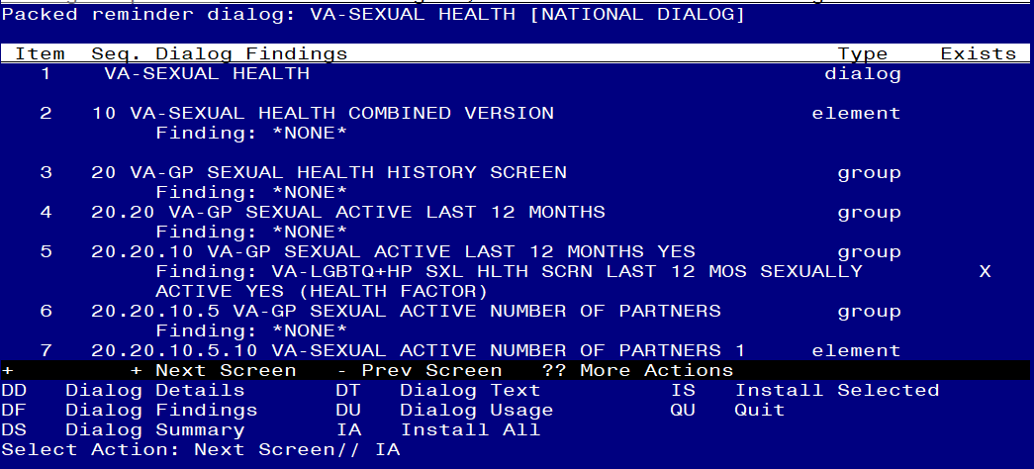
At the Select Action prompt, type IA to install the dialog – VA-SEXUAL HEALTH
Install reminder dialog and all components with no further changes: Y//ES

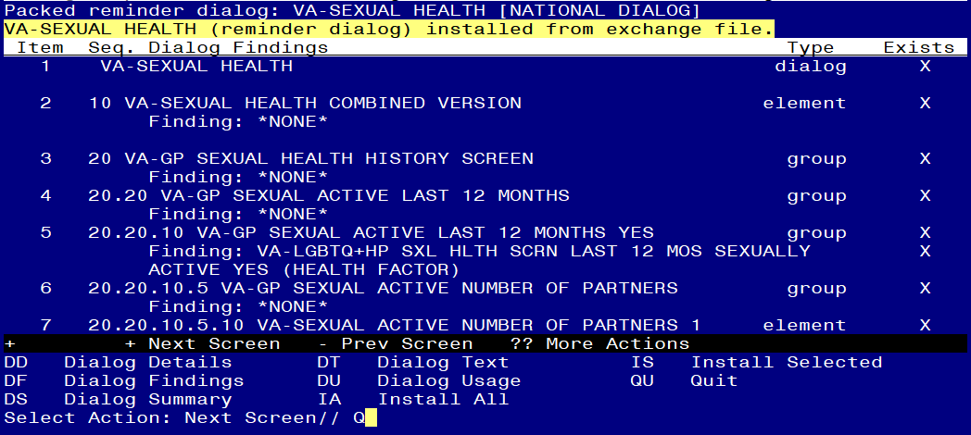

When the dialog has completed installation, you will then be returned to this screen. At the Select Action prompt, type Q.

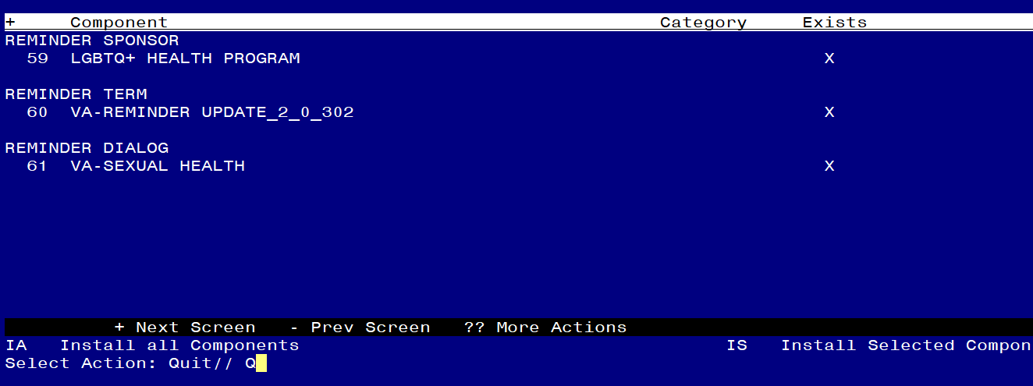
You will then be returned to this screen. At the Select Action prompt, type Q.

Install complete.

Post Installation

- Setup of Note Title.

The note title to create to associate with this template is:

SEXUAL HEALTH REVIEW

VHA Enterprise Standard Title: PRIMARY CARE NOTE

You can add these to your document class where PRIMARY CARE progress notes are located.

Note: Comprehensive information on Creating new Document Classes and Titles can be found beginning on page 54 of the TIU/ASU Implementation Guide at the following link: http://www.va.gov/vdl/documents/Clinical/CPRS-Text_Integration_Utility_(TIU)/tiuim.pdf

- Make the Dialog templates available to be attached to a Personal or Shared templates or to be able to attach the dialog to a progress note title.
Select Reminder Managers Menu <TEST ACCOUNT> Option: CP CPRS Reminder Configuration
CA Add/Edit Reminder Categories
CL CPRS Lookup Categories
CS CPRS Cover Sheet Reminder List
MH Mental Health Dialogs Active
PN Progress Note Headers
RA Reminder GUI Resolution Active
TIU TIU Template Reminder Dialog Parameter
DEVL Evaluate Coversheet List on Dialog Finish
DL Default Outside Location
PT Position Reminder Text at Cursor
LINK Link Reminder Dialog to Template
TEST CPRS Coversheet Time Test
NP New Reminder Parameters
GEC GEC Status Check Active
WH WH Print Now Active
Select CPRS Reminder Configuration <TEST ACCOUNT> Option: TIU TIU Template Reminder Dialog Parameter
Reminder Dialogs allowed as Templates may be set for the following:
1 User USR [choose from NEW PERSON]
3 Service SRV [choose from SERVICE/SECTION]
4 Division DIV [SALT LAKE CITY]
5 System SYS [NATREM.FO-SLC.MED.VA.GOV]
Enter selection: 5 Choose the appropriate number for your site. Your site may do this by System or other levels. The example below uses SYSTEM level.
Setting Reminder Dialogs allowed as Templates for System: NATREM.FO-SLC.MED.VA.GOV
Select Display Sequence: ?
388 VA-COVID-19 TELEPHONE FOLLOW-UP
389 VA-SRA-CONSULT RESPONSE (D)
When you type a question mark above, you will see the list of #’s (with dialogs) that are already taken. Choose a number NOT on this list. For this example, 390 is not present so I will use 390.
Select Display Sequence: 390
Are you adding 390 as a new Display Sequence? Yes// YES
Display Sequence: 390// <Enter> 390
Clinical Reminder Dialog: VA-SEXUAL HEALTH reminder dialog NATIONAL
...OK? Yes// <Enter> (Yes)

- Associate the reminder dialogs with the note title in CPRS
- In CPRS, open the Template Editor, expand Document Titles, select the appropriate folder (if applicable), then click New Template (top right-hand corner).
Sr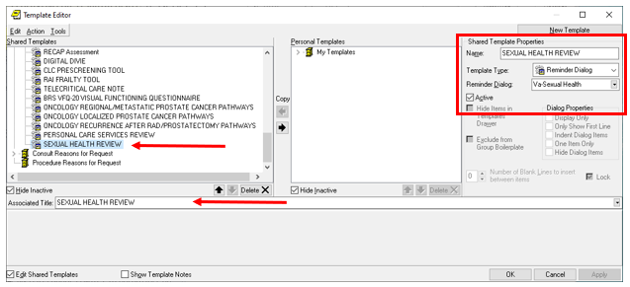

Type in the following information:
Name: SEXUAL HEALTH REVIEW
Template Type: Reminder Dialog
Reminder Dialog: VA-SEXUAL HEALTH
Next, type in the Associated Title name SEXUAL HEALTH REVIEW
–– then click Apply.

