Update _2_0_303

Clinical Reminders

VA-BRIEF ADHD IDENTIFICATION TOOL

Install Guide

December 2022

Product Development
Office of Information Technology
Department of Veterans Affairs

Table of Contents
Introduction 1
Install Details 2
Install Example 2
Post Installation 5

Introduction

Purpose. The purpose of the template is to identify which patients with complaints of inattention and/or hyperactivity/impulsivity should have further evaluation for ADHD. The template DOES NOT diagnose ADHD or assist in the diagnosis of other conditions where inattention, impulsivity, or hyperactivity are present.

Rationale. There is significant variation within VA regarding the diagnosis of ADHD and the prescription of stimulant medication. Data suggests that ADHD may be underdiagnosed in VA, and clinical decision making in support of ADHD diagnosis or stimulant prescribing often lacks standardization and appropriate documentation. Thus, it is clear that VA providers (primarily mental health and primary care teams) need support for determining which patients with complaints of inattention/hyperactivity, or other concerns consistent with ADHD, actually necessitate a comprehensive diagnostic evaluation by mental health. Improving care for ADHD starts with improved screening. This template is the first step towards a standardized approach to the identification of ADHD.

UPDATE_2_0_303 contains 1 Reminder Exchange entry:

UPDATE_2_0_303 VA-BRIEF ADHD IDENTIFICATION TOOL

The exchange file contains the following components:

REMINDER DIALOG LINK TYPE
VA-ASRS RESULT POSITIVE LINK
VA-ASRS RESULT NEGATIVE LINK

HEALTH FACTORS
VA-REMINDER UPDATES [C]
VA-UPDATE_2_0_303
VA-BAIT ADHD TOOL [C]
VA-BAID ADHD SYMPTOMS UNKNOWN IF INTERFERE W SOC ACAD OCCUP FXN
VA-BAIT ADHD SYMPTOMS DO NOT INTERFERE W SOC ACAD OCCUP FXN
VA-BAIT ADHD SYMPTOMS INTERFERE W SOC ACAD OCCUP FXN
VA-BAIT ADHD SYMPTOMS BEFORE AGE 12 UNKNOWN IF PRESENT
VA-BAIT ADHD SYMPTOMS BEFORE AGE 12 NOT PRESENT
VA-BAIT ADHD SYMPTOMS BEFORE AGE 12 PRESENT

REMINDER TERM
VA-REMINDER UPDATE_2_0_303

REMINDER DIALOG
VA-BRIEF ADHD IDENTIFICATION TOOL (BAIT)

Install Details

This update is being distributed as a web host file. The address for the host file is: https://REDACTED/UPDATE_2_0_303.PRD

The file will be installed using Reminder Exchange, programmer access is not required.

Installation:
=============
This update can be loaded with users on the system. Installation will take less than 5 minutes.

Install Example

Go to Reminder exchange in Vista.
To Load the exchange file, use LWH. The URL is https://REDACTED/UPDATE_2_0_303.PRD

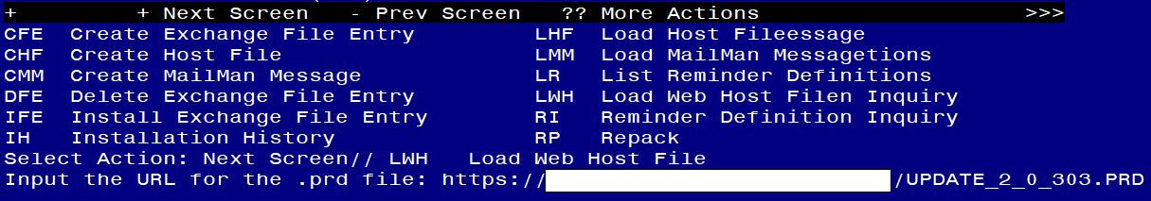
You will see a message indicating the file was loaded successfully.

Search and locate an entry titled UPDATE_2_0_303 VA-BRIEF ADHD IDENTIFICATION TOOL in reminder exchange.

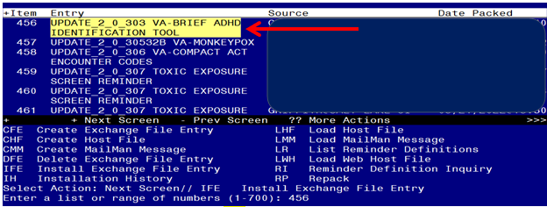
At the Select Action prompt, enter IFE for Install Exchange File Entry
Enter the number that corresponds with your entry titled UPDATE_2_0_303 VA-BRIEF ADHD IDENTIFICATION TOOL (in this example it is entry 456, it will vary by site) that is dated 11/30/2022.
If you see a prompt “FINDING entry MH.ASRS does not exist…”, choose the replace option and replace with the finding ASRS-6.

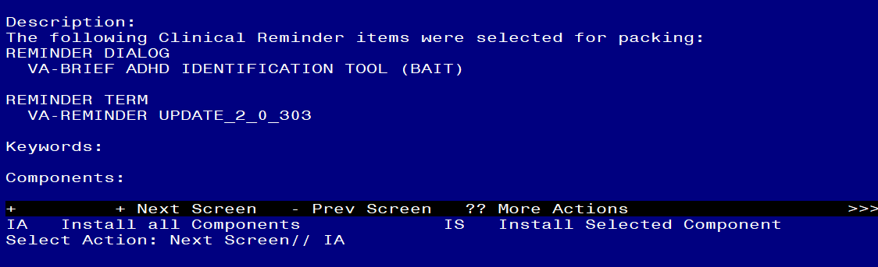

At the Select Action prompt, type IA for Install all Components and hit enter.
For all new entries in any category you will choose I to Install
SKIP any items in any category you are prompted to overwrite.

You will then be prompted to install the dialog component.
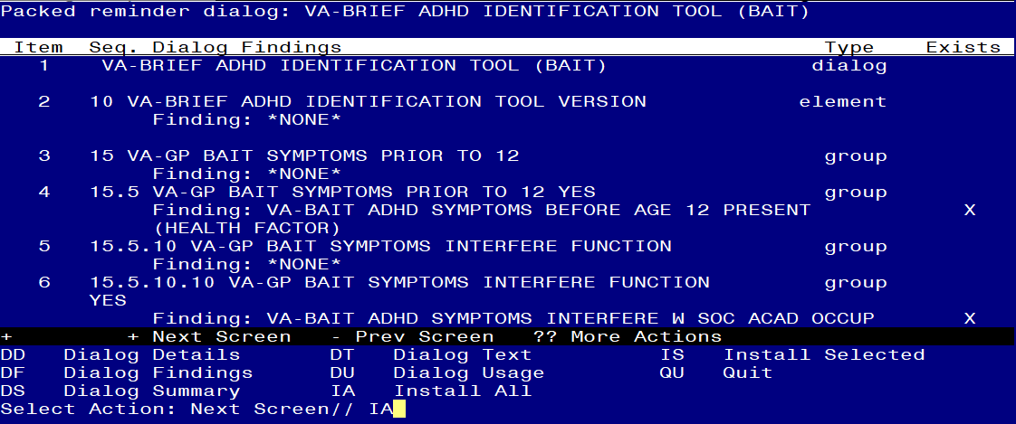
At the Select Action prompt, type IA to install the dialog – VA-BRIEF ADHD IDENTIFICATION TOOL (BAIT)
Install reminder dialog and all components with no further changes: Y//ES

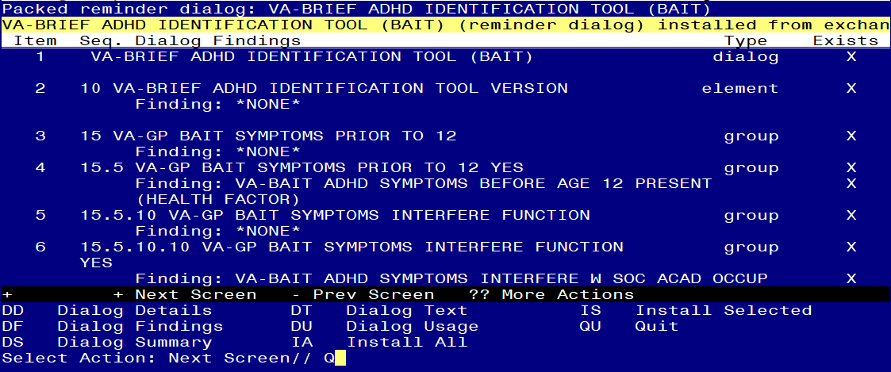
When the dialog has completed installation, you will then be returned to this screen. At the Select Action prompt, type Q.

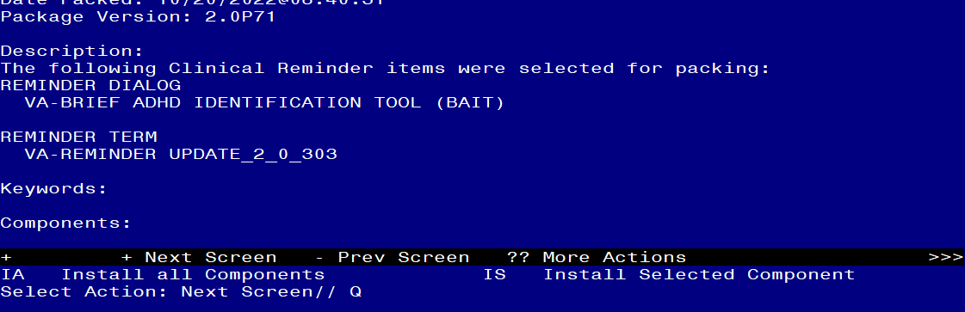
You will then be returned to this screen. At the Select Action prompt, type Q.

Install complete.

Post Installation
- Make the Dialog templates available to be attached to a Personal or Shared templates or to be able to attach the dialog to a progress note title.
Select Reminder Managers Menu <TEST ACCOUNT> Option: CP CPRS Reminder Configuration
CA Add/Edit Reminder Categories
CL CPRS Lookup Categories
CS CPRS Cover Sheet Reminder List
MH Mental Health Dialogs Active
PN Progress Note Headers
RA Reminder GUI Resolution Active
TIU TIU Template Reminder Dialog Parameter
DEVL Evaluate Coversheet List on Dialog Finish
DL Default Outside Location
PT Position Reminder Text at Cursor
LINK Link Reminder Dialog to Template
TEST CPRS Coversheet Time Test
NP New Reminder Parameters
GEC GEC Status Check Active
WH WH Print Now Active
Select CPRS Reminder Configuration <TEST ACCOUNT> Option: TIU TIU Template Reminder Dialog Parameter
Reminder Dialogs allowed as Templates may be set for the following:
1 User USR [choose from NEW PERSON]
3 Service SRV [choose from SERVICE/SECTION]
4 Division DIV [SALT LAKE CITY]
5 System SYS [NATREM.FO-SLC.MED.VA.GOV]
Enter selection: 5 Choose the appropriate number for your site. Your site may do this by System or other levels. The example below uses SYSTEM level.
Setting Reminder Dialogs allowed as Templates for System: NATREM.FO-SLC.MED.VA.GOV
Select Display Sequence: ?
388 VA-COVID-19 TELEPHONE FOLLOW-UP
389 VA-SRA-CONSULT RESPONSE (D)
When you type a question mark above, you will see the list of #’s (with dialogs) that are already taken. Choose a number NOT on this list. For this example, 390 is not present so I will use 390.
Select Display Sequence: 390
Are you adding 390 as a new Display Sequence? Yes// YES
Display Sequence: 390// <Enter> 390
Clinical Reminder Dialog: VA-BRIEF ADHD IDENTIFICATION TOOL (BAIT) reminder dialog NATIONAL
...OK? Yes// <Enter> (Yes)

- Add the template to your shared template folder so it can be used with any note title.
  - In CPRS, open the Template Editor, expand Shared Templates, select the appropriate folder (if applicable), then click New Template (top right-hand corner).
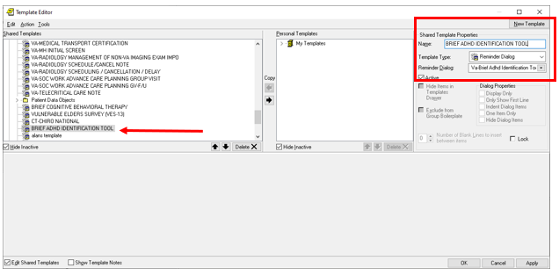

Type in the following information:
Name: BRIEF ADHD IDENTIFICATION TOOL
Template Type: Reminder Dialog
Reminder Dialog: VA-BRIEF ADHD IDENTIFICATION TOOL (BAIT)
–– then click Apply.

