Update_2_0_304

Clinical Reminders

VA-MISC Update 20

Install Guide

December 2022

Product Development
Office of Information Technology
Department of Veterans Affairs

Table of Contents
Introduction 1
Pre-Installation 6
Install Details 7
Install Example 7
Post Installation 18

Introduction

This update contains minor spelling corrections and other changes/edits to existing clinical reminder content, a full list of the changes can be found here:

https://REDACTED/MISC_UPDATE_20 CHANGES

UPDATE_2_0_304 contains 1 Reminder Exchange entry:
UPDATE_2_0_304 VA-MISC UPDATE 20

The exchange file contains the following components:

REMINDER GENERAL FINDINGS
PREGNANCY ENDED REASON MATERNAL MORTALITY

TIU TEMPLATE FIELD
VA-WH PAP INFORMATION
VA-CRC COLONOSCOPY SCHEDULE INSTRUCTIONS
VA-ETHICS-FORM 10-0137A
VA-ETHICS-LINK-HB-1004-02
VA-OSP CRISTAL
VA-LST WP MAND 2 LINE
TEXT NO LIMIT
BLANK TEXT FIELD FOR DIALOGS
VA-LIPID MGMT GUIDANCE
RX STATIN MOD/HI DOSE

HEALTH FACTORS
VA-REMINDER UPDATES [C]
VA-UPDATE_2_0_304
WH PAP SMEAR [C]
WH ORDER PAP SMEAR SCREEN HF
WH ORDER HPV LAB
OUTSIDE CERVICAL FDA HRHPV TESTING NEG
OUTSIDE CERVICAL HPV TESTING POSITIVE
OUTSIDE CERVICAL HPV TESTING NEGATIVE
WH PAP SMEAR SCREEN FREQ – 3Y
WH PAP SMEAR SCREEN FREQ – 6M
WH PAP SMEAR SCREEN FREQ – 4M
WH PAP SMEAR SCREEN FREQ – 2Y
WH PAP SMEAR SCREEN FREQ – 1Y
WH PAP SMEAR SCREEN NOT INDICATED
WH CERV CA SCRN N/A 5 YRS-LE<5YRS
WH PAP SMEAR SCREEN FREQ - 5Y
VA LIFE EXPECTANCY [C]
VA LIMITED LIFE EXPECTANCY
REMINDER FACTORS [C]
LIFE EXPECTANCY < 1 YEAR
LIFE EXPECTANCY < 6 MONTHS
INACTIVATE CERVIX CANCER SCREEN
WH OUTSIDE ABNORMAL (OTHER) PAP
WH OUTSIDE ABNORMAL (ASCUS) PAP
WH OUTSIDE NORMAL PAP
VA-WH HPV OBTAINED
VA-WH CERVICAL CYTOLOGY OBTAINED
VA-SUICIDE BEHAVIOR AND OVERDOSE REPORT [C]
VA-SBOR EVENT TYPE SUICIDE ATT YES
VA-SUICIDE RISK ASSESSMENT [C]
VA-SUICIDE PRIOR ATTEMPT DATE
ETHICS-LST CONSENT [C]
ETHICS-LST CONSENT-MDC-FACILITY APPROVED
ETHICS-LST CONSENT-PATIENT
ETHICS-LST CONSENT-SURROGATE
ETHICS-LST CONSENT-SAPO-PENDING MDC
ETHICS-DECISION-MAKING CAPACITY [C]
ETHICS-DECISION-MAKING CAPACITY-NO
ETHICS-SURROGATE [C]
ETHICS-SURROGATE-DOES NOT HAVE
ETHICS-LST-PLANS-BASIS [C]
ETHICS-LST-PLANS-NO DMC-SAPO/MDC
ETHICS-SURROGATE-HAS
ETHICS-DECISION-MAKING CAPACITY-YES
VA-EYE CARE AT-RISK SCREEN [C]
VA-EYE AT RISK SCREEN HX LASER TX/INJ LAST 2YRS
VA-OUTSIDE DIAB EYE UNK AT-RISK SCRN
VA-OUTSIDE DIAB EYE ABN AT-RISK SCRN
VA-OUTSIDE DIAB EYE NORMAL AT-RISK SCRN
VA-OUTSIDE EYE AT-RISK SCREEN
VA-ONC PRCA CRPC M0 PATHWAY [C]
VA-ONC PRCA CRPC M0 <=10M CLIN TRIAL
VA-ONCOLOGY PATHWAYS [C]
VA-ONC PRCA MOLECULAR TESTING
VA-ONC PRCA RADIATION THERAPY RECURRENCE PATHWAY
INCORRECT DIAGNOSES [C]
VA-INCORRECT REVASCULARIZATION CODE
INCORRECT DIAGNOSIS OF ATHEROSCLEROSIS
VA-INCORRECT DIABETES DIAGNOSIS
LIPID MED INTERVENTIONS [C]
DECLINES STATIN ADJUSTMENT
STATIN - ADR TO ALL AVAILABLE
STATIN - TEMPORARY CONTRAINDICATION
DECLINES STATIN THERAPY
VA-STATIN LIFE EXPECTANCY < 2 YEARS
STATIN RX DOSE REVIEWED AND UPDATED
VA-STATIN NON-VA MED VERIFIED
STATIN - ON HIGHEST TOLERATED DOSE
REFUSED LIPID MED ADJUSTMENT
LIPID LOWERING MEDS ADJUSTED
OUTSIDE STATIN - MODERATE OR HIGH DOSE
LIPID MEDS NON-ADHERENCE
LIPID LOWERING MEDS INITIAL ORDER

REMINDER SPONSOR
OFFICE OF MENTAL HEALTH SERVICES
NATIONAL GASTROENTEROLOGY & HEPATOLOGY PROGRAM
OFFICE OF PATIENT CARE SERVICES
WOMEN VETERANS HEALTH PROGRAM AND NATIONAL CENTER FOR HEALTH PROMOTION AND DISEASE PREVENTION (NCP)
WOMEN VETERANS HEALTH PROGRAM
VHA NATIONAL CENTER FOR HEALTH PROMOTION AND DISEASE PREVENTION (NCP) AND VHA OFFICE OF WOMEN’S HEALTH
MENTAL HEALTH SERVICES AND WOMEN VETERANS HEALTH PROGRAM
VHA GI FIELD ADVISORY COMMITTEE
NATIONAL CENTER FOR ETHICS IN HEALTH CARE
Office of Nursing Service
OFFICE OF TELEHEALTH SERVICES STORE AND FORWARDTELEHEALTH
VHA CARDIOLOGY SERVICES

REMINDER COMPUTED FINDING
VA-IS INPATIENT
VA-AGE
VA-REMINDER DEFINITION
VA-FILEMAN DATE
VA-ALLERGY

REMINDER TAXONOMY
VA-OUD ALL SOURCES
VA-STIMULANT USE DISORDER ALL SOURCES
VA-ADVANCED LIVER DISEASE INPT DX
VA-DEMENTIA DIAGNOSIS
VA-TERMINAL CANCER PATIENTS
VA-CERVICAL CA/ABNORMAL PAP
VA-WH PAP SMEAR OBTAINED
VA-DIABETES HEDIS
VA-STATIN OTHER REVASCULARIZATION
VA-STATIN PCI
VA-STATIN CABG
VA-IHD AND ASVD
VA-DIABETES HEDIS PROB LIST
VA-STATIN-ESRD
VA-STATIN MUSCULAR PAIN AND DISEASE
VA-STATIN CIRRHOSIS

REMINDER TERM
VA-NALOXONE PRESCRIPTION ON FILE
VA-OUD STIMULANT USE DISORDER REMINDER TERM
VA-REMINDER UPDATE_2_0_304
VA-AGE<30
VA-WH PAP SMEAR FREQ SETTINGS
VA-WH PAP SMEAR SCREEN NOT INDICATED
VA-WH PAP SMEAR SCREEN FREQ – 1Y
VA-BL WH PAP REVIEW FREQ
VA-BL TELE EYE DIABETIC PT
VA-BL STATIN INPT/OUTPT RX
VA-BL LDL REVASCULARIZATION
VA-IHD/ASVD DX INCORRECT
VA-IHD AND ASVD
VA-DIABETES DX INCORRECT
VA-DIABETES MEDICATIONS
VA-BL LDL DM AND CV DISEASE
VA-BL LDL CV DISEASE ONLY
VA-BL LDL DIABETES DX ONLY
VA-STATIN DRUGS
VA-BL LDL STATIN NON-VA MED VERIFIED
VA-BL STATIN RX ACTIVE/SUSPENDED
VA-STATIN DRUGS NON-VA
VA-STATIN TEMPORARY CONTRAIND
VA-STATIN ADR ALL HF
VA-STATIN ADR
VA-STATIN NON-VA MOD/HI DOSE THERAPY
VA-STATIN ON HIGHEST TOLERATED DOSE
VA-LDL NON-ADHERENCE WITH RX
VA-STATIN DECLINES
VA-STATIN ADD/ADJUST
VA-REVASCULARIZATION CODE INCORRECT
VA-STATIN REVASCULARIZATION CODES
VA-STATIN MOD DOSE (IF SPLIT, NOT MODERATE)
VA-STATIN HI/MOD DOSE (IF SPLIT, STILL MODERATE)
VA-STATIN LIFE EXPECTANCY < 2 YEARS

REMINDER DEFINITION
VA-NALOXONE ORDER CHECK
VA-BL WH PAP REVIEW FREQ
VA-BL LDL REVASCULARIZATION
VA-BL LDL DM AND CV DISEASE
VA-BL LDL CV DISEASE ONLY
VA-BL LDL DIABETES DX ONLY
VA-BL LDL NON-VA STATIN VERIFIED
VA-LIPID STATIN RX CVD/DM

HEALTH SUMMARY COMPONENT
PCE HEALTH FACTORS SELECTED

HEALTH SUMMARY TYPE
VA-SBOR EVENT DATE

HEALTH SUMMARY OBJECTS
VA-SBOR EVENT DATE (TIU)

TIU DOCUMENT DEFINITION
VA-SBOR EVENT DATE

REMINDER ORDER CHECK RULES
VA-NALOXONE FOR OPIOID USE DISORDER

REMINDER DIALOG
VA-GP MISC UPDATE 20
VA-LIPID STATIN RX CVD/DM

Pre-Installation

Prior to installing this Update:

- Check Reminder Exchange Install History (IH) and ensure your facility has installed the following (previously released) Updates:

  - UPDATE_2_0_146 VA-EYE CARE AT RISK REMINDERS
  - UPDATE_2_0_282 VA-MATERNITY CARE COORDINATION UPDATE
  - UPDATE_2_0_287 VA-ONCOLOGY CLINICAL PATHWAYS - PROSTATE CANCER
  - UPDATE_2_0_278 VA-RADIOLOGY SCHEDULING CANCELLATION DELAY

- From the Reminder Order Check menu, Reminder Order Check Rule Inquiry (RI) and capture/save the following reminder order check rule:

  - VA-NALOXONE FOR OPIOID USE DISORDER

(You need to confirm whether the Status is set to PRODUCTION or INACTIVE. If it is set to PRODUCTION, you will need to reset the status in the post-Installation steps).

VA-NALOXONE FOR OPIOID USE DISORDER
-----------------------------------------------------------------------------
Display Name: NALOXONE RECOMMENDED FOR OPIOID USE DISORDER OR STIMULANT USE DI
Class: NATIONAL
Sponsor:
Review Date:
Description:
Status: INACTIVE (it may be set to PRODUCTION in your site’s system)

- From the Reminder Definition Management menu, Inquire about Reminder Definition (RI) and capture/save the following reminder definition:

  - VA-LIPID STATIN RX CVD/DM

(You will use this capture to verify all terms have the same mappings and that the Reminder Dialog is linked, upon completion of the post-installation steps).

- From the Reminder Dialog Management menu, Inquire/Print (INQ) and capture/save the following ELEMENT and GROUP:

- ELEMENT: VA-WH PAP HPV TESTING
- GROUP: VAL-WH ORDER PAP SMEAR

Identify the orders that you have mapped as an additional finding. Re-mapping steps of these order are outlined in the post-Installation steps.

Install Details

This update is being distributed as a web host file. The address for the host file is: https://REDACTED/UPDATE_2_0_304.PRD

The file will be installed using Reminder Exchange, programmer access is not required.

Installation:
=============
This update can be loaded with users on the system. Installation will take less than 15 minutes.

Install Example
To Load the Web Host File. Navigate to Reminder exchange in Vista
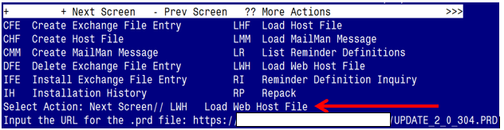

At the Select Action: prompt, enter LWH for Load Web Host File
At the Input the url for the .prd file: prompt, type the following web address:
https://REDACTED/UPDATE_2_0_304.PRD
You should see a message at the top of your screen that the file successfully loaded.

Search for and locate the reminder exchange entry titled UPDATE_2_0_304 VA-MISC UPDATE 20.

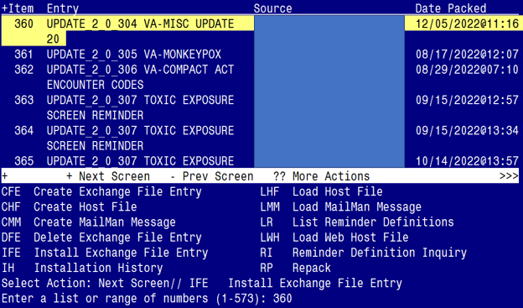

At the Select Action prompt, enter IFE for Install Exchange File Entry
Enter the number that corresponds with your entry titled UPDATE_2_0_304 VA-MISC UPDATE 20 (in this example it is entry 360, it will vary by site). The exchange file date should be 12/05/2022@11:16.

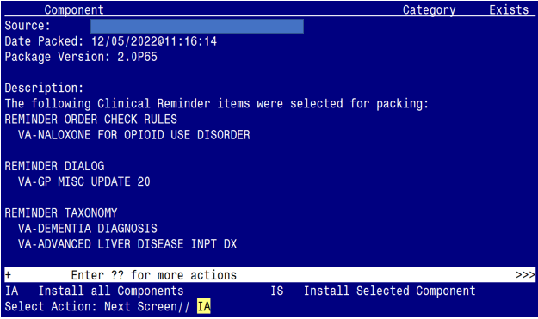

At the Select Action prompt, type IA for Install all Components and hit enter.
Select Action: Next Screen// IA Install all Components
You will see several prompts:

Individual components for which you may (or may not) be prompted are listed below, along with the response you should provide.

For all new components, choose I to Install.

For any component NOT listed below, choose S to Skip.

TIU TEMPLATE FIELD entry VA-CRC COLONOSCOPY SCHEDULE INSTRUCTIONS is NEW,
what do you want to do?

Select one of the following:

C Create a new entry by copying to a new name
I Install
Q Quit the install
S Skip, do not install this entry

Enter response: I// nstall

TIU TEMPLATE FIELD entry named VA-ETHICS-FORM 10-0137A already exists
but the packed component is different, what do you want to do?

Select one of the following:

C Create a new entry by copying to a new name
O Overwrite the current entry
U Update
Q Quit the install
S Skip, do not install this entry

Enter response: O// o Overwrite the current entry

TIU TEMPLATE FIELD entry named VA-OSP CRISTAL already exists but the
packed component is different, what do you want to do?

Select one of the following:

C Create a new entry by copying to a new name
O Overwrite the current entry
U Update
Q Quit the install
S Skip, do not install this entry

Enter response: O// o Overwrite the current entry

HEALTH FACTORS entry VA-UPDATE_2_0_304 is NEW,
what do you want to do?

Select one of the following:

C Create a new entry by copying to a new name
I Install
Q Quit the install
S Skip, do not install this entry

Enter response: I// nstall....

HEALTH FACTORS entry named INACTIVE CERVIX CANCER SCREEN already exists but the packed component is different, what do you want to do?

Select one of the following:

C Create a new entry by copying to a new name
O Overwrite the current entry
U Update
Q Quit the install
S Skip, do not install this entry

Enter response: O// Skip, do not install this entry

HEALTH FACTORS entry VA-WH HPV OBTAINED is NEW,
what do you want to do?

Select one of the following:

C Create a new entry by copying to a new name
I Install
Q Quit the install
S Skip, do not install this entry

Enter response: I// nstall....

HEALTH FACTORS entry VA-WH CERVIVAL CYTOLOGY OBTAINED is NEW,
what do you want to do?

Select one of the following:

C Create a new entry by copying to a new name
I Install
Q Quit the install
S Skip, do not install this entry

Enter response: I// nstall....

HEALTH FACTORS entry named ETHICS-LST CONSENT [C] already exists but
the packed component is different, what do you want to do?

Select one of the following:

C Create a new entry by copying to a new name
O Overwrite the current entry
U Update
Q Quit the install
S Skip, do not install this entry

Enter response: O// verwrite the current entry

HEALTH FACTORS entry named ETHICS-DECISION-MAKING CAPACITY [C]
already exists but the packed component is different, what do you
want to do?

Select one of the following:

C Create a new entry by copying to a new name
O Overwrite the current entry
U Update
Q Quit the install
S Skip, do not install this entry

Enter response: O// verwrite the current entry

HEALTH FACTORS entry named ETHICS-SURROGATE [C] already exists but
the packed component is different, what do you want to do?

Select one of the following:

C Create a new entry by copying to a new name
O Overwrite the current entry
U Update
Q Quit the install
S Skip, do not install this entry

Enter response: O// verwrite the current entry

HEALTH FACTORS entry named ETHICS-LST-PLANS-BASIS [C] already exists
but the packed component is different, what do you want to do?

Select one of the following:

C Create a new entry by copying to a new name
O Overwrite the current entry
U Update
Q Quit the install
S Skip, do not install this entry

Enter response: O// verwrite the current entry

HEALTH FACTORS entry named ETHICS-LST-PLANS-NO DMC-SAPO/MDC already
exists but the packed component is different, what do you want to do?

Select one of the following:

C Create a new entry by copying to a new name
O Overwrite the current entry
U Update
Q Quit the install
S Skip, do not install this entry

Enter response: O// verwrite the current entry

HEALTH FACTORS entry named VA-ONC PRCA CRPC M0 <=10M CLIN TRIAL
already exists but the packed component is different, what do you
want to do?

Select one of the following:

C Create a new entry by copying to a new name
O Overwrite the current entry
U Update
Q Quit the install
S Skip, do not install this entry

Enter response: O// verwrite the current entry

HEALTH FACTORS entry named VA-ONC PRCA MOLECULAR TESTING already
exists but the packed component is different, what do you want to do?

Select one of the following:

C Create a new entry by copying to a new name
O Overwrite the current entry
U Update
Q Quit the install
S Skip, do not install this entry

Enter response: O// verwrite the current entry

HEALTH FACTORS entry named VA-ONC PRCA RADIATION THERAPY RECURRENCE
PATHWAY already exists but the packed component is different, what do you want to do?

Select one of the following:

C Create a new entry by copying to a new name
O Overwrite the current entry
U Update
Q Quit the install
S Skip, do not install this entry

Enter response: O// verwrite the current entry

REMINDER TAXONOMY entry named VA-ADVANCED LIVER DISEASE INPT DX
already exists but the packed component is different, what do you want to do?

Select one of the following:

C Create a new entry by copying to a new name
O Overwrite the current entry
U Update
Q Quit the install
S Skip, do not install this entry

Enter response: O// verwrite the current entry

REMINDER TAXONOMY entry named VA-DEMENTIA DIAGNOSIS
already exists but the packed component is different, what do you want to do?

Select one of the following:

C Create a new entry by copying to a new name
O Overwrite the current entry
U Update
Q Quit the install
S Skip, do not install this entry

Enter response: O// verwrite the current entry

REMINDER TERM entry VA-REMINDER UPDATE_2_0_304 is NEW, what do you want to do?

Select one of the following:

C Create a new entry by copying to a new name
I Install
Q Quit the install
S Skip, do not install this entry

Enter response: I// nstall..

REMINDER TERM entry named VA-AGE<30 already exists but the packed
component is different, what do you want to do?

Select one of the following:

C Create a new entry by copying to a new name
M Merge findings
O Overwrite the current entry
U Update
Q Quit the install
S Skip, do not install this entry

Enter response: O// Skip, do not install this entry

REMINDER DEFINITION entry named VA-LIPID STATIN RX CVD/DM
already exists but the packed component is different, what do you
want to do?

Select one of the following:

C Create a new entry by copying to a new name
O Overwrite the current entry
U Update
Q Quit the install
S Skip, do not install this entry

Enter response: O// verwrite the current entry
REMINDER DEFINITION entry named VA-BL WH PAP REVIEW FREQ
already exists but the packed component is different, what do you
want to do?

Select one of the following:

C Create a new entry by copying to a new name
O Overwrite the current entry
U Update
Q Quit the install
S Skip, do not install this entry

Enter response: Skip, do not install this entry..

HEALTH SUMMARY TYPE entry named VA-SBOR EVENT DATE already exists but
the packed component is different, what do you want to do?

Select one of the following:

C Create a new entry by copying to a new name
O Overwrite the current entry
U Update
Q Quit the install
S Skip, do not install this entry

Enter response: O// Skip, do not install this entry..

REMINDER ORDER CHECK RULES entry named VA-NALOXONE FOR OPIOID USE
DISORDER already exists but the packed component is different, what
do you want to do?

Select one of the following:

C Create a new entry by copying to a new name
O Overwrite the current entry
U Update
Q Quit the install
S Skip, do not install this entry

Enter response: O// verwrite the current entry

You will be promped to install the 1st dialog component:

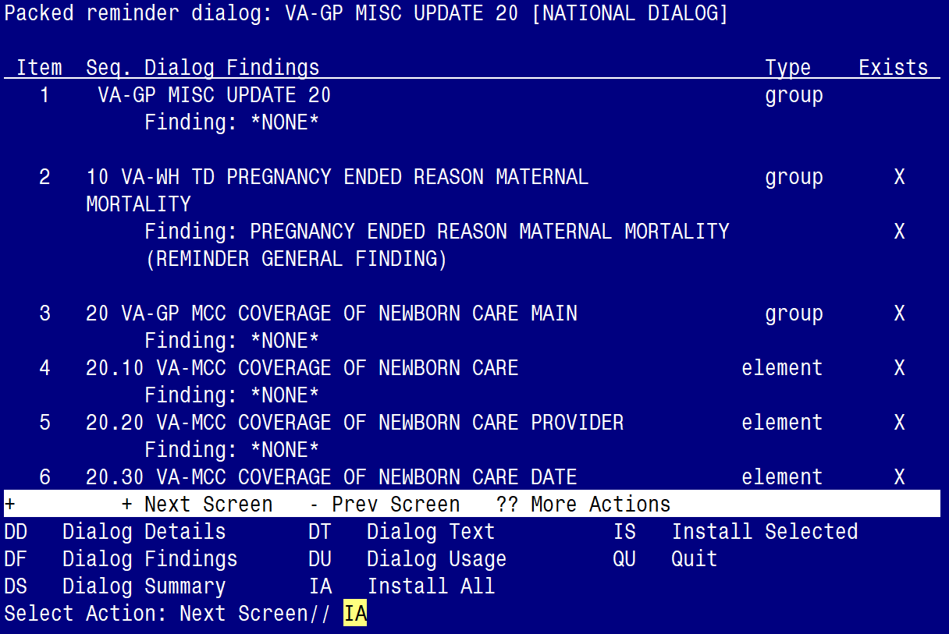

At the Select Action prompt, type IA to install the dialog – VA-GP MISC UPDATE 20
Select Action: Next Screen// IA Install All
Install reminder dialog and all components with no further changes: Y// ES

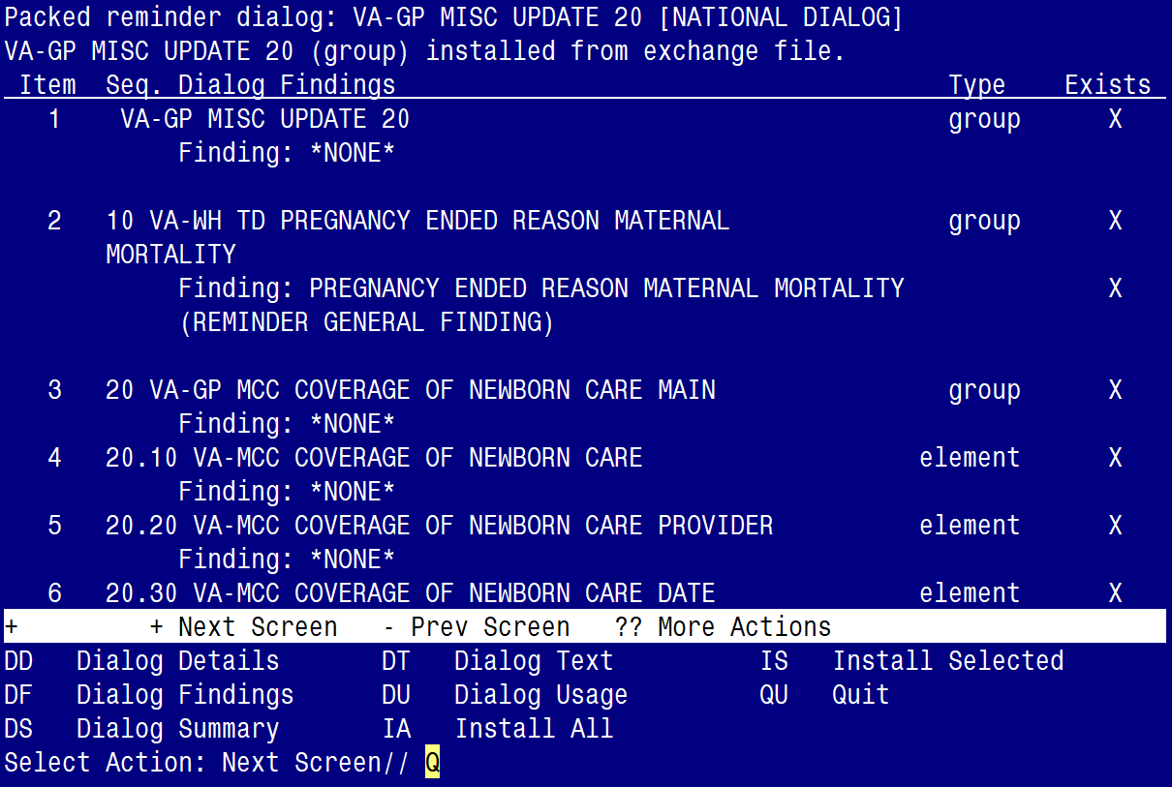

When the dialog has completed installation, you will then be returned to this screen. At the Select Action prompt, type Q.

You will be promped to install the 2nd dialog component:
(DO NOT INSTALL THIS ONE, JUST SELECT Q FOR QUIT)

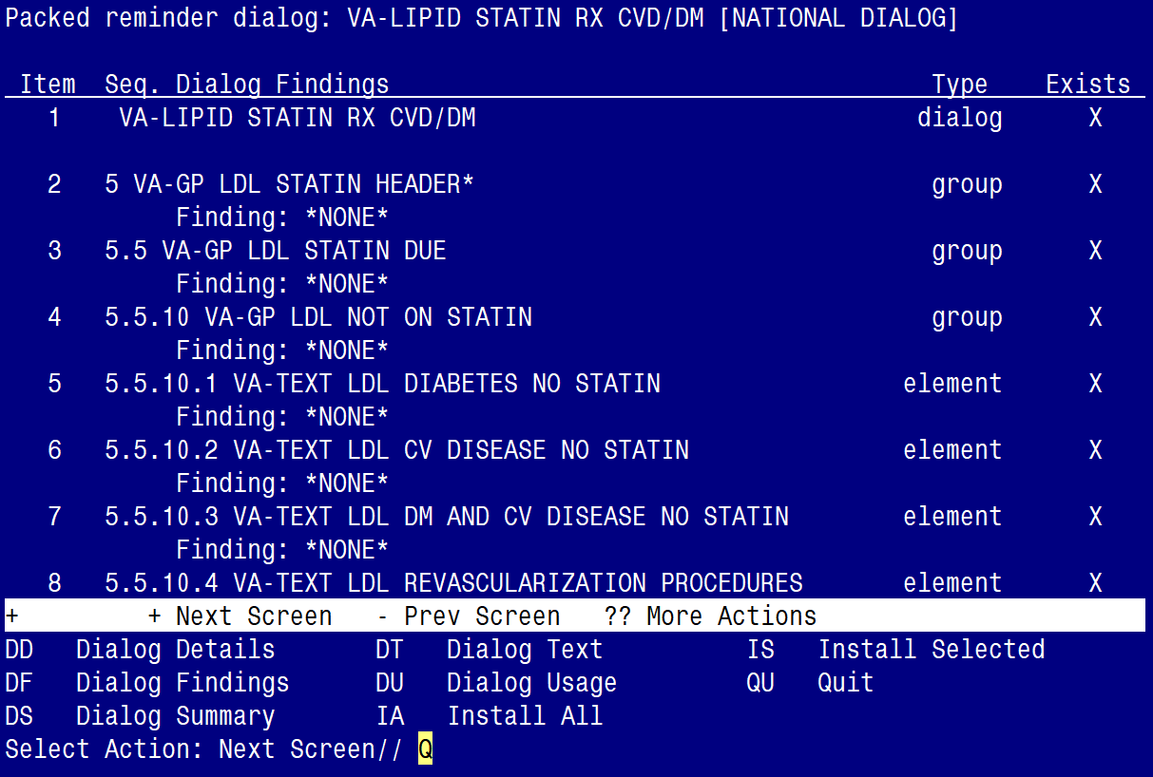

At the Select Action prompt, type Q.

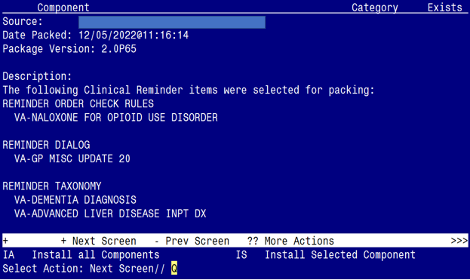

You will be returned to this screen. Type Q to quit.

Install Completed

Post Installation

- Refer to the Inquiry/Print (INQ) you saved during the Pre-Installation steps for the following REMINDER DEFINITION:

VA-LIPID STATIN RX CVD/DM

- Add any ‘local’ finding items back to each term, if needed.

- Ensure the VA-LIPID STATIN RX CVD/DM dialog is linked to the reminder definition (see highlighted text below); if not, link it back using the Reminder Dialog Management menu.

REMINDER DEFINITION INQUIRY

VA-LIPID STATIN RX CVD/DM
-----------------------------------

Print Name: Assess Statin Use – Lipids (CVD/DM)
Class: NATIONAL
Sponsor: VHA CARDIOLOGY SERVICES
Review Date:
Rescission Date:
Usage: CPRS, DATA EXTRACT, REPORTS
Related VA-* Reminder:
Reminder Dialog: VA-LIPID STATIN RX CVD/DM

- Refer to the Inquire/Print (INQ) you saved during the Pre-Installation steps for the following REMINDER ORDER CHECK RULE:

VA-NALOXONE FOR OPIOID USE DISORDER

- Confirm the ‘Status’ field, from your captured Inquiry, matches the ‘Status’ field in the Reminder Order Check Rule.

  - If it matches, no action is needed.

  - If it doesn’t match, you will need to edit the ‘Status’ field to reset it.

(e.g., if the captured Inquiry shows the ‘Status’ as PRODUCTION and the Reminder Order Check is showing a ‘Status’ as Inactive, you will need to edit the Reminder Order Check Rule and reset the Status back to PRODUCTION).

- Refer to the Inquire/Print (INQ) you saved during the Pre-Installation steps for the following ELEMENT and GROUP:

ELEMENT: VA-WH PAP HPV TESTING
GROUP: VAL-WH ORDER PAP SMEAR

- Map the quick orders identified in the pre-installation step to the element’s additional finding, as needed.

ELEMENT: VA-WH PAP HPV TESTING
FINDING ITEM: WH ORDER HPV LAB//

Additional findings: none
Select ADDITIONAL FINDING: Enter “Q.”, then name of local quick order

GROUP: VAL-WH ORDER PAP SMEAR
FINDING ITEM: WH ORDER PAP SMEAR SCREEN HF//

Additional findings: none
Select ADDITIONAL FINDING: Enter “Q.”, then name of local quick order

