Update _2_0_307A

Clinical Reminders

TOXIC EXPOSURE SCREEN REMINDER

Install Guide

November 2022

Product Development
Office of Information Technology
Department of Veterans Affairs

Table of Contents
Introduction 1
Install Details 3
Install Example 3
Post Installation 6

Introduction
This update contains the following:

- FF(1) in the reminder definition VA-TOXIC EXPOSURE SCREENING FOLLOW-is being updated to ignore the time on resolution evaluation and only look at the date.

Before:
---- Begin: FF(1)-------------------------
Function String: MRD(2)'<MRD(1,3)
After:
---- Begin: FF(1)--------------------------
Function String: $P(MRD(2),".")'<($P(MRD(1,3),"."))

UPDATE_2_0_307A contains 1 Reminder Exchange entry:
UPDATE_2_0_307A TOXIC EXPOSURE SCREEN REMINDER UPDATE

The exchange file contains the following components:

REMINDER GENERAL FINDINGS
VIEW PROGRESS NOTE TEXT

TIU TEMPLATE FIELD
VA-ENV EXP OTHER
VA-TOX EXP VSO
VA-WORD

HEALTH FACTORS
VA-REMINDER UPDATES [C]
VA-UPDATE_2_0_307A
VA-TOXIC EXPOSURE SCREEN [C]
VA-TOX EXP SCRN VETERAN CONCERN OTHER EXPOSURE
VA-TOX EXP SCRN VETERAN CONCERN RADIATION EXPOSURE
VA-TOX EXP SCRN VETERAN CONCERN GULF WAR EXPOSURE
VA-TOX EXP SCRN VETERAN CONCERN CAMP LEJEUNE EXPOSURE
VA-TOX EXP SCRN VETERAN CONCERN AIRBORNE HAZARD BURN PIT
VA-TOX EXP SCRN VETERAN CONCERN AGENT ORANGE
VA-TOX EXP SCRN FOLLOW UP NO CONNECTIONS GIVEN
VA-TOX EXP SCRN FOLLOW UP CONSULT TO SOCIAL WORK
VA-TOX EXP SCRN FOLLOW UP CONSULT TO TES NAVIGATOR
VA-TOX EXP SCRN FOLLOW UP CONSULT TO REGISTRY PROGRAM
VA-TOX EXP SCRN FOLLOW UP CONNECTED WITH VSO
VA-TOX EXP SCRN FOLLOW UP CONNECTED WITH VBA
VA-TOX EXP SCRN VETERAN CONCERN TOXIC EXP NO MED CONCERNS
VA-TOX EXP SCRN VETERAN CONCERN TOXIC EXP MED CONCERNS
VA-TOX EXP SCRN VETERAN CONCERN TOXIC EXP MED QUESTIONS
VA-TOX EXP SCRN VETERAN CONCERN TOXIC EXP NO QUESTIONS
VA-TOX EXP SCRN VETERAN CONCERN TOXIC EXP PRESUMP COND QUESTIONS
VA-TOX EXP SCRN VETERAN CONCERN TOXIC EXP BENEFIT QUESTIONS
VA-TOX EXP SCRN VETERAN CONCERN TOXIC EXP VA ENROLL QUESTIONS
VA-TOX EXP SCRN VETERAN CONCERN TOXIC EXP REGISTRY QUESTIONS
VA-TOX EXP SCRN VETERAN CONCERN DOESNT KNOW
VA-TOX EXP SCRN VETERAN CONCERN DECLINED
VA-TOX EXP SCRN VETERAN CONCERN NONE

REMINDER SPONSOR
OFFICE OF PUBLIC HEALTH AND ENVIRONMENTAL HAZARDS

REMINDER TAXONOMY
VA-TOXIC EXPOSURE

REMINDER TERM
VA-REMINDER UPDATE_2_0_307A
VA-TOXIC EXPOSURE
VA-TOXIC EXPOSURE SCREEN QUESTIONS
VA-TOX EXP SCRN VETERAN CONCERN DECLINED TO ANSWER
VA-TOXIC EXPOSURE SCREEN CONCERN NONE
VA-TOX EXP SCRN VETERAN CONCERN DOESNT KNOW
VA-TOXIC EXPOSURE FOLLOW UP

REMINDER DEFINITION
VA-TOXIC EXPOSURE SCREENING FOLLOW-UP

HEALTH SUMMARY TYPE:
VA-TOXIC EXP QUESTIONS
VA-TOXIC EXPOSURE

HEALTH SUMMARY OBJECTS
VA-TOXIC EXP QUESTIONS (TIU)
VA-TOXIC EXPOSURE (TIU)

TIU DOCUMENT DEFINITION:
VA-TOXIC EXP QUESTIONS
VA-TOXIC EXPOSURE

REMINDER DIALOG
VA-TOXIC EXPOSURE SCREENING PROVIDER FOLLOW UP

Install Details

This update is being distributed as a web host file. The address for the host file is: https://REDACTED /UPDATE_2_0_307A.PRD

The file will be installed using Reminder Exchange, programmer access is not required.

Installation:
=============
This update can be loaded with users on the system. Installation will take less than 10 minutes.

Install Example
To Load the exchange file, use LWH. The URL is https://REDACTED /UPDATE_2_0_307A.PRD

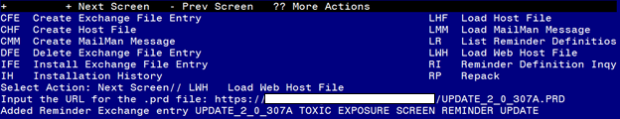
You should see a message that the file was loaded successfully.

Search and locate an entry titled UPDATE_2_0_307A TOXIC EXPOSURE SCREEN REMINDER UPDATE in reminder exchange.

At the Select Action prompt, enter IFE for Install Exchange File Entry
Enter the number that corresponds with your entry titled UPDATE_2_0_307A TOXIC EXPOSURE SCREEN REMINDER (in this example it is entry 338, it will vary by site) that is dated 11/21/2022. 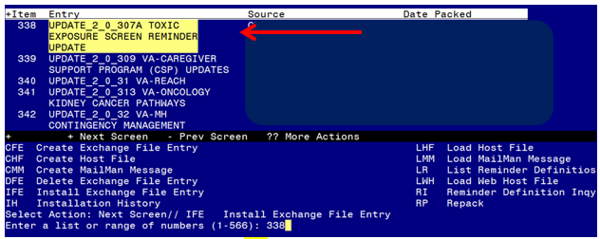
DO NOT INSTALL ALL

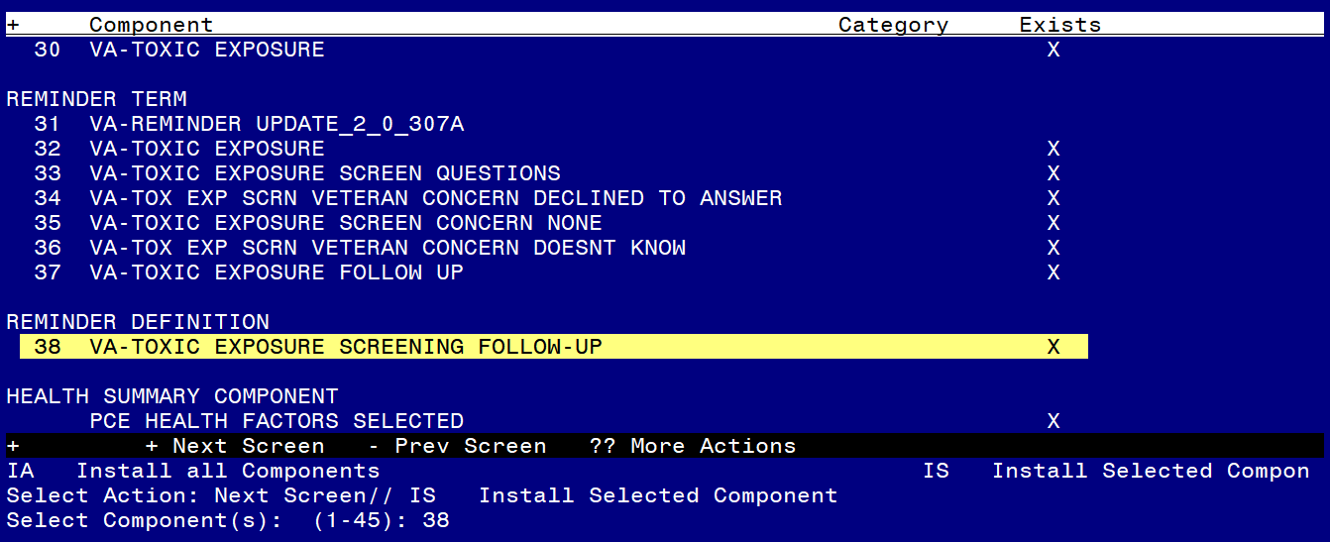
Do not install all, you will install select ONLY item 38 the reminder definition VA-TOXIC EXPOSURE SCREENING PROVIDER FOLLOW UP and overwrite when prompted.

Select Action: Next Screen// IS Install Selected Component
Select Component(s): (1-45): 38

REMINDER DEFINITION entry named VA-TOXIC EXPOSURE SCREENING FOLLOW-UP
already exists but the packed component is different, what do you
want to do?
Select one of the following:
C Create a new entry by copying to a new name
O Overwrite the current entry
U Update
Q Quit the install
S Skip, do not install this entry
Enter response: O// <<hit enter here>> Overwrite the current entry
Are you sure you want to overwrite? N// Y YES

No other components need to be installed.

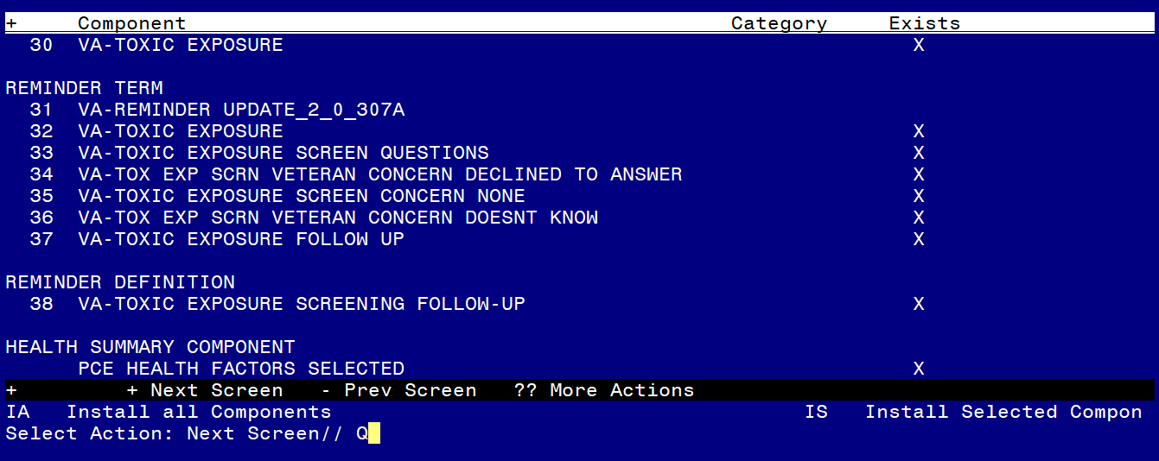

You will then be returned to this screen. At the Select Action prompt, type Q.

Install complete.

Post Installation
Using the reminder manager menu in VistA, choose reminder inquiry and review the reminder definition VA-TOXIC EXPOSURE SCREENING FOLLOW UP, FF1 should look like this:

---- Begin: FF(1)--------------------------
Function String: $P(MRD(2),".")'<($P(MRD(1,3),"."))

