Update _2_0_307B

Clinical Reminders

TOXIC EXPOSURE SCREEN REMINDER UPDATE

Install Guide

January 2023

Product Development
Office of Information Technology
Department of Veterans Affairs

Table of Contents
Introduction 1
Install Details 4
Install Example 7
Post Installation 11

Introduction
This update contains the following:

- The Toxic Exposure Screening reminder dialog template was updated with branching logic using USER CLASS.

- If a person with the user class PHYSICIAN, PHYSICIAN ASSISTANT, NURSE PRACTITIONER or RN TES NAVIGATOR opens the toxic exposure screening reminder, they will see a comprehensive version that includes the screening and the follow up eliminating the need to complete the separate Toxic Exposure Screening Follow-Up reminder if applicable to the patient.

- Other users will see the screen only and if the screen indicates a follow up is needed, they should notify a MD/DO/APRN/PA with clinical privileges or RN TES Navigators with required scope of practice of need for completion of Toxic Exposure Screening Follow-Up reminder.

- The Toxic Exposure Screening Follow-Up reminder was updated to add two new options
  - Veteran declines further assistance at this time – this will resolve the reminder
  - Unable to contact Veteran/caregiver for follow-up of toxic exposure concerns. – this option will not resolve the reminder but the patient will fall off the national report after 2 documented contact attempts

- The Toxic Exposure Screening Follow-Up reminder will stay due for one year, if it has not been completed in one year, it will no longer be applicable, and the Toxic Exposure Screening reminder will be due again.

- Additional guidance was added in the Toxic Exposure Screening Follow-Up reminder dialog.

- A new hyperlink was added for the PACT ACT Benefit Flyer to the hyperlink sections throughout the dialog. PACT Act Benefits flyer_9_508 (va.gov)

- There are minor wording and spacing changes throughout both dialogs.

UPDATE_2_0_307B contains 1 Reminder Exchange entry:
UPDATE_2_0_307B TOXIC EXPOSURE SCREEN REMINDER UPDATE

The exchange file contains the following components:

REMINDER GENERAL FINDINGS
VIEW PROGRESS NOTE TEXT

TIU TEMPLATE FIELD
VA-ENV EXP VBA
VA-ENV EXP SYMP CL
VA-ENV EXP SYMP RA
VA-ENV EXP SYMP AO
VA-ENV EXP SYMP GW2
VA-ENV EXP SYMP GW
VA-ENV EXP SYMP AH
VA-ENV EXP OTHER
VA-TOX EXP VSO
VA-WORD
VA-TOXIC CONTACT
VA-TES OMB DATE
VA-TES OMB NUM

HEALTH FACTORS
VA-REMINDER UPDATES [C]
VA-UPDATE_2_0_307B
VA-TOXIC EXPOSURE SCREEN [C]
VA-TOX EXP SCRN VETERAN CONCERN TOXIC EXP NO MED CONCERNS
VA-TOX EXP SCRN VETERAN CONCERN TOXIC EXP MED CONCERNS
VA-TOX EXP SCRN FOLLOW UP NO CONNECTIONS GIVEN
VA-TOX EXP SCRN FOLLOW UP CONSULT TO SOCIAL WORK
VA-TOX EXP SCRN FOLLOW UP CONSULT TO TES NAVIGATOR
VA-TOX EXP SCRN FOLLOW UP CONSULT TO REGISTRY PROGRAM
VA-TOX EXP SCRN FOLLOW UP CONNECTED WITH VSO
VA-TOX EXP SCRN FOLLOW UP CONNECTED WITH VBA
VA-TOX EXP SCRN VETERAN CONCERN TOXIC EXP REGISTRY QUESTIONS
VA-TOX EXP SCRN VETERAN CONCERN TOXIC EXP VA ENROLL QUESTIONS
VA-TOX EXP SCRN VETERAN CONCERN TOXIC EXP BENEFIT
QUESTIONS
VA-TOX EXP SCRN VETERAN CONCERN TOXIC EXP NO QUESTIONS
VA-TOX EXP SCRN VETERAN CONCERN DOESNT KNOW
VA-TOX EXP SCRN VETERAN CONCERN DECLINED
VA-TOX EXP SCRN VETERAN CONCERN EDUCATION PROVIDED OTHER
VA-TOX EXP SCRN VETERAN CONCERN OTHER EXPOSURE
VA-TOX EXP SCRN VETERAN CONCERN EDUCATION PROVIDED RADIATION
VA-TOX EXP SCRN VETERAN CONCERN RADIATION EXPOSURE
VA-TOX EXP SCRN VETERAN CONCERN EDUCATION PROVIDED GULF WAR
VA-TOX EXP SCRN VETERAN CONCERN GULF WAR EXPOSURE
VA-TOX EXP SCRN VETERAN CONCERN EDUCATION PROVIDED CL
VA-TOX EXP SCRN VETERAN CONCERN CAMP LEJEUNE EXPOSURE
VA-TOX EXP SCRN VETERAN CONCERN EDUCATION PROVIDED AHBP
VA-TOX EXP SCRN VETERAN CONCERN AIRBORNE HAZARD BURN PIT
VA-TOX EXP SCRN VETERAN CONCERN EDUCATION PROVIDED AO
VA-TOX EXP SCRN VETERAN CONCERN AGENT ORANGE
VA-TOX EXP SCRN VETERAN CONCERN NONE
VA-TOX EXP SCRN VETERAN CONCERN TOXIC EXP MED QUESTIONS
VA-TOX EXP SCRN VETERAN CONCERN TOXIC EXP DECLINE FOLLOWUP
VA-TOX EXP SCRN VETERAN CONCERN TOXIC EXP FOLLOW LETTER 2 ATT
VA-TOX EXP SCRN VETERAN CONCERN TOXIC EXP FOLLOW VETTEXT 2 ATT
VA-TOX EXP SCRN VETERAN CONCERN TOXIC EXP FOLLOW SECUR MSG 2 ATT
VA-TOX EXP SCRN VETERAN CONCERN TOXIC EXP FOLL PHONE NO MSG 2ATT
VA-TOX EXP SCRN VETERAN CONCERN TOXIC EXP FOLLOW PHONE MSG 2 ATT
VA-TOX EXP SCRN VETERAN CONCERN TOXIC EXP 2ND ATTEMPT FOLLOWUP
VA-TOX EXP SCRN VETERAN CONCERN TOXIC EXP FOLLOW LETTER
VA-TOX EXP SCRN VETERAN CONCERN TOXIC EXP FOLLOW VETTEXT
VA-TOX EXP SCRN VETERAN CONCERN TOXIC EXP FOLLOW SECURE MESSAGE
VA-TOX EXP SCRN VETERAN CONCERN TOXIC EXP FOLLOW PHONE NO MSG
VA-TOX EXP SCRN VETERAN CONCERN TOXIC EXP FOLLOW PHONE LEFT MSG
VA-TOX EXP SCRN VETERAN CONCERN TOXIC EXP FIRST ATTEMPT FOLLOWUP
VA-TOX EXP SCRN VETERAN CONCERN TOXIC EXP UNABLE CONTACT FOLLOW
VA-TOX EXP SCRN VETERAN CONCERN TOXIC EXP PRESUMP COND QUESTIONS

REMINDER TAXONOMY
VA-TOXIC EXPOSURE

REMINDER TERM
VA-REMINDER UPDATE_2_0_307B
VA-TOXIC EXPOSURE
VA-TOXIC EXPOSURE SCREEN QUESTIONS
VA-TOX EXP SCRN VETERAN CONCERN DECLINED TO ANSWER
VA-TOXIC EXPOSURE SCREEN CONCERN NONE
VA-TOX EXP SCRN VETERAN CONCERN DOESNT KNOW
VA-TOXIC EXPOSURE FOLLOW UP
VA-USER CLASS FOR TES FOLLOWUP
VA-TOXIC EXPOSURE SCREEN RESOLUTION

REMINDER DEFINITION
VA-TOXIC EXPOSURE SCREENING FOLLOW-UP
VA-TOXIC EXPOSURE

HEALTH SUMMARY TYPE:
VA-TOXIC EXP QUESTIONS
VA-TOXIC EXPOSURE

HEALTH SUMMARY OBJECTS
VA-TOXIC EXP QUESTIONS (TIU)
VA-TOXIC EXPOSURE (TIU)

TIU DOCUMENT DEFINITION:
VA-TOXIC EXP QUESTIONS
VA-TOXIC EXPOSURE

REMINDER DIALOG
VA-TOXIC EXPOSURE SCREENING PROVIDER FOLLOW UP
VA-TOXIC EXPOSURE

Install Details

This update is being distributed as a web host file. The address for the host file is: https://REDACTED /UPDATE_2_0_307B.PRD

The file will be installed using Reminder Exchange, programmer access is not required.

Installation:
=============
This update can be loaded with users on the system. Installation will take less than 10 minutes.

Pre-Install
- Any local modifications to template fields or to the dialog will be overwritten. Please make note of your local modifications prior to re-entering them in the post-install.

Inquire/print the following reminder dialog elements to identify if you have any orders added as an additional finding and/or if you have changed the reminder dialog text:
VAL-TOXIC EXPOSURE SCREENING LOCAL CONTACT INFO
VAL-TOXIC EXPOSURE SCREENING REGISTRY EXAM CONSULT
VAL-TOXIC EXPOSURE SCREENING REGISTRY EXAM TES NAV
VAL-TOXIC EXPOSURE SCREENING REGISTRY EXAM SOCIAL WORK

You will add these orders back and update the dialog text in the post install.

- Create a NEW User Class in VistA:
In the toxic exposure screening reminder, branching logic is used to show a comprehensive screening option based on user class. The comprehensive screening includes the follow up and should be completed by MD/DO/APRN/PA with clinical privileges or RN TES Navigators with required scope of practice and training.

To facilitate this, sites need to create a new user class called RN TES NAVIGATOR to assign to the appropriate RNs if needed.
After creating the user class RN TES NAVIGATOR, assign this to any RNs at your site who are considered RN TES Navigators for the purpose of processing the clinical reminders (they should have clinical privileges, the required scope of practice and have completed the appropriate training). This is optional. Not all sites will use RNs in this role, so check first with your leadership to see who should have this user class assigned.

After you create the new user class, you will add this new user class as a subcategory to the NURSE user class.

Steps to Create User Class:
From User Class Management Menu:

--- User Class Management Menu ---
1 User Class Definition
2 List Membership by User
3 List Membership by Class
5 Manage Business Rules

Select User Class Management Option: 1 User Class Definition
Select User Class Status: ACTIVE// <enter> Active
Start With Class: FIRST// <enter>
Go To Class: LAST// <enter>
Searching for the User Classes.............
Select Action: Next Screen// CR Create a Class
Select CLASS: RN TES NAVIGATOR
Are you adding “RN TES NAVIGATOR” as a new USR CLASS (the 126TH)? No// Y
NAME: RN TES NAVIGATOR Replace <enter>
DISPLAY NAME: RN TES NAVIGATOR Replace <enter>
ABBREVIATION: TESNAV<enter>
ACTIVE: 1 Active
Select SUBCLASS: <enter> ............
After it is created, you will add it as a subclass to your NURSE entry.

Use the FIND option and locate your entry for Nurse – it should display as +NURSE
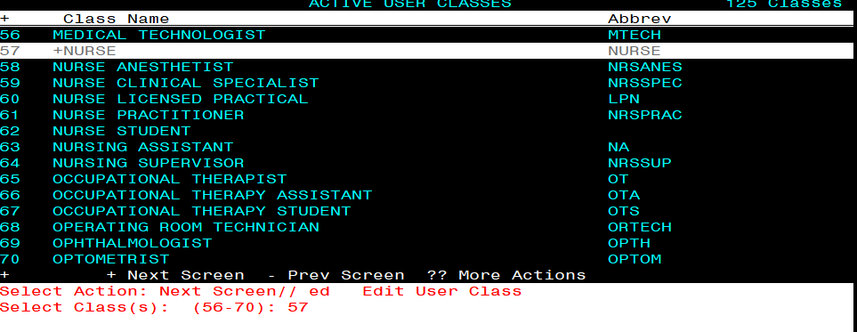
Select Action: Next Screen// ED Edit User Class
Select Class(s): (56-70): 57 (this number will vary by site)
Editing #57
NAME: NURSE//<enter>
DISPLAY NAME: Nurse// <enter>
ABBREVIATION: NURSE// <enter>
ACTIVE: Active// <enter>
Select SUBCLASS: NURSE LICENSED PRACTICAL// RN TES NAVIGATOR
Are you adding 'RN TES NAVIGATOR' as a new SUBCLASS?
No// Y (Yes)
Select SUBCLASS: <enter>
** You will need to assign this newly created User Class as an additional user class to any RNs who are considered RN TES Navigators with required scope of practice and authorized to complete the TES Follow up . Not every site will have RNs in this role, if your site does not have anyone in that role, you will not need to assign to any users**

Install Example
To Load the exchange file, use LWH. The URL is https://REDACTED /UPDATE_2_0_307B.PRD

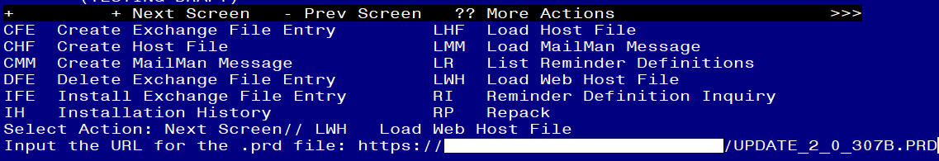
You should see a message that the file was loaded successfully.

Search and locate an entry titled UPDATE_2_0_307B TOXIC EXPOSURE SCREEN REMINDER UPDATE in reminder exchange.
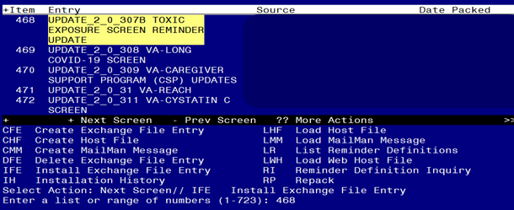
At the Select Action prompt, enter IFE for Install Exchange File Entry
Enter the number that corresponds with your entry titled UPDATE_2_0_307B TOXIC EXPOSURE SCREEN REMINDER (in this example it is entry 468, it will vary by site) that is dated 01/26/2023.
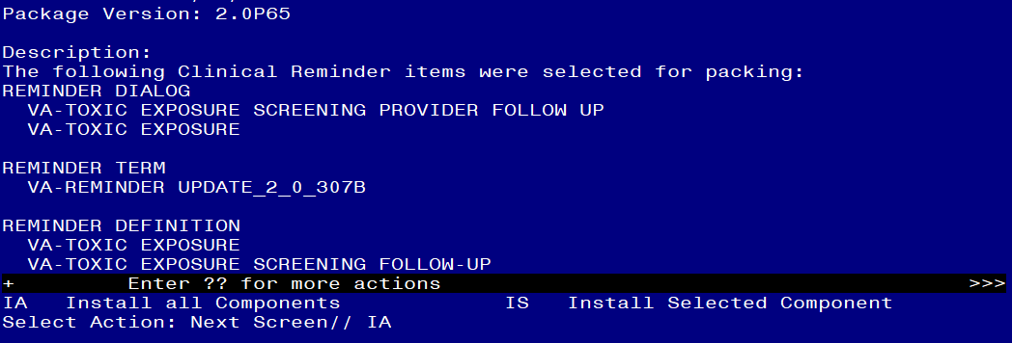
At the Select Action prompt, type IA for Install all Components and hit enter.
Any items that are NEW in any of the below categories, you should INSTALL
OVERWRITE any TIU TEMPLATE FIELDS that you are prompted to overwrite EXCEPT for this field: VA-TOX EXP VSO Do not overwrite your local changes to that txml template field.
SKIP any HEALTH FACTORS if you are prompted to overwrite
SKIP any REMINDER TAXONOMIES that you are prompted to overwrite
OVERWRITE any REMINDER TERMS that you are prompted to overwrite
OVERWRITE any REMINDER DEFINITIONS that you are prompted to overwrite.
OVERWRITE any HEALTH SUMMARY TYPE entries if you are prompted to overwrite
OVERWRITE any HEALTH SUMMARY OBJECTS entries if you are prompted to overwrite
OVERWRITE any TIU DOCUMENT DEFINITION entries if you are prompted to overwrite
You will then be prompted to install the first Dialog component.
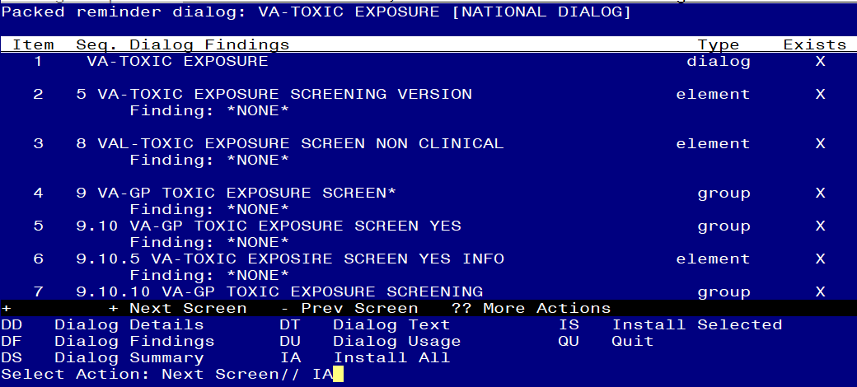
At the Select Action prompt, type IA to install the dialog – VA-TOXIC EXPOSURE
Install reminder dialog and all components with no further changes: Y// ES....

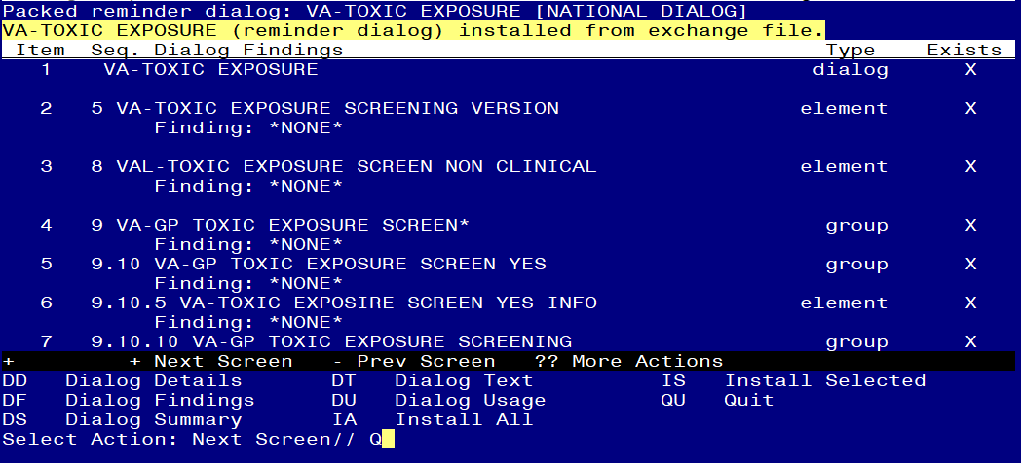

When the dialog has completed installation, you will then be returned to this screen. At the Select Action prompt, type Q.

You will then be prompted to install the next Dialog component.
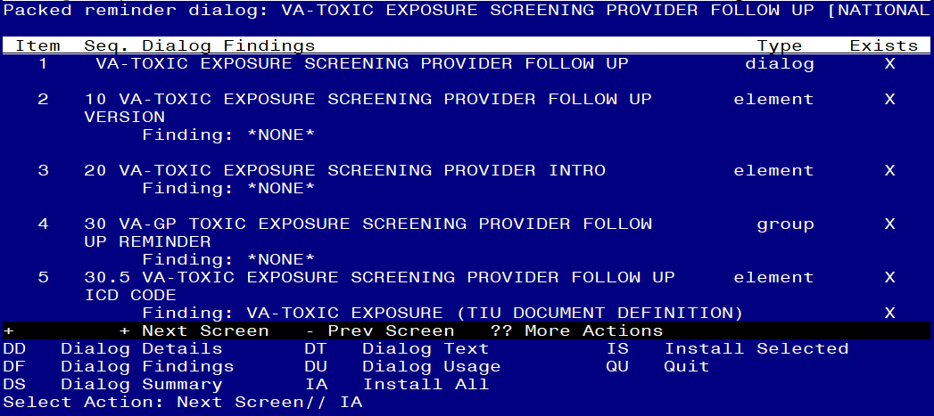

At the Select Action prompt, type IA to install the dialog – VA-TOXIC EXPOSURE SCREENING PROVIDER FOLLOW UP
Install reminder dialog and all components with no further changes: Y// ES

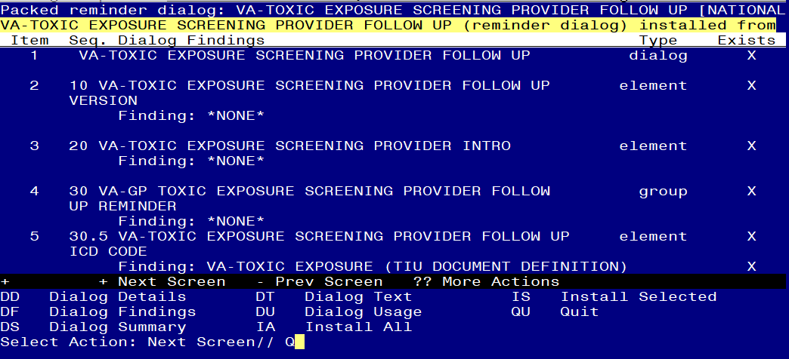

When the dialog has completed installation, you will then be returned to this screen. At the Select Action prompt, type Q.

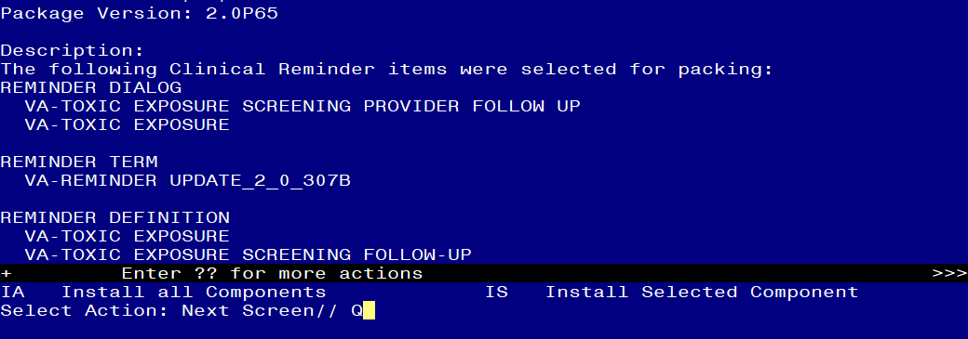

You will then be returned to this screen. At the Select Action prompt, type Q.

Install complete.

Post Installation

- Open the reminder Toxic Exposure Screening and confirm the version displays as 2.2
- Open the reminder Toxic Exposure Screening Follow-up and confirm the version displays as 2.2.
- Using your pre-install inquiry, update the dialog text and findings:
  - In Vista, using the menu, Reminder Dialog Management, Reminder Dialogs, change your view to Element view. Search for and find the element VAL-TOXIC EXPOSURE SCREENING LOCAL CONTACT INFO. Edit the DIALOG/PROGRESS NOTE TEXT and replace the lines with “xxxxxxx” with the text for local contacts you identified in the pre-install.
  - Add consult/referrals to follow up reminder. Review your pre-install inquiry and edit the additional findings and dialog text to match.
    - VAL-TOXIC EXPOSURE SCREENING REGISTRY EXAM CONSULT – represents a Consult/Referral to Registry Program
    - VAL-TOXIC EXPOSURE SCREENING REGISTRY EXAM TES NAV – represents a Consult/Referral to TES Navigator
    - VAL-TOXIC EXPOSURE SCREENING REGISTRY EXAM SOCIAL WORK – represents a Consult/Referral to Social Work
To add a quick order, in Vista, using the menu, Reminder Dialog Management, Reminder Dialogs, change your view to Element view. Search for and find the appropriate element and add your quick order as an Additional Finding – DO NOT CHANGE OR REMOVE THE HEALTH FACTOR IN THE FINDING FIELD.

