Update _2_0_307

Clinical Reminders

TOXIC EXPOSURE SCREEN REMINDER

Install Guide

September 2022

Product Development
Office of Information Technology
Department of Veterans Affairs

Table of Contents
Introduction 1
Install Details 6
Install Example 7
Post Installation 14

Introduction
This update contains the following:
- There is a new reminder definition and dialog VA-TOXIC EXPOSURE (print name Toxic Exposure Screen)
Description:

As required by the Honoring our PACT Act (Public Law 117-168), VA is
required to incorporate a screening to help determine potential toxic
exposures during active service for all enrolled Veterans.

This screening will occur at least once every 5 years, and if an exposure
is reported, the patient will be offered additional resources.

Possible exposures include:
Burn Pits/Airborne Hazards
Gulf War related exposures
Agent Orange
Radiation
Camp Lejeune contaminated water exposure
Other environmental exposures

If the patient declines or answers that they don’t know, the reminder will be due in 1 year.

- There is a new reminder and definition VA-TOXIC EXPOSURE SCREENING FOLLOW-UP (print name Toxic Exposure Screening Follow-Up)
Description:

As Required by the Honoring our PACT Act (Public Law 117-168) VA is
following up on any potential toxic exposures during active service to determine if the veteran has related health concerns.

This reminder will be due on
1. Veterans that indicate they have a possible toxic exposure during their initial screening.
2. Veterans that indicate they DONT KNOW if they have a possible toxic exposure AND they have a Health/Medical, Benefits/Claims, VA Healthcare Enrollment and Eligibility, OR Registry Question during their initial screening.

The follow up reminder will resolve when a response is entered regarding health concerns.

It should be completed by a Primary Care Provider/TES navigator provider.

- The reminder definition and reminder dialog VA-IRAQ & AFGHAN POST-DEPLOY SCREEN (print name Iraq&Afghan Post-Deployment Screen ) will be inactivated. This reminder is no longer required for use.

- The existing reminder definition and reminder dialog VA-EMBEDDED FRAGMENTS SCREENING (print name Screen for Embedded Fragments ) were updated.

Description:

Patients that have a service separation date after 09/11 should be screened for embedded fragments one time if they have not previously been screened. If the Veteran has a new service separation date later than the previous screening, it will come due again.

The VA-EMBEDDED FRAGMENTS SCREENING reminder will be due on patients that would have had the VA-IRAQ & AFGHAN POST-DEPLOY SCREEN reminder due.

Make sure the existing VA-EMBEDDED FRAGMENTS SCREENING (print name Screen for Embedded Fragments) is assigned at the same cover sheet level you have/had the VA-IRAQ & AFGHAN POST-DEPLOY SCREEN assigned.

No content changes were made to the VA-EMBEDDED FRAGMENTS SCREENING questions

UPDATE_2_0_307 contains 1 Reminder Exchange entry:
UPDATE_2_0_307 TOXIC EXPOSURE SCREEN REMINDER

The exchange file contains the following components:

REMINDER GENERAL FINDINGS
VIEW PROGRESS NOTE TEXT

TIU TEMPLATE FIELD
VA-TOXIC CONTACT
VA-ENV EXP OTHER
VA-TOX EXP VSO
VA-WORD
VA-ENV EXP SYMP RA
VA-ENV EXP SYMP GW2
VA-ENV EXP SYMP GW
VA-ENV EXP SYMP CL
VA-ENV EXP SYMP AH
VA-ENV EXP SYMP AO
VA*I/A QM CLINICAL GUIDELINES
BLANK TEXT FIELD FOR DIALOGS
VA-BLANK
EF CONTACT INFO
VA-EF HANDOUT
VA-EF LINK

HEALTH FACTORS
VA-REMINDER UPDATES [C]
VA-UPDATE_2_0_307
VA-TOXIC EXPOSURE SCREEN [C]
VA-TOX EXP SCRN VETERAN CONCERN TOXIC EXP MED QUESTIONS
VA-TOX EXP SCRN VETERAN CONCERN TOXIC EXP REGISTRY QUESTIONS
VA-TOX EXP SCRN VETERAN CONCERN TOXIC EXP VA ENROLL QUESTIONS
VA-TOX EXP SCRN VETERAN CONCERN TOXIC EXP BENEFIT QUESTIONS
VA-TOX EXP SCRN VETERAN CONCERN TOXIC EXP NO QUESTIONS
VA-TOX EXP SCRN VETERAN CONCERN DOESNT KNOW
VA-TOX EXP SCRN VETERAN CONCERN DECLINED
VA-TOX EXP SCRN FOLLOW UP NO CONNECTIONS GIVEN
VA-TOX EXP SCRN FOLLOW UP CONSULT TO SOCIAL WORK
VA-TOX EXP SCRN FOLLOW UP CONSULT TO TES NAVIGATOR
VA-TOX EXP SCRN FOLLOW UP CONSULT TO REGISTRY PROGRAM
VA-TOX EXP SCRN FOLLOW UP CONNECTED WITH VSO
VA-TOX EXP SCRN FOLLOW UP CONNECTED WITH VBA
VA-TOX EXP SCRN VETERAN CONCERN TOXIC EXP NO MED CONCERNS
VA-TOX EXP SCRN VETERAN CONCERN TOXIC EXP MED CONCERNS
VA-TOX EXP SCRN VETERAN CONCERN EDUCATION PROVIDED OTHER
VA-TOX EXP SCRN VETERAN CONCERN OTHER EXPOSURE
VA-TOX EXP SCRN VETERAN CONCERN EDUCATION PROVIDED RADIATION
VA-TOX EXP SCRN VETERAN CONCERN RADIATION EXPOSURE
VA-TOX EXP SCRN VETERAN CONCERN EDUCATION PROVIDED GULF WAR
VA-TOX EXP SCRN VETERAN CONCERN GULF WAR EXPOSURE
VA-TOX EXP SCRN VETERAN CONCERN EDUCATION PROVIDED CL
VA-TOX EXP SCRN VETERAN CONCERN CAMP LEJEUNE EXPOSURE
VA-TOX EXP SCRN VETERAN CONCERN EDUCATION PROVIDED AHBP
VA-TOX EXP SCRN VETERAN CONCERN AIRBORNE HAZARD BURN PIT
VA-TOX EXP SCRN VETERAN CONCERN EDUCATION PROVIDED AO
VA-TOX EXP SCRN VETERAN CONCERN AGENT ORANGE
VA-TOX EXP SCRN VETERAN CONCERN NONE
VA-TOX EXP SCRN VETERAN CONCERN TOXIC EXP PRESUMP COND QUESTIONS
IRAQ/AFGHANISTAN [C]
OEF/OIF SCREEN COMPLETED OUTSIDE
MENTAL HEALTH [C]
SEVERE CHRONIC COGNITIVE IMPAIRMENT
UNABLE TO SCREEN - ACUTE ILLNESS
REFUSED ID & OTHER SX SCREEN
SKIN LESION SCREEN NEGATIVE
SKIN LESION SCREEN POSITIVE
NO EMBEDDED FRAGMENTS
EMBEDDED FRAGMENTS [C]
EF-NO BLAST/EXPLOSION INJURY
EF-CONTACT EMAIL
EF-CONTACT PHONE NUMBER
EF-CONTACT NAME
EF-UNKNOWN IF FRAGMENTS IN BODY
EF-NO FRAGMENTS IN BODY
EF-FRAGMENTS ON RADIOGRAPH
EF-UNKNOWN IF FRAGMENTS ON RADIOGRAPH
EF-NO FRAGMENTS ON RADIOGRAPH
EF-FRAGMENTS IN BODY
EF-UNKNOWN IF REMOVED IN SURGERY
EF-FRAGMENTS NOT REMOVED IN SURGERY
EF-FRAGMENTS SENT TO LAB
EF-UNKNOWN IF SENT TO LAB
EF-FRAGMENTS NOT SENT TO LAB
EF-FRAGMENTS REMOVED IN SURGERY
EF-BLAST SOURCE OTHER
EF-BLAST SOURCE UNKNOWN
EF-FRIENDLY FIRE
EF-ENEMY FIRE
EF-GRENADE
EF-LAND MINE
EF-RPG
EF-IED
EF-NOT IN VEHICLE
EF-IN VEHICLE
EF-BLAST/EXPLOSION INJURY
EF-NO BULLET INJURY
EF-BULLET INJURY
EMBEDDED FRAGMENTS PRESENT
GI SYMPTOMS SCREEN NEGATIVE
GI SYMPTOMS SCREEN POSITIVE
UNEXPLAINED FEVERS SCREEN NEGATIVE
UNEXPLAINED FEVERS SCREEN POSITIVE
SYRIA SERVICE
UZBEKISTAN SERVICE
TAJIKISTAN SERVICE
PHILIPPINES SERVICE
PAKISTAN SERVICE
KYRGYZSTAN SERVICE
GEORGIA SERVICE
AFGHANISTAN SERVICE
OTHER SERVICE LOCATION
TURKEY SERVICE
SAUDI ARABIA SERVICE
KUWAIT SERVICE
IRAQ SERVICE
NO IRAQ/AFGHAN SERVICE
IRAQ/AFGHAN SERVICE
OTHER PHYSICAL SYMPTOMS SCREEN NEGATIVE
OTHER PHYSICAL SYMPTOMS SCREEN POSITIVE

REMINDER SPONSOR
OFFICE OF PUBLIC HEALTH AND ENVIRONMENTAL HAZARDS
NATIONAL CLINICAL PRACTICE GUIDELINE COUNCIL
MENTAL HEALTH SERVICES
OFFICE OF QUALITY & PERFORMANCE
VA TOXIC EMBEDDED FRAGMENT SURVEILLANCE CENTER
OFFICE OF PATIENT CARE SERVICES
MENTAL HEALTH AND BEHAVIORAL SCIENCE STRATEGIC GROUP

REMINDER TAXONOMY
VA-TOXIC EXPOSURE

REMINDER TERM
VA-REMINDER UPDATE_2_0_307
VA-TOXIC EXPOSURE
VA-USER CLASS FOR COGNITIVE IMPAIRMENT
VA-PERSISTENT RASH (IRAQ/AFGHANISTAN)
VA-BL OEF/OIF SKIN SX
VA-EMBEDDED FRAGMENTS (IRAQ/AFGHANISTAN)
VA-BL OEF/OIF EMBEDDED FRAGMENTS
VA-GI SYMPTOMS (IRAQ/AFGHANISTAN)
VA-BL OEF/OIF GI SX
VA-UNEXPLAINED FEVER (IRAQ/AFGHANISTAN)
VA-BL OEF/OIF FEVER
VA-IRAQ/AFGHAN SERVICE REGISTRATION
VA-IRAQ/AFGHAN SERVICE
VA-OTHER SYMPTOMS (IRAQ/AFGHANISTAN)
VA-OEF/OIF SCREEN DONE ELSEWHERE
VA-COGNITIVE IMPAIRMENT
VA-REFUSED ID & OTHER SX SCREEN
VA-ACTIVE DUTY
VA-COMBAT VET
VA-IRAQ/AFGHAN PERIOD OF SERVICE
VA-IRAQ/AFGHAN SERVICE NO
VA-TOXIC EXPOSURE SCREEN QUESTIONS
VA-TOX EXP SCRN VETERAN CONCERN DECLINED TO ANSWER
VA-TOXIC EXPOSURE SCREEN CONCERN NONE
VA-TOX EXP SCRN VETERAN CONCERN DOESNT KNOW
VA-TOXIC EXPOSURE FOLLOW UP
VA-TOXIC EXPOSURE SCREEN RESOLUTION

REMINDER DEFINITION
VA-BL OEF/OIF SKIN SX
VA-BL OEF/OIF EMBEDDED FRAGMENTS
VA-BL OEF/OIF GI SX
VA-BL OEF/OIF FEVER
VA-IRAQ & AFGHAN POST-DEPLOY SCREEN
VA-TOXIC EXPOSURE SCREENING FOLLOW-UP
VA-TOXIC EXPOSURE
VA-EMBEDDED FRAGMENTS SCREEN

HEALTH SUMMARY TYPE:
VA-TOXIC EXP QUESTIONS
VA-TOXIC EXPOSURE

HEALTH SUMMARY OBJECTS
VA-TOXIC EXP QUESTIONS (TIU)
VA-TOXIC EXPOSURE (TIU)

TIU DOCUMENT DEFINITION:

REMINDER DIALOG
VA-TOXIC EXPOSURE
VA-TOXIC EXPOSURE SCREENING PROVIDER FOLLOW UP
VA-IRAQ & AFGHANISTAN POST DEPLOYMENT SCREEN
VA-EMBEDDED FRAGMENTS SCREENING

Install Details

This update is being distributed as a web host file. The address for the host file is: https://REDACTED /UPDATE_2_0_307.PRD

The file will be installed using Reminder Exchange, programmer access is not required.

Installation:
=============
This update can be loaded with users on the system. Installation will take less than 10 minutes.

Install Example
To Load the exchange file, use LWH. The URL is https://REDACTED /UPDATE_2_0_307.PRD

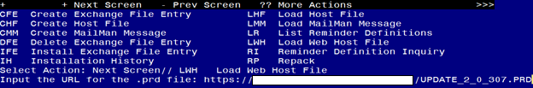
You should see a message that the file was loaded successfully.

Search and locate an entry titled UPDATE_2_0_307 TOXIC EXPOSURE SCREEN REMINDER in reminder exchange. 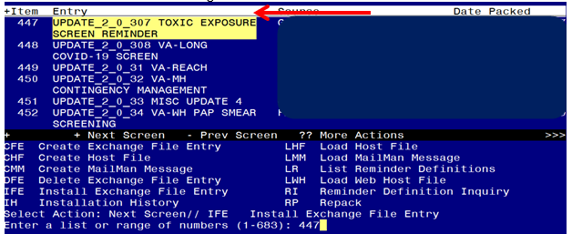

At the Select Action prompt, enter IFE for Install Exchange File Entry
Enter the number that corresponds with your entry titled UPDATE_2_0_307 TOXIC EXPOSURE SCREEN REMINDER (in this example it is entry 447, it will vary by site) that is dated 10/14/2022.
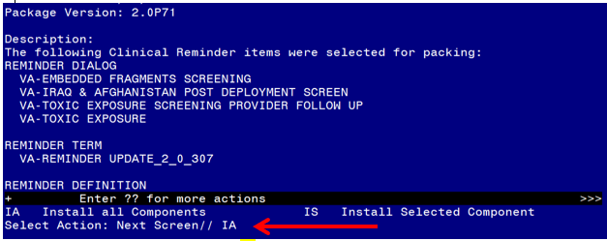
At the Select Action prompt, type IA for Install all Components and hit enter.
For all new entries in any category you will choose I to Install
OVERWRITE any TIU TEMPLATE FIELDS that you are prompted to overwrite
OVERWRITE any HEALTH FACTORS if you are prompted to overwrite
SKIP any REMINDER SPONSORS if you are prompted to overwrite
SKIP any REMINDER TERMS that you are prompted to overwrite with one exception, you will overwrite the reminder term VA-EMBEDDED FRAGMENTS (IRAQ/AFGHANISTAN)
REMINDER TERM entry named VA-EMBEDDED FRAGMENTS (IRAQ/AFGHANISTAN)already exists but the packed component is different, what do you want to do?
Select one of the following:
C Create a new entry by copying to a new name
M Merge findings
O Overwrite the current entry
U Update
Q Quit the install
S Skip, do not install this entry
Enter response: O// verwrite the current entry
Are you sure you want to overwrite? N// YES
FOR THE TEST SITES, ALSO OVERWRITE THIS TERM: VA-TOXIC EXPOSURE SCREEN RESOLUTION
OVERWRITE any REMINDER DEFINITIONS that you are prompted to overwrite.
SKIP any HEALTH SUMMARY TYPE entries if you are prompted to overwrite
SKIP any HEALTH SUMMARY OBJECTS entries if you are prompted to overwrite
SKIP any TIU DOCUMENT DEFINITION entries if you are prompted to overwrite
You will then be prompted to install the first Dialog component.

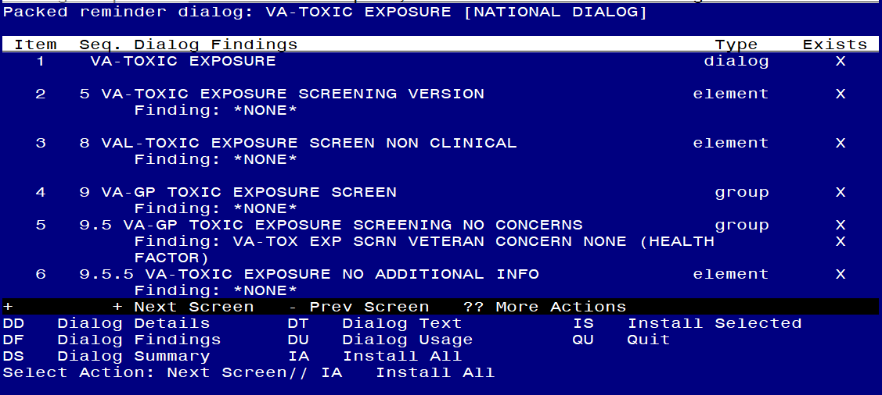

At the Select Action prompt, type IA to install the dialog – VA-TOXIC EXPOSURE
Hit enter when prompted to link to the definition:
Install reminder dialog and all components with no further changes: Y// ES....
Reminder Dialog VA-TOXIC EXPOSURE SCREEN is not linked to a reminder.
Select Reminder to Link: VA-TOXIC EXPOSURE// HIT ENTER AT THIS PROMPT

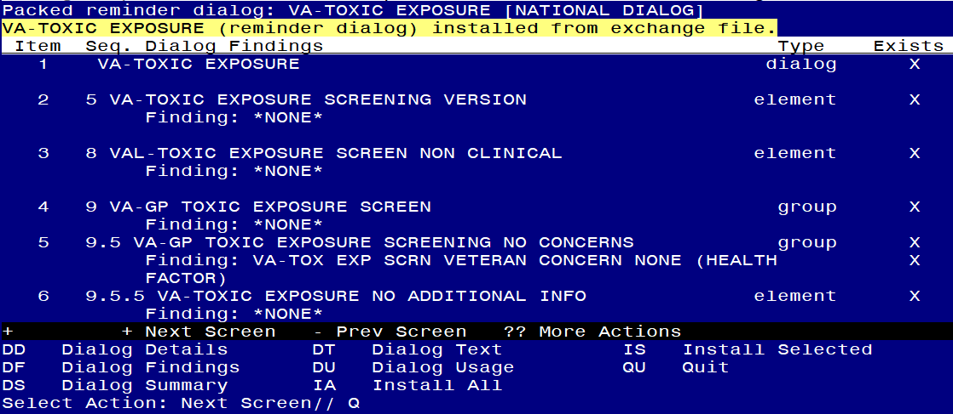

When the dialog has completed installation, you will then be returned to this screen. At the Select Action prompt, type Q.

You will then be prompted to install the next Dialog component.

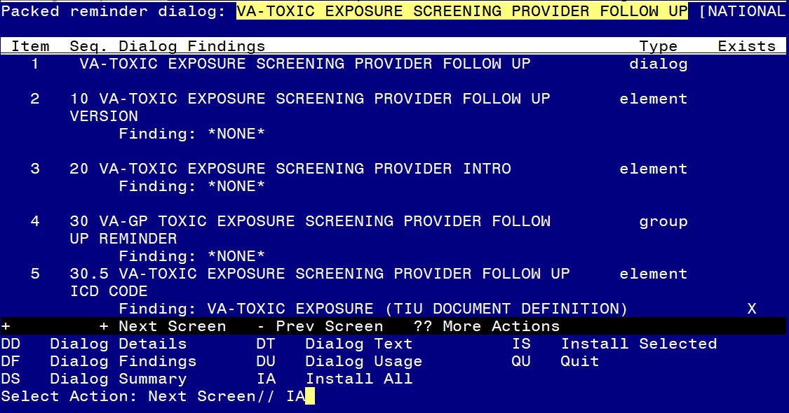
At the Select Action prompt, type IA to install the dialog – VA-TOXIC EXPOSURE SCREENING PROVIDER FOLLOW UP
Hit enter when prompted to link to the definition:
Install reminder dialog and all components with no further changes: Y// ES....
Reminder Dialog VA-TOXIC EXPOSURE SCREENING FOLLOW UP is not linked to a reminder.
Select Reminder to Link: VA-TOXIC EXPOSURE SCREENING FOLLOW-UP// HIT ENTER AT THIS PROMPT

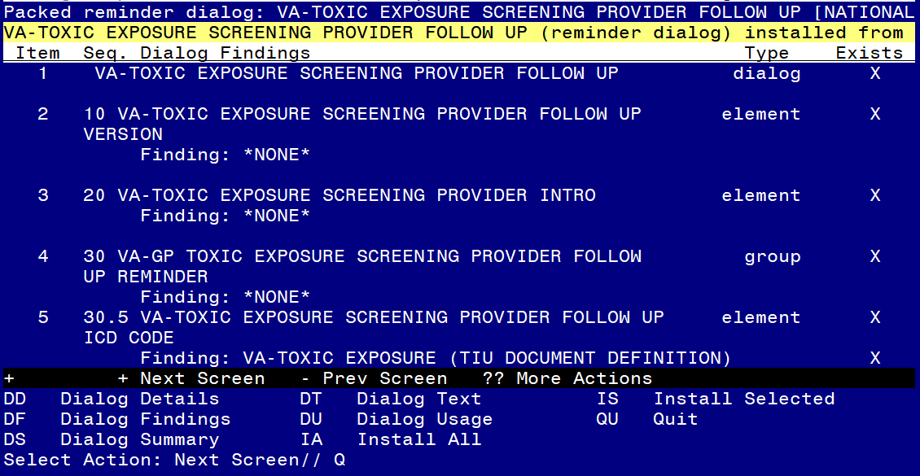

When the dialog has completed installation, you will then be returned to this screen. At the Select Action prompt, type Q.
You will then be prompted to install the next Dialog component.
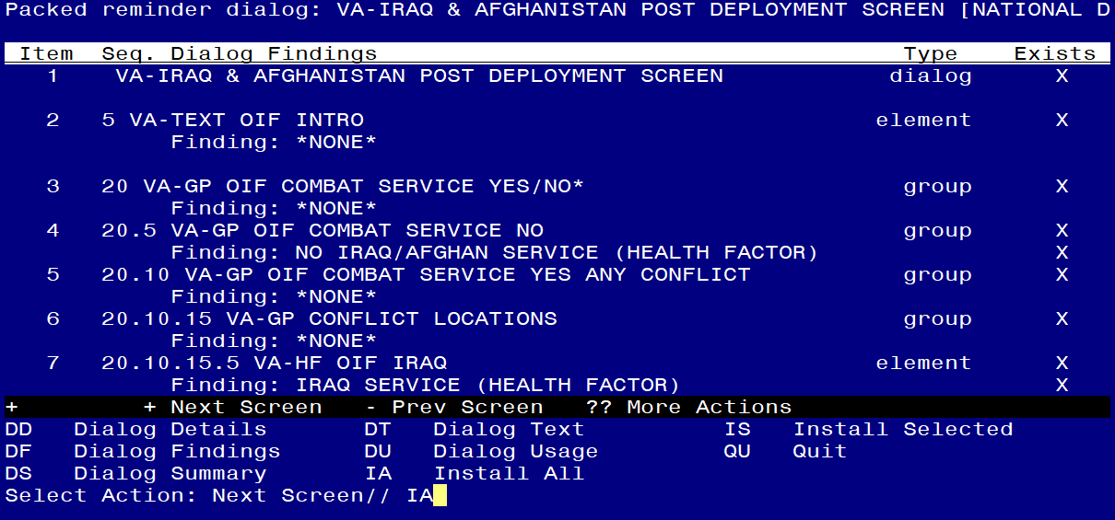

At the Select Action prompt, type IA to install the dialog – VA-IRAQ & AFGHANISTAN POST DEPLOYMENT SCREEN
Install reminder dialog and all components with no further changes: Y// ES....

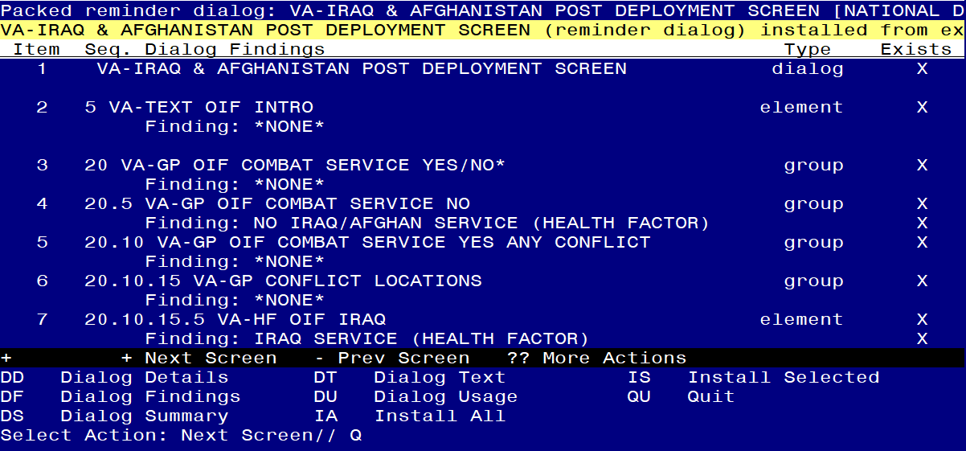
This dialog will take a few minutes to install.

When the dialog has completed installation, you will then be returned to this screen. At the Select Action prompt, type Q.

You will then be prompted to install the next Dialog component.
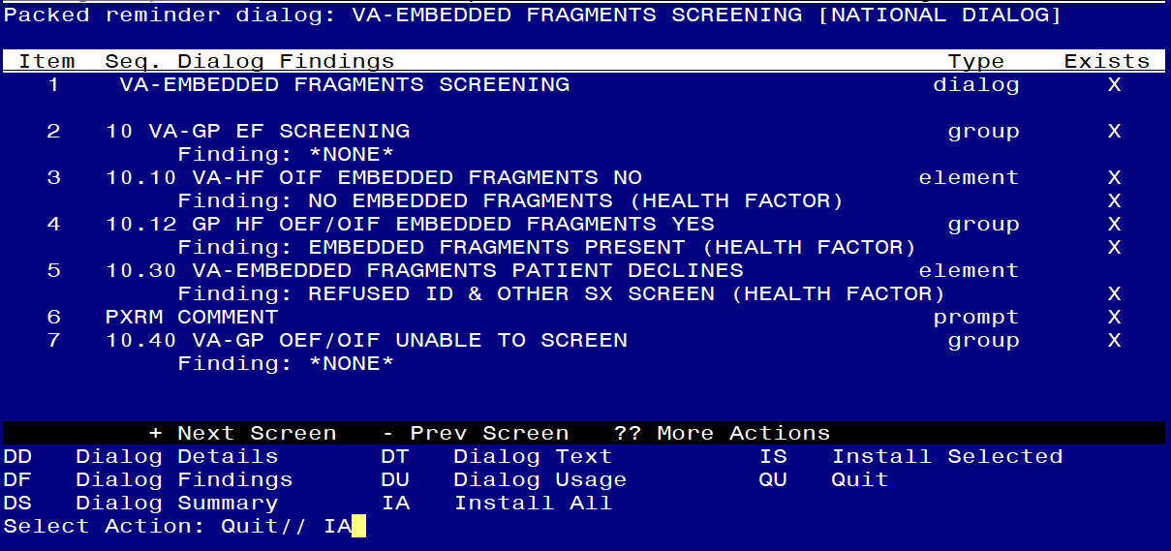

At the Select Action prompt, type IA to install the dialog – VA-EMBEDDED FRAGMENTS SCREENING
Install reminder dialog and all components with no further changes: Y// ES....

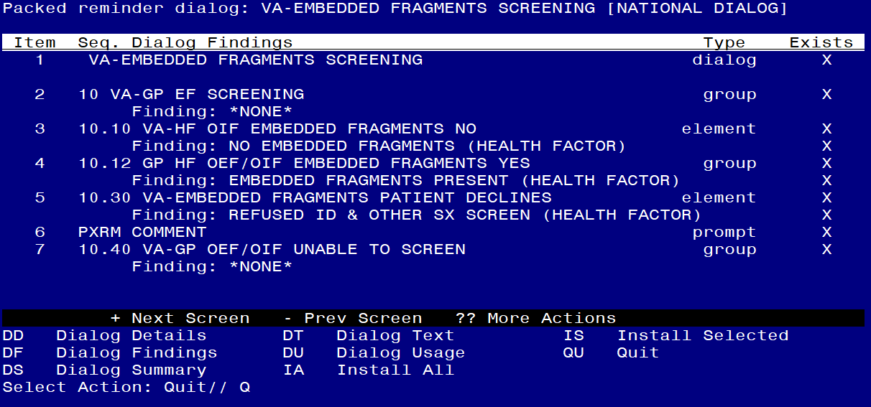

When the dialog has completed installation, you will then be returned to this screen. At the Select Action prompt, type Q.

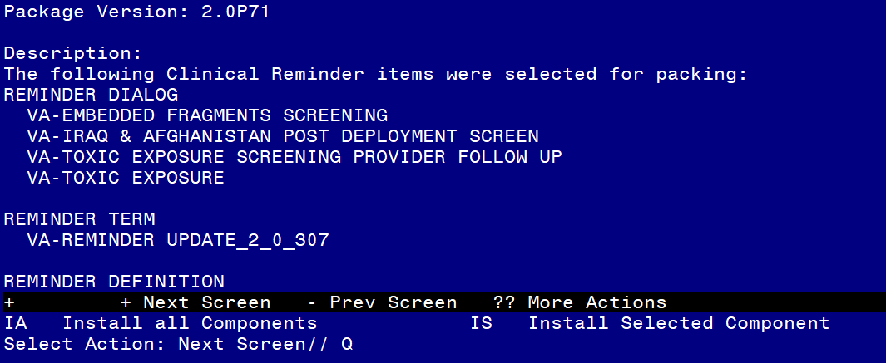

You will then be returned to this screen. At the Select Action prompt, type Q.

Install complete.

Post Installation
- Add local contact information to the reminder dialog element VAL-TOXIC EXPOSURE SCREENING LOCAL CONTACT INFO. Facilities are responsible for providing contact information for local resources that align(s) with the items below. One Point of Contact (POC) may cover more than 1 topic (or all); or each facility may have a different POC for each question. At a minimum, recommend including Position title (i.e. PACT Act Coordinator, Social Worker, Environmental Health Coordinator, etc.) and telephone #.

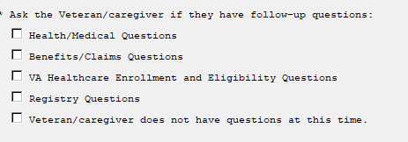

You will be updating this section of the dialog to add contact information:
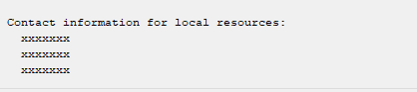

In Vista, using the menu, Reminder Dialog Management, Reminder Dialogs, change your view to Element view. Search for and find the element VAL-TOXIC EXPOSURE SCREENING LOCAL CONTACT INFO. Edit the DIALOG/PROGRESS NOTE TEXT and replace the lines with “xxxxxxx” with the local contacts identified for the four items above and which areas they will answer questions for.
Example:
Benefits/Claim Questions: Role/Title, xxx-xxx-xxxx
VA Healthcare Enrollment: Role/Title, xxx-xxx-xxxx
Registry: Role/Title, xxx-xxx-xxxx
This information should be available in the template before you turn this reminder on.

- Update local record management information. In the paperwork reduction statement that is required to be read by nonclinical staff, there is a section for who to contact with comments about the length of the survey. The text is defaulted to “HIMS for records management questions”:
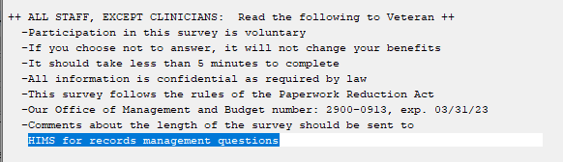
This information is in the template field named VA-TOXIC CONTACT and can be changed locally by using the template field editor in CPRS.
It does not appear in the CPRS progress note.
- Update local Veteran Service Officer (VSO) contact information. In the follow up reminder, there is a field for Veteran Service Officer, the text is defaulted now to “LOCAL VSO CONTACT NUMBER HERE”:
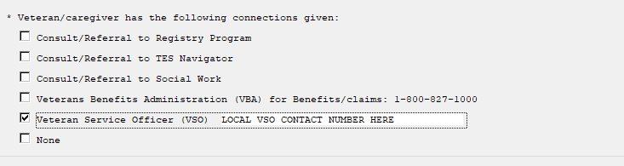
This information is in the template field named VA-TOX EXP VSO and can be changed locally by using the template field editor in CPRS.
It does appear in the CPRS progress note when that option is chosen in the template

- Add consult/referrals to follow up reminder.
The following elements can be used to place consult orders if your facility has a consult service for that item.
VAL-TOXIC EXPOSURE SCREENING REGISTRY EXAM CONSULT – represents a Consult/Referral to Registry Program
VAL-TOXIC EXPOSURE SCREENING REGISTRY EXAM TES NAV – represents a Consult/Referral to TES Navigator
VAL-TOXIC EXPOSURE SCREENING REGISTRY EXAM SOCIAL WORK – represents a Consult/Referral to Social Work
To add a quick order, in Vista, using the menu, Reminder Dialog Management, Reminder Dialogs, change your view to Element view. Search for and find the appropriate element and add your quick order as an Additional Finding – DO NOT CHANGE OR REMOVE THE HEALTH FACTOR IN THE FINDING FIELD.

- Add the two new reminders to the cover sheet at the appropriate level – You will use the Add Cover Sheet Reminder option in CPRS.
The new reminders should be added to your facility cover sheet reminder list on or after Nov 7, 2022. You should not begin screening prior to this date.
The print names are:
- Toxic Exposure Screen
- Toxic Exposure Screening Follow-Up

- Confirm the reminder VA-EMBEDDED FRAGMENTS SCREENING (print name Screen for Embedded Fragments ) is assigned to the cover sheet for any users that were responsible for completing the VA-IRAQ & AFGHAN POST-DEPLOY SCREEN reminder. This reminder was already existing and may already be assigned. The content of the reminder has not changed.

