Update_2_0_309

Clinical Reminders

VA-CAREGIVER SUPPORT PROGRAM (CSP) UPDATES

Install Guide

September 2022

Product Development
Office of Information Technology
Department of Veterans Affairs

Table of Contents
Introduction 1
Install Details 3
Install Example 4
Post Installation 7

Introduction
In October 2020 the Caregiver Support Program (CSP) implemented approximately 20 new notes/reminder dialogs in support of implementing changes to the Program of Comprehensive Assistance for Family Caregivers Program that were required under the MISSION Act.

This update includes edits to six (6) of the CSP dialogs to meet updated regulations outlined in phase two of the CSP expansion; documented in the MISSION Act. The link below highlights each edit made to the individual six CSP dialogs.

REDACTED URL

UPDATE_2_0_309 contains 1 Reminder Exchange entry:
UPDATE_2_0_309 VA-CAREGIVER SUPPORT PROGRAM (CSP) UPDATES

The exchange file contains the following components:

TIU TEMPLATE FIELD
WORD 2 LINES1 REQ
VA*CG W-P2LINES(REQ)

HEALTH FACTORS
VA-REMINDER UPDATES [C]
VA-UPDATE_2_0_309
VA-CSP CEAT [C]
VA-CSP CEAT VETERAN UNABLE TO SELF SUST
VA-CSP CEAT VETERAN ABLE TO SELF SUSTAIN
VA-CSP CEAT NO SUPERVISION NEED
VA-CSP CEAT SUPERVISON NEED
VA-CSP CEAT NO ADL NEED
VA-CSP CEAT ADL NEED MOBILITY
VA-CSP CEAT ADL NEED FEEDING
VA-CSP CEAT ADL NEED TOILETING
VA-CSP CEAT ADL NEED DEVICE ASSIST
VA-CSP CEAT ADL NEED GROOMING
VA-CSP CEAT ADL NEED BATHING
VA-CSP CEAT ADL NEED DRESSING
VA-CSP CEAT ADL NEEDS
VA-CSP CEAT ASSMNT ALL YES
VA-CSP PCAFC [C]
VA-CSP PCAFC RESIDES IN STATE NO
VA-CSP PCAFC RESIDES IN STATE YES
VA-CSP PCAFC PCP ONGOING NO
VA-CSP PCAFC PCP ONGOING YES
VA-CSP PCAFC CARE AT HOME NO
VA-CSP PCAFC CARE AT HOME YES
VA-CSP PCAFC SERIOUS INJURY 70% SC NO
VA-CSP PCAFC SERIOUS INJURY 70% SC YES
VA-CSP PCAFC VET OR MED DC NO
VA-CSP PCAFC VET OR MED DC YES
VA-CSP CEAT SERIOUS INJURY 70% SC YES
VA-CSP CEAT SERIOUS INJURY 70% SC NO
VA-CSP CEAT DENIAL CAREGIVER DECEASED
VA-CSP CEAT DENIAL VETERAN DECEASED
VA-CSP CEAT DENIAL WITHDREW APPLICATION
VA-CSP CEAT DENIAL CG NOT CAPABLE
VA-CSP CEAT DENIAL NOT FAMILY
VA-CSP CEAT DENIAL CG NOT 18
VA-CSP CEAT DENIAL NO PC TEAM
VA-CSP CEAT DENIAL NOT RECEIVING CARE
VA-CSP CEAT DENIAL NOT NEEDED OR OTHER
VA-CSP CEAT DENIAL NOT IN BEST INTEREST
VA-CSP CEAT DENIAL NO ADL NEED
VA-CSP CEAT DENIAL NO SC DISABILITY
VA-CSP CEAT DENIAL NOT A VETERAN OR SM
VA-CSP CEAT DENIAL AP NOT COMP WI 90D
VA-CSP CEAT DENIAL NOT LIVING IN US
VA-CSP CEAT FINAL REVIEW DENIED
VA-CSP CEAT INITAL REVIEW DENIED
VA-CSP CAREGIVER DISCHARGE [C]
VA-CSP DISCHARGE ROI INFO PROVIDED
VA-CSP CAREGIVER APPROVAL [C]
VA-CSP DISCHARGE VA/COMMUNITY INFO PROVIDED
VA-CSP DISCHARGE OTHER INFO PROVIDED
VA-CSP DISCHARGE APPEAL INFO PROVIDED
VA-CSP DISCHARGE GENERAL CAREGIVER INFO PROVIDED
VA-CSP DISCHARGE VA ERROR
VA-CSP DISCHARGE CG NOT CAPABLE
VA-CSP DISCHARGE NOT LIVING IN US
VA-CSP DISCHARGE NOT FAMILY
VA-CSP DISCHARGE NO REASSESSMENT
VA-CSP DISCHARGE NO WELLNESS CONTACTS
VA-CSP DISCHARGE NO PC TEAM
VA-CSP DISCHARGE NOT RECEIVING CARE
VA-CSP DISCHARGE OTHERS PROVIDING
VA-CSP DISCHARGE CG UNWILLING
VA-CSP DISCHARGE PERSONAL SAFETY
VA-CSP DISCHARGE NEGLECT OR ABUSE
VA-CSP DISCHARGE FRAUD
VA-CSP DISCHARGE CAREGIVER REQUEST IPV
VA-CSP DISCHARGE VETERAN DECEASED
VA-CSP DISCHARGE CAREGIVER DECEASED
VA-CSP DISCHARGE VETERAN REQUEST
VA-CSP DISCHARGE CAREGIVER REQUEST
VA-CSP DISCHARGE VET INSTITUTIONALIZED
VA-CSP DISCHARGE CG INSTITUTIONALIZED
VA-CSP DISCHARGE NOT IN BEST INTEREST
VA-CSP DISCHARGE NO ADL NEED
VA-CSP DISCHARGE NO SC DISABILITY
VA-CSP DISCHARGE BASED ON CG ASSESS
VA-CSP CAREGIVER DENIAL [C]
VA-CSP DENIAL NOT IN BEST INTEREST
VA-CSP DENIAL CG NOT CAPABLE
VA-CSP DENIAL NOT FAMILY
VA-CSP DENIAL CG NOT 18
VA-CSP DENIAL NO PC TEAM
VA-CSP DENIAL NOT RECEIVING CARE
VA-CSP DENIAL NOT NEEDED OR OTHER
VA-CSP DENIAL NO ADL NEED
VA-CSP DENIAL NO SC DISABILITY
VA-CSP DENIAL NOT A VETERAN OR SM
VA-CSP DENIAL NOT LIVING IN US
VA-CSP DENIAL VETERAN DECEASED
VA-CSP DENIAL WITHDREW APPLICATION
VA-CSP DENIAL AP NOT COMPLETE WI 90D
VA-CSP DENIAL CAREGIVER DECEASED

REMINDER TERM
VA-REMINDER UPDATE_2_0_309

REMINDER DIALOG
VA-GP CSP UPDATES AUGUST 22

Install Details

This update is being distributed as a web host file. The address for the host file is: https://REDACTED/UPDATE_2_0_309.PRD

The file will be installed using Reminder Exchange, programmer access is not required.

Installation:
=============
This update can be loaded with users on the system. Installation will take less than 15 minutes.

Install Example
To Load the Web Host File. Navigate to Reminder exchange in Vista

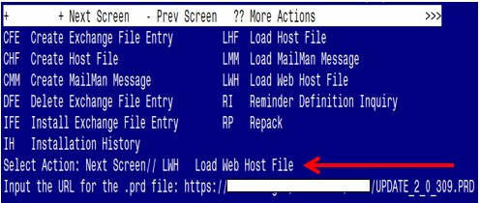

At the Select Action: prompt, enter LWH for Load Web Host File
At the Input the url for the .prd file: prompt, type the following web address:
https://REDACTED/UPDATE_2_0_309.PRD
You should see a message at the top of your screen that the file successfully loaded.

Search for and locate the reminder exchange entry titled UPDATE_2_0_309 VA-CAREGIVER SUPPORT PROGRAM (CSP) UPDATES

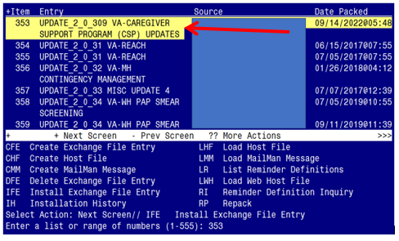

At the Select Action prompt, enter IFE for Install Exchange File Entry
Enter the number that corresponds with your entry titled UPDATE_2_0_309 VA-CAREGIVER SUPPORT PROGRAM (CSP) UPDATES (in this example it is entry 353, it will vary by site). The exchange file date should be 09/14/2022@05:48.
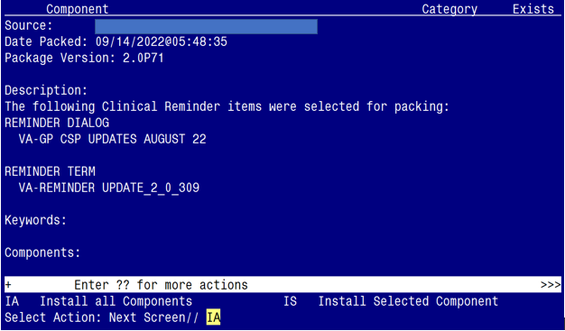

At the Select Action prompt, type IA for Install all Components and hit enter.
Select Action: Next Screen// IA Install all Components

You will see several prompts:
1 - For all new components, choose I to Install
2 - For existing components, choose O to Overwrite.

You will be promped to install the dialog component:

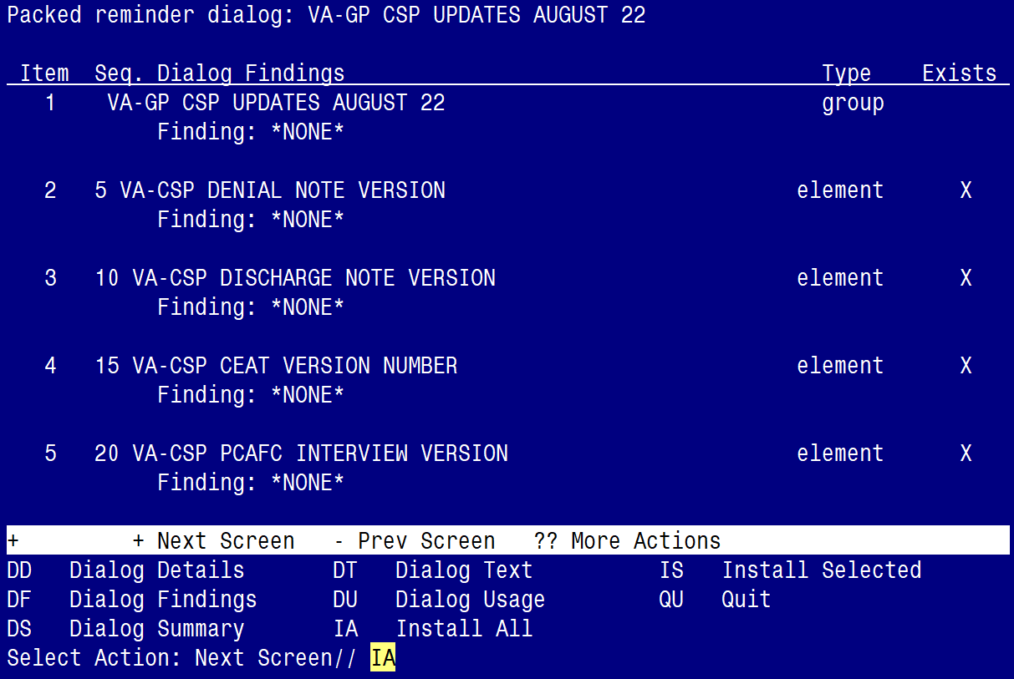

At the Select Action prompt, type IA to install the dialog – VA-GP CSP UPDATES AUGUST 22
Select Action: Next Screen// IA Install All
Install reminder dialog and all components with no further changes: Y// ES
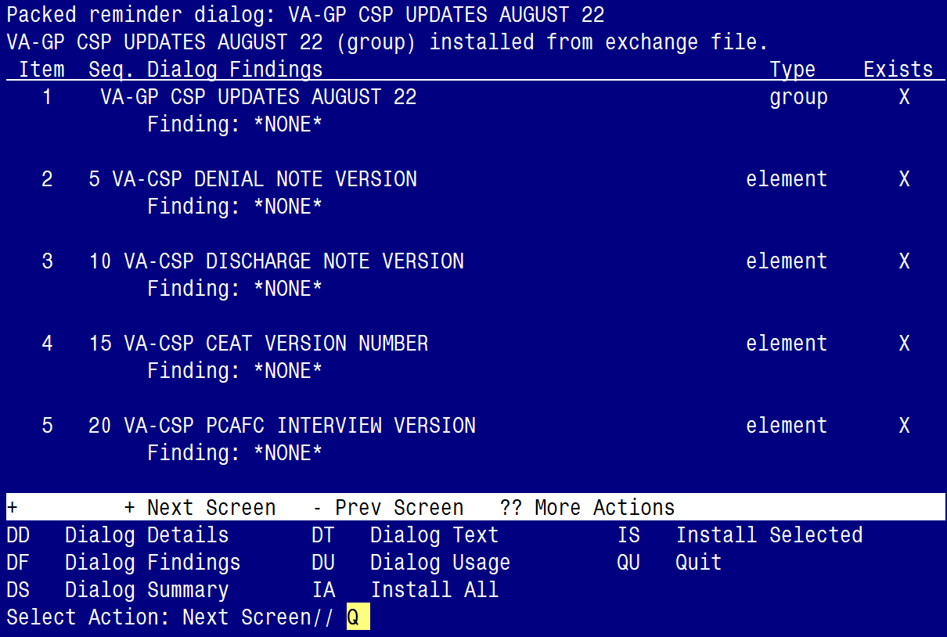

When the dialog has completed installation, you will then be returned to this screen. At the Select Action prompt, type Q.

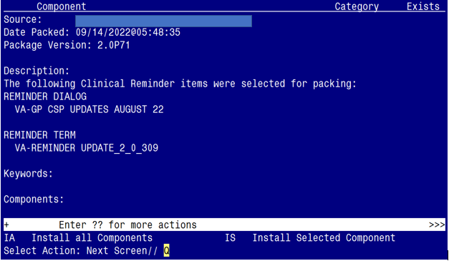

You will be returned to this screen. Type Q to quit.

Install Completed

Post Installation

There are no Post Installation steps for this Clinical Reminder Update.

