Update _2_0_311

Clinical Reminders

VA-CYSTATIN C SCREEN

Install Guide

December 2022

Product Development
Office of Information Technology
Department of Veterans Affairs

Table of Contents
Introduction 1
Pre-Install 3
Install Details 3
Install Example 3
Post Installation 7

Introduction

Description:

This update contains a new cover sheet clinical reminder VA-CYSTATIN C SCREEN that will be used to assist the user in the consideration of ordering a Cystatin C with eGFR for an accurate assessment of renal function if the patient has one of the following:

- New CKD with an eGFR 45-59 mL/min/1.73 m2
  - New CKD with most recent eGFR 45-59 mL/min/1.73 m2
  - No values >60 in the past 90 days
  - No values between 45-59 with a lookback starting at 180 days to 2 years.

- Decreased muscle mass:(i.e. Above knee amputation, Progressive
neurodegenerative disorder (e.g. ALS)

- Severe malnutrition

- Paraplegia/Quadriplegia

- BMI greater than 40 kg/m2

DUE ANNUALLY for patients with Decreased muscle mass and/or BMI >40.

DUE ONCE for patients with a new CKD w/eGFR 45-59ml/min/1.73m2

DUE ONCE for patients with Above knee amputation

UPDATE_2_0_311 contains 1 Reminder Exchange entry:
UPDATE_2_0_311 VA-CYSTATIN C SCREEN

The exchange file contains the following components:

REMINDER GENERAL FINDINGS
VIEW PROGRESS NOTE TEXT

HEALTH FACTORS
VA-REMINDER UPDATES [C]
VA-UPDATE_2_0_311
VA-CYSTATIN C [C]
VA-CYSTATIN C OTHER REASON NOT ORDERED
VA-CYSTATIN C NOT CLINICALLY INDICATED
VA-CYSTATIN C WAITING FOR NON-VA RESULTS
VA-CYSTATIN C DONE AT NON-VA
VA-CYSTATIN C PT DECLINES
VA-CYSTATIN C ORDERED WITH NEXT LABS
SHORTENED LIFE EXPECTANCY [C]
LIFE EXPECTANCY LESS THAN 6 MONTHS
LIFE EXPECTANCY < 3 MONTHS
REMINDER FACTORS [C]
LIFE EXPECTANCY < 6 MONTHS

REMINDER SPONSOR
OFFICE OF PATHOLOGY AND LABORATORY MEDICAL SERVICE (PLMS)
MENTAL HEALTH SERVICES

REMINDER TAXONOMY
VA-CYSTATIN C EGFR-AMPUTATION
VA-CYSTATIN C EGFR-PARA/QUAD & NEUROMUSCULAR
VA-CYSTATIN C EGFR-MALNUTRITION & OBESITY

REMINDER TERM
VA-REMINDER UPDATE_2_0_311
VA-CREATININE EGFR
VA-CREATININE EGFR>59
VA-CYSTATIN C EGFR BMI>40
VA-CYSTATIN C NOT CLINICALLY INDICATED
VA-CYSTATIN C WAITING RESULTS
VA-CYSTATIN C DONE AT NON-VA
VA-CYSTATIN C PT DECLINES
VA-CYSTATIN C ORDERED WITH NEXT LABS
VA-LIFE EXPECTANCY <6 MONTHS
VA-CYSTATIN C EGFR STATUS ACTIVE/PENDING
VA-CYSTATIN C OTHER REASON NOT ORDERED
VA-CYSTATIN C EGFR LAB COMPLETE
VA-CYSTATIN C EGFR AMPUTATION
VA-CYSTATIN C EGFR EVALUATE DIAGNOSES

REMINDER DEFINITION
VA-CYSTATIN C SCREEN

REMINDER DIALOG
VA-CYSTATIN C W/EGFR SCREEN

Pre-Install

Check with your laboratory to identify the lab tests for these two items:
- Estimated Glomerular Filtration Rate (eGFR) (creatinine based eGFR)
- Cystatin C

Identify the quick order your site uses for the laboratory test Cystatin C with Cystatin C eGFR.

Install Details

This update is being distributed as a web host file. The address for the host file is: https://REDACTED/UPDATE_2_0_311.PRD

The file will be installed using Reminder Exchange, programmer access is not required.

Installation:
=============
This update can be loaded with users on the system. Installation will take less than 10 minutes.

Install Example

To Load the exchange file, use LWH. The URL is https://REDACTED/UPDATE_2_0_311.PRD

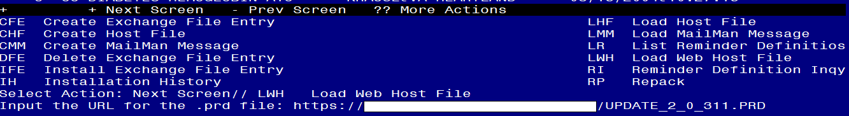
You should see a message that the file was loaded successfully.

Search and locate an entry titled UPDATE_2_0_311 VA-CYSTATIN C SCREEN in reminder exchange.
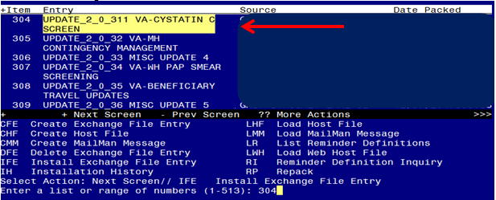
At the Select Action prompt, enter IFE for Install Exchange File Entry
Enter the number that corresponds with your entry titled UPDATE_2_0_311 VA-CYSTATIN C SCREEN (in this example it is entry 304, it will vary by site) that is dated 11/21/2022.
***There is a new reminder sponsor associated with this install. You will need to do an IS to selectively install reminder sponsor OFFICE OF PATHOLOGY AND LABORATORY MEDICAL SERVICE (PLMS). If you don’t install this first, you will receive errors when installing the health factors. Please do this step prior to continuing!

YOU NEED TO INSTALL SELECT THE NEW REMINDER SPONSOR ENTRY ONLY (ITEM 17):
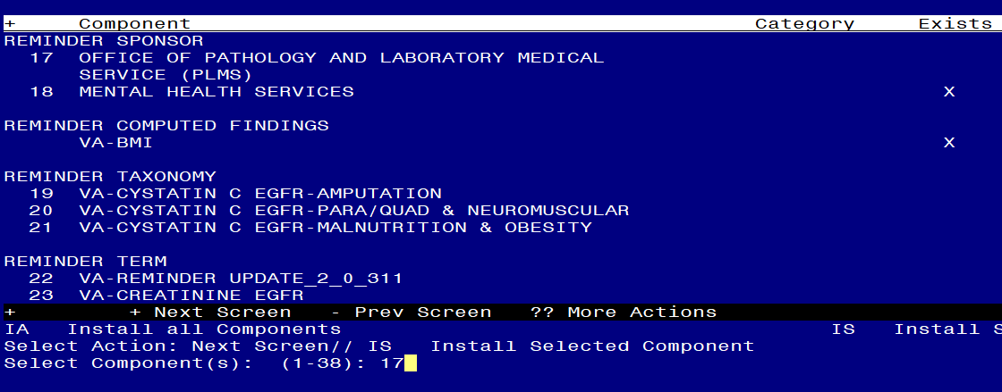
At the Select Action prompt, type
IS for Install Selected Component and hit enter.
At the Select Component, type 17 and hit enter
Select Action: Quit// IS Install Selected Component
Select Component(s): (1-38): 17
REMINDER SPONSOR entry OFFICE OF PATHOLOGY AND LABORATORY MEDICAL SERVICE (PLMS) is NEW, what do you want to do?
Select one of the following:
C Create a new entry by copying to a new name
I Install
Q Quit the install
S Skip, do not install this entry
Enter response: I// nstall

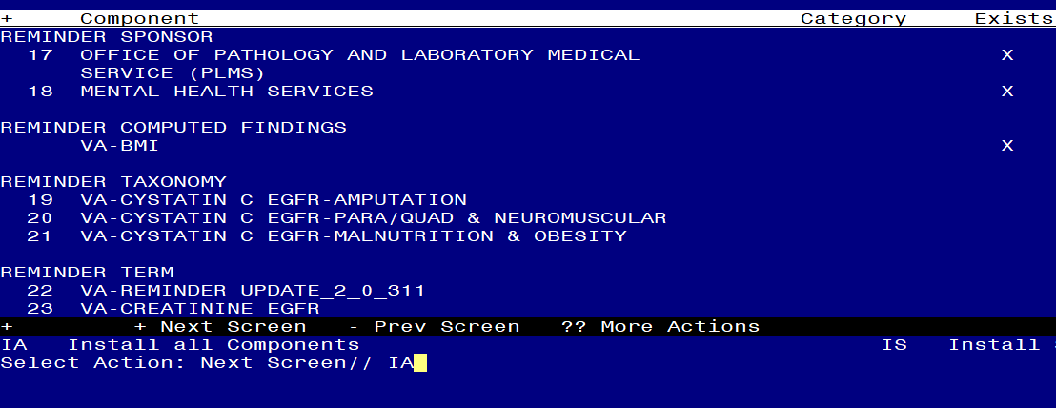 At the Select Action prompt, type IA for Install all Components and hit enter.
For all new entries in any category you will choose I to Install
Skip any items in any category you are prompted to overwrite

You will then be prompted to install the Dialog component.
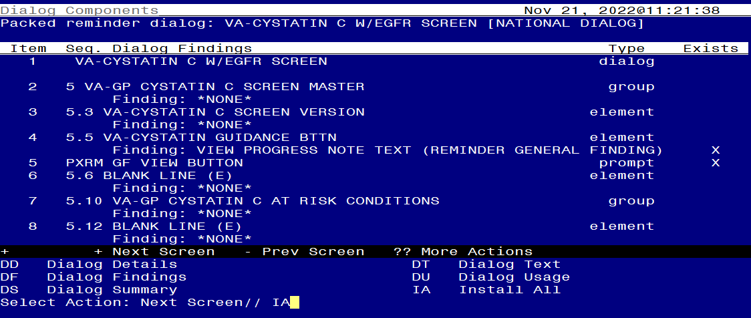

At the Select Action prompt, type IA to install the dialog – VA-CYSTATIN C W/EGFR SCREEN
Hit enter when prompted to link to the definition:
Install reminder dialog and all components with no further changes: Y// ES....
Reminder Dialog VA-CYSTATIN C W/EGFR SCREEN is not linked to a reminder.
Select Reminder to Link: VA-CYSTATIN C SCREEN// <<HIT ENTER HERE>>

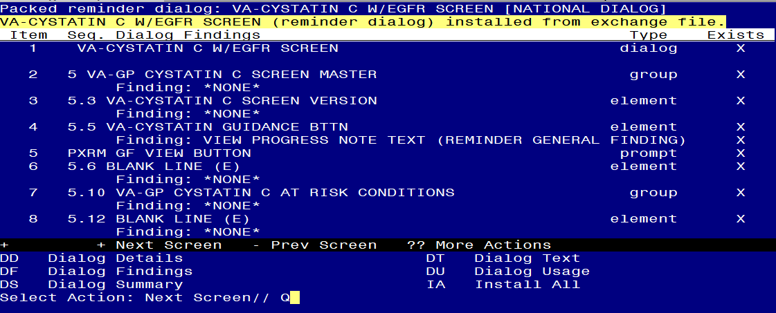

When the dialog has completed installation, you will then be returned to this screen. At the Select Action prompt, type Q.
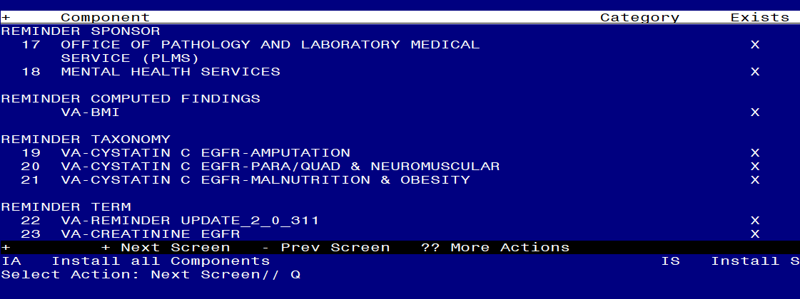

You will then be returned to this screen. At the Select Action prompt, type Q.

Install complete.

Post Installation

- Add local LAB TESTS that represent Estimated Glomerular Filtration Rate (eGFR) (creatinine based eGFR) to the reminder term VA-CREATININE EGFR. The findings that you add should be LT type findings. Ex: LT.EGFR. You do not need to add a status or info in any other field.

- Add local LAB TESTS that represent CYSTATIN C to the reminder term VA-CYSTATIN C EGFR LAB COMPLETE. The findings that you add should be LT type findings. Ex: LT.CYSTATIN C. You do not need to add a status or info in any other field.

- Add orderable items that represent Cystatin C with eGFR to the reminder term VA-CYSTATIN C EGFR STATUS ACTIVE/PENDING. The findings that you add should be OI type findings. Ex: OI.CYSTATIN C PANEL. You do not need to add a status or info in any other field.

- Add lab order to the reminder dialog. Using the Vista Menu, Reminder Dialog Manager, DI- Reminder Dialog, change view to element and edit reminder dialog element VAL-CYSTATIN C ORDERED adding your quick order for a Cystatin C with eGFR lab test as a finding item
- Add the new reminder to the cover sheet for the appropriate users. You will use the Add Cover Sheet Reminder option in CPRS. The print name is Cystatin C with eGFR Screen. Because this is a new reminder, you may want to turn on only for a few individuals to test before expanding usage.

