

**Update _2_0_313**

Clinical Reminders

VA-ONCOLOGY KIDNEY CANCER PATHWAYS

Install Guide

**December 2022**

Product Development

Office of Information Technology

Department of Veterans Affairs

Table of Contents

Introduction 1

Install Details 4

Install Example 4

Post Installation 7

# Introduction

This update is for Kidney Cancer Clinical Pathways. Clinical pathways standardize evidence-based practices to ensure high quality, cost-effective care for patients at each point in their care plan. The Kidney Cancer Clinical Pathways template will be used to document treatment decisions related to kidney cancer. These templates were developed by the National Oncology Program Office in collaboration with an interdisciplinary team of subject matter experts, with the support of national program offices such as medical oncology, radiation oncology, surgery, pathology, and pharmacy.

The purpose of these templates is to collect data on Clinical pathways utilization and will facilitate continuous process improvement efforts, which may result in a change to provider practice, local processes, or a change to the Clinical pathway recommendations. Recommendations are based upon national guidelines, published literature, and institutional experience with efficacy, toxicity and cost.

VHA Directive 1415 requires that all sites use the National Oncology templates. If your site does not provide oncology services, the site must request a waiver to exempt it from the requirement to use the National Oncology templates. The waiver can be requested by emailing REDACTED.

There is one template. It will be in shared templates and connected to a note title ONCOLOGY KIDNEY CANCER PATHWAYS.

Any person on the care team can complete the templates (medical oncologist, radiation oncologist, surgeon).

UPDATE_2_0_313 contains 1 Reminder Exchange entry:

**UPDATE_2_0_313 VA-ONCOLOGY KIDNEY CANCER PATHWAYS**

**The exchange file contains the following components:**

**REMINDER GENERAL FINDINGS**

VIEW PROGRESS NOTE TEXT

**TIU TEMPLATE FIELD**

VA-ONC OFF REASON TXT

VA-ONC TREATMENT REASON

VA-ONC CLINICAL TRIAL

VA-ONC INSTRUCTIONS ON/OFF PATHWAY

VA-ONC KIDNEY PATHWAYS

**HEALTH FACTORS**

VA-REMINDER UPDATES [C]

VA-UPDATE_2_0_313

VA-ONC KID STAGE IV CLINICAL PATHWAY [C]

VA-ONC KID STAGE IV PROG AFTER INTER FAVOR PEMBRO+AXIT

VA-ONC KID STAGE IV NOT CAND INTER IN/POOR OFF PATH RSN

VA-ONC KID STAGE IV PROGRESS AFTER 1ST LINE OFF PATH RSN

VA-ONC KID STAGE IV PROGRESS AFTER 1ST LINE OFF PATH TX

VA-ONC KID STAGE IV PROGRESS AFTER 1ST LINE CABOZANTINIB

VA-ONC KID STAGE IV PROGRESS AFTER 1ST LINE CLINICAL TRIAL

VA-ONC KID STAGE IV NO PROG AFTER INTER OFF PATH RSN

VA-ONC KID STAGE IV NO PROG AFTER INTER OFF PATH TX

VA-ONC KID STAGE IV NO PROG AFTER INTER SURVEILLANCE

VA-ONC KID STAGE IV NO PROG AFTER INTER CLINICAL TRIAL

VA-ONC KID STAGE IV PROG AFTER INTER IN/POOR OFF PATH TX

VA-ONC KID STAGE IV PROG AFTER INTER IN/POOR IPI+NIVO

VA-ONC KID STAGE IV PROG AFTER INTER IN/POOR CLINICAL TRIAL

VA-ONC KID STAGE IV PROG AFTER INTER FAVOR OFF PATH RSN

VA-ONC KID STAGE IV PROG AFTER INTER FAVOR OFF PATH TX

VA-ONC KID STAGE IV PROG AFTER INTERFAVOR PEMBRO+AXIT

VA-ONC KID STAGE IV PROG AFTER INTER FAVOR CLINICAL TRIAL

VA-ONC KID STAGE IV PROG AFTER INTER IN/POOR OFF PATH RSN

VA-ONC KID STAGE IV NOT CAND INTER IN/POOR OFF PATH TX

VA-ONC KID STAGE IV NOT CAND INTER IN/POOR IPI+NIVO

VA-ONC KID STAGE IV NOT CAND INTER IN/POOR CLINICAL TRIAL

VA-ONC KID STAGE IV NOT CAND INTER FAVOR OFF PATH RSN

VA-ONC KID STAGE IV NOT CAND INTER FAVOR OFF PATH TX

VA-ONC KID STAGE IV NOT CAND INTER FAVOR PEMBRO+AXIT

VA-ONC KID STAGE IV NOT CAND INTER FAVOR CLINICAL TRIAL

VA-ONC KID STAGE IV CAND INTER OFF PATH RSN

VA-ONC KID STAGE IV CAND INTER OFF PATH TX

VA-ONC KID STAGE IV CAND INTER METASTASIS DIRECTED TX

VA-ONC KID STAGE IV CAND INTER CYTO NEPHRECTOMY

VA-ONC KID STAGE IV CAND INTER CLINICAL TRIAL

VA-ONC KID STAGE III CLINICAL PATHWAY [C]

VA-ONC KID STAGE III S/P SURG OFF PATH RSN

VA-ONC KID STAGE III S/P SURG OFF PATH TX

VA-ONC KID STAGE III S/P SURG ADJ PEMBRO W SURV

VA-ONC KID STAGE III S/P SURG CLINICAL TRIAL

VA-ONC KID STAGE III SURG OFF PATH RSN

VA-ONC KID STAGE III SURG OFF PATH TX

VA-ONC KID STAGE III SURG RADICAL NEPHRECTOMY

VA-ONC KID STAGE III SURG CLINICAL TRIAL

VA-ONC KID STAGE II CLINICAL PATHWAY [C]

VA-ONC KID STAGE II NO ADJ PEMBRO OFF PATH RSN

VA-ONC KID STAGE II NO ADJ PEMBRO OFF PATH TX

VA-ONC KID STAGE II NO ADJ PEMBRO SURVEILLANCE

VA-ONC KID STAGE II NO ADJ PEMBRO CLINICAL TRIAL

VA-ONC KID STAGE II CAND ADJ PEMBRO OFF PATH RSN

VA-ONC KID STAGE II CAND ADJ PEMBRO OFF PATH TX

VA-ONC KID STAGE II CAND ADJ PEMBRO

VA-ONC KID STAGE II CAND ADJ PEMBRO CLINICAL TRIAL

VA-ONC KID STAGE II SURGERY OFF PATH RSN

VA-ONC KID STAGE II SURGERY OFF PATH TX

VA-ONC KID STAGE II SURGERY RADICAL NEPHRECTOMY

VA-ONC KID STAGE II SURGERY PARTIAL NEPHRECTOMY

VA-ONC KID STAGE II SURGERY CLINICAL TRIAL

VA-ONC KID STAGE I CLINICAL PATHWAY [C]

VA-ONC KID STAGE I T1B OFF PATH RSN

VA-ONC KID STAGE I T1B OFF PATH TX

VA-ONC KID STAGE I T1B ABLATIVE PROCEDURES W SURV

VA-ONC KID STAGE I T1B ACTIVE SURVEILLANCE

VA-ONC KID STAGE I T1B RADICAL NEPHRECTOMY W SURV

VA-ONC KID STAGE I T1B PARTIAL NEPHRECTOMY W SURV

VA-ONC KID STAGE I T1B CLINICAL TRIAL

VA-ONC KID STAGE I T1A OFF PATH RSN

VA-ONC KID STAGE I T1A OFF PATH TX

VA-ONC KID STAGE I T1A RENAL BIOPSY W SURV

VA-ONC KID STAGE I T1A ABLATIVE PROCEDURES W SURV

VA-ONC KID STAGE I T1A RADICAL NEPHRECTOMY W SURV

VA-ONC KID STAGE I T1A PARTIAL NEPHRECTOMY W SURV

VA-ONC KID STAGE I T1A ACTIVE SURVEILLANCE

VA-ONC KID STAGE I T1A CLINICAL TRIAL

VA-ONCOLOGY PATHWAYS [C]

VA-ONC KID STAGE IV CLINICAL PATHWAY

VA-ONC KID STAGE III CLINICAL PATHWAY

VA-ONC KID STAGE II CLINICAL PATHWAY

VA-ONC KID STAGE I CLINICAL PATHWAY

**REMINDER TERM**

VA-REMINDER UPDATE_2_0_313

**HEALTH SUMMARY TYPE**

VA-ONCOLOGY PATHWAYS (HS)

**HEALTH SUMARY OBJECTS**

VA-ONCOLOGY PATHWAYS (TIU)

**TIU DOCUMENT DEFINITION**

VA-ONCOLOGY PATHWAYS

**REMINDER DIALOG**

VA-ONCOLOGY KIDNEY CANCER PATHWAYS

# Install Details

This update is being distributed as a web host file. The address for the host file is: https://REDACTED/UPDATE_2_0_313.PRD

The file will be installed using Reminder Exchange, programmer access is not required.

Installation:

=============

This update can be loaded with users on the system. Installation will take less than 5 minutes.

# Pre-Install

1. Inquire/print the following reminder dialog elements to identify if you have any orders added as an additional finding:

VA-ONC UROLOGY CONSULT

VA-ONC RADIATION ONCOLOGY CONSULT

You will add these orders back to the elements in the post install.

# Install Example

Go to Reminder exchange in Vista.

To Load the exchange file, use LWH. The URL is https://REDACTED/UPDATE_2_0_313.PRD

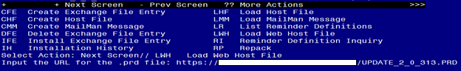

You will see a message indicating the file was loaded successfully.

Search and locate an entry titled UPDATE_2_0_313 VA-ONCOLOGY KIDNEY CANCER PATHWAYS in reminder exchange.

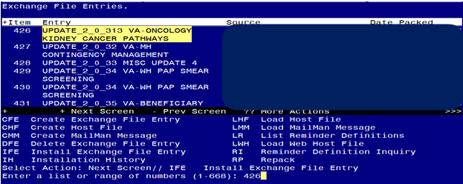

At the **Select Action** prompt, enter **IFE** for Install Exchange File Entry

Enter the number that corresponds with your entry titled UPDATE_2_0_313 VA-ONCOLOGY KIDNEY CANCER PATHWAYS *(in this example it is entry 426, it will vary by site)* that is dated 11/18/2022.

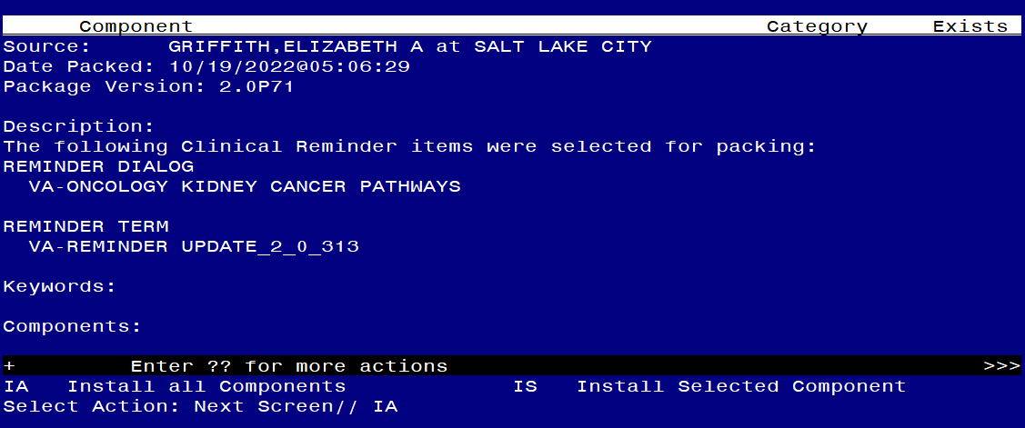

At the **Select Action** prompt, type **IA** for Install all Components and hit enter.

**For all new entries in any category you will choose I to Install**

**Overwrite any items in any category you are prompted to overwrite.**

You will then be prompted to install the dialog component.

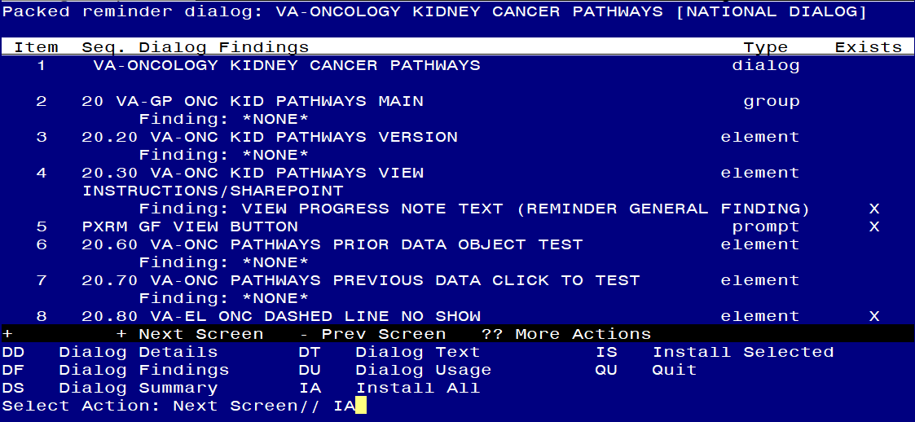

At the **Select Action** prompt, type **IA** to install the dialog – **VA-ONCOLOGY KIDNEY CANCER PATHWAYS**

Install reminder dialog and all components with no further changes: Y//ES

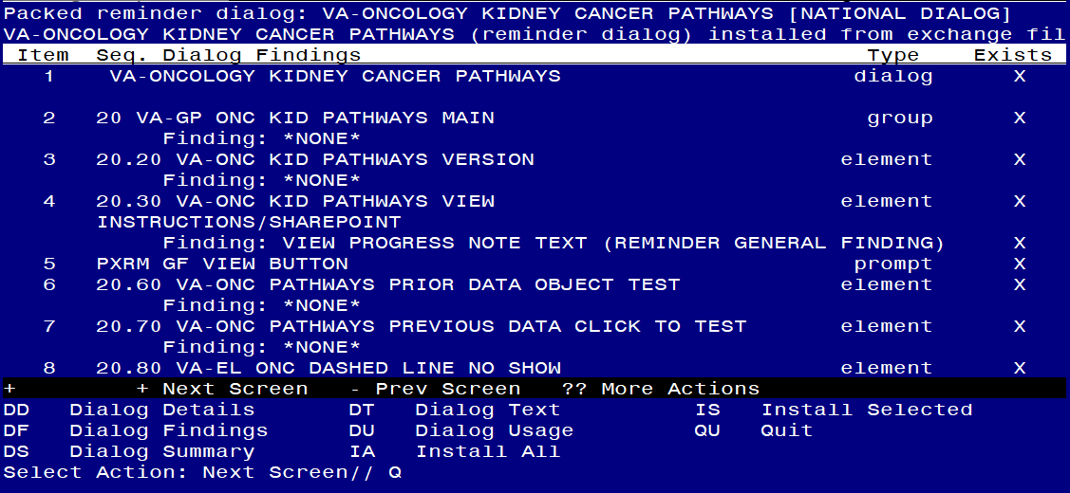

When the dialog has completed installation, you will then be returned to this screen. At the **Select Action** prompt, type **Q.**

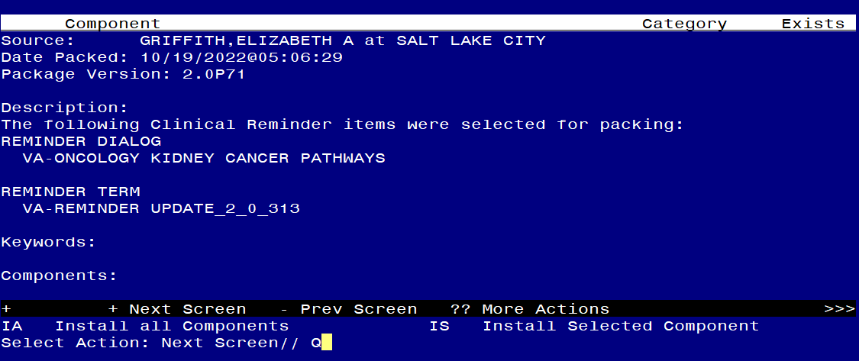

You will then be returned to this screen. At the **Select Action** prompt, type **Q.**

Install complete.

# Post Installation

1. **Setup of Note Title.**

The note title to create to associate with this template is:

ONCOLOGY KIDNEY CANCER PATHWAYS

VHA Enterprise Standard Title: HEMATOLOGY AND ONCOLOGY NOTE

**You can add these to your document class where oncology progress notes are located.**

***Note:*** *Comprehensive information on Creating new Document Classes and Titles can be found beginning on page 54 of the TIU/ASU Implementation Guide at the following link:* [*http://www.va.gov/vdl/documents/Clinical/CPRS-Text_Integration_Utility_(TIU)/tiuim.pdf*](http://www.va.gov/vdl/documents/Clinical/CPRS-Text_Integration_Utility_(TIU)/tiuim.pdf)

1. **Make the Dialog templates available to be attached to a Personal or Shared templates or to be able to attach the dialog to a progress note title.**

Select Reminder Managers Menu <TEST ACCOUNT> Option: **CP** CPRS Reminder Configuration

CA Add/Edit Reminder Categories

CL CPRS Lookup Categories

CS CPRS Cover Sheet Reminder List

MH Mental Health Dialogs Active

PN Progress Note Headers

RA Reminder GUI Resolution Active

TIU TIU Template Reminder Dialog Parameter

DEVL Evaluate Coversheet List on Dialog Finish

DL Default Outside Location

PT Position Reminder Text at Cursor

LINK Link Reminder Dialog to Template

TEST CPRS Coversheet Time Test

NP New Reminder Parameters

GEC GEC Status Check Active

WH WH Print Now Active

Select CPRS Reminder Configuration <TEST ACCOUNT> Option: **TIU** TIU Template Reminder Dialog Parameter

Reminder Dialogs allowed as Templates may be set for the following:

1 User USR [choose from NEW PERSON]

3 Service SRV [choose from SERVICE/SECTION]

4 Division DIV [SALT LAKE CITY]

5 System SYS [NATREM.FO-SLC.MED.VA.GOV]

Enter selection: **5** *Choose the appropriate number for your site. Your site may do this by System or other levels. The example below uses SYSTEM level.*

Setting Reminder Dialogs allowed as Templates for System: NATREM.FO-SLC.MED.VA.GOV

Select Display Sequence: **?**

388 VA-COVID-19 TELEPHONE FOLLOW-UP

389 VA-SRA-CONSULT RESPONSE (D)

*When you type a question mark above, you will see the list of #’s (with dialogs) that are already taken. Choose a number* ***NOT*** *on this list. For this example, 390 is not present so I will use 390.*

Select Display Sequence: **390**

Are you adding 390 as a new Display Sequence? Yes// **YES**

Display Sequence: 390// <Enter> 390

Clinical Reminder Dialog: **VA-ONCOLOGY KIDNEY CANCER PATHWAYS** reminder dialog NATIONAL

...OK? Yes// <Enter> (Yes)

1. **Associate the reminder dialogs with the note title in CPRS**

In CPRS, open the Template Editor, expand Document Titles, select the appropriate folder (if applicable), then click New Template (top right-hand corner).

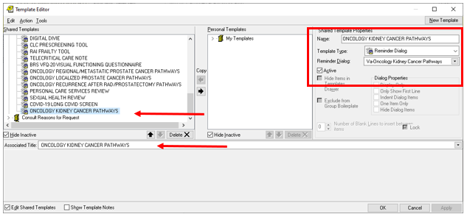

Type in the following information:

Name: **ONCOLOGY KIDNEY CANCER PATHWAYS**

Template Type: **Reminder Dialog**

Reminder Dialog: **VA-ONCOLOGY KIDNEY CANCER PATHWAYS**

Next, type in the Associated Title name **ONCOLOGY KIDNEY CANCER PATHWAYS**

–– then click Apply.

1. **Add the template to** your shared template folder so it can be used with any note title.
   1. In CPRS, open the Template Editor, expand Shared Templates, select the appropriate oncology folder (if applicable), then click New Template (top right-hand corner).

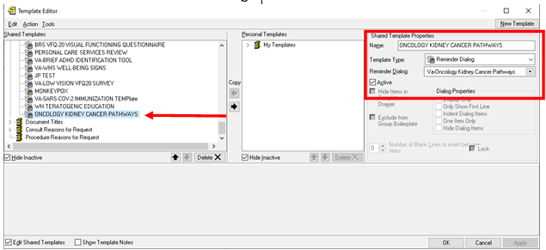

Type in the following information:

Name: **ONCOLOGY KIDNEY CANCER PATHWAYS**

Template Type: **Reminder Dialog**

Reminder Dialog: **VA-ONCOLOGY KIDNEY CANCER PATHWAYS**

–– then click Apply.

1. Review the pre-install inquiry, if you have a quick order as an additional finding for these elements, you will need to add them back:

VA-ONC UROLOGY CONSULT

VA-ONC RADIATION ONCOLOGY CONSULT

1. Optional – you Can add an order menu to the surveillance elements:

VA-ONC KID STAGE I SURVEILLANCE TXT

VA-ONC KID STAGE II/III SURVEILLANCE TXT

VA-ONC KID STAGE IV SURVEILLANCE TXT

Example order menu for surveillance elements (your site would need to create this based on orders available at your site):

