Update _2_0_314

Clinical Reminders

VA-COMMUNITY CARE COLONOSCOPY FOLLOW-UP RECOMMENDATIONS

Install Guide

December 2022

Product Development
Office of Information Technology
Department of Veterans Affairs

Table of Contents
Introduction 1
Install Details 2
Install Example 2
Post Installation 5

Introduction

This reminder dialog is released as an optional opportunity to document colonoscopy follow-up recommendations provided by community care providers. The dialog is intended to be completed by community care staff to transcribe the future screening recommendations documented by an outside provider to reset the appropriate national CRC screening reminder and VSSC reports. Sites may use this reminder dialog if their facility policies and processes allow their staff to document follow-up colonoscopy recommendations that have been provided by community care providers. Implementation of this dialog must be coordinated with the appropriate local Community Care and GI staff.

The reminder dialog includes the national CRCS health factors follow-up interval recommendations. If an interval is selected, it will resolve the national Colonoscopy Gap Reminder, reset the national Colorectal Cancer Average Risk reminder or the Colorectal Cancer Colonoscopy Follow Up reminder, and remove the patient from the VSSC Gap Report for the applicable amount of time.

There are two implementation options for this dialog to assist in documenting recommended colonoscopy follow-up care from the community providers:
- Use the reminder dialog template as a stand-alone by placing it in your Template Drawer under Shared Templates.
- Link the VA-COMMUNITY CARE COLONOSCOPY RECOMMENDED FOLLOW-UP reminder dialog template to the COMMUNITY CARE-CONSULT RESULT COLONOSCOPY note title. You will need to instruct the end users to associate this note title to the COMMUNITY CARE-COLONOSCOPY consult when completing.

UPDATE_2_0_314 contains 1 Reminder Exchange entry:
UPDATE_2_0_314 VA-CCRT CARE COORDINATION REVIEW TEAM NOTIFICATION

The exchange file contains the following components:

TIU TEMPLATE FIELD
VA-ONLINE CALCULATOR
DATE (*)

HEALTH FACTORS
VA-CRC HF CATEGORY [C]
VA-CRC CC NO FU DOCUMENTED
VA-CRC PROMPT COLONOSCOPY 2.5YR
VA-CRC PROMPT COLONOSCOPY 1.5YR
VA-CRC PROMPT COLONOSCOPY 10YR
VA-CRC PROMPT COLONOSCOPY 9YR
VA-CRC PROMPT COLONOSCOPY 8YR
VA-CRC PROMPT COLONOSCOPY 7YR
VA-CRC PROMPT COLONOSCOPY 6YR
VA-CRC PROMPT COLONOSCOPY 5YR
VA-CRC PROMPT COLONOSCOPY 4YR
VA-CRC PROMPT COLONOSCOPY 3YR
VA-CRC PROMPT COLONOSCOPY 2YR
VA-CRC PROMPT COLONOSCOPY 1 YEAR OR LESS

REMINDER SPONSOR
Office of Nursing Service

REMINDER TERM
VA-REMINDER UPDATE_2_0_314

REMINDER DIALOG
VA-COMMUNITY CARE COLONOSCOPY RECOMMENDED FOLLOW-UP

Install Details
This update is being distributed as a web host file. The address for the host file is: https://REDACTED /UPDATE_2_0_314.PRD
The file will be installed using Reminder Exchange, programmer access is not required.

Installation:
=============
This update can be loaded with users on the system. Installation will take less than 5 minutes.

Install Example
To Load the Web Host File. Navigate to Reminder exchange in Vista
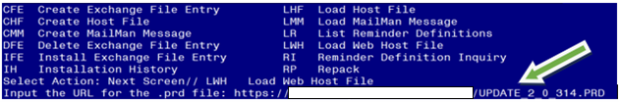

At the Select Action: prompt, enter LWH for Load Web Host File
At the Input the url for the .prd file: prompt, type the following web address:
https://REDACTED /UPDATE_2_0_314.PRD

You should see a message at the top of your screen that the file successfully loaded.

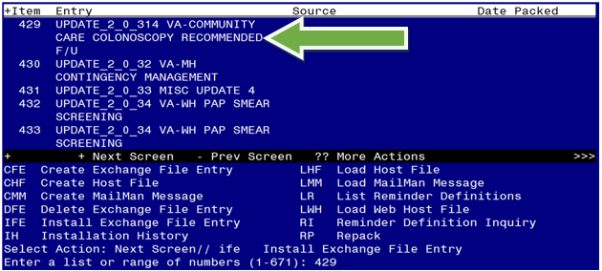

Search and locate an entry titled UPDATE_2_0_314 VA-COMMUNITY CARE COLONOSCOPY RECOMMENDED F/U in reminder exchange.

At the Select Action prompt, enter IFE for Install Exchange File Entry

Enter the number that corresponds with your entry UPDATE_2_0_314 VA-COMMUNITY CARE COLONOSCOPY RECOMMENDED F/U
(In this example it is entry 429. It will vary by site). The date of the exchange file should be 12/15/2022.

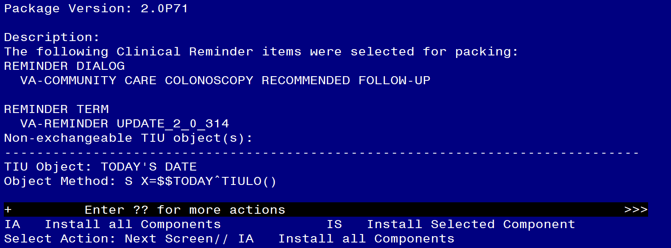

At the Select Action prompt, type IA for Install all Components and hit enter.
Select Action: Next Screen// IA Install all Components
You will see several prompts, for all new entries you will choose I to Install
For components that already exists but the packed component is different, choose S to Skip.
You will be promped to install the reminder dialog component (VA-COMMUNITY CARE COLONOSCOPY RECOMMENDED FOLLOW-UP). You will choose to install all even though some components may have an X to indicate that they exist.
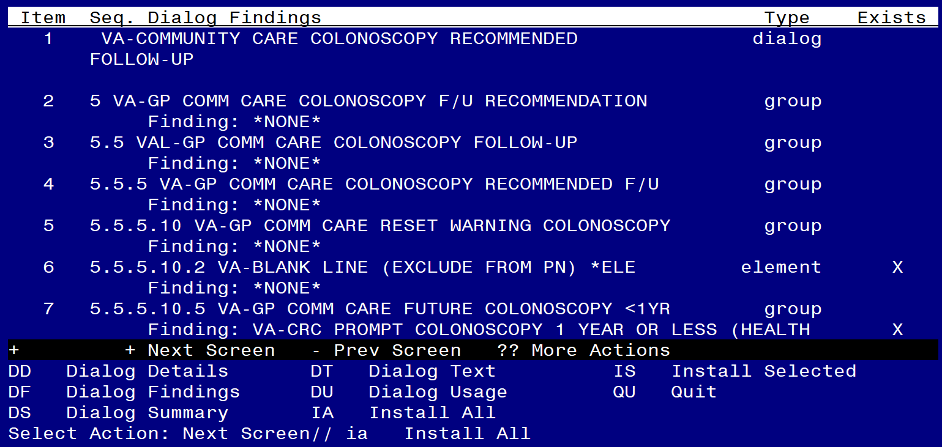

At the Select Action prompt, type IA to install the dialog: VA-COMMUNITY CARE COLONOSCOPY RECOMMENDED FOLLOW-UP

Select Action: Next Screen// IA Install All

Install reminder dialog and all components with no further changes: Y// Yes
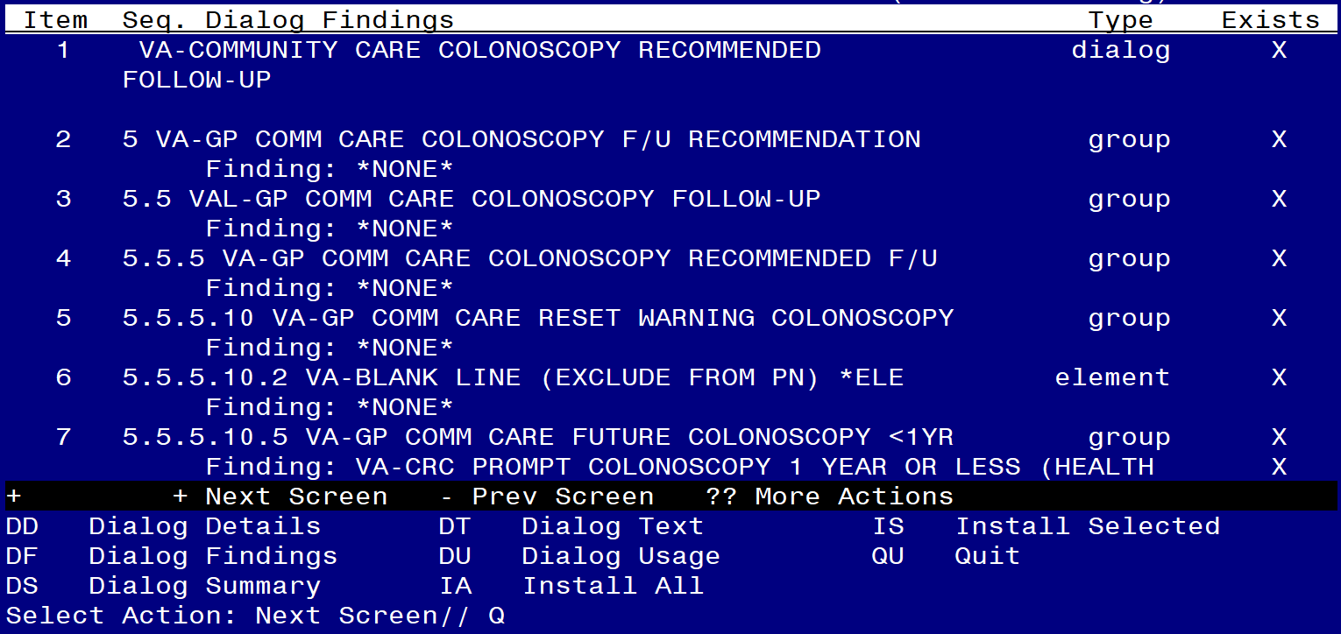

After completing this dialog install, you will type Q.

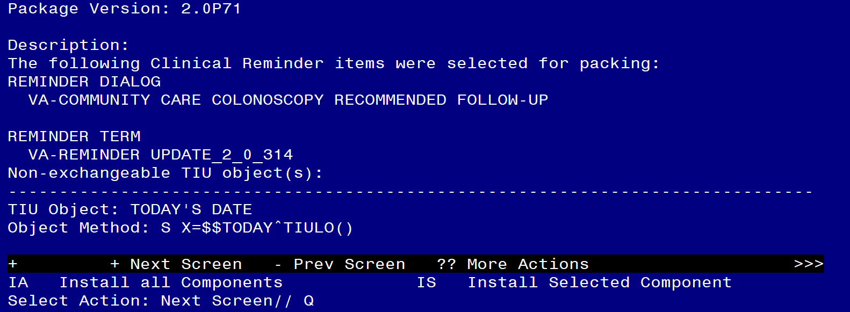
You will then be returned to this screen. At the Select Action prompt, type Q.

Install complete.

Post Installation

- Implementation of this dialog must be coordinated with the appropriate local Community Care staff. Do not complete the remaining steps without completing the necessary coordination and approval.

- Make the Dialog template available to be attached to a Personal or Shared template or to be able to attach the dialog to a progress note title.

Select Reminder Managers Menu <TEST ACCOUNT> Option: CP CPRS Reminder Configuration
CA Add/Edit Reminder Categories
CL CPRS Lookup Categories
CS CPRS Cover Sheet Reminder List
MH Mental Health Dialogs Active
PN Progress Note Headers
RA Reminder GUI Resolution Active
TIU TIU Template Reminder Dialog Parameter
DEVL Evaluate Coversheet List on Dialog Finish
DL Default Outside Location
PT Position Reminder Text at Cursor
LINK Link Reminder Dialog to Template
TEST CPRS Coversheet Time Test
NP New Reminder Parameters
GEC GEC Status Check Active
WH WH Print Now Active
Select CPRS Reminder Configuration <TEST ACCOUNT> Option: TIU TIU Template Reminder Dialog Parameter

Reminder Dialogs allowed as Templates may be set for the following:

1 User USR [choose from NEW PERSON]
3 Service SRV [choose from SERVICE/SECTION]
4 Division DIV [SALT LAKE CITY]
5 System SYS [NATREM.FO-SLC.MED.VA.GOV]

Enter selection: 5 Choose the appropriate number for your site. Your site may do this by System or other levels. The example below uses SYSTEM level.

Setting Reminder Dialogs allowed as Templates for System: NATREM.FO-SLC.MED.VA.GOV
Select Display Sequence: ?

388 VA-COVID-19 TELEPHONE FOLLOW-UP
389 VA-SRA-CONSULT RESPONSE (D)

When you type a question mark above, you will see the list of #’s (with dialogs) that are already taken. Choose a number NOT on this list. For this example, 390 is not present so I will use 390.

Select Display Sequence: 390
Are you adding 390 as a new Display Sequence? Yes// YES

Display Sequence: 390// <Enter> 390
Clinical Reminder Dialog: VA-COMMUNITY CARE COLONOSCOPY RECOMMENDED FOLLOW-UP reminder dialog NATIONAL
...OK? Yes// <Enter> (Yes)

- Implement the dialog according to local policy and decision.

