Update _2_0_315

Clinical Reminders

VA-CONFIRMATION OF MALIGNANCY
Install Guide

January 2023

Product Development
Office of Information Technology
Department of Veterans Affairs

Table of Contents
Introduction 1
Install Details 2
Install Example 2
Post Installation 5

Introduction
The purpose of this dialog is to ensure confirmation of all elements of a newly diagnosed malignancy by a second pathologist (excluding primary basal cell carcinoma and squamous cell carcinoma of the skin) that impact clinical management. Each PLMS Service Chief is responsible for ensuring the process of the second pathologist who confirms the new malignancy to review the entire component of the malignant diagnosis. This procedure may be used in both conventional histopathology as well as telepathology. This procedure only applies to cases signed out at a VHA facility by credentialled and privileged pathologists.

The exchange file contains the following components:

TIU TEMPLATE FIELD
WORD PROCESSING LARGE REQUIRED DATE (*)
WORD PROCESS (REQUIRED)
HEALTH FACTORS
VA-PLMS INVASION EXTENT BY REVIEW PATH CONFIRMED NO
VA-PLMS INVASION EXTENT BY REVIEW PATH CONFIRMED YES
VA-PLMS INVASION EXTENT CONFIRMED BY REVIEW PATH N/A
VA-PLMS MALIGNANCY BY REVIEW PATH CONFIRMED NO
VA-PLMS MALIGNANCY BY REVIEW PATH CONFIRMED YES
VA-PLMS MALIGNANCY CONFIRMATION [C]
VA-PLMS MARGIN STATUS BY REVIEW PATH CONFIRMED N/A
VA-PLMS MARGIN STATUS BY REVIEW PATH CONFIRMED NO
VA-PLMS MARGIN STATUS BY REVIEW PATH CONFIRMED YES
VA-PLMS METASTASIS STATUS BY REVIEW PATH CONFIRMED N/A
VA-PLMS METASTASIS STATUS BY REVIEW PATH CONFIRMED NO
VA-PLMS METASTASIS STATUS BY REVIEW PATH CONFIRMED YES
VA-PLMS PATHOLOGIST ORIGINAL
VA-PLMS PATHOLOGIST REVIEWING
VA-PLMS SPECIMEN ACCESSION
VA-PLMS STATION NUMBER ORIGINAL
VA-PLMS STATION NUMBER REVIEWING
VA-PLMS TUMOR GRADE BY REVIEW PATH CONFIRMED N/E
VA-PLMS TUMOR GRADE BY REVIEW PATH CONFIRMED NO
VA-PLMS TUMOR GRADE BY REVIEW PATH CONFIRMED YES
VA-PLMS TUMOR TYPE BY REVIEW PATH CONFIRMED N/E
VA-PLMS TUMOR TYPE BY REVIEW PATH CONFIRMED NO
VA-PLMS TUMOR TYPE BY REVIEW PATH CONFIRMED YES
VA-REMINDER UPDATES [C]
VA-UPDATE_2_0_315

REMINDER SPONSOR
OFFICE OF PATHOLOGY AND LABORATORY MEDICAL SERVICE (PLMS)

REMINDER DIALOG
VA-PLMS CONFIRMATION OF MALIGNANCY

REMINDER TERM
VA-REMINDER UPDATE_2_0_315

REMINDER TAXONOMY
VA-PLMS CPT 80505
VA-PLMS CPT 80504
VA-PLMS CPT 80503

Install Details
This update is being distributed as a web host file. The address for the host file is: https://REDACTED/UPDATE_2_0_315.PRD

Installation:
=============
This update can be loaded with users on the system. Installation will take less than 5 minutes.

Install Example
To Load the Web Host File. Navigate to Reminder exchange in Vista
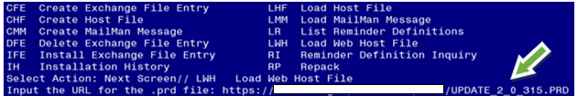

At the Select Action: prompt, enter LWH for Load Web Host File
At the Input the url for the .prd file: prompt, type the following web address:
https://REDACTED/UPDATE_2_0_315.PRD

You should see a message at the top of your screen that the file successfully loaded.
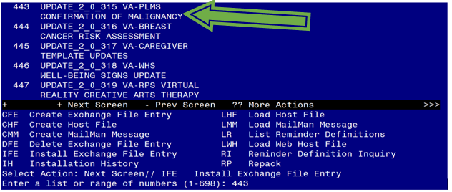

Search and locate an entry titled UPDATE_2_0_315 VA-PLMS CONFIRMATION OF MALIGNANCY in reminder exchange.

At the Select Action prompt, enter IFE for Install Exchange File Entry

Enter the number that corresponds with your entry UPDATE_2_0_315 VA-PLMS CONFIRMATION OF MALIGNANCY.
(In this example it is entry 443. It will vary by site). The date of the exchange file should be 02/02/2023.

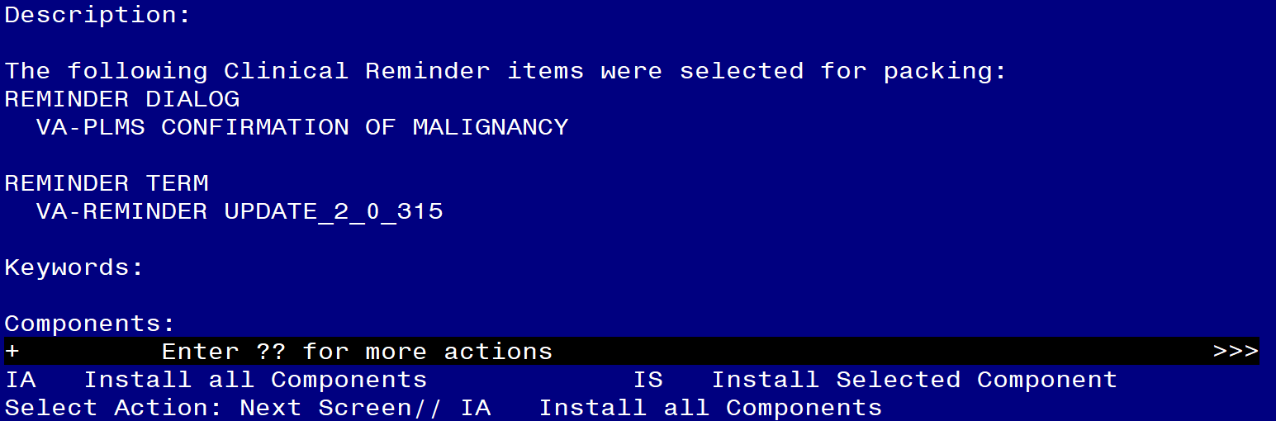

At the Select Action prompt, type IA for Install all Components and hit enter.
Select Action: Next Screen// IA Install all Components

You will see several prompts, for all new entries you will choose I to Install
For components that already exists but the packed component is different, choose O to Overwrite.

You will be promped to install the reminder dialog component (VA-PLMS CONFIRMATION OF MALIGNANCY). You will choose to install all even though some components may have an X to indicate that they exist.
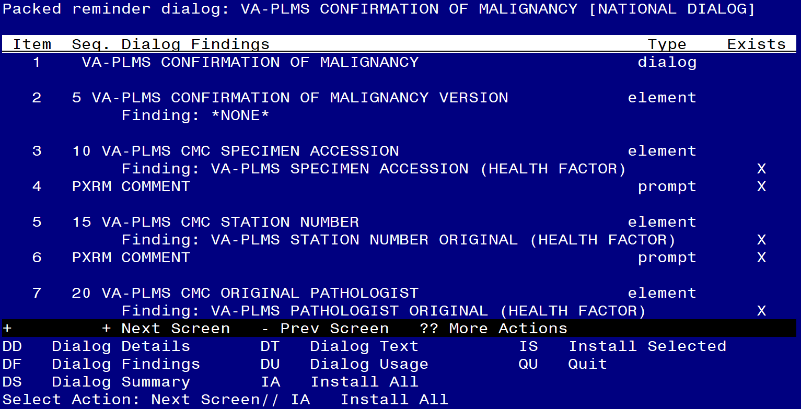

At the Select Action prompt, type IA to install the dialog.
Install reminder dialog and all components with no further changes: Yes

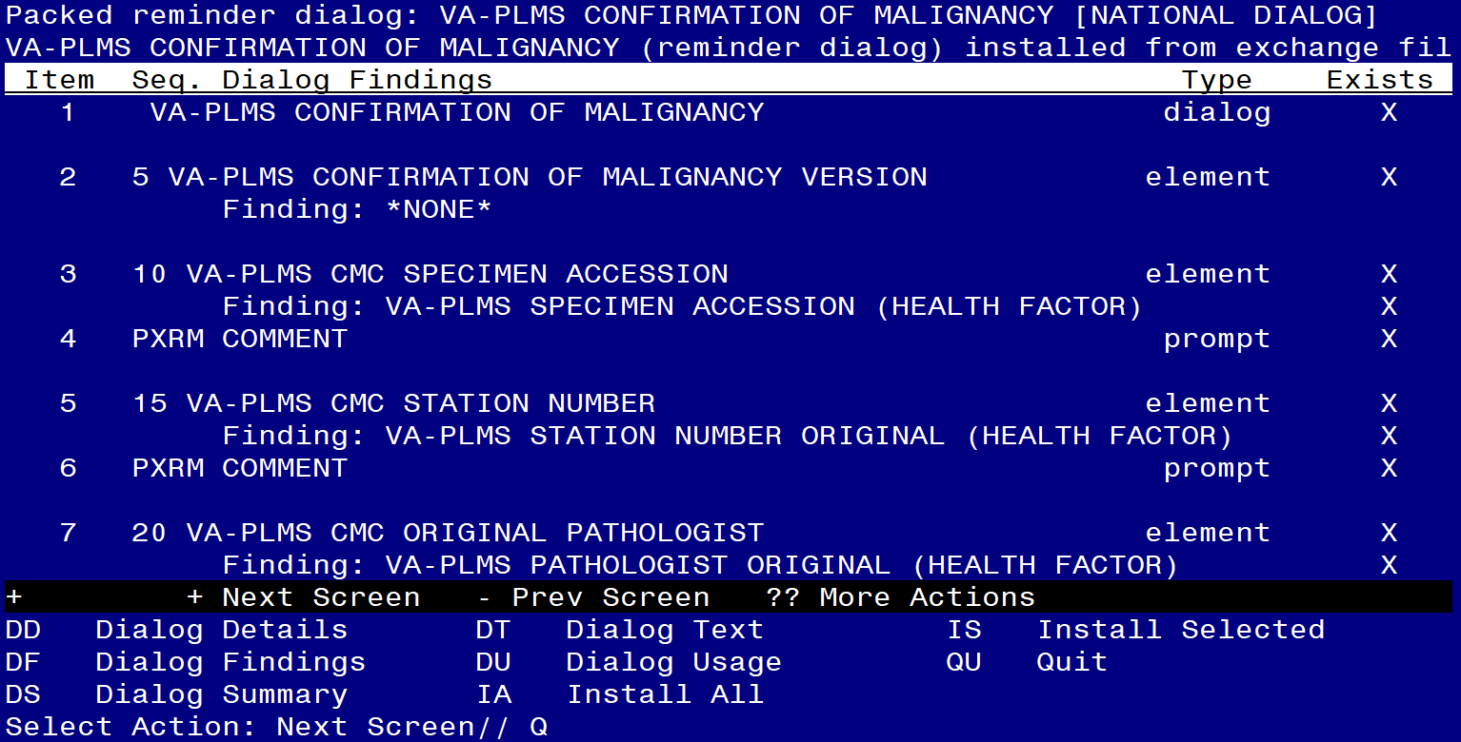

After completing this dialog install, you will type Q.

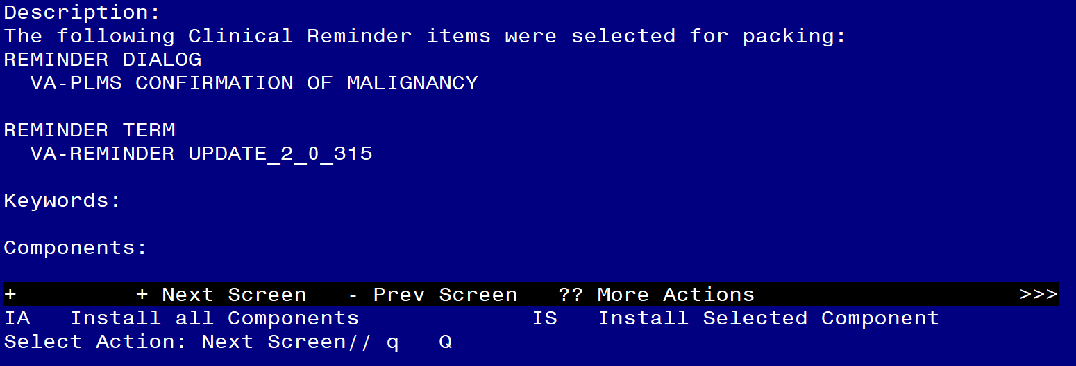
You will then be returned to this screen. At the Select Action prompt, type Q.

Install complete.

Post Installation

- Make the Dialog template available to be attached to a Personal or Shared template or to be able to attach the dialog to a progress note title.

Select Reminder Managers Menu <TEST ACCOUNT> Option: CP CPRS Reminder Configuration
CA Add/Edit Reminder Categories
CL CPRS Lookup Categories
CS CPRS Cover Sheet Reminder List
MH Mental Health Dialogs Active
PN Progress Note Headers
RA Reminder GUI Resolution Active
TIU TIU Template Reminder Dialog Parameter
DEVL Evaluate Coversheet List on Dialog Finish
DL Default Outside Location
PT Position Reminder Text at Cursor
LINK Link Reminder Dialog to Template
TEST CPRS Coversheet Time Test
NP New Reminder Parameters
GEC GEC Status Check Active
WH WH Print Now Active
Select CPRS Reminder Configuration <TEST ACCOUNT> Option: TIU TIU Template Reminder Dialog Parameter

Reminder Dialogs allowed as Templates may be set for the following:

1 User USR [choose from NEW PERSON]
3 Service SRV [choose from SERVICE/SECTION]
4 Division DIV [SALT LAKE CITY]
5 System SYS [NATREM.FO-SLC.MED.VA.GOV]

Enter selection: 5 Choose the appropriate number for your site. Your site may do this by System or other levels. The example below uses SYSTEM level.

Setting Reminder Dialogs allowed as Templates for System: NATREM.FO-SLC.MED.VA.GOV
Select Display Sequence: ?

388 VA-COVID-19 TELEPHONE FOLLOW-UP
389 VA-SRA-CONSULT RESPONSE (D)

When you type a question mark above, you will see the list of #’s (with dialogs) that are already taken. Choose a number NOT on this list. For this example, 390 and 391 are not present so those numbers can be used.

Select Display Sequence: 390
Are you adding 390 as a new Display Sequence? Yes// YES

Display Sequence: 390// <Enter>
Clinical Reminder Dialog: VA-PLMS CONFIRMATION OF MALIGNANCY
reminder dialog NATIONAL
...OK? Yes// Yes

- Setup of Note Title (optional).

The note title to create to associate with this template is: PATHOLOGY MALIGNANCY CONFIRMATION

VHA Enterprise Standard Title: PATHOLOGY NOTE

You can add this to the appropriate document class.

Note: Comprehensive information on Creating new Document Classes and Titles can be found beginning on page 54 of the TIU/ASU Implementation Guide at the following link: http://www.va.gov/vdl/documents/Clinical/CPRS-Text_Integration_Utility_(TIU)/tiuim.pdf

- Associate the reminder dialogs with the note titles in CPRS

In CPRS, open the Template Editor, expand Document Titles, select the appropriate folder (if applicable), then click New Template (top right-hand corner).

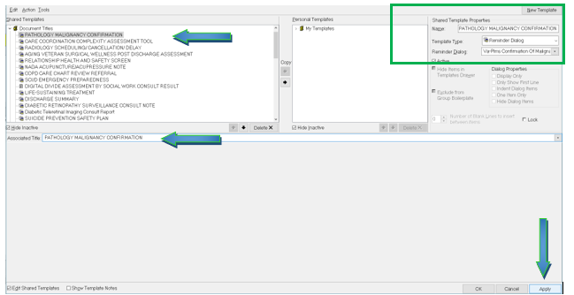

Type in the following information:
Name: PATHOLOGY MALIGNANCY CONFIRMATION
Template Type: Reminder Dialog
Reminder Dialog: VA-PLMS CONFIRMATION OF MALIGNANCY

Next, type in the Associated Title name –– then click Apply.

