Update_2_0_317

Clinical Reminders

VA-CAREGIVER TEMPLATE UPDATES

Install Guide

December 2022

Product Development
Office of Information Technology
Department of Veterans Affairs

Table of Contents
Introduction 1
Install Details 10
Install Example 10
Post Installation 16

Introduction
In October 2020 the Caregiver Support Program (CSP) implemented approximately 20 new notes/reminder dialogs in support of implementing changes to the Program of Comprehensive Assistance for Family Caregivers Program that were required under the MISSION Act.

In support of the MISSION Act and the Program of Comprehensive Assistance for Family Caregivers (PCAFC), this update includes edits to the CEAT Consult, CSP PCAFC Application Intake, CSP PCAFC Home Care Assessments for both the Veteran and Caregiver and the CSP PCAFC Reassessment Review dialog templates, to include options based on new regulations, to remove redundancies and add missing elements.

The version numbers for the four reminder dialog templates are now as follows:

Reminder Dialog: VA-CSP PCAFC INTAKE

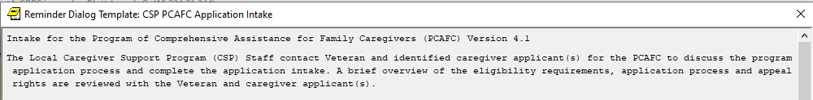

Reminder Dialog: VA-CSP PCAFC RE-ASSESSMENT

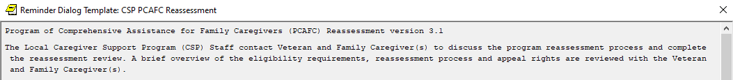

Reminder Dialog: VA-CSP INITIAL HOME-CARE ASSESSMENT VETERAN

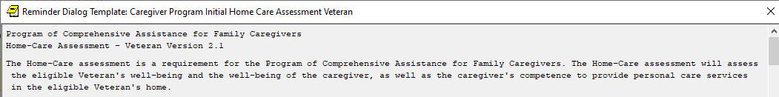

Reminder Dialog: VA-CSP INITIAL HOME-CARE ASSESSMENT CAREGIVER

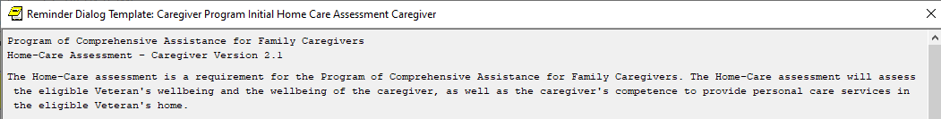

UPDATE_2_0_317 contains 1 Reminder Exchange entry:
UPDATE_2_0_317 VA-CAREGIVER TEMPLATE UPDATES

The exchange file contains the following components:

TIU TEMPLATE FIELD
WORD 1 LINE1 PC
VA-CSP FUNCT CLARIFY
TEXT (1-70)
WORD 2 LINES1 REQ
TEXT (1-70) REQUIRED
TEXT NO LIMIT
TEXT (1-10 CHAR) REQ
VA-CSP OXYGEN PRN/CONTINUOUS
TEXT (1-4)R
TEXT (1-60 CHAR)R
VA-WORD
DATE (*)
WORD PROCESSING FIELD
VA-CSP WP 3L IND 2
VA-CSP EDIT 30
VA-CSP RELATIONSHIP
YES / NO
YES OR NO
OTHER NON-VA
OTHER TEXT
VA-BRANCH OF SERVICE

HEALTH FACTORS
VA-REMINDER UPDATES [C]
VA-UPDATE_2_0_317
VA-CAREGIVER PROGRAM [C]
VA-CSP PCAFC HOME ASSESS VET FALL NO
VA-CSP PCAFC HOME ASSESS VET FALL YES WITH INJ
VA-CSP PCAFC HOME ASSESS VET FALL YES WITH NO INJ
VA-CSP PCAFC HOME ASSESS VET UNADDRESSED MED CONC NO
VA-CSP PCAFC HOME ASSESS VET UNADDRESSED MED CONC YES
VA-CSP PCAFC HOME ASSESS VET SPI LIMIT SUMMARY
VA-CSP PCAFC HOME ASSESS VET CEAT PCS SPI NO
VA-CSP PCAFC HOME ASSESS VET CEAT PCS SPI YES
VA-CSP PCAFC HOME ASSESS VET ABILITY SELF SAFETY PRES DIR
VA-CSP PCAFC HOME ASSESS VET VISIT DATE
VA-CSP PCAFC HOME ASSESS VET SCG TWO
VA-CSP PCAFC HOME ASSESS VET SCG
VA-CSP PCAFC HOME ASSESS VET REASSESS
VA-CSP PCAFC HOME ASSESS VET INITIAL
VA-CSP PCAFC HOME ASSESS VET REC REFERRAL
VA-CSP PCAFC HOME ASSESS VET REC REFERRA TELEHEALTH
VA-CSP PCAFC HOME ASSESS VET REC HOME VISIT
VA-CSP PCAFC HOME ASSESS VET REC CLINIC VISIT
VA-CSP PCAFC HOME ASSESS VET FU RECOMMEND
VA-CSP PCAFC HOME ASSESS VET NO FU
VA-CSP PCAFC HOME ASSESS VET NO UNMET NEEDS
VA-CSP PCAFC HOME ASSESS VET UNMET OTHER
VA-CSP PCAFC HOME ASSESS VET UNMET EMERG PLAN
VA-CSP PCAFC HOME ASSESS VET UNMET ENVIRON
VA-CSP PCAFC HOME ASSESS VET UNMET BEHAV MGMT
VA-CSP PCAFC HOME ASSESS VET UNMET COMM COG
VA-CSP PCAFC HOME ASSESS VET UNMET SPI
VA-CSP PCAFC HOME ASSESS VET UNMET ADL
VA-CSP PCAFC HOME ASSESS VET UNMET MED MGMT
VA-CSP PCAFC HOME ASSESS VET UNMET NEEDS
VA-CSP PCAFC HOME ASSESS VET SECURITY MEASURES NO
VA-CSP PCAFC HOME ASSESS VET SECURITY MEASURES YES
VA-CSP PCAFC HOME ASSESS VET PESTS NO
VA-CSP PCAFC HOME ASSESS VET PESTS YES
VA-CSP PCAFC HOME ASSESS VET ELECTRIC MED EQUIP NO
VA-CSP PCAFC HOME ASSESS VET ELECTRIC MED EQUIP YES
VA-CSP PCAFC HOME ASSESS VET MEDICATION SUPPLY NA
VA-CSP PCAFC HOME ASSESS VET MEDICATION SUPPLY NO
VA-CSP PCAFC HOME ASSESS VET MEDICATION SUPPLY YES
VA-CSP PCAFC HOME ASSESS VET MEDICATION STORAGE SAFE NA
VA-CSP PCAFC HOME ASSESS VET MEDICATION STORAG SAFE NO
VA-CSP PCAFC HOME ASSESS VET MEDICATION STORAGE SAFE YES
VA-CSP PCAFC HOME ASSESS VET CARE SUPPLY STORAG SAFE NA
VA-CSP PCAFC HOME ASSESS VET CARE SUPPLY STORAGE SAFE NO
VA-CSP PCAFC HOME ASSESS VET CARE SUPPLY STORAGE SAFE YES
VA-CSP PCAFC HOME ASSESS VET OXYGEN STORAGE SAFE NA
VA-CSP PCAFC HOME ASSESS VET OXYGEN STORAGE SAFE NO
VA-CSP PCAFC HOME ASSESS VET OXYGEN STORAGE SAFE YES
VA-CSP PCAFC HOME ASSESS VET VENTILATION NO
VA-CSP PCAFC HOME ASSESS VET VENTILATION YES
VA-CSP PCAFC HOME ASSESS VET HAZARDS SAFETY CONCERNS NO
VA-CSP PCAFC HOME ASSESS VET HAZARDS SAFET CONCERNS YES
VA-CSP PCAFC HOME ASSESS VET FALL RISKS NOTED NO
VA-CSP PCAFC HOME ASSESS VET FALL RISKS NOTED YES
VA-CSP PCAFC HOME ASSESS VET DETERIOR WALLS DOOR NO
VA-CSP PCAFC HOME ASSESS VET DETERIOR WALLS DOOR YES
VA-CSP PCAFC HOME ASSESS VET TEMP CONTROL NO
VA-CSP PCAFC HOME ASSESS VET TEMP CONTROL YES
VA-CSP PCAFC HOME ASSESS VET COOKING FACILITY NO
VA-CSP PCAFC HOME ASSESS VET FOOD SUPPLY NO
VA-CSP PCAFC HOME ASSESS VET FOOD SUPPLY YES
VA-CSP PCAFC HOME ASSESS VET COLD FOOD STORAGE NO
VA-CSP PCAFC HOME ASSESS VET COLD FOOD STORAGE YES
VA-CSP PCAFC HOME ASSESS VET RUNNING WATER NO
VA-CSP PCAFC HOME ASSESS VET RUNNING WATER YES
VA-CSP PCAFC HOME ASSESS VET BATH GRAB BARS NO
VA-CSP PCAFC HOME ASSESS VET BATH GRAB BARS YES
VA-CSP PCAFC HOME ASSESS VET BATH CHAIR NO
VA-CSP PCAFC HOME ASSESS VET BATH CHAIR YES
VA-CSP PCAFC HOME ASSESS VET STAIR HANDRAILS NO
VA-CSP PCAFC HOME ASSESS VET STAIR HANDRAILS YES
VA-CSP PCAFC HOME ASSESS VET FIRST FLOOR SLEEP NO
VA-CSP PCAFC HOME ASSESS VET FIRST FLOOR SLEEP YES
VA-CSP PCAFC HOME ASSESS VET ELEVATOR NA
VA-CSP PCAFC HOME ASSESS VET ELEVATOR NO
VA-CSP PCAFC HOME ASSESS VET ELEVATOR YES
VA-CSP PCAFC HOME ASSESS VET STAIRS NO
VA-CSP PCAFC HOME ASSESS VET STAIRS YES
VA-CSP PCAFC HOME ASSESS VET FLASHLIGHT NO
VA-CSP PCAFC HOME ASSESS VET FLASHLIGHT YES
VA-CSP PCAFC HOME ASSESS VET FIRE EXTING NO
VA-CSP PCAFC HOME ASSESS VET FIRE EXTING YES
VA-CSP PCAFC HOME ASSESS VET SMOKE DETECT NO
VA-CSP PCAFC HOME ASSESS VET SMOKE DETECT YES
VA-CSP PCAFC HOME ASSESS VET EMERGENCY PLAN NO
VA-CSP PCAFC HOME ASSESS VET EMERGENCY PLAN YES
VA-CSP PCAFC HOME ASSESS VET SAFE IN HOME NO
VA-CSP PCAFC HOME ASSESS VET SAFE IN HOME YES
VA-CSP PCAFC HOME ASSESS VET IPV DV NO
VA-CSP PCAFC HOME ASSESS VET IPV DV YES
VA-CSP PCAFC HOME ASSESS UNADDRESSED MENTAL EMO CONC NO
VA-CSP PCAFC HOME ASSESS UNADDRESSED MENTAL EMO CONC YES
VA-CSP PCAFC HOME ASSESS VET IADL DIFFICULT FINANCES
VA-CSP PCAFC HOME ASSESS VET IADL DIFFICULT MED MGMT
VA-CSP PCAFC HOME ASSESS VET IADL DIFFICULT PHONE USE
VA-CSP PCAFC HOME ASSESS VET IADL DIFFICULT TRANSPORT
VA-CSP PCAFC HOME ASSESS VET IADL DIFFICULT SHOPPING
VA-CSP PCAFC HOME ASSESS VET IADL DIFFICULT HOUSEWORK
VA-CSP PCAFC HOME ASSESS VET IADL DIFFICULT MEA PREP
VA-CSP PCAFC HOME ASSESS VET IADL DIFFICULT YES
VA-CSP PCAFC HOME ASSESS VET IADL DIFFICULT NO
VA-CSP PCAFC HOME ASSESS VET SPECIALTY CARE OTHER
VA-CSP PCAFC HOME ASSESS VET SPECIALTY CARE BLOOD PRESSURE
VA-CSP PCAFC HOME ASSESS VET SPECIALTY CARE DIABETIC CARE
VA-CSP PCAFC HOME ASSESS VET SPECIALTY CARE CPAP
VA-CSP PCAFC HOME ASSESS VET SPECIALTY CARE SKIN CARE
VA-CSP PCAFC HOME ASSESS VET SPECIALTY CARE OXYGEN
VA-CSP PCAFC HOME ASSESS VET SPECIALTY CARE FEEDING TUBE
VA-CSP PCAFC HOME ASSESS VET SPECIALTY CARE TRACH
VA-CSP PCAFC HOME ASSESS VET SPECIALTY CARE COLOSTOMY
VA-CSP PCAFC HOME ASSESS VET SPECIALTY CARE FOLEY
VA-CSP PCAFC HOME ASSESS VET SPECIALTY CARE YES
VA-CSP PCAFC HOME ASSESS VET SPECIALTY CARE NONE
VA-CSP PCAFC HOME ASSESS VET EQUIP NONE
VA-CSP PCAFC HOME ASSESS VET EQUIP YES
VA-CSP PCAFC HOME ASSESS VET TRANSFER NEEDS ASSIST
VA-CSP PCAFC HOME ASSESS VET TRANSFER IND
VA-CSP PCAFC HOME ASSESS VET AMBULATION NEEDS ASSIST
VA-CSP PCAFC HOME ASSESS VET AMBULATION IND
VA-CSP PCAFC HOME ASSESS VET FEEDING SPECIAL UTENSILS
VA-CSP PCAFC HOME ASSESS VET FEEDING NEEDS ASSIST
VA-CSP PCAFC HOME ASSESS VET FEEDING IND
VA-CSP PCAFC HOME ASSESS VET BLADDER CONTINENT NO
VA-CSP PCAFC HOME ASSESS VET BLADDER CONTINENT YES
VA-CSP PCAFC HOME ASSESS VET BOWEL CONTINENT NO
VA-CSP PCAFC HOME ASSESS VET BOWEL CONTINENT YES
VA-CSP PCAFC HOME ASSESS VET TOILETING NEEDS ASSIST
VA-CSP PCAFC HOME ASSESS VET TOILETING IND
VA-CSP PCAFC HOME ASSESS VET PROSTHETICS NA
VA-CSP PCAFC HOME ASSESS VET PROSTHETICS NEEDS ASSIST
VA-CSP PCAFC HOME ASSESS VET PROSTHETICS IND
VA-CSP PCAFC HOME ASSESS VET GROOM NEEDS ASSIST
VA-CSP PCAFC HOME ASSESS VET GROOM IND
VA-CSP PCAFC HOME ASSESS VET BATH NEEDS ASSIST
VA-CSP PCAFC HOME ASSESS VET BATH IND
VA-CSP PCAFC HOME ASSESS VET DRESS NEEDS ASSIST
VA-CSP PCAFC HOME ASSESS VET DRESS IND
VA-CSP PCAFC HOME ASSESS VET ADL LIMIT SUMMARY
VA-CSP PCAFC HOME ASSESS VET CEAT PCS ADL NO
VA-CSP PCAFC HOME ASSESS VET CEAT PCS ADL YES
VA-CSP PCAFC HOME ASSESS VET EMERGENCY HELP
VA-CSP PCAFC HOME ASSESS VET PCS NO
VA-CSP PCAFC HOME ASSESS VET PCS YES
VA-CSP PCAFC HOME ASSESS VET SAFETY NO
VA-CSP PCAFC HOME ASSESS VET SAFETY YES
VA-CSP PCAFC HOME ASSESS VET PCG
VA-CSP PCAFC HOME ASSESS VET OTHER SUPP NO
VA-CSP PCAFC HOME ASSESS VET OTHER SUPP YES
VA-INITIAL HOME ASSESSMENT VETERAN
VA-CSP PCAFC HOME ASSESS CG VISIT DATE
VA-CSP PCAFC HOME ASSESS CG REASSESS
VA-CSP PCAFC HOME ASSESS CG INITIAL
VA-CSP PCAFC HOME ASSESS CG REFER OTHER
VA-CSP PCAFC HOME ASSESS CG REFER ACP
VA-CSP PCAFC HOME ASSESS CG REFER LEGAL ASSIST
VA-CSP PCAFC HOME ASSESS CG REFER FINANCE PLAN
VA-CSP PCAFC HOME ASSESS CG REFER PEER SUPP
VA-CSP PCAFC HOME ASSESS CG REFER HEALTH COACH
VA-CSP PCAFC HOME ASSESS CG REFER MH COACH
VA-CSP PCAFC HOME ASSESS CG REFER VA COMM SERVICE
VA-CSP PCAFC HOME ASSESS CG REFER ED TRAIN
VA-CSP PCAFC HOME ASSESS CG REC REFERRAL
VA-CSP PCAFC HOME ASSESS CG FU RECOMMEND
VA-CSP PCAFC HOME ASSESS CG NO FU
VA-CSP PCAFC HOME ASSESS CG UNMET OTHER
VA-CSP PCAFC HOME ASSESS CG UNMET RESOURCE
VA-CSP PCAFC HOME ASSESS CG UNMET EMERG PLAN
VA-CSP PCAFC HOME ASSESS CG UNMET ENVIRON
VA-CSP PCAFC HOME ASSESS CG UNMET SELF CARE
VA-CSP PCAFC HOME ASSESS CG UNMET BEHAV MGMT
VA-CSP PCAFC HOME ASSESS CG UNMET COMM COG
VA-CSP PCAFC HOME ASSESS CG UNMET SPI
VA-CSP PCAFC HOME ASSESS CG UNMET ADL
VA-CSP PCAFC HOME ASSESS CG UNMET MED MGMT
VA-CSP PCAFC HOME ASSESS CG UNMET NEEDS
VA-CSP PCAFC HOME ASSESS CG NO UNMET NEEDS
VA-CSP PCAFC HOME ASSESS CG VCL ACCESS NO
VA-CSP PCAFC HOME ASSESS CG VCL ACCESS YES
VA-CSP PCAFC HOME ASSESS CG SAFE HOME NO
VA-CSP PCAFC HOME ASSESS CG SAFE HOME YES
VA-CSP PCAFC HOME ASSESS CG MANAGE MEDS NA
VA-CSP PCAFC HOME ASSESS CG MANAGE MEDS NO
VA-CSP PCAFC HOME ASSESS CG MANAGE MEDS YES
VA-CSP PCAFC HOME ASSESS CG PCP CONTACT NO
VA-CSP PCAFC HOME ASSESS CG PCP CONTACT YES
VA-CSP PCAFC HOME ASSESS CG EDUC SUPP NO
VA-CSP PCAFC HOME ASSESS CG EDUC SUPP YES
VA-CSP PCAFC HOME ASSESS CG RESPITE NO
VA-CSP PCAFC HOME ASSESS CG RESPITE YES
VA-CSP PCAFC HOME ASSESS CG PLAN ASSIST NO
VA-CSP PCAFC HOME ASSESS CG PLAN ASSIST YES
VA-CSP PCAFC HOME ASSESS CG RECOG AT RISK NA
VA-CSP PCAFC HOME ASSESS CG RECOG AT RISK NO
VA-CSP PCAFC HOME ASSESS CG RECOG AT RISK YES
VA-CSP PCAFC HOME ASSESS CG CLIN INTERV NA
VA-CSP PCAFC HOME ASSESS CG CLIN INTERV NO
VA-CSP PCAFC HOME ASSESS CG CLIN INTERV YES
VA-CSP PCAFC HOME ASSESS CG BEH MGMT NA
VA-CSP PCAFC HOME ASSESS CG BEH MGMT NO
VA-CSP PCAFC HOME ASSESS CG BEH MGMT YES
VA-CSP PCAFC HOME ASSESS CG STRUCTURE NA
VA-CSP PCAFC HOME ASSESS CG STRUCTURE NO
VA-CSP PCAFC HOME ASSESS CG STRUCTURE YES
VA-CSP PCAFC HOME ASSESS CG REDIRECT NA
VA-CSP PCAFC HOME ASSESS CG REDIRECT NO
VA-CSP PCAFC HOME ASSESS CG REDIRECT YES
VA-CSP PCAFC HOME ASSESS CG PCS SPI NA
VA-CSP PCAFC HOME ASSESS CG PCS SPI NO
VA-CSP PCAFC HOME ASSESS CG PCS SPI YES
VA-CSP PCAFC HOME ASSESS CG PCS ADL NA
VA-CSP PCAFC HOME ASSESS CG PCS ADL NO
VA-CSP PCAFC HOME ASSESS CG PCS ADL YES
VA-CSP PCAFC HOME ASSESS CG SCG TWO
VA-CSP PCAFC HOME ASSESS CG SCG
VA-CSP PCAFC HOME ASSESS CG PCG
VA-INITIAL HOME ASSESSMENT CAREGIVER
VA-CSP PCAFC [C]
VA-CSP PCAFC 2ND SEC FAM APPLIC FAM NO
VA-CSP PCAFC 2ND SEC FAM APPLIC FAM YES
VA-CSP PCAFC 2ND SEC FAM APPLIC 18YO NO
VA-CSP PCAFC 2ND SEC FAM APPLIC 18YO YES
VA-CSP PCAFC 2ND SEC FAM APPLIC ROI NO
VA-CSP PCAFC 2ND SEC FAM APPLIC ROI YES
VA-CSP PCAFC 2ND SEC APPLICANT NAME
VA-CSP PCAFC 2ND SEC FAMILY APPLICANT
VA-CSP PCAFC SEC FAM APPLIC FAM NO
VA-CSP PCAFC SEC FAM APPLIC FAM YES
VA-CSP PCAFC SEC FAM APPLIC ROI NO
VA-CSP PCAFC SEC FAM APPLIC ROI YES
VA-CSP PCAFC SECONDARY APPLICANT NAME
VA-CSP PCAFC SECONDARY FAMILY APPLICANT
VA-CSP PCAFC PRIM FAM APPLIC FAM NO
VA-CSP PCAFC PRIM FAM APPLIC FAM YES
VA-CSP PCAFC PRIM FAM APPLIC 18YO NO
VA-CSP PCAFC PRIM FAM APPLIC 18YO YES
VA-CSP PCAFC PRIM FAM APPLIC ROI NO
VA-CSP PCAFC PRIM FAM APPLIC ROI YES
VA-CSP PCAFC PRIM FAMILY APPLICANT NAME
VA-CSP PCAFC PRIMARY FAMILY APPLICANT
VA-CSP PCAFC RESIDES IN STATE NO
VA-CSP PCAFC RESIDES IN STATE YES
VA-CSP PCAFC PCP ONGOING NO
VA-CSP PCAFC PCP ONGOING YES
VA-CSP PCAFC CARE AT HOME NO
VA-CSP PCAFC CARE AT HOME YES
VA-CSP PCAFC SERIOUS INJURY 70% SC NO
VA-CSP PCAFC SERIOUS INJURY 70% SC YES
VA-CSP PCAFC VET OR MED DC NO
VA-CSP PCAFC VET OR MED DC YES
VA-CSP PCAFC VA FIDUCIARY NO
VA-CSP PCAFC VA FIDUCIARY YES
VA-CSP PCAFC ADV DIRECTIVE NO
VA-CSP PCAFC ADV DIRECTIVE YES
VA-CSP PCAFC LEGAL GUARDIAN NO
VA-CSP PCAFC LEGAL GUARDIAN YES
VA-CSP PCAFC FOSTER/AL/OTHER INSTIT NO
VA-CSP PCAFC FOSTER/AL/OTHER INSTIT YES
VA-CSP PCAFC OTHER CAREGIVER INPUT
VA-CSP PCAFC 2ND SEC CAREGIVER INPUT
VA-CSP PCAFC SECONDARY CAREGIVER INPUT
VA-CSP PCAFC PRIMARY CAREGIVER INPUT
VA-CSP PCAFC VETERAN INPUT
VA-CSP PCAFC IN-HOME VISIT
VA-CSP PCAFC FACILITY VISIT
VA-CSP PCAFC TELEHEALTH VISIT
VA-CSP PCAFC TELEPHONE VISIT
VA-CSP PCAFC DOES NOT MEET REQUIREMENTS
VA-CSP PCAFC SEC FAM APPLIC MEETS REQ
VA-CSP PCAFC 10-10CG VALID
VA-CSP PCAFC INFO REVIEWED/VERIFIED
VA-CSP PCAFC SEC FAM APPLIC 18YO NO
VA-CSP PCAFC SEC FAM APPLIC 18YO YES
VA-CSP PCAFC ACTIVE DUTY/RESERVES NO
VA-CSP PCAFC MED DC NO
VA-CSP PCAFC P/P RATING NO
VA-CSP PCAFC P/P RATING YES
VA-CSP PCAFC MEB NO
VA-CSP PCAFC MEB YES
VA-CSP PCAFC PEB NO
VA-CSP PCAFC PEB YES
VA-CSP PCAFC MED DC YES
VA-CSP PCAFC ACTIVE DUTY/RESERVES YES

REMINDER SPONSOR
CAREGIVER SUPPORT PROGRAM

REMINDER TERM
VA-REMINDER UPDATE_2_0_317

HEALTH SUMMARY COMPONENT
MAS DISABILITIES

HEALTH SUMMARY TYPE
Service Connected Disabilities

HEALTH SUMMARY OBJECTS
SERVICE DISABILITIES (TIU)

TIU DOCUMENT DEFINITION
PATIENT DATE OF BIRTH
PATIENT NAME
PATIENT SSN
SERVICE DISABILITIES

REMINDER DIALOG
VA-CSP INITIAL HOME-CARE ASSESSMENT VETERAN
VA-CSP INITIAL HOME-CARE ASSESSMENT CAREGIVER
VA-CSP PCAFC RE-ASSESSMENT
VA-CSP PCAFC INTAKE

Install Details

This update is being distributed as a web host file. The address for the host file is: https://REDACTED/UPDATE_2_0_317.PRD

The file will be installed using Reminder Exchange, programmer access is not required.

Installation:
=============
This update can be loaded with users on the system. Installation will take less than 15 minutes.

Install Example
To Load the Web Host File. Navigate to Reminder exchange in Vista

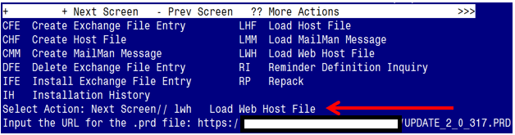

At the Select Action: prompt, enter LWH for Load Web Host File
At the Input the url for the .prd file: prompt, type the following web address:
https://REDACTED/docs/UPDATE_2_0_317.PRD
You should see a message at the top of your screen that the file successfully loaded.

Search for and locate the reminder exchange entry titled UPDATE_2_0_317 VA-CAREGIVER TEMPLATE UPDATES

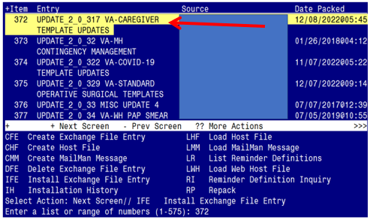

At the Select Action prompt, enter IFE for Install Exchange File Entry
Enter the number that corresponds with your entry titled UPDATE_2_0_317 VA-CAREGIVER TEMPLATE UPDATES (in this example it is entry 372, it will vary by site). The exchange file date should be 12/08/2022@05:45.

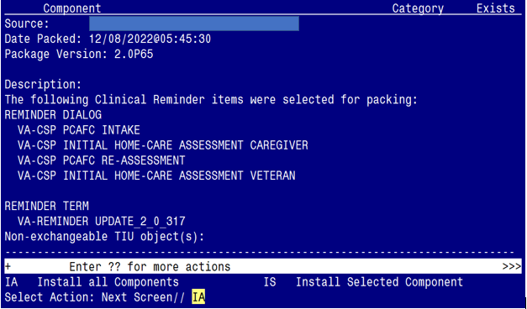

At the Select Action prompt, type IA for Install all Components and hit enter.
Select Action: Next Screen// IA Install all Components

You will see several prompts:
1 - For all new components, choose I to Install
2 - For existing components, choose O to Overwrite.
You will be promped to install the 1st dialog component:

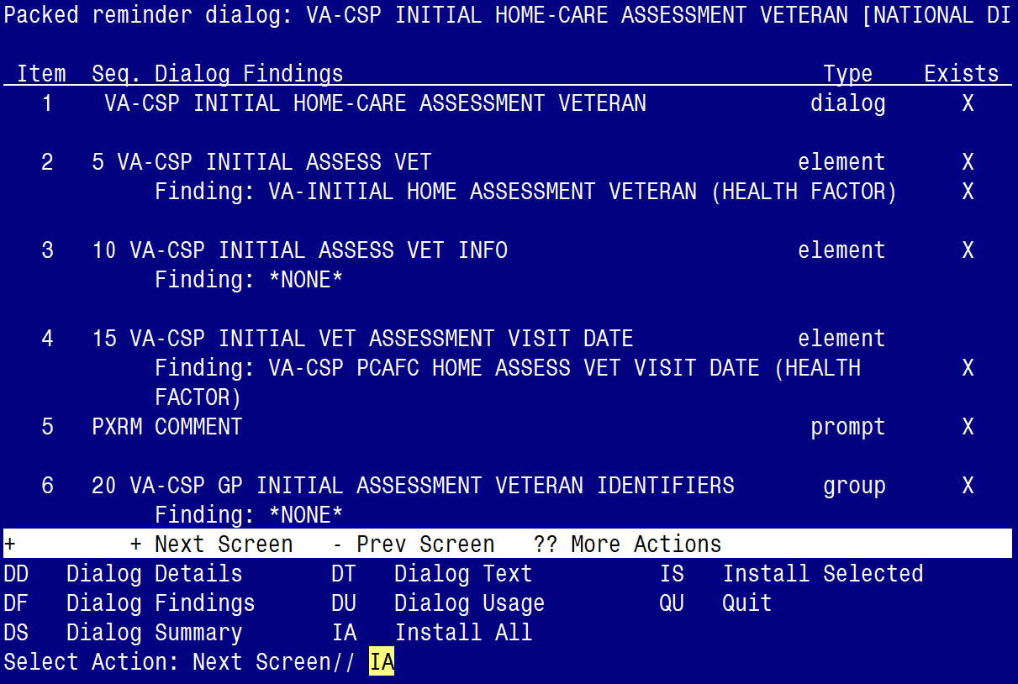

At the Select Action prompt, type IA to install the dialog:
VA-CSP INITIAL HOME-CARE ASSESSMENT VETERAN
Select Action: Next Screen// IA Install All
Install reminder dialog and all components with no further changes: Y// ES

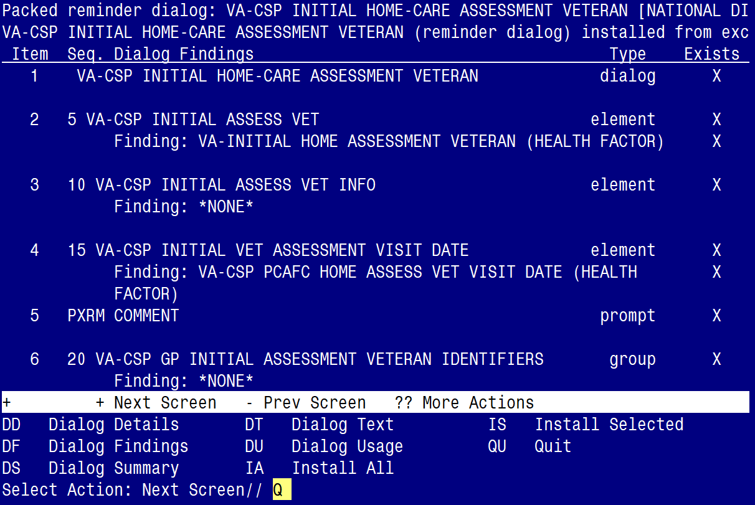

When the dialog has completed installation, you will then be returned to this screen. At the Select Action prompt, type Q.
You will be promped to install the 2nd dialog component:

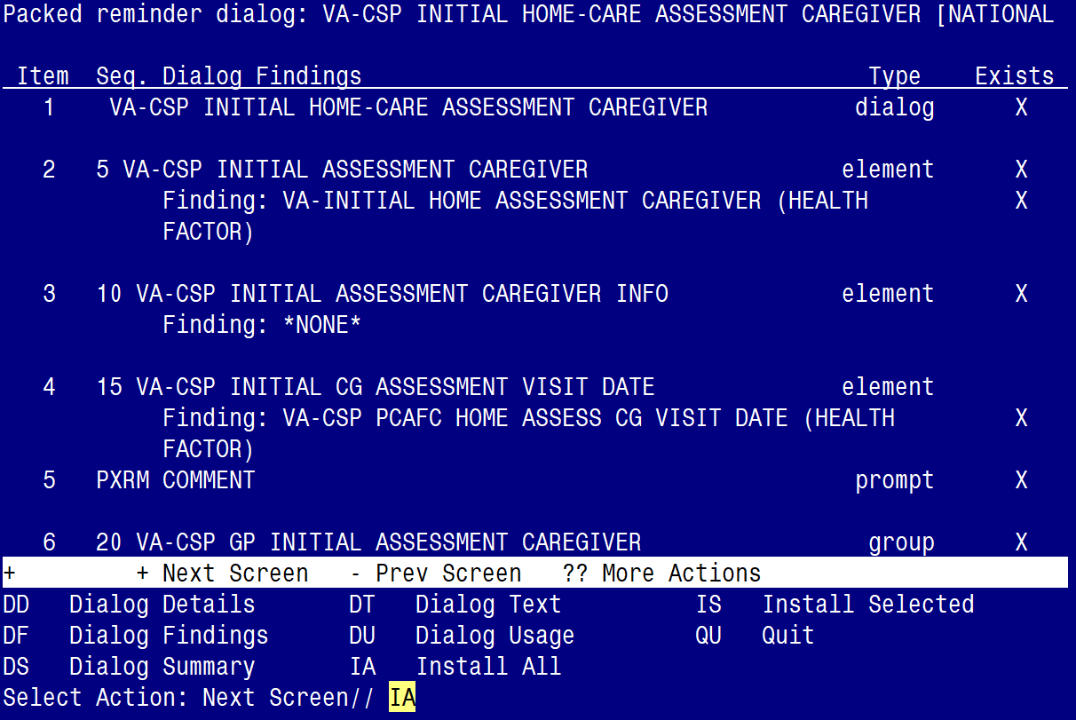

At the Select Action prompt, type IA to install the dialog:
VA-CSP INITIAL HOME-CARE ASSESSMENT CAREGIVER
Select Action: Next Screen// IA Install All
Install reminder dialog and all components with no further changes: Y// ES

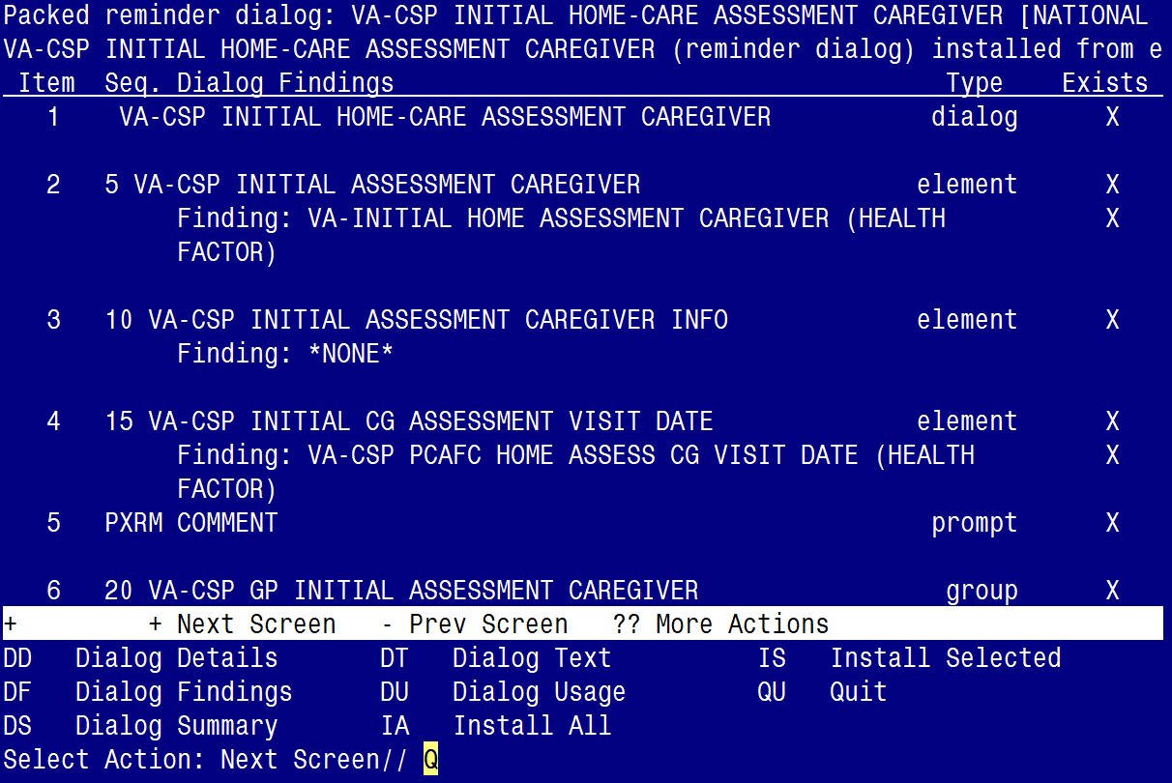

When the dialog has completed installation, you will then be returned to this screen. At the Select Action prompt, type Q.
You will be promped to install the 3rd dialog component:

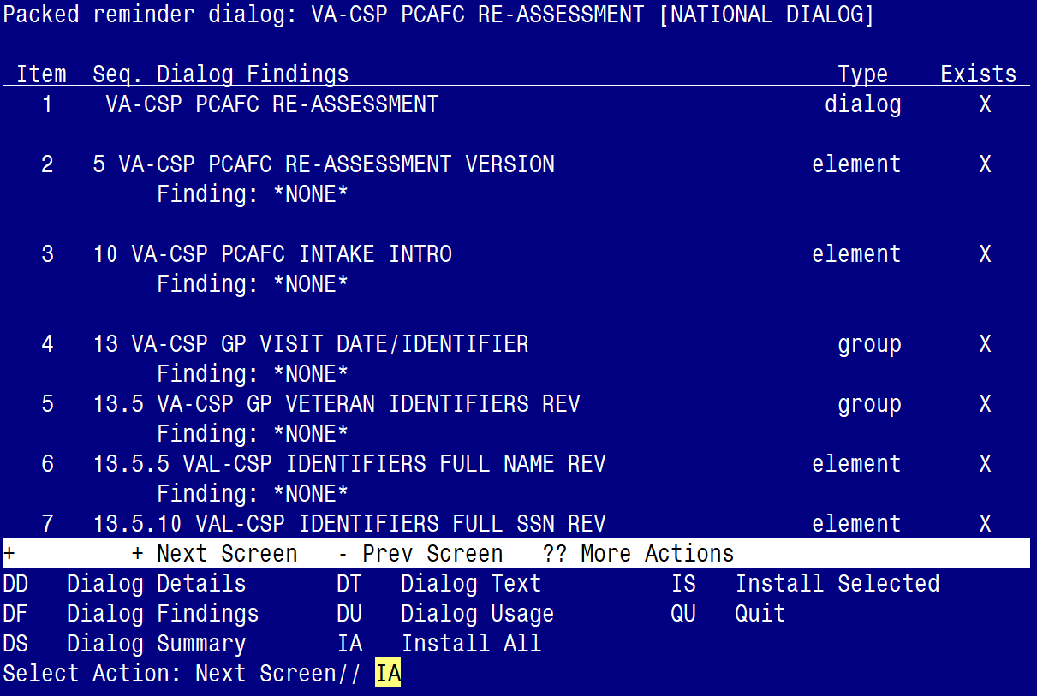

At the Select Action prompt, type IA to install the dialog:
VA-CSP PCAFC RE-ASSESSMENT
Select Action: Next Screen// IA Install All
Install reminder dialog and all components with no further changes: Y// ES

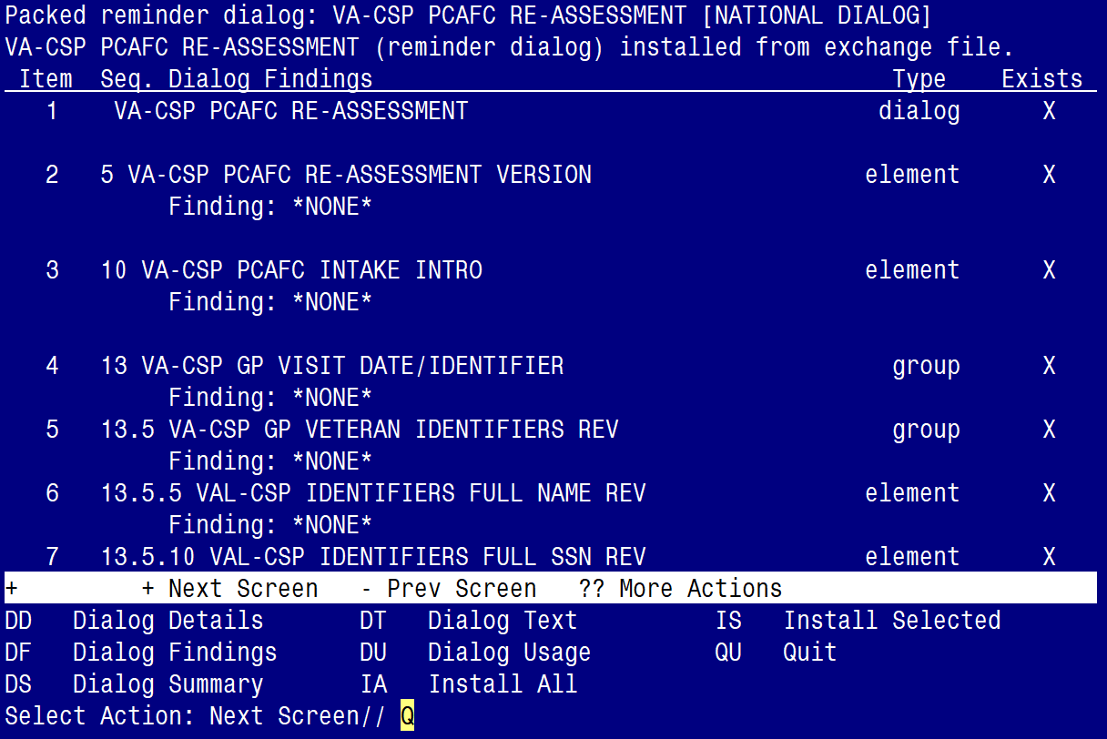

When the dialog has completed installation, you will then be returned to this screen. At the Select Action prompt, type Q.
You will be promped to install the 4th dialog component:

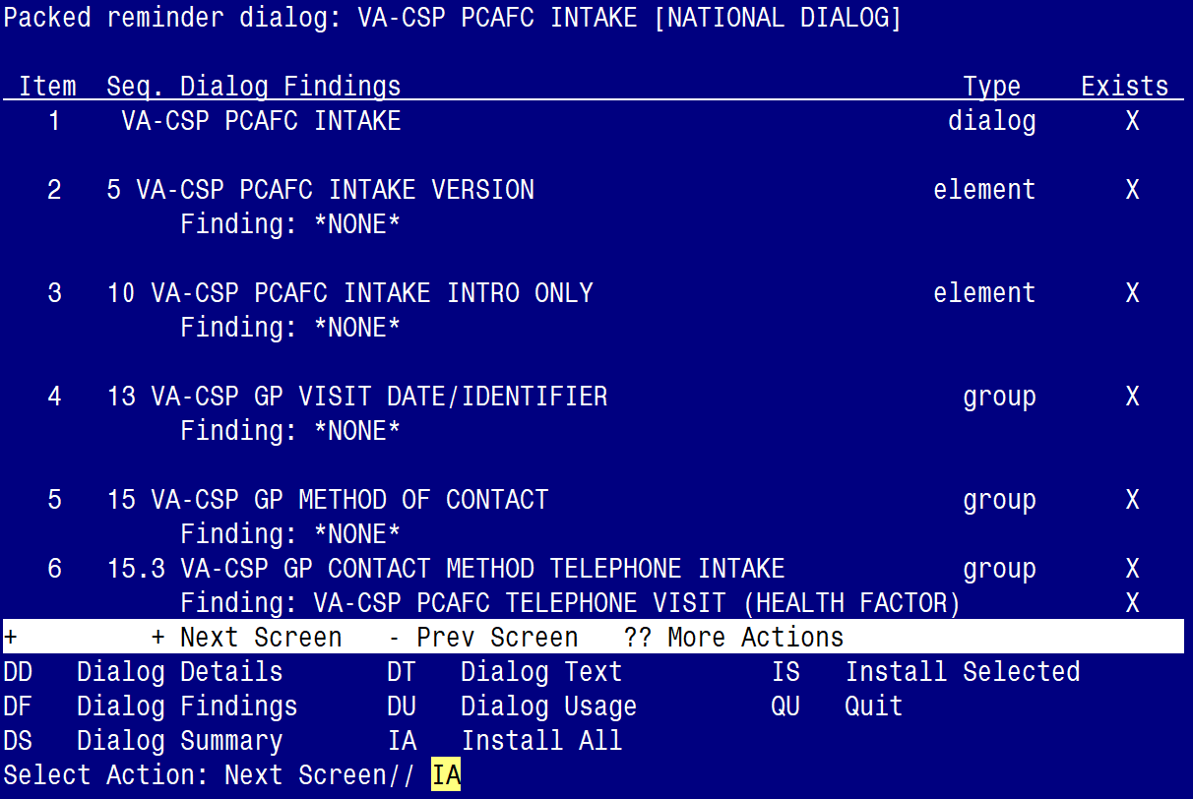

At the Select Action prompt, type IA to install the dialog:
VA-CSP PCAFC INTAKE
Select Action: Next Screen// IA Install All
Install reminder dialog and all components with no further changes: Y// ES

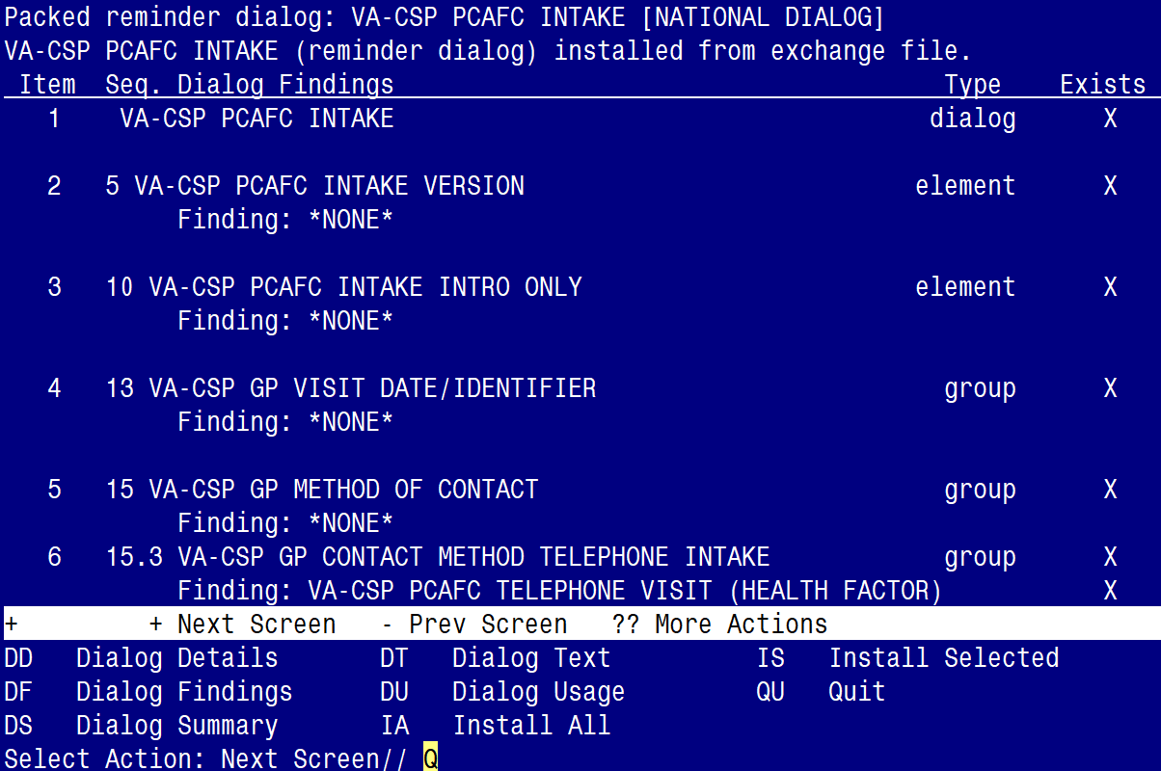

When the dialog has completed installation, you will then be returned to this screen. At the Select Action prompt, type Q.

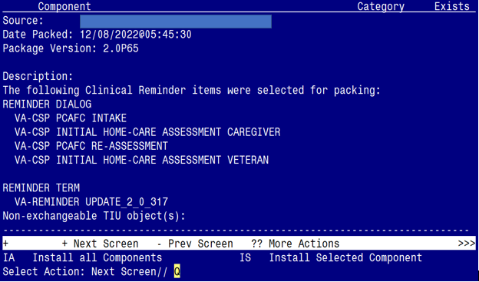

You will be returned to this screen. Type Q to quit.

Install Completed

Post Installation

- Add your facility’s data object for veteran address and veteran phone number to the dialog text in the following ELEMENTS:

Element: VAL-CSP INITIAL ASSESSMENT CAREGIVER ADDRESS/PHONE
Address: ***insert data object for patient address***
Phone number: ***insert data object for patient phone***

Element: VAL-TH VVC TELEPHONE TRIAGE CONTACT PHONE OBJECT
*PHONE OBJECT HERE*

Element: VAL-TH VVC TELEPHONE TRIAGE PATIENT LOCATION HOME
Home *PATIENT ADDRESS OBJECT HERE*

Element: VAL-CSP PCAFC VETERAN NAME/SSN
Veteran address: NEED OBJECT
Veteran phone #: NEED OBJECT

- Confirm the highlighted data objects are present in the dialog text for the following ELEMENTS: (add them, if not)

Element: VA-CSP HOME-CARE ASSESSMENT CG IDENTIFIERS
Full name: |PATIENT NAME|
Date of birth: |PATIENT DATE OF BIRTH|

Element: VA-CSP HOME-CARE ASSESSMENT VET IDENTIFIERS
Full name: |PATIENT NAME|
Date of birth: |PATIENT DATE OF BIRTH|

Element: VAL-CSP IDENTIFIERS FULL NAME REV
Full name: |PATIENT NAME|

Element: VAL-CSP IDENTIFIERS FULL SSN REV
Full SSN: |PATIENT SSN|

Element: VAL-CSP IDENTIFIERS DOB REV
Date of birth: |PATIENT DATE OF BIRTH|

- Download the Consult Reason-for-Request TXML file for the following consult service:

CSP PCAFC CENTRALIZED ELIGIBILITY AND APPEALS TEAM OUTPT

Follow the instructions below to update the Consult Reason for Request in CPRS.

Download the TXML file from here > REDACTED

- Select the three ellipses next to the name “CSP CEAT Reason for Request” and then select the three ellipses next to the word “FOLLOW”

SCREEN SHOT REDACTED

- Select “Download”

SCREEN SHOT REDACTED

- Select “Save as”
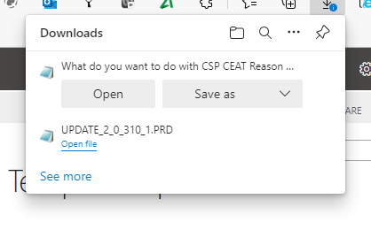

- Choose a location to save the TXML file. (In this example it was saved to the desktop)
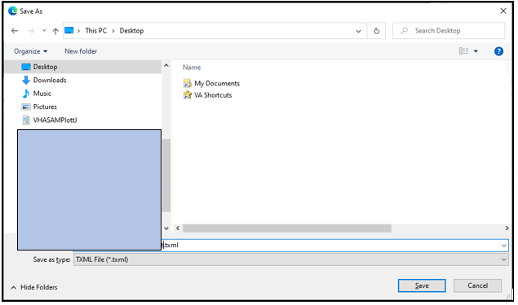
- In CPRS, select the NOTES tab > then OPTIONS > then Edit Shared Templates. Locate the Consult Reasons For Request folder and then locate the Consult titled:

CSP PCAFC CENTRALIZED ELIGIBILITY AND APPEALS TEAM OUTPT
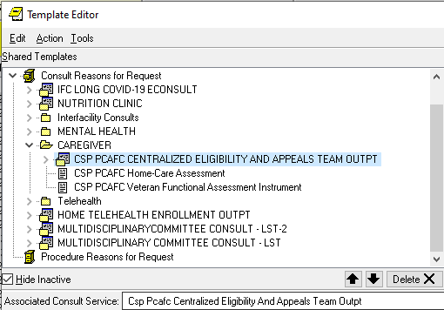
- Disassociate (remove) the ‘Associated Consult Service’ so it can be re-associated after importing the updated Reason for Request TXML file (see next step below)

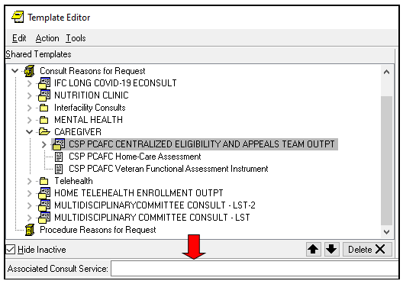

- Import the CEAT Consult Reason for Request TXML file that you previously downloaded and saved.

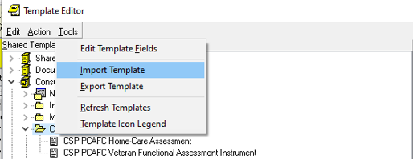

In the ‘Associated Consult Service’ field enter the CSP PCAFC CENTRALIZED ELIGIBILITY AND APPEALS TEAM OUTPT consult service to associate the consult service name to the newly imported TXML file.

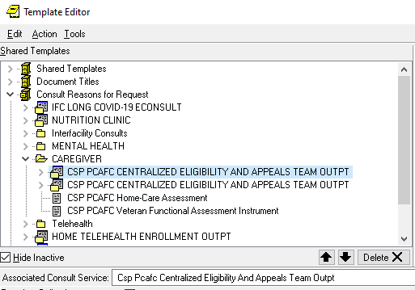

- If you choose to do so, you can mark the ‘old’ TXML file as inactive. To do so, highlight the ‘old’ the file and mouse-click the check box in the ‘Active’ field
