Update _2_0_321

Clinical Reminders

TERATOGENIC MEDICATIONS UPDATE 2022_03

Install Guide

December 2022

Product Development
Office of Information Technology
Department of Veterans Affairs

Table of Contents
Introduction 1
Install Details 2
Pre-Installation 4
Installation 4
Install Example 5
Post-Install Set-up Instructions 8

Introduction

UPDATE_2_0_321 contains 1 Reminder Exchange entry: UPDATE_2_0_321 VA-TERATOGENIC MEDS ORDER CHECKSUPDATE 2022_03

The Teratogenic Medications Order Check Interim Solution was originally released as VistA patch PXRM*2*22 in July 2012. The interim solution is intended to have regular updates for clinical content, primarily to add newly approved medications that have a noted risk during pregnancy and that warrant an order check. This update, UPDATE_2_0_321 represents the third update in 2022.

- Drugs added to the pregnancy order checks and lactation level 1 order check are the result of routine review and update from First Databank for new medications that have a risk to the fetus or breastfeeding child.
- Lamotrigine has been removed from the order check as it is associated with the lowest risk of congenital malformations among the antiepileptic drug class.

Below are the changes:
- Reminder order check group VA-WH HIRISK MEDICATIONS (LACTATION LEVEL 1) GROUP updated.

The following DG (Drug Generic) findings were added to the ORDER CHECK ITEM LIST:
ABROCITINIB
AMOXICILLIN/CLARITHROMYCIN/VONOPRAZAN
AMOXICILLIN/VONOPRAZAN
BRINCIDOFOVIR
FLORTAUCIPIR F-18
LEVOKETOCONAZOLE
OTESECONAZOLE
PACRITINIB
TEBENTAFUSP-TEBN
TECOVIRIMAT

- Reminder order check groups updated:
VA-WH HIRISK MEDICATIONS (MOD/HIGH RISK DURING PREGNANCY) GROUP
VA-WH HIRISK MEDICATIONS (MODERATE/HIGH RISK) GROUP
The following DG (Drug Generic) findings were added to the ORDER CHECK ITEM LIST:
BRINCIDOFOVIR
LONAFARNIB
OTESECONAZOLE

The following DG (Drug Generic) findings were removed from the ORDER CHECK ITEM LIST:
LAMOTRIGINE
- The reminder order check VA-NALOXONE FOR OPIOID USE DISORDER was updated to shorten the Display Name. The updated display name is: NALOXONE RECOMMENDED FOR OPIOID OR STIMULANT USE DISORDER

- The reminder dialog VA-WH TERATOGENIC EDUCATION was updated so that if it is opened on a patient with birth sex male, it will not display the options to document counseling.
  - If opened on a female patient, it will look like this with the appropriate options already checked (the only change is the version number):
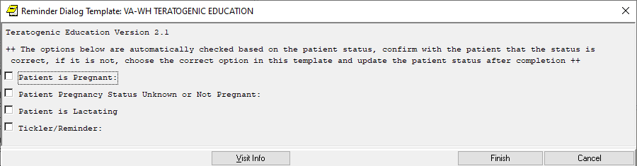

  - If opened on a male patient, it will look like this (new/updated):
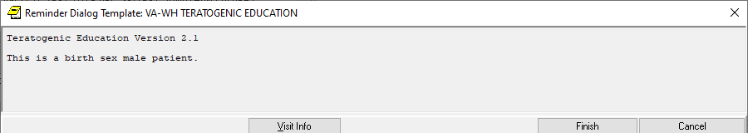

Install Details

This update is being distributed as a web host file. The address for the host file is: https://REDACTED/UPDATE_2_0_321.PRD

The following reminder content is included in this UPDATE:

REMINDER GENERAL FINDINGS
TICKLER REMINDER COMMENT
TICKLER REMINDER

HEALTH FACTORS
WH PAP SMEAR [C]
WH HYSTERECTOMY W/CERVIX REMOVED
VA-REMINDER UPDATES [C]
VA-UPDATE_2_0_321
VA-WH MEDICATION REVIEW [C]
VA-WH MED REVIEW HARMFUL MEDS COUNSELING COMPLETED
VA-WH MED REVIEW HARMFUL MEDS COUNSELING BY ANOTHER

REMINDER SPONSOR
OFFICE OF MENTAL HEALTH SERVICES
WOMEN VETERANS HEALTH PROGRAM
OFFICE OF NURSING INFORMATICS
VHA NATIONAL CENTER FOR HEALTH PROMOTION AND DISEASE PREVENTION (NCP) AND VHA OFFICE OF WOMEN'S HEALTH

REMINDER TAXONOMY
VA-OUD ALL SOURCES
VA-STIMULANT USE DISORDER ALL SOURCES
VA-WH TUBAL REANASTOMOSIS (TAXONOMY)
VA-WH TUBAL LIGATION CODES (TAXONOMY)
VA-WH HYSTERECTOMY W/CERVIX REMOVED
VA-WH TERATOGENIC MEDICATIONS EXCLUSIONS TAXONOMY

REMINDER TERM
VA-NALOXONE PRESCRIPTION ON FILE
VA-OUD STIMULANT USE DISORDER REMINDER TERM
VA-WH TUBAL REANASTOMOSIS (TERM)
VA-WH TUBAL LIGATION CODES (TERM)
VA-WH HIRISK LACTATING EXPIRED DOC
VA-WH HIRISK LACTATING CURRENT DOC
VA-REMINDER UPDATE_2_0_321
VA-SEX MALE
VA-BL LACTATING PATIENT
VA-BL PREGNANT PATIENT

REMINDER DEFINITION
VA-NALOXONE ORDER CHECK
VA-WH HIRISK ORDER CHECK - PREGNANT
VA-WH HIRISK ORDER CHECK - NO PREG DOC
VA-WH MEDICALLY UNABLE TO CONCEIVE
VA-WH HIRISK ORDER CHECK - NOT PREGNANT
VA-WH UPDATE LACTATION STATUS
VA-WH HIRISK ORDER CHECK - LACTATING
VA-WH BL POTENTIALLY UNSAFE ORDERS
VA-WH BL POTENTIALLY TERATOGENIC ORDERS

REMINDER ORDER CHECK RULES
VA-NALOXONE FOR OPIOID USE DISORDER
VA-WH HIRISK MEDS (MODERATE/HIGH RISK) NO PREG DOC RULE
VA-WH HIRISK MEDS (MODERATE/HIGH RISK) NOT PREG RULE
VA-WH HIRISK MEDS (MODERATE/HIGH RISK) PREG RULE
VA-WH HIRISK MEDS (LACT 1) EXPIRED DOC RULE
VA-WH HIRISK MEDS (LACT 1) RULE

REMINDER ORDER CHECK ITEMS GROUP
VA-WH HIRISK MEDICATIONS (MODERATE/HIGH RISK) GROUP
VA-WH HIRISK MEDICATIONS (MOD/HIGH RISK DURING PREGNANCY) GROUP
VA-WH HIRISK MEDICATIONS (LACTATION LEVEL 1) GROUP

REMINDER DIALOG
VA-WH TERATOGENIC EDUCATION

Pre-Installation
Prior to installing this Update:

- Using the VistA menu, ROC Reminder Order Check Menu , RI Reminder Order Check Rule Inquiry, review the STATUS of the reminder order check VA-NALOXONE FOR OPIOID USE DISORDER.

If your site is using this reminder order check and the status is PROD, you will need to put this back into PROD mode after install.

- Clinical Reminder Update_2_0_284 Teratogenic Medications Update 2022_02 should be installed before installing this update. Review the install history in reminder exchange to confirm that you have installed.

The Install Guide is available at the following link: REDACTED as this is an internal VA site.

Installation:
This update can be loaded with users on the system. Installation will take less than five minutes.
The file will be installed using Reminder Exchange, programmer access is not required.

Install Example

To Load the Web Host File. Navigate to Reminder exchange in Vista
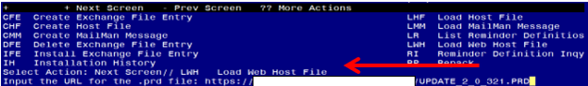
At the Select Action: prompt, enter LWH for Load Web Host File
At the Input the url for the .prd file: prompt, type the following web address:
https://REDACTED /UPDATE_2_0_321.PRD

You should see a message at the top of your screen that the file successfully loaded.
Navigate to the exchange entry named UPDATE_2_0_321 VA-TERATOGENIC MEDS ORDER CHECKSUPDATE 2022_03
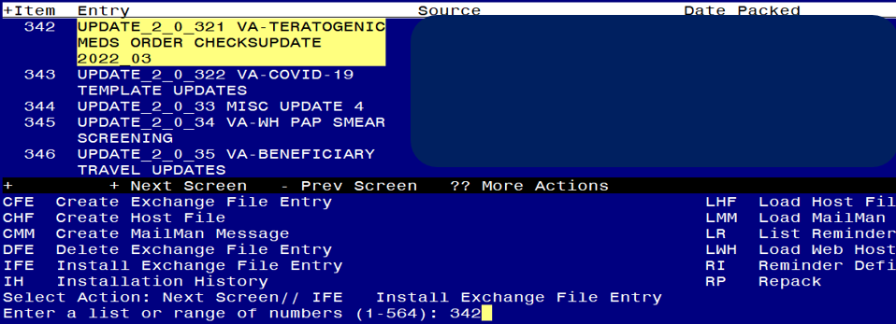
At the Select Action prompt, enter IFE for Install Exchange File Entry
Enter the number that corresponds with your entry UPDATE_2_0_321 VA-TERATOGENIC MEDS ORDER CHECKS UPDATE 2022_03 (in this example it is entry 342, it will vary by site, The exchange date should be 11/18/2022).

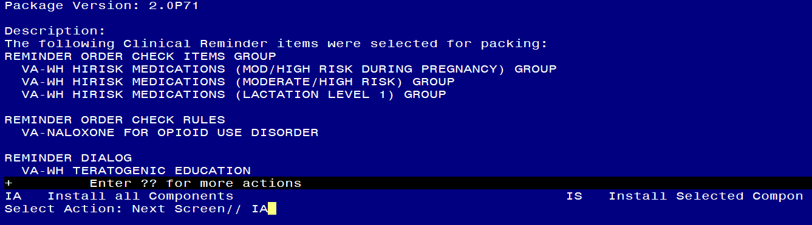
At the Select Action prompt, type IA for Install all Components and hit enter.
Any items that are NEW in any categories, you should INSTALL
If you are prompted to overwrite any reminder general findings, you should choose SKIP – you will install the new ones
If you are prompted to overwrite any health factors, you should choose SKIP - You will install the new ones
If you are prompted to overwrite any reminder sponsor, you should choose SKIP
If you are prompted to overwrite any reminder taxonomies, you should choose SKIP
If you are prompted to overwrite any reminder terms, you should choose SKIP – You will install the new terms
If you are prompted to overwrite any reminder definitions, you should choose SKIP
If you are prompted to overwrite any REMINDER ORDER CHECK RULES, you will OVERWRITE ONLY the reminder order check rule VA-NALOXONE FOR OPIOID USE DISORDER, if prompted to overwrite any of the others, choose SKIP.
If you are prompted to overwrite any REMINDER ORDER CHECK ITEMS GROUP, you should choose Overwrite
** In your test account, when overwriting the reminder order check groups, some drugs (DG findings) may not exist, choose Delete if prompted to replace an entry**

You will be prompted to install the reminder dialog component VA-WH TERATOGENIC EDUCATION.
- You will choose to install all even though the components have an X to indicate that they exist.
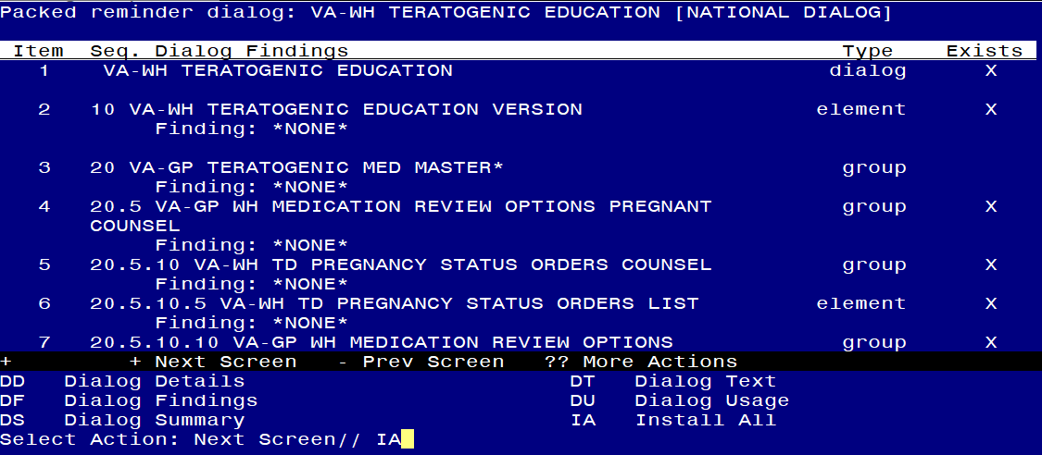
Select Action: Next Screen// IA Install All
Install reminder dialog and all components with no further changes: Y// Yes
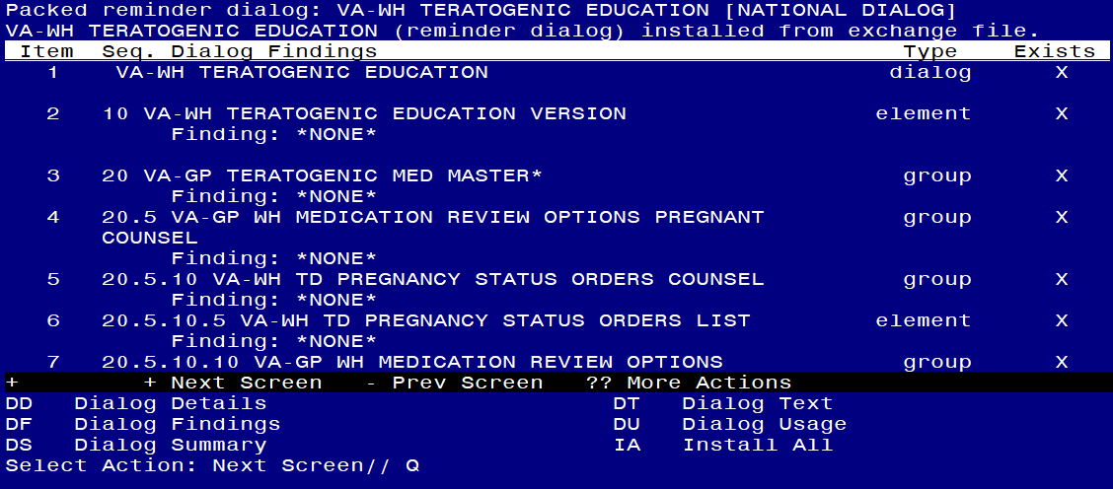
Select Action: Next Screen// Q

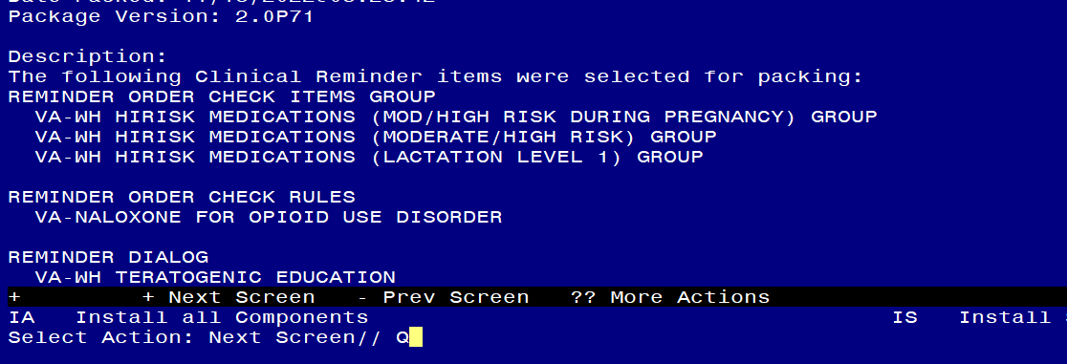
You will then be returned to this screen. At the Select Action prompt, type Q.

Install Complete

Post-Install Set-up Instructions

- Activate the Reminder Order Check Rule (if needed)
If the pre-install status of the reminder order check rule VA-NALOXONE FOR OPIOID USE DISORDER was set to PRODUCTION, you may need to update the order check rule after installation and set it back to PRODUCTION.

The option represented here is Add/Edit Reminder Order Check Rule [PXRM ORDER CHECK RULE EDIT].
Select Reminder Order Check Menu <TEST ACCOUNT> Option: RE Add/Edit Reminder Order Check Rule
Select Reminder Order Check Rule by one of the following:

N: ORDER CHECK RULE NAME
R: REMINDER DEFINITION
T: REMINDER TERM
Q: QUIT
Select Reminder Order Check Rule by: (N/R/T/Q): N// <ENTER>
Select Reminder Order Check Rule: VA-NALOXONE FOR OPIOID USE DISORDER
RULE NAME: VA-NALOXONE FOR OPIOID USE DISORDER
DISPLAY NAME: NALOXONE RECOMMENDED FOR OPIOID OR STIMULANT USE DISORDER
STATUS: PROD
SEVERITY: MEDIUM
CLASS: NATIONAL
SPONSOR: WOMEN VETERANS HEALTH PROGRAM
REVIEW DATE:
_____________________________________________________________
I=INACTIVE, P=PRODUCTION, T=TESTING

- Confirm the WH order check rules listed below are in PROD status and if they are not, update them using the Vista Menu Add/Edit Reminder Order Check Rule [PXRM ORDER CHECK RULE EDIT].
VA-WH HIRISK MEDS (MODERATE/HIGH RISK) NO PREG DOC RULE
VA-WH HIRISK MEDS (MODERATE/HIGH RISK) NOT PREG RULE
VA-WH HIRISK MEDS (MODERATE/HIGH RISK) PREG RULE
VA-WH HIRISK MEDS (LACT 1) EXPIRED DOC RULE
VA-WH HIRISK MEDS (LACT 1) RULE

