Update_2_0_325

Clinical Reminders

VA-MHRRTP DIALOG UPDATE

INSTALLATION and SETUP GUIDE

January 2023

Product Development
Department of Veterans Affairs

Contents

Introduction 3
Pre-Install 10
Install Details 10
Install Example 10
Post-Install 15

Introduction

The Mental Health Residential Rehabilitation Treatment Program (MH RRTP) Screening, Status Update, and Discharge Templates were developed by the Veterans Health Administration Office of Mental Health and Suicide Prevention in collaboration with MH RRTP managers from several VISNs, VISN and facility mental health leadership, and other subject-matter-experts. The dialogs were first released in July 2018 in Update_2_0_44 and updated in November 2020 in Update 2_0_104. This update includes several revisions to each of the three dialogs.

The templates were designed to address the need for critical information at the time of screening, while waiting for admission (Status Update), and at the time of discharge. The purpose of the three templates is to use national health factors to capture local data to improve the ability of programs to more accurately track wait times and provide local outcome data.

The three templates are brief and designed to be integrated into existing, local processes for documentation. The templates do not reflect the full scope of typical documentation for screening, discharge and clinical encounters with the hope that this will maximize flexibility in local implementation.

Programs are not required to use a standard note template. Programs are strongly encouraged to integrate the templates into existing documentation processes so accurate and reliable data will be available to the programs.

This update will update the following reminder content:

TIU TEMPLATE FIELD
BLANK SPACE1
DATE (REQ)
VA-MHRRTP EDIT

HEALTH FACTORS
VA-UPDATE_2_0_325
VA-MH-RRTP [C]
VA-MH-RRTP DC DECEASED
VA-MH-RRTP ADDL SVC NONE
VA-MH-RRTP ADDL SVC OTHER
VA-MH-RRTP ADDL SVC CHAPLAIN
VA-MH-RRTP ADDL SVC PEER SUPPORT
VA-MH-RRTP ADDL SVC INTEG DUAL DX
VA-MH-RRTP ADDL SVC NUTRITION
VA-MH-RRTP ADDL SVC WHOLE HEALTH
VA-MH-RRTP ADDL SVC FAMILY COUNSEL
VA-MH-RRTP ADDL SVC MUTUAL SUPPORT
VA-MH-RRTP ADDL SVC NON-VA VOC SVC
VA-MH-RRTP ADDL SVC VA VOC SVC
VA-MH-RRTP ADDL SVC CWT SUPP EDU
VA-MH-RRTP ADDL SVC CWT TW
VA-MH-RRTP ADDL SVC CWT SUPP EMP
VA-MH-RRTP ADDL SVC OCC THERAPY
VA-MH-RRTP ADDL SVC KINESIOTHERAPY
VA-MH-RRTP ADDL SVC REC THERAPY
VA-MH-RRTP ADDL SVC PSYCHOTHERAPY
VA-MH-RRTP EBP OTHER
VA-MH-RRTP EBP WET
VA-MH-RRTP EBP 12 STEP
VA-MH-RRTP EBP SIT
VA-MH-RRTP EBP SOCIAL SKILLS
VA-MH-RRTP EBP PE
VA-MH-RRTP EBP PST
VA-MH-RRTP EBP PCT
VA-MH-RRTP EBP NET
VA-MH-RRTP EBP MET
VA-MH-RRTP EBP MBCT
VA-MH-RRTP EBP IPT
VA-MH-RRTP EBP EMDR
VA-MH-RRTP EBP DBT
VA-MH-RRTP EBP CM SUD
VA-MH-RRTP EBP CPT GROUP
VA-MH-RRTP EBP CPT IND
VA-MH-RRTP EBP CBSG SUD
VA-MH-RRTP EBP CBT SP
VA-MH-RRTP EBP CBT SUD
VA-MH-RRTP EBP CBT DEPRESSION
VA-MH-RRTP EBP CBT PAIN
VA-MH-RRTP EBP ASPI
VA-MH-RRTP EBP ACT
VA-MH-RRTP PTSD CC OTHER
VA-MH-RRTP PTSD CC NONVA RRTP
VA-MH-RRTP PTSD CC NONVA INPT
VA-MH-RRTP PTSD CC NONVA OUTPT
VA-MH-RRTP PTSD CC VET CENT
VA-MH-RRTP PTSD CC VA
VA-MH-RRTP VET DECLINED MH F/U APPT
VA-MH-RRTP LEFT DID NOT SPEAK TO STAFF
VA-MH-RRTP LEFT F/U APPT SCH W/IN 24 HRS
VA-MH-RRTP MHTC UNKNOWN
VA-MH-RRTP MHTC NOTIFIED D/C
VA-MH-RRTP PTSD NO TX
VA-MH-RRTP PTSD NON-MASD NO
VA-MH-RRTP PTSD NO EBP NOTAVAIL
VA-MH-RRTP PTSD NO EBP NOTAPPRO
VA-MH-RRTP PTSD NO EBP VET DECLIN
VA-MH-RRTP PTSD NO EBP ALR COMP
VA-MH-RRTP PTSD NO EBP
VA-MH-RRTP PTSD EBP SESS NUM PARTIAL
VA-MH-RRTP PTSD EBP PARTIAL TEXT
VA-MH-RRTP PTSD EBP PARTIAL
VA-MH-RRTP PTSD EBP OTHER
VA-MH-RRTP PTSD EBP EXP
VA-MH-RRTP PTSD EBP TFCBT
VA-MH-RRTP PTSD EBP EMDR
VA-MH-RRTP PTSD EBP PE
VA-MH-RRTP PTSD EBP CPT GRP
VA-MH-RRTP PTSD EBP CPT IND
VA-MH-RRTP PTSD EBP SESS NUM
VA-MH-RRTP PTSD EBP COMPLETE
VA-MH-RRTP PTSD MASD NO
VA-MH-RRTP PTSD MASD ADDITIONAL NO
VA-MH-RRTP PTSD MASD ADDITIONAL YES
VA-MH-RRTP PTSD MASD SESSIONS
VA-MH-RRTP PTSD MASD DAYS
VA-MH-RRTP PTSD MASD STARTED
VA-MH-RRTP PTSD MASD TRANSFER
VA-MH-RRTP PTSD MASD COMPLETE
VA-MH-RRTP PTSD TX ANY
VA-MH-RRTP DCEMP UNKNOWN
VA-MH-RRTP DCEMP VOLUNTEER
VA-MH-RRTP DCEMP STUDENT
VA-MH-RRTP DCEMP TRAIN
VA-MH-RRTP DCEMP CWT
VA-MH-RRTP DCEMP FULL
VA-MH-RRTP DCEMP PART
VA-MH-RRTP DCEMP UNEMPSEEK
VA-MH-RRTP DCEMP UNEMPNOT
VA-MH-RRTP DCEMP RETIRE
VA-MH-RRTP DCDISP FAMFRIENDS TEMP
VA-MH-RRTP DCDISP UNKNOWN
VA-MH-RRTP DCDISP INCARCERATE
VA-MH-RRTP DCDISP NOTHABIT
VA-MH-RRTP DCDISP SHELTER
VA-MH-RRTP DCDISP HOTEL
VA-MH-RRTP DCDISP LTC
VA-MH-RRTP DCDISP INPTMED
VA-MH-RRTP DCDISP INPTMH
VA-MH-RRTP DCDISP RRTP
VA-MH-RRTP DCDISP TRANSHOUSE
VA-MH-RRTP DCDISP FAMFRIENDS
VA-MH-RRTP DCDISP OWNHOUSE
VA-MH-RRTP DC OTHER RRTP
VA-MH-RRTP DC INCARCERATE
VA-MH-RRTP DC AMA
VA-MH-RRTP DC INCREASE
VA-MH-RRTP DC RULE OTHER
VA-MH-RRTP DC RULE USE
VA-MH-RRTP DC RULE THREAT
VA-MH-RRTP DC RULE
VA-MH-RRTP DC PARTIAL
VA-MH-RRTP DC COMPLETE
VA-MH-RRTP DC TRANSFER
VA-MH-RRTP DC DISCHARGE
VA-MH-RRTP DISCHARGE COUNT
HOMELESSNESS SCREENING [C]
VA-FOOD UNABLE TO ANSWER
VA-FOOD DECLINES SCREENING
NURSING HOME RESIDENT
VA-FOOD ALREADY RECEIVING ASSISTANCE
VA-HOMELESS FOOD SCREEN NOT PERFORMED
VA-MONEY TO BUY FOOD-NO CURRENT CONCERN
REFERRED TO DIETICIAN FOOD
REFERRED TO SOCIAL WORK FOOD
NO REFERRALS REQUESTED FOOD
VA-MONEY TO BUY FOOD-YES CURRENT CONCERN
VA-FOOD 12MO ACTUALLY RAN OUT SOMETIMES
VA-FOOD 12MO ACTUALLY RAN OUT OFTEN
VA-FOOD 12MO WORRY RUN OUT SOMETIMES
VA-FOOD 12MO WORRY RUN OUT OFTEN
VA-FOOD 12MO ACTUALLY RAN OUT NEVER
VA-HOMELESSNESS FOOD SHORTAGE YES
VA-FOOD 12MO WORRY RUN OUT NEVER
ALREADY RECEIVING ASSIST WITH HOUSING
UNABLE TO PERFORM HOMELESS SCREEN
DECLINES HOMELESS SCREEN
VA-HOMELESS SCREENING NOT PERFORMED
BEST WAY TO REACH
DECLINES HOMELESS REFERRAL
REFERRED TO HOMELESS PROGRAM
CURRENT LIVING [C]
LIVES OTHER
LIVES ON STREET
LIVES IN SHELTER
LIVES IN INSTITUTION
LIVES IN MOTEL/HOTEL
LIVES WITH FRIEND OR FAMILY
LIVES IN HOUSE WITH SUBSIDY
LIVES IN HOUSE NO SUBSIDY
POSITIVE - HAS NO STABLE HOUSING
NEGATIVE - HAS NO HOUSING CONCERNS
DECLINES SOCIAL WORK REFERRAL
REFERRED TO SOCIAL WORK
POSITIVE - HAS WORRIES ABOUT HOUSING
NEGATIVE - HAS STABLE HOUSING
VA-MH RRTP PRIORITY ADMIT NO
VA-MH RRTP PRIORITY ADMIT YES
VA-MH-RRTP SCREEN HOUSING HIGH RISK
VA-MH-RRTP SCREEN HOUSING HOMELESS
VA-MHRRTP SCREEN NO COVID
VA-MHRRTP SCREEN COVID SYMPTOMS
VA-MHRRTP SCREEN COVID CAPACITY
VA-SUICIDE RISK ASSESSMENT [C]
VA-SUICIDE RISK ACUTE LOW
VA-SUICIDE RISK ACUTE INTERMEDIATE
VA-SUICIDE RISK ACUTE HIGH
VA-SUICIDE RISK CHRONIC LOW
VA-SUICIDE RISK CHRONIC INTERMEDIATE
VA-SUICIDE RISK CHRONIC HIGH
VA-MH RRTP SCREEN NEW
VA-MH RRTP SCREEN TRANSFER
VA-MH RRTP SCREEN COUNT
VA-MH-RRTP PTSD MASD TRACK
VA-MH-RRTP SEPARATE DOM TRACK
VA-MH-RRTP OTHER TRACK
VA-MH-RRTP VOCATIONAL TRACK
VA-MH-RRTP PAIN TRACK
VA-MH-RRTP GAMBLING TRACK
VA-MH-RRTP TBI TRACK
VA-MH-RRTP WOMENS PROGRAM TRACK
VA-MH-RRTP MENS PROGRAM TRACK
VA-MH-RRTP SUD&SMI TRACK
VA-MH-RRTP SUD&PTSD TRACK
VA-MH-RRTP SERIOUS MENTAL ILLNESS TRACK
VA-MH-RRTP MST TRACK
VA-MH-RRTP PTSD TRACK
VA-MH-RRTP SUD TRACK
VA-MH-RRTP NO TRACKS
VA-MH-RRTP SCREEN ALT REFERRAL VA
VA-MH-RRTP SCREEN ALT REFERRAL CC
VA-MH RRTP SCREEN ALT REFERRAL
VA-MH-RRTP SCREEN DENY HOUSING ONLY
VA-MH-RRTP SCREEN DENY HARM
VA-MH-RRTP SCREEN DENY STABLE
VA-MH-RRTP SCREEN DENY LRALT
VA-MH-RRTP SCREEN DENY SELFCARE
VA-MH-RRTP SCREEN DENY PRESERV
VA-MH-RRTP SCREEN DENY INPT
VA-MH-RRTP SCREEN DENY MED
VA-MH RRTP SCREEN ADMIT NO
VA-MH-RRTP SCREEN VET DECLINE
VA-MH-RRTP SCREEN TRANSPORT OTHER
VA-MH-RRTP SCREEN TRANSPORT ASSIST
VA-MH-RRTP SCREEN TRANSPORT RIDESHARE
VA-MH-RRTP SCREEN TRANSPORT VA TRANSPORT
VA-MH-RRTP SCREEN TRANSPORT DRIVE
VA-MH-RRTP SCREEN 30D ALT NOT AVAIL
VA-MH-RRTP SCREEN ACCEPT ROUTINE SCHED
VA-MH-RRTP SCREEN 30D ALT DECLINE
VA-MH-RRTP SCREEN ACCEPT REQUIRE LATER
VA-MH-RRTP SCREEN ACCEPT PRI SCHED
VA-MH-RRTP SCREEN ACCEPT REQST LTR
VA-MH-RRTP SCREEN PRIORITY NOT SCHEDULED
VA-MH-RRTP SCREEN ACCEPT FIRST AVAIL
VA-MH-RRTP SCREEN ACCEPT ADMIT DATE
VA-MH-RRTP SCREEN ACCEPT
VA-MH-RRTP SCREEN HOUSING INCARCERATED
VA-MH-RRTP SCREEN HOUSING STABLE
VA-MH-RRTP SCREEN HOUSING UNSTABLE
VA-MH-RRTP REFTRRRTP
VA-MH-RRTP REFGENRRTP
VA-MH-RRTP REFDCHVRRTP
VA-MH-RRTP REFPTSDRRTP
VA-MH-RRTP REFSUDRRTP
VA-MH-RRTP STATUS ALREADY
VA-MH-RRTP UPDATE ALT REFERRAL
VA-MH-RRTP UPDATE ADMIT NO NOTAPPROP
VA-MH-RRTP UPDATE ADMIT NO VETLOST
VA-MH-RRTP UPDATE ADMIT NO VETREM
VA-MH-RRTP UPDATE ADMIT NO
VA-MH RRTP UPDATE PRIORITY NOT SCHEDULED
VA-MH RRTP UPDATE ACCEPT REQUIRE LATER
VA-MH-RRTP UPDATE ACCEPT REQST LTR
VA-MH RRTP UPDATE ACCEPT PRI SCHED
VA-MH-RRTP UPDATE ACCEPT FIRST AVAIL
VA-MH RRTP UPDATE PRIORITY ADMIT NO
VA-MH RRTP UPDATE PRIORITY ADMIT YES
VA-MH-RRTP UPDATE ADMIT
VA-MH-RRTP UPDATE COUNT

REMINDER SPONSOR
OFFICE OF MENTAL HEALTH SERVICES
MENTAL HEALTH SERVICES
HOMELESSNESS OFFICE
OFFICE OF MH AND SUICIDE PREVENTION

REMINDER COMPUTED FINDINGS
VA-IS INPATIENT
VA-ACTIVE PATIENT RECORD FLAGS
VA-PROGRESS NOTE

REMINDER LOCATION LIST
VA-HOMELESSNESS STOP CODES

REMINDER TERM
VA-BL FOOD INSECURITY POSITIVE
VA-HOMELESSNESS - ALREADY RECEIVING SERVICES
VA-REMINDER UPDATE_2_0_325

REMINDER DEFINITION
VA-OBJ MH RRTP OBJECT
VA-BL HIGH RISK FOR SUICIDE

HEALTH SUMMARY TYPE
VA-MH RRTP DATA OBJECT
VA-HOMELESS SCREENING 12MO
VA-CSSRS 24 HOURS
VA-CSRE RISK 24 HOURS
VA-BL HIGH RISK FOR SUICIDE

TIU DOCUMENT DEFINITION
VA-MH RRTP DATA OBJECT
VA-HOMELESS SCREENING 12MO
VA-C-SSRS LAST DAY
VA-CSRE RISK 24 HOURS
BL HIGH RISK FOR SUIC

REMINDER DIALOG
VA-MHRRTP STATUS UPDATE
VA-MHRRTP SCREENING
VA-MHRRTP DISCHARGE

Pre-Install

- Using the menu, Reminder Dialog Management, Reminder Dialogs, Change the view to element and complete an inquiry for the following elements for post-installation steps. The quick orders mapped to these elements will need to be remapped.
VA-OI HOMELESS REFERRAL
VA-OI SOCIAL WORK REFERRAL
VAL-OI SOCIAL WORK REFERRAL
VAL-OI DIETARY REFERRAL

- Using the menu options, Reminder Manager, Reminder Term Management, Inquire about Reminder Term, print an inquire into the Reminder Term VA-HOMELESSNESS - ALREADY RECEIVING SERVICES for reference post-install.

Install Details

This update is being distributed as a web host file. The address for the host file is:

https://REDACTED/UPDATE_2_0_325.PRD

The file will be installed using Reminder Exchange, programmer access is not required.
Installation:
=============
This update can be loaded with users on the system. Installation will take less than 15 minutes.

Install Example

To Load the Web Host File. Navigate to Reminder exchange in Vista
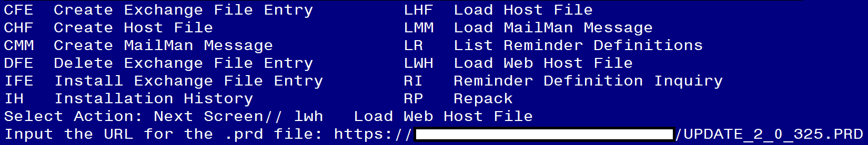

At the Select Action: prompt, enter LWH for Load Web Host File
At the Input the url for the .prd file: prompt, type or copy and paste the following web address:
https://REDACTED/UPDATE_2_0_325.PRD

You should see a message at the top of your screen that the file successfully loaded.

Search and locate the entry that begins with UPDATE_2_0_325 in reminder exchange.
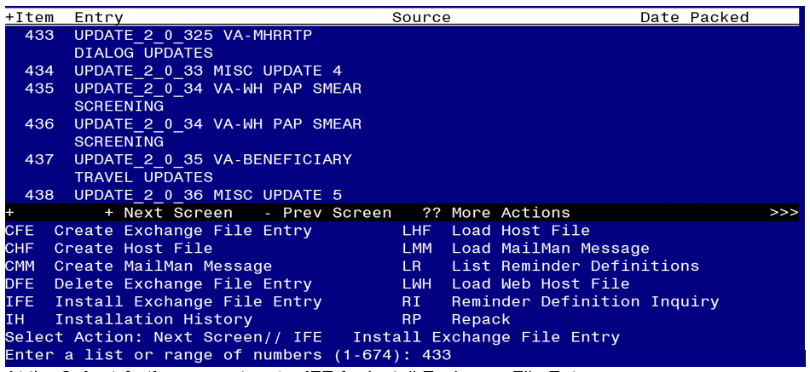
At the Select Action prompt, enter IFE for Install Exchange File Entry
Enter the number that corresponds with your entries titled UPDATE_2_0_325 VA-MHRRTP DIALOG UPDATES (in this example it is entry 433, it will vary by site). Make sure the entry has date/time 1/12/2023.
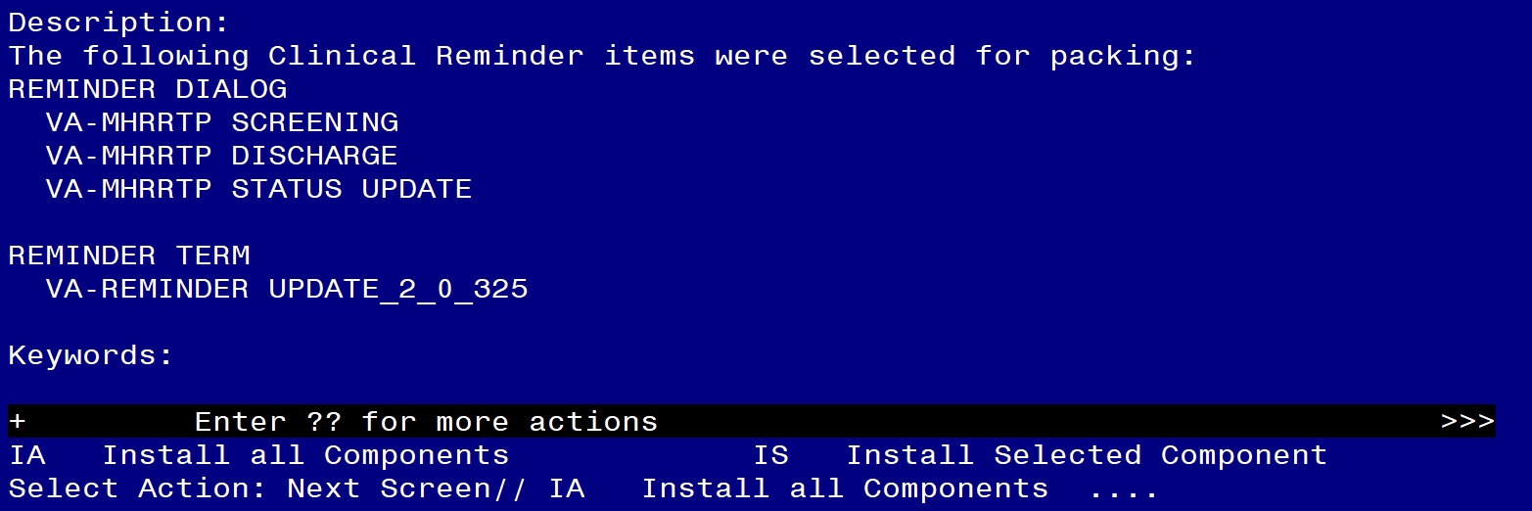
At the Select Action prompt, type IA for Install All Component and hit enter.

Any items that are NEW in any categories, you should INSTALL

If you are prompted to overwrite any health factors, you should choose Overwrite

If you are prompted to overwrite the health summary type and objects, you should choose Overwrite

If you are prompted to overwrite any other component, you should choose SKIP

There are three reminder dialogs included in this update, you will be promped three different times to install the dialog components

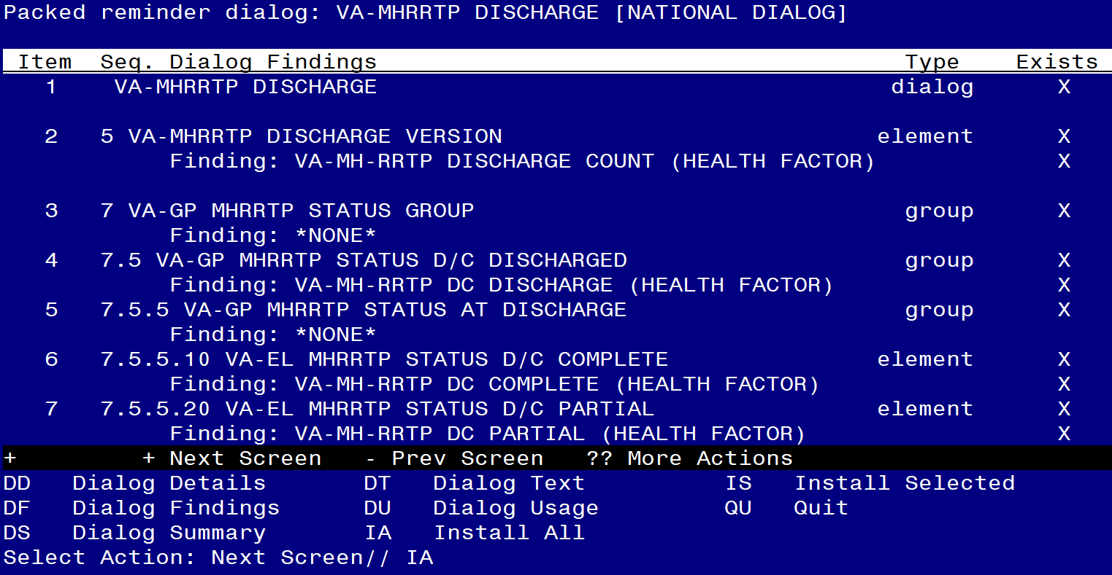

At the Select Action prompt, type IA to install the dialog VA-MHRRTP DISCHARGE
Select Action: Next Screen// IA Install All
Install reminder dialog and all components with no further changes: YES

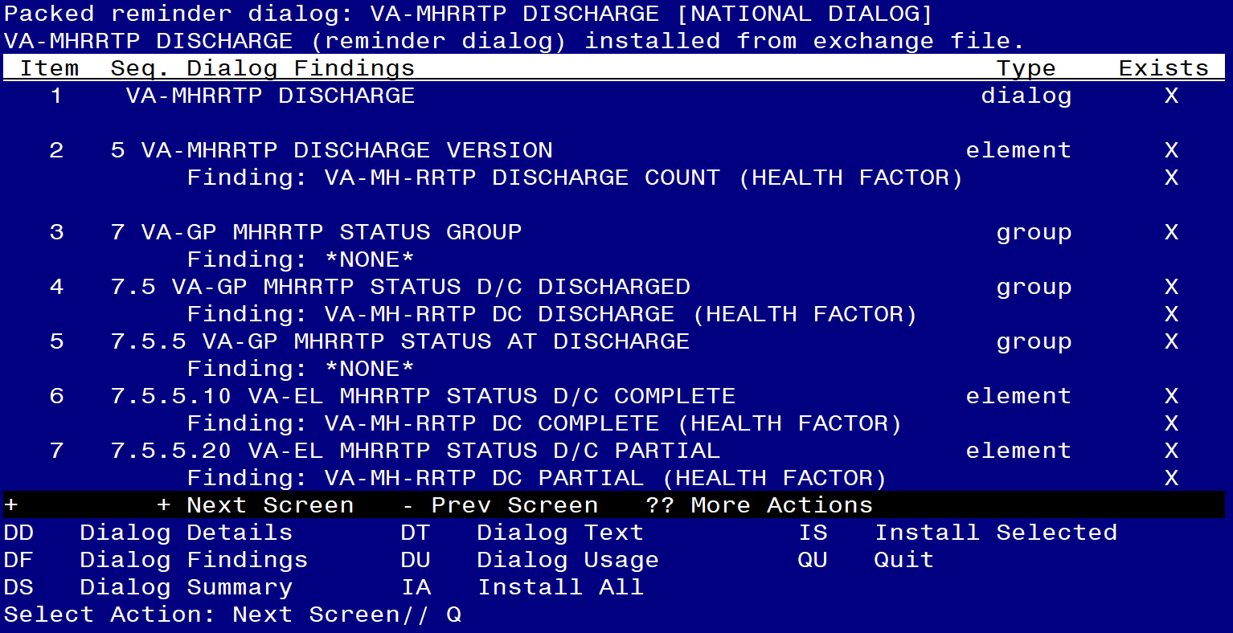

After completing this dialog install, you will type Q to move to the next dialog to install

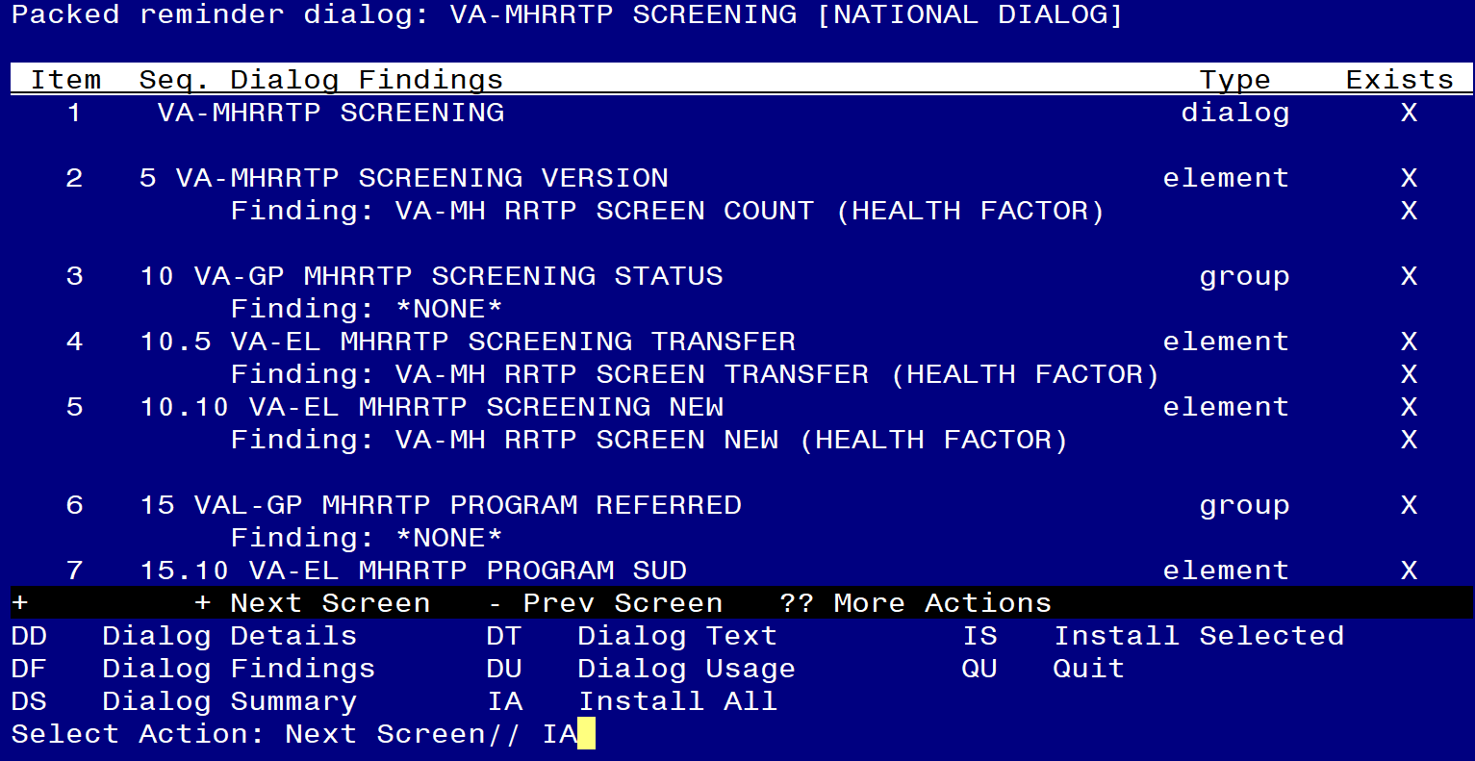

At the Select Action prompt, type IA to install the dialog VA-MHRRTP SCREENING
Select Action: Next Screen// IA Install All
Install reminder dialog and all components with no further changes: YES

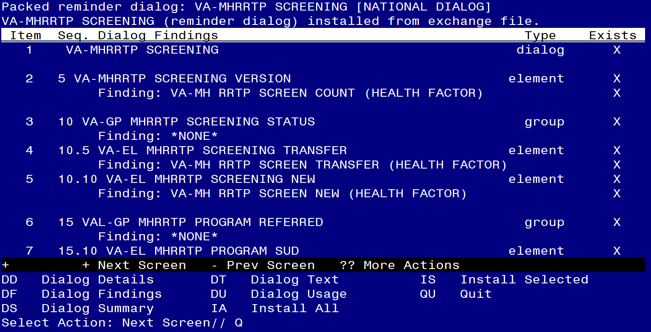

After completing this dialog install, you will type Q to move to the next dialog to install

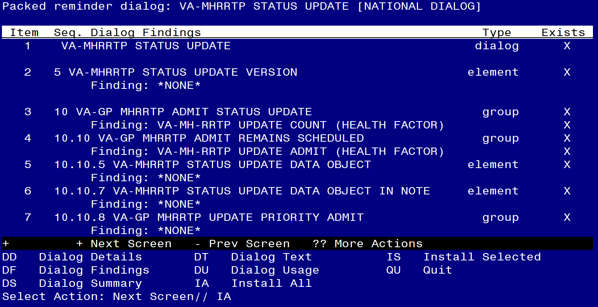

At the Select Action prompt, type IA to install the dialog – VA-MHRRTP STATUS UPDATE
Select Action: Next Screen// IA Install All
Install reminder dialog and all components with no further changes: YES

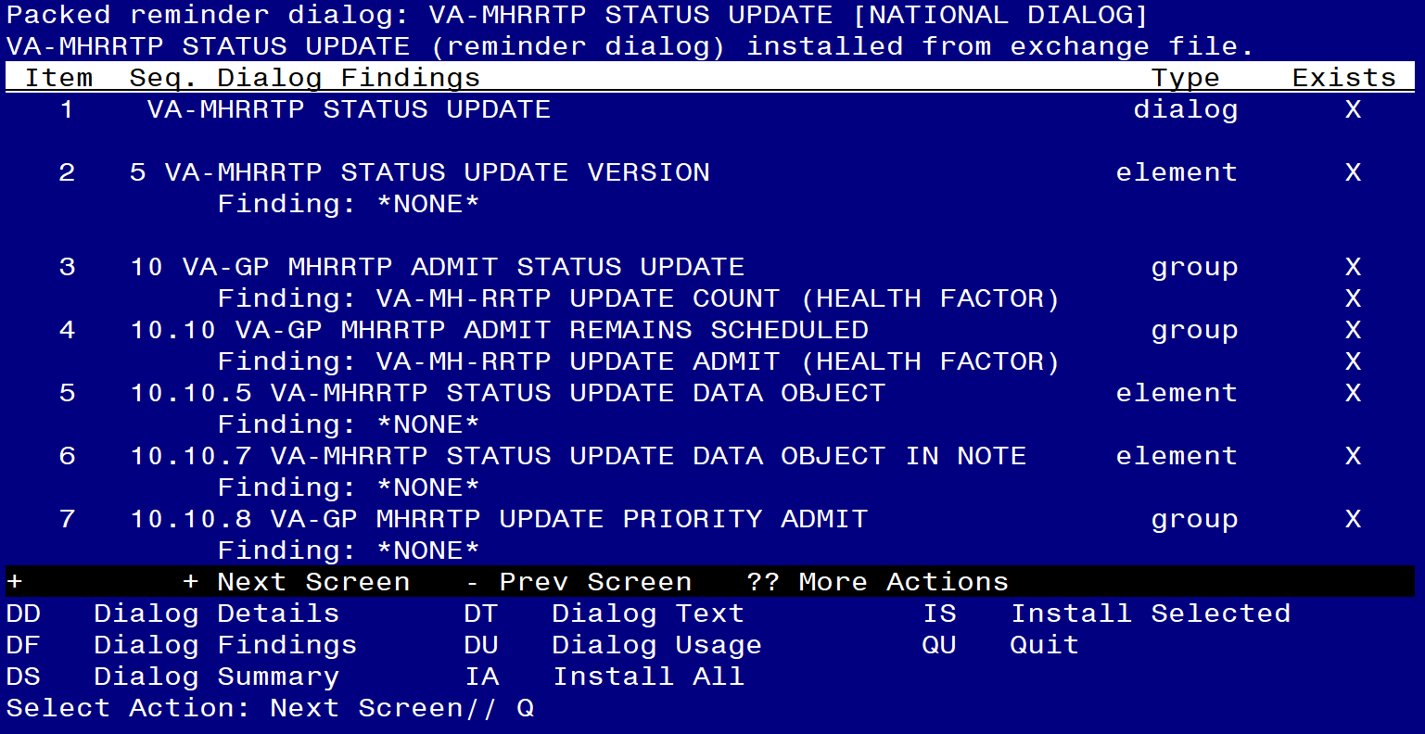

After completing this dialog install, you will type Q and be prompted for the items below.
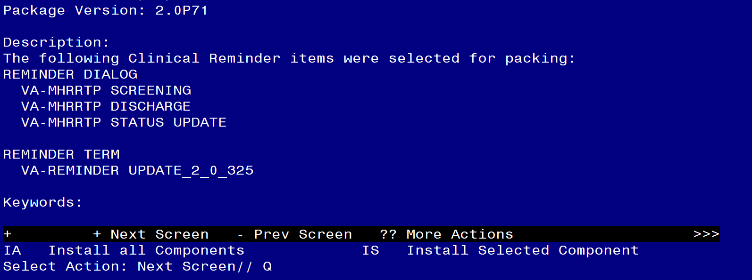
After all the dialogs and components have been installed, you will then be returned to this screen. At the Select Action prompt, type Q.

Post-Install

- Setup of Note Titles

(If the dialogs are already linked to shared templates and note titles, then these steps can be skipped.)

If you do not have RRTP note titles, you can create new note titles to connect to the reminder dialogs included in this update. These note titles are not required.

You will need to create 3 new note titles – one for each reminder dialog.
The VHA Enterprise Standard Title for all is: MENTAL HEALTH NOTE

Note Title #1: MHRRTP SCREENING
Note Title #2: MHRRTP STATUS UPDATE
Note Title #3: MHRRTP DISCHARGE

Comprehensive information on Creating Document Definitions can be found beginning on page 47 of the TIU/ASU Implementation Guide

Note: Please review the content of these new dialogs, if you have existing notes and reminder dialogs that you use in the RRTP setting, you can incorporate the contents of these templates into your existing local dialog by adding the main groups. Please work with your RRTP staff to decide the best way to incorporate these components into your local processes.

- Link dialogs to Shared Templates and/or link to Note Title. (If the dialogs are already linked to shared templates and note titles, then these steps can be skipped.)

From the Reminders Manager Menu:

CF Reminder Computed Finding Management ...
RM Reminder Definition Management ...
SM Reminder Sponsor Management ...
TXM Reminder Taxonomy Management
TRM Reminder Term Management ...
LM Reminder Location List Management ...
RX Reminder Exchange
RT Reminder Test
OS Other Supporting Menus ...
INFO Reminder Information Only Menu ...
DM Reminder Dialog Management ...
CP CPRS Reminder Configuration ...
RP Reminder Reports ...
MST Reminders MST Synchronization Management ...
PL Reminder Patient List Menu ...
PAR Reminder Parameters ...
VS NLM Value Set Menu
ROC Reminder Order Check Menu ...
CQM NLM Clinical Quality Measures Menu
XM Reminder Extract Menu ...

Select Reminder Managers Menu Option: CPRS Reminder Configuration

CA Add/Edit Reminder Categories
CL CPRS Lookup Categories
CS CPRS Cover Sheet Reminder List
MH Mental Health Dialogs Active
PN Progress Note Headers
RA Reminder GUI Resolution Active
TIU TIU Template Reminder Dialog Parameter
DEVL Evaluate Coversheet List on Dialog Finish
DL Default Outside Location
PT Position Reminder Text at Cursor
LINK Link Reminder Dialog to Template
TEST CPRS Coversheet Time Test
NP New Reminder Parameters
GEC GEC Status Check Active
WH WH Print Now Active

Select CPRS Reminder Configuration Option: Link Reminder Dialog to Template

Select Dialog Definition: VA-MHRRTP SCREENING reminder dialog NATIONAL
...OK? Yes// (Yes)

Enter template name: MHRRTP SCREENING

Link template to Document Title? YES

Select Document Definition: MHRRTP SCREENING

Repeat for the VA-MHRRTP STATUS UPDATE and VA-MHRRTP DISCHARGE dialogs.

- Compare the reminder term VA-HOMELESSNESS - ALREADY RECEIVING SERVICES to the pre-install inquiry

*if you skipped this reminder term during installation, it should not be changed.

Using the menu, Reminder Manager, Reminder Term Management, Add/Edit Reminder Term, edit the reminder term VA-HOMELESSNESS - ALREADY RECEIVING SERVICES to align with your pre-install inquiry.
- If your site did not have the mapped finding(s) CF.VA-PROGRESS NOTE pre-installation, you can delete those finding items from the term.
- If your site DID have the mapped finding(s) CF.VA-PROGRESS NOTE, then update the computer finding parameter field of those finding items and replace the *** with your pre-install mapped item.

- Add the orderable items within the dialog:

Using the menu, Reminder Dialog Management, Reminder Dialogs, Change the view to element. Search for the following elements and edit to align with your pre-install inquiry.
VA-OI HOMELESS REFERRAL
VA-OI SOCIAL WORK REFERRAL
VAL-OI SOCIAL WORK REFERRAL
VAL-OI DIETARY REFERRAL

- Confirm the revisions listed in the dialog changes document are present in the dialogs.

