Update_2_0_329

Clinical Reminders

VA-STANDARD OPERATIVE SURGICAL TEMPLATES

Install Guide

January 2023

Product Development
Office of Information Technology
Department of Veterans Affairs

Table of Contents
Introduction 1
Install Details 3
Install Example 3
Post Installation 9

Introduction
The purpose of these templates is to provide standardized documentation for Commission on Cancer (COC) operative standards. These document requirements go into effect as of January 2023 for all Commission on Cancer operative sites. The following templates, utilized by surgical clinicians, will allow VA and DOD to analyze metrics for these procedures and provide a standardized method to document Commission on Cancer Operative Standards for:
- Colectomy Resection
- Sentinel Node Biopsy for Breast Cancer
- Axillary Lymph Node for Breast Cancer
- Wide Local Excision for Primary Cutaneous Melanoma

UPDATE_2_0_329 contains 1 Reminder Exchange entry:
UPDATE_2_0_329 VA-STANDARD OPERATIVE SURGICAL TEMPLATES

The exchange file contains the following components:
TIU TEMPLATE FIELD
VA-SOR USAGE TEXT
VA-SOR COPYRIGHT

HEALTH FACTORS
VA-REMINDER UPDATES [C]
VA-UPDATE_2_0_329
VA-SOR MELANOMA [C]
VA-SOR MELANOMA WLE DEPTH OTHER
VA-SOR MELANOMA WLE DEPTH ONLY SKIN AND SUPERFIC SUBCUT FAT
VA-SOR MELANOMA WLE DEPTH FULL THICK TO FASCIA
VA-SOR MELANOMA WLE CLINICAL MARGIN WIDTH 2 CM
VA-SOR MELANOMA WLE CLINICAL MARGIN WIDTH OTHER
VA-SOR MELANOMA WLE CLINICAL MARGIN WIDTH OTH COSM/ANAT CONCERN
VA-SOR MELANOMA WLE CLINICAL MARGIN WIDTH 1 CM
VA-SOR MELANOMA WLE CLINICAL MARGIN WIDTH 0.5 CM
VA-SOR MELANOMA WLE BRESLOW THICK INVASIVE MM
VA-SOR MELANOMA WLE BRESLOW THICK MELANOMA IN SITU
VA-SOR MELANOMA WLE WITH CURATIVE INTENT NO
VA-SOR MELANOMA WLE WITH CURATIVE INTENT YES
VA-COLECTOMY (C) [C]
VA-SOR COLON RESECTION PRIM TUMOR LOC HEPATIC FLEXURE
VA-SOR COLON RESECT OTHER
VA-SOR COLON RESECT EXT TOT ABD COL W PROCT LIG MES & RECT
VA-SOR COLON RESECT EXT TOT ABD COL LIG ILEOC RT&MID COL INF MES
VA-SOR COLON RESECT EXT SIGMOID RESECT LIG INF MESENTERIC
VA-SOR COLON RESECT EXT LT HEMICOL LIG INF MESENTERIC
VA-SOR COLON RESECT EXT SPLENIC FLEX RESECT LIG MID & ASC LT COL
VA-SOR COLON RESECT EXT TRANSVERSE COLECT LIG MID COLIC
VA-SOR COLON RESECT EXT EXTD RT HEMICOL LIG ILEOCOL RT & MID COL
VA-SOR COLON RESECT EXT RT HEMICOL LIG ILEOCOL RT COLIC
VA-SOR COLON RESECTION PRIM TUMOR LOC CECUM
VA-SOR COLON RESECTION WITHOUT CURATIVE INTENT
VA-SOR COLON RESECTION WITH CURATIVE INTENT
VA-SOR BREAST SENTINEL NODE [C]
VA-SOR BREAST SLN BX POSITIVE CLIP LN REMOVED N/A
VA-SOR BREAST SLN BX POSITIVE CLIP LN REMOVED NO
VA-SOR BREAST SLN BX POSITIVE CLIP LN REMOVED YES
VA-SOR BREAST SLN BX ALL PALPABLY SUSPICIOUS LN REMOVED N/A
VA-SOR BREAST SLN BX ALL PALPABLY SUSPICIOUS LN REMOVED NO
VA-SOR BREAST SLN BX ALL PALPABLY SUSPICIOUS LN REMOVED YES
VA-SOR BREAST SLN BX ALL SIGNIF RADIOACT LN REMOVED N/A
VA-SOR BREAST SLN BX ALL SIGNIF RADIOACT LN REMOVED NO
VA-SOR BREAST SLN BX ALL SIGNIF RADIOACT LN REMOVED YES
VA-SOR BREAST SLN BX ALL LN END DYE LYMPH CHANNEL REMOVED N/A
VA-SOR BREAST SLN BX ALL LN END DYE LYMPH CHANNEL REMOVED NO
VA-SOR BREAST SLN BX ALL LN END DYE LYMPH CHANNEL REMOVED YES
VA-SOR BREAST SLN BX NEOADJUVANT TRACER USED N/A
VA-SOR BREAST SLN BX NEOADJUVANT TRACER USED OTHER
VA-SOR BREAST SLN BX NEOADJUVANT TRACER SUPERPARAMAG IRON OX
VA-SOR BREAST SLN BX NEOADJUVANT TRACER USED RADIOACTIVE
VA-SOR BREAST SLN BX NEOADJUVANT TRACER USED DYE
VA-SOR BREAST SLN BX NON-NEOADJUVANT TRACER USED N/A
VA-SOR BREAST SLN BX NON-NEOADJUVANT TRACER USED OTHER
VA-SOR BREAST SLN BX NON-NEOADJUVANT TRACER SUPERPARAMAG IRON OX
VA-SOR BREAST SLN BX NON-NEOADJUVANT TRACER USED RADIOACTIVE
VA-SOR BREAST SLN BX NON-NEOADJUVANT TRACER USED DYE
VA-SOR BREAST SLN BX WITH CURATIVE INTENT NO
VA-SOR BREAST SLN BX WITH CURATIVE INTENT YES
VA-SOR BREAST AXILLARY DISSECTION [C]
VA-SOR BREAST ALND WITH LEVEL 3 LN REMOVED NO
VA-SOR BREAST ALND WITH LEVEL 3 LN REMOVED YES
VA-IHP SOR BREAST ALND NERVES IDENTIFY PRESERVE OTHER
VA-IHP SOR BREAST ALND NERVES ID PRESERVE BRANCH INTERCOSTOBRACH
VA-SOR BREAST ALND IDENTIFY PRESERVE THORACODORSAL NRV
VA-SOR BREAST ALND IDENTIFY PRESERVE LONG THORACIC NRV
VA-SOR BREAST ALND WITHIN BOUND AX VN CHEST WALL LAT DORSI NO
VA-SOR BREAST ALND WITHIN BOUND AX VN CHEST WALL LAT DORSI YES
VA-SOR BREAST ALND WITHOUT CURATIVE INTENT
VA-SOR BREAST ALND WITH CURATIVE INTENT

REMINDER SPONSOR
OFFICE OF SURGICAL SERVICES

REMINDER TERM
VA-REMINDER UPDATE_2_0_329

REMINDER DIALOG
VA-SOR WIDE LOCAL EXCISION FOR PRIMARY CUTANEOUS MELANOMA
VA-SOR COLON RESECTION
VA-SOR BREAST SENTINEL NODE
VA-SOR BREAST AXILLARY NODE NOTE

Install Details

This update is being distributed as a web host file. The address for the host file is: https://REDACTED/UPDATE_2_0_329.PRD

The file will be installed using Reminder Exchange, programmer access is not required.

Installation:
=============
This update can be loaded with users on the system. Installation will take less than 30 minutes.

Install Example
To Load the Web Host File. Navigate to Reminder exchange in Vista
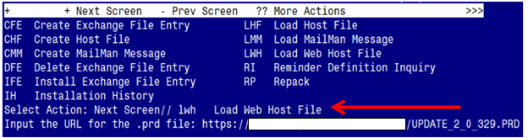

At the Select Action: prompt, enter LWH for Load Web Host File
At the Input the url for the .prd file: prompt, type the following web address:
https://REDACTED/UPDATE_2_0_329.PRD
You should see a message at the top of your screen that the file successfully loaded.

Search for and locate the reminder exchange entry titled:
UPDATE_2_0_329 VA-STANDARD OPERATIVE SURGICAL TEMPLATES
(see screenshot on the next page)
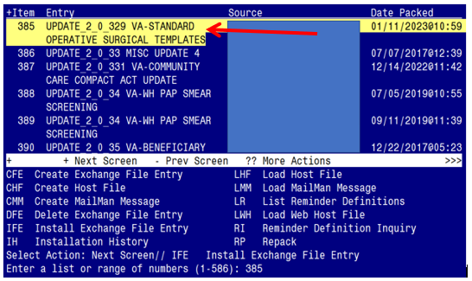

At the Select Action prompt, enter IFE for Install Exchange File Entry
Enter the number that corresponds with your entry titled UPDATE_2_0_329 VA-STANDARD OPERATIVE SURGICAL TEMPLATES (in this example it is entry 385, it will vary by site). The exchange file date should be 01/11/2023@10:59.

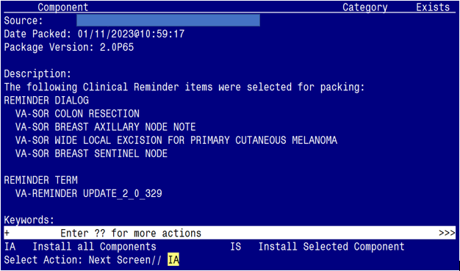

At the Select Action prompt, type IA for Install all Components and hit enter.
Select Action: Next Screen// IA Install all Components

You will see several prompts:
1 - For all new components, choose I to Install
2 - For existing components, choose S to SKIP
You will be promped to install the 1st dialog component:

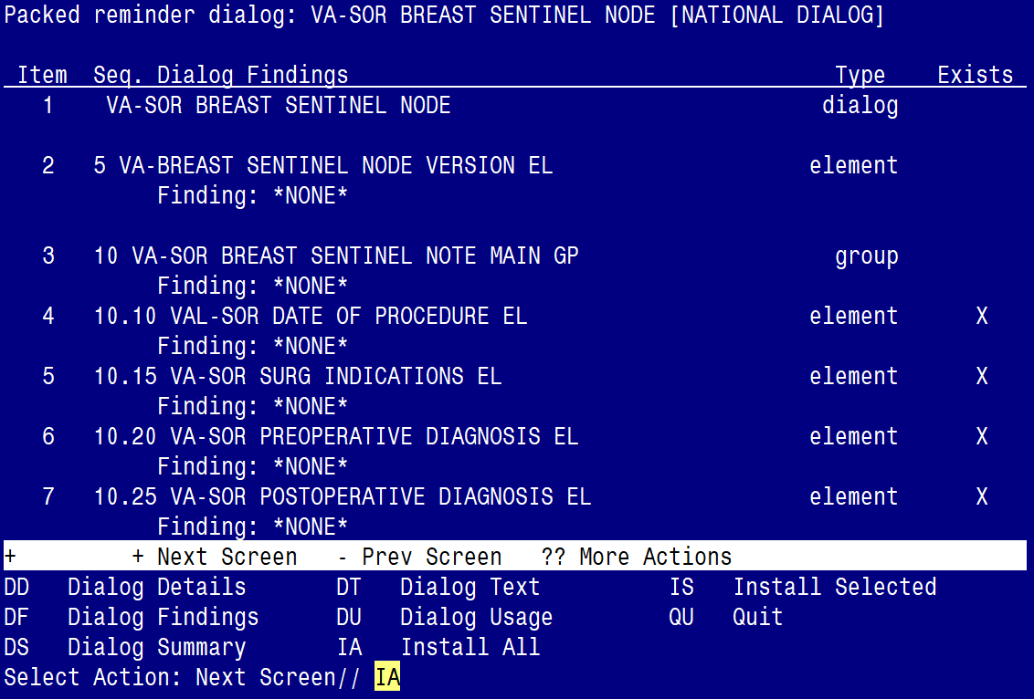

At the Select Action prompt, type IA to install the dialog – VA-SOR BREAST SENTINEL NODE
Select Action: Next Screen// IA Install All
Install reminder dialog and all components with no further changes: Y// ES

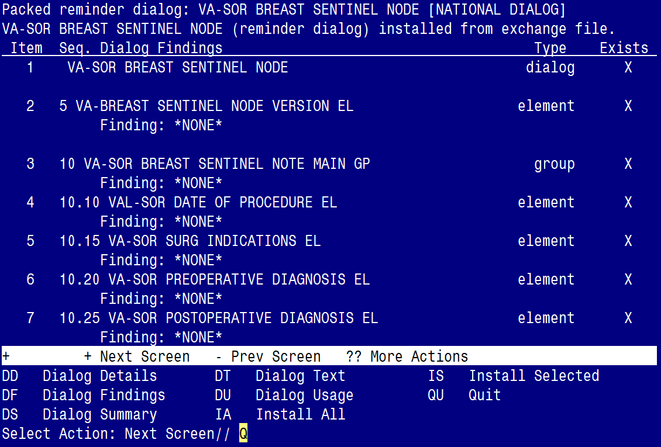

When the dialog has completed installation, you will then be returned to this screen. At the Select Action prompt, type Q.
You will be promped to install the 2nd dialog component:

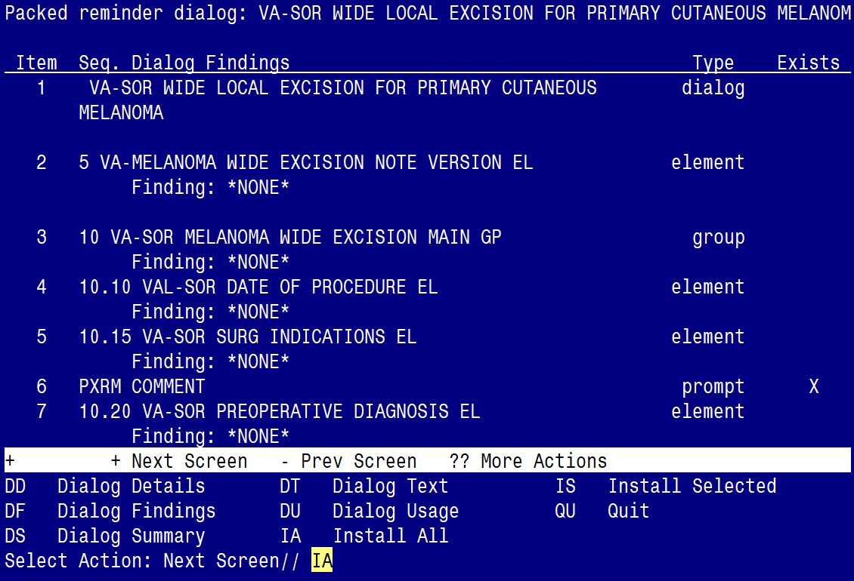

At the Select Action prompt, type IA to install the dialog – VA-SOR WIDE LOCAL EXCISION FOR PRIMARY CUTANEOUS MELANOMA
Select Action: Next Screen// IA Install All
Install reminder dialog and all components with no further changes: Y// ES

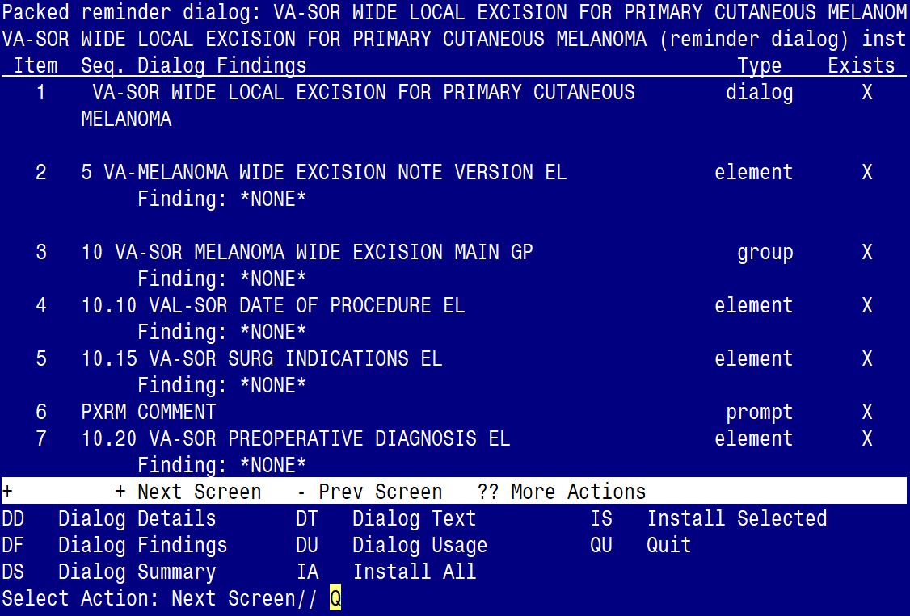

When the dialog has completed installation, you will then be returned to this screen. At the Select Action prompt, type Q.
You will be promped to install the 3rd dialog component:

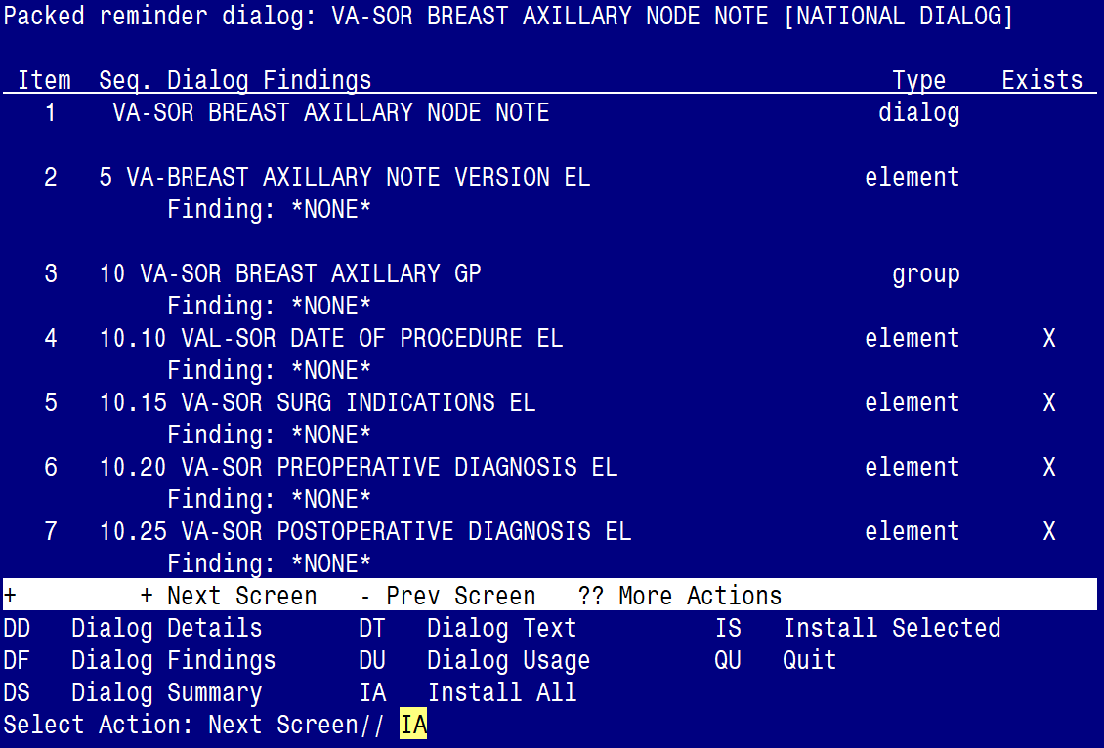

At the Select Action prompt, type IA to install the dialog – VA-SOR BREAST AXILLARY NODE NOTE
Select Action: Next Screen// IA Install All
Install reminder dialog and all components with no further changes: Y// ES

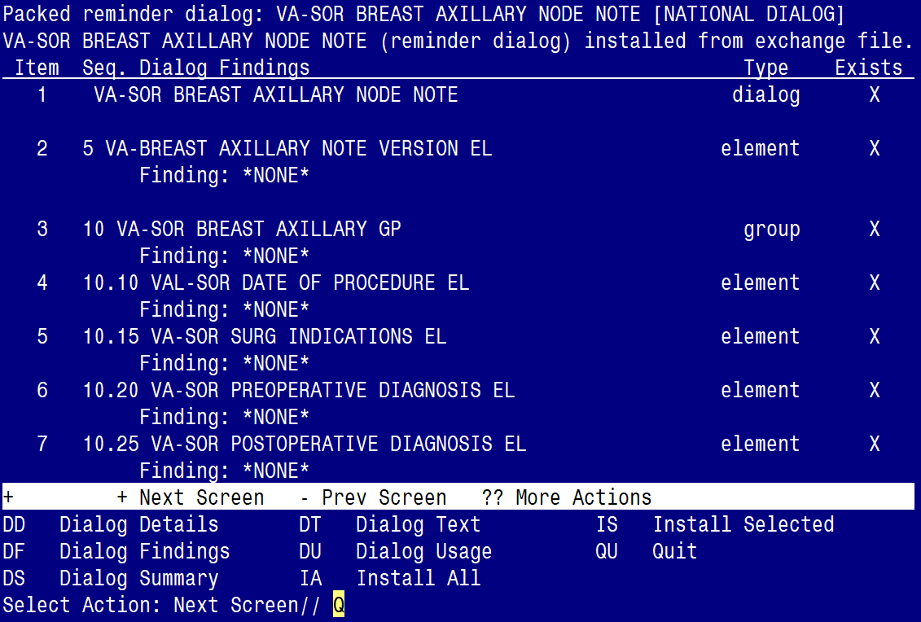

When the dialog has completed installation, you will then be returned to this screen. At the Select Action prompt, type Q.
You will be promped to install the 4th dialog component:

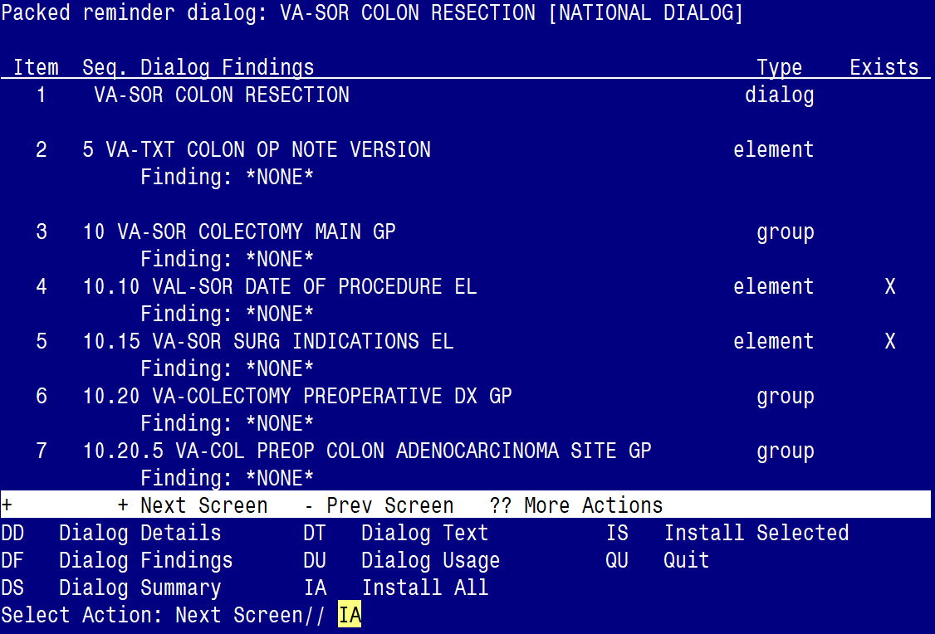

At the Select Action prompt, type IA to install the dialog – VA-SOR COLON RESECTION
Select Action: Next Screen// IA Install All
Install reminder dialog and all components with no further changes: Y// ES

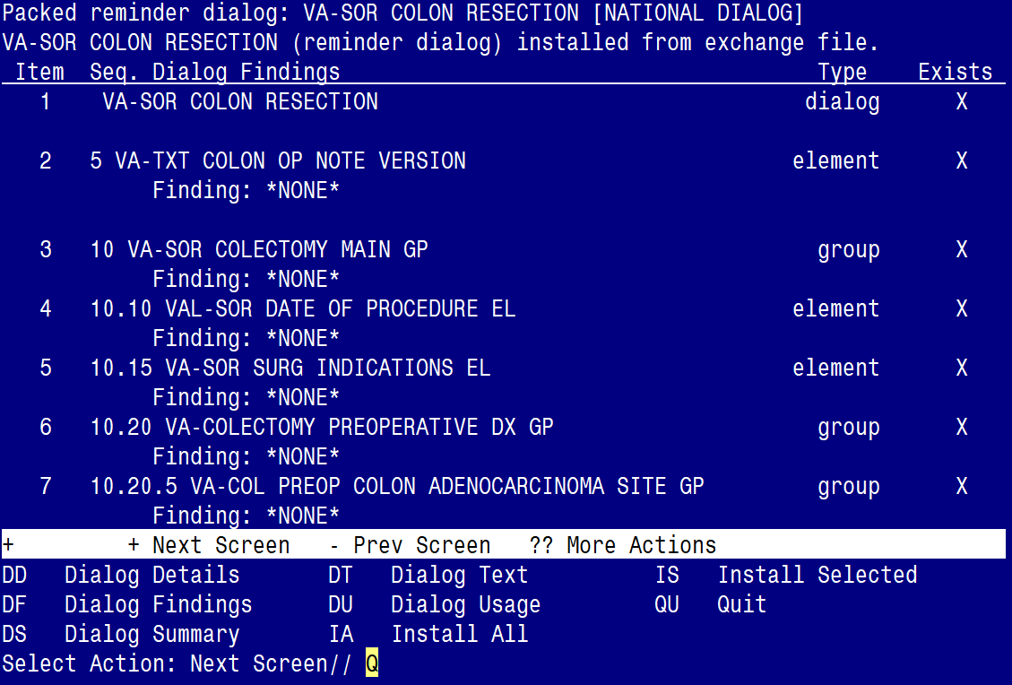

When the dialog has completed installation, you will then be returned to this screen. At the Select Action prompt, type Q.

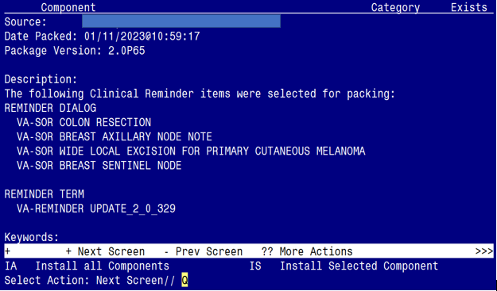

You will be returned to this screen. Type Q to quit.

Install Completed

Post Installation

- Make the Dialog able to be attached to a Personal/Shared template or to a progress note title.

From the Reminders Manager Menu:
Select Reminder Managers Menu Option: CP CPRS Reminder Configuration
CA Add/Edit Reminder Categories
CL CPRS Lookup Categories
CS CPRS Cover Sheet Reminder List
MH Mental Health Dialogs Active
PN Progress Note Headers
RA Reminder GUI Resolution Active
TIU TIU Template Reminder Dialog Parameter
DL Default Outside Location
PT Position Reminder Text at Cursor
Select CPRS Reminder Configuration Option: TIU TIU Template Reminder Dialog Parameter
Reminder Dialogs allowed as Templates may be set for the following:
1 User USR [choose from NEW PERSON]
3 Service SRV [choose from SERVICE/SECTION]
4 Division DIV [choose from INSTITUTION]
5 System SYS [NATREM.FO-SLC.MED.VA.GOV]
Enter selection: 5 Choose the appropriate number for your site. Your site may do this by System or other levels. The example below uses SYSTEM level

Setting Reminder Dialogs allowed as Templates for System:
Select Display Sequence: ?

148 VA-VETERANS CHOICE NOTE
149 VA-TBI SCREENING
When you type a question mark above, you will see the list of #’s (with dialogs) that are already taken. Choose a number NOT on this list. For this example, looking above I see the number 150 is not present, so I will use 150.

Select Display Sequence: 150
Are you adding 150 as a new Display Sequence? Yes// Y YES
Display Sequence: 150// <Enter> 150
Clinical Reminder Dialog: type in the name of the dialog
VA-SOR BREAST AXILLARY NODE NOTE then <enter>
reminder dialog NATIONAL
OK? Yes// <Enter> (Yes)
Select Display Sequence: 151
Are you adding 151 as a new Display Sequence? Yes// Y YES
Display Sequence: 151// <Enter> 151
Clinical Reminder Dialog: type in the name of the dialog
VA-SOR BREAST SENTINEL NODE then <enter>
reminder dialog NATIONAL
OK? Yes// <Enter> (Yes)
Select Display Sequence: 152
Are you adding 153 as a new Display Sequence? Yes// Y YES
Display Sequence: 153// <Enter> 152
Clinical Reminder Dialog: type in the name of the dialog
VA-SOR COLON RESECTION then <enter>
reminder dialog NATIONAL
OK? Yes// <Enter> (Yes)
Select Display Sequence: 153
Are you adding 155 as a new Display Sequence? Yes// Y YES
Display Sequence: 155// <Enter> 155
Clinical Reminder Dialog: type in the name of the dialog
VA-SOR WIDE LOCAL EXCISION FOR PRIMARY CUTANEOUS MELANOMA then <enter>
reminder dialog NATIONAL
OK? Yes// <Enter> (Yes)

- Setup of Note titles
You will need to create four new note titles for these templates, as follows:

AXILLARY LYMPH NODE DISSECTION FOR BREAST CANCER NOTE
SENTINEL NODE BIOPSY FOR BREAST CANCER NOTE
COLON RESECTION NOTE
WIDE LOCAL EXCISION FOR PRIMARY CUTANEOUS MELANOMA NOTE

You can place them in the same document class as your other surgery notes.

All the note titles above are to be mapped to the following VHA Enterprise Standard Title: SURGERY NOTE

Comprehensive information on Creating Document Definitions can be found beginning on page 47 of the TIU/ASU Implementation Guide

- Associate the reminder dialogs with the note titles in CPRS
To do this, go to Template Editor, then Document Titles, select the appropriate folder
(if applicable), and choose New Template (top right-hand corner).

- Type in the following information:
Name: AXILLARY LYMPH NODE DISSECTION FOR BREAST CANCER NOTE
Template Type: Reminder Dialog
Reminder Dialog: VA-SOR BREAST AXILLARY NODE NOTE

Next, type in the Associated Title, which in this case is AXILLARY LYMPH NODE DISSECTION FOR BREAST CANCER NOTE and hit Apply.

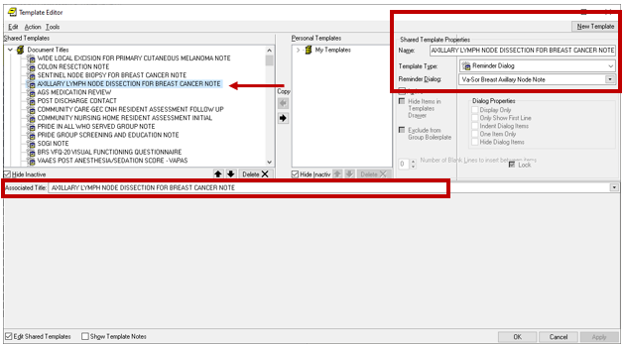
- Name: SENTINEL NODE BIOPSY FOR BREAST CANCER NOTE
Template Type: Reminder Dialog
Reminder Dialog: VA-SOR BREAST SENTINEL NODE
Associated Title: SENTINEL NODE BIOPSY FOR BREAST CANCER NOTE

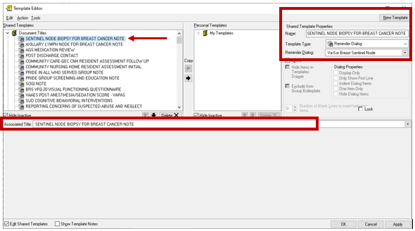

- Name: COLON RESECTION NOTE
Template Type: Reminder Dialog
Reminder Dialog: VA-SOR COLON RESECTION
Associated Title: COLON RESECTION NOTE

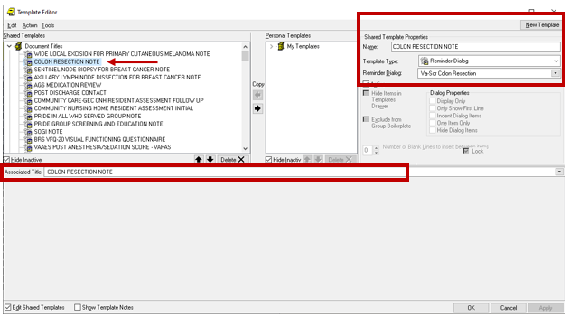
- Name: WIDE LOCAL EXCISION FOR PRIMARY CUTANEOUS MELANOMA NOTE
Template Type: Reminder Dialog
Reminder Dialog: VA-SOR WIDE LOCAL EXCISION FOR PRIMARY CUTANEOUS MELANOMA
Associated Title: WIDE LOCAL EXCISION FOR PRIMARY CUTANEOUS MELANOMA NOTE

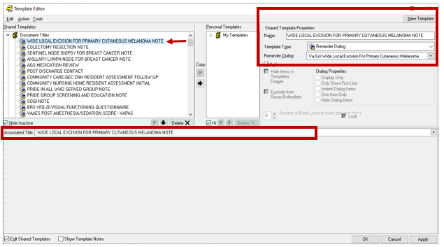

- Add your site’s DATE template field in the following ELEMENT:

Element: VAL-SOR DATE OF PROCEDURE EL
DIALOG/PROGRESS NOTE TEXT:
Date of Procedure: ***Replace with local DATE template field***

