Update _2_0_330

Clinical Reminders

VA-MONKEYPOX/SMALLPOX VACCINE REMINDER

Install Guide

February 2023

Product Development
Office of Information Technology
Department of Veterans Affairs

Table of Contents
Introduction 1
Install Details 4
Install Example 4
Post Installation 8

Introduction

This reminder update has two main components:
- A new reminder definition: VA-MONKEYPOX/SMALLPOX VACCINE
Description:

Received first dose of VACCINIA, SMALLPOX MONKEYPOX VACCINE LIVE, PF and at least 28 days have passed since that first dose.

Technical Description:

Cohort Logic:

Received first dose of VACCINIA, SMALLPOX MONKEYPOX VACCINE LIVE, PF and at least 28 days have passed since that first dose.

Resolution Logic:

Any of the following resolves the reminder:
- Receiving a second dose of VACCINIA, SMALLPOX MONKEYPOX VACCINE no sooner than 28 days after the first dose.
- Refusing vaccine (resolves for the refusal period chosen)
- Vaccine contraindicated (resolves permanently)

- An update to the existing reminder dialog VA-MONKEYPOX
  - A new section was added that can be used to screen patients for Smallpox/Monkeypox vaccination

  - In the vaccination section, document administration of vaccine, Subcutaneous is now the first option and no longer requires justification/explanation.

UPDATE_2_0_330 contains 1 Reminder Exchange entry:
UPDATE_2_0_330 VA-MONKEYPOX/SMALLPOX VACCINE REMINDER

The exchange file contains the following components:
REMINDER GENERAL FINDINGS
VIEW PROGRESS NOTE TEXT

TIU TEMPLATE FIELD
VA-MONKEYPOX CDC INTERVAL URL
VA-MONKEYPOX CDC URL
BLANK TEXT FIELD FOR DIALOGS
VA-VANOD BLANK
IM PHARMACY PHONE NUMBERS
IM VIS MPOX URL
IM MPX ADMIN INFO
MPX JYNNEOS PATIENT HTML
MPX JYNNEOS PROVIDER HTML
VA-MONKEYPOX INTERIM GUIDANCE
VA-MONKEYPOX CDC NOTIFY CLOSE CONTACTS URL
VA-MONKEYPOX CDC PREVENTING SPREAD URL
VA-MONKEYPOX CDC WHAT TO DO IF SICK URL
WORD 2 LINES

HEALTH FACTORS
VA-REMINDER UPDATES [C]
VA-UPDATE_2_0_330
VA-MONKEYPOX[C]
VA-MONKEYPOX VACCINE EDUCATION VVC/TELE VST
VA-MPOX AT RISK FOR EXPOSURE NO
VA-MPOX HISTORY OF KELOID NO
VA-MPOX HISTORY OF KELOID YES
VA-MPOX SYMPTOMS NO
VA-MPOX SYMPTOMS YES
VA-MPOX AT RISK FOR EXPOSURE YES
VA-MPOX EXPOSURE WITHIN LAST 14 DAYS NO
VA-MPOX EXPOSURE WITHIN LAST 14 DAYS YES
VA-MPOX SEVERE ALLERGIC RXN POST JYNNEOS VACCINE NA
VA-MPOX SEVERE ALLERGIC RXN POST JYNNEOS VACCINE NO
VA-MPOX SEVERE ALLERGIC RXN POST JYNNEOS VACCINE YES
VA-MONKEYPOX LAB PCR OUTSIDE - INDETERMINATE
VA-MONKEYPOX LAB PCR OUTSIDE - PENDING
VA-MONKEYPOX LAB PCR OUTSIDE - NEGATIVE
VA-MONKEYPOX LAB PCR OUTSIDE - POSITIVE
VA-MONKEYPOX LAB PCR OUTSIDE - MONKEYPOX CONFIRMED
VA-MONKEYPOX LAB PCR OUTSIDE – ORTHOPOX PRESUMPTIVE
IMMUNIZATION [C]
VA-MONKEYPOX (JYNNEOS) VACCINE INTRADERMAL DOSE VOLUME 0.1ML

REMINDER SPONSOR
NATIONAL CENTER FOR HEALTH PROMOTION AND DISEASE PREVENTION (NCP)
POPULATION HEALTH
VA NATIONAL CENTER FOR HEALTH PROMOTION AND DISEASE PREVENTION (NCP)

REMINDER TAXONOMY
VA-IMMUNIZATION INJECTION 90471
VA-IMMUNIZATION ICD10 CODE

REMINDER TERM
VA-REMINDER UPDATE_2_0_330
VA-CURRENT INPATIENT
VA-IM NO DOSES AVAIL MONKEYPOX 206
VA-MONKEYPOX/SMALLPOX ADMINISTRATION SUPPRESSION
VA-MONKEYPOX/SMALLPOX ORDER SUPPRESSION

REMINDER DEFINITION
VA-MONKEYPOX/SMALLPOX VACCINE

HEALTH SUMMARY TYPE
VA-MONKEYPOX IM

HEALTH SUMMARY OBJECTS
VA-MONKEYPOX IM (TIU)

TIU DOCUMENT DEFINITION
VA-MONKEYPOX IM

REMINDER DIALOG
VA-MONKEYPOX/SMALLPOX VACCINE
VA-MONKEYPOX

Install Details

Installation:
=============
This update can be loaded with users on the system. Installation will take less than 5 minutes. This update is being distributed as a web host file.
The address for the host file is:
https://REDACTED/UPDATE_2_0_330.PRD

Install Example

To load the Web Host File. Navigate to Reminder exchange in Vista
At the Select Action: prompt, enter LWH for Load Web Host File
https://Redacted/UPDATE_2_0_330.PRD
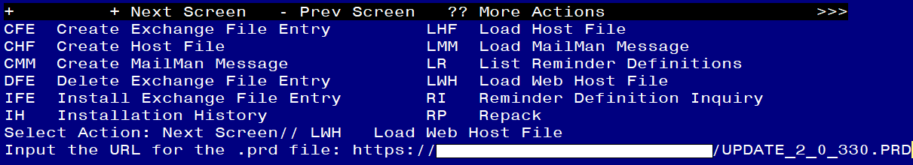
You should see a message at the top of your screen that the file loaded successfully
Search and locate an entry titled UPDATE_2_0_330 VA-MONKEYPOX/SMALLPOX VACCINE REMINDER in reminder exchange.
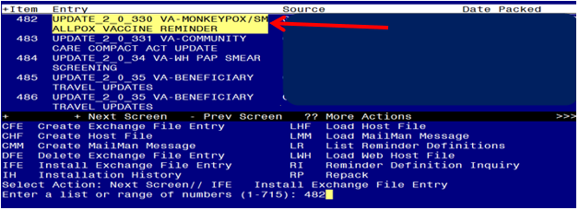
At the Select Action prompt, enter IFE for Install Exchange File Entry
Enter the number that corresponds with your entry UPDATE_2_0_330 VA-MONKEYPOX/SMALLPOX VACCINE REMINDER (in this example it is entry 482 it will vary by site). The date of the exchange file should be 01/11/2023.

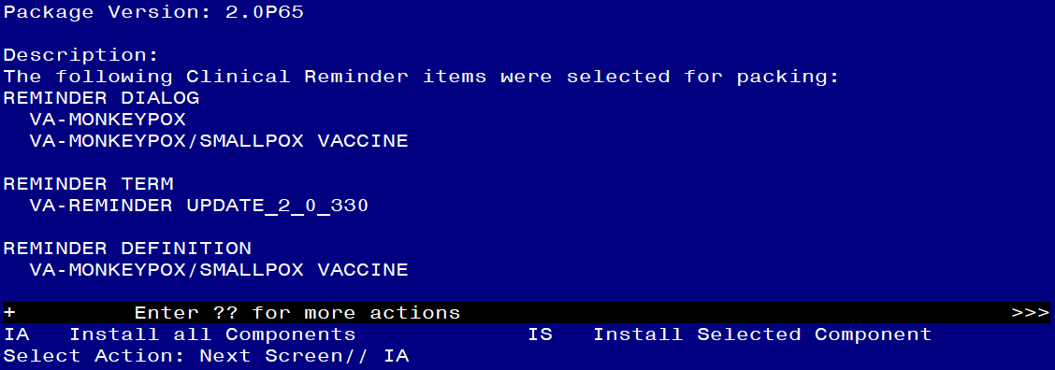
At the Select Action prompt, type IA for Install all Components and hit enter.
For all new entries in any category you will choose I to Install
Skip any items in any category you are prompted to overwrite

You will then be prompted to install the FIRST dialog component.

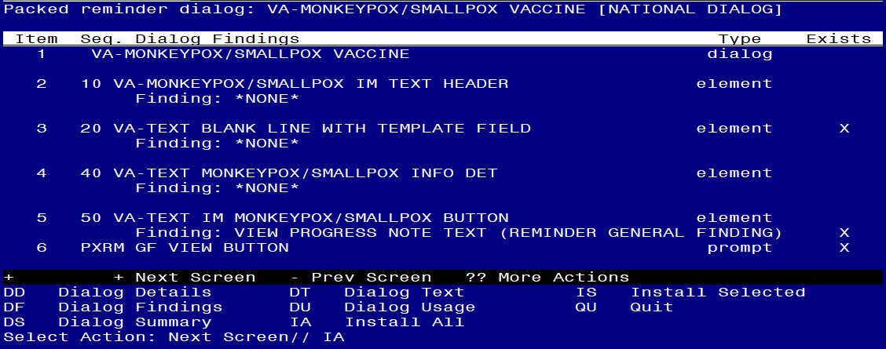
At the Select Action prompt, type IA to install the dialog – VA-MONKEYPOX/SMALLPOX VACCINE
Install reminder dialog and all components with no further changes: Y//ES

You may see this additional prompt, hit enter to link:
Reminder Dialog VA-MONKEYPOX/SMALLPOX VACCINE is not linked to a reminder.

Select Reminder to Link: VA-MONKEYPOX/SMALLPOX VACCINE//<<hit enter here>>

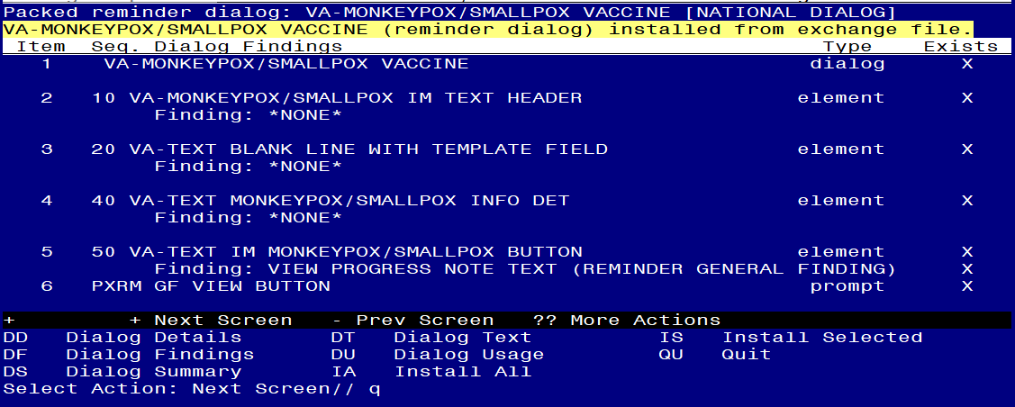
When the dialog has completed installation, you will then be returned to this screen. At the Select Action prompt, type Q.

You will then be prompted to install the NEXT dialog component.
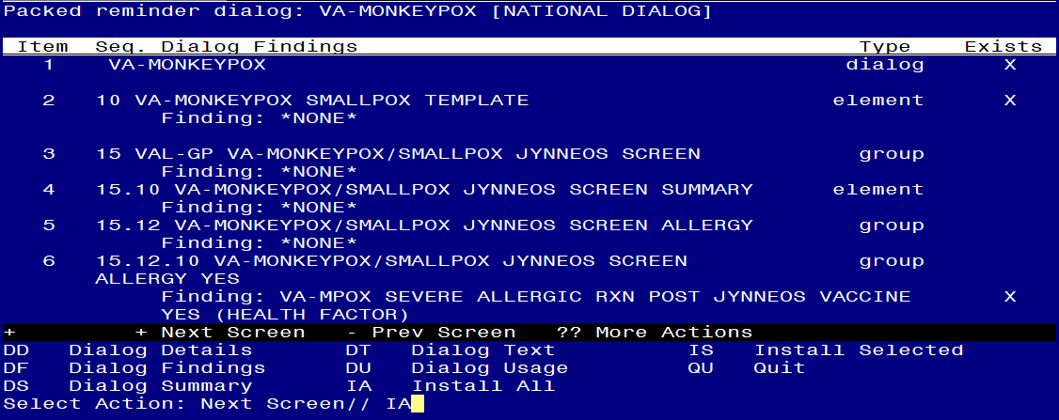
At the Select Action prompt, type IA to install the dialog – VA-MONKEYPOX
Install reminder dialog and all components with no further changes: Y//ES

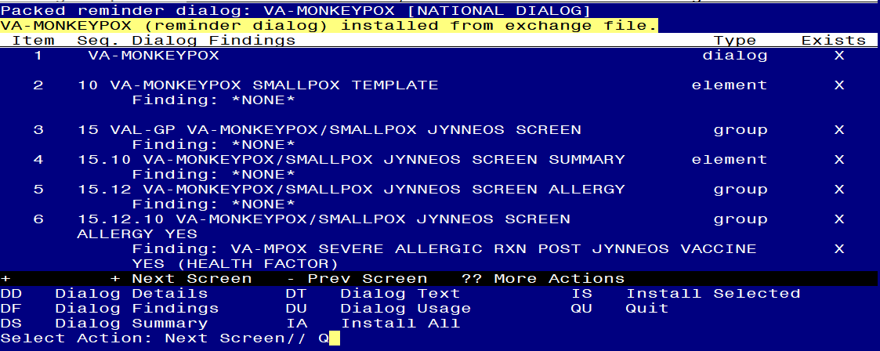
When the dialog has completed installation, you will then be returned to this screen. At the Select Action prompt, type Q.

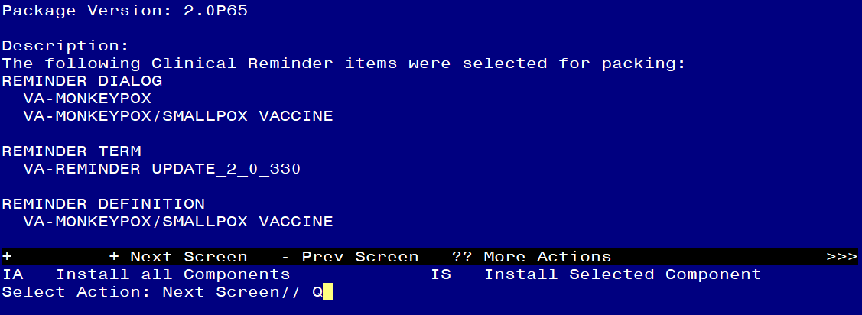
You will then be returned to this screen. At the Select Action prompt, type Q.

Install complete.

Post Installation

- Open the existing MONKEYPOX note that was updated (reminder dialog VA-MONKEYPOX) and confirm the version displays as 2.1 and you see the new section “Screen for Smallpox/Monkeypox vaccination “.

- Add your local orders to the reminder dialog
  - Add your order for monkeypox/smallpox vaccine as a finding item to these reminder dialog elements:
VA-MONKEYPOX/SMALLPOXKELOID YES ACTIONSORDER
VA-MONKEYPOX/SMALLPOXKELOID NO ACTION ORDER
VA-GP IM MONKEYPOX/SMALLPOX ORDER

  - Add your return to clinic order (optional) as a finding item to these reminder dialog elements:
VA-MONKEYPOX/SMALLPOXKELOID YES ACTIONS SCHEDULE
VA-MONKEYPOX/SMALLPOXKELOID NO ACTION SCHEDULE

- Assign the new reminder VA-MONKEYPOX/SMALLPOX VACCINE print name Monkeypox/Smallpox Vaccine to the cover sheet at the appropriate level. (OPTIONAL). It is recommended you assign to a few users to test before expanding use.
Note: Use of this reminder is not mandated, your facility can decide if they want to use it and how to assign it.

- Update reminder term VA-MONKEYPOX/SMALLPOX ORDER SUPPRESSION (optional)

If you want to suppress the ordering option in the dialog connected to the reminder definition, then follow the instructions for the reminder term VA-MONKEYPOX/SMALLPOX ORDER SUPPRESSION

To suppress the dialog element for specific user classes: VA-ASU USER CLASS Enter the user class that should NOT see the dialog element. If more than one user class is needed, add additional findings of the CF VA-ASU USER CLASS for each one as needed.

To suppress the dialog element for all users: VA-AGE change the < sign to a > sign in the CF for patient age.

To suppress for specific user classes, in the above Terms configure the VA-ASU USER CLASS computed finding and DELETE the VA-AGE finding. NOTE: If the Age finding is not deleted, the user class settings will not work.

- Update reminder term VA-MONKEYPOX/SMALLPOX ADMINISTRATION SUPPRESSION (optional)

If you want to suppress the administration option in the dialog connected to the reminder definition, then follow the Instructions for the reminder term VA-MONKEYPOX/SMALLPOX ADMINISTRATION SUPPRESSION

To suppress the dialog element for specific user classes: VA-ASU USER CLASS Enter the user class that should NOT see the dialog element. If more than one user class is needed, add additional findings of the CF VA-ASU USER CLASS for each one as needed.

To suppress the dialog element for all users: VA-AGE change the < sign to a > sign in the CF for patient age.

To suppress for specific user classes, in the above Terms configure the VA-ASU USER CLASS computed finding and DELETE the VA-AGE finding. NOTE: If the Age finding is not deleted, the user class settings will not work.

