Update _2_0_365

Clinical Reminders

VA-LONG COVID-19 CONSULT RESPONSE

Install Guide

July 2023

Product Development
Office of Information Technology
Department of Veterans Affairs

Table of Contents
Introduction 1
Install Details 6
Pre-Install 7
Install Example 7
Post Installation 10

Introduction
Description:
Long COVID Clinic Consultation and Consultation Response: Currently in the pilot phase, these templates were developed to refer a Veteran with Long COVID symptoms to a Long COVID Clinic for further evaluation or treatment.

This release includes a txml template that can be used with your local consult to your long covid clinic in addition to the reminder dialog template.

The Long COVID Clinic Consultation txml template was developed to allow providers, from a variety of settings, to solicit input in the care of a Veteran with known or suspected Long COVID. The template can be used as a one-time consult or for continued care in a Long COVID Clinic. The referring provider indicates symptom(s) that are of concern and may require further evaluation or treatment. The Long COVID Clinic team will review the request and determine appropriate treatment plan.

The Long COVID Clinic Consultation Response reminder dialog template was developed to allowing the Long COVID Clinic team to respond to consultation request. Responding clinician will provide feedback for treatment outside of the Long COVID Clinic or develop a treatment plan within the Long COVID Clinic environment. Information collected using this template can be used as the baseline assessment of symptoms to track Veteran response to treatment plan.

This reminder dialog consultation response template can be attached to a consult note title to respond to/close the long-COVID-19 consult or your facility can add it to the shared template folder or other note title to work with your workflow.

UPDATE_2_0_365 contains 1 Reminder Exchange entry:
UPDATE_2_0_365 VA-LONG COVID-19 CONSULT RESPONSE

The exchange file contains the following components:

REMINDER DIALOG LINK TYPE
VA-WHS VITALITY/WELL-BEING SCORE LESS THAN 20

TIU TEMPLATE FIELD
VA-WORD
OTHER NON-VA
OTHER TEXT
VA-TEXT (3 CHAR)R
VA-WORDR

HEALTH FACTORS
VA-REMINDER UPDATES [C]
VA-UPDATE_2_0_365
VA-COVID-19 [C]
VA-LONG COVID CONSULT REASON
VA-LONG COVID CONSULT VVC CONTACT
VA-LONG COVID C19 PRESCRN TELEPHONE CONTACT
VA-LONG COVID CONSULT TELEPHONE CONTACT
VA-LONG COVID CONSULT IN PERSON CONTACT
VA-LONG COVID WHAT IS MOST IMPORTANT
VA-LONG COVID DATE OF C19 CAUSED SYMPTOMS
VA-LONG COVID CONSULT OTHER SYMPTOM RECOMMEND
VA-LONG COVID CONSULT MENTAL HEALTH REC OTHER
VA-LONG COVID CONSULT MENTAL HEALTH REC WHOLE HEALTH CONSULT
VA-LONG COVID CONSULT MENTAL HEALTH REC NEUROPSYCH CONSULT
VA-LONG COVID CONSULT MENTAL HEALTH REC SLEEP CONSULT
VA-LONG COVID CONSULT MENTAL HEALTH REC CHAMPLAIN CONSULT
VA-LONG COVID CONSULT MENTAL HEALTH REC PT CONSULT
VA-LONG COVID CONSULT MENTAL HEALTH REC SW CONSULT
VA-LONG COVID CONSULT MENTAL HEALTH REC NUTRITION CONSULT
VA-LONG COVID CONSULT MENTAL HEALTH REC MH CONSULT
VA-LONG COVID CONSULT MENTAL HEALTH REC DHA EPA SUP
VA-LONG COVID CONSULT MENTAL HEALTH REC FISH OIL
VA-LONG COVID CONSULT MENTAL HEALTH REC ANTIDEPRESSANT
VA-LONG COVID CONSULT HEADACHE REC OTHER
VA-LONG COVID CONSULT HEADACHE REC WHOLE HEALTH COACHING
VA-LONG COVID CONSULT HEADACHE REC SLEEP SPEC CONSULT
VA-LONG COVID CONSULT HEADACHE REC OSTEO CONSULT
VA-LONG COVID CONSULT HEADACHE REC CHIRO CONSULT
VA-LONG COVID CONSULT HEADACHE REC NUTRITION CONSULT
VA-LONG COVID CONSULT HEADACHE REC NEURO CONSULT
VA-LONG COVID CONSULT HEADACHE REC MAG OXIDE SUPPLEMENT
VA-LONG COVID CONSULT HEADACHE REC B12 SUPPLEMENT
VA-LONG COVID CONSULT FATIGUE REC WHOLE HEALTH COACHING
VA-LONG COVID CONSULT FATIGUE REC SLEEP SPECIALIST CONSULT
VA-LONG COVID CONSULT FATIGUE REC OTHER
VA-LONG COVID CONSULT FATIGUE REC NUTRITION CONSULT
VA-LONG COVID CONSULT FATIGUE REC MH CONSULT
VA-LONG COVID CONSULT FATIGUE REC PULMONARY CONSULT
VA-LONG COVID CONSULT FATIGUE REC CARDIOLOGY CONSULT
VA-LONG COVID CONSULT FATIGUE REC PM&R CONSULT
VA-LONG COVID CONSULT FATIGUE REC PT CONSULT
VA-LONG COVID CONSULT FATIGUE REC OT CONSULT
VA-LONG COVID CONSULT FATIGUE REC DHA/EPA SUPPLEMENT
VA-LONG COVID CONSULT FATIGUE REC FISH OIL SUPPLEMENT
VA-LONG COVID CONSULT FATIGUE REC VITAMIN D SUPPLEMENT
VA-LONG COVID CONSULT FATIGUE REC B12 SUPPLEMENT
VA-LONG COVID CONSULT FATIGUE REC HEPATITIS C TEST
VA-LONG COVID CONSULT FATIGUE REC HIV TEST
VA-LONG COVID CONSULT FATIGUE REC STRESS TEST
VA-LONG COVID CONSULT FATIGUE REC O2 SATURATION
VA-LONG COVID CONSULT FATIGUE REC PFT
VA-LONG COVID CONSULT FATIGUE REC ECG
VA-LONG COVID CONSULT FATIGUE REC CXR
VA-LONG COVID CONSULT DYSPNEA REC CXR
VA-LONG COVID CONSULT DYSPNEA REC OTHER
VA-LONG COVID CONSULT DYSPNEA REC WHOLE HEALTH COACH
VA-LONG COVID CONSULT DYSPNEA REC SLP CONSULT
VA-LONG COVID CONSULT DYSPNEA REC OT CONSULT
VA-LONG COVID CONSULT DYSPNEA REC ENT CONSULT
VA-LONG COVID CONSULT DYSPNEA REC PUL REHAB CONSULT
VA-LONG COVID CONSULT DYSPNEA REC CARD CONSULT
VA-LONG COVID CONSULT DYSPNEA REC PULM CONSULT
VA-LONG COVID CONSULT DYSPNEA REC TROPONIN
VA-LONG COVID CONSULT DYSPNEA REC CBC
VA-LONG COVID CONSULT DYSPNEA REC STRESS TEST
VA-LONG COVID CONSULT DYSPNEA REC O2 SAT
VA-LONG COVID CONSULT DYSPNEA REC PFT
VA-LONG COVID CONSULT COUGH REC OTHER
VA-LONG COVID CONSULT COUGH REC PULMONARY CONSULT
VA-LONG COVID CONSULT COG IMPAIR REC OTHER
VA-LONG COVID CONSULT COG IMPAIR REC SLEEP SPEC CONSULT
VA-LONG COVID CONSULT COG IMPAIR REC NEUROPSYCH TEST
VA-LONG COVID CONSULT COG IMPAIR REC NEUROLOGY CONSULT
VA-LONG COVID CONSULT COG IMPAIR REC NUTRITION CONSULT
VA-LONG COVID CONSULT COG IMPAIR REC PCMHI CONSULT
VA-LONG COVID CONSULT COG IMPAIR REC SLP CONSULT
VA-LONG COVID CONSULT COG IMPAIR REC OT CONSULT
VA-LONG COVID CONSULT CHEST PAIN REC OTHER
VA-LONG COVID CONSULT CHEST PAIN REC CHIRO CONSULT
VA-LONG COVID CONSULT CHEST PAIN REC PT CONSULT
VA-LONG COVID CONSULT CHEST PAIN REC CARDIOLOGY CONSULT
VA-LONG COVID CONSULT CHEST PAIN REC NSAIDS
VA-LONG COVID CONSULT ANS DYSREG REC OTHER
VA-LONG COVID CONSULT ANS DYSREG REC NUTRITION CONSULT
VA-LONG COVID CONSULT ANS DYSREG REC OT CONSULT
VA-LONG COVID CONSULT ANS DYSREG REC CARD CONSULT
VA-LONG COVID CONSULT ANS DYSREG REC PT CONSULT
VA-LONG COVID CONSULT ANS DYSREG REC ECG
VA-LONG COVID CONSULT ANOSMIA DYSGEUSIA REC OTHER
VA-LONG COVID CONSULT ANOSMIA DYSGEUSIA REC WHOLE HEALTH COACH
VA-LONG COVID CONSULT ANOSMIA DYSGEUSIA REC NEURO CONSULT
VA-LONG COVID CONSULT ANOSMIA DYSGEUSIA REC ENT CONSULT
VA-LONG COVID CONSULT ANOSMIA DYSGEUSIA REC OT CONSULT
VA-LONG COVID CONSULT ANOSMIA DYSGEUSIA REC SLP CONSULT
VA-LONG COVID CONSULT ANOSMIA DYSGEUSIA REC INTRANASAL STEROID
VA-PHP [C]
VA-PHP MAP
VA-LONG COVID MAP REVIEWED
VA-COVID-19 SURGICAL HISTORY
VA-COVID-19 PSYCHIATRIC HISTORY
VA-COVID-19 SOCIAL HISTORY OTHER SUBSTANCE USE
VA-COVID-19 SOCIAL HISTORY ALCOHOL USE
VA-COVID-19 SOCIAL HISTORY TOBACCO USE
VA-COVID-19 SOCIAL HISTORY PHYSICAL ACTIVITY
VA-COVID-19 SOCIAL HISTORY GENERAL DIET
VA-COVID-19 SOCIAL HISTORY HOMELESS
VA-COVID-19 SOCIAL HISTORY HOUSING
VA-COVID-19 SOCIAL HISTORY OTHER
VA-COVID-19 SOCIAL HISTORY JOB
VA-COVID-19 MED HX ORGAN TRANSPLANT
VA-COVID-19 MED HX CVA
VA-COVID-19 MED HX PREGNANCY
VA-COVID-19 MED HX DEMENTIA
VA-COVID-19 MED HX OBESITY
VA-COVID-19 MED HX BREASTFEEDING
VA-COVID-19 MED HX OTHER
VA-COVID-19 MED HX CANCER
VA-COVID-19 MED HX HTN
VA-COVID-19 MED HX IMMUNOCOMPROMISED
VA-COVID-19 MED HX LIVER DISEASE
VA-COVID-19 MED HX ESRD
VA-COVID-19 MED HX INSULIN FOR DIABETES
VA-COVID-19 MED HX DIABETES
VA-COVID-19 MED HX HEART DISEASE
VA-COVID-19 MED HX LUNG DISEASE
VA-COVID-19 MED HX AGE
VA-COVID-19 ROS SKIN
VA-COVID-19 ROS PSYCH
VA-COVID-19 ROS MS
VA-COVID-19 ROS NEURO
VA-COVID-19 ROS GU
VA-COVID-19 ROS EYE
VA-COVID-19 ROS OTHER
VA-COVID-19 ROS GI
VA-COVID-19 ROS CV
VA-COVID-19 ROS RESP
VA-COVID-19 ROS ENT
VA-COVID-19 ROS GENERAL
VA-LONG-COVID-19 FOCUSED EXAM EXTREMITIES
VA-LONG-COVID-19 FOCUSED EXAM HEART
VA-LONG-COVID-19 FOCUSED EXAM PSYCHIATRIC
VA-LONG-COVID-19 FOCUSED EXAM NEURO
VA-LONG-COVID-19 FOCUSED EXAM MUSCULOSKELETAL
VA-LONG-COVID-19 FOCUSED EXAM SKIN
VA-LONG-COVID-19 FOCUSED EXAM ABDOMEN
VA-LONG-COVID-19 FOCUSED EXAM CHEST
VA-LONG-COVID-19 FOCUSED EXAM ORAL CAVITY
VA-LONG-COVID-19 FOCUSED EXAM EYES
VA-LONG-COVID-19 FOCUSED EXAM GENERAL
VA-HEALTH AND WELL BEING [C]
VA-WHS SCORE OF 20% OR LESS
VA-WHS VITALITY/WELL-BEING NOTE
VA-WHS VITALITY/WELL BEING SCORE
VA-LONG COVID C19 WELL BEING SIGNS REVIEWED
VA-LONG COVID SCRN C19 HX HOSPITAL NO ADMIT
VA-LONG COVID C19 HX SUPPLEMENTAL MEDICATIONS
VA-LONG COVID C19 HX OTC TREATMENT
VA-LONG COVID SCRN C19 HX TREATMENT RECVD
VA-LONG COVID SCRN C19 HX SERIOUS HEALTH ISSUES
VA-LONG COVID C19 HX DISCHARGED HOME ON O2
VA-LONG COVID SCRN C19 HX O2
VA-LONG COVID C19 HX DISCHARGED TO ACUTE REHAB
VA-LONG COVID C19 HX DISCHARGED TO SNF
VA-LONG COVID C19 HX DISCHARGED TO HOME
VA-LONG COVID SCRN C19 HX VENT
VA-LONG COVID SCRN C19 HX ICU
VA-LONG COVID SCRN C19 HX HOSPITAL ADMIT
VA-LONG COVID SCRN C19 HX ACUTE SXS
VA-LONG COVID C19 HISTORY REVIEWED
VA-LONG COVID C19 MEDICATION REVIWED
VA-LONG COVID C19 IMAGING REVIEWED
VA-LONG COVID SCRN C19 ECG REVIEWED
VA-LONG COVID C19 LABS REVIEWED
VA-LONG COVID CONSULT SYMPTOM OTHER SYMPTOM
VA-LONG COVID CONSULT SYMPTOM MH (ANXIETY/DEPRESSION/PTSD)
VA-LONG COVID CONSULT SYMPTOM HEADACHES
VA-LONG COVID CONSULT SYMPTOM FATIGUE ACT INTOLERANCE
VA-LONG COVID CONSULT SYMPTOM DYSEGEUSIA
VA-LONG COVID CONSULT SYMPTOM DYSPNEA
VA-LONG COVID CONSULT SYMPTOM COUGH
VA-LONG COVID CONSULT SYMPTOM COGNITIVE IMPAIRMENT
VA-LONG COVID CONSULT SYMPTOM CHEST PAIN
VA-LONG COVID CONSULT SYMPTOM ANS DYSREGULATION
VA-LONG COVID CONSULT SYMPTOM ANOSMIA

REMINDER SPONSOR
WOMEN VETERANS HEALTH PROGRAM
OFFICE OF PATIENT CENTERED CARE AND CULTURAL TRANSFORMATION

REMINDER TERM
VA-REMINDER UPDATE_2_0_365
VA-SEX MALE
VA-COVID-19 IMMUNIZATION BL

HEALTH SUMMARY TYPE
VA-PHP MAP
VA-WELL BEING SIGNS TOTAL
SARS-COV-2 IMMUNIZATION

HEALTH SUMMARY OBJECTS
VA-PHP MAP (TIU)
VA-WELL BEING SIGNS TOTAL (TIU)
SARS-COV-2 IMMUNIZATION (TIU)

TIU DOCUMENT DEFINITION
VA-PHP MAP
VA-WELL BEING SIGNS TOTAL
SARS-COV-2 IMMUNIZATION

REMINDER DIALOG
VA-COVID-19 LONG COVID CONSULT RESPONSE

Install Details
This update is being distributed as a web host file. The address for the host file is: https://Redacted /UPDATE_2_0_365.PRD

The file will be installed using Reminder Exchange, programmer access is not required.

Installation:
=============
This update can be loaded with users on the system. Installation will take less than 5 minutes.

Pre-Install
When you install in production, two elements will get overwritten, these elements contain local patient data objects for Address and Telephone and are used in multiple VVC templates.

Using the menu Reminder Dialog Management, Reminder Dialogs, change your view to Element. Inquire into the following elements and review the dialog text, this will assist you in identifying what objects to add back post-installation.
- VAL-TH VVC TELEPHONE TRIAGE PATIENT LOCATION HOME
- VAL-TH VVC TELEPHONE TRIAGE CONTACT PHONE OBJECT

Install Example
To Load the exchange file, use LWH. The URL is https://Redacted/UPDATE_2_0_365.PRD

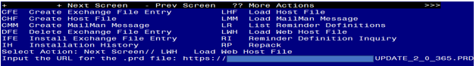
You should see a message that the file was loaded successfully.

Search and locate an entry titled UPDATE_2_0_365 VA-LONG COVID-19 CONSULT RESPONSE in reminder exchange.
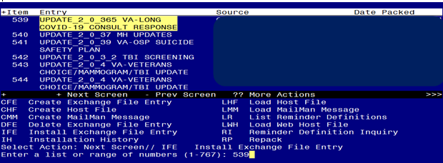
At the Select Action prompt, enter IFE for Install Exchange File Entry
Enter the number that corresponds with your entry titled UPDATE_2_0_365 VA-LONG COVID-19 CONSULT RESPONSE (in this example it is entry 365, it will vary by site) that is dated 06/16/2023.

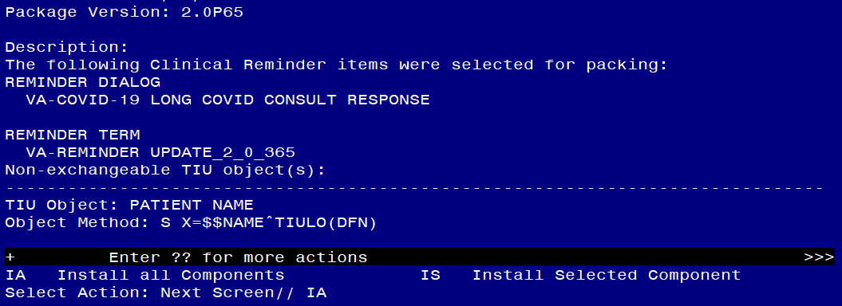
At the Select Action prompt, type IA for Install all Components and hit enter.
For all new entries in any category you will choose I to Install
Skip any items in any category you are prompted to overwrite

You will then be prompted to install the dialog component.
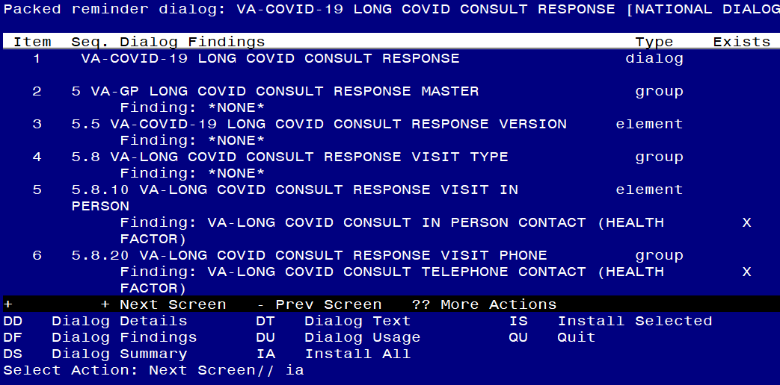
At the Select Action prompt, type IA to install the dialog – VA-COVID-19 LONG COVID CONSULT RESPONSE
Install reminder dialog and all components with no further changes: Y//ES

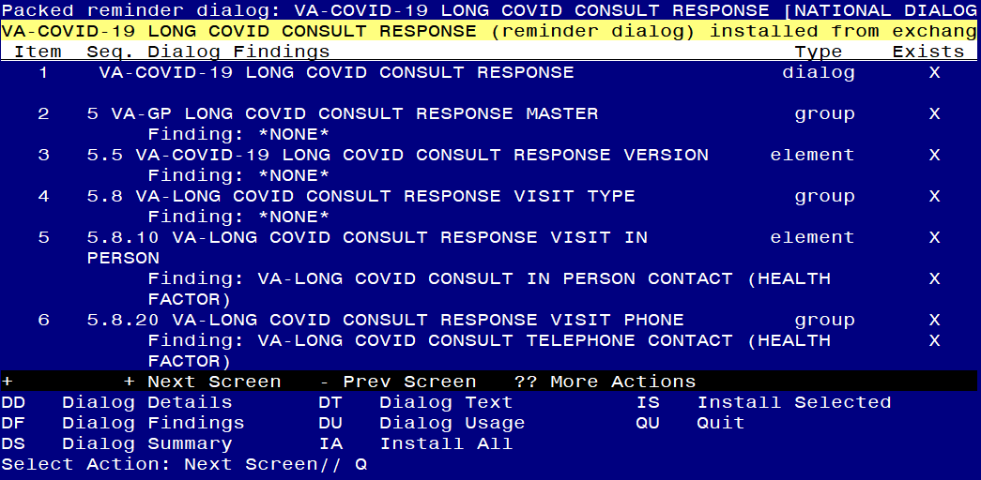

When the dialog has completed installation, you will then be returned to this CONSULT RESPONSE. At the Select Action prompt, type Q.

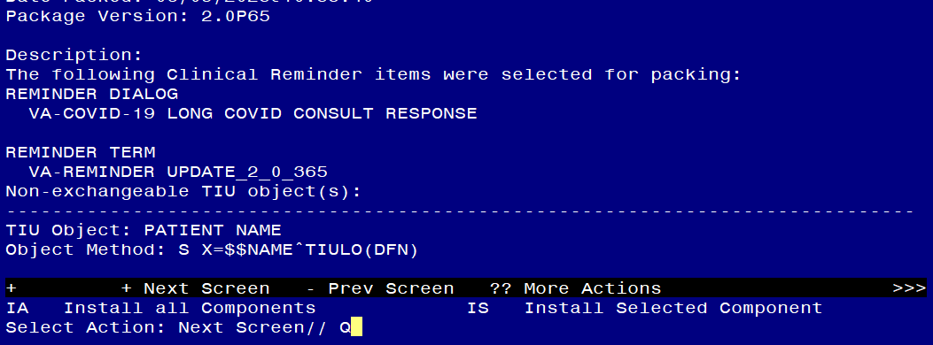
You will then be returned to this screen. At the Select Action prompt, type Q.

Install complete.

Post Installation
These first two post install steps should be completed by every site after installation:

- Add your local DATA OBJECT FOR PATIENT ADDRESS to the following element: VAL-TH VVC TELEPHONE TRIAGE PATIENT LOCATION HOME
Using the menu Reminder Dialog Management, Reminder Dialogs, change your view to Element.
Search for and edit the following element: VAL-TH VVC TELEPHONE TRIAGE PATIENT LOCATION HOME

- Add your local DATA OBJECT FOR PATIENT PHONE NUMBER to the following element: VAL-TH VVC TELEPHONE TRIAGE CONTACT PHONE OBJECT
Using the menu Reminder Dialog Management, Reminder Dialogs, change your view to Element.
Search for and edit the following element: VAL-TH VVC TELEPHONE TRIAGE CONTACT PHONE OBJECT

Sites that do not have a long covid program do not need to complete any remaining post install setup.

- Setup of Note Title.

The suggested note title to create to associate with this template is:

LONG COVID-19 CONSULT RESPONSE

**if your site has a specific consult note naming convention you can change this to align with your local practices, you can also decide to set up in the shared template folder only and not associate with a note title – consult with your local LONG-COVID-19 program on what their preference is **

VHA Enterprise Standard Title: CONSULT
You can add this to your consult document class. (if this will be used to close a consult)

Note: Comprehensive information on Creating new Document Classes and Titles can be found beginning on page 54 of the TIU/ASU Implementation Guide at the following link: http://www.va.gov/vdl/documents/Clinical/CPRS-Text_Integration_Utility_(TIU)/tiuim.pdf

- Make the Dialog templates available to be attached to a Personal or Shared templates or to be able to attach the dialog to a progress note title.
Select Reminder Managers Menu <TEST ACCOUNT> Option: CP CPRS Reminder Configuration
CA Add/Edit Reminder Categories
CL CPRS Lookup Categories
CS CPRS Cover Sheet Reminder List
MH Mental Health Dialogs Active
PN Progress Note Headers
RA Reminder GUI Resolution Active
TIU TIU Template Reminder Dialog Parameter
DEVL Evaluate Coversheet List on Dialog Finish
DL Default Outside Location
PT Position Reminder Text at Cursor
LINK Link Reminder Dialog to Template
TEST CPRS Coversheet Time Test
NP New Reminder Parameters
GEC GEC Status Check Active
WH WH Print Now Active
Select CPRS Reminder Configuration <TEST ACCOUNT> Option: TIU TIU Template Reminder Dialog Parameter
Reminder Dialogs allowed as Templates may be set for the following:
1 User USR [choose from NEW PERSON]
3 Service SRV [choose from SERVICE/SECTION]
4 Division DIV [SALT LAKE CITY]
5 System SYS [NATREM.FO-SLC.MED.VA.GOV]
Enter selection: 5 Choose the appropriate number for your site. Your site may do this by System or other levels. The example below uses SYSTEM level.
Setting Reminder Dialogs allowed as Templates for System: NATREM.FO-SLC.MED.VA.GOV
Select Display Sequence: ?
388 VA-COVID-19 TELEPHONE FOLLOW-UP
389 VA-SRA-CONSULT RESPONSE (D)
When you type a question mark above, you will see the list of #’s (with dialogs) that are already taken. Choose a number NOT on this list. For this example, 390 is not present so I will use 390.
Select Display Sequence: 390
Are you adding 390 as a new Display Sequence? Yes// YES
Display Sequence: 390// <Enter> 390
Clinical Reminder Dialog: VA-COVID-19 LONG COVID CONSULT RESPONSE reminder dialog NATIONAL
...OK? Yes// <Enter> (Yes)

- Associate the reminder dialogs with the note title in CPRS
- In CPRS, open the Template Editor, expand Document Titles, select the appropriate folder (if applicable), then click New Template (top right-hand corner).
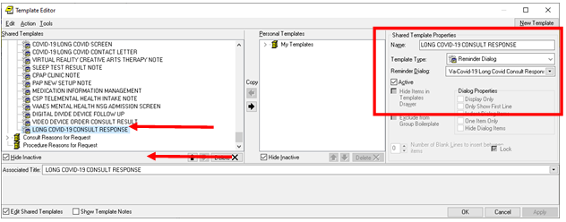

Type in the following information:
Name: LONG COVID-19 CONSULT RESPONSE
Template Type: Reminder Dialog
Reminder Dialog: VA-COVID-19 LONG COVID CONSULT RESPONSE
Next, type in the Associated Title name LONG COVID-19 CONSULT RESPONSE (or the note title you created in step 2)
–– then click Apply.

You may also want to add to your shared template folder, consult with your local Long COVID-19 program for their preferences.

- Add local object that represents military history.
Add your local objects that would represent military history to the reminder dialog element VAL-LONG COVID MILITARY HX. Replace the DIALOG/PROGRESS NOTE TEXT “<<insert local data object here>>” with any object(s) that you have that would represent a Veteran’s military history. This could include, branch of service, dates of service and service connection information.

- Add local object that represents most recent vital signs.
Add your local object that would represent the most recent vital signs to the reminder dialog element VAL-LONG COVID FOCUSED EXAM CURRENT VITALS. Replace the DIALOG/PROGRESS NOTE TEXT “<<insert object here>>” with an object that displays the most recent vital signs.

- Add additional local items to the consult response section (optional).
There are 2 disabled reminder dialog groups VAL-GP COVID-19 LONG COVID CONSULT RESPONSE LOCAL and VAL-GP COVID-19 LONG COVID CONSULT RESPONSE LOCAL 2 located below the option to document that well-being signs were reviewed. If your site would like to add additional items to the consult response template, you can edit these groups and add local content.

