Update _2_0_367

Clinical Reminders

VA-ONC LUNG CANCER FOLLOW UP AND CONSULT

Install Guide

August 2023

Product Development
Office of Information Technology
Department of Veterans Affairs

Table of Contents
Introduction 1
Pre-Install 1
Install Details 20
Install Example 20
Post Installation 27

Introduction

The purpose of these lung cancer follow-up and consult templates is to standardize follow-up care, regulate data capture, and to acquire the required documentation as determined by the National Oncology Program (NOP). Every VA with an Oncology program should be utilizing these notes to ensure standardized data capture for NOP dashboards.

In addition, the lung cancer clinical pathways are included the follow-up notes/consult reports to facilitate ease of use. Oncology Clinical Pathways (CPs) are decision-support tools that translate published evidence into standardized treatment process maps to help guide cancer treatment decisions. Oncology CPs are different from treatment guidelines, as CPs recommend a standard treatment based on efficacy, toxicity, and cost. VA Oncology CPs are developed by an interdisciplinary subject matter expert (SME) group and approved by national program offices.

The lung cancer follow-up reminder dialogs were built with the Cerner APSO (assessment, plan, subjective, objective) format. Furthermore, there are only 2 required mandatory fields. The 5 reminder dialog templates will be utilized by all VA medical centers with an Oncology service. Additionally, the 5 reminder dialog templates will also be used as consult reports and utilized by all Oncology providers:
Nurse Practitioners
Physician Assistants
Residents
Fellows
Physicians

VHA Directive 1415 requires that all sites use the National Oncology templates. If your site does not provide oncology services, the site must request a waiver to exempt it from the requirement to use the National Oncology templates. The waiver can be requested by emailing REDACTED

Pre-Install
Using the VistA menu Reminder Dialog Manager, Reminder Dialog, change your view to elements and do an inquire/print on the following reminder dialog elements, you will need to use this as a reference to use when adding the following orderable items during post-install. You may not have anything mapped to these elements. This was an optional step in the previous lung pathways install.

• VA-ONC RADIATION ONCOLOGY CONSULT
• VA-ONC LUNG REFER TO PALLIATIVE CARE
• VAL-ONC LUNG IVB POS 1ST OTHER
• VA-ONC HOSPICE REFERRAL
• VA-ONC LUNG SURGICAL CONSULT
• VA-EL ONC LUNG ON PDL1
• VA-EL ONC LUNG PTHWY NGS ON
• VA-EL ONC LUNG PTHWY LIQUID BIOPSY

UPDATE_2_0_367 contains 1 Reminder Exchange entry:

UPDATE_2_0_367 VA-ONC LUNG CANCER FOLLOW UP AND CONSULT REPORT

The exchange file contains the following components:

REMINDER GENERAL FINDINGS
VIEW PROGRESS NOTE TEXT

TEMPLATE FIELD
VA-ONC CN PREVIOUS NOTE VIEW
VA-ONC PRESUMPTIVE CONDITIONS
VA-ONC PATHWAYS SHAREPOINT
VA-ONC NPOP SHAREPOINT
VA-ONC CLINICAL TRIAL
VA-ONC OFF REASON TXT
VA-ONC TREATMENT REASON
VA-ONC WP 2 LINES
EDIT 55+
TELEHEALTH EMERGENCIES VA LOCATIONS
TELEHEALTH EMERGENCIES NON-VA LOCATIONS
VA-ONC VAMC SITE NAME
TEXT (1-50 CHAR)
VA-ONC CN EMOTIONAL WB
DATE
VA-ONC CN LUNG CHIEF COMPLAINT

HEALTH FACTORS
VA-REMINDER UPDATES [C]
VA-UPDATE_2_0_367
VA-ONC CN [C]
VA-ONC CN LUNG
VA-ONC LUNG SCLC LIMITED STAGE 1ST LINE PATHWAY [C]
VA-ONC LUNG SCLC LIMITED SUB PS3-4 OFF PATH RSN
VA-ONC LUNG SCLC LIMITED SUB PS3-4 OFF PATH TX
VA-ONC LUNG SCLC LIMITED SUB PS3-4 MRI SURVEILLANCE
VA-ONC LUNG SCLC LIMITED SUB PS3-4 CLINICAL TRIAL
VA-ONC LUNG SCLC LIMITED SUB NO PROG OFF PATH RSN
VA-ONC LUNG SCLC LIMITED SUB NO PROG OFF PATH TX
VA-ONC LUNG SCLC LIMITED SUB NO PROG REFER RAD ONC
VA-ONC LUNG SCLC LIMITED SUB NO PROG CLINICAL TRIAL
VA-ONC LUNG SCLC LIMITED INITIAL OFF PATH RSN
VA-ONC LUNG SCLC LIMITED INITIAL OFF PATH TX
VA-ONC LUNG SCLC LIMITED INITIAL CIS+ETO+CHEST RAD
VA-ONC LUNG SCLC LIMITED INITIAL CLINICAL TRIAL
VA-ONC LUNG SCLC LIMITED INITIAL CONTRA OFF PATH RSN
VA-ONC LUNG SCLC LIMITED INITIAL CONTRA OFF PATH TX
VA-ONC LUNG SCLC LIMITED INITIAL CONTRA CARBO+ETO+CHEST RAD
VA-ONC LUNG SCLC LIMITED INITIAL CONTRA CLINICAL TRIAL
VA-ONC LUNG SQUAMOUS RELAPSE PATHWAY [C]
VA-ONC LUNG SQR 2ND IMMUNO AMEN RAD OFF PATH REASON
VA-ONC LUNG SQR 3RD LINE NOT AMEN RAD OFF PATH REASON
VA-ONC LUNG SQR 3RD LINE NOT AMEN RAD OFF PATH TX
VA-ONC LUNG SQR 3RD LINE NOT AMEN RAD REFER PALL CARE
VA-ONC LUNG SQR 3RD LINE NOT AMEN RAD CLINICAL TRIAL
VA-ONC LUNG SQR 3RD LINE AMEN RAD OFF PATH REASON
VA-ONC LUNG SQR 3RD LINE AMEN RAD OFF PATH TX
VA-ONC LUNG SQR 3RD LINE AMEN RAD REFER RAD ONC
VA-ONC LUNG SQR 3RD LINE AMEN RAD CLINICAL TRIAL
VA-ONC LUNG SQR 2ND IMMUNO NOT AMEN RAD OFF PATH REASON
VA-ONC LUNG SQR 2ND IMMUNO NOT AMEN RAD OFF PATH TX
VA-ONC LUNG SQR 2ND IMMUNO NOT AMEN RAD CARBO+PACLITAXEL
VA-ONC LUNG SQR 2ND IMMUNO NOT AMEN RAD CLINICAL TRIAL
VA-ONC LUNG SQR 2ND IMMUNO AMEN RAD OFF PATH TX
VA-ONC LUNG SQR 2ND IMMUNO AMEN RAD REFER RAD ONC
VA-ONC LUNG SQR 2ND IMMUNO AMEN RAD CLINICAL TRIAL
VA-ONC LUNG SQR 2ND CHEMO+/-IMMUNO NOT AMEN RAD OFF PATH RSN
VA-ONC LUNG SQR 2ND CHEMO+/-IMMUNO NOT AMEN RAD OFF PATH TX
VA-ONC LUNG SQR 2ND CHEMO+/-IMMUNO NOT AMEN RAD DOCETAXEL
VA-ONC LUNG SQR 2ND CHEMO+/-IMMUNO NOT AMEN RAD CLINICAL TRIAL
VA-ONC LUNG SQR 2ND CHEMO+/-IMMUNO AMEN RAD OFF PATH REASON
VA-ONC LUNG SQR 2ND CHEMO+/-IMMUNO AMEN RAD OFF PATH TX
VA-ONC LUNG SQR 2ND CHEMO+/-IMMUNO AMEN RAD REFER RAD ONC
VA-ONC LUNG SQR 2ND CHEMO+/-IMMUNO AMEN RAD CLINICAL TRIAL
ONCOLOGY (ONC) LUNG CANCER TREATMENTS [C]
ONC LUNG PALLIATIVE REFERRAL
VA-ONC LUNG SCLC RELAPSE PATHWAY [C]
VA-ONC LUNG SCLC RELAPSE >6M OFF PATH RSN
VA-ONC LUNG SCLC RELAPSE >6M OFF PATH TX
VA-ONC LUNG SCLC RELAPSE >6M CARBO+ETO
VA-ONC LUNG SCLC RELAPSE >6M CLINICAL TRIAL
VA-ONC LUNG SCLC RELAPSE PS 3-4 OFF PATH RSN
VA-ONC LUNG SCLC RELAPSE PS 3-4 OFF PATH TX
VA-ONC LUNG SCLC RELAPSE PS 3-4 REFER HOSPICE
VA-ONC LUNG SCLC RELAPSE PS 3-4 CLINICAL TRIAL
VA-ONC LUNG SCLC RELAPSE PS 0-1-2 OFF PATHWAY RSN
VA-ONC LUNG SCLC RELAPSE PS 0-1-2 OFF PATHWAY TX
VA-ONC LUNG SCLC RELAPSE PS 0-1-2 LURBINECTEDIN
VA-ONC LUNG SCLC RELAPSE PS 0-1-2 CLINICAL TRIAL
VA-ONC LUNG SCLC RELAPSE >6M CARBO+ETO+ATEZ
VA-ONC LUNG SCLC EXTENSIVE STAGE CLINICAL PATHWAY [C]
VA-ONC LUNG SCLC EXT SUB NO PROG OFF PATH RSN
VA-ONC LUNG SCLC EXT SUB NO PROG OFF PATH TX
VA-ONC LUNG SCLC EXT SUB NO PROG MAIN ATEZO
VA-ONC LUNG SCLC EXT SUB NO PROG CLINICAL TRIAL
VA-ONC LUNG SCLC EXT INI IMMUNO OFF PATH RSN
VA-ONC LUNG SCLC EXT INI IMMUNO OFF PATH TX
VA-ONC LUNG SCLC EXT INI IMMUNO REFER HOSPICE
VA-ONC LUNG SCLC EXT INI IMMUNO CLINICAL TRIAL
VA-ONC LUNG SCLC EXT INI CHEMO OFF PATH RSN
VA-ONC LUNG SCLC EXT INI CHEMO OFF PATH TX
VA-ONC LUNG SCLC EXT INI CHEMO CARBO+ETO
VA-ONC LUNG SCLC EXT INI CHEMO CLINICAL TRIAL
VA-ONC LUNG SCLC EXT INI CHEMO/IMMUNO OFF PATH RSN
VA-ONC LUNG SCLC EXT INI CHEMO/IMMUNO OFF PATH TX
VA-ONC LUNG SCLC EXT INI CHEMO/IMMUNO CARBO+ETO+ATEZO
VA-ONC LUNG SCLC EXT INI CHEMO/IMMUNO CLINICAL TRIAL
VA-ONC LUNG SCLC EXT SYMPTOM METS OFF PATH RSN
VA-ONC LUNG SCLC EXT SYMPTOM METS OFF PATH TX
VA-ONC LUNG SCLC EXT SYMPTOM METS CLINICAL TRIAL
VA-ONC LUNG SCLC EXT SYMPTOM METS REFER RAD ONC
VA-ONC LUNG SCLC INCIDENTAL DISCOVERY PATHWAY [C]
VA-ONC LUNG SCLC INCIDENTAL INCOMPLETE RESECT OFF PATH RSN
VA-ONC LUNG SCLC INCIDENTAL INCOMPLETE RESECT OFF PATH TX
VA-ONC LUNG SCLC INCIDENTAL INCOMPLETE RESECT CIS+ETO+RAD
VA-ONC LUNG SCLC INCIDENTAL INCOMPLETE RESECT CLINICAL TRIAL
VA-ONC LUNG SCLC INCIDENTAL COMPLETE RESECT OFF PATH RSN
VA-ONC LUNG SCLC INCIDENTAL COMPLETE RESECT OFF PATH TX
VA-ONC LUNG SCLC INCIDENTAL COMPLETE RESECT CIS+ETO
VA-ONC LUNG SCLC INCIDENTAL COMPLETE RESECT CLINICAL TRIAL
VA-ONC LUNG NSCLC STAGE IVA M1B/M1A PATHWAY [C]
VA-ONC LUNG IVA M1B/M1A AMEN DEF TX OFF PATHWAY REASON
VA-ONC LUNG IVA M1B/M1A AMEN DEF TX OFF PATHWAY TX
VA-ONC LUNG IVA M1B/M1A AMEN DEF TX REFER RAD ONC/ONC/SURG
VA-ONC LUNG IVA M1B/M1A AMEN DEF TX CLINICAL TRIAL
VA-ONC LUNG NON-SQUAMOUS RELAPSE PATHWAY [C]
VA-ONC LUNG NSR 3RD LINE AMEN RAD OFF PATH RSN
VA-ONC LUNG NSR 3RD LINE AMEN RAD OFF PATH TX
VA-ONC LUNG NSR 3RD LINE AMEN RAD ONC
VA-ONC LUNG NSR 3RD LINE AMEN RAD CLINICAL TRIAL
VA-ONC LUNG NSR 2ND IMMUNO AMEN RAD OFF PATH RSN
VA-ONC LUNG NSR 2ND IMMUNO AMEN RAD OFF PATH TX
VA-ONC LUNG NSR 2ND IMMUNO AMEN RAD ONC
VA-ONC LUNG NSR 2ND IMMUNO AMEN RAD CLINICAL TRIAL
VA-ONC LUNG NSR 2ND CHEMO+/-IMMUNO AMEN RAD OFF PATH RSN
VA-ONC LUNG NSR 2ND CHEMO+/-IMMUNO AMEN RAD OFF PATH TX
VA-ONC LUNG NSR 2ND CHEMO+/-IMMUNO AMEN RAD ONC
VA-ONC LUNG NSR 2ND CHEMO+/-IMMUNO AMEN RAD CLINICAL TRIAL
VA-ONC LUNG NSR 2ND CHEMO+/-IMMUNO EGFR EXON 20 INS MOBOCERTINIB
VA-ONC LUNG NSR 2ND S/P IMMUNO PROG EGFREX20 MOBOCERTINIB
VA-ONC LUNG NSR 2ND CHEMO+/-IMMUNO HER2 OFF PATH RSN
VA-ONC LUNG NSR 2ND CHEMO+/-IMMUNO HER2 OFF PATH TX
VA-ONC LUNG NSR 2ND CHEMO+/-IMMUNO HER2 TRASTUZUMAB
VA-ONC LUNG NSR 2ND CHEMO+/-IMMUNO HER2 CLINICAL TRIAL
VA-ONC LUNG NSR 2ND S/P IMMUNO PROG HER2 OFF PATH RSN
VA-ONC LUNG NSR 2ND S/P IMMUNO PROG HER2 OFF PATH TX
VA-ONC LUNG NSR 2ND S/P IMMUNO PROG HER2 TRASTUZUMAB
VA-ONC LUNG NSR 2ND S/P IMMUNO PROG HER2 CLINICAL TRIAL
VA-ONC LUNG NSR 2ND CHEMO+/-IMMUNO KRAS G12 SOTORASIB
VA-ONC LUNG NSR 2ND S/P IMMUNO PROG NO KRASG12/EGFREX20 OFF RSN
VA-ONC LUNG NSR 2ND S/P IMMUNO PROG NO KRASG12/EGFRX20 OFF TX
VA-ONC LUNG NSR 2ND S/P IMMUNO PROG NO KRASG12/EGFREX20 DOC
VA-ONC LUNG NSR 2ND S/P IMMUNO PROG NO KRASG12/EGFREX20 CLIN TR
VA-ONC LUNG NSR 2ND S/P IMMUNO PROG EGFREX20 OFF PATH REASON
VA-ONC LUNG NSR 2ND S/P IMMUNO PROG EGFREX20 OFF PATH TREATMENT
VA-ONC LUNG NSR 2ND S/P IMMUNO PROG EGFREX20 AMIVANTAMAB
VA-ONC LUNG NSR 2ND S/P IMMUNO PROG EGFREX20 CLIN TRIAL
VA-ONC LUNG NSR 2ND CHEMO+/-IMMUNO NO KRASG12/EGFREX20 OFF RSN
VA-ONC LUNG NSR 2ND CHEMO+/-IMMUNO NO KRASG12/EGFREX20 OFF TX
VA-ONC LUNG NSR 2ND CHEMO+/-IMMUNO NO KRASG12/EGFREX20 DOCETAXEL
VA-ONC LUNG NSR 2ND CHEMO+/-IMMUNO NO KRASG12/EGFREX20 CLIN TR
VA-ONC LUNG NSR 2ND S/P IMMUNO PROG KRAS G12C OFF PATH RSN
VA-ONC LUNG NSR 2ND IMMUNO ALONE OFF PATHWAY REASON
VA-ONC LUNG NSR 2ND CHEMO+/-IMMUNO EGFR EXON 20 INS OFF PATH RSN
VA-ONC LUNG NSR 3RD LINE PREV DOCETAXEL OFF PATHWAY REASON
VA-ONC LUNG NSR 3RD LINE NO PREV DOCE TX OFF PATH REASON
VA-ONC LUNG NSR 2ND CHEMO+/-IMMUNO KRAS G12 OFF PATH REASON
VA-ONC LUNG NSR 3RD LINE PREV DOCETAXEL OFF PATHWAY TX
VA-ONC LUNG NSR 3RD LINE PREV DOCETAXEL REFER TO HOSPICE
VA-ONC LUNG NSR 3RD LINE PREV DOCETAXEL CLINICAL TRIAL
VA-ONC LUNG NSR 3RD LINE NO PREV DOCE TX OFF PATH TX
VA-ONC LUNG NSR 3RD LINE NO PREV DOCE TX DOCETAXEL
VA-ONC LUNG NSR 3RD LINE NO PREV DOCE TX CLINICAL TRIAL
VA-ONC LUNG NSR 2ND S/P IMMUNO PROG KRAS G12C OFF PATH TX
VA-ONC LUNG NSR 2ND S/P IMMUNO PROG KRAS G12C SOTORASIB
VA-ONC LUNG NSR 2ND S/P IMMUNO PROG KRAS G12C CLIN TRIAL
VA-ONC LUNG NSR 2ND IMMUNO ALONE OFF PATHWAY TX
VA-ONC LUNG NSR 2ND IMMUNO ALONE CARBOPLATIN+PEMET REXED
VA-ONC LUNG NSR 2ND CHEMO+/-IMMUNO EGFR EXON 20 INS OFF PATH TX
VA-ONC LUNG NSR 2ND IMMUNO ALONE CLINICAL TRIAL
VA-ONC LUNG NSR 2ND CHEMO+/-IMMUNO EGFR EXON 20 INS CLIN TRIAL
VA-ONC LUNG NSR 2ND CHEMO+/-IMMUNO KRAS G12 OFF PATH TX
VA-ONC LUNG NSR 2ND CHEMO+/-IMMUNO EGFR EXON 20 INS AMIVANTAMAB
VA-ONC LUNG NSR 2ND CHEMO+/-IMMUNO KRAS G12 CLINICAL TRIAL
VA-ONC LUNG IVA/IVB MUTATION NEGATIVE PATHWAY [C]
VA-ONC LUNG IVA/IVB NEG MUT NO /CHEMO/IMMUNO OFF PATHWAY REASON
VA-ONC LUNG IVA/IVB NEG MUT NO CHEMO/IMMUNO OFF PATHWAY TX
VA-ONC LUNG IVA/IVB NEG MUT NO CHEMO/IMMUNO HOSPICE
VA-ONC LUNG IVA/IVB NEG MUT NO CHEMO/IMMUNO CLINICAL TRIAL
VA-ONC LUNG IVA/IVB NEG MUT PDL1>=50 CHEMO PEMBROLIZUMAB ALONE
VA-ONC LUNG IVA/IVB NEG MUT NO IMMUNO OFF PATHWAY TX
VA-ONC LUNG IVA/IVB NEG MUT NO IMMUNO CLINICAL TRIAL
VA-ONC LUNG IVA/IVB NEG MUT NO IMMUNO OFF PATHWAY REASON
VA-ONC LUNG IVA/IVB NEG MUT NO IMMUNO CARBO+PEM
VA-ONC LUNG IVA/IVB NEG MUT PDL1>=50 CHEMO OFF PATHWAY REASON
VA-ONC LUNG IVA/IVB NEG MUT PDL1>1 NO CHEMO OFF PATHWAY REASON
VA-ONC LUNG IVA/IVB NEG MUT PDL1<50 CHEMO OFF PATHWAY REASON
VA-ONC LUNG IVA/IVB NEG MUT PDL1>1 NO CHEMO OFF PATHWAY TX
VA-ONC LUNG IVA/IVB NEG MUT PDL1>1 NO CHEMO PEMBRO ALONE
VA-ONC LUNG IVA/IVB NEG MUT PDL1>=50 CHEMO OFF PATHWAY TX
VA-ONC LUNG IVA/IVB NEG MUT PDL1>=50 CHEMO CLINICAL TRIAL
VA-ONC LUNG IVA/IVB NEG MUT PDL1>1 NO CHEMO CLINICAL TRIAL
VA-ONC LUNG IVA/IVB NEG MUT PDL1>=50 CHEMO EMBRO+CARBO+PEMETREX
VA-ONC LUNG IVA/IVB NEG MUT PDL1<50 CHEMO OFF PATHWAY TX
VA-ONC LUNG IVA/IVB NEG MUT PDL1<50 CHEMO PEMBRO+CARBO+PEMETREX
VA-ONC LUNG IVA/IVB NEG MUT PDL1<50 CHEMO CLINICAL TRIAL
VA-ONC LUNG IVA/IVB MUTATION POSITIVE PATHWAY [C]
VA-ONC LUNG IVA/IVB SUB POS MUT EGFR 19/21 L858R OFF PATH REASON
VA-ONC LUNG IVA/IVB SUB POS MUT EGFR 19/21 L858R FF PATH TX
VA-ONC LUNG IVA/IVB SUB POS MUT EGFR 19/21 L858R DOCETAXEL
VA-ONC LUNG IVA/IVB SUB POS MUT EGFR 19/21 L858R CLINICAL TRIAL
VA-ONC LUNG IVA/IVB SUB POS MUT ALL OTHER MUT OFF PATHWAY RSN
VA-ONC LUNG IVA/IVB SUB POS MUT ALK GENE FUSION OFF PATHWAY RSN
VA-ONC LUNG IVA/IVB 2ND POS MUT ALL OTHER MUT OFF PATHWAY REASON
VA-ONC LUNG IVA/IVB 2ND POS MUT EXON19/21 L858R OFF PATHWAY RSN
VA-ONC LUNG IVA/IVB 2ND POS MUT ALK GENE FUSION OFF PATHWAY RSN
VA-ONC LUNG IVA/IVB 1ST POS MUT ROS1 GENE FUSION OFF PATHWAY RSN
VA-ONC LUNG IVA/IVB 1ST POS MUT RET REARRANGE OFF PATHWAY REASON
VA-ONC LUNG IVA/IVB 1ST POS MUT NTRK GENE FUSION OFF PATHWAY RSN
VA-ONC LUNG IVA/IVB 1ST POS MUT MET EXON 14 SKIP OFF PATHWAY RSN
VA-ONC LUNG IVA/IVB 1ST POS MUT EGFR 19/21 L858R OFF PATHWAY RSN
VA-ONC LUNG IVA/IVB 1ST POS MUT BRAF V600E OFF PATHWAY REASON
VA-ONC LUNG IVA/IVB 1ST POS MUT ALK GENE FUSION OFF PATHWAY RSN
VA-ONC LUNG IVA/IVB 1ST POS MUT NTRK GENE FUSION ENTRECTINIB
VA-ONC LUNG IVA/IVB SUB POS MUT ALL OTHER MUT OFF PATHWAY TX
VA-ONC LUNG IVA/IVB SUB POS MUT ALL OTHER MUT DOCETAXEL
VA-ONC LUNG IVA/IVB SUB POS MUT ALL OTHER MUT CLINICAL TRIAL
VA-ONC LUNG IVA/IVB SUB POS MUT ALK GENE FUSION OFF PATHWAY TX
VA-ONC LUNG IVA/IVB SUB POS MUT ALK GENE FUSION DOCETAXEL
VA-ONC LUNG IVA/IVB SUB POS MUT ALK GENE FUSION CARBO+PEM+/-CI
VA-ONC LUNG IVA/IVB SUB POS MUT ALK GENE FUSION CLINICAL TRIAL
VA-ONC LUNG IVA/IVB 2ND POS MUT ALL OTHER MUT OFF PATHWAY TX
VA-ONC LUNG IVA/IVB 2ND POS MUT ALL OTHER MUT CARBO+PEM+/-CI
VA-ONC LUNG IVA/IVB 2ND POS MUT ALL OTHER MUT CLINICAL TRIAL
VA-ONC LUNG IVA/IVB 2ND POS MUT ALK GENE FUSION OFF PATHWAY TX
VA-ONC LUNG IVA/IVB 2ND POS MUT ALK GENE FUSION LORLATINIB
VA-ONC LUNG IVA/IVB 2ND POS MUT ALK GENE FUSION CLINICAL TRIAL
VA-ONC LUNG IVA/IVB 2ND POS MUT EXON19/21 L858R OFF PATHWAY TX
VA-ONC LUNG IVA/IVB 2ND POS MUT EXON19/21 L858R CARBO+PEM+/-CI
VA-ONC LUNG IVA/IVB 2ND POS MUT EXON19/21 L858R CLINICAL TRIAL
VA-ONC LUNG IVA/IVB 1ST POS MUT NON STANDARD NPOP CONSULT
VA-ONC LUNG IVA/IVB 1ST POS MUT NTRK GENE FUSION OFF PATHWAY TX
VA-ONC LUNG IVA/IVB 1ST POS MUT NTRK GENE FUSION CLINICAL TRIAL
VA-ONC LUNG IVA/IVB 1ST POS MUT BRAF V600E OFF PATHWAY TX
VA-ONC LUNG IVA/IVB 1ST POS MUT BRAF V600E DABRAFENIB+TRAMETINIB
VA-ONC LUNG IVA/IVB 1ST POS MUT BRAF V600E CLINICAL TRIAL
VA-ONC LUNG IVA/IVB 1ST POS MUT ROS1 GENE FUSION OFF PATHWAY TX
VA-ONC LUNG IVA/IVB 1ST POS MUT ROS1 GENE FUSION ENTRECTINIB
VA-ONC LUNG IVA/IVB 1ST POS MUT ROS1 GENE FUSION CLINICAL TRIAL
VA-ONC LUNG IVA/IVB 1ST POS MUT RET REARRANGE OFF PATHWAY TX
VA-ONC LUNG IVA/IVB 1ST POS MUT RET REARRANGE SELPERCATNIB
VA-ONC LUNG IVA/IVB 1ST POS MUT RET REARRANGE CLINICAL TRIAL
VA-ONC LUNG IVA/IVB 1ST POS MUT MET EXON 14 SKIP OFF PATHWAY TX
VA-ONC LUNG IVA/IVB 1ST POS MUT MET EXON 14 SKIP CAPMATINIB
VA-ONC LUNG IVA/IVB 1ST POS MUT MET EXON 14 SKIP CLINICAL TRIAL
VA-ONC LUNG IVA/IVB 1ST POS MUT ALK GENE FUSION OFF PATHWAY TX
VA-ONC LUNG IVA/IVB 1ST POS MUT ALK GENE FUSION ALECTINIB
VA-ONC LUNG IVA/IVB 1ST POS MUT ALK GENE FUSION CLINICAL TRIAL
VA-ONC LUNG IVA/IVB 1ST POS MUT EGFR 19/21 L858R OFF PATHWAY TX
VA-ONC LUNG IVA/IVB 1ST POS MUT EGFR 19/21 L858R OSIMERTINIB
VA-ONC LUNG IVA/IVB 1ST POS MUT EGFR 19/21 L858R CLINICAL TRIAL
VA-ONC LUNG SQUAMOUS STAGE IVB PATHWAY [C]
VA-ONC LUNG SQUIVB PDL1 >=50% PEM ALONE
VA-ONC LUNG SQUIVB NO IMMUNO\NO CHEMO OFF PATH REASON
VA-ONC LUNG SQUIVB NO IMMUNO\NO CHEMO OFF PATH TX
VA-ONC LUNG SQUIVB NO IMMUNO\NO CHEMO REFER HOSPICE
VA-ONC LUNG SQUIVB NO IMMUNO\NO CHEMO CLINICAL TRIAL
VA-ONC LUNG SQUIVB PD-L1>=1% IMMUNO ONLY OFF PATH REASON
VA-ONC LUNG SQUIVB PD-L1>=1% IMMUNO ONLY OFF PATH TX
VA-ONC LUNG SQUIVB PD-L1>=1% IMMUNO ONLY PEMBRO
VA-ONC LUNG SQUIVB PD-L1>=1% IMMUNO ONLY CLINICAL TRIAL
VA-ONC LUNG SQUIVB CHEMO ONLY OFF PATH REASON
VA-ONC LUNG SQUIVB CHEMO ONLY OFF PATH TX
VA-ONC LUNG SQUIVB CHEMO ONLY CARBO+PAC
VA-ONC LUNG SQUIVB CHEMO ONLY CLINICAL TRIAL
VA-ONC LUNG SQUIVB PDL1 >=50% OFF PATHWAY REASON
VA-ONC LUNG SQUIVB PDL1 >=50% OFF PATHWAY TX
VA-ONC LUNG SQUIVB PDL1 >=50% PEM+CARBO+PAC +PEM MAIN
VA-ONC LUNG SQUIVB PDL1 >=50% CLINICAL TRIAL
VA-ONC LUNG SQUIVB PDL1 0-49% OFF PATHWAY REASON
VA-ONC LUNG SQUIVB PDL1 0-49% OFF PATHWAY TX
VA-ONC LUNG SQUIVB PDL1 0-49% PEM+CARBO+PAC
VA-ONC LUNG SQUIVB PDL1 0-49% CLINICAL TRIAL
VA-ONC LUNG SQUIVB SYMPTOMATIC REFER RAD ONC
VA-ONC LUNG METASTATIC NSCLC MOLECULAR TESTING [C]
VA-ONC LUNG TISSUE SUFFICIENCY UNKNOWN
VA-ONC LUNG CGP ORDER FUTURE DATE
VA-ONC LUNG PD-L1 ORDER FUTURE DATE
VA-ONC LUNG LIQUID BIOPSY: ON PATH
VA-ONC LUNG TISSUE SUFFICIENT: OFF PATH
VA-ONC LUNG REASSESS: ON PATH
VA-ONC LUNG REPEAT BIOPSY: ON PATH
VA-ONC LUNG TISSUE SUFFICIENT: ON PATH
VA-ONC LUNG CGP ORDER: OFF PATH
VA-ONC LUNG CGP ORDER: ON PATH
VA-ONC LUNG PD-L1 ORDER: OFF PATH
VA-ONC LUNG PD-L1 ORDER: ON PATH
VA-ONC LUNG NSCLC STAGE III UNRESECTABLE CLINICAL PATHWAY [C]
VA-ONC LUNG NSCLC III UNRESECT S/P CHEMO OFF PATH RSN
VA-ONC LUNG NSCLC III UNRESECT S/P CHEMO OFF PATH TX
VA-ONC LUNG NSCLC III UNRESECT S/P CHEMO SURVEILLANCE
VA-ONC LUNG NSCLC III UNRESECT S/P CHEMO CLINICAL TRIAL
VA-ONC LUNG NSCLC III UNRESECT SUB NO IMMUNO OFF PATH RSN
VA-ONC LUNG NSCLC III UNRESECT SUB NO IMMUNO OFF PATH TX
VA-ONC LUNG NSCLC III UNRESECT SUB NO IMMUNO SURVEILLANCE
VA-ONC LUNG NSCLC III UNRESECT SUB NO IMMUNO CLIN TRIAL
VA-ONC LUNG NSCLC III UNRESECT SUB IMMUNO OFF PATH RSN
VA-ONC LUNG NSCLC III UNRESECT SUB IMMUNO OFF PATH TX
VA-ONC LUNG NSCLC III UNRESECT SUB IMMUNO DURVALUMAB
VA-ONC LUNG NSCLC III UNRESECT SUB IMMUNO CLIN TRIAL
VA-ONC LUNG NSCLC III UNRESECT INI SQU OFF PATH RSN
VA-ONC LUNG NSCLC III UNRESECT INI SQU OFF PATH TX
VA-ONC LUNG NSCLC III UNRESECT INI SQU CARBO+PAC+RAD
VA-ONC LUNG NSCLC III UNRESECT INI SQU CLINICAL TRIAL
VA-ONC LUNG NSCLC III UNRESECT INI NSQ OFF PATH RSN
VA-ONC LUNG NSCLC III UNRESECT INI NSQ OFF PATH TX
VA-ONC LUNG NSCLC III UNRESECT INI NSQ CARBO+PEM+RAD
VA-ONC LUNG NSCLC III UNRESECT INI NSQ CLINICAL TRIAL
VA-ONC LUNG NSCLC III UNRESECT INI CON RAD OFF PATH RSN
VA-ONC LUNG NSCLC III UNRESECT INI CON RAD OFF PATH TX
VA-ONC LUNG NSCLC III UNRESECT INI CON RAD CARBO+PAC+RAD
VA-ONC LUNG NSCLC III UNRESECT INI CON RAD CLINICAL TRIAL
VA-ONC LUNG PANCOAST CLINICAL PATHWAY [C]
VA-ONC LUNG PAN NO SURG/YES CON CIS/ETO OFF PATH RSN
VA-ONC LUNG PAN NO SURG/YES CON CIS/ETO OFF PATH TX
VA-ONC LUNG PAN NO SURG/YES CON CIS/ETO ARBO+PAC+RAD+DURVALUMAB
VA-ONC LUNG PAN NO SURG/YES CON CIS/ETO CLINICAL TRIAL
VA-ONC LUNG PAN NO SURG/NO CON CIS/ETO OFF PATH RSN
VA-ONC LUNG PAN NO SURG/NO CON CIS/ETO OFF PATH TX
VA-ONC LUNG PAN NO SURG/NO CON CIS/ETO +RAD+DURVALUMAB
VA-ONC LUNG PAN SURG/YES CON CIS/ETO OFF PATH RSN
VA-ONC LUNG PAN NO SURG/NO CON CIS/ETO CLINICAL TRIAL
VA-ONC LUNG PAN SURG/YES CON CIS/ETO OFF PATH TX
VA-ONC LUNG PAN SURG/YES CON CIS/ETO CARBO+PAC+RAD+SURG
VA-ONC LUNG PAN SURG/YES CON CIS/ETO CLINICAL TRIAL
VA-ONC LUNG PAN SURG/NO CON CIS/ETO OFF PATH RSN
VA-ONC LUNG PAN SURG/NO CON CIS/ETO OFF PATH TX
VA-ONC LUNG PAN SURG/NO CON CIS/ETO +RAD+SURG
VA-ONC LUNG PAN SURG/NO CON CIS/ETO CLINICAL TRIAL
VA-ONC LUNG NSCLC IIIA CLINICAL PATHWAY [C]
VA-ONC LUNG NSCLC IIIA R1/R2 NO RRS OFF PATH RSN
VA-ONC LUNG NSCLC IIIA R1/R2 NO RRS OFF PATH TX
VA-ONC LUNG NSCLC IIIA R1/R2 NO RRS REF RADONC
VA-ONC LUNG NSCLC IIIA R1/R2 NO RRS CLIN TRIAL
VA-ONC LUNG NSCLC IIIA R1/R2 RRS OFF PATH RSN
VA-ONC LUNG NSCLC IIIA R1/R2 RRS OFF PATH TX
VA-ONC LUNG NSCLC IIIA R1/R2 RRS RERESECT
VA-ONC LUNG NSCLC IIIA R1/R2 RRS CLIN TRIAL
VA-ONC LUNG NSCLC IIIA R0 OFF PATH RSN
VA-ONC LUNG NSCLC IIIA R0 OFF PATH TX
VA-ONC LUNG NSCLC IIIA R0 SURVEILLANCE
VA-ONC LUNG NSCLC IIIA R0 CLIN TRIAL
VA-ONC LUNG NSCLC IIIA NO PROG OFF PATH RSN
VA-ONC LUNG NSCLC IIIA NO PROG OFF PATH TX
VA-ONC LUNG NSCLC IIIA NO PROG SURGERY
VA-ONC LUNG NSCLC IIIA NO PROG CLIN TRIAL
VA-ONC LUNG NSCLC IIIA INITIAL TX SQU OFF PATH RSN
VA-ONC LUNG NSCLC IIIA INITIAL TX SQU OFF PATH TX
VA-ONC LUNG NSCLC IIIA INITIAL TX SQU CIS+DOCETAXEL
VA-ONC LUNG NSCLC IIIA INITIAL TX SQU CLIN TRIAL
VA-ONC LUNG NSCLC IIIA INITIAL TX NSQ OFF PATH RSN
VA-ONC LUNG NSCLC IIIA INITIAL TX NSQ OFF PATH TX
VA-ONC LUNG NSCLC IIIA INITIAL TX NSQ CIS+PEMETREXED
VA-ONC LUNG NSCLC IIIA INITIAL TX NSQ CLIN TRIAL
VA-ONC LUNG NSCLC IIA/IIB CLINICAL PATHWAY [C]
VA-ONC LUNG NSCLC IIA/IIB R1/R2 NO RRS SQU OFF PATH RSN
VA-ONC LUNG NSCLC IIA/IIB POST RESECT SQU OFF PATH RSN
VA-ONC LUNG NSCLC IIA/IIB POST RESECT SQU OFF PATH TX
VA-ONC LUNG NSCLC IIA/IIB POST RESECT SQU CIS+DOC+REF RAD ONC
VA-ONC LUNG NSCLC IIA/IIB POST RESECT SQU CLINICAL TRIAL
VA-ONC LUNG NSCLC IIA/IIB POST RESECT NSQ OFF PATH RSN
VA-ONC LUNG NSCLC IIA/IIB POST RESECT NSQ OFF PATH TX
VA-ONC LUNG NSCLC IIA/IIB POST RESECT NSQ CIS+PEME+REF RAD ONC
VA-ONC LUNG NSCLC IIA/IIB POST RESECT NSQ CLINICAL TRIAL
VA-ONC LUNG NSCLC IIA/IIB R1/R2 NO RRS SQU OFF PATH TX
VA-ONC LUNG NSCLC IIA/IIB R1/R2 NO RRS SQU CIS+DOC+RAD ONC
VA-ONC LUNG NSCLC IIA/IIB R1/R2 NO RRS SQU CLIN TRIAL
VA-ONC LUNG NSCLC IIA/IIB R1/R2 NO RRS NSQ OFF PATH RSN
VA-ONC LUNG NSCLC IIA/IIB R1/R2 NO RRS NSQ OFF PATH TX
VA-ONC LUNG NSCLC IIA/IIB R1/R2 NO RRS NSQ CIS+PEME+RAD ONC
VA-ONC LUNG NSCLC IIA/IIB R1/R2 NO RRS NSQ CLIN TRIAL
VA-ONC LUNG NSCLC IIA/IIB R1/R2 RRS OFF PATH RSN
VA-ONC LUNG NSCLC IIA/IIB R1/R2 RRS OFF PATH TX
VA-ONC LUNG NSCLC IIA/IIB R1/R2 RRS RERESECT
VA-ONC LUNG NSCLC IIA/IIB R1/R2 RRS CLIN TRIAL
VA-ONC LUNG NSCLC IIA/IIB R0 SQU OFF PATH RSN
VA-ONC LUNG NSCLC IIA/IIB R0 SQU OFF PATH TX
VA-ONC LUNG NSCLC IIA/IIB R0 SQU CLIN TRIAL
VA-ONC LUNG NSCLC IIA/IIB R0 NSQ OFF PATH RSN
VA-ONC LUNG NSCLC IIA/IIB R0 NSQ OFF PATH TX
VA-ONC LUNG NSCLC IIA/IIB R0 NSQ CIS+PEME
VA-ONC LUNG NSCLC IIA/IIB R0 SQU CIS+DOCE
VA-ONC LUNG NSCLC IIA/IIB R0 NSQ CLIN TRIAL
VA-ONC LUNG NSCLC IIA/IIB NO SURG OFF PATH RSN
VA-ONC LUNG NSCLC IIA/IIB NO SURG OFF PATH TX
VA-ONC LUNG NSCLC IIA/IIB NO SURG REF ONC/RAD ONC
VA-ONC LUNG NSCLC IIA/IIB NO SURG CLIN TRIAL
VA-ONC LUNG NSCLC IIA/IIB SURG OFF PATH RSN
VA-ONC LUNG NSCLC IIA/IIB SURG OFF PATH TX
VA-ONC LUNG NSCLC IIA/IIB SURG RESECTION
VA-ONC LUNG NSCLC IIA/IIB SURG CLINICAL TRIAL
VA-ONC LUNG NSCLC STAGE IA/IB PATHWAY[C]
VA-ONC LUNG NSCLC IA/IB SURG SUBLOBAR RESECTION
VA-ONC LUNG NSCLC IA/IB SURG SEGMENTECTOMY
VA-ONC LUNG NSCLC IA/IB PATH NEG MARGINS SURVEILLANCE
VA-ONC LUNG NSCLC IA/IB PATH POS MARG NO RERESECT OFF PATH RSN
VA-ONC LUNG NSCLC IA/IB PATH POS MARG NO RERESECT OFF PATH TX
VA-ONC LUNG NSCLC IA/IB PATH POS MARG NO RERESECT REF RAD ONC
VA-ONC LUNG NSCLC IA/IB PATH POS MARG NO RERESECT CLINICAL TRIAL
VA-ONC LUNG NSCLC IA/IB PATH POS MARG RERESECT OFF PATH RSN
VA-ONC LUNG NSCLC IA/IB PATH POS MARG RERESECT OFF PATH TX
VA-ONC LUNG NSCLC IA/IB PATH POS MARG RERESECT
VA-ONC LUNG NSCLC IA/IB PATH POS MARG RERESECT CLIN TRIAL
VA-ONC LUNG NSCLC IA/IB PATH NEG MARGINS OFF PATH RSN
VA-ONC LUNG NSCLC IA/IB PATH NEG MARGINS OFF PATH TX
VA-ONC LUNG NSCLC IA/IB PATH NEGATIVE MARGINS SURVEILLANCE
VA-ONC LUNG NSCLC IA/IB PATH NEG MARGINS CLIN TRIAL
VA-ONC LUNG NSCLC PATH IB NEG MARG CLIN TRIAL
VA-ONC LUNG NSCLC PATH IB POS MARG NO RERESECT OFF PATH RSN
VA-ONC LUNG NSCLC PATH IB POS MARG NO RERESECT OFF PATH TX
VA-ONC LUNG NSCLC PATH IB POS MARG NO RERESECT REF RAD ONC
VA-ONC LUNG NSCLC PATH IB POS MARG NO RERESECT CLINICAL TRIAL
VA-ONC LUNG NSCLC PATH IB POS MARG RERESECT OFF PATH RSN
VA-ONC LUNG NSCLC PATH IB POS MARG RERESECT OFF PATH TX
VA-ONC LUNG NSCLC PATH IB POS MARG RERESECT
VA-ONC LUNG NSCLC PATH IB POS MARG RERESECT CLIN TRIAL
VA-ONC LUNG NSCLC PATH IB NEG MARG OFF PATHWAY RSN
VA-ONC LUNG NSCLC PATH IB NEG MARG OFF PATHWAY TX
VA-ONC LUNG NSCLC PATH IB NEG MARG SURVEILLANCE
VA-ONC LUNG NSCLC PATH IB NEG MARG CLINICAL TRIAL
VA-ONC LUNG NSCLC PATH IA POS MARG NO RERESECT OFF PATH RSN
VA-ONC LUNG NSCLC PATH IA POS MARG NO RERESECT OFF PATH TX
VA-ONC LUNG NSCLC PATH IA POS MARG NO RERESECT REF RAD ONC
VA-ONC LUNG NSCLC PATH IA POS MARG NO RERESECT CLINICAL TRIAL
VA-ONC LUNG NSCLC PATH IA POS MARG RERESECT OFF PATH RSN
VA-ONC LUNG NSCLC PATH IA POS MARG RERESECT OFF PATH TX
VA-ONC LUNG NSCLC PATH IA POS MARG RERESECT
VA-ONC LUNG NSCLC PATH IA POS MARG RERESECT CLIN TRIAL
VA-ONC LUNG NSCLC PATH IA NEG MARGINS OFF PATH RSN
VA-ONC LUNG NSCLC PATH IA NEG MARGINS OFF PATH TX
VA-ONC LUNG NSCLC PATH IA NEG MARGINS SURVEILLANCE
VA-ONC LUNG NSCLC PATH IA NEG MARGINS CLIN TRIAL
VA-ONC LUNG NSCLC IA/IB SURG NO OFF PATH RSN
VA-ONC LUNG NSCLC IA/IB SURG NO OFF PATH TX
VA-ONC LUNG NSCLC IA/IB SURG NO REF RAD ONC
VA-ONC LUNG NSCLC IA/IB SURG NO CLIN TRIAL
VA-ONC LUNG NSCLC IA/IB SURG OFF PATH RSN
VA-ONC LUNG NSCLC IA/IB SURG OFF PATH TX
VA-ONC LUNG NSCLC IA/IB SURG LOBECTOMY
VA-ONC LUNG NSCLC IA/IB SURG CLIN TRIAL
ONC LUNG LLL-WEDGE RESECTION
ONC LUNG LUL-WEDGE RESECTION
ONC LUNG RLL-WEDGE RESECTION
ONC LUNG RML-WEDGE RESECTION
ONC LUNG RUL-WEDGE RESECTION
ONC LUNG LLL-SEGMENTECTOMY
ONC LUNG RML-SEGMENTECTOMY
ONC LUNG LUL-SEGMENTECTOMY
ONC LUNG RUL-SEGMENTECTOMY
ONC LUNG RIGHT SIDE-PNEUMONECTOMY
ONC LUNG LEFT SIDE-PNEUMONECTOMY
ONC LUNG LLL-LOBECTOMY
ONC LUNG LUL-LOBECTOMY
ONC LUNG RLL-LOBECTOMY
ONC LUNG RML-LOBECTOMY
ONC LUNG RUL-LOBECTOMY
ONC LUNG TRAMETINIB STOP DATE
ONC LUNG TRAMETINIB START DATE
ONC LUNG DABRAFENIB STOP DATE
ONC LUNG DABRAFENIB START DATE
ONC LUNG BRIGATINIB STOP DATE
ONC LUNG BRIGATINIB START DATE
ONC LUNG ATEZOLUMUMAB STOP DATE
ONC LUNG ATEZOLUMUMAB START DATE
ONC LUNG DURVALUMAB STOP DATE
ONC LUNG DURVALUMAB START DATE
ONC LUNG CONSENT FOR CHEMO NOT OBTAINED
ONC LUNG CONSENT FOR CHEMO OBTAINED
ONC LUNG TOPOTECAN STOP DATE
ONC LUNG TOPOTECAN START DATE
ONC LUNG STEREOTACTIC BODY RT-UNKNOWN
ONC LUNG RT INTENT DISCUSSED-UNKNOWN
ONC LUNG CHEMO INTENT DISCUSSED-UNKNOWN
ONC LUNG CLINICAL TRIAL
ONC LUNG CLINICAL TRIAL STOP DATE
ONC LUNG CLINICAL TRIAL START DATE
ONC LUNG RT INTENT-SINGLE MODALITY
ONC LUNG CHEMO INTENT-SINGLE MODALITY
ONC LUNG RAMUCIRUMAB STOP DATE
ONC LUNG RAMUCIRUMAB START DATE
ONC LUNG PEMBROLIZUMAB STOP DATE
ONC LUNG PEMBROLIZUMAB START DATE
ONC LUNG NIVOLUMAB STOP DATE
ONC LUNG NIVOLUMAB START DATE
ONC LUNG ALECTINIB STOP DATE
ONC LUNG ALECTINIB START DATE
ONC LUNG NECITUMUMAB STOP DATE
ONC LUNG NECITUMUMAB START DATE
ONC LUNG OSIMERTINIB STOP DATE
ONC LUNG OSIMERTINIB START DATE
ONC LUNG GEFITINIB STOP DATE
ONC LUNG GEFITINIB START DATE
ONC LUNG AFATINIB STOP DATE
ONC LUNG AFATINIB START DATE
ONC LUNG OTHER RT STOP DATE
ONC LUNG OTHER RT START DATE
ONC LUNG BONE RT STOP DATE
ONC LUNG BONE RT START DATE
ONC LUNG BRAIN RT STOP DATE
ONC LUNG BRAIN RT START DATE
ONC LUNG CHEST RT STOP DATE
ONC LUNG CHEST RT START DATE
ONC LUNG CHEMO OTHER STOP DATE
ONC LUNG CHEMO OTHER START DATE
ONC LUNG BEVACIZUMAB STOP DATE
ONC LUNG PEMETREXED STOP DATE
ONC LUNG PEMETREXED START DATE
ONC LUNG CHEMO STOP DATE
ONC LUNG CHEMO START DATE
ONC LUNG BEVACIZUMAB START DATE
ONC LUNG CERITINIB STOP DATE
ONC LUNG CERITINIB START DATE
ONC LUNG CRIZOTINIB STOP DATE
ONC LUNG CRIZOTINIB START DATE
ONC LUNG ERLOTINIB STOP DATE
ONC LUNG ERLOTINIB START DATE
ONC LUNG IRINOTECAN STOP DATE
ONC LUNG IRINOTECAN START DATE
ONC LUNG ETOPOSIDE STOP DATE
ONC LUNG ETOPOSIDE START DATE
ONC LUNG VINORELBINE STOP DATE
ONC LUNG VINORELBINE START DATE
ONC LUNG GEMITABINE STOP DATE
ONC LUNG GEMITABINE START DATE
ONC LUNG PACLITAXEL STOP DATE
ONC LUNG PACLITAXEL START DATE
ONC LUNG DOCETAXEL STOP DATE
ONC LUNG DOCETAXEL START DATE
ONC LUNG CARBOPLATIN STOP DATE
ONC LUNG CARBOPLATIN START DATE
ONC LUNG CISPLATIN STOP DATE
ONC LUNG CISPLATIN START DATE
ONC LUNG CHEMO TYPE-CERITINIB
ONC LUNG RT TYPE-CONCURRENT
ONC LUNG CHEMO TYPE-CRIZOTINIB
ONC LUNG RT STOPPED-SITE CHANGE
ONC LUNG RT STOPPED-OTHER
ONC LUNG RT STOPPED-TOXICITY
ONC LUNG RT STOPPED-PATIENT REQUEST
ONC LUNG RT STOPPED-PROGRESSION
ONC LUNG RT STOPPED-PLAN COMPLETED
ONC LUNG REFERRAL-YES
ONC LUNG PCU REFERRAL-NO
ONC LUNG HOSPICE REFERRAL
ONC LUNG REFERRAL-PATIENT DECLINED
ONC LUNG REFERRAL-NOT APPROPRIATE
ONC LUNG REFERRAL-SERVICE NOT AVAILABLE
ONC LUNG REFERRAL-OTHER
ONC LUNG PRESENTED TO TUMOR BOARD-YES
ONC LUNG PRESENTED TO TUMOR BOARD-NO
ONC LUNG PRESENTED TO TUMOR BOARD-N/A
ONC LUNG SURGERY TYPE-LOBECTOMY
ONC LUNG SURGERY TYPE-PNEUMONECTOMY
ONC LUNG SURGERY TYPE-SEGMENTECTOMY
ONC LUNG SURGERY TYPE-WEDGE RESECTION
ONC LUNG SURGERY OUTCOME-CLEAR MARGINS
ONC LUNG SURGERY OUTCOME-+ MARGINS
ONC LUNG SURGERY OUTCOME-NOT RESECTABLE
ONC LUNG SURGERY OUTCOME-RESULT PENDING
ONC LUNG SURGERY OUTCOME-NOT DETERMINED
ONC LUNG SURGERY-NOT RECOMMENDED
ONC LUNG SURGERY NO-PATIENT DECLINED
ONC LUNG SURGERY NO-OTHER REASON
ONC LUNG LN SAMPLING-ULTRASOUND
ONC LUNG LN SAMPLING-MEDIASTINOSCOPY
ONC LUNG LN SAMPLING-SURGERY
ONC LUNG LN SAMPLING DONE-NO
ONC LUNG CHEMO INTENT-ADJUVANT
ONC LUNG CHEMO INTENT-PALLIATIVE
ONC LUNG CHEMO INTENT-NOT DETERMINED
ONC LUNG RT TYPE-ADJUVANT
ONC LUNG CHEMO INTENT DISCUSSED-YES
ONC LUNG CHEMO INTENT DISCUSSED-NO
ONC LUNG RT TYPE-NEOADJUVANT
ONC LUNG CHEMO TYPE-CISPLATIN
ONC LUNG CHEMO TYPE-CARBOPLATIN
ONC LUNG CHEMO TYPE-VINORELBINE
ONC LUNG CHEMO TYPE-DOCETAXEL
ONC LUNG CHEMO TYPE-PACLITAXEL
ONC LUNG CHEMO TYPE-PEMETREXED
ONC LUNG CHEMO TYPE-GEMCITABINE
ONC LUNG CHEMO TYPE-ETOPOSIDE
ONC LUNG CHEMO TYPE-IRINOTECAN
ONC LUNG CHEMO TYPE-ERLOTINIB
ONC LUNG CHEMO TYPE-BEVACIZUMAB
ONC LUNG CHEMO TYPE-OTHER
ONC LUNG CHEMO STOPPED-PLAN COMPLETED
ONC LUNG CHEMO STOPPED-TOXICITY
ONC LUNG CHEMO STOPPED-PROGRESSION
ONC LUNG CHEMO STOPPED-PATIENT REQUEST
ONC LUNG CHEMO STOPPED-OTHER
ONC LUNG CHEMO NOT ADMIN-PT DECLINED
ONC LUNG CHEMO NOT ADMIN-OTHER
ONC LUNG CHEMO INTENT-CONCURRENT
ONC LUNG DOUBLET NO-CONTRAINDICATED
ONC LUNG DOUBLET NO-DECLINED
ONC LUNG DOUBLET NO-N/A
ONC LUNG DOUBLET NO-OTHER
ONC LUNG CHEMO INTENT-NEOADJUVANT
ONC LUNG CHEMO NOT ADMIN-NOT RECOMMENDED
ONC LUNG RT INTENT-PALLIATIVE
ONC LUNG RT INTENT-CURATIVE
ONC LUNG RT INTENT-NOT DETERMINED
ONC LUNG RT INTENT DISCUSSED-YES
ONC LUNG RT INTENT DISCUSSED-NO
ONC LUNG STEREOTACTIC BODY RT-YES
ONC LUNG STEREOTACTIC BODY RT-NO
ONC LUNG RT SITE-CHEST
ONC LUNG RT SITE-BRAIN
ONC LUNG RT SITE-BONE
ONC LUNG RT SITE-OTHER
ONC LUNG RT NOT ADMIN-CONTRAINDICATED
ONC LUNG RT NOT ADMIN-PT DECLINED
ONC LUNG RT NOT ADMIN-OTHER
ONCOLOGY (ONC) LUNG CANCER DIAGNOSES [C]
VA-ONC LUNG METASTASIS OTHER
VA-ONC LUNG METASTASIS CONTRALATERAL LUNG
VA-ONC LUNG METASTASIS IPSILATERAL LUNG
VA-ONC LUNG METASTASIS ADRENAL GLAND
VA-ONC LUNG METASTASIS BONES
VA-ONC LUNG METASTASIS LIVER
VA-ONC LUNG METASTASIS BRAIN
VA-ONC LUNG METASTASIS LYMPH NODES
ONC LUNG PATHOLOGICAL PRIMARY TUMOR-T0
ONC LUNG CLINICAL PRIMARY TUMOR-T0
ONC LUNG CANCER-RML
ONC LUNG CANCER-RLL
ONC LUNG CANCER-LUL
ONC LUNG CANCER-LLL
ONC LUNG CANCER-RUL
ONC LUNG RLL-SEGMENTECTOMY
ONC LUNG PATHOLOGICAL PRIMARY TUMOR-T2
ONC LUNG CLINICAL PRIMARY TUMOR-T2
ONC LUNG CLINICAL PRIMARY TUMOR-T1
ONC LUNG PATHOLOGICAL PRIMARY TUMOR-T1
ONC LUNG CLINICAL PRIMARY TUMOR-T1A(MI)
ONC LUNG PATH PRIMARY TUMOR-T1A(MI)
ONC LUNG CLIN DISTANT METASTASIS-M1C
ONC LUNG PATHOLOGICAL PRIMARY TUMOR-TIS
ONC LUNG PATHOLOGICAL PRIMARY TUMOR-T1C
ONC LUNG PATH DISTANT METASTASIS-M1C
ONC LUNG PATHOLOGICAL-SUMMARY STAGE IVB
ONC LUNG PATHOLOGICAL-SUMMARY STAGE IVA
ONC LUNG PATHOLOGICAL-SUMMARY STAGE IIIC
ONC LUNG PATHOLOGICAL-SUMMARY STAGE IA3
ONC LUNG PATHOLOGICAL-SUMMARY STAGE IA2
ONC LUNG PATHOLOGICAL-SUMMARY STAGE IA1
ONC LUNG CLINICAL PRIMARY TUMOR-TIS
ONC LUNG CLINICAL PRIMARY TUMOR-T1C
ONC LUNG CLINICAL-SUMMARY STAGE IVB
ONC LUNG CLINICAL-SUMMARY STAGE IVA
ONC LUNG CLINICAL-SUMMARY STAGE IIIC
ONC LUNG CLINICAL-SUMMARY STAGE IA3
ONC LUNG CLINICAL-SUMMARY STAGE IA2
ONC LUNG CLINICAL-SUMMARY STAGE IA1
ONC LUNG PRECISION ONCOLOGY
ONC LUNG PD-L1-RESULTS PENDING
ONC LUNG PD-L1-NOT DONE
ONC LUNG PD-L1-NEGATIVE
ONC LUNG PD-L1-POSITIVE
ONC LUNG TISSUE SAMPLE SENT TO POP
ONC LUNG TISSUE SAMPLE SENT
ONC LUNG CLIN DISTANT METASTASIS-M1B
ONC LUNG CLIN DISTANT METASTASIS-M1A
ONC LUNG CLIN DISTANT METASTASIS-M1
ONC LUNG CLIN DISTANT METASTASIS-M0
ONC LUNG CLIN DISTANT METASTASIS-MX
ONC LUNG CLIN REGIONAL LYMPH NODES-N3
ONC LUNG CLIN REGIONAL LYMPH NODES-N2
ONC LUNG CLIN REGIONAL LYMPH NODES-N1
ONC LUNG CLIN REGIONAL LYMPH NODES-N0
ONC LUNG CLIN REGIONAL LYMPH NODES-NX
ONC LUNG CLINICAL PRIMARY TUMOR-T4
ONC LUNG CLINICAL PRIMARY TUMOR-T3
ONC LUNG CLINICAL PRIMARY TUMOR-T2B
ONC LUNG CLINICAL PRIMARY TUMOR-T2A
ONC LUNG CLINICAL PRIMARY TUMOR-T1B
ONC LUNG CLINICAL PRIMARY TUMOR-T1A
ONC LUNG CLINICAL PRIMARY TUMOR-TX
ONC LUNG CLINICAL TNM STAGE DATE-
ONC LUNG PATH DISTANT METASTASIS-M1B
ONC LUNG PATH DISTANT METASTASIS-M1A
ONC LUNG PATH DISTANT METASTASIS-M1
ONC LUNG PATH DISTANT METASTASIS-M0
ONC LUNG PATH DISTANT METASTASIS-MX
ONC LUNG PATH REGIONAL LYMPH NODES-N3
ONC LUNG PATH REGIONAL LYMPH NODES-N2
ONC LUNG PATH REGIONAL LYMPH NODES-N1
ONC LUNG PATH REGIONAL LYMPH NODES-N0
ONC LUNG PATH REGIONAL LYMPH NODES-NX
ONC LUNG PATHOLOGICAL PRIMARY TUMOR-T4
ONC LUNG PATHOLOGICAL PRIMARY TUMOR-T3
ONC LUNG PATHOLOGICAL PRIMARY TUMOR-T2B
ONC LUNG PATHOLOGICAL PRIMARY TUMOR-T2A
ONC LUNG PATHOLOGICAL PRIMARY TUMOR-T1B
ONC LUNG PATHOLOGICAL PRIMARY TUMOR-T1A
ONC LUNG PATHOLOGICAL PRIMARY TUMOR-TX
ONC LUNG PATHOLOGICAL TNM STAGE DATE-
ONC LUNG HISTOLOGY-OTHER
ONC LUNG CLINICAL-SUMMARY STAGE 0
ONC LUNG CLINICAL-SUMMARY STAGE I
ONC LUNG CLINICAL-SUMMARY STAGE IA
ONC LUNG CLINICAL-SUMMARY STAGE IB
ONC LUNG CLINICAL-SUMMARY STAGE II
ONC LUNG CLINICAL-SUMMARY STAGE IIA
ONC LUNG CLINICAL-SUMMARY STAGE IIB
ONC LUNG CLINICAL-SUMMARY STAGE III
ONC LUNG CLINICAL-SUMMARY STAGE IIIA
ONC LUNG CLINICAL-SUMMARY STAGE IIIB
ONC LUNG CLINICAL-SUMMARY STAGE IV
ONC LUNG CLINICAL-SUMMARY STAGE UNKNOWN
ONC LUNG CLINICAL-SUMMARY STAGE LIM
ONC LUNG CLINICAL-SUMMARY STAGE EXTENS
ONC LUNG EGFR TEST-NOT DONE
ONC LUNG EGFR TEST-RESULTS PENDING
ONC LUNG EGFR TEST-WILD TYPE
ONC LUNG EGFR TEST-MUTANT
ONC LUNG ALK TRANSLOCATION-NOT DONE
ONC LUNG ALK TRANSLOCATION-RESULT PENDING
ONC LUNG ALK TRANSLOCATION-NORMAL
ONC LUNG ALK TRANSLOCATION-REARRANGED
ONC LUNG FIRST ABNORMAL RADIOLOGY DATE-
ONC LUNG INITIAL DIAGNOSIS DATE-
ONC LUNG HISTOLOGY-ADENOCARCINOMA
ONC LUNG HISTOLOGY-SQUAMOUS CELL
ONC LUNG HISTOLOGY-LARGE CELL
ONC LUNG HISTOLOGY-NSCLC, NOS
ONC LUNG HISTOLOGY-SCLC
ONC LUNG ECOG-0
ONC LUNG ECOG-1
ONC LUNG ECOG-2
ONC LUNG ECOG-3
ONC LUNG ECOG-4
ONC LUNG ECOG-5
ONC LUNG ECOG-UNKNOWN
ONC LUNG PATHOLOGICAL-SUMMARY STAGE 0
ONC LUNG PATHOLOGICAL-SUMMARY STAGE I
ONC LUNG PATHOLOGICAL-SUMMARY STAGE IA
ONC LUNG PATHOLOGICAL-SUMMARY STAGE IB
ONC LUNG PATHOLOGICAL-SUMMARY STAGE II
ONC LUNG PATHOLOGICAL-SUMMARY STAGE IIA
ONC LUNG PATHOLOGICAL-SUMMARY STAGE IIB
ONC LUNG PATHOLOGICAL-SUMM STAGE III
ONC LUNG PATHOLOGICAL-SUMMARY STAGE IIIA
ONC LUNG PATHOLOGICAL-SUMMARY STAGE IIIB
ONC LUNG PATHOLOGICAL-SUMMARY STAGE IV
ONC LUNG PATHOLOGICAL-SUMMARY STAGE UNK
ONC LUNG PATHOLOGICAL-SUMM STAGE LIM
ONC LUNG PATHOLOGICAL-SUMM STAGE EXT
ONC LUNG MOLECULAR TEST-OTHER
VA-ONCOLOGY PATHWAYS [C]
VA-ONC LUNG SQUAMOUS STAGE IVB PATHWAY
VA-ONC LUNG IVA/IVB MUTATION NEGATIVE PATHWAY
VA-ONC LUNG IVA/IVB MUTATION POSITIVE PATHWAY
VA-ONC LUNG NSCLC STAGE IVA M1B/M1A PATHWAY
VA-ONC LUNG MOLECULAR TESTING
VA-ONC GOALS OF CARE [C]
VA-ONC GOALS OF CARE PALLIATIVE
VA-ONC GOALS OF CARE CURATIVE
VA-ONC PAIN MANAGEMENT PLAN [C]
VA-ONC PAIN PLAN INITIAL
VA-ONC PAIN PLAN MGT BY HEMONC
VA-ONC PAIN PLAN ADEQUATE
VA-ONC PAIN PLAN NEEDS ADJUSTMENT
VA-ONC PAIN MGT PLAN OPIOID PRESCRIBED
VA-ONC PAIN MGT PLAN BOWEL REGIMEN
VA-ONC PAIN MGT PLAN NON OPIOID PLAN
VA-ONC PAIN PLAN MANAGED BY
VA-ONC PAIN PLAN DECLINED
VA-ONC PAIN DENIES
VA-ONC LUNG AJCC EDITION [C]
VA-ONC LUNG AJCC 8TH EDITION
VA-ONC LUNG AJCC 7TH EDITION
VA-ONC CN TIME SPENT CHART REVIEW
VA-ONC CN TIME SPENT FACE TO FACE
VA-ONC CN TIME SPENT VVC CHART REVIEW
VA-ONC CN TIME SPENT VVC FACE TO FACE
VA-ONC CN TIME SPENT CVT FACE TO FACE
VA-ONC CN TIME SPENT CVT CHART REVIEW
VA-ONC LUNG NOTE TITLES [C]
VA-ONC LUNG CANCER METASTASIS IVA-IVB NOTE
VA-ONC LUNG SQUAMOUS 2ND/3RD LINE PATHWAY
VA-ONC LUNG NON-SQUAMOUS 2ND/3RD LINE PATHWAY
VA-ONC LUNG CANCER 2ND/3RD LINE METASTATIC NOTE
VA-ONC LUNG NSCLC STAGE III UNRESECTABLE CLINICAL PATHWAY
VA-ONC LUNG PANCOAST CLINICAL PATHWAY
VA-ONC LUNG CANCER ADVANCED STAGE IIIB-IIIC & PANCOAST NOTE
VA-ONC LUNG SCLC RELAPSE PATHWAY
VA-ONC LUNG SCLC LIMITED STAGE 1ST LINE PATHWAY
VA-ONC LUNG SCLC EXTENSIVE STAGE CLINICAL PATHWAY
VA-ONC LUNG SCLC INCIDENTAL DISCOVERY PATHWAY
VA-ONC LUNG CANCER SMALL CELL (SCLC) NOTE
VA-ONC LUNG NSCLC STAGE IA/IB PATHWAY
VA-ONC LUNG NSCLC IIA/IIB CLINICAL PATHWAY
VA-ONC LUNG NSCLC IIAB/IIIA RESECTABLE CLINICAL PATHWAY [C]
VA-ONC LUNG NSCLC IIAB/IIIA NO PROG AFTER 1ST LINE CLIN TRIAL
VA-ONC LUNG NSCLC IIAB/IIIA NO PROG AFTER 1ST LINE SURGERY
VA-ONC LUNG NSCLC IIAB/IIIA NO PROG AFTER 1ST LINE OFF PATH TX
VA-ONC LUNG NSCLC IIAB/IIIA NO PROG AFTER 1ST LINE OFF PATH RSN
VA-ONC LUNG NSCLC IIAB/IIIA NO MUT SQU NO CIS CLIN TRIAL
VA-ONC LUNG NSCLC IIAB/IIIA NO MUT SQU NO CIS OFF PATH RSN
VA-ONC LUNG NSCLC IIAB/IIIA NO MUT SQU NO CIS OFF PATH TX
VA-ONC LUNG NSCLC IIAB/IIIA NO MUT SQU NO CIS PAC+CAR+NIV
VA-ONC LUNG NSCLC IIAB/IIIA NO MUT SQU CAND CIS OFF PATH RSN
VA-ONC LUNG NSCLC IIAB/IIIA NO MUT SQU CAND CIS OFF PATH TX
VA-ONC LUNG NSCLC IIAB/IIIA NO MUT SQU CAND CIS PAC+CIS+NIV
VA-ONC LUNG NSCLC IIAB/IIIA NO MUT SQU CAND CIS CLIN TRIAL
VA-ONC LUNG NSCLC IIAB/IIIA NO MUT NSQ NO CIS OFF PATH TX
VA-ONC LUNG NSCLC IIAB/IIIA NO MUT NSQ NO CIS OFF PATH RSN
VA-ONC LUNG NSCLC IIAB/IIIA NO MUT NSQ NO CIS PEM+CAR+NIV
VA-ONC LUNG NSCLC IIAB/IIIA NO MUT NSQ NO CIS CLIN TRIAL
VA-ONC LUNG NSCLC IIAB/IIIA NO MUT NSQ CAND CIS OFF PATH TX
VA-ONC LUNG NSCLC IIAB/IIIA NO MUT NSQ CAND CIS OFF PATH RSN
VA-ONC LUNG NSCLC IIAB/IIIA NO MUT NSQ CAND CIS PEM+CIS+NIV
VA-ONC LUNG NSCLC IIAB/IIIA NO MUT NSQ CAND CIS CLIN TRIAL
VA-ONC LUNG NSCLC IIAB/IIIA EGFR/ALK MUT CLIN TRIAL
VA-ONC LUNG NSCLC IIAB/IIIA EGFR/ALK SURGERY
VA-ONC LUNG NSCLC IIAB/IIIA EGFR/ALK OFF PATH TX
VA-ONC LUNG NSCLC IIAB/IIIA EGFR/ALK OFF PATH RSN
VA-ONC LUNG NSCLC IIAB/IIIA NO MUT R0 CLIN TRIAL
VA-ONC LUNG NSCLC IIAB/IIIA NO MUT R0 SURVEILLANCE
VA-ONC LUNG NSCLC IIAB/IIIA NO MUT R0 OFF PATH RSN
VA-ONC LUNG NSCLC IIAB/IIIA NO MUT R0 OFF PATH TX
VA-ONC LUNG NSCLC IIAB/IIIA NO MUT R1/R2 NO RRS CLIN TRIAL
VA-ONC LUNG NSCLC IIAB/IIIA NO MUT R1/R2 NO RRS REF RADONC
VA-ONC LUNG NSCLC IIAB/IIIA NO MUT R1/R2 NO RRS OFF PATH RSN
VA-ONC LUNG NSCLC IIAB/IIIA NO MUT R1/R2 NO RRS OFF PATH TX
VA-ONC LUNG NSCLC IIAB/IIIA NO MUT R1/R2 RRS RERESECT
VA-ONC LUNG NSCLC IIAB/IIIA NO MUT R1/R2 RRS CLIN TRIAL
VA-ONC LUNG NSCLC IIAB/IIIA NO MUT R1/R2 RRS OFF PATH RSN
VA-ONC LUNG NSCLC IIAB/IIIA NO MUT R1/R2 RRS OFF PATH TX
VA-ONC LUNG NSCLC IIAB/IIIA SURG/NEO ADJ PERFORM MOLE TEST
VA-ONC LUNG NSCLC IIAB/IIIA RESECTABLE CLINICAL PATHWAY
VA-ONC LUNG CANCER EARLY STAGE IA-IIIA NOTE

REMINDER SPONSOR
VHA ONCOLOGY
Office of Nursing Service

REMINDER TERM
VA-REMINDER UPDATE_2_0_367
VA-ONC CN BRANCH LUNG
VA-ONC GOALS OF CARE RT
VA-ONC PAIN EFFECTIVENESS RT
VA-ONC LUNG METASTASIS RT
VA-ONC LUNG HISTOLOGY RT
VA-ONC LUNG PERFORMANCE STATUS RT
VA-ONC LUNG MOLECULAR TESTING RT
VA-ONC LUNG CLINICAL STAGE RT
VA-ONC LUNG DATE OF DIAGNOSIS RT
VA-ONC ASU ATTENDING

HEALTH SUMMARY COMPONENT
PCE HEALTH FACTORS SELECTED

HEALTH SUMMARY TYPE
VA-ONC CN PREVIOUS LUNG (HS)
VA-ONCOLOGY PATHWAYS LUNG (HS)
VA-ONC CN LUNG HISTORY (HS)
VA-ONC GOALS OF CARE HS
VA-ONC PCA PAIN
VA-ONC LUNG METASTASIS
VA-ONC LUNG HISTOLOGY
VA-ONC LUNG ECOG PS
VA-ONC LUNG MOLECULAR TESTS
VA-ONC LUNG STAGING
VA-ONC LUNG DIAGNOSIS DATE

HEALTH SUMMARY OBJECTS
VA-ONC CN PREVIOUS LUNG (TIU)
VA-ONCOLOGY PATHWAYS LUNG (TIU)
VA-ONC CN LUNG HISTORY (TIU)
VA-ONC GOALS OF CARE HS (TIU)
VA-ONC PCA PAIN (TIU)
VA-ONC LUNG METASTASIS (TIU)
VA-ONC LUNG HISTOLOGY
VA-ONC LUNG ECOG PS
VA-ONC LUNG MOLECULAR TESTS
VA-ONC LUNG STAGING
VA-ONC LUNG DIAGNOSIS DATE

TIU DOCUMENT DEFINITION
VA-ONC CN PREVIOUS LUNG
VA-ONCOLOGY PATHWAYS LUNG
VA-ONC CN LUNG HISTORY
VA-ONC GOALS OF CARE HS
VA-ONC PCA PAIN
VA-ONC LUNG METASTASIS
VA-ONC LUNG HISTOLOGY
VA-ONC LUNG ECOG PS
VA-ONC LUNG MOLECULAR TEST
VA-ONC LUNG STAGING
VA-ONC LUNG DIAGNOSIS DATES

REMINDER DIALOG
VA-ONCOLOGY LUNG CANCER METASTASIS IVA-IVB FOLLOW-UP
VA-ONCOLOGY LUNG CANCER 2ND/3RD LINE METASTATIC FOLLOW-UP
VA-ONCOLOGY LUNG CANCER STAGE IIIB-IIIC & PANCOAST FOLLOW-UP
VA-ONCOLOGY LUNG CANCER SMALL CELL FOLLOW-UP
VA-ONCOLOGY LUNG CANCER EARLY STAGE IA-IIIA FOLLOW-UP

Install Details
This update is being distributed as a web host file. The address for the host file is: https://REDACTED /UPDATE_2_0_367.PRD

The file will be installed using Reminder Exchange, programmer access is not required.

Installation:
=============
This update can be loaded with users on the system. Installation will take less than 15 minutes, total setup time could take close to an hour.

Install Example
Go to Reminder exchange in Vista.
To Load the exchange file, use LWH. The URL is https://REDACTED/UPDATE_2_0_367.PRD

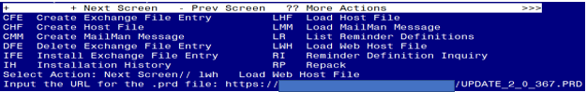
You will see a message indicating the file was loaded successfully.

Search and locate an entry titled UPDATE_2_0_367 VA-ONC LUNG CANCER FOLLOW UP AND CONSULT REPORT in reminder exchange.
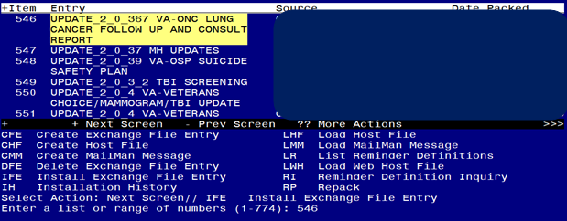
At the Select Action prompt, enter IFE for Install Exchange File Entry
Enter the number that corresponds with your entry titled UPDATE_2_0_367 VA-ONC LUNG CANCER FOLLOW UP AND CONSULT REPORT (in this example it is entry 546, it will vary by site) that is dated 07/27/2023.

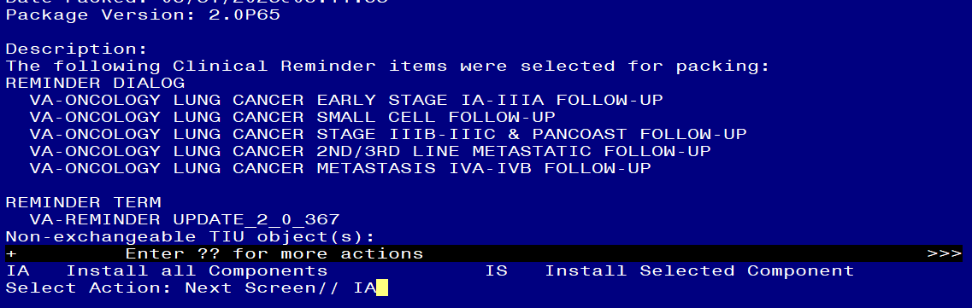

At the Select Action prompt, type IA for Install all Components and hit enter.
Install all new components.
Overwrite any components that exist but are different.

You will then be prompted to install the first dialog component
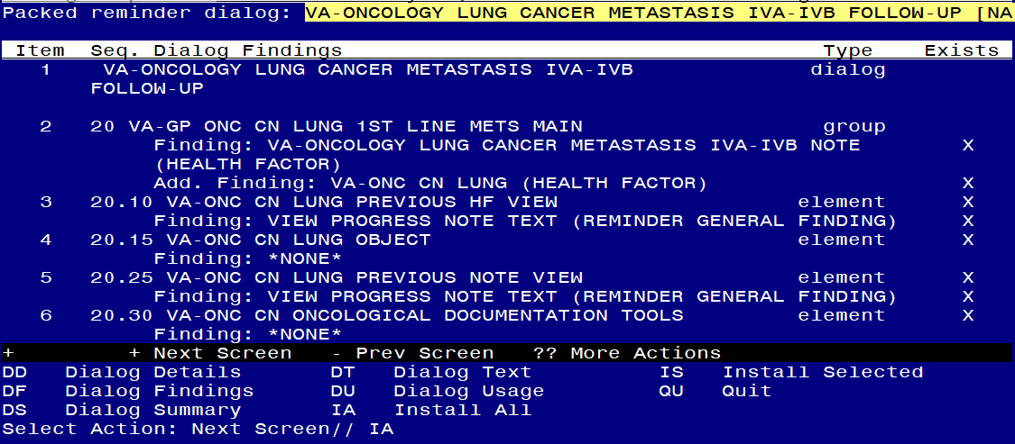
At the Select Action prompt, type IA to install the dialog – VA-ONCOLOGY LUNG CANCER METASTASIS IVA-IVB FOLLOW-UP
Install reminder dialog and all components with no further changes: Y//ES

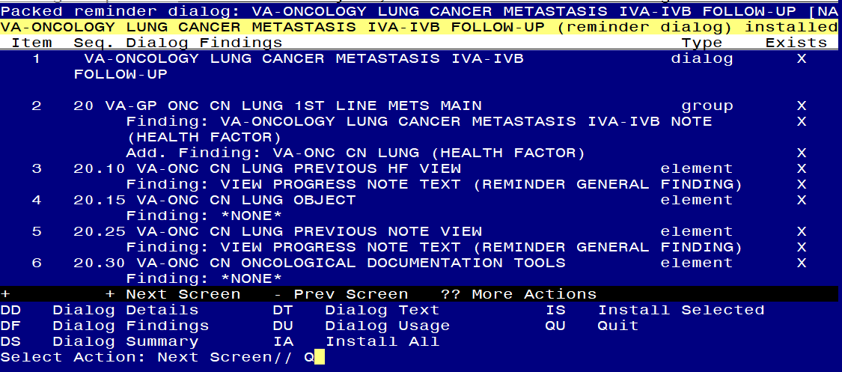
When the dialog has completed installation, you will then be returned to this screen. At the Select Action prompt, type Q.

You will then be prompted to install the next dialog component.
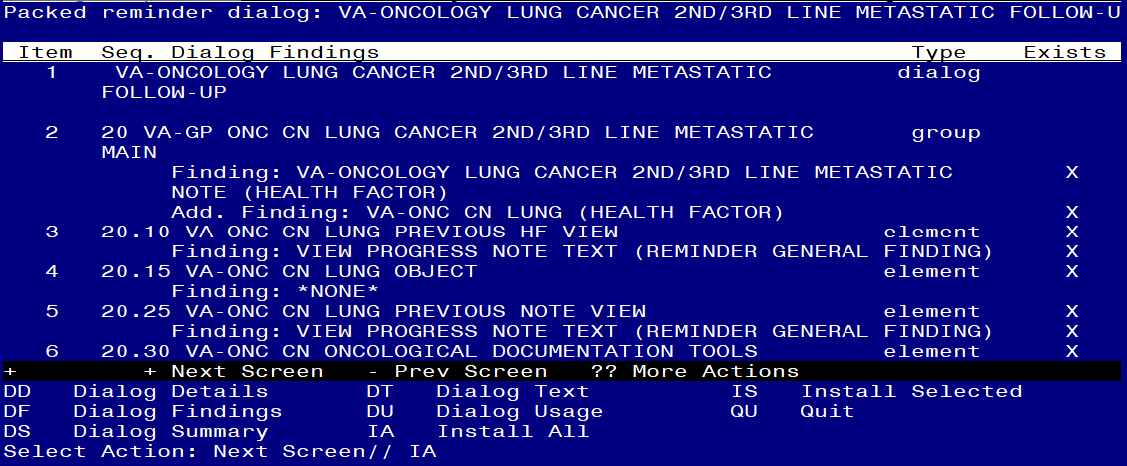
At the Select Action prompt, type IA to install the dialog – VA-ONCOLOGY LUNG CANCER 2ND/3RD LINE METASTATIC FOLLOW-UP
Install reminder dialog and all components with no further changes: Y//ES
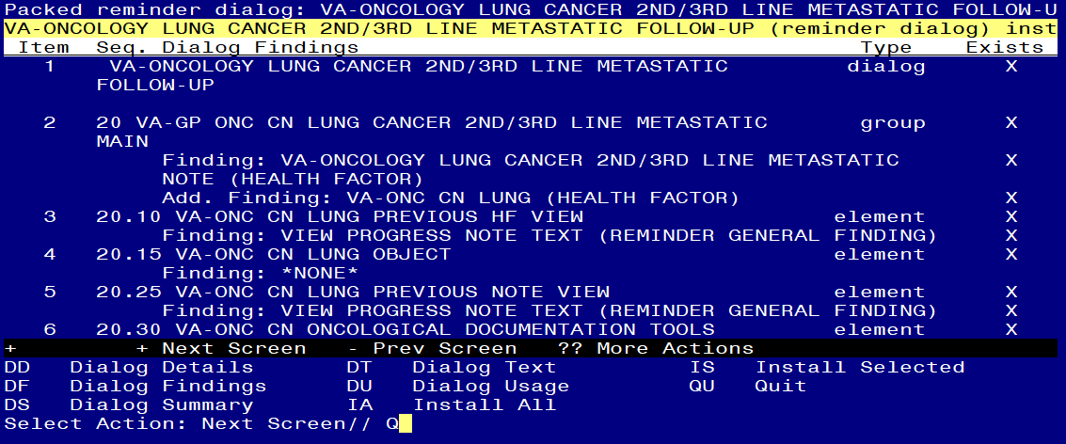

When the dialog has completed installation, you will then be returned to this screen. At the Select Action prompt, type Q.

You will then be prompted to install the next dialog component.
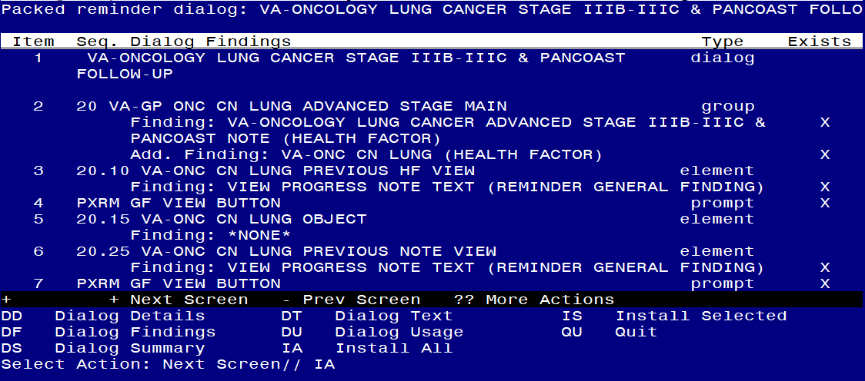
At the Select Action prompt, type IA to install the dialog – VA-ONCOLOGY LUNG CANCER STAGE IIIB-IIIC & PANCOAST FOLLOW-UP
Install reminder dialog and all components with no further changes: Y//ES
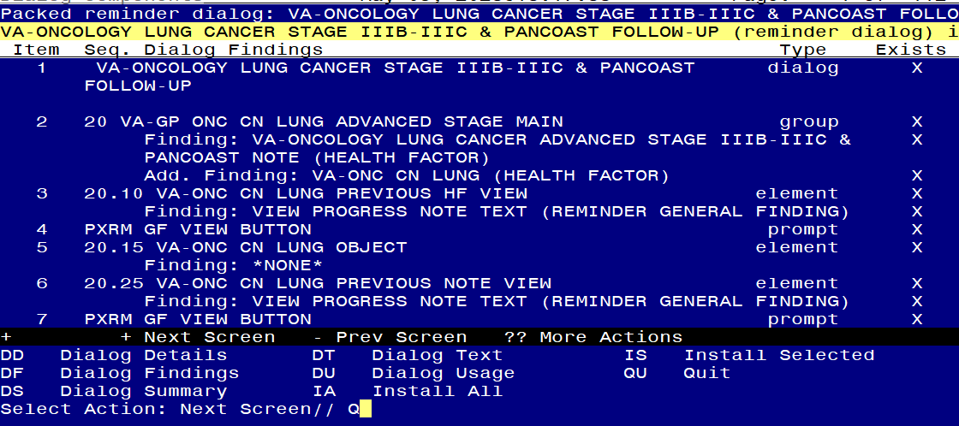

When the dialog has completed installation, you will then be returned to this screen. At the Select Action prompt, type Q.

You will then be prompted to install the next dialog component
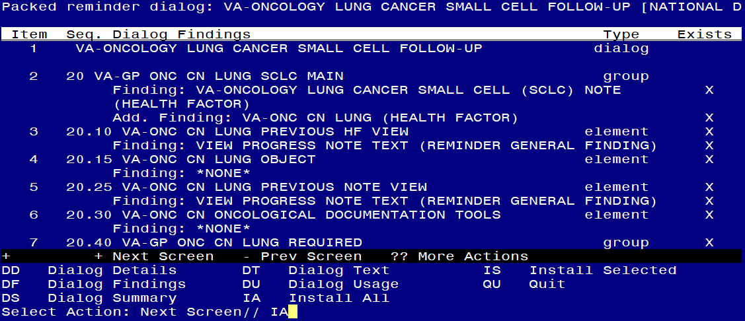
At the Select Action prompt, type IA to install the dialog – VA-ONCOLOGY LUNG CANCER SMALL CELL FOLLOW-UP
Install reminder dialog and all components with no further changes: Y//ES

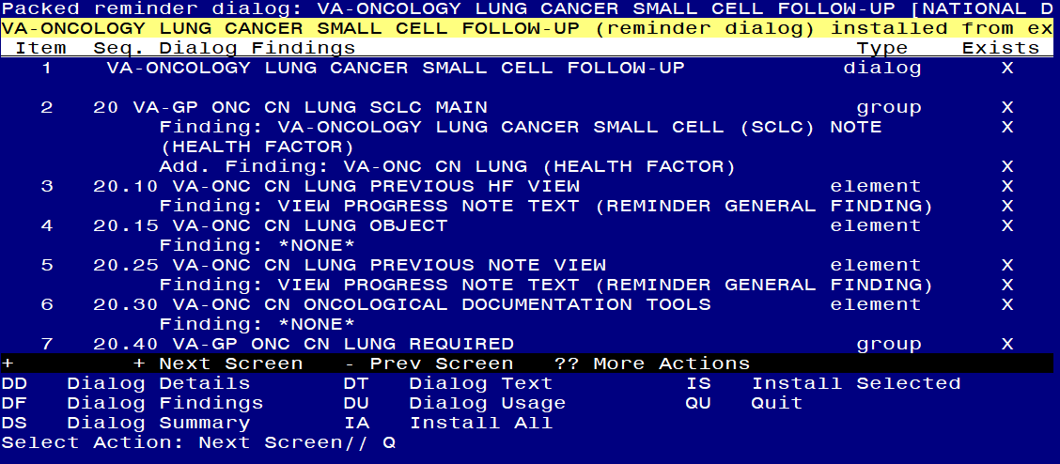
When the dialog has completed installation, you will then be returned to this screen. At the Select Action prompt, type Q.

You will then be prompted to install the next dialog component
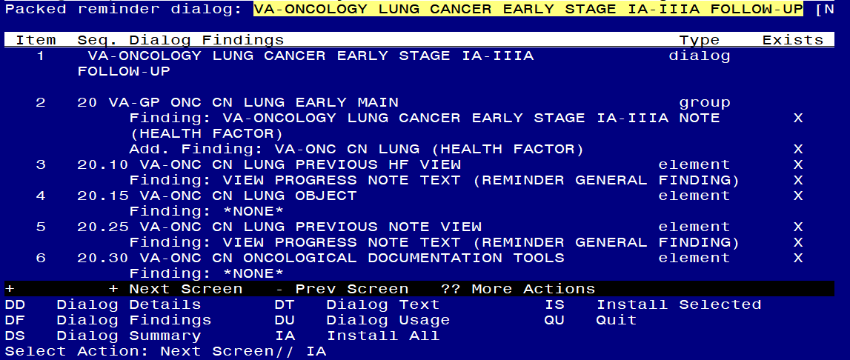
At the Select Action prompt, type IA to install the dialog – VA-ONCOLOGY LUNG CANCER EARLY STAGE IA-IIIA FOLLOW-UP
Install reminder dialog and all components with no further changes: Y//ES

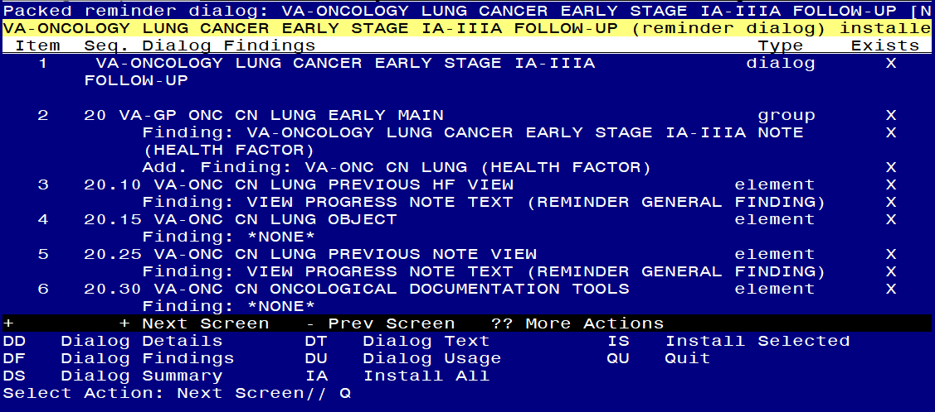
When the dialog has completed installation, you will then be returned to this screen. At the Select Action prompt, type Q.

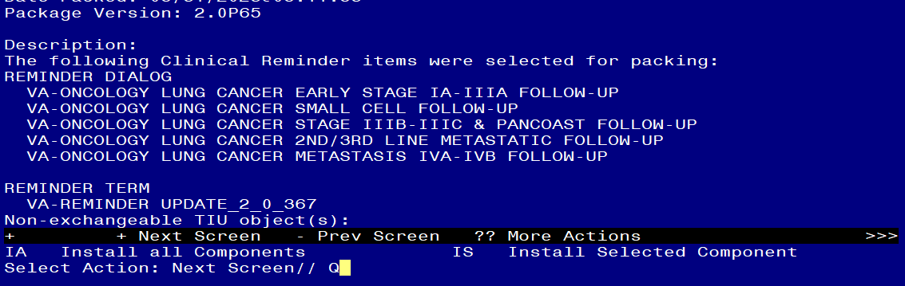
You will then be returned to this screen. At the Select Action prompt, type Q.

Install complete.

Post Installation

- Setup of Note Titles.

The note titles to create to associate with this template are:
ONCOLOGY LUNG CANCER EARLY STAGE IA-IIIA FOLLOW-UP
ONCOLOGY LUNG CANCER STAGE IIIB-IIIC AND PANCOAST FOLLOW-UP
ONCOLOGY LUNG CANCER METASTASIS IVA-IVB FOLLOW-UP
ONCOLOGY LUNG CANCER 2ND/3RD LINE METASTATIC FOLLOW-UP ONCOLOGY LUNG CANCER SMALL CELL (SCLC) FOLLOW-UP

VHA Enterprise Standard Title: HEMATOLOGY AND ONCOLOGY NOTE
You can add these to your document class where progress notes used by Oncology are located. They should not be in your consult document class.

In addition to those notes, you will also need to create 5 consult note titles.
ONCOLOGY LUNG CANCER EARLY STAGE IA-IIIA CONSULT
ONCOLOGY LUNG CANCER STAGE IIIB-IIIC AND PANCOAST CONSULT
ONCOLOGY LUNG CANCER METASTASIS IVA-IVB CONSULT
ONCOLOGY LUNG CANCER 2ND/3RD LINE METASTATIC CONSULT
ONCOLOGY LUNG CANCER SMALL CELL (SCLC) CONSULT

VHA Enterprise Standard Title: HEMATOLOGY AND ONCOLOGY CONSULT
These note titles should be in your consult document class.

Note: Comprehensive information on Creating new Document Classes and Titles can be found beginning on page 54 of the TIU/ASU Implementation Guide at the following link: http://www.va.gov/vdl/documents/Clinical/CPRS-Text_Integration_Utility_(TIU)/tiuim.pdf

- Make the Dialog template available to be attached to a Personal or Shared template or to be able to attach the dialog to a progress note title. (You can use the LINK feature in this menu for steps 2 and 3 if you choose to)
Select Reminder Managers Menu <TEST ACCOUNT> Option: CP CPRS Reminder Configuration
CA Add/Edit Reminder Categories
CL CPRS Lookup Categories
CS CPRS Cover Sheet Reminder List
MH Mental Health Dialogs Active
PN Progress Note Headers
RA Reminder GUI Resolution Active
TIU TIU Template Reminder Dialog Parameter
DEVL Evaluate Coversheet List on Dialog Finish
DL Default Outside Location
PT Position Reminder Text at Cursor
LINK Link Reminder Dialog to Template
TEST CPRS Coversheet Time Test
NP New Reminder Parameters
GEC GEC Status Check Active
WH WH Print Now Active
Select CPRS Reminder Configuration <TEST ACCOUNT> Option: TIU TIU Template Reminder Dialog Parameter
Reminder Dialogs allowed as Templates may be set for the following:

1 User USR [choose from NEW PERSON]
3 Service SRV [choose from SERVICE/SECTION]
4 Division DIV [SALT LAKE CITY]
5 System SYS [NATREM.FO-SLC.MED.VA.GOV]
Enter selection: 5 Choose the appropriate number for your site. Your site may do this by System or other levels. The example below uses SYSTEM level.
Setting Reminder Dialogs allowed as Templates for System: NATREM.FO-SLC.MED.VA.GOV
Select Display Sequence:
388 VA-COVID-19 TELEPHONE FOLLOW-UP
389 VA-SRA-CONSULT RESPONSE (D)
When you type a question mark above, you will see the list of #’s (with dialogs) that are already taken. Choose a number NOT on this list. For this example, 391 is not present so I will use 391.

Select Display Sequence: 391
Are you adding 391 as a new Display Sequence? Yes// YES
Display Sequence: 391// <Enter> 391
Clinical Reminder Dialog: VA-ONCOLOGY LUNG CANCER STAGE IIIB-IIIC & PANCOAST FOLLOW-UP
reminder dialog NATIONAL
...OK? Yes// <Enter> (Yes)
Select Display Sequence: 392
Are you adding 392 as a new Display Sequence? Yes// YES
Display Sequence: 392// <Enter> 392
Clinical Reminder Dialog: VA-ONCOLOGY LUNG CANCER SMALL CELL FOLLOW-UP
reminder dialog NATIONAL
...OK? Yes// <Enter> (Yes)

Select Display Sequence: 393
Are you adding 393 as a new Display Sequence? Yes// YES
Display Sequence: 393// <Enter> 393
Clinical Reminder Dialog: VA-ONCOLOGY LUNG CANCER 2ND/3RD LINE METASTATIC FOLLOW-UP
reminder dialog NATIONAL
...OK? Yes// <Enter> (Yes)

Select Display Sequence: 394
Are you adding 394 as a new Display Sequence? Yes// YES
Display Sequence: 394// <Enter> 394
Clinical Reminder Dialog: VA-ONCOLOGY LUNG CANCER METASTASIS IVA-IVB FOLLOW-UP
reminder dialog NATIONAL
...OK? Yes// <Enter> (Yes)

Select Display Sequence: 395
Are you adding 395 as a new Display Sequence? Yes// YES
Display Sequence: 395// <Enter> 395
Clinical Reminder Dialog: VA-ONCOLOGY LUNG CANCER EARLY STAGE IA-IIIA FOLLOW-UP
reminder dialog NATIONAL
...OK? Yes// <Enter> (Yes)

- Associate the reminder dialogs with the note title in CPRS. In addition to connecting to the note titles, you should also add these to a shared template folder for your oncology service.

In CPRS, open the Template Editor, expand Document Titles, select the appropriate folder (if applicable), then click New Template (top right-hand corner).
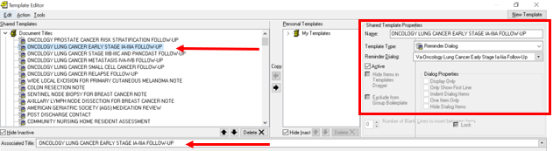

- Type in the following information:
Name: ONCOLOGY LUNG CANCER EARLY STAGE IA-IIIA FOLLOW-UP
Template Type: Reminder Dialog
Reminder Dialog: VA-ONCOLOGY LUNG CANCER EARLY STAGE IA-IIIA FOLLOW-UP

Next, type in the Associated Title name - ONCOLOGY LUNG CANCER EARLY STAGE IA-IIIA FOLLOW-UP - then click Apply.

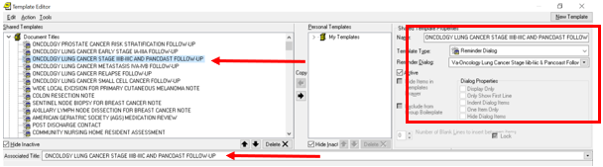

- Type in the following information:
Name: ONCOLOGY LUNG CANCER STAGE IIIB-IIIC AND PANCOAST FOLLOW-UP
Template Type: Reminder Dialog
Reminder Dialog VA-ONCOLOGY LUNG CANCER STAGE IIIB-IIIC AND PANCOAST FOLLOW-UP

Next, type in the Associated Title name - ONCOLOGY LUNG CANCER STAGE IIIB-IIIC AND PANCOAST FOLLOW-UP - then click Apply.
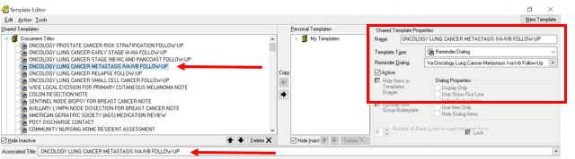

- Type in the following information:
Name: ONCOLOGY LUNG CANCER METASTASIS IVA-IVB FOLLOW-UP
Template Type: Reminder Dialog
Reminder Dialog: VA-ONCOLOGY LUNG CANCER METASTASIS IVA-IVB FOLLOW-UP

Next, type in the Associated Title name - ONCOLOGY LUNG CANCER METASTASIS IVA-IVB FOLLOW-UP - then click Apply.

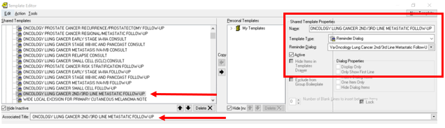

- Type in the following information:
Name: ONCOLOGY LUNG CANCER 2ND/3RD LINE METASTATIC FOLLOW-UP
Template Type: Reminder Dialog
Reminder Dialog: VA- ONCOLOGY LUNG CANCER 2ND/3RD LINE METASTATIC FOLLOW-UP

Next, type in the Associated Title name – ONCOLOGY LUNG CANCER 2ND/3RD LINE METASTATIC FOLLOW-UP – then click Apply.

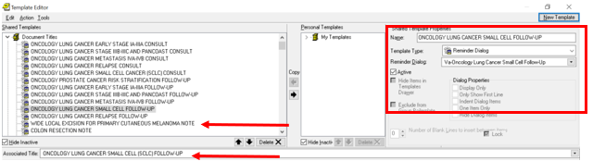

- Type in the following information:
Name: ONCOLOGY LUNG CANCER SMALL CELL (SCLC) FOLLOW-UP
Template Type: Reminder Dialog
Reminder Dialog: VA-ONCOLOGY LUNG CANCER SMALL CELL FOLLOW-UP

Next, type in the Associated Title name - ONCOLOGY LUNG CANCER SMALL CELL (SCLC) FOLLOW-UP – then click Apply.

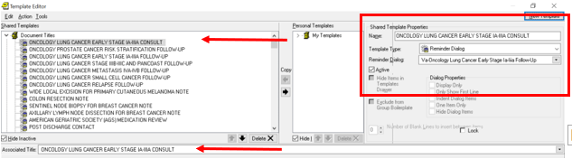

- Type in the following information:
Name: ONCOLOGY LUNG CANCER EARLY STAGE IA-IIIA CONSULT
Template Type: Reminder Dialog
Reminder Dialog: VA-ONCOLOGY LUNG CANCER EARLY STAGE IA-IIIA FOLLOW-UP

Next, type in the Associated Title name - ONCOLOGY LUNG CANCER EARLY STAGE IA-IIIA CONSULT - then click Apply.

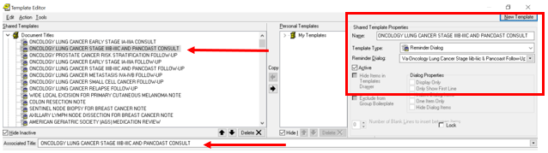

- Type in the following information:
Name: ONCOLOGY LUNG CANCER STAGE IIIB-IIIC AND PANCOAST CONSULT
Template Type: Reminder Dialog
Reminder Dialog: VA-ONCOLOGY LUNG CANCER STAGE IIIB-IIIC AND PANCOAST FOLLOW-UP

Next, type in the Associated Title name – ONCOLOGY LUNG CANCER STAGE IIIB-IIIC AND PANCOAST CONSULT – then click Apply.

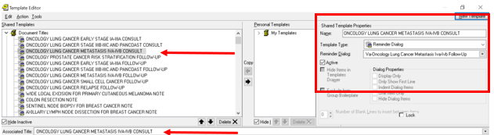

- Type in the following information:
Name: ONCOLOGY LUNG CANCER METASTASIS IVA-IVB CONSULT
Template Type: Reminder Dialog
Reminder Dialog: VA-ONCOLOGY LUNG CANCER METASTASIS IVA-IVB FOLLOW-UP

Next, type in the Associated Title name - ONCOLOGY LUNG CANCER METASTASIS IVA-IVB CONSULT – then click Apply.

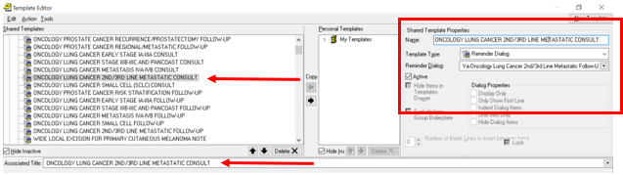

- Type in the following information:
Name: ONCOLOGY LUNG CANCER 2ND/3RD LINE METASTATIC CONSULT
Template Type: Reminder Dialog
Reminder Dialog: VA-ONCOLOGY LUNG CANCER 2ND/3RD LINE METASTATIC FOLLOW-UP

Next, type in the Associated Title name - ONCOLOGY LUNG CANCER 2ND/3RD LINE METASTATIC CONSULT – then click Apply.

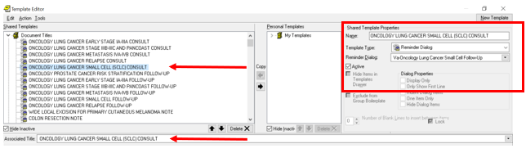

- Type in the following information:
Name: ONCOLOGY LUNG CANCER SMALL CELL (SCLC) CONSULT
Template Type: Reminder Dialog
Reminder Dialog: VA- ONCOLOGY LUNG CANCER SMALL CELL FOLLOW-UP

Next, type in the Associated Title name - ONCOLOGY LUNG CANCER SMALL
CELL (SCLC) CONSULT – then click Apply.

4. Add objects to the reminder dialog.

Using the VistA menu Reminder Dialog Management (DM), Reminder Dialogs (DI), and Change View (CV) to Dialog Elements (E) view.

- Locate and edit the reminder dialog element:
VAL-ONC CN PATIENT DEMOGRAPHICS

Edit the DIALOG/PROGRESS NOTE TEXT and Replace the following data objects with your local data objects if you do not have the included object.
- |PATIENT SEX|
- |PATIENT RACE|
- |PATIENT AGE|
- |PATIENT NAME

- Locate and edit the reminder dialog element:
VAL-ONC CN VITALS TXT

Edit the DIALOG/PROGRESS NOTE TEXT and replace the text (add local object here) with your local data object for the following:
- Temperature
- Pulse
- Respiration
- Pulse Oximetry
- Blood Pressure
- Pain
- Height
- Weight

- Locate and edit the reminder dialog element:
VAL-ONC CN LABS & IMAGING

EDIT the DIALOG/PROGRESS NOTE TEXT and replace the text:
(please reference official report in record) with your local data objects for the most recent LABS & IMAGING.

*Or your site can choose to leave the verbiage “(please reference official report in record)” without inserting data objects.
- Locate and edit the reminder dialog element:
VAL-ONC CN VISIT VVC CONTACT HOME ADDRESS

EDIT the DIALOG/PROGRESS NOTE TEXT and Replace the text Home address: ADD local patient address object here with your local data object.

- Locate and edit the reminder dialog element:
VAL-ONC CN VISIT VVC CONTACT PHONE NUMBER HOME/CELL.

EDIT the DIALOG/PROGRESS NOTE TEXT and replace (ADD patient xxx phone object here) with your local data object the following:
- Cell phone
- Home phone
- Work phone
- Suppress the resident supervision statement (if applicable):
The template utilized branching logic via the element VAL-ONC CN ATTENDING OF RECORD to suppress documenting resident supervision in the dialog if needed.

*This is a local element and can be disabled if not applicable to your site.

You should add user classes that do not need to document resident supervision (i.e. Attending Physician, etc.). To add user classes, edit the reminder term VA-ONC ASU ATTENDING. To add an additional user class, use the quote ““ characters “CF.VA-ASU USER CLASS” and set the computed finding parameter of your new finding to the appropriate user class.

The reminder term is being released with the ASU class of ATTENDING PHYSICIAN and NURSE PRACTITIONER. Edit according to your local practices.
If a user does not have one of the included user classes, the following will appear in the note.

- Enter your site name in the template field: {FLD:VA-ONC VAMC SITE NAME}.

- Add consult quick orders as an additional finding to the elements identified in the pre-install:
- VA-ONC RADIATION ONCOLOGY CONSULT – map radiation oncology consult
- VA-ONC LUNG REFER TO PALLIATIVE CARE - map palliative care consult
- VAL-ONC LUNG IVB POS 1ST OTHER – map IFC PRECISION ONCOLOGY ELECTRONIC CONSULT (element can also be inactivated if you don’t have the Precision Oncology consult).
- VA-ONC HOSPICE REFERRAL - map hospice consult
- VA-ONC LUNG SURGICAL CONSULT – map thoracic surgery consult

Add lab quick orders to these elements. Check with your local LIM. Your site may not have any lab orders for these tests; some sites use a consult for molecular testing. If your site does not have either, nothing else is needed.
- VA-EL ONC LUNG ON PDL1 - map PD-L1 order
- VA-EL ONC LUNG PTHWY NGS ON – map Tumor Genomic testing order
- VA-EL ONC LUNG PTHWY LIQUID BIOPSY - map order for liquid biopsy

- Map the ten note titles to the HS Object |VA-ONC CN PREVIOUS LUNG|:

NOTE TITLES:
- ONCOLOGY LUNG CANCER EARLY STAGE IA-IIIA FOLLOW-UP
- ONCOLOGY LUNG CANCER STAGE IIIB-IIIC AND PANCOAST FOLLOW-UP
- ONCOLOGY LUNG CANCER METASTASIS IVA-IVB FOLLOW-UP
- ONCOLOGY LUNG CANCER 2ND/3RD LINE METASTATIC FOLLOW-UP
- ONCOLOGY LUNG CANCER SMALL CELL (SCLC) FOLLOW-UP
- ONCOLOGY LUNG CANCER EARLY STAGE IA-IIIA CONSULT
- ONCOLOGY LUNG CANCER STAGE IIIB-IIIC AND PANCOAST CONSULT
- ONCOLOGY LUNG CANCER METASTASIS IVA-IVB CONSULT
- ONCOLOGY LUNG CANCER 2ND/3RD LINE METASTATIC CONSULT
- ONCOLOGY LUNG CANCER SMALL CELL (SCLC) CONSULT

HS OBJECT:
|VA-ONC CN PREVIOUS LUNG|

Example:
Start with the TIU Maintenance Menu Document Definitions (Manager) Create TIU/Health Summary Objects SL “VA-ONC CN PREVIOUS “ Detailed Display/Edit HS Object

Map the note title the 10 note titles to the following object.

HS Object: VA-ONC CN PREVIOUS LUNG (TIU)
Health Summary Type: VA-ONC CN PREVIOUS LUNG (HS)
Report Period:
Creator:
HS Object

Print Label: NO Print Report Date and Time: NO
Print Blank Line after Label: NO Print Confidentiality Banner: NO
Customized Header: YES Print Report Date and Time: NO
Suppress Components w/o Data: YES Print Component Header: NO
Print Deceased Information: NO Print Time-Occurrence Limits: NO
National Object: NO Underline Component Header: NO
Blank Line After Header: NO
Overwrite No Data: No Teleoncology note found

Select Item(s): Quit// Edit HS Type

Editing Health Summary Type VA-ONC CN PREVIOUS LUNG (HS)'

NAME: VA-ONC CN PREVIOUS LUNG (HS) Replace
TITLE:
SUPPRESS PRINT OF COMPONENTS WITHOUT DATA: yes//
LOCK:
OWNER:
Select COMPONENT: SPN
SPN PROGRESS NOTES SELECTED SPN
SUMMARY ORDER: 5// 5
OCCURRENCE LIMIT: 1
TIME LIMIT:
HEADER NAME: Selected Prog Notes//

No selection items chosen.

Select new items one at a time in the sequence you want them displayed.
You may select any number of items.

Select SELECTION ITEM: ONCOLOGY LUNG CANCER EARLY STAGE IA-IIIA FOLLOW-UP

Continue to add all the note titles listed above. When you are finished, you should have the following:

PROGRESS NOTES SELECTED (SPN)
1 ONCOLOGY LUNG CANCER EARLY STAGE IA-IIIA FOLLOW-UP
2 ONCOLOGY LUNG CANCER STAGE IIIB-IIIC AND PANCOAST FOLLOW-UP
3 ONCOLOGY LUNG CANCER METASTASIS IVA-IVB FOLLOW-UP
4 ONCOLOGY LUNG CANCER 2ND/3RD LINE METASTATIC FOLLOW-UP
5 ONCOLOGY LUNG CANCER SMALL CELL (SCLC) FOLLOW-UP
6 ONCOLOGY LUNG CANCER EARLY STAGE IA-IIIA CONSULT
7 ONCOLOGY LUNG CANCER STAGE IIIB-IIIC AND PANCOAST CONSULT
8 ONCOLOGY LUNG CANCER METASTASIS IVA-IVB CONSULT
9 ONCOLOGY LUNG CANCER 2ND/3RD LINE METASTATIC CONSULT
10 ONCOLOGY LUNG CANCER SMALL CELL (SCLC) CONSULT

- **Optional** - The following note titles may be inactivated since the pathways now exist in the follow-up notes. Please ensure if you inactivate the note titles, that the templates are available in the Oncology shared templates folder and users at your site are aware they are being inactivated.

- ONCOLOGY-EARLY STAGE LUNG CANCER PATHWAYS
- ONCOLOGY-LOCALLY ADVANCED LUNG CANCER PATHWAYS
- ONCOLOGY-FIRST LINE STAGE IV METASTATIC LUNG CANCER PATHWAYS
- ONCOLOGY-LUNG CANCER RELAPSE PATHWAYS
- ONCOLOGY-SMALL CELL LUNG CANCER PATHWAYS

- **Optional** - Add local reminder dialog groups and elements if needed. This template was built with the standard items needed for complete documentation. If a site would like to add guidance or information specific to that site, you can add text to the local reminder dialog group VAL-GP ONC CN LUNG LOCAL GROUP using the reminder dialog editor. This group is at the end of the dialog. This dialog group will install disabled, and you will need to remove the disable flag for it to be used.

