Update _2_0_369

Clinical Reminders

VA-CSP CAREGIVER TELEMENTAL HEALTH INTAKE

Install Guide

June 2023

Product Development
Office of Information Technology
Department of Veterans Affairs

Table of Contents
Introduction 1
Install Details 2
Install Example 3
Post Installation 6

Introduction

In support of the MISSION Act and Family Caregivers enrolled in the Program of Comprehensive Assistance for Family Caregivers (PCAFC), this Caregiver Support Program Mental Health Intake Template is a new template being developed in conjunction with the TeleMental Health Consult. This intake note will be completed by clinicians staffed at each Caregiver Support Program VISN in response to accepted referrals via the TeleMental Health Consult.

Local Caregiver Support Program staff at each site will submit the TeleMental Health Consult via the EHR after talking with caregivers enrolled in PCAFC who are requesting telemental health counseling services. The assigned clinical staff at the VISN will review the consult and determine if this Caregiver Mental Health Intake template will be completed based on the outcome of the consult. This template will be documented in the caregiver's collateral health record in the EHR. Per the national CSP Directive and 38 CFR, caregivers enrolled in PCAFC are entitled to counseling and support services offered by the VA. This template and associated consult will allow CSP staff to route referrals for Family Caregivers requesting to participate in telepsychotherapy for non-acute mental health services. Caregiver Support Program facility staff are authorized to submit referrals to the appropriate Clinical Resource Hub to address Family Caregivers' needs.

***AT THE TIME OF THIS RELEASE, ONLY VISN 16 WILL NEED TO IMPLEMENT. ALL SITES MUST INSTALL AND WAIT FOR YOUR VISN TO BE NOTIFIED WHEN IT IS TIME FOR YOU TO IMPLEMENT THIS RELEASE***

UPDATE_2_0_369 contains 1 Reminder Exchange entry:

UPDATE_2_0_369 VA-CSP CAREGIVER TELEMENTAL HEALTH INTAKE

The exchange file contains the following components:

REMINDER DIALOG LINK TYPE
VA-ALCOHOL POSITIVE WARM HANDOFF CHECK

TIU TEMPLATE FIELD
VA-CSP WP 4L
VA*CG BLANK SPACE2
VA-CSP CG STRENGTHS
VA-CSP CG NEEDS HELP
VA-CSP CG NEEDS
VA-CSP YES/NO R
VA-CSP ED3
DATE & TIME (REQ)

HEALTH FACTORS
VA-REMINDER UPDATES [C]
VA-UPDATE_2_0_369
VA-CSP PCAFC [C]
VA-CSP PCAFC CG TMH VETERAN NO
VA-CSP PCAFC CG TMH VETERAN YES

REMINDER SPONSOR
CAREGIVER SUPPORT PROGRAM
MENTAL HEALTH SERVICES
OFFICE OF MENTAL HEALTH SERVICES

REMINDER TERM
VA-REMINDER UPDATE_2_0_369

REMINDER DIALOG
VA-CSP CAREGIVER TELEMENTAL HEALTH INTAKE NOTE

Install Details
This update is being distributed as a web host file. The address for the host file is: https://Redacted /UPDATE_2_0_369.PRD

The file will be installed using Reminder Exchange, programmer access is not required.

Installation:
=============
This update can be loaded with users on the system. Installation will take less than 5 minutes.

Install Example

Go to Reminder exchange in Vista.
To Load the exchange file, use LWH. The URL is
https://REDACTED /UPDATE_2_0_369.PRD

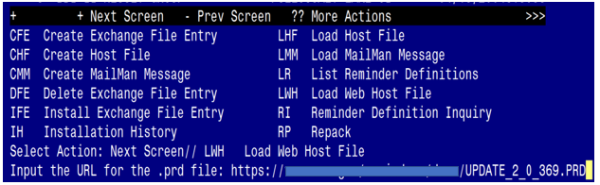
You will see a message indicating the file was loaded successfully.

Search and locate an entry titled UPDATE_2_0_369 VA-CSP CAREGIVER TELEMENTAL HEALTH INTAKE in reminder exchange.
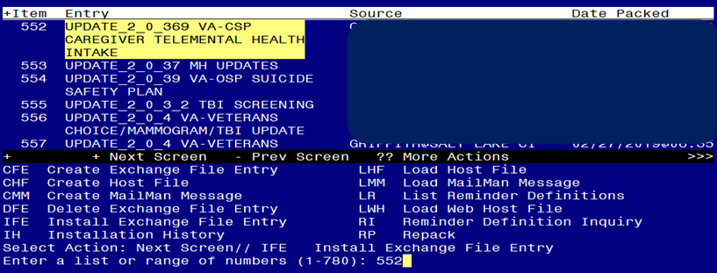
At the Select Action prompt, enter IFE for Install Exchange File Entry
Enter the number that corresponds with your entry titled UPDATE_2_0_369 VA-CSP CAREGIVER TELEMENTAL HEALTH INTAKE NOTE (in this example it is entry 552, it will vary by site) that is dated 06/16/2023.

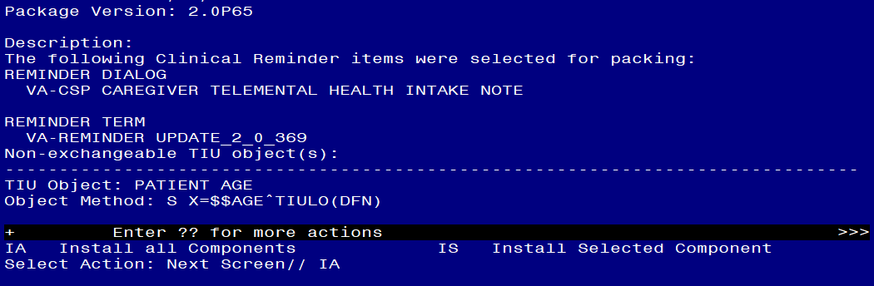

At the Select Action prompt, type IA for Install all Components and hit enter.
For all new entries in any category you will choose I to Install
SKIP any items in any category you are prompted to overwrite.

You will then be prompted to install the dialog component.
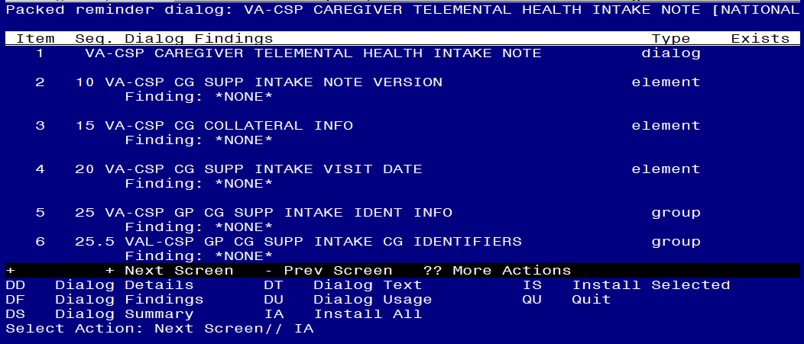
At the Select Action prompt, type IA to install the dialog – VA-CSP CAREGIVER TELEMENTAL HEALTH INTAKE NOTE
Install reminder dialog and all components with no further changes: Y//ES

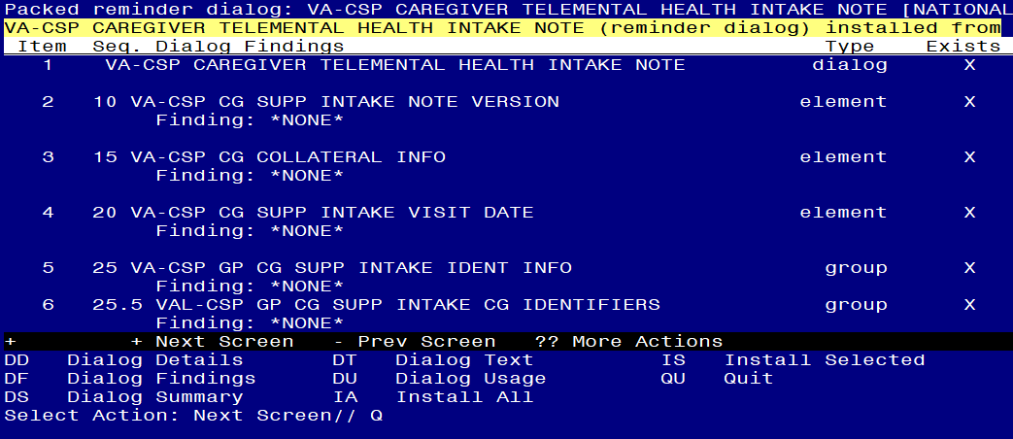
When the dialog has completed installation, you will then be returned to this screen. At the Select Action prompt, type Q.

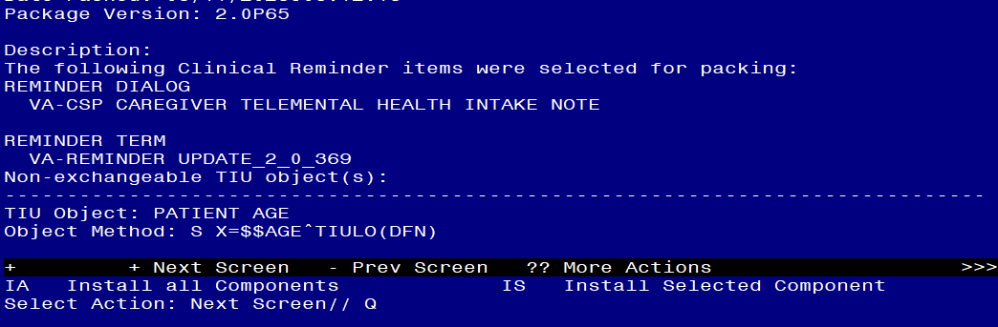
You will then be returned to this screen. At the Select Action prompt, type Q.

Install complete.

Post Installation
***AT THE TIME OF THIS RELEASE, ONLY VISN 16 WILL NEED TO COMPLETE THE POST INSTALL.***

- Setup of Note Title.

The suggested note title to create to associate with this template is:

CSP TELEMENTAL HEALTH INTAKE NOTE

VHA Enterprise Standard Title: CAREGIVER CERTIFICATE
You can add this to the document class where multidisciplinary notes are stored.

Note: Comprehensive information on Creating new Document Classes and Titles can be found beginning on page 54 of the TIU/ASU Implementation Guide at the following link: http://www.va.gov/vdl/documents/Clinical/CPRS-Text_Integration_Utility_(TIU)/tiuim.pdf

- Make the Dialog templates available to be attached to a Personal or Shared templates or to be able to attach the dialog to a progress note title.
Select Reminder Managers Menu <TEST ACCOUNT> Option: CP CPRS Reminder Configuration
CA Add/Edit Reminder Categories
CL CPRS Lookup Categories
CS CPRS Cover Sheet Reminder List
MH Mental Health Dialogs Active
PN Progress Note Headers
RA Reminder GUI Resolution Active
TIU TIU Template Reminder Dialog Parameter
DEVL Evaluate Coversheet List on Dialog Finish
DL Default Outside Location
PT Position Reminder Text at Cursor
LINK Link Reminder Dialog to Template
TEST CPRS Coversheet Time Test
NP New Reminder Parameters
GEC GEC Status Check Active
WH WH Print Now Active
Select CPRS Reminder Configuration <TEST ACCOUNT> Option: TIU TIU Template Reminder Dialog Parameter
Reminder Dialogs allowed as Templates may be set for the following:
1 User USR [choose from NEW PERSON]
3 Service SRV [choose from SERVICE/SECTION]
4 Division DIV [SALT LAKE CITY]
5 System SYS [NATREM.FO-SLC.MED.VA.GOV]
Enter selection: 5 Choose the appropriate number for your site. Your site may do this by System or other levels. The example below uses SYSTEM level.
Setting Reminder Dialogs allowed as Templates for System: NATREM.FO-SLC.MED.VA.GOV
Select Display Sequence: ?
388 VA-COVID-19 TELEPHONE FOLLOW-UP
389 VA-SRA-CONSULT RESPONSE (D)
When you type a question mark above, you will see the list of #’s (with dialogs) that are already taken. Choose a number NOT on this list. For this example, 390 is not present so I will use 390.
Select Display Sequence: 390
Are you adding 390 as a new Display Sequence? Yes// YES
Display Sequence: 390// <Enter> 390
Clinical Reminder Dialog: VA-CSP CAREGIVER TELEMENTAL HEALTH INTAKE NOTE reminder dialog NATIONAL
...OK? Yes// <Enter> (Yes)

- Add the template to the document title
  - In CPRS, open the Template Editor, expand Document Titles, select the appropriate folder (if applicable), then click New Template (top right-hand corner).
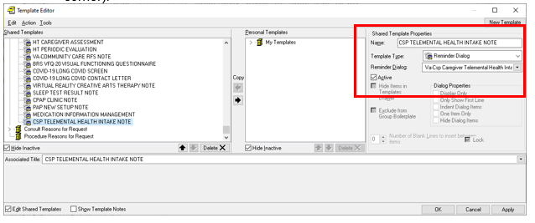

Type in the following information:
Name: CSP TELEMENTAL HEALTH INTAKE NOTE
Template Type: Reminder Dialog
Reminder Dialog: VA-CSP CAREGIVER TELEMENTAL HEALTH INTAKE NOTE
Associated Title: CSP TELEMENTAL HEALTH INTAKE NOTE

–– then click Apply.

- Update reminder dialog
Using the VistA menu reminder Dialog manager, Reminder Dialogs, change your view to element view.
- Locate and edit the reminder dialog element VAL-CSP GP CG SUPP INTAKE CG IDENTIFIERS edit the DIALOG/PROGRESS NOTE TEXT and Replace the text |PATIENT NAME|, with your local object if you do not have the included object.
- Locate and edit the reminder dialog element VA-CSP INITIAL ASSESSMENT CAREGIVER SSN edit the DIALOG/PROGRESS NOTE TEXT and Replace the text |PATIENT SSN|, with your local object if you do not have the included object.
- Locate and edit the reminder dialog element VA-CSP INITIAL ASSESSMENT CAREGIVER DOB edit the DIALOG/PROGRESS NOTE TEXT and Replace the text |PATIENT DATE OF BIRTH|, with your local object if you do not have the included object.
- Locate and edit the reminder dialog element VA-CSP CG SUPP INTAKE CAREGIVER AGE edit the DIALOG/PROGRESS NOTE TEXT and Replace the text |PATIENT AGE|, with your local object if you do not have the included object.

