Update _2_0_371

Clinical Reminders

VA-WH BREAST CANCER RISK ASSESSMENT REMINDER DEFINITION

Install Guide

August 2023

Product Development
Office of Information Technology
Department of Veterans Affairs

Table of Contents
Introduction 1
Install Details 2
Install Example 3
Post Installation 6

Introduction
Description:
​​ The Dr Kate Hendricks Thomas Supported Expanded Review for Veterans in Combat Environments Act (Dr. Kate Hendricks Thomas SERVICE Act) mandates access to mammograms for all female Veterans who have had military toxic exposures.
This reminder captures information around breast cancer risk, including a family history pointing to a possible genetic propensity for breast cancer. It also includes the military toxic exposure clinical reminder for patients who are enrolled in VHA healthcare for efficient review and completion. The template guides clinicians in their decision making around breast cancer screening. The reminder is designed for primary care and/or women’s health providers.

Installation is mandatory, but implementation and use are optional. Implementation should be coordinated with primary care and/or women’s health staff.

This update contains one reminder dialog and one reminder definition. The VA-WH BREAST CANCER RISK ASSESSMENT DEFINITION VERSION reminder dialog is new. It is similar to the VA-WH BREAST CANCER RISK ASSESSMENT dialog released in Update 316 and Update 316A but is built specifically for use with a cover sheet reminder. It will be linked to the VA-WH BREAST CANCER RISK ASSESSMENT reminder definition.

Clinical Reminder Update 316A must be installed and post-installation steps completed before installing this update.

UPDATE_2_0_371 contains 1 Reminder Exchange entry:
UPDATE_2_0_371 VA-BREAST CANCER RISK ASSESSMENT

The exchange file contains the following components:

HEALTH FACTORS
VA-REMINDER UPDATES
VA-UPDATE_2_0_371
WH MAMMOGRAM [C]
WH BILATERAL MASTECTOMY
REMINDER FACTORS
LIFE EXPECTANCY < 5 YEARS
VA-WH BREAST CANCER RISK ASSESSMENT
VA-WH BCRA N/A MALE, NO ESTROGEN 5 YEARS
VA-WH BCRA DECLINES ASSESSMENT
VA-WH BCRA DEFER ASSESSMENT
VA-WH BCRA SERVICE ACT AREA NO
LIFE EXPECTANCY <6 MONTHS
VA LIFE EXPECTANCY
VA LIMITED LIFE EXPECTANCY
LIFE EXPECTANCY < 1 YEAR
LIFE EXPECTANCY < 6 MONTHS
VA-WH BCRA TOXIC EXPOSURE POSITIVE
VA-WH BCRA TOXIC EXPOSURE NEGATIVE
VA-WH BCRA PERSONAL/FAMILY HISTORY POSITIVE
VA-WH BCRA PERSONAL/FAMILY HISTORY NEGATIVE

REMINDER SPONSOR
WOMEN VETERANS HEALTH PROGRAM

REMINDER TERM
VA-REMINDER UPDATE_2_0_371
VA-WH BCRA OUTCOME
VA-WH BCRA DEFER
VA-WH BCRA DECLINE
VA-WH BCRA NOT INDICATED
VA-WH BCRA TOXIC EXPOSURE
VA-WH BCRA PERSONAL/FAMILY HISTORY

REMINDER DEFINITION
VA-WH BREAST CANCER RISK ASSESSMENT

REMINDER TAXONOMY
VA-TERMINAL CANCER PATIENTS

REMINDER DIALOG
VA-WH BREAST CANCER RISK ASSESSMENT DEFINITION VERSION

Pre-Installation

- Clinical Reminder Update 316A must be installed and post-installation steps completed before installing this update.

Install Details
This update is being distributed as a web host file. The address for the host file is: https://REDACTED /UPDATE_2_0_371.PRD
The file will be installed using Reminder Exchange, programmer access is not required.

Installation:
=============
This update can be loaded with users on the system. Installation will take less than 5 minutes.

Install Example
To Load the Web Host File. Navigate to Reminder exchange in Vista
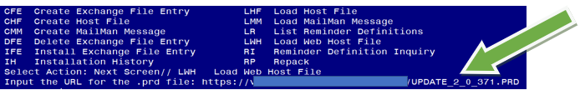

At the Select Action: prompt, enter LWH for Load Web Host File
At the Input the url for the .prd file: prompt, type the following web address:
https://REDACTED /UPDATE_2_0_371.PRD

You should see a message at the top of your screen that the file successfully loaded.

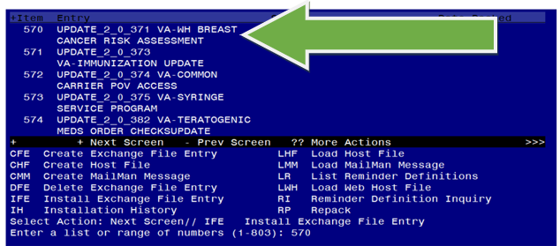
Search and locate an entry titled UPDATE_2_0_371 VA-BREAST CANCER RISK ASSESSMENT in reminder exchange.
At the Select Action prompt, enter IFE for Install Exchange File Entry

Enter the number that corresponds with your entry UPDATE_2_0_371 VA-BREAST CANCER RISK ASSESSMENT
(In this example it is entry 570. It will vary by site). The date of the exchange file should be 07/14/2023.

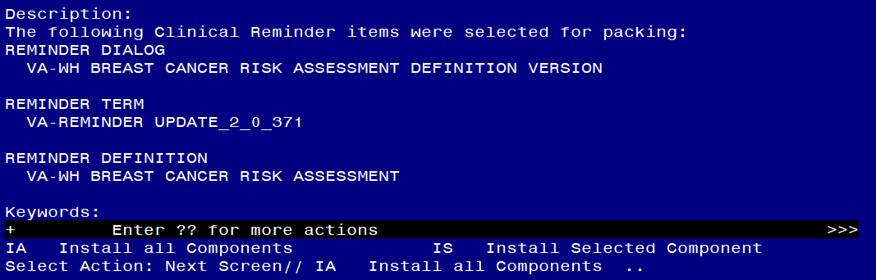

At the Select Action prompt, type IA for Install all Components and hit enter.
Select Action: Next Screen// IA Install all Components

You will see several prompts, for all new entries you will choose I to Install

For all other components that already exists but the packed component is different, choose S to Skip.

You will be prompted to install the reminder dialog component (VA-WH BREAST CANCER RISK ASSESSMENT DEFINITION VERSION). You will choose to install all even though some components may have an X to indicate that they exist.
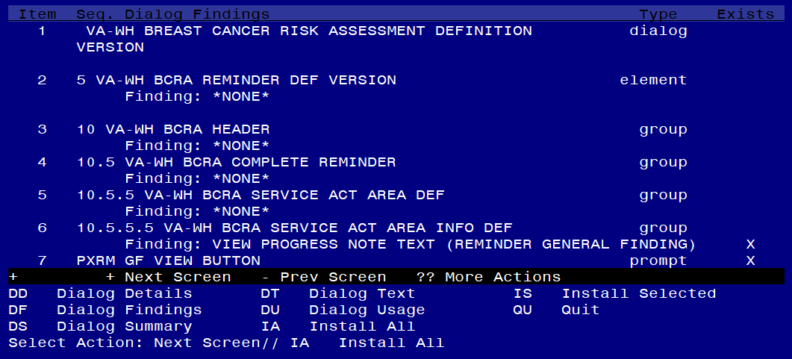

At the Select Action prompt, type IA to install the dialog: VA-WH BREAST CANCER RISK ASSESSMENT DEFINITION VERSION

Select Action: Next Screen// IA Install All

Install reminder dialog and all components with no further changes: Y// Yes
Reminder Dialog VA-WH BREAST CANCER RISK ASSESSMENT DEFINITION VERSION is not linked to a reminder.

Select Reminder to Link: VA-WH BREAST CANCER RISK ASSESSMENT

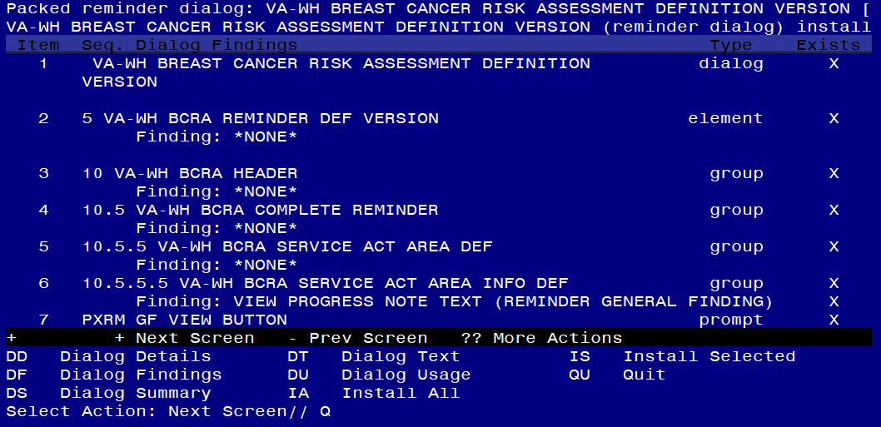

After completing this dialog install, you will type Q.

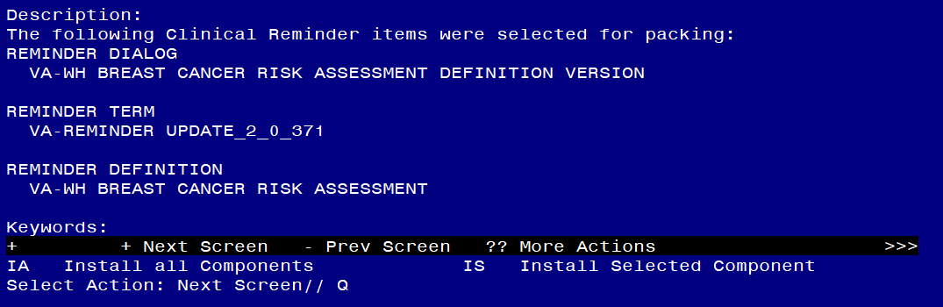

You will then be returned to this screen. At the Select Action prompt, type Q.

Install complete.

Post Installation

- Embed the following items into the VAL-WH BCRA SERVICE ACT AREA YES DEF group.

  - Navigate to the reminder dialog group menu in VistA and locate the VAL-WH BCRA SERVICE ACT AREA YES DEF group.

NAME: VAL-WH BCRA SERVICE ACT AREA YES DEF
DISABLE: <enter>
CLASS: LOCAL/<enter>/
SPONSOR: <enter>
REVIEW DATE: <enter>
RESOLUTION TYPE: <enter>
ORDERABLE ITEM: <enter>
FINDING ITEM: <enter>
Additional findings: <enter>none
Select ADDITIONAL FINDING: <enter>
GROUP CAPTION: <enter>
PUT A BOX AROUND THE GROUP: YES// <enter>
SHARE COMMON PROMPTS: <enter>
MULTIPLE SELECTION: <enter>
HIDE/SHOW GROUP: HIDE// <enter>
GROUP HEADER DIALOG TEXT:
Yes

Edit? NO// <enter>
GROUP HEADER ALTERNATE P/N TEXT:
The patient served in an area under the Service Act.

Edit? NO// <enter>
EXCLUDE FROM PROGRESS NOTE: <enter>
SUPPRESS CHECKBOX: <enter>
NUMBER OF INDENTS:<enter>
INDENT PROGRESS NOTE TEXT://<enter>
Select SEQUENCE: 5
DIALOG ELEMENT: VA-WH BCRA PERSONAL AND FAMILY HISTORY PRIOR
dialog element ...OK? Yes// Yes

EXCLUDE FROM PN TEXT: <enter>

Select SEQUENCE: 10
DIALOG ELEMENT: VA-BLANK LINE DIALOG & NOTE dialog element
...OK? Yes// Yes

EXCLUDE FROM PN TEXT: <enter>

Select SEQUENCE: 15
DIALOG ELEMENT: VA-WH BCRA PERSONAL HISTORY RISK ASSMNT
1 VA-WH BCRA PERSONAL HISTORY RISK ASSMNT dialog group
2 VA-WH BCRA PERSONAL HISTORY RISK ASSMNT INITIAL dialog group
3 VA-WH BCRA PERSONAL HISTORY RISK ASSMNT OUTCOME dialog group
CHOOSE 1-3: 1 VA-WH BCRA PERSONAL HISTORY RISK ASSMNT dialog group NATIONAL
EXCLUDE FROM PN TEXT: <enter>

Select SEQUENCE: 20
DIALOG ELEMENT: VAL-WH BCRA TOXIC EXPOSURE SCREEN dialog group LOCAL
...OK? Yes// Yes

EXCLUDE FROM PN TEXT: <enter>

Select SEQUENCE: 25
DIALOG ELEMENT: VA-BCRA OPTIONS dialog group NATIONAL
...OK? Yes// (Yes)

Select SEQUENCE: <enter>
Select BRANCHING LOGIC SEQUENCE: <enter>
Checking reminder dialog for errors..
NO ERRORS FOUND
Input your edit comments.
Edit? NO//<enter>

- Coordinate implementation with local primary care and/or women’s health staff.

- If leadership decides to implement the cover sheet reminder, add the new reminder definition to your CPRS cover sheet.

The steps below describe how to add this clinical reminder to the CPRS cover sheet at the SYSTEM level. Follow local policies for assigning cover sheet reminders.

  - On the CPRS cover sheet, select the clock icon
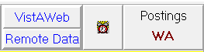

  - Select ACTION > EDIT COVER SHEET REMINDER LIST

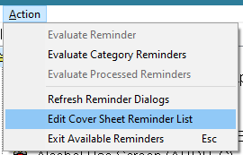
  - Add the Service Act Breast Cancer Risk Assessment (VA-WH BREAST CANCER RISK ASSESSMENT) defintion to the SYSTEM level for your Cover Sheet
The steps below describe how to add this clinical reminder to the CPRS cover sheet at the SYSTEM level. Follow local policies for assigning cover sheet reminders.

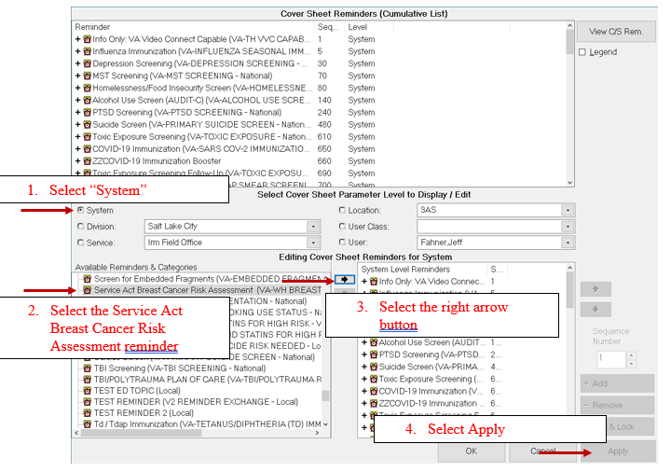

- Open the dialog linked to the reminder definition and confirm it matches the screenshot below:

