Update _2_0_375

Clinical Reminders

VA-SYRINGE SERVICE PROGRAM

Install Guide

July 2023

Product Development
Office of Information Technology
Department of Veterans Affairs

Table of Contents
Introduction 1
Install Details 4
Install Example 4
Post Installation 7

Introduction
This new template ensures documentation of the provision of syringe services, including for syringes provided with and without a prescription (e.g., pharmacy and logistics, respectively).

There is a proposed National Directive supporting these efforts that is going through the national concurrence process.

This note has been approved by the National Harm Reduction Support & Development Workgroup and circulated widely with key SMEs and program offices.

UPDATE_2_0_375 contains 1 Reminder Exchange entry:

UPDATE_2_0_375 VA-SYRINGE SERVICE PROGRAM

The exchange file contains the following components:

REMINDER GERENAL FINDINGS
VIEW PROGRESS NOTE TEXT

TIU TEMPLATE FIELD
VA-TOB LINK
VA-OSP OUD MED
VA-SUD LINK
VA-OSP OEND SHAREPOINT
VA-NALOXONE PATIENT GUIDE
VA-SEX HISTORY LINK
VA-PREP LINK
VA-HIV PREVENTION LINK
VA-HEP C LINK
VA-HEP B LINK
VA-HEP A LINK
VA-STI PREV
VA-SPP LOCATOR
VA-SPP HANDOUT
VA-BLANK

HEALTH FACTORS
VA-REMINDER UPDATES [C]
VA-UPDATE_2_0_375
VA-SSP [C]
VA-SSP REFERRAL COMMENTS
VA-SSP REFERRAL DECLINED
VA-SSP REFERRAL NONE
VA-SSP REFERRAL OTHER
VA-SSP REFERRAL PCP
VA-SSP REFERRAL PCMHI/MH
VA-SSP REFERRAL WOUND CARE
VA-SSP REFERRAL SOCIAL WORK
VA-SSP REFERRAL LIVER CLINIC
VA-SSP REFERRAL INFECTIOUS DISEASE
VA-SSP REFERRAL SUD
VA-NALOXONE [C]
VA-NALOXONE RX OTHER
VA-HAS NALOXONE RX
VA-PATIENT DECLINED NALOXONE
VA-NALOXONE RX REQUEST PROVIDER NOTIFIED
VA-NALOXONE RX ORDERED
VA-SSP OTHER KIT SYRINGE GAUGE
VA-SSP OTHER KIT #SYRINGES
VA-SSP KIT ADD HARM RED SUPPLY OTHER
VA-SSP KIT ADD HARM RED SUPPLY SHARPS CONT
VA-SSP KIT ADD HARM RED SUPPLY NALOXONE
VA-SSP KIT ADD HARM RED SUPPLY FENT TEST STRIPS
VA-SSP KIT ADD HARM RED SUPPLY CONDOMS
VA-OTHER SSP KIT
VA-SSP KIT LOGISTICS 27G 100 SYRINGES
VA-SSP KIT LOGISTICS 27G 20 SYRINGES
VA-SSP KIT LOGISTICS 27G
VA-SSP KIT LOGISTICS 29G 100 SYRINGES
VA-SSP KIT LOGISTICS 29G 20 SYRINGES
VA-SSP KIT LOGISTICS 29G
VA-SSP KIT LOGISTICS 30G 100 SYRINGES
VA-SSP KIT LOGISTICS 30G 20 SYRINGES
VA-SSP KIT LOGISTICS 30G
VA-SSP KIT CLINIC/LOGISTICS
VA-SSP KIT PHARMACY
VA-SSP DECLINED SSP KIT
VA-SSP HAS CURRENT SSP KIT
HEPATITIS C [C]
PREVIOUS NEGATIVE ANTI-HCV
PREVIOUS POSITIVE ANTI-HCV
OUTSIDE SEROLOGY [C]
OUTSIDE HEPATITIS A SEROPOSITIVE
VA-SUICIDE RISK ASSESSMENT [C]
VA-SUICIDE LETHAL ATT OVERDOSE
VA-SUICIDE ATTEMPT OVERDOSE
VA-SUICIDE BEHAVIOR AND OVERDOSE REPORT [C]
VA-SBOR METHOD TYPE OVERDOSE
VA-SSP PAST YR XYLAZINE
VA-SSP PAST YR OTHER SUBSTANCE
VA-SSP PAST YR ALCOHOL
VA-SSP PAST YR NICOTINE
VA-SSP PAST YR CANNABIS
VA-SSP PAST YR SEDATIVES
VA-SSP PAST YR STIMULANTS
VA-SSP PAST YR OPIOIDS
VA-SSP OTHER INDICATION
VA-SSP IDU

REMINDER SPONSOR
MENTAL HEALTH SERVICES
VA NATIONAL CENTER FOR HEALTH PROMOTION AN DISEASE PREVENTION (NCP)

REMINDER TAXONOMY
VA-OVERDOSE

REMINDER TERM
VA-REMINDER UPDATE_2_0_375
VA-WH GONORRHEA AND CHLAMYDIA STI SCREEN LAB
RESULTS
VA-RPR LAB TEST
VA-HIV SEROLOGY
VA-HEP C VIRUS ANTIBODY NEGATIVE
VA-HEP C VIRUS ANTIBODY POSITIVE
VA-HEPATITIS B SURFACE ANTIBODY
VA-HEPATITIS B SURFACE ANTIGEN
VA-HEPATITIS B CORE ANTIBODY (IGG/TOTAL)
VA-HEPATITIS A SEROLOGY IGG/TOTAL
VA-HEPATITIS B IMMUNIZATION ADJUVANT
VA-HEPATITIS B IMMUNIZATION 3/4 DOSE SERIES
VA-HAV VACCINE (FULL OR HALF DOSE ANTIGEN)
VA-HIV PREP MEDICATION
VA-NALOXONE PRESCRIPTION
VA-PREVIOUS OVERDOSE
VA-LAST DISPENSED SYRINGE KIT

REMINDER DEFINITION
VA-MH SSP DISPLAY PRIOR INFO OBJECT
VA-MH LAST DISPENSED SSP OBJECT

HEALTH SUMMARY TYPE
VA-SSP PT INFO
VA-MH LAST DISPENSED SSP

HEALTH SUMMARY OBJECTS
VA-SSP PT INFO (TIU)
VA-MH LAST DISPENSED SSP (TIU)

TIU DOCUMENT DEFINITION
VA-SSP PT INFO
VA-MH LAST DISPENSED SSP

REMINDER DIALOG
VA-MH SYRINGE SERVICE PROGRAM

Install Details

This update is being distributed as a web host file. The address for the host file is: https://REDACTED /UPDATE_2_0_375.PRD

The file will be installed using Reminder Exchange, programmer access is not required.

Installation:
=============
This update can be loaded with users on the system. Installation will take less than 5 minutes.

Pre-Install
Using the VistA menu Reminder Dialog Manager, Reminder Dialog, change your view to GROUP and do an inquire/print on the reminder dialog group VAL-NALOXONE REQUEST as you will need to use as reference to use to add back during the post-install.

Install Example

Go to Reminder exchange in Vista. To Load the exchange file, use LWH. The URL is
https://REDACTED /UPDATE_2_0_375.PRD

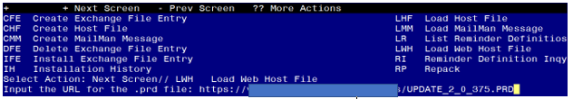
You will see a message indicating the file was loaded successfully.

Search and locate an entry titled UPDATE_2_0_375 VA-SYRINGE SERVICE PROGRAM in reminder exchange.
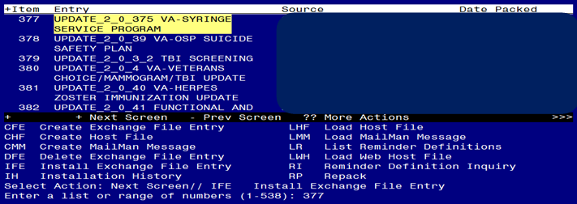
At the Select Action prompt, enter IFE for Install Exchange File Entry
Enter the number that corresponds with your entry titled UPDATE_2_0_375 VA-SYRINGE SERVICE PROGRAM (in this example it is entry 377, it will vary by site) that is dated 07/19/2023.

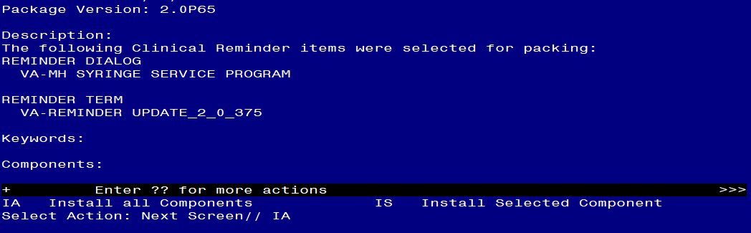

At the Select Action prompt, type IA for Install all Components and hit enter.
For all new entries in any category you will choose I to Install
SKIP any items in any category you are prompted to overwrite.

You will then be prompted to install the dialog component.
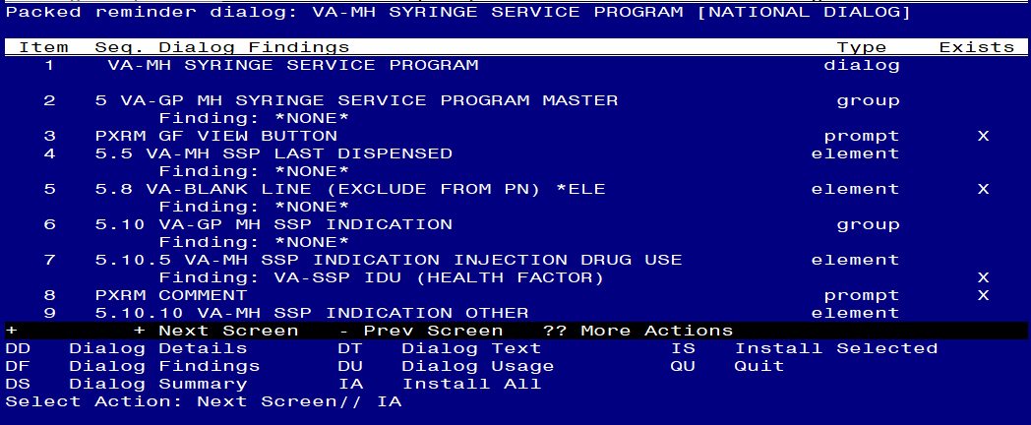
At the Select Action prompt, type IA to install the dialog – VA-MH SYRINGE SERVICE PROGRAM
Install reminder dialog and all components with no further changes: Y//ES

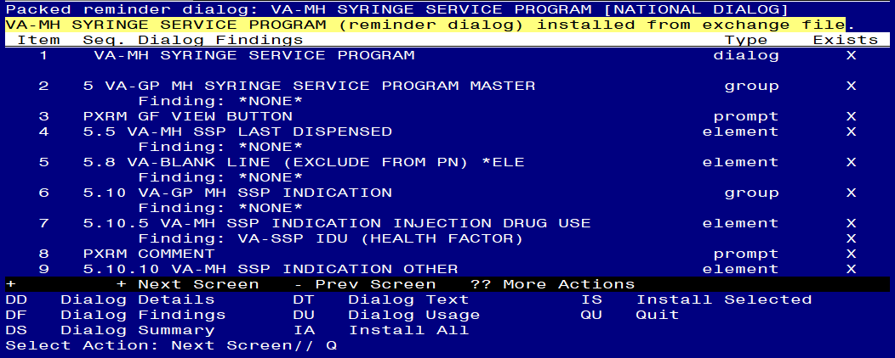
When the dialog has completed installation, you will then be returned to this screen. At the Select Action prompt, type Q.

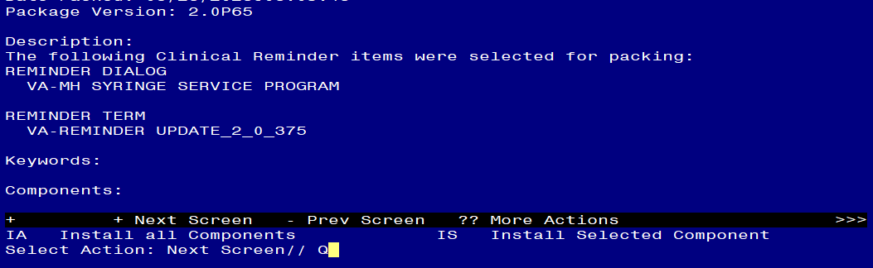
You will then be returned to this screen. At the Select Action prompt, type Q.

Install complete.

Post Installation
- Update reminder dialog – add the order identified in the pre-install to this item. ALL SITES SHOULD DO THIS STEP, EVEN IF YOU ARE NOT PARTICIPATING IN THIS PROGRAM/NOT IMPLENTING THE NEW NOTE.

Using the VistA menu reminder Dialog manager, Reminder Dialogs, change your view to group view.
- VAL-NALOXONE REQUEST – add the quick order for naloxone identified in the pre-install.

The remaining steps are for sites participating in the syringe service program. If you are not sure if your site participates, you can send an email using this link: REDACTED EMAIL
Setup of Note Title

The suggested note title to create to associate with this template is:

SYRINGE SERVICE PROGRAM

VHA Enterprise Standard Title: MEDICATION MGT NOTE
You can add this to the document class where multidisciplinary notes are stored.

Note: Comprehensive information on Creating new Document Classes and Titles can be found beginning on page 54 of the TIU/ASU Implementation Guide at the following link: http://www.va.gov/vdl/documents/Clinical/CPRS-Text_Integration_Utility_(TIU)/tiuim.pdf

- Make the Dialog templates available to be attached to a Personal or Shared templates or to be able to attach the dialog to a progress note title.
Select Reminder Managers Menu <TEST ACCOUNT> Option: CP CPRS Reminder Configuration
CA Add/Edit Reminder Categories
CL CPRS Lookup Categories
CS CPRS Cover Sheet Reminder List
MH Mental Health Dialogs Active
PN Progress Note Headers
RA Reminder GUI Resolution Active
TIU TIU Template Reminder Dialog Parameter
DEVL Evaluate Coversheet List on Dialog Finish
DL Default Outside Location
PT Position Reminder Text at Cursor
LINK Link Reminder Dialog to Template
TEST CPRS Coversheet Time Test
NP New Reminder Parameters
GEC GEC Status Check Active
WH WH Print Now Active
Select CPRS Reminder Configuration <TEST ACCOUNT> Option: TIU TIU Template Reminder Dialog Parameter
Reminder Dialogs allowed as Templates may be set for the following:
1 User USR [choose from NEW PERSON]
3 Service SRV [choose from SERVICE/SECTION]
4 Division DIV [SALT LAKE CITY]
5 System SYS [NATREM.FO-SLC.MED.VA.GOV]
Enter selection: 5 Choose the appropriate number for your site. Your site may do this by System or other levels. The example below uses SYSTEM level.
Setting Reminder Dialogs allowed as Templates for System: NATREM.FO-SLC.MED.VA.GOV
Select Display Sequence: ?
388 VA-COVID-19 TELEPHONE FOLLOW-UP
389 VA-SRA-CONSULT RESPONSE (D)
When you type a question mark above, you will see the list of #’s (with dialogs) that are already taken. Choose a number NOT on this list. For this example, 390 is not present so I will use 390.
Select Display Sequence: 390
Are you adding 390 as a new Display Sequence? Yes// YES
Display Sequence: 390// <Enter> 390
Clinical Reminder Dialog: VA-MH SYRINGE SERVICE PROGRAM reminder dialog NATIONAL
...OK? Yes// <Enter> (Yes)

- Add the template to the document title
  - In CPRS, open the Template Editor, expand Document Titles, select the appropriate folder (if applicable), then click New Template (top right-hand corner).
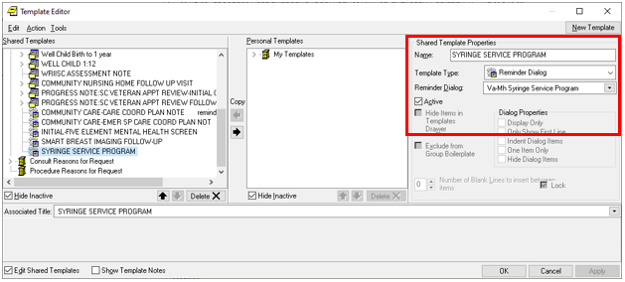

Type in the following information:
Name: SYRINGE SERVICE PROGRAM
Template Type: Reminder Dialog
Reminder Dialog: VA-MH SYRINGE SERVICE PROGRAM
Associated Title: SYRINGE SERVICE PROGRAM

–– then click Apply.

++ You can also add this template to your shared template folder to make it easy to access. ++

- Update reminder dialog – to add the orders to your dialog, you may need to work with your local lab and pharmacy to identify the correct orders.

Using the VistA menu reminder Dialog manager, Reminder Dialogs, change your view to group view.
- VA-GP SPP ORDER SSP KIT VA PHARM add your local menu with the syringe service orders as an additional finding

For the elements listed below, your site can choose to use a menu or individual orders.
Here are two examples of harm reduction menus, you can create something similar for your site:
Example 1:
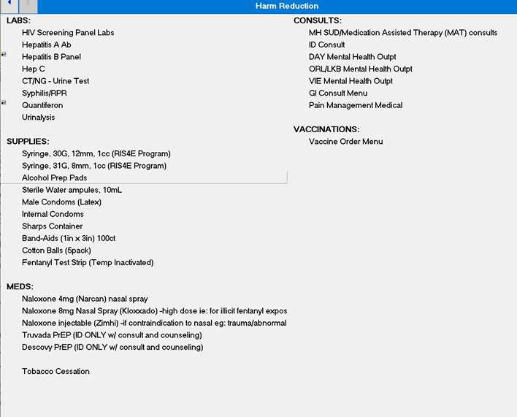

Example 2:
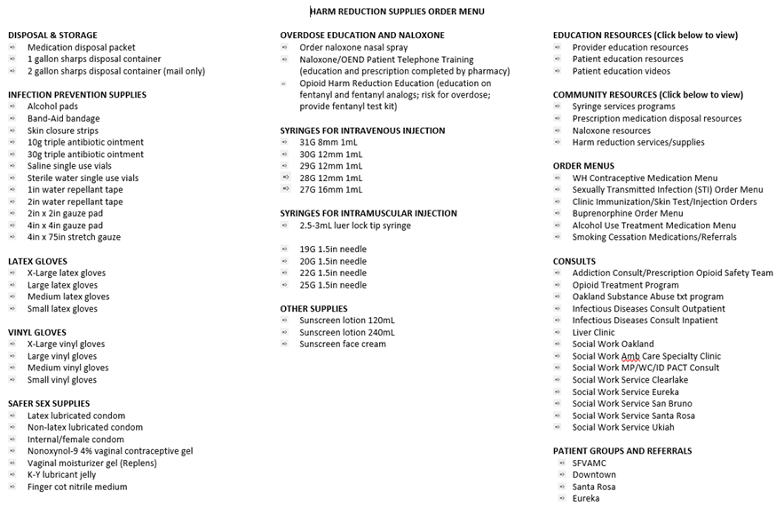

If you choose to use a harm reduction menu, then you can add that as an additional finding to the reminder dialog group: VA-GP SPP ADDITIONAL ORDER OPTIONS and you do not need to add an order to the individual elements listed below. Please ensure that all items listed below are included in your local harm reduction menu.
If you choose to order each item individually, add the orders as listed below.

Using the VistA menu reminder Dialog manager, Reminder Dialogs, change your view to element view.

- VAL-SPP ADDITIONAL ORDER CONDOMS - add your local order for condoms orders as an additional finding.
- VAL-SPP ADDITIONAL ORDER HEPA- add your local order for a hepatitis A vaccination orders as an additional finding.
- VAL-SPP ADDITIONAL ORDER HEPB - add your local order for a hepatitis B vaccination orders as an additional finding.
- VAL-SPP ADDITIONAL ORDER PREP – Add your local order for Pre-exposure Prophylaxis (PrEP) to prevent HIV infection as an additional finding.
- VAL-SPP ADDITIONAL ORDER TOB MEDS – Add your local order or menu for tobacco cessation medications as an additional finding.
- VAL-SPP ADDITIONAL ORDER HEPA LAB- add your local order for a hepatitis A lab test as an additional finding.
- VAL-SPP ADDITIONAL ORDER HEPB LAB - add your local order for a hepatitis B lab test as an additional finding.
- VAL-SPP ADDITIONAL ORDER HEPC LAB - add your local order for a hepatitis c lab test as an additional finding.
- VAL-SPP ADDITIONAL ORDER SYPHILIS SCREEN - add your local order for a syphilis screen lab test as an additional finding.
- VAL-SPP ADDITIONAL ORDER CG SCREEN- add your local order for a Chlamydia/Gonorrhea screening (oral/rectal/urine) lab test as an additional finding.
- VAL-SPP ADDITIONAL ORDER HIV SCREEN- add your local order for a HIV screening (Ag/Ab and RNA) as an additional finding.
- VAL-SPP ADDITIONAL ORDER TB SCREEN Q - add your local order for a TB screens (quantiferon gold) as an additional finding.
- VAL-SPP ADDITIONAL ORDER REFER SUD - add your local order for a substance use disorder consult or referral as an additional finding.
- VAL-SPP ADDITIONAL ORDER REFER ID - add your local order for a infectious disease consult or referral as an additional finding
- VAL-SPP ADDITIONAL ORDER REFER LIVER CLINIC - add your local order for a liver clinic consult or referral as an additional finding.
- VAL-SPP ADDITIONAL ORDER REFER SOCIAL WORK - add your local order for a social work consult or referral as an additional finding.
- VAL-SPP ADDITIONAL ORDER REFER WOUND - add your local order for a wound clinic consult or referral as an additional finding.
- VAL-SPP ADDITIONAL ORDER REFER PCMHI- If you have one, add your local consult or referral to Primary Care Mental Health Integration (PCMHI) or mental health treatment as an additional finding.
- VAL-SPP ADDITIONAL ORDER REFER PACT- If you have one, add your local consult or Referral to primary care provider or PACT team as an additional finding.

++ you may want to add the below item even if you use a harm reduction menu ++

- VAL-SPP ADDITIONAL ORDER REFER SUICIDE PREVENTION - add your local order for a suicide prevention consult or referral as an additional finding

- Update reminder terms, the following reminder terms should be updated with your local items as indicated below.:
  - VA-RPR LAB TEST – this term should contain lab tests that represent a RPR.
  - VA-HIV PREP MEDICATION – this term should contain drug findings that represent HIV PREP medication.
  - VA-LAST DISPENSED SYRINGE KIT – this term should contain orderable items that represent syringe kits, include all statuses.
  - VA-HAV VACCINE (FULL OR HALF DOSE ANTIGEN) – this term should contain Immunization findings for Hepatitis A immunization.
  - VA-NALOXONE PRESCRIPTION – this term should contain drug findings that represent a naloxone prescription

These items are used in a reminder definition that is part of a data object that will populate the ‘View Relevant Patient Information” button. If your site prefers a different format for the data in this button, you can edit the reminder dialog element VAL-MH SSP DISPLAY PRIOR INFO and insert your own data objects.

