Update _2_0_382

Clinical Reminders

TERATOGENIC MEDICATIONS UPDATE 2023-02

Install Guide

August 2023

Product Development
Office of Information Technology
Department of Veterans Affairs

Table of Contents
Introduction 1
Pre-Installation 2
Installation: 2
Install Example 3
Post-Install Set-up Instructions 6

Introduction

UPDATE_2_0_382 contains 1 Reminder Exchange entry: UPDATE_2_0_382 VA-TERATOGENIC MEDS ORDER CHECKS UPDATE 2023-02

The Teratogenic Medications Order Check Interim Solution was originally released as VistA patch PXRM*2*22 in July 2012. The interim solution is intended to have regular updates for clinical content, primarily to add newly approved medications that have a noted risk during pregnancy and that warrant an order check. This update, UPDATE_2_0_382 represents the second update in 2023.

- Drugs added to the high risk, pregnancy order checks and lactation level 1 order check are the result of routine review and update from First Databank for new medications that have a risk to the fetus or breastfeeding child.

Below are the changes:
- Reminder order check group: VA-WH HIRISK MEDICATIONS (MOD/HIGH RISK DURING PREGNANCY) GROUP
Updated to add:
DP.APREPITANT 130MG/18ML INJ,EMULSION
DP.APREPITANT 32MG/4.4ML INJ,EMULSION,VIL
- Reminder order check groups VA-WH HIRISK MEDICATIONS (LACTATION LEVEL 1) GROUP
Updated to add
DG.DABIGATRAN

This update is being distributed as a web host file. The address for the host file is: https://Redacted/UPDATE_2_0_382.PRD

The following reminder content is included in this UPDATE:

HEALTH FACTORS
VA-REMINDER UPDATES [C]
VA-UPDATE_2_0_382

REMINDER SPONSOR
WOMEN VETERANS HEALTH PROGRAM
OFFICE OF NURSING INFORMATICS

REMINDER TERM
VA-WH HIRISK LACTATING EXPIRED DOC
VA-WH HIRISK LACTATING CURRENT DOC
VA-REMINDER UPDATE_2_0_382

REMINDER DEFINITION
VA-WH UPDATE LACTATION STATUS
VA-WH HIRISK ORDER CHECK - PREGNANT
VA-WH HIRISK ORDER CHECK - LACTATING

REMINDER ORDER CHECK RULES
VA-WH HIRISK MEDS (LACT 1) EXPIRED DOC RULE
VA-WH HIRISK MEDS (LACT 1) RULE
VA-WH HIRISK MEDS (MODERATE/HIGH RISK) PREG RULE

REMINDER ORDER CHECK ITEMS GROUP
VA-WH HIRISK MEDICATIONS (LACTATION LEVEL 1) GROUP
VA-WH HIRISK MEDICATIONS (MOD/HIGH RISK DURING PREGNANCY) GROUP

Pre-Installation
Prior to installing this Update:

- Clinical Reminder Update_2_0_284 Teratogenic Medications Update 2022_02, Clinical Reminder Update_2_0_321 Teratogenic Medications Update 2022_03 and Update_2_0_352 Teratogenic Medications Update 2023_01 should be installed before installing this update. Review the install history in reminder exchange to confirm that you have installed.

The 284 Install Guide is available at the following link: Redacted
The 321 Install Guide is available at the following link: Redacted
The 352 Install guide is available at the following link Redacted

Installation:
This update can be loaded with users on the system. Installation will take less than five minutes.
The file will be installed using Reminder Exchange, programmer access is not required.

Install Example

To Load the Web Host File. Navigate to Reminder exchange in Vista
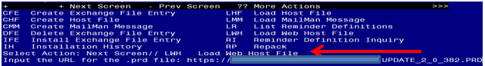
At the Select Action: prompt, enter LWH for Load Web Host File
At the Input the url for the .prd file: prompt, type the following web address:
https://Redacted/UPDATE_2_0_382.PRD

You should see a message at the top of your screen that the file successfully loaded.
Navigate to the exchange entry named UPDATE_2_0_382 VA-TERATOGENIC MEDS ORDER CHECKSUPDATE 2023-02
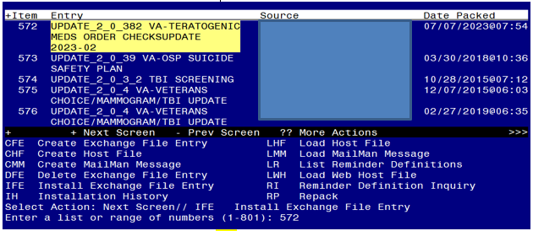
At the Select Action prompt, enter IFE for Install Exchange File Entry
Enter the number that corresponds with your entry UPDATE_2_0_382 VA-TERATOGENIC MEDS ORDER CHECKSUPDATE 2023-02 (in this example it is entry 572, it will vary by site, The exchange date should be 07/07/2023).

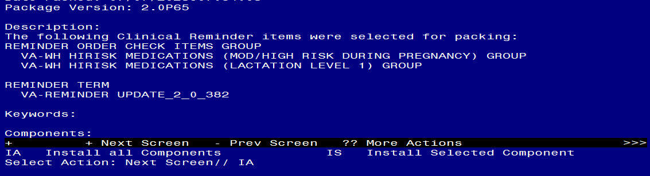
At the Select Action prompt, type IA for Install all Components and hit enter.
Any items that are NEW in any categories, you should INSTALL
If you are prompted to overwrite any health factors, you should choose SKIP - You will install the new ones
If you are prompted to overwrite any reminder sponsor, you should choose SKIP
If you are prompted to overwrite any reminder terms, you should choose SKIP
If you are prompted to overwrite any reminder definitions, you should choose SKIP
If you are prompted to overwrite any REMINDER ORDER CHECK RULES, you should choose SKIP
If you are prompted to overwrite any REMINDER ORDER CHECK ITEMS GROUP, you should choose Overwrite
** In your test account, when overwriting the reminder order check groups, some newer drugs (DG findings) may not exist, choose Delete if prompted to replace an entry**

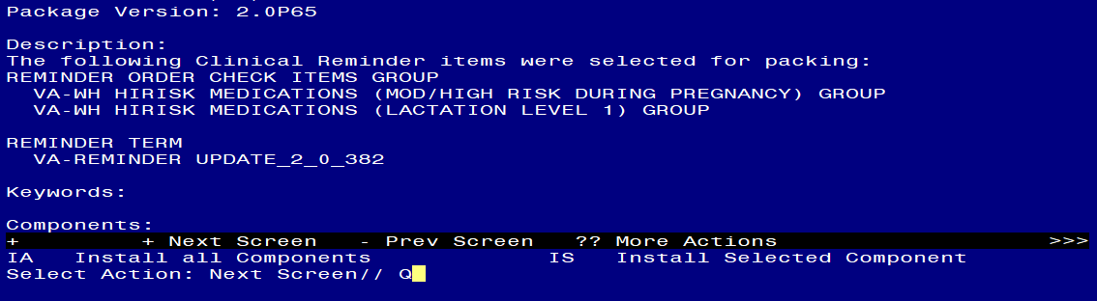
You will then be returned to this screen. At the Select Action prompt, type Q.

Install Complete

Post-Install Set-up Instructions

Installation of this update should not have impacted your order check rules, but as a safety measure, you should confirm the WH order check rules listed below are in PROD status and if they are not, update them using the Vista Menu Add/Edit Reminder Order Check Rule

VA-WH HIRISK MEDS (MODERATE/HIGH RISK) PREG RULE
VA-WH HIRISK MEDS (LACT 1) RULE

The option represented here is Add/Edit Reminder Order Check Rule [PXRM ORDER CHECK RULE EDIT].
Select Reminder Order Check Menu <TEST ACCOUNT> Option: RE Add/Edit Reminder Order Check Rule
Select Reminder Order Check Rule by one of the following:

N: ORDER CHECK RULE NAME
R: REMINDER DEFINITION
T: REMINDER TERM
Q: QUIT

Select Reminder Order Check Rule by: (N/R/T/Q): N// <ENTER>
ORDER CHECK RULE NAME
Select Reminder Order Check Rule: VA-WH HIRISK MEDS (MODERATE/HIGH RISK) PREG RULE
RULE NAME: VA-WH HIRISK MEDS (MODERATE/HIGH RISK) PREG RULE
DISPLAY NAME: Known/Potential Unsafe Medication (High Risk-to-Benefit Ratio)
STATUS: PROD
CLASS: NATIONAL
SPONSOR: WOMEN VETERANS HEALTH PROGRAM
REVIEW DATE:
_____________________________________________________________
I=INACTIVE, P=PRODUCTION, T=TESTING

Repeat for all the listed Reminder Order Check Rules

