Update_2_0_386

Clinical Reminders

VA-COVID-19 ED Triage Template Update

Install Guide

August 2023

Product Development
Office of Information Technology
Department of Veterans Affairs

Table of Contents
Introduction 1
Install Details 2
Install Example 2
Post Installation 5

Introduction
This update will disable the COVID-19 Screen located in the emergency department triage template.

UPDATE_2_0_386contains 1 Reminder Exchange entry:
UPDATE_2_0_386 VA-COVID-19 EMERGENCY DEPT TRIAGE UPDATE

The exchange file contains the following components:

HEALTH FACTORS :
VA-REMINDER UPDATES [C]
VA-UPDATE_2_0_386
VA-TRAVEL SCREEN [C]
VA-COVID-19 PRIOR DIAGNOSIS
VA-COVID-19 [C]
VA-COVID WAITING TEST RESULTS
VA-COVID SCREEN NEGATIVE
VA-COVID-19 EXPOSURE DATE
VA-COVID-19 SYMPTOM ONSET DATE
VA-COVID SCREEN POSITIVE
VA-EXPOSURE TO COVID NO
VA-EXPOSURE TO COVID YES
VA-EXPOSURE TO FEVER/RESP ILL 14D
VA-COVID-19 NO SYMPTOMS
VA-SYMPTOM VOMITING
VA-SYMPTOM SORE THROAT
VA-SYMPTOM SHORTNESS OF BREATH
VA-SYMPTOM RUNNY NOSE
VA-SYMPTOM NAUSEA
VA-SYMPTOM MUSCLE PAIN
VA-SYMPTOM LOSS OF TASTE OR SMELL
VA-SYMPTOM HEADACHE
VA-SYMPTOM FEVER
VA-SYMPTOM FATIGUE
VA-SYMPTOM DIARRHEA
VA-SYMPTOM COUGH
VA-SYMPTOM CHILLS
VA-TRAVEL 21 DAYS UNABLE TO ANSWER

REMINDER TERM
VA-REMINDER UPDATE_2_0_386

REMINDER DIALOG
VA-GP ED TRIAGE TRAVEL SCREEN

Install Details

This update is being distributed as a web host file. The address for the host file is: https://REDACTED /UPDATE_2_0_386.PRD

The file will be installed using Reminder Exchange, programmer access is not required.

Installation:
=============
This update can be loaded with users on the system. Installation will take less than 5 minutes.

Install Example
To Load the Web Host File. Navigate to Reminder exchange in Vista
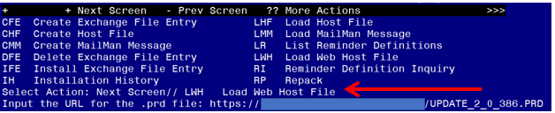

At the Select Action: prompt, enter LWH for Load Web Host File
At the Input the url for the .prd file: prompt, type the following web address:
https://REDACTED /UPDATE_2_0_386.PRD
You should see a message at the top of your screen that the file successfully loaded.

Search for and locate the reminder exchange entry titled UPDATE_2_0_386 VA-COVID-19 EMERGENCY DEPT TRIAGE UPDATE

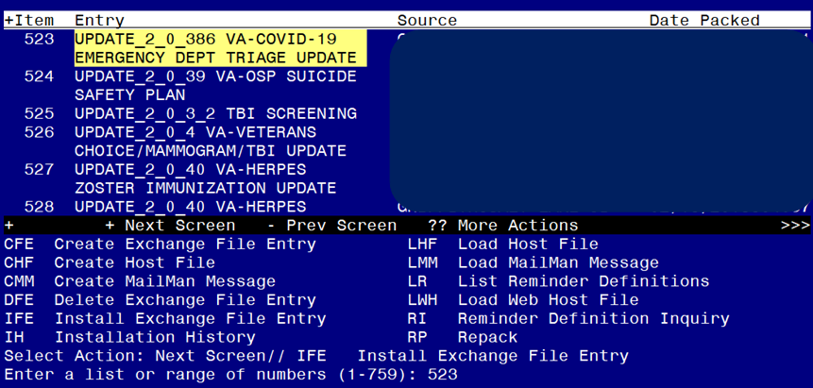
At the Select Action prompt, enter IFE for Install Exchange File Entry
Enter the number that corresponds with your entry titled UPDATE_2_0_386 VA-COVID-19 EMERGENCY DEPT TRIAGE UPDATE (in this example it is entry 523, it will vary by site). The exchange file date is 07/21/2023.

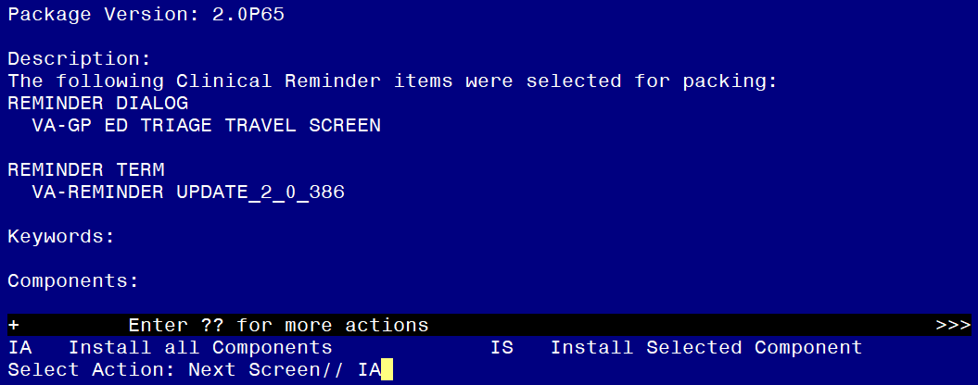

At the Select Action prompt, type IA for Install all Components and hit enter.
Select Action: Next Screen// IA Install all Components
You should Install all new components.
If you are prompted to overwrite any components, choose SKIP.

You will be promped to install the dialog component:

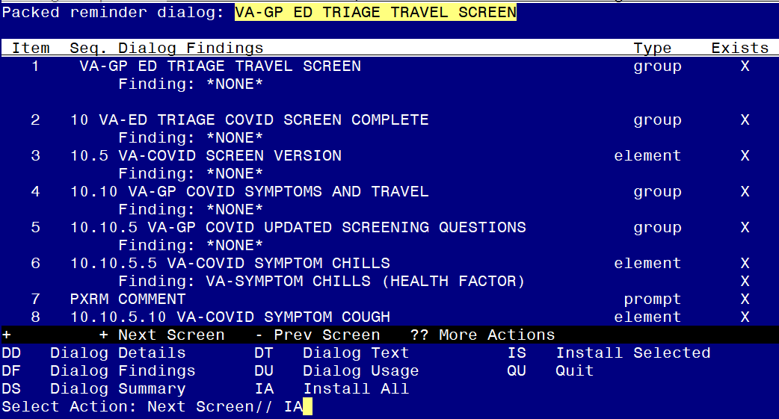
At the Select Action prompt, type IA to install the dialog – VA-GP ED TRIAGE TRAVEL SCREEN
Select Action: Next Screen// IA Install All
Install reminder dialog and all components with no further changes: Y// ES

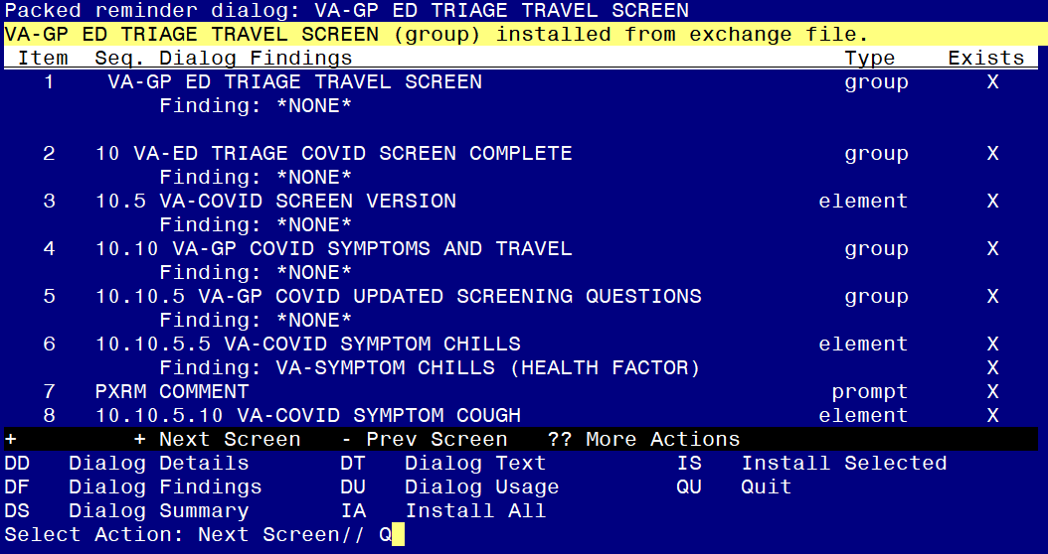
When the dialog has completed installation, you will then be returned to this screen. At the Select Action prompt, type Q.
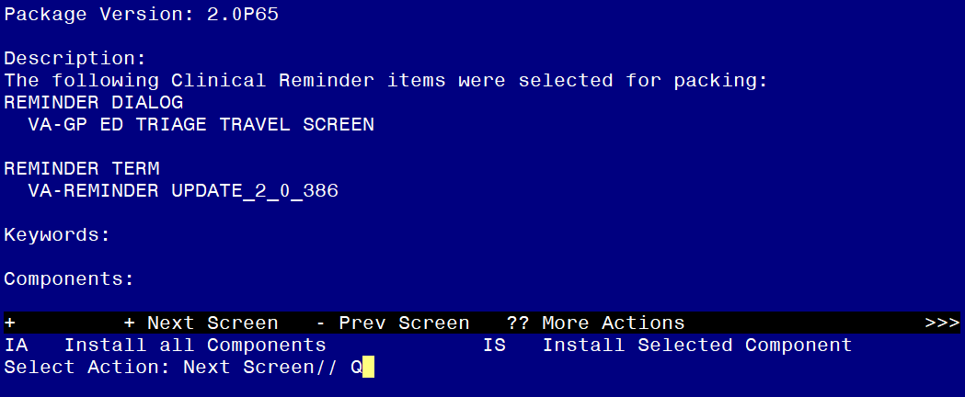

You will be returned to this screen. Type Q to quit.

Install Completed

Post Installation

Open the ED Triage note in CPRS and confirm the COVID-19 Screen no longer displays above the suicide screen option within the template.

Note: If your site would like to continue screening for COVID-19 in the Emergency Department, you can add it back to the end of the template in the local section. You would add the reminder dialog group VA-GP COVID SCREEN COMPLETE as a sequence in the reminder dialog group VAL-GP ED TRIAGE PLACEHOLDER. You may need to enable the placeholder group if your site was not using it previously.

