Update _2_0_390

Clinical Reminders

INFLUENZA REMINDER UPDATE 2023

Install Guide

August 2023

Product Development
Office of Information Technology
Department of Veterans Affairs

Table of Contents
Introduction 1
Pre-Install 1
Install Details 3
Install Example 3
Post Installation 7

Introduction

DO NOT INSTALL THIS INTO YOUR PRODCTION ACCOUNT UNTIL YOUR SITE HAS YOUR FLU FORMULATIONS FOR 2023-2024 FLU SEASON AND YOU ARE READY TO ADMINISTER. YOU WILL NEED TO COORDINATE WITH YOUR FLU COMMITTEE AND POSSIBLY PHARMACY

UPDATE 390 Influenza Reminder Update for 2023-24 influenza season contains the following updates.
- Update start date to 7/30/23
- Update stop date to 5/8/24
- Update formulations in the dialog.
- Update dialog to version 4.
- Update seasonal contraindication start date to 7/30/23

UPDATE_2_0_390 contains 1 Reminder Exchange entry:
UPDATE_2_0_390 FLU REMINDER 2023-2024

The exchange file contains the following components:

REMINDER GENERAL FINDINGS
VIEW PROGRESS NOTE TEXT

TIU TEMPLATE FIELD
BLANK TEXT FIELD FOR DIALOGS
VA-INFLUENZA RECOMMEND
VA-INFLUENZA SUMMARY
IM SCRIBE
IM INFLUENZA VACCINE POST SEASON MESSAGE
IM INFLUENZA VACCINE REMINDER DIALOG HEADER
VA-LOCATIONS
IM INFLUENZA COUNSELING
IM PHARMACY PHONE NUMBERS
IM VIS INFLUENZA IN URL
IM VIS INFLUENZA URL
NCP INFLUENZA IMMUNIZATION GUIDANCE

HEALTH FACTORS
VA-REMINDER UPDATES [C]
VA-UPDATE_2_0_390
IMMUNIZATION [C]
VA-INFLUENZA IMM CONTRAINDICATION
VA-INFLUENZA IMM NONE CURRENT SEASON
VA-FLU EDUCATION VIRTUAL/TELEHEALTH VST
VA-INFLUENZA IMM PERM CONTRAINDICATION
VA-INFLUENZA IMM SEASON CONTRAINDICATION
VA-INFLUENZA IMM REFUSED

REMINDER SPONSOR
VA NATIONAL CENTER FOR HEALTH PROMOTION AND DISEASE PREVENTION (NCP)
NATIONAL CENTER FOR HEALTH PROMOTION AND DISEASE PREVENTION (NCP)

REMINDER COMPUTED FINDINGS
VA-FILEMAN DATE
VA-ASU USER CLASS
VA-AGE

REMINDER TAXONOMY
VA-IMMUNIZATION ICD10 CODE

REMINDER TERM
VA-REMINDER UPDATE_2_0_390
VA-INFLUENZA CONTRAINDICATION
VA-INFLUENZA IMM SEASON STOP DATE
VA-INFLUENZA ADMIN SUPPRESSION
VA-IM NO DOSES AVAIL FLU 149
VA-IM NO DOSES AVAIL FLU 185
VA-IM NO DOSES AVAIL FLU 186
VA-IM NO DOSES AVAIL FLU 171
VA-IM NO DOSES AVAIL FLU 197
VA-INFLUENZA HIGH DOSE SUPPRESS OPTION
VA-IM NO DOSES AVAIL FLU 205
VA-IM NO DOSES AVAIL FLU 158
VA-IM NO DOSES AVAIL FLU 150
VA-INFLUENZA ORDER SUPPRESSION
VA-INFLUENZA IMM NOT DONE THIS SEASON
VA-INFLUENZA IMM CONTRAINDICATION
VA-INFLUENZA IMM SEASON START DATE
VA-INFLUENZA IMM SEASONAL VACCINE FORMULATIONS

REMINDER DEFINITION
VAL-BL INFLUENZA CONTRAINDICATION
VA-INFLUENZA SEASONAL IMMUNIZATION

HEALTH SUMMARY TYPE
VA-INFLUENZA CONTRA

HEALTH SUMMARY OBJECTS
VA-INFLUENZA CONTRA (TIU)

TIU DOCUMENT DEFINITION
VA-INFLUENZA CONTRA

REMINDER DIALOG
VA-INFLUENZA IMMUNIZATION

Pre-Install

Using the menu Reminder Dialog Manager, reminder Dialog, change view to group view, review the reminder dialog group VAL-OI IM INFLUENZA OUTPT and identify any quick order added as a finding or additional finding.

Install Details
DO NOT INSTALL THIS INTO YOUR PRODUCTION ACCOUNT UNTIL YOUR SITE HAS YOUR FLU FORMULATIONS FOR 2023-2024 FLU SEASON AND YOU ARE READY TO ADMINISTER. YOU WILL NEED TO COORDINATE WITH YOUR FLU COMMITTEE AND POSSIBLY PHARMACY
This update is being distributed as a web host file. The address for the host file is: https://REDACTED/UPDATE_2_0_390.PRD

The file will be installed using Reminder Exchange, programmer access is not required.

Installation:
=============
This update can be loaded with users on the system. Installation will take less than 30 minutes.

Install Example
To Load the exchange file, use LWH. The URL is
https://REDACTED /UPDATE_2_0_390.PRD

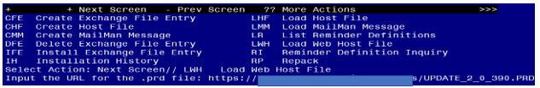

You should see a message that the file was loaded successfully.

Search and locate an entry titled UPDATE_2_0_390 FLU REMINDER 2023-2024 in reminder exchange.
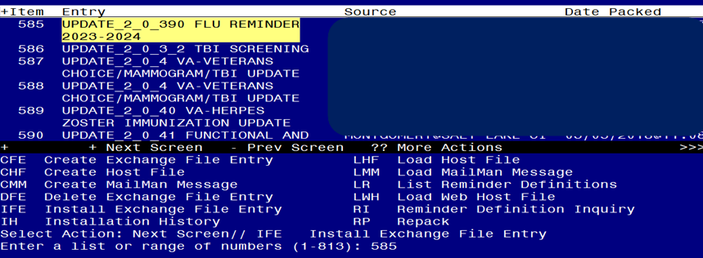

At the Select Action prompt, enter IFE for Install Exchange File Entry
Enter the number that corresponds with your entry titled UPDATE_2_0_390 FLU REMINDER 2023-2024 (in this example it is entry 585, it will vary by site) that is dated 07/31/2023.

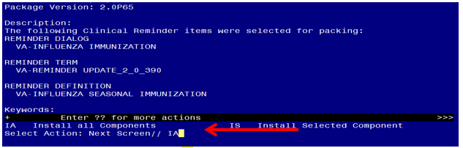
At the Select Action prompt, type IA for Install all Components and hit enter.

For all new entries you will choose I to Install

For any TIU TEMPLATE FIELD that exist but are different, use OVERWRITE action
For HEALTH FACTORS that exist but are different use OVERWRITE action
For any REMINDER TERM that exist but are different, use the SKIP action except for the following 3 terms. For these three terms use OVERWRITE action
VA-INFLUENZA IMM SEASON START DATE
VA-INFLUENZA IMM SEASON STOP DATE
VA-INFLUENZA IMM CONTRAINDICATION
For any reminder definition that that exists but is different, use OVERWRITE action
For any HEALTH SUMMARY TYPE that exist but are different, use the SKIP action

++ In your test account, if you get prompted that any formulations do not exist, you can choose D to delete. You should not get that error in production where the immunization file should be up to date. ++
You will be promped to install the reminder dialog component: Many sites have made local edits to the influenza dialog and this will install will override all your local modifications
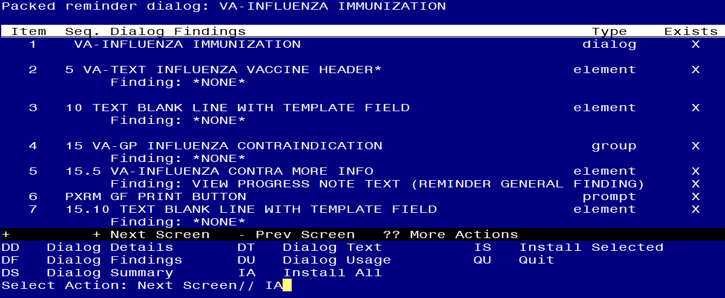

At the Select Action prompt, type IA to install all items.. If you have made local changes, this will overwrite all your changes!!

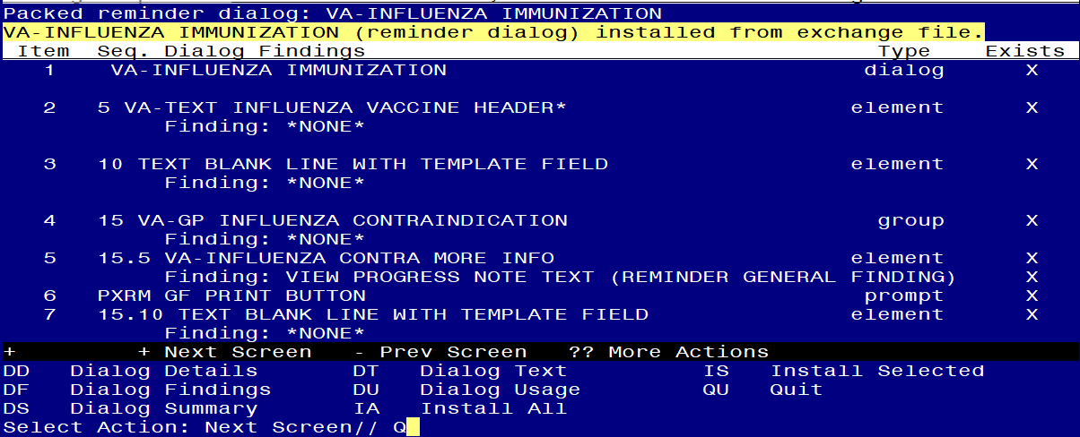
When the dialog has completed installation, you will then be returned to this screen. At the Select Action prompt, type Q.

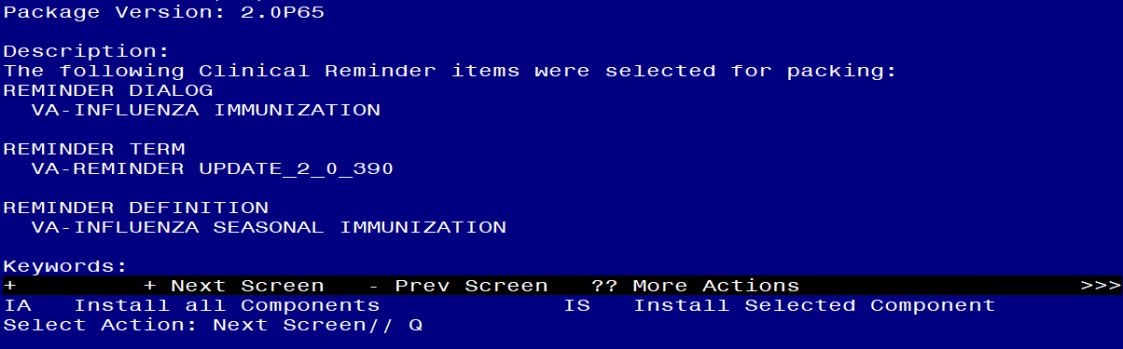

Type Q to exit the dialog installation

Post Installation

- Using the pre-install inquiry, add the appropriate immunization quick orders as a FINDING ITEM on the reminder dialog group VAL-OI IM INFLUENZA OUTPT. (You may not have had an order on this group, it is a local site decision on whether or not to add one, if you are not sure, review with your Pharmacy AdPac.
The finding item should be your local order or ordering menu for seasonal influenza.
- If you want to suppress the ordering option in the dialog or the administration option in the INFLUENZA dialog, then follow the instructions in the following reminder terms. If you did not overwrite these terms during installation, they should work the same as in previous seasons.
  - VA-INFLUENZA ORDER SUPPRESSION
  - VA-INFLUENZA ADMIN SUPPRESSION
To suppress the dialog element for specific user classes: VA-ASU USER CLASS Enter the user class that should NOT see the dialog element. If more than one user class is needed, add additional findings of the CF VA-ASU USER CLASS for each one as needed.
To suppress the dialog element for all users: VA-AGE change the < sign to a > sign in the CF for patient age.
To suppress for specific user classes, in the above Terms configure the VA-ASU USER CLASS computed finding and DELETE the VA-AGE finding. NOTE: If the Age finding is not deleted, the user class settings will not work.
Other Local Options
- Season Start Date: There is a reminder term, VA-INFLUENZA IMM SEASON START DATE, for the season start date. This is the date before which any vaccination will be ignored for this current season. The reminder is exported with a date of 7/30/2023. You should not need to change this date for the 2023-2024 flu season.

- Season Stop Date: There is a reminder term to indicate the date that a facility chooses to stop giving vaccine, VA-INFLUENZA IMM SEASON STOP DATE. Each spring, when flu season is over based on community incidence, the facility chooses to stop giving vaccine. After this date has passed as defined in this reminder term, the reminder logic changes to turn off if the vaccine was refused during the season or if someone records that the patient did not get vaccine during the season. The dialog also changes to a post-season version once this date has passed.
The term is exported with a default of 5/8/2024 which will need to be updated by each site in the spring of 2024 when a decision is made to stop giving vaccine.
- Dialog Text: much of the informational text and all of the administration options in the reminder dialog are local. You can edit the information text to add flu clinic hours or other local information. You can add or remove any of the flu vaccination options – the 3 formulary vaccine formulations are included by default but the group that contains them is local.
- High dose suppression: if you want to completely suppress the option to document high dose vaccine on some group of patients, you can do that by making the condition in the reminder term shown below true for those patients. The reminder dialog is exported with a default age of 18 - for patients under the age of 18, the option to document high dose is suppressed.
PLEASE be careful with this option -if a nurse administers high dose vaccine and then opens the dialog and the option is not there, they are likely to record the vaccine incorrectly.
VA-INFLUENZA HIGH DOSE SUPPRESS OPTION
-------------------------------------------
Class: NATIONAL
Sponsor: VA National Center for Health Promotion and Disease Prevention (NCP)
Description:
Enter any condition or reminder definition that defines a population for
whom the option to see the High Dose flu vaccine administration option will
be suppressed.
If this term is true, then that option will be suppressed.
Findings:
Finding Item: VA-AGE (FI(1)=CF(27))
Finding Type: REMINDER COMPUTED FINDING
Condition: I V<18

- Adding non-formulary formulations: The group for administering vaccine, VAL-GP IM INFLUENZA ADMIN OPTIONS, is local. There are several formulations that have dialog groups available but not viewable because the groups are installed as disabled. There is also an additional local option that you can use and edit the text if your site purchases something other than the options provided. If your site wants to use one of the hidden options, you can remove the disable from the dialog group in Vista.
The reminder dialog will install with these CVX codes enabled, your site can disable one or more of these if you do not provide that formulation :
150 - Fluzone – syringe
158 - Fluzone - multidose vial
197 - Fluzone – syringe (High Dose)
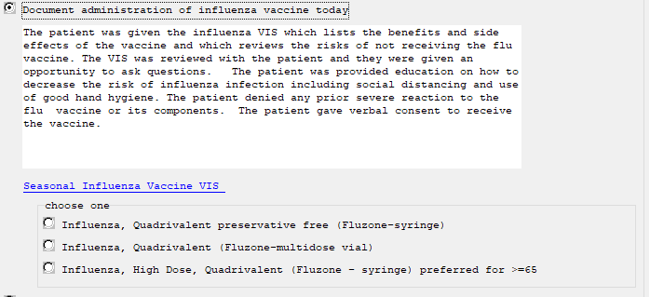

These additional CVX codes are available but disabled in the dialog and can be enabled if appropriate for your site, please work with your local Pharmacy to make sure you have the appropriate CVX codes enabled:
149 – FluMist (this option has an additional VIS sheet link)
171 - Flucelvax – syringe
185 - Flublok – syringe
186 - Flucelvax – multidose vial
205 - Fluad – syringe

Install complete.

