

**Update\_2\_0\_266**

Clinical Reminders

VA-OEND REMINDER UPDATE

Install Guide

**June 2022**

Product Development

Office of Information Technology

Department of Veterans Affairs

Table of Contents

[Introduction 1](#_Toc85633959)

[Pre-Install 6](#_Toc85633960)

[Install Details 6](#_Toc85633961)

[Install Example 6](#_Toc85633962)

[Post Installation 11](#_Toc85633963)

# Introduction

Expanding the current clinical reminder and Clinical Reminder Order Check (CROC) is critical as the majority of overdose deaths are opioid-related, including stimulant overdose deaths given the high rates of polysubstance use and rise in illicit stimulants containing deadly amounts of fentanyl and carfentanil. With regards to opioid-related stimulant deaths, in 2019, 76% of overdose deaths involving cocaine also involved an opioid and 54% of overdose deaths involving psychostimulants also involved an opioid ([NCHS Data Brief, Number 406, April 2021 (cdc.gov)](https://gcc02.safelinks.protection.outlook.com/?url=https%3A%2F%2Fwww.cdc.gov%2Fnchs%2Fdata%2Fdatabriefs%2Fdb406-H.pdf&data=04%7C01%7C%7Cc8993fcc018448e8440d08da0157cbf7%7Ce95f1b23abaf45ee821db7ab251ab3bf%7C0%7C0%7C637823773828604474%7CUnknown%7CTWFpbGZsb3d8eyJWIjoiMC4wLjAwMDAiLCJQIjoiV2luMzIiLCJBTiI6Ik1haWwiLCJXVCI6Mn0%3D%7C3000&sdata=7QRqOu9tVQhj2u5bpmM45Xt6LaOE9OLqUGvervZ0yqE%3D&reserved=0)). Thus, the vast majority of stimulant-related overdose deaths involve opioids. It is for this reason that we are working to expand naloxone distribution to patients with stimulant use disorders.

 We are also updating the print names for the reminder dialog and clinical reminder to more accurately reflect their content which includes BOTH overdose education and naloxone. This will allow for a wider array of staff to utilize these products.

This update includes

1. An update to the clinical reminder VA-NALOXONE OFFER PRESCRIPTION to include patients with a history of stimulant use disorder in addition to patients with opioid use disorder that do not have current Naloxone in the cohort logic and reminder dialog description:
   1. Expand cohort logic to INCLUDE patients with stimulant use disorder (F14.1x, F14.2x, F14.9x, F15.1x, F15.2x, and F15.9x)
   2. Update the print name, change from “Offer Naloxone Prescription” to “Offer Overdose Education and Naloxone”.
   3. Modify reminder dialog to remove the word “prescription”.
   4. Modify reminder dialog to display the following info (changes are highlighted):

This reminder will come due for any patient that has had:

one or more outpatient Opioid Use Disorder (OUD) OR Stimulant Use Disorder encounter diagnoses in the past two years

       —OR—

one or more inpatient OUD OR Stimulant Use Disorder diagnoses in the past year

      —AND—1

No naloxone ordered in the past 335 days

This reminder supports standardized Opioid Overdose Education and Naloxone Distribution (OEND). Because OUD and Stimulant Use Disorder diagnoses are strong risk factors for overdose, OEND is recommended. Specifically, the majority of overdose deaths are opioid-related, including stimulant overdose deaths given high rates of polysubstance use and rise in illicit stimulants containing deadly amounts of fentanyl or carfentanil. OEND should include critical education on opioid overdose prevention, recognition, and response.

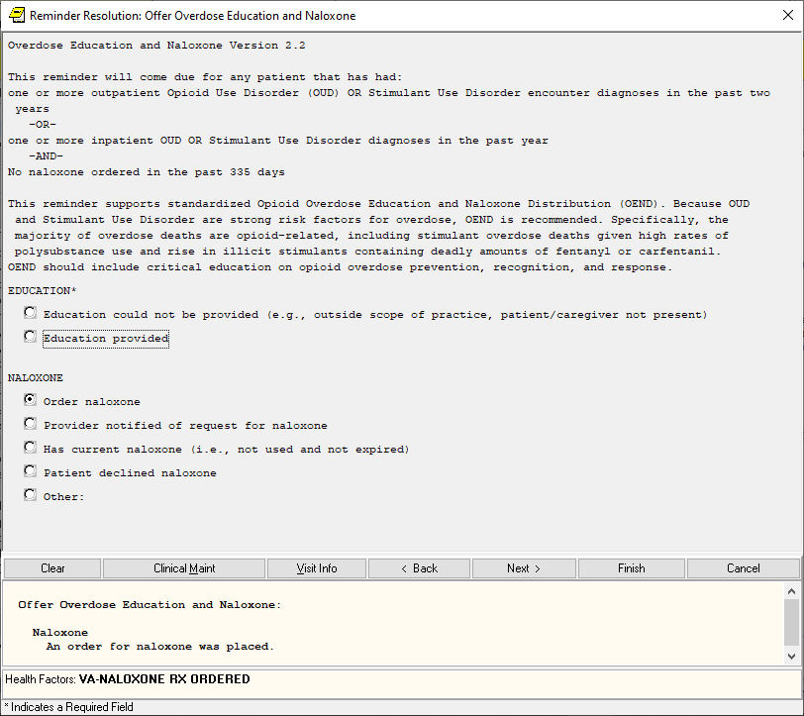

1. The stand-alone template reminder dialog was updated to remove the word “prescription”

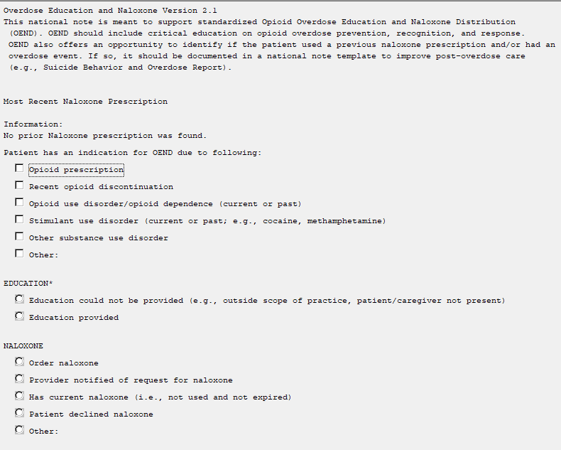

1. The reminder order check rule VA-NALOXONE FOR OPIOID USE DISORDER was also updated to include patients in the cohort that have a diagnosis of stimulant use disorder within the past year. The text was updated to reflect the updated reminder definition and note name.

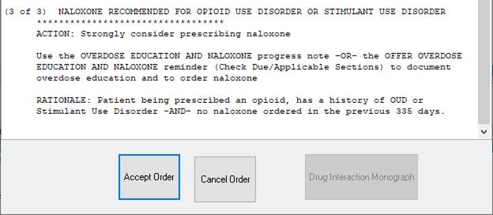

1. The reminder order check rule MEDICATION FOR OPIOID USE DISORDER was updated to reflect the new reminder definition and note name.

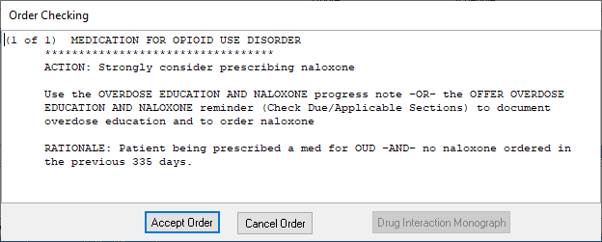

UPDATE\_2\_0\_266 contains 1 Reminder Exchange entry:

UPDATE\_2\_0\_266 VA-OEND REMINDER UPDATE

**The exchange file contains the following components:**

**TIU TEMPLATE FIELD**

VA-OPIOID NALOXONE AUTO

VA-OPIOID NALOXONE NASAL

VA-OPIOID INTRO TO NALOXONE DISORDER

VA-OPIOID INTRO TO NALOXONE PRESCRIBE

VA-NALOXONE PATIENT GUIDE

VA-OSP OEND SHAREPOINT

**HEALTH FACTORS**

VA-REMINDER UPDATES [C]

VA-UPDATE\_2\_0\_266

VA-NALOXONE [C]

VA-NALOXONE RX FOR STIMULANT USE DISORDER

VA-NALOXONE RX FOR OTHER REASON

VA-NALOXONE RX FOR OTHER SUD

VA-NALOXONE RX FOR OUD

VA-NALOXONE RX FOR OPIOID DISCONT

VA-NALOXONE RX FOR OPIOID RX

VA-NALOXONE ED-TEACH BACK

VA-NALOXONE RESOURCES-OTHER

VA-NALOXONE VIDEO-AUTO-INJECTOR

VA-NALOXONE VIDEO-SPRAY

VA-NALOXONE VIDEO-OUD

VA-NALOXONE VIDEO-RX OPIOIDS

VA-NALOXONE ED TO CAREGIVER OR OTHER

VA-NALOXONE ED TO PATIENT

VA-NALOXONE RX OTHER

VA-HAS NALOXONE RX

VA-PATIENT DECLINED NALOXONE

VA-NALOXONE RX REQUEST PROVIDER NOTIFIED

VA-NALOXONE RX ORDERED

**REMINDER SPONSOR**

MENTAL HEALTH SERVICES

OFFICE OF MENTAL HEALTH SERVICES

**REMINDER TAXONOMY**

VA-OUD ALL SOURCES

VA-STIMULANT USE DISORDER ALL SOURCES

VA-STIMULANT USE DISORDER IP

VA-OUD DIAGNOSIS IP

VA-OUD DIAGNOSIS OP

VA-STIMULANT USE DISORDER OP

**REMINDER TERM**

VA-NALOXONE PRESCRIPTION ON FILE

VA-OUD STIMULANT USE DISORDER REMINDER TERM

VA-REMINDER UPDATE\_2\_0\_266

VA-NALOXONE DECLINED

VA-NALOXONE PROVIDER NOTIFIED

VA-NALOXONE OUD DIAGNOSIS INPATIENT

VA-NALOXONE NOT NEEDED

VA-NALOXONE ORDER

VA-NALOXONE OUD DIAGNOSIS OUTPATIENT

**REMINDER DEFINITION**

VA-NALOXONE ORDER CHECK

VA-NALOXONE OBJECT

VA-NALOXONE OFFER PRESCRIPTION

**HEALTH SUMMARY TYPE**

VA-NALOXONE

**HEALTH SUMMARY OBJECTS**

VA-NALOXONE (TIU)

**TIU DOCUMENT DEFINITION**

VA-NALOXONE

**REMINDER ORDER CHECK RULES**

VA-MEDICATION FOR OPIOID USE DISORDE

VA-NALOXONE FOR OPIOID USE DISORDER

**REMINDER DIALOG**

VA-NALOXONE PRESCRIBING

VA-NALOXONE OFFER PRESCRIPTION

# Pre-Install

1. Check your Reminder Exchange Install History (IH) and ensure you have installed the previously released **UPDATE\_2\_0\_222 VA-OEND REMINDER**
2. **Find Naloxone order currently in use.**

* Using the Vista Menu, Reminder Dialog Manager, DI- Reminder Dialog, change view to group view and Inq/Print the reminder dialog group VAL-NALOXONE REQUEST. You will need to identify the local order or menu used as a finding item and add this order back post install.

# Install Details

This update is being distributed as a web host file. The address for the host file is: https://REDACTED/UPDATE\_2\_0\_266.PRD

The file will be installed using Reminder Exchange, programmer access is not required.

Installation:

=============

This update can be loaded with users on the system. Installation will take less than 10 minutes.

# Install Example

To Load the exchange file, use LWH. The URL is https://REDACTED /UPDATE\_2\_0\_266.PRD

**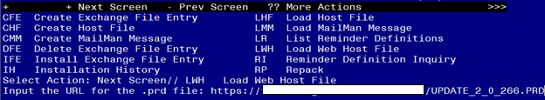**

You should see a message that the file was loaded successfully.

Terminal window screen shot of the message displaying the URL of the file that was successfully loaded.  Part of the URL has been redacted as it is a VA only internal web site URL.

Search and locate an entry titled UPDATE\_2\_0\_266 VA-OEND REMINDER UPDATE in reminder exchange.

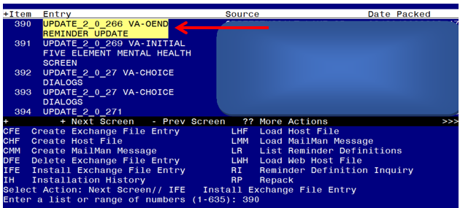

At the **Select Action** prompt, enter **IFE** for Install Exchange File Entry

Enter the number that corresponds with your entry titled UPDATE\_2\_0\_266 VA-OEND REMINDER UPDATE *(in this example it is entry 390, it will vary by site)* that is dated 06/08/2022.

For the Reminder Dialog "VA NALOXONE PRESCRIBING: 
Terminal screen shot of the first terminal window in Reminder Exchange listing the Clinical Reminder Items that were selected for packing.  It shows IA for "Install All" entered at the prompt. At the **Select Action** prompt, type **IA** for Install all Components and hit enter.

**For all new entries in any category you will choose I to Install**

**You will overwrite the following items, if you are prompted to overwrite any other items, choose skip.**

**REMINDER TERMS:**

VA-NALOXONE OUD DIAGNOSIS INPATIENT

VA-NALOXONE OUD DIAGNOSIS OUTPATIENT

**REMINDER DEFINITIONS:**

VA-NALOXONE ORDER CHECK

VA-NALOXONE OFFER PRESCRIPTION

**REMINDER ORDER CHECK RULES:**

VA-MEDICATION FOR OPIOID USE DISORDER

VA-NALOXONE FOR OPIOID USE DISORDER

You will then be prompted to install the first reminder dialog component. You will choose IA to install all even though some items will already have an X to indicate they exist.

For the Reminder Dialog "VA NALOXONE PRESCRIBING:
Screen shot of the terminal window showing a list of elements, groups and dialogs with the text with IA for "Install All" entered at the "Select Action:" Prompt.  The correct entry is described in the text.


At the **Select Action** prompt, type **IA** to install the dialog – **VA-NALOXONE PRESCRIBING**

Install reminder dialog and all components with no further changes: Y// ES....

For the Reminder Dialog "VA NALOXONE PRESCRIBING:
Screen shot of the last of the list of elements, groups and dialogs that needed to be installed with a Q for quit entered at the "Select Action:" prompt because they now all exist.  


When the dialog has completed installation, you will then be returned to this screen. At the **Select Action** prompt, type **Q.**

You will then be prompted to install the next reminder dialog component. You will choose IA to install all even though some items will already have an X to indicate they exist.

For the VA_NALOXONE OFFER PRESCRIPTION National Reminder Dialog:
Screen shot of the terminal window showing a list of elements, groups and dialogs with the text with IA for "Install All" entered at the "Select Action:" Prompt.  The correct entry is described in the text.

At the **Select Action** prompt, type **IA** to install the dialog – **VA-NALOXONE OFFER PRESCRIPTION**

Install reminder dialog and all components with no further changes: Y// ES....

For the VA_NALOXONE OFFER PRESCRIPTION National Reminder Dialog:

Screen shot of the last of the list of elements, groups and dialogs that needed to be installed with a Q for quit entered at the "Select Action:" prompt because they now all exist.  

When the dialog has completed installation, you will then be returned to this screen. At the **Select Action** prompt, type **Q.**

Screen shot of the terminal window showing that after all of the groups, elements and dialogs have been installed, the reminder that was installed with Q entered for quit to finish. The name of the VA employee at the Source line label has been redacted.



You will then be returned to this screen. At the **Select Action** prompt, type **Q.**

Install complete.

# Post Installation

1. Using your document definition manager, you will need to inactivate and CHANGE the note title Naloxone Prescribing to Overdose Education and Naloxone, you will then need to also change the print name and activate the note title after changing.

The intent and content of this note is unchanged except for the title, the program office understands that this will change the note title historically and would like that change to be made so that the note is able to be used by a wide range of disciplines.

***Note:*** *Comprehensive information on Creating new Document Classes and Titles can be found beginning on page 54 of the TIU/ASU Implementation Guide at the following link:* [*http://www.va.gov/vdl/documents/Clinical/CPRS-Text\_Integration\_Utility\_(TIU)/tiuim.pdf*](http://www.va.gov/vdl/documents/Clinical/CPRS-Text_Integration_Utility_(TIU)/tiuim.pdf)

1. **Add naloxone order identified in pre-install to reminder dialog.** Using the Vista Menu, Reminder Dialog Manager, DI- Reminder Dialog, change view to GROUP view edit the reminder dialog group VAL-NALOXONE REQUEST, add the quick order identified in the pre-install as a finding item.
2. **Activate the Reminder Order Check Rules (optional)**

The installation of CLINICAL REMINDER UPDATE\_2\_0\_266 will require the STATUS of the Reminder Order Check Rules, VA-NALOXONE FOR OPIOID USE DISORDER and VA-MEDICATION FOR OPIOID USE DISORDER to be changed to PROD.   Shown below are the steps to make this change which should be done for both rules if your site uses the national version of these order checks.

The option represented here is **Add/Edit Reminder Order Check Rule [PXRM ORDER CHECK RULE EDIT].**

Select Reminder Order Check Menu Option: **RE**  Add/Edit Reminder Order Check Rule

Select Reminder Order Check Rule by:  (N/R/T/Q): N// **N**  ORDER CHECK RULE NAME

Select Reminder Order Check Rule: VA-NALOXONE FOR OPIOID USE DISORDER

RULE NAME: VA-NALOXONE FOR OPIOID USE DISORDER

DISPLAY NAME: **NALOXONE RECOMMENDED FOR OPIOID USE DISORDER OR STIMULANT USE DISORDER**

STATUS: **PROD**

**^ *change to PROD to activate Production Mode***

CLASS: **NATIONAL**

SPONSOR:

REVIEW DATE:

\_\_\_\_\_\_\_\_\_\_\_\_\_\_\_\_\_\_\_\_\_\_\_\_\_\_\_\_\_\_\_\_\_\_\_\_\_\_\_\_\_\_\_\_\_\_\_\_\_\_\_\_\_\_\_

I=INACTIVE, P=PRODUCTION, T=TESTING

Save and Exit

**Repeat for the Reminder Order Check Rule** VA-MEDICATION FOR OPIOID USE DISORDER

1. **Test reminder order check (optional)**

If you would like to test the reminder order check, here is a way you can test after you have updated to production status.

On a TEST patient that does not have a naloxone prescription

1. Add a diagnosis of F14.10 to an encounter within the past year
2. Using the Non VA Meds Order option, attempt to document a NON VA Morphine Tab, SA prescription
   1. Choose a dosage, schedule and explanation
   2. Choose Accept Order

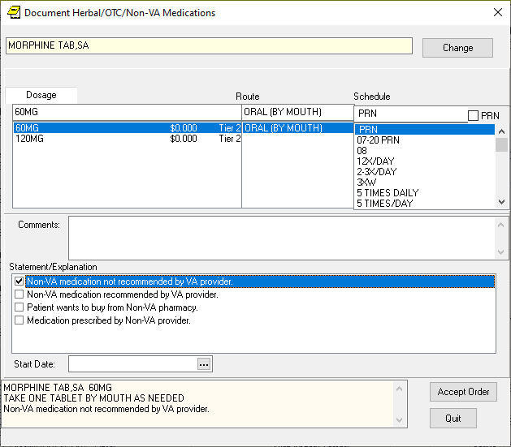

1. You should see the ORDER check, NALOXONE RECOMMENDED FOR OPIOID USE DISORDER OR STIMULANT USE DISORDER.



1. Choose Cancel order
2. Testing is complete after you have confirmed the order check will appear as indicated.