Update_2_0_270

Clinical Reminders

VA-MISC Update 17

Install Guide

June 2022

Product Development
Office of Information Technology
Department of Veterans Affairs

Table of Contents
Introduction 1
Pre-Installation 4
Install Details 5
Install Example 5
Post Installation 22

Introduction

This update contains minor spelling corrections and other changes/edits to existing clinical reminder content, a full list of the changes can be found in the Document MISC_UPDATE_17_CHANGES in docx or pdf format in the VistA Documentation Library, https://www.va.gov/vdl.

UPDATE_2_0_270 contains 1 Reminder Exchange entry:
UPDATE_2_0_270 VA-MISC UPDATE 17

The exchange file contains the following components:

MH TESTS AND SURVEYS
PHQ-2

REMINDER DIALOG LINK TYPE
VA-DEPRESSION POSITIVE WARM HANDOFF CHECK

TIU TEMPLATE FIELD
VA-HCOE HA DURATION
VA-HCOE HA SYMPTOMS
YES / NO
VA-HCOE HA INTENSITY
VA-HCOE HA PAIN TYPE
VA-HCOE HA LOCATION
VA-HCOE HA FREQUENCY
TEXT (1-60 CHAR)
VA-HCOE HA CAUSE
NUM REQ
YES/NO/UNSURE
VA-HCOE CBT MOTOR
TEXT (1-10 CHAR)
NCP HERPES ZOSTER DETAILED GUIDANCE
CDC ZOSTER VACCINE RECOMMENDATIONS
NCP HERPES ZOSTER GUIDANCE
WOUND DRESSSINGS
EDIT 20
YES NO NA

HEALTH FACTORS
VA-REMINDER UPDATES [C]
VA-UPDATE_2_0_270
VA-SCI/D BLADDER MGMT-SURG PROCEDURES [C]
VA SCI/D BLADDER SURG HX-OTHER
VA-SCI/D BLADDER SURG HX-SUPRAPUBIC CATH
VA-SCI/D BLADDER SURG HX-SPHINCTEROTOMY
VA-SCI/D BLADDER SURG HX-SACR ANT STIM
VA-SCI/D BLADDER SURG HX-ILEOVESICOSTOMY
VA-SCI/D BLADDER SURG HX-ILEAL CONDUIT
VA-SCI/D BLADDER SURG HX-CONTINENT STOMA
VA-SCI/D BLADDER SURG HX-AUGMENTATION
VA-SCI/D BLADDER SURG HX-ART SPHINCTER
VA-SCI/D BLADDER SURG HX-NONE
VA-SCI/D BLADDER MGMT-COLLECTION DEVICE [C]
VA-SCI/D BLADDER COLLECTION-FOLEY/LEG BAG
VA-SCI/D BLADDER COLLECTION-URINAL
VA-SCI/D BLADDER COLLECTION-OSTOMY BAG
VA-SCI/D BLADDER COLLECTION-DIAPER/PAD
VA-SCI/D BLADDER COLLECTION-CONDOM CATH
VA-SCI/D BLADDER COLLECTION-NONE
VA-SCI/D BLADDER MGMT-EMPTYING METHOD [C]
VA-SCI/D BLADDER-SACRAL ANT ROOT STIM
VA-SCI/D BLADDER EMPTY METHOD-UNKNOWN
VA-SCI/D BLADDER INTRMNT CATH-ATNDT
VA-SCI/D BLADDER INTRMNT CATH-SELF
VA-SCI/D BLADDER EMPTY METHOD-OTHER
VA-SCI/D BLADDER-DIALYSIS
VA-SCI/D BLADDER-UROSTOMY
VA-SCI/D BLADDER INDWELL CATH-SUPRAPUBIC
VA-SCI/D BLADDER INDWELL CATH-TRANSURETH
VA-SCI/D BLADDER REFLEX TRIG-EXT COMP
VA-SCI/D BLADDER REFLEX TRIG-STRAINING
VA-SCI/D BLADDER REFLEX TRIG-INVOLUNTARY
VA-SCI/D BLADDER REFLEX TRIG-VOLUNTARY
VA-SCI/D BLADDER-NORMAL VOIDING
VA-SCI/D REVIEW DATE [C]
VA-SCI/D BLADDER MGMT REVIEW DATE
VA-HEADACHE CENTER OF EXCELLENCE COGNITIVE BEH THERAPY
VA-HCOE CBT MOD-SEV DEP SYMP
VA-VAAES LINE [C]
VA-VAAES MIDLINE INSERT PREP DRAPE
VA-VAAES MIDLINE INSERT PREP MASK
VA-VAAES MIDLINE INSERT PREP GOWN
VA-VAAES MIDLINE INSERT PREP STERILE GLOVES
VA-VAAES MIDLINE INSERT PREP CAP
VA-VAAES MIDLINE INSERTION PREP OTHER
VA-VAAES MIDLINE INSERTION PREP ANTIMIC
VA-VAAES MIDLINE INSERTION PREP CHLOR
VA-VAAES MIDLINE INSERT PREP HAND HYGIENE
VA-VAAES CENTRAL LINE #2 INSERT PREP DRAPE
VA-VAAES CENTRAL LINE #2 INSERT PREP MASK
VA-VAAES CENTRAL LINE #2 INSERT PREP GOWN
VA-VAAES CENTRAL LINE #2 INSERT PREP STERILE GLOVES
VA-VAAES CENTRAL LINE #2 INSERT PREP CAP
VA-VAAES CL#2 INSERTION PREP OTHER
VA-VAAES CL#2 INSERTION PREP ANTIMIC
VA-VAAES CL#2 INSERTION PREP CHLOR
VA-VAAES CENTRAL LINE #2 INSERT PREP HAND HYGIENE
VA-VAAES CENTRAL LINE #1 INSERT PREP DRAPE
VA-VAAES CENTRAL LINE #1 INSERT PREP MASK
VA-VAAES CENTRAL LINE #1 INSERT PREP GOWN
VA-VAAES CENTRAL LINE #1 INSERT PREP STERILE GLOVES
VA-VAAES CENTRAL LINE #1 INSERT PREP CAP
VA-VAAES CL#1 INSERTION PREP OTHER
VA-VAAES CL#1 INSERTION PREP ANTIMIC
VA-VAAES CL#1 INSERTION PREP CHLOR
VA-VAAES CENTRAL LINE #1 INSERT PREP HAND HYGIENE
VA-VAAES PICC INSERT PREP DRAPE
VA-VAAES PICC INSERT PREP MASK
VA-VAAES PICC INSERT PREP GOWN
VA-VAAES PICC INSERT PREP STERILE GLOVES
VA-VAAES PICC INSERT PREP CAP
VA-VAAES PICC INSERTION PREP OTHER
VA-VAAES PICC INSERTION PREP ANTIMIC
VA-VAAES PICC INSERTION PREP CHLOR
VA-VAAES PICC INSERT PREP HAND HYGIENE

REMINDER SPONSOR
VHA NATIONAL CENTER FOR HEALTH PROMOTION AND DISEASE PREVENTION (NCP) AND VHA OFFICE OF WOMEN'S HEALTH
OFFICE OF NURSING SERVICE
NATIONAL CENTER FOR HEALTH PROMOTION AND DISEASE PREVENTION (NCP)
OFFICE OF NURSING INFORMATICS
MENTAL HEALTH SERVICES
OFFICE OF TELEHEALTH SERVICES STORE AND FORWARD TELEHEALTH

REMINDER TAXONOMY
VA-WH HYSTERECTOMY W/CERVIX REMOVED
VA-WH PAP SMEAR SCREEN CODES

REMINDER TERM
VA-REMINDER UPDATE_2_0_270
VA-SCI/D BLADDER MGMT-SURG HX (OBJ)
VA-SCI/D BLADDER MGMT-COLLECTION (OBJ)
VA-SCI/D BLADDER MGMT-EMPTYING METH (OBJ)
VA-SCI/D BLADDER MANAGEMENT STATUS
REMINDER DEFINITION
VA-OBJ SCI/D BLADDER MGMT-SURG HX
VA-OBJ SCI/D BLADDER MGMT-COLLECTION DEVICE
VA-OBJ SCI/D BLADDER MGMT-EMPTYING METHOD

HEALTH SUMMARY COMPONENT
CLINICAL REMINDER FINDINGS
PCE HEALTH FACTORS SELECTED

HEALTH SUMMARY TYPE
VA-SCI/D BLADDER MGMT-SURG HX
VA-SCI/D BLADDER-COLL DEVICE
VA-SCI/D BLADDER MGT-EMP METH
VA-SCI/D BLADDER MGMT REV DATE

HEALTH SUMMARY OBJECTS
VA-SCI/D BLADDER MGMT-SURG HX (TIU)
VA-SCI/D BLADDER MGMT-COLLECTION DEVICE (TIU)
VA-SCI/D BLADDER MGMT-EMPTYING METHOD (TIU)
VA-SCI/D BLADDER MGMT REV DATE

TIU DOCUMENT DEFINTION
VA-SCI/D BLADDER MGMT-SURG HX
VA-SCI/D BLADDER MGMT-COLLECTION DEVICE
VA-SCI/D BLADDER MGMT-EMPTYING METHOD
VA-SCI/D BLADDER MGMT REV DATE

REMINDER DIALOG
VA-GP MISC UPDATE 17

Pre-Installation

Prior to installing this Update:

- Check Reminder Exchange Install History (IH) and ensure your facility has installed the following (previously released) Updates:

  - UPDATE_2_0_192 VA-MH UPDATES 8.0
  - UPDATE_2_0_212 VA-AES SHIFT ASSESSMENT BUNDLE
  - UPDATE_2_0_213 VA-SCI/D EMERGENCY DIALOGS
  - UPDATE_2_0_241 VA-HCOE TEMPLATES
  - UPDATE_2_0_232 VA-TELEWOUND IMAGER AND READER TEMPLATES
  - UPDATE_2_0_262 VA-HERPES ZOSTER REMINDER UPDATE

Install Details

This update is being distributed as a web host file. The address for the host file is: https://REDACTED/UPDATE_2_0_270.PRD

The file will be installed using Reminder Exchange, programmer access is not required.

Installation:
=============
This update can be loaded with users on the system. Installation will take less than 15 minutes.

Install Example
To Load the Web Host File. Navigate to Reminder exchange in Vista

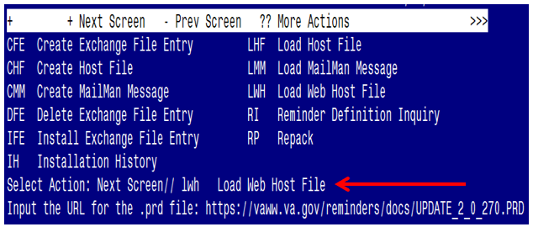

At the Select Action: prompt, enter LWH for Load Web Host File
At the Input the url for the .prd file: prompt, type the following web address:
https://REDACTED/UPDATE_2_0_270.PRD
You should see a message at the top of your screen that the file successfully loaded.

Search for and locate the reminder exchange entry titled UPDATE_2_0_270 VA-MISC UPDATE 17 (see screenshot below).

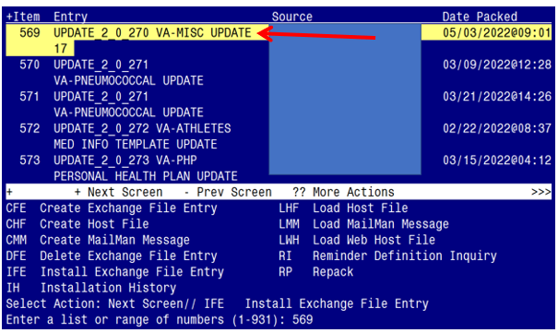

At the Select Action prompt, enter IFE for Install Exchange File Entry
Enter the number that corresponds with your entry titled UPDATE_2_0_270 VA-MISC UPDATE 17 (in this example it is entry 569, it will vary by site). The exchange file date should be 05/03/2022@09:01.

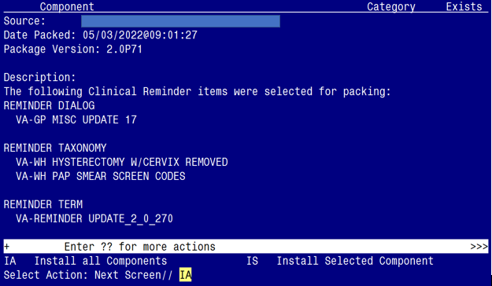

At the Select Action prompt, type IA for Install all Components and hit enter.
Select Action: Next Screen// IA Install all Components

You will see several prompts:

1 - For all new components, you will choose I to Install

2 - For some components, you will choose O to Overwrite.

3 - For some components, you will choose S to Skip

Each individual component you may be prompted for is listed below, along with the response you should provide

TIU TEMPLATE FIELD entry named VA-HCOE HA CAUSE already exists but the packed component is different, what do you want to do?

Select one of the following:

C Create a new entry by copying to a new name
O Overwrite the current entry
U Update
Q Quit the install
S Skip, do not install this entry

Enter response: O// verwrite the current entry
Are you sure you want to overwrite? N// y YES..

TIU TEMPLATE FIELD entry named YES/NO/UNSURE already exists but the packed component is different, what do you want to do?

Select one of the following:

C Create a new entry by copying to a new name
O Overwrite the current entry
U Update
Q Quit the install
S Skip, do not install this entry

Enter response: O// s Skip, do not install this entry

TIU TEMPLATE FIELD entry named VA-HCOE CBT MOTOR already exists but the packed component is different, what do you want to do?

Select one of the following:

C Create a new entry by copying to a new name
O Overwrite the current entry
U Update
Q Quit the install
S Skip, do not install this entry

Enter response: O// verwrite the current entry
Are you sure you want to overwrite? N// y YES.

TIU TEMPLATE FIELD entry named NCP HERPES ZOSTER DETAILED GUIDANCE
already exists but the packed component is different, what do you want to do?

Select one of the following:

C Create a new entry by copying to a new name
O Overwrite the current entry
U Update
Q Quit the install
S Skip, do not install this entry

Enter response: O// verwrite the current entry
Are you sure you want to overwrite? N// y YES..

TIU TEMPLATE FIELD entry named WOUND DRESSSINGS already exists but the packed component is different, what do you want to do?

Select one of the following:

C Create a new entry by copying to a new name
O Overwrite the current entry
U Update
Q Quit the install
S Skip, do not install this entry

Enter response: O// verwrite the current entry
Are you sure you want to overwrite? N// y YES...

TIU TEMPLATE FIELD entry named YES NO NA already exists but the packed component is different, what do you want to do?

Select one of the following:

C Create a new entry by copying to a new name
O Overwrite the current entry
U Update
Q Quit the install
S Skip, do not install this entry

Enter response: O// s Skip, do not install this entry

HEALTH FACTORS entry VA-UPDATE_2_0_270 is NEW,
what do you want to do?

Select one of the following:

C Create a new entry by copying to a new name
I Install
Q Quit the install
S Skip, do not install this entry

Enter response: I// nstall............

HEALTH FACTORS entry VA-SCI/D BLADDER COLLECTION-FOLEY/LEG BAG is NEW, what do you want to do?

Select one of the following:

C Create a new entry by copying to a new name
I Install
Q Quit the install
S Skip, do not install this entry

Enter response: I// nstall

HEALTH FACTORS entry VA-SCI/D BLADDER COLLECTION-URINAL is NEW,
what do you want to do?

Select one of the following:

C Create a new entry by copying to a new name
I Install
Q Quit the install
S Skip, do not install this entry

Enter response: I// nstall.

HEALTH FACTORS entry named VA-SCI/D BLADDER COLLECTION-DIAPER/PAD
already exists but the packed component is different, what do you want to do?

Select one of the following:

C Create a new entry by copying to a new name
O Overwrite the current entry
U Update
Q Quit the install
S Skip, do not install this entry

Enter response: O// verwrite the current entry
Are you sure you want to overwrite? N// y YES......................

HEALTH FACTORS entry VA-VAAES MIDLINE INSERT PREP DRAPE is NEW,
what do you want to do?

Select one of the following:

C Create a new entry by copying to a new name
I Install
Q Quit the install
S Skip, do not install this entry

Enter response: I// nstall

HEALTH FACTORS entry VA-VAAES MIDLINE INSERT PREP MASK is NEW,
what do you want to do?

Select one of the following:

C Create a new entry by copying to a new name
I Install
Q Quit the install
S Skip, do not install this entry

Enter response: I// nstall

HEALTH FACTORS entry VA-VAAES MIDLINE INSERT PREP GOWN is NEW,
what do you want to do?

Select one of the following:

C Create a new entry by copying to a new name
I Install
Q Quit the install
S Skip, do not install this entry

Enter response: I// nstall

HEALTH FACTORS entry VA-VAAES MIDLINE INSERT PREP STERILE GLOVES is NEW, what do you want to do?

Select one of the following:

C Create a new entry by copying to a new name
I Install
Q Quit the install
S Skip, do not install this entry

Enter response: I// nstall

HEALTH FACTORS entry VA-VAAES MIDLINE INSERT PREP CAP is NEW,
what do you want to do?

Select one of the following:

C Create a new entry by copying to a new name
I Install
Q Quit the install
S Skip, do not install this entry

Enter response: I// nstall...

HEALTH FACTORS entry VA-VAAES MIDLINE INSERT PREP HAND HYGIENE is NEW, what do you want to do?

Select one of the following:

C Create a new entry by copying to a new name
I Install
Q Quit the install
S Skip, do not install this entry

Enter response: I// nstall

HEALTH FACTORS entry VA-VAAES CENTRAL LINE #2 INSERT PREP DRAPE is NEW, what do you want to do?

Select one of the following:

C Create a new entry by copying to a new name
I Install
Q Quit the install
S Skip, do not install this entry

Enter response: I// nstall

HEALTH FACTORS entry VA-VAAES CENTRAL LINE #2 INSERT PREP MASK is NEW, what do you want to do?

Select one of the following:

C Create a new entry by copying to a new name
I Install
Q Quit the install
S Skip, do not install this entry

Enter response: I// nstall

HEALTH FACTORS entry VA-VAAES CENTRAL LINE #2 INSERT PREP GOWN is NEW, what do you want to do?

Select one of the following:

C Create a new entry by copying to a new name
I Install
Q Quit the install
S Skip, do not install this entry

Enter response: I// nstall

HEALTH FACTORS entry VA-VAAES CENTRAL LINE #2 INSERT PREP STERILE GLOVES is NEW, what do you want to do?

Select one of the following:

C Create a new entry by copying to a new name
I Install
Q Quit the install
S Skip, do not install this entry

Enter response: I// nstall

HEALTH FACTORS entry VA-VAAES CENTRAL LINE #2 INSERT PREP CAP is NEW,
what do you want to do?

Select one of the following:

C Create a new entry by copying to a new name
I Install
Q Quit the install
S Skip, do not install this entry

Enter response: I// nstall...

HEALTH FACTORS entry VA-VAAES CENTRAL LINE #2 INSERT PREP HAND HYGIENE is NEW, what do you want to do?

Select one of the following:

C Create a new entry by copying to a new name
I Install
Q Quit the install
S Skip, do not install this entry

Enter response: I// nstall

HEALTH FACTORS entry VA-VAAES CENTRAL LINE #1 INSERT PREP DRAPE is NEW, what do you want to do?

Select one of the following:

C Create a new entry by copying to a new name
I Install
Q Quit the install
S Skip, do not install this entry

Enter response: I// nstall

HEALTH FACTORS entry VA-VAAES CENTRAL LINE #1 INSERT PREP MASK is NEW, what do you want to do?

Select one of the following:

C Create a new entry by copying to a new name
I Install
Q Quit the install
S Skip, do not install this entry

Enter response: I// nstall

HEALTH FACTORS entry VA-VAAES CENTRAL LINE #1 INSERT PREP GOWN is NEW, what do you want to do?

Select one of the following:

C Create a new entry by copying to a new name
I Install
Q Quit the install
S Skip, do not install this entry

Enter response: I// nstall

HEALTH FACTORS entry VA-VAAES CENTRAL LINE #1 INSERT PREP STERILE GLOVES is NEW, what do you want to do?

Select one of the following:

C Create a new entry by copying to a new name
I Install
Q Quit the install
S Skip, do not install this entry

Enter response: I// nstall

HEALTH FACTORS entry VA-VAAES CENTRAL LINE #1 INSERT PREP CAP is NEW,
what do you want to do?

Select one of the following:

C Create a new entry by copying to a new name
I Install
Q Quit the install
S Skip, do not install this entry

Enter response: I// nstall...

HEALTH FACTORS entry VA-VAAES CENTRAL LINE #1 INSERT PREP HAND HYGIENE is NEW, what do you want to do?

Select one of the following:

C Create a new entry by copying to a new name
I Install
Q Quit the install
S Skip, do not install this entry

Enter response: I// nstall...

REMINDER TAXONOMY entry named VA-WH PAP SMEAR SCREEN CODES already
exists but the packed component is different, what do you want to do?

Select one of the following:

C Create a new entry by copying to a new name
O Overwrite the current entry
U Update
Q Quit the install
S Skip, do not install this entry

Enter response: O// verwrite the current entry
Are you sure you want to overwrite? N// y YES

REMINDER TAXONOMY entry named VA-WH HYSTERECTOMY W/CERVIX REMOVED already exists but the packed component is different, what do you want to do?

Select one of the following:

C Create a new entry by copying to a new name
O Overwrite the current entry
U Update
Q Quit the install
S Skip, do not install this entry

Enter response: O// verwrite the current entry
Are you sure you want to overwrite? N// y YES

REMINDER TERM entry VA-REMINDER UPDATE_2_0_270 is NEW, what do you want to do?

Select one of the following:

C Create a new entry by copying to a new name
I Install
Q Quit the install
S Skip, do not install this entry

Enter response: I// nstall....

REMINDER TERM entry VA-SCI/D BLADDER MGMT-COLLECTION (OBJ) already exists but the packed component is different, what do you want to do?

Select one of the following:

C Create a new entry by copying to a new name
I Install
Q Quit the install
S Skip, do not install this entry

Enter response: O// s Skip, do not install this entry

REMINDER DEFINITION entry named VA-OBJ SCI/D BLADDER MGMT-SURG HX
already exists but the packed component is different, what do you want to do?

Select one of the following:

C Create a new entry by copying to a new name
O Overwrite the current entry
U Update
Q Quit the install
S Skip, do not install this entry

Enter response: O// s Skip, do not install this entry

REMINDER DEFINITION entry named VA-OBJ SCI/D BLADDER MGMT-EMPTYING
METHOD already exists but the packed component is different, what do you want to do?

Select one of the following:

C Create a new entry by copying to a new name
O Overwrite the current entry
U Update
Q Quit the install
S Skip, do not install this entry

Enter response: O// s Skip, do not install this entry

HEALTH SUMMARY TYPE entry named VA-SCI/D BLADDER MGMT-SURG HX already
exists but the packed component is different, what do you want to do?

Select one of the following:

C Create a new entry by copying to a new name
O Overwrite the current entry
U Update
Q Quit the install
S Skip, do not install this entry

Enter response: O// s Skip, do not install this entry

HEALTH SUMMARY TYPE entry named VA-SCI/D BLADDER-COLL DEVICE already
exists but the packed component is different, what do you want to do?

Select one of the following:

C Create a new entry by copying to a new name
O Overwrite the current entry
U Update
Q Quit the install
S Skip, do not install this entry

Enter response: O// s Skip, do not install this entry

HEALTH SUMMARY TYPE entry named VA-SCI/D BLADDER MGT-EMP METH already
exists but the packed component is different, what do you want to do?

Select one of the following:

C Create a new entry by copying to a new name
O Overwrite the current entry
U Update
Q Quit the install
S Skip, do not install this entry

Enter response: O// s Skip, do not install this entry

HEALTH SUMMARY TYPE entry named VA-SCI/D BLADDER MGMT REV DATE
already exists but the packed component is different, what do you want to do?

Select one of the following:

C Create a new entry by copying to a new name
O Overwrite the current entry
U Update
Q Quit the install
S Skip, do not install this entry

Enter response: O// s Skip, do not install this entry

HEALTH SUMMARY OBJECTS entry named VA-SCI/D BLADDER MGMT-SURG HX
(TIU) already exists but the packed component is different, what do you want to do?

Select one of the following:

C Create a new entry by copying to a new name
O Overwrite the current entry
U Update
Q Quit the install
S Skip, do not install this entry

Enter response: O// s Skip, do not install this entry

You will be promped to install the dialog component:

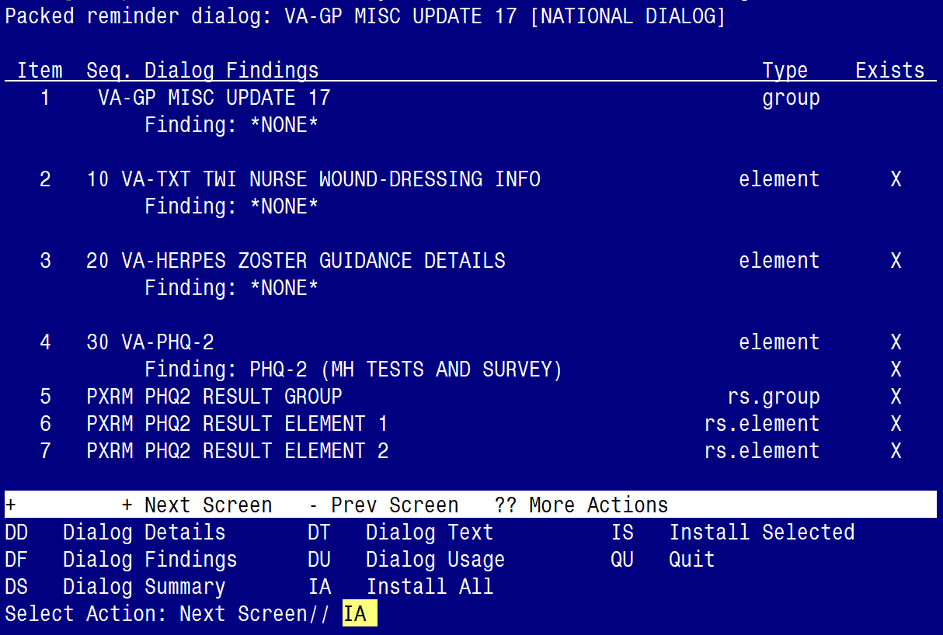

At the Select Action prompt, type IA to install the dialog – VA-GP MISC UPDATE 17
Select Action: Next Screen// IA Install All
Install reminder dialog and all components with no further changes: Y// ES

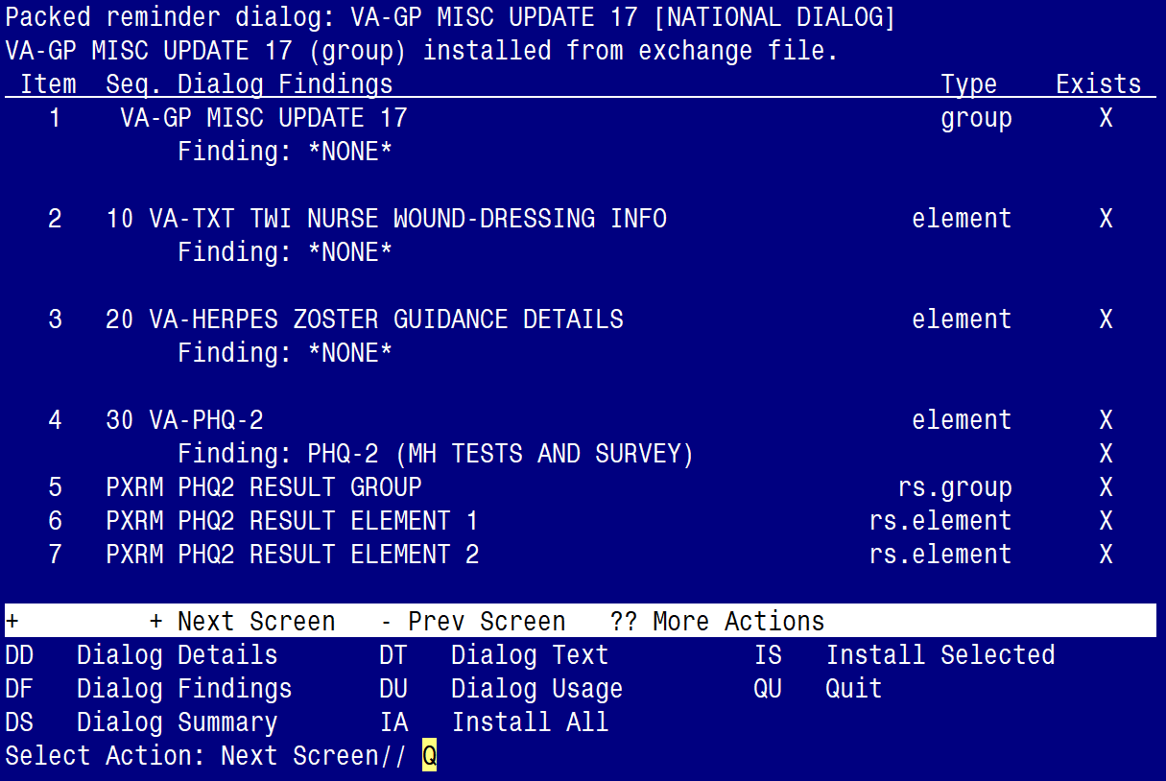

When the dialog has completed installation, you will then be returned to this screen. At the Select Action prompt, type Q.

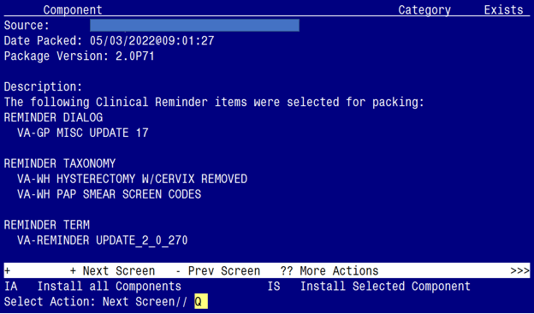

You will be returned to this screen. Type Q to quit.
Install Completed

Post Installation

- No post-installation steps are needed.

