Update _2_0_275

Clinical Reminders

VA-HCC (Hepatocellular Carcinoma) SURVEILLANCE REMINDER

Install Guide

July 2022

Product Development
Office of Information Technology
Department of Veterans Affairs

Table of Contents
Introduction 1
Pre-Install 2
Install Details 3
Install Example 3
Post Installation 7

Introduction
People with cirrhosis and some people with chronic hepatitis B are at increased risk of hepatocellular carcinoma. Surveillance ultrasound with or without alpha-fetoprotein (AFP) every 6 months is recommended. This reminder was developed by the National Gastroenterology & Hepatology Program for use by primary care providers.

COHORT:
Any patient with one inpatient or two outpatient cirrhosis diagnoses
or
Some patients with chronic hepatitis B
2 positive Hep B Surface Antigen (HBsAg) and/or HBV DNA results 6 months apart:
African/African American 20 and older
Asian/Pacific Islander male 40 and older
Asian/Pacific Islander female 50 and older

RESOLUTION:
Imaging for liver and HCC (US, MRI, or CT)
Outside imaging results documented
Patient refusal

NOT APPLICABLE:
Diagnosis for known HCC
Limited life expectancy
Incorrect diagnosis documented
Community liver care

UPDATE_2_0_275 contains 1 Reminder Exchange entry:
UPDATE_2_0_275 VA-HCC REMINDER

The exchange file contains the following components:

HEALTH FACTORS
VA-REMINDER UPDATES [C]
VA-UPDATE_2_0_275
VA-HCC LIVER CANCER [C]
VA-HCC INCORRECT DIAGNOSIS CHRONIC HBV
VA-HCC INCORRECT DIAGNOSIS CIRRHOSIS
VA-HCC NON-VA LIVER CARE
VA-HCC SURVEILLANCE NOT INDICATED
VA-HCC SURVEILLANCE DECLINES IMAGING
OUTSIDE RESULTS [C]
OUTSIDE AFP RESULT
OUTSIDE ULTRASOUND/CT OF LIVER RESULT

REMINDER SPONSOR
NATIONAL GASTROENTEROLOGY & HEPATOLOGY PROGRAM
NATIONAL CENTER FOR HEALTH PROMOTION AND DISEASE
PREVENTION (NCP)

REMINDER TAXONOMY
VA-HEPATOCELLULAR CARCINOMA
VA-LIVER CANCER PROCEDURE/IMAGING
VA-ADVANCED LIVER DISEASE DX CODES

REMINDER TERM
VA-REMINDER UPDATE_2_0_275
VA-RACE BLACK OR AFRICAN AMERICAN RT
VA-HEPATITIS B SURFACE ANTIGEN
VA-HCC DECLINES IMAGING FOR SURVEILLANCE
VA-HCC IMAGING FOR LIVER CANCER
VA-HCC IMAGING OI RT
VA-HCC INCORRECT DIAGNOSIS OF CIRRHOSIS
VA-HCC INCORRECT DIAGNOSIS OF CHRONIC HBV
VA-RACE ASIAN OR NATIVE HAWAIIAN/PACIFIC ISLANDER RT
VA-HCC SURVEILLANCE NOT INDICATED
VA-HCC HEPATITIS B VIRUS DNA RT
VA-HCC ADVANCED LIVER DISEASE DX

REMINDER DEFINITION
VA-HCC SURVEILLANCE

REMINDER DIALOG
VA-HCC SURVEILLANCE

Pre-Install

- Print a copy of the following terms. This term should be skipped during installation. Use the printed copy to compare the terms post-installation to confirm the term has not changed.
  - VA-HEPATITIS B SURFACE ANTIGEN

- Coordinate with appropriate staff to gather the appropriate findings for the following terms to map during post-installation.
  - VA-HCC HEPATITIS B VIRUS DNA RT
    - All local HBV DNA lab tests should be mapped to this term. Coordinate with the local Lab Information Manager and/or clinical staff to identify the correct lab tests.

  - VA-HCC IMAGING OI RT
    - Any local abdominal ultrasound orderable items appropriate for liver cancer screening should be mapped to this term. Many sites may have only one ultrasound appropriate for screening. Coordinate with local clinical staff to identify the correct abdominal ultrasounds.

- Identify local quick orders for the following to map to the reminder dialog during post-installation.
    - Abdominal ultrasound appropriate for liver cancer screening
    - Alfa-fetoprotein lab test
    - Consult order for GI and/or hepatology

Install Details

This update is being distributed as a web host file. The address for the host file is: https://REDACTED/UPDATE_2_0_275.PRD

The file will be installed using Reminder Exchange, programmer access is not required.

Installation:
=============
This update can be loaded with users on the system. Installation will take less than 10 minutes.

Install Example
To Load the exchange file, use LWH. The URL is
https://REDACTED/UPDATE_2_0_275.PRD

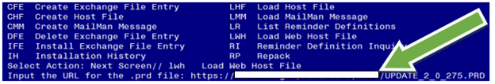

Search and locate an entry titled UPDATE_2_0_275 VA-HCC SURVEILLANCE REMINDER in reminder exchange. 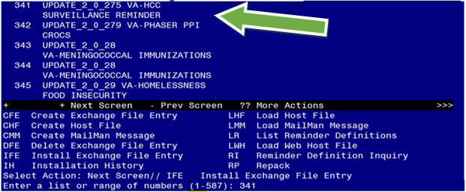
At the Select Action prompt, enter IFE for Install Exchange File Entry
Enter the number that corresponds with your entry titled UPDATE_2_0_275 VA- HCC SURVEILLANCE REMINDER (in this example it is entry 341, it will vary by site) that is dated 05/27/2022.

This update adds a new reminder sponsor, which is linked to the new health factors. Install the reminder sponsor first to prevent errors when installing all.

Select IS for Install Selected Component and choose component 13. Then select Install.

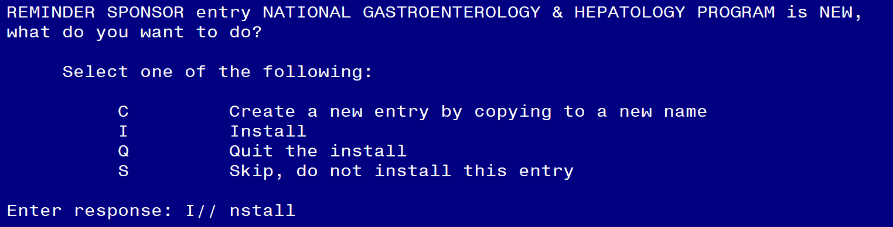

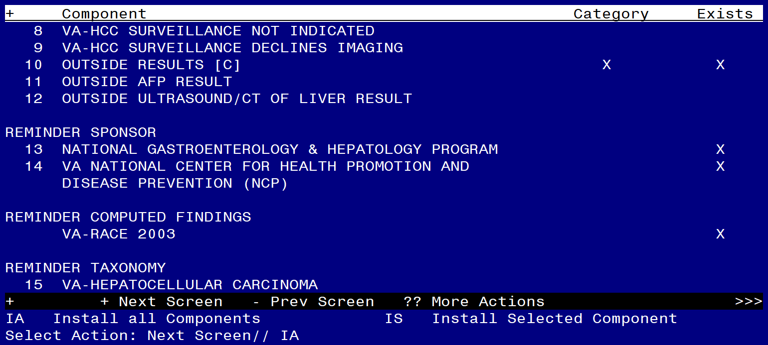
At the Select Action prompt, type IA for Install all Components and hit enter.

For all new entries choose I to Install

For existing items choose SKIP. Do not overwrite the VA-HEPATITIS B SURFACE ANTIGEN reminder term!

You will then be prompted to install the Dialog component.
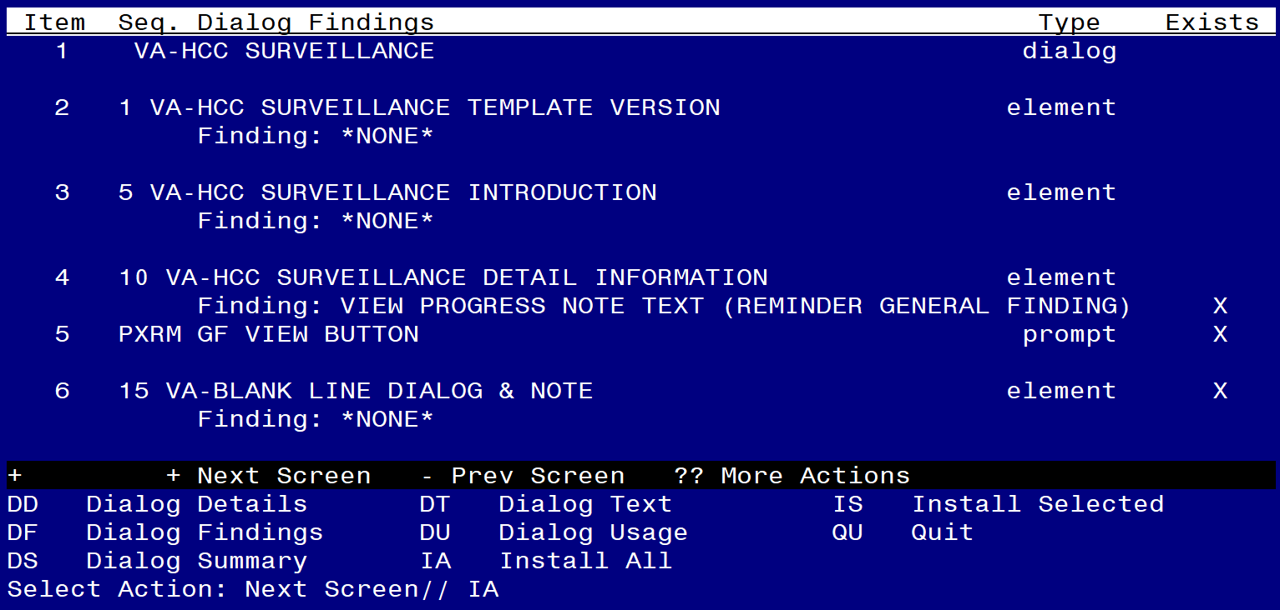

At the Select Action prompt, type IA to install the dialog – VA-HCC SURVEILLANCE

Hit enter when prompted to link to the definition.

Install reminder dialog and all components with no further changes: Y// ES....
Select Reminder to Link: VA-HCC SURVEILLANCE// VA-HCC SURVEILLANCE
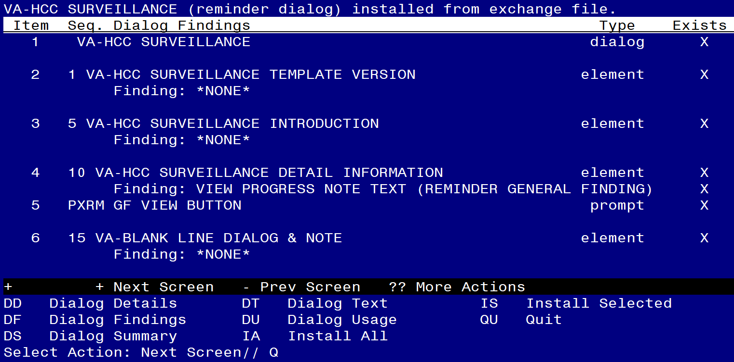

When the dialog has completed installation, you will then be returned to this screen. At the Select Action prompt, type Q.

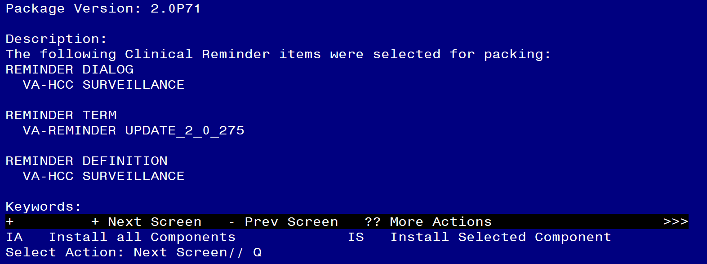

You will then be returned to this screen. At the Select Action prompt, type Q.

Install complete.

Post-Installation

- Coordinate with local staff and add local Hepatitis B Virus DNA lab test(s) to the reminder term VA-HCC HEPATITIS B VIRUS DNA RT. Add the below text string to the CONDITION field, so the term is evaluated as true if the lab test is positive.

CF Reminder Computed Finding Management ...
RM Reminder Definition Management ...
SM Reminder Sponsor Management ...
TXM Reminder Taxonomy Management
TRM Reminder Term Management ...
LM Reminder Location List Management ...
RX Reminder Exchange
RT Reminder Test
OS Other Supporting Menus ...
INFO Reminder Information Only Menu ...
DM Reminder Dialog Management ...
CP CPRS Reminder Configuration ...
RP Reminder Reports ...
MST Reminders MST Synchronization Management ...
PL Reminder Patient List Menu ...
PAR Reminder Parameters ...
VS NLM Value Set Menu
ROC Reminder Order Check Menu ...
CQM NLM Clinical Quality Measures Menu
XM Reminder Extract Menu ...

Select Reminder Managers Menu <TEST ACCOUNT> Option: TRM

TL List Reminder Terms
TI Inquire about Reminder Term
TE Add/Edit Reminder Term
TC Copy Reminder Term
TICS Integrity Check Selected
TICA Integrity Check All
TEST Term Test

Select Reminder Term Management <TEST ACCOUNT> Option: TE

Select Reminder Term: VA-HCC HEPATITIS B VIRUS DNA

Reminder Term has no findings!

Select Finding: Enter “LT.” then the name of the lab test

Searching for a LABORATORY TEST, (pointed-to by FINDING ITEM)

Searching for a LABORATORY TEST
HBV DNA
...OK? Yes//Yes
Are you adding 'HBV DNA' as a new FINDINGS? No// Yes
Editing Finding Number: 1
FINDING ITEM: HBV DNA//
BEGINNING DATE/TIME:
ENDING DATE/TIME:
OCCURRENCE COUNT:
CONDITION: Enter “I +V>0”
CONDITION CASE SENSITIVE: NO//
USE STATUS/COND IN SEARCH:

- Add local orderable item(s) for abdominal ultrasounds to the reminder term VA-HCC IMAGING OI RT.
CF Reminder Computed Finding Management ...
RM Reminder Definition Management ...
SM Reminder Sponsor Management ...
TXM Reminder Taxonomy Management
TRM Reminder Term Management ...
LM Reminder Location List Management ...
RX Reminder Exchange
RT Reminder Test
OS Other Supporting Menus ...
INFO Reminder Information Only Menu ...
DM Reminder Dialog Management ...
CP CPRS Reminder Configuration ...
RP Reminder Reports ...
MST Reminders MST Synchronization Management ...
PL Reminder Patient List Menu ...
PAR Reminder Parameters ...
VS NLM Value Set Menu
ROC Reminder Order Check Menu ...
CQM NLM Clinical Quality Measures Menu
XM Reminder Extract Menu ...

Select Reminder Managers Menu <TEST ACCOUNT> Option: TRM

TL List Reminder Terms
TI Inquire about Reminder Term
TE Add/Edit Reminder Term
TC Copy Reminder Term
TICS Integrity Check Selected
TICA Integrity Check All
TEST Term Test

Select Reminder Term Management <TEST ACCOUNT> Option: TE

Select Reminder Term: VA-HCC IMAGING OI RT

Select Finding: Enter “OI” then name of abdominal ultrasound order

Are you adding 'ULTRASOUND' as a new FINDINGS? No//Yes
Editing Finding Number: 1
FINDING ITEM: ULTRASOUND//
BEGINNING DATE/TIME:
ENDING DATE/TIME:
OCCURRENCE COUNT:
USE START DATE:
CONDITION:
CONDITION CASE SENSITIVE: NO//
USE STATUS/COND IN SEARCH:

No statuses defined for this finding item

Select one of the following:

A ADD STATUS
D DELETE A STATUS
S SAVE AND QUIT
Q QUIT WITHOUT SAVING CHANGES

Enter response: S// ADD STATUS
1 - * (WildCard)
2 - ACTIVE
3 - CANCELLED
4 - COMPLETE
5 - DELAYED
6 - DISCONTINUED
7 - DISCONTINUED/EDIT
8 - EXPIRED
9 - FLAGGED
10 - HOLD
11 - LAPSED
12 - NO STATUS
13 - PARTIAL RESULTS
14 - PENDING
15 - RENEWED
16 - SCHEDULED
17 - UNRELEASED
Select a Order Status from or enter '^' to Quit: (1-17): 2,15,16,14

Statuses already defined for this finding item:
ACTIVE
PENDING
RENEWED
SCHEDULED

Select one of the following:

A ADD STATUS
D DELETE A STATUS
S SAVE AND QUIT
Q QUIT WITHOUT SAVING CHANGES

Enter response: SAVE AND QUIT

- Confirm the reminder term VA-HEPATITIS B SURFACE ANTIGEN matches the printed copy completed in pre-installation. Edit as necessary.

- Map the appropriate local order dialogs to FINDING ITEM field in the following elements.

  - VA-HCC SURVEILLANCE ULTRASOUND ORDER
FINDING ITEM: Enter “Q.” then the name of the local order for abdominal ultrasound.

  - VA-HCC SURVEILLANCE AFP ORDER
FINDING ITEM: Enter “Q.” then the name of the local order for Alfa-fetoprotein
test.

  - VA-HCC SURVEILLANCE GI/LIVER CONSULT ORDER
FINDING ITEM: Enter “Q.” then the name of the local consult order for GI and/or
hepatology.

- Add the new reminder to the cover sheet for the appropriate users. You will use the Add Cover Sheet Reminder option in CPRS. The print name is “Liver Cancer (HCC) Surveillance”. Because this is a new reminder, you may want to turn on only for a few individuals to test before expanding usage.

