Update _2_0_106

Clinical Reminders

VA-Oncology Dialog Updates

Install Guide

March 2020

Product Development
Office of Information Technology
Department of Veterans Affairs

Table of Contents
Introduction 1
Install Details 36
Install Example 36
Post Installation 40

Introduction

Description:
The National Oncology CRC and Head/Neck reminder dialogs have been updated to reflect American Joint Cancer Committee (AJCC) 8th edition staging elements/definitions. The previous dialogs contained AJCC 7th edition. Please contact REDACTED.

Clinical CRC (Reminder dialog: VA-ONCOLOGY COLORECTAL)
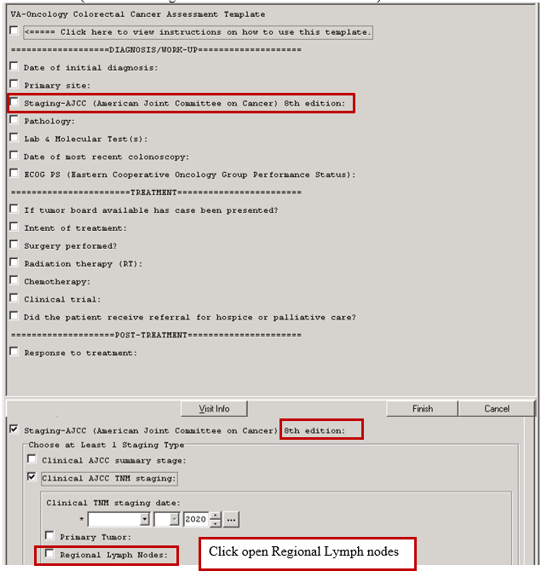
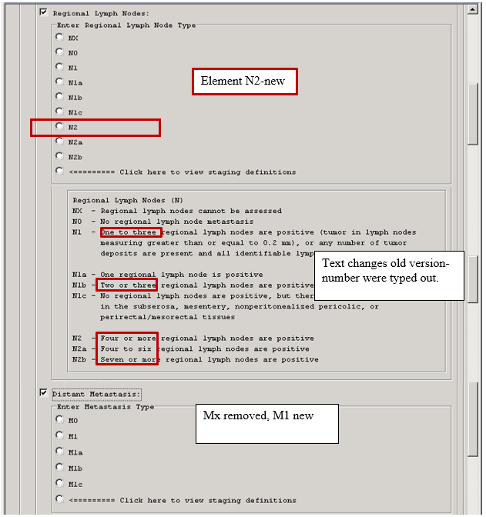

Click open CRC Pathological TNM stage section
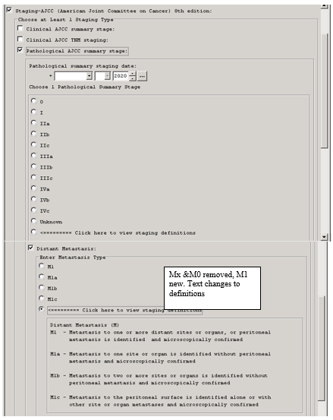

Path CRC Staging---cont
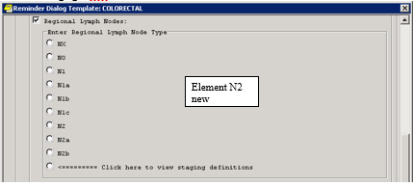

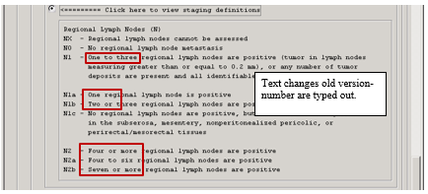

Reminder Dialog: VA-ONCOLOGY HEAD NECK-- Head & Neck changes: 2 new elements and HFs. Remainder are text only changes. **Clinical staging change screen shots are pgs. 5-15 and pathological screen shot changes are 16-15.

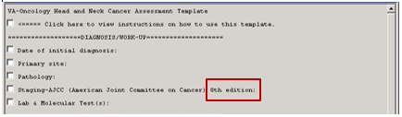

Clinical Staging Definiton Section
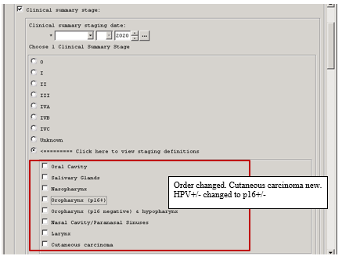

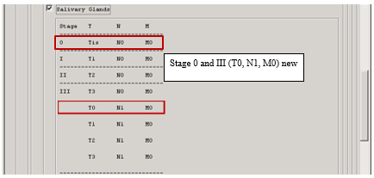

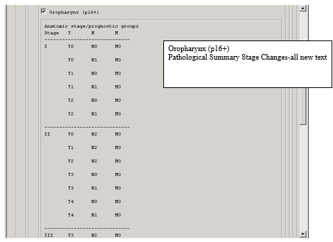

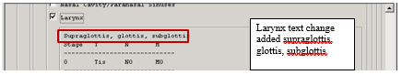

Clinical TNM Staging Con’t
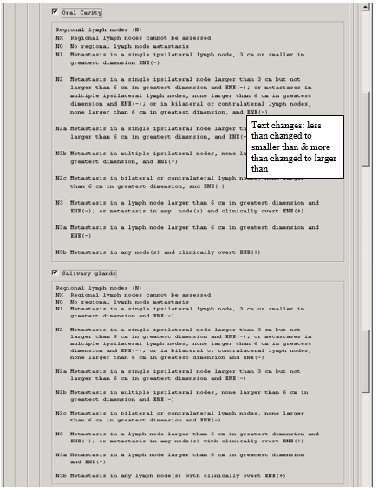

Clinical TNM Staging Con’t
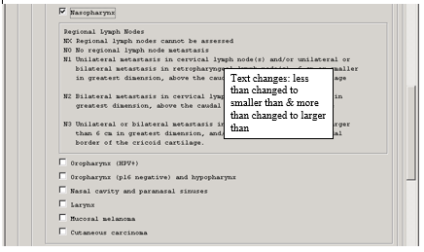

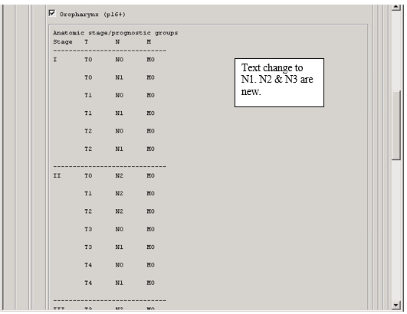
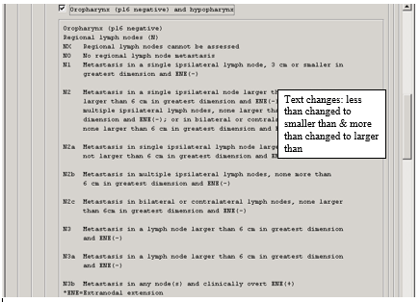

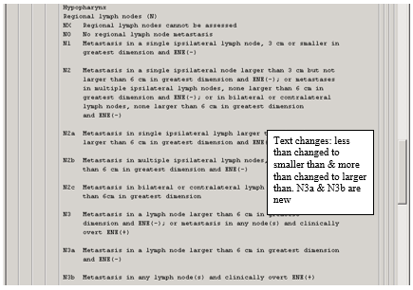

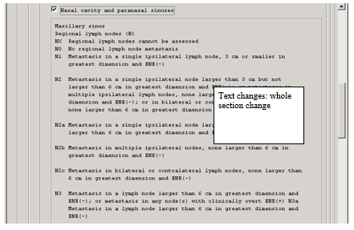

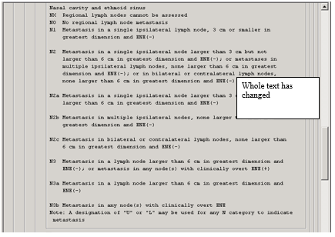

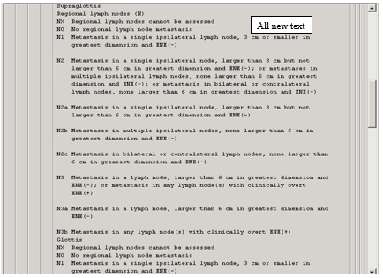

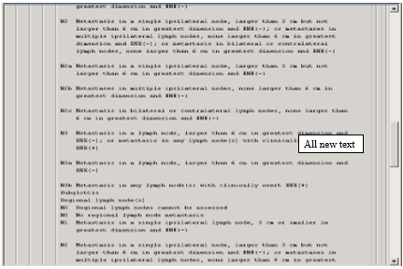

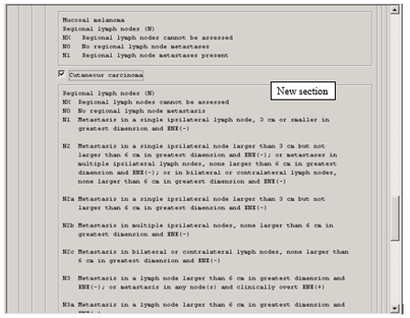

Pathological TNM stage for next 10 pages
Region Lymph Nodes, Oral cavity
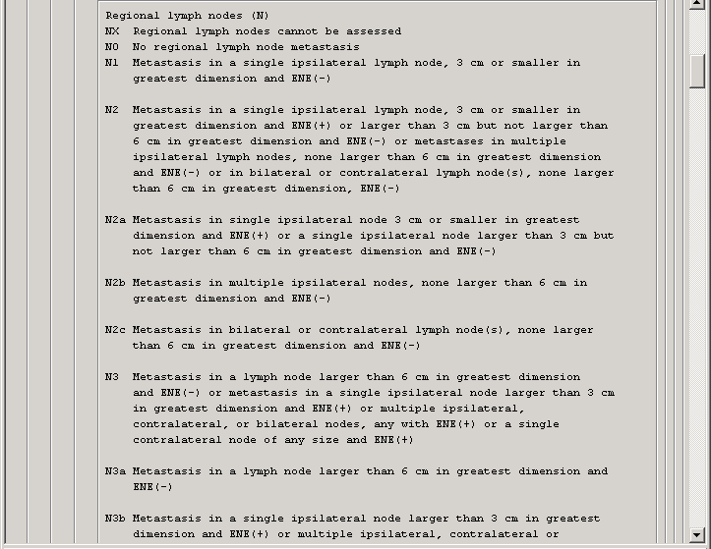
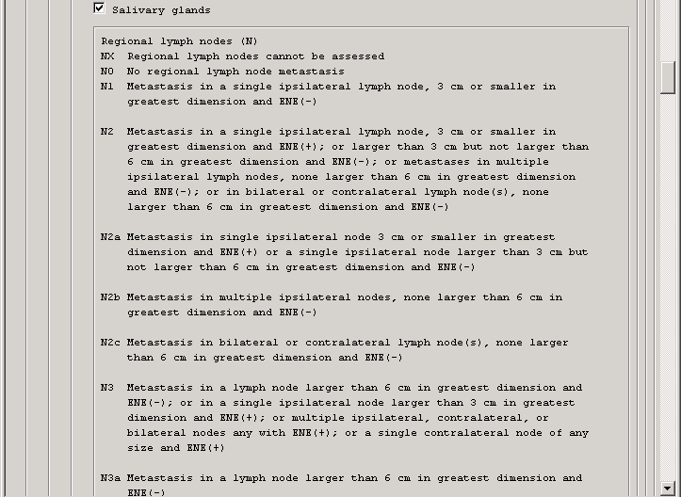

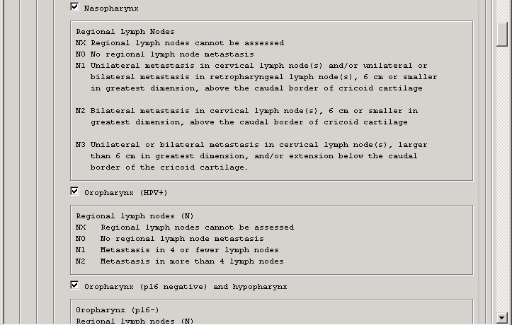

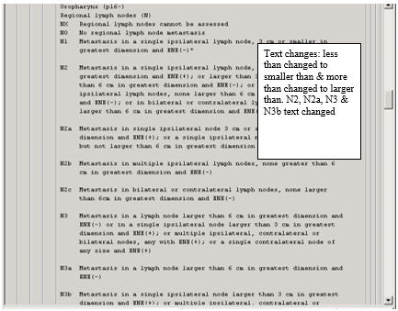
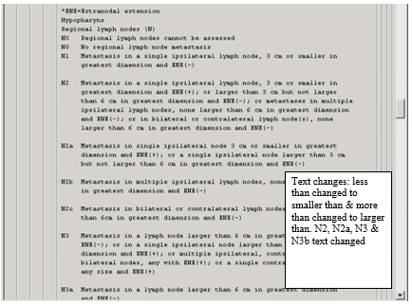
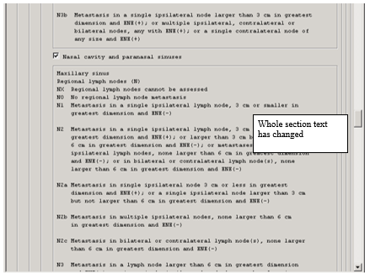
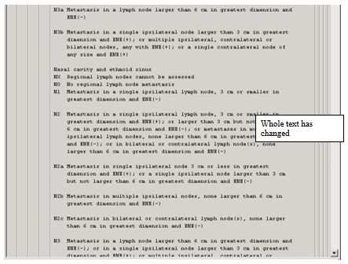
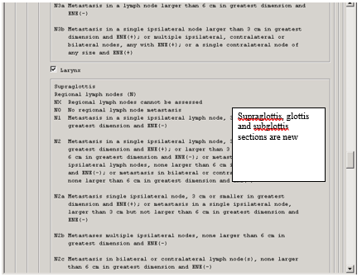
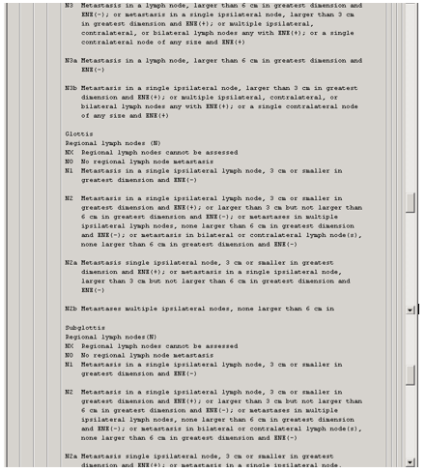

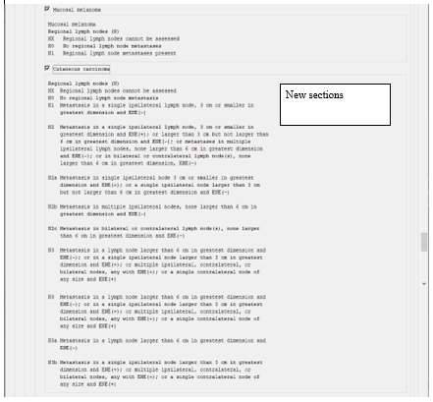

UPDATE_2_0_106 contains 1 Reminder Exchange entry:
UPDATE_2_0_106 VA-ONCOLOGY DIALOG UPDATES

The exchange file contains the following components:

HEALTH FACTORS
VA-REMINDER UPDATES
VA-UPDATE_2_0_106
Head & Neck Cancer Diagnosis
ONC Head Neck Tissue Sample Sent:
ONC Head Neck Tissue Sample Sent to POP
ONC Head Neck Testing Other
ONC Head Neck p16 Test-Results Pending
ONC Head Neck p16 Test Not Done
ONC Head Neck p16-
ONC Head Neck p16+
ONC Head Neck HPV Negative
ONC Head Neck Primary Site Larynx
ONC Head Neck Site Oropharynx (p16-)
ONC Head Neck Primary Site Nasal Cavity
ONC Head Neck Primary Site Nasopharynx
ONC Head Neck Site Oropharynx (HPV+)
ONC Head Neck Site Paranasal Sinuses
ONC Head Neck Site Salivary Glands
ONC Head Neck Primary Site Hypopharynx
ONC Head Neck Primary Site:
ONC Head Neck Primary Site Oral Cavity
ONC Head Neck Primary Site Oropharynx
ONC Head Neck Histologic Grade-G4
ONC Head Neck Histologic Grade-G3
ONC Head Neck Histologic Grade-G2
ONC Head Neck Histologic Grade-G1
ONC Head Neck Histologic Grade-GX
ONC Head Neck Histologic Grade-Unknown
ONC Head Neck Path TNM Staging Date:
ONC Head Neck Pathological Stage-M1
ONC Head Neck Pathological Stage-N3c
ONC Head Neck Pathological Stage-N3b
ONC Head Neck Pathological Stage-N3a
ONC Head Neck Pathological Stage-N2c
ONC Head Neck Pathological Stage-N2b
ONC Head Neck Pathological Stage-N2a
ONC Head Neck Pathological Stage-N2
ONC Head Neck Pathological Stage-N3
ONC Head Neck Pathological Stage-N1
ONC Head Neck Pathological Stage-N0
ONC Head Neck Pathological Stage-NX
ONC Head Neck Pathological Stage-T0
ONC Head Neck Pathological Stage-T4
ONC Head Neck Pathological Stage-T4b
ONC Head Neck Pathological Stage-T4a
ONC Head Neck Pathological Stage-T3
ONC Head Neck Pathological Stage-T2
ONC Head Neck Pathological Stage-T1
ONC Head Neck Pathological Stage-Tis
ONC Head Neck Pathological Stage-TX
ONC Head Neck Clinical Stage-N2c
ONC Head Neck Clinical Stage-N3b
ONC Head Neck Clinical Stage-N3a
ONC Head Neck Clinical Stage-N2b
ONC Head Neck Clinical Stage-N2a
ONC Head Neck Clinical Stage-N2
ONC Head Neck Clinical Stage-N3
ONC Head Neck Clinical Stage-N1
ONC Head Neck Clinical Stage-N0
ONC Head Neck Clinical Stage-NX
ONC Head Neck Clinical Stage-M1
ONC Head Neck Clinical Stage-M0
ONC Head Neck Clinical Stage-T0
ONC Head Neck Clinical Stage-T4
ONC Head Neck Clinical Stage-T4b
ONC Head Neck Clinical Stage-T4a
ONC Head Neck Clinical Stage-T3
ONC Head Neck Clinical Stage-T2
ONC Head Neck Clinical Stage-T1
ONC Head Neck Clinical Stage-Tis
ONC Head Neck Clinical Stage-TX
ONC Head Neck Clin TNM Staging Date:
ONC Head Neck Path Summary Stage-IVC
ONC Head Neck Path Summary Stage-Unknown
ONC Head Neck Path Summary Stage-IVB
ONC Head Neck Path Summary Stage-IVA
ONC Head Neck Clinical Summary Stage-III
ONC Head Neck Path Summary Stage-II
ONC Head Neck Path Summary Stage-I
ONC Head Neck Path Summary Stage-0
ONC Head Neck Path Summary Staging Date:
ONC Head Neck Clinical Summary Stage-IVC
ONC Head Neck Clin Summary Stage-Unknown
ONC Head Neck Clinical Summary Stage-IVB
ONC Head Neck Clinical Summary Stage-IVA
ONC Head Neck Clinical Summary Stage-II
ONC Head Neck Clinical Summary Stage-I
ONC Head Neck Clinical Summary Stage-0
ONC Head Neck Clin Summary Staging Date:
ONC Head Neck Pathological Stage-M0
ONC Head Neck Pathological Stage-MX
ONC Head Neck Path Summary Stage-III
ONC Head Neck Clinical Stage-MX
Head & Neck Cancer Post-Treatment
ONC Head Neck-Response Not Determined
ONC Head Neck-Progression of Disease
ONC Head Neck-No Recurrence of Disease
ONC Head Neck-Recurrence of Disease
ONC Head Neck-Stable Disease
ONC Head Neck-Partial Response
ONC Head Neck-Complete Response
Head & Neck Cancer Treatment
ONC Head Neck RT Stopped:
ONC Head Neck RT Stopped-Pt Request
ONC Head Neck RT Stopped-Progression
ONC Head Neck RT Stopped-Toxicity
ONC Head Neck RT Stopped-Plan Complete
ONC Head Neck Chemo Stopped:
ONC Head Neck Chemo Stopped-Pt Request
ONC Head Neck Chemo Stopped-Progression
ONC Head Neck Chemo Stopped-Toxicity
ONC Head Neck Chemo-Plan Complete
ONC Head Neck Referral:
ONC Head Neck Referral Service Unavail
ONC Head Neck Referral Not Appropriate
ONC Head Neck Pt Declined Referral
ONC Head Neck Palliative Referral
ONC Head Neck Hospice Referral
ONC Head Neck Clinical Trial:
ONC Head Neck Clinical Trial Stop Date
ONC Head Neck Clinical Trial Start Date
ONC Head Neck RT Dose Fraction
ONC Head Neck RT Total Dose
ONC Head Neck RT Stop Date
ONC Head Neck RT Start Date
ONC Head Neck RT Chest Dose Fraction
ONC Head Neck RT Chest Total Dose
ONC Head Neck RT-Chest Stop Date
ONC Head Neck RT-Chest Start Date
ONC Head Neck RT Brain Dose Fraction
ONC Head Neck RT Brain Total Dose
ONC Head Neck RT-Brain Stop Date
ONC Head Neck RT-Brain Start Date
ONC Head Neck RT Axillary Dose Fraction
ONC Head Neck RT Axillary Total Dose
ONC Head Neck RT-Axillary Stop Date
ONC Head Neck RT-Axillary Start Date
ONC Head Neck RT Neck Dose Fraction
ONC Head Neck RT Neck Total Dose
ONC Head Neck RT-Neck Stop Date
ONC Head Neck RT-Neck Start Date
ONC Head Neck RT Pt Declined
ONC Head Neck RT Not Administered
ONC Head Neck RT Not Recommended
ONC Head Neck Chemo Stop Date
ONC Head Neck Chemo Start Date
ONC Head Neck Doxorubicin Stop Date
ONC Head Neck Doxorubicin Start Date
ONC Head Neck Adriamycin Stop Date
ONC Head Neck Adriamycin Start Date
ONC Head Neck Epirubicin Stop Date
ONC Head Neck Epirubicin Start Date
ONC Head Neck Nivolumab Stop Date
ONC Head Neck Nivolumab Start Date
ONC Head Neck Pembrolizumab Stop Date
ONC Head Neck Pembrolizumab Start Date
ONC Head Neck Afatinib Stop Date
ONC Head Neck Afatinib Start Date
ONC Head Neck Gemcitabine Stop Date
ONC Head Neck Gemcitabine Start Date
ONC Head Neck Hydroxyurea Stop Date
ONC Head Neck Hydroxyurea Start Date
ONC Head Neck Methotrexate Stop Date
ONC Head Neck Methotrexate Start Date
ONC Head Neck Vinorelbine Stop Date
ONC Head Neck Vinorelbine Start Date
ONC Head Neck Docetaxel Stop Date
ONC Head Neck Docetaxel Start Date
ONC Head Neck Paclitaxel Stop Date
ONC Head Neck Paclitaxel Start Date
ONC Head Neck Cetuximab Stop Date
ONC Head Neck Cetuximab Start Date
ONC Head Neck Capecitabine Stop Date
ONC Head Neck Capecitabine Start Date
ONC Head Neck Carboplatin Stop Date
ONC Head Neck Carboplatin Start Date
ONC Head Neck Cisplatin High Stop
ONC Head Neck Cisplatin High Start
ONC Head Neck Cisplatin Stop Date
ONC Head Neck Cisplatin Start Date
ONC Head Neck 5-FU Stop Date
ONC Head Neck 5-FU Start Date
ONC Head Neck Chemo Not Admin:
ONC Head Neck Chemo-Pt Declined
ONC Head Neck Chemo Not Recommended
ONC Head Neck Surgery Results-Unknown
ONC Head Neck Surgery-Results Pending
ONC Head Neck-Tumor Not Resectable
ONC Head Neck Surgery Outcome-+ Margins
ONC Head Neck Surgery-Clear Margins
ONC Head Neck Surgery:
ONC Head Neck Sublingual Gland Resection
ONC Head Neck Submandibular Gland Resect
ONC Head Neck-Total Parotidectomy
ONC Head Neck Radical Maxillectomy
ONC Head Neck Partial Maxillectomy
ONC Head Neck Total Laryngectomy
ONC Head Neck Partial Laryngectomy
ONC Head Neck-Laryngopharyngectomy
ONC Head Neck Surgery-Tonsillectomy
ONC Head Neck Surgery-Palatectomy
ONC Head Neck Surgery-Maxillectomy
ONC Head Neck Surgery-Mandibulectomy
ONC Head Neck Surgery Glossectomy
ONC Head Neck Surgery Not Performed:
ONC Head Neck Surgery-Pt Declined
ONC Head Neck Surgery Not Recommended
ONC Head Neck Treatment Discuss Unknown
ONC Head Neck Intent Not Discussed
ONC Head Neck Intent Treatment Discussed
ONC Head Neck Treatment Intent-Unknown
ONC Head Neck Treatment-Palliative
ONC Head Neck Treatment Intent-Curative
ONC Head Neck Tumor Board-N/A
ONC Head Neck Tumor Board-No
ONC Head Neck Tumor Board-Yes
ONC Head Neck LN Laterality-Unknown
ONC Head Neck ECOG PS-Unknown
ONC Head Neck ECOG PS-5
ONC Head Neck ECOG PS-4
ONC Head Neck ECOG PS-3
ONC Head Neck ECOG PS-2
ONC Head Neck ECOG PS-1
ONC Head Neck ECOG PS-0
ONC Head Neck No. Lymph Nodes Examined
ONC Head Neck No. Lymph Nodes w/Cancer
ONC Head Neck LN Laterality-Midline
ONC Head Neck LN Laterality-Left
ONC Head Neck LN Laterality-Right
ONC Head Neck Histology:
ONC Head Neck Histology Adenocarcinoma
ONC Head Neck Histology Squamous Cell
ONC Head Neck Date of Diagnosis
ONC Head Neck Superficial Parotidectomy
Oncology (ONC) Colorectal (CRC) Workup
ONC CRC Path Regional Lymph Nodes-N2
ONC CRC Path Regional Lymph Nodes-N1
ONC CRC Path Regional Lymph Nodes-N2b
ONC CRC Path Regional Lymph Nodes-N2a
ONC CRC Path Regional Lymph Nodes-N1c
ONC CRC Path Regional Lymph Nodes-N1b
ONC CRC Path Regional Lymph Nodes-N1a
ONC CRC Path Regional Lymph Nodes-N0
ONC CRC Path Regional Lymph Nodes-NX
ONC CRC Path Distant Metastasis-M1
ONC CRC Path Distant Metastasis-M1c
ONC CRC Path Distant Metastasis-M1b
ONC CRC Path Distant Metastasis-M1a
ONC CRC Pathological Primary Tumor-T3
ONC CRC Pathological Primary Tumor-T4
ONC CRC Pathological Primary Tumor-T4b
ONC CRC Pathological Primary Tumor-T4a
ONC CRC Pathological Primary Tumor-T2
ONC CRC Pathological Primary Tumor-T1
ONC CRC Pathological Primary Tumor-Tis
ONC CRC Pathological Primary Tumor-T0
ONC CRC Pathological Primary Tumor-TX
ONC CRC Pathological TNM Stage Date-
ONC CRC Clin Regional Lymph Nodes-N2
ONC CRC Clin Regional Lymph Nodes-N1
ONC CRC Clin Regional Lymph Nodes-N2b
ONC CRC Clin Regional Lymph Nodes-N2a
ONC CRC Clin Regional Lymph Nodes-N1c
ONC CRC Clin Regional Lymph Nodes-N1b
ONC CRC Clin Regional Lymph Nodes-N1a
ONC CRC Clinical Regional Lymph Nodes-N0
ONC CRC Clinical Regional Lymph Nodes-NX
ONC CRC Clinical Distant Metastasis-M1
ONC CRC Clin Distant Metastasis-M1c
ONC CRC Clin Distant Metastasis-M1b
ONC CRC Clin Distant Metastasis-M1a
ONC CRC Clinical Primary Tumor-T4
ONC CRC Clinical Primary Tumor-T4b
ONC CRC Clinical Primary Tumor-T4a
ONC CRC Clinical Primary Tumor-T3
ONC CRC Clinical Primary Tumor-T2
ONC CRC Clinical Primary Tumor-T1
ONC CRC Clinical Primary Tumor-Tis
ONC CRC Clinical Primary Tumor-T0
ONC CRC Clinical Primary Tumor-TX
ONC CRC Clinical TNM Stage Date-
ONC CRC Pathological Summary Stage-IVc
ONC CRC Pathological Summary Stage-IIIc
ONC CRC Path Summary Stage-Unknown
ONC CRC Pathological Summary Stage-IVb
ONC CRC Pathological Summary Stage-IVa
ONC CRC Pathological Summary Stage-IIIb
ONC CRC Pathological Summary Stage-IIIa
ONC CRC Pathological Summary Stage-IIc
ONC CRC Pathological Summary Stage-IIb
ONC CRC Pathological Summary Stage-IIa
ONC CRC Pathological Summary Stage-I
ONC CRC Pathological Summary Stage-0
ONC CRC Path Summary Stage Date-
ONC CRC Clinical Summary Stage-IVc
ONC CRC Clinical Summary Stage-IIIc
ONC CRC Clinical Summary Stage-Unknown
ONC CRC Clinical Summary Stage-IVb
ONC CRC Clinical Summary Stage-IVa
ONC CRC Clinical Summary Stage-IIIb
ONC CRC Clinical Summary Stage-IIIa
ONC CRC Clinical Summary Stage-IIc
ONC CRC Clinical Summary Stage-IIb
ONC CRC Clinical Summary Stage-IIa
ONC CRC Clinical Summary Stage-I
ONC CRC Clinical Summary Stage-0
ONC CRC Clinical Summary Stage Date-
ONC CRC Clinical Distant Metastasis-M0
ONC CRC Clinical Distant Metastasis-MX
ONC CRC Path Distant Metastasis-M0
ONC CRC Path Distant Metastasis-MX
Oncology (ONC) Colorectal (CRC) FollowUp
ONC CRC-Response Not Determined
ONC CRC-No Recurrence of Disease
ONC CRC-Recurrence of Disease
ONC CRC-Stable Disease
ONC CRC-Partial Response
ONC CRC-Complete Response
Oncology (ONC) Colorectal (CRC) Treatmnt
ONC CRC Referral
ONC CRC Referral Service Unavailable
ONC CRC Referral Not Appropriate
ONC CRC Pt Declined Referral
ONC CRC Palliative Referral
ONC CRC Hospice Referral
ONC CRC Clinical Trial Stop Date-
ONC CRC Clinical Trial Start Date-
ONC CRC Clinical Trial
ONC CRC Chemo Stop Date-
ONC CRC Chemo Start Date-
ONC CRC Chemotherapy
ONC CRC Trifluridine/Tipiracil Stop-
ONC CRC Trifluridine/Tipiracil Start-
ONC CRC Chemo Regorafenib Stop Date-
ONC CRC Chemo Regorafenib Start Date-
ONC CRC Chemo Ziv-aflibercept Stop-
ONC CRC Chemo Ziv-aflibercept Start-
ONC CRC Chemo Ramucirumab Stop Date-
ONC CRC Chemo Ramucirumab Start Date-
ONC CRC Chemo Panitumumab Stop Date-
ONC CRC Chemo Panitumumab Start Date-
ONC CRC Chemo Cetuximab Start Date-
ONC CRC Chemo Capecitabine Stop Date-
ONC CRC Chemo Capecitabine Start Date-
ONC CRC Chemo Bevacizumab Stop Date-
ONC CRC Chemo Bevacizumab Start Date-
ONC CRC Chemo Leucovorin Stop Date-
ONC CRC Chemo Leucovorin Start Date-
ONC CRC Chemo Oxaliplatin Stop Date-
ONC CRC Chemo Oxaliplatin Start Date-
ONC CRC Chemo 5-Fluorouracil Stop Date-
ONC CRC Chemo 5-Fluorouracil Start Date-
ONC CRC Chemotherapy Not Admin
ONC CRC Chemotherapy Pt Declined
ONC CRC Chemo Not Recommended
ONC CRC Radiation Stop Date-
ONC CRC Radiation Start Date-
ONC CRC Radiation Site-
ONC CRC Radiation Chest Stop Date-
ONC CRC Radiation Chest Start Date-
ONC CRC Radiation Liver Stop Date-
ONC CRC Radiation Liver Start Date-
ONC CRC Radiation Rectum Stop Date-
ONC CRC Radiation Rectum Start Date-
ONC CRC Radiation Colon Stop Date-
ONC CRC Radiation Colon Start Date-
ONC CRC No Radiation Therapy
ONC CRC Pt Declined Radiation Therapy
ONC CRC Radiation Not Recommended
ONC CRC Surgery-
ONC CRC Surgery-Diverting Ostomy
ONC CRC Abdominal Perineal Resection
ONC CRC Surgery-Low Anterior Resection
ONC CRC Surgery-Subtotal Colectomy
ONC CRC Surgery-Sigmoidectomy
ONC CRC Surgery-Transverse Colectomy
ONC CRC Surgery-Left Hemicolectomy
ONC CRC Surgery-Right Hemicolectomy
ONC CRC Surgery-Ileocecectomy
ONC CRC Surgery-Colectomy
ONC CRC Surgery Not Performed Other-
ONC CRC Surgery-Not Recommended
ONC CRC Intent Treatment Not Discussed
ONC CRC Intent of Treatment Discussed
ONC CRC Treatment-Not Determined
ONC CRC Treatment-Palliative
ONC CRC Treatment-Curative
ONC CRC Other Lab Test
ONC CRC ECOG PS-5
ONC CRC ECOG PS-4
ONC CRC ECOG PS-3
ONC CRC ECOG PS-2
ONC CRC ECOG PS-1
ONC CRC ECOG PS-0
ONC CRC Most Recent Colonoscopy Date-
ONC CRC Precision Oncology
ONC CRC HER2 FISH
ONC CRC HER2 IHC
ONC CRC CDX2 Negative
ONC CRC CDX2 Positive
ONC CRC MSI Low
ONC CRC MSI High
ONC CRC BRAF Mutant Type
ONC CRC BRAF Wild Type
ONC CRC NRAS Mutant Type
ONC CRC NRAS Wild Type
ONC CRC KRAS Mutant Type
ONC CRC KRAS Wild Type
ONC CRC No. of Lymph Nodes Examined
ONC CRC No. of Lymph Nodes W/Cancer
ONC CRC Histology
ONC CRC Histology Adenocarcinoma
ONC CRC Primary Site-
ONC CRC Primary Site-Rectum
ONC CRC Primary Site-Colon
ONC CRC Date of Diagnosis
ONC CRC No Tumor Board Available
ONC CRC Chemo Cetuximab Stop Date-
ONC CRC Case Presented to Tumor Board
ONC CRC Case Not Presented Tumor Board
ONC CRC Response-Progression

REMINDER SPONSOR
VHA ONCOLOGY

REMINDER TERM
VA-REMINDER UPDATE_2_0_106
VA-ONC HEAD NECK LAB RT
VA-ONC HEAD NECK PRIMARY SITE RT
VA-ONC HEAD NECK STAGING RT
VA-ONC HEAD NECK TITLE RT
VA-ONC CRC STAGING RT
VA-ONC CRC TITLE RT

REMINDER DIALOG
VA-GP ONCOLOGY DIALOG UPDATES

HEALTH SUMMARY TYPE
VA-ONC HEAD NECK LAB
VA-ONC HEAD NECK PRIMARY SITE
VA-ONC HEAD NECK STAGING
VA-ONC HEAD NECK HEADER 3
VA-ONC HEAD NECK HEADER 2
VA-ONC HEAD NECK HEADER 1
VA-ONC CRC STAGING
VA-ONC CRC HEADER 3
VA-ONC CRC HEADER 2
VA-ONC CRC HEADER 1

HEALTH SUMMARY OBJECTS
VA-ONC HEAD NECK LAB
VA-ONC HEAD NECK PRIMARY SITE
VA-ONC HEAD NECK STAGING
VA-ONC HEAD NECK HEADER 3
VA-ONC HEAD NECK HEADER 2
VA-ONC HEAD NECK HEADER 1
VA-ONC CRC STAGING
VA-ONC CRC HEADER 3
VA-ONC CRC HEADER 2
VA-ONC CRC HEADER 1

TIU DOCUMENT DEFNITION
VA-ONC HEAD NECK LAB
VA-ONC HEAD NECK PRIMARY SITE
VA-ONC HEAD NECK STAGING
VA-ONC HEAD NECK HEADER 3
VA-ONC HEAD NECK HEADER 2
VA-ONC HEAD NECK HEADER 1
VA-ONC CRC STAGING
VA-ONC CRC HEADER 3
VA-ONC CRC HEADER 2
VA-ONC CRC HEADER 1

Install Details

This update is being distributed as a web host file. The address for the host file is: https://vaww.va.gov/reminders/docs/UPDATE_2_0_106.PRD

If your site is unable to use LWH, you will have a vista mail message with subject of UPDATE 106.

The file will be installed using Reminder Exchange, programmer access is not required.

Installation:
=============
This update can be loaded with users on the system. Installation will take between 30 minutes to one hour.

Pre-Install

You should have installed UPDATE_2_0_20 COLON CANCER DIALOGS prior to installation of this update and UPDATE_2_0_26 VA-HEAD AND NECK CANCER DIALOGS

https://www.va.gov/vdl/documents/Clinical/CPRS-Clinical_Reminders/update_2_0_20_ig.pdf

https://www.va.gov/vdl/documents/Clinical/CPRS-Clinical_Reminders/update_2_0_26_ig.pdf

Install Example
To Load the Web Host File. Navigate to Reminder exchange in Vista
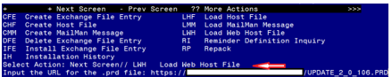

At the Select Action: prompt, enter LWH for Load Web Host File
At the Input the url for the .prd file: prompt, type the following web address:
https://vaww.va.gov/reminders/docs/UPDATE_2_0_106.PRD

You should see a message at the top of your screen that the file successfully loaded.

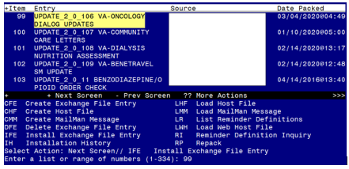Search and locate an entry titled UPDATE_2_0_106 VA-ONCOLOGY DIALOG UPDATES NOTE in reminder exchange.

At the Select Action prompt, enter IFE for Install Exchange File Entry
Enter the number that corresponds with your entry titled UPDATE_2_0_106 VA-ONCOLOGY DIALOG UPDATES (in this example it is entry 99 it will vary by site). The exchange file date should be 03/04/2020.
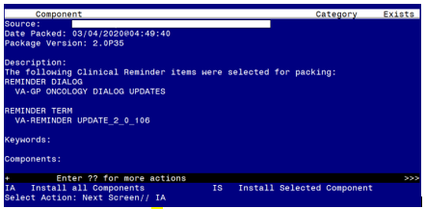

At the Select Action prompt, type IA for Install all Components and hit enter.
Select Action: Next Screen// IA Install all Components
You will see several prompts, for all new entries you will choose I to Install
For components that already exists but the packed component is different, you will choose O to Overwrite.
You will be promped to install the reminder dialog component – you should install even if there is an x that shows the item exists – this is an update and therefore you want to install to update your existing components:
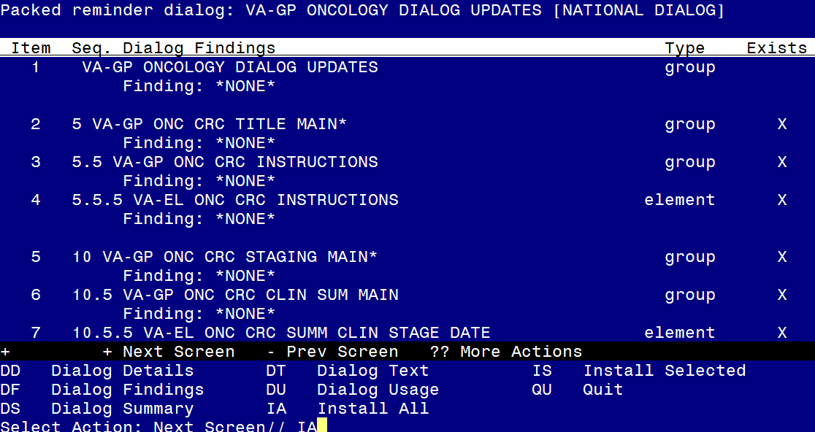
At the Select Action prompt, type IA to install the dialog – VA-GP ONCOLOGY DIALOG UPDATES
Select Action: Next Screen// IA Install All
Install reminder dialog and all components with no further changes: Y// Yes
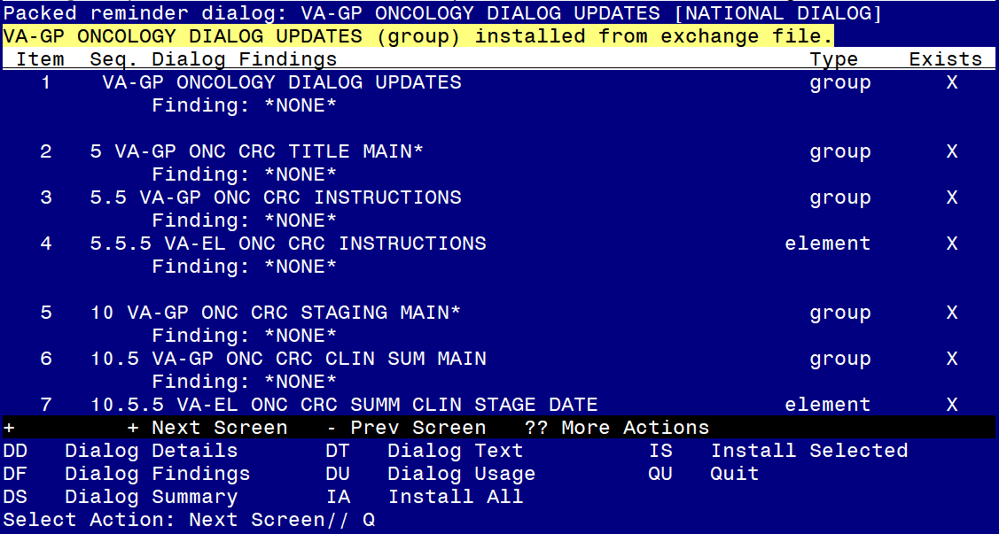
When the dialog has completed installation, you will then be returned to this screen. At the Select Action prompt, type Q.

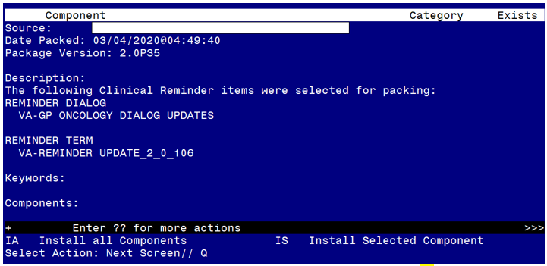
You will then be returned to this screen. At the Select Action prompt, type Q.

Install complete.

Post Installation

Let your oncology staff that use these notes know that the updated templates for colorectal cancer and head and neck cancer have been installed. This is an update to existing reminder dialogs, no specific setup should be needed.

