Update _2_0_110

Clinical Reminders

VA-TH DIGITAL DIVIDE ASSESSMENT BY SOCIAL WORK CONSULT RESULT NOTE

Install Guide

July 2020

Product Development
Office of Information Technology
Department of Veterans Affairs

Table of Contents
Introduction 1
Pre-Installation 2
Install Details 2
Install Example 3
Post Installation 7

Introduction

Description:
In late 2019, The Office of Connected Care released instructions for sites to create a national digital divide device consult for requesting a device for patients, a consult order template, and a txml version of the corresponding consult result note. This update includes the reminder dialog for the consult result note, which replaces the txml version. The included consult result dialog should be used by a social worker to determine eligibility for the Lifeline program, qualification for a VA loaned tablet, or qualification for a smartphone (for Veterans enrolled in HUD-VASH).

UPDATE_2_0_110 contains 1 Reminder Exchange entry:

UPDATE_2_0_110 VA-TH DIGITAL DIVIDE ASSMNT BY SOCIAL WORK

The exchange file contains the following components:

TIU TEMPLATE FIELD
WORD PROCESSING (REQ)
TEXT (1-60 CHARACTERS) REQ
LIFELINESUPPORT.ORG
VA-FED POVERTY LEVEL THRESHOLD
LIFELINE ELIGIBILITY

HEALTH FACTORS
VA-REMINDER UPDATES
VA-UPDATE_2_0_110
VA-TH DIGITAL DIVIDE
VA-TH DD PREFERS SMARTPHONE
VA-TH DD PREFERS TABLET
VA-TH DD DEVICE ADDRESS CPRS
VA-TH DD DEVICE ADDRESS FACILITY
VA-TH DD DEVICE ADDRESS ALTERNATE
VA-TH DD DEVICE REQUIRES PERIPHERALS
VA-TH DD DEVICE/TABLET NO
VA-TH DD DEVICE/TABLET YES
VA-TH DD HOME INTERNET W/VIDEO NO
VA-TH DD HOME INTERNET W/VIDEO YES
VA-TH DD DEVICE NO PERIPHERALS
VA-TH DD PATIENT NOT INTERESTED
VA-TH DD LIFELINE NOT ELIGIBLE
VA-TH DD LIFELINE PENDING
VA-TH DD LIFELINE INTEREST

REMINDER SPONSOR
Office of Connected Care

REMINDER TERM
VA-REMINDER UPDATE_2_0_110

HEALTH SUMMARY TYPE
DIG DIVIDE CONSULT NOTE

HEALTH SUMMARY OBJECT
DIGITAL DIVIDE CONSULT RESULT NOTE (TIU)

TIU DOCUMENT DEFINITION
DIGITAL DIVIDE CONSULT RESULT NOTE

REMINDER DIALOG
VA-TH DIGITAL DIVIDE NOTE OBJECT
VA-TH DIGITAL DIVIDE ASSMNT BY SOCIAL WORK

Pre-Installation

- The VA-TH DIGITAL DIVIDE ASSMNT BY SOCIAL WORK is the consult result note for the digital divide consult. Instructions for creating the consult and the consult order template were released by the Office of Connected Care in 2019. The instructions have also been attached to the release of this install guide in a separate document. The consult result note is intended to be completed by social work. Coordinate the consult order implementation and workflow with local telehealth and social work staff. Education for the consult was provided to telehealth and social work staff by their national program offices. Three local class groups are included in the dialog for local content if necessary.
- A TIU object name DIGITAL DIVIDE CONSULT RESULT NOTE is included, which is used in the VIDEO DEVICE ORDER consult txml template. It is deployed in the VA-TH DIGITAL DIVIDE NOTE OBJECT element, but the element only serves as way to deliver the object. The element is not used in the reminder dialog. Instructions for configuring the object are included in the post-installation instructions.

Install Details

This update is being distributed as a web host file. The address for the host file is: https://REDACTED /UPDATE_2_0_110.PRD

The file will be installed using Reminder Exchange, programmer access is not required.

If your site is unable to use LWH, you will have a vista mail message with subject of UPDATE 110.

Installation:
=============
This update can be loaded with users on the system. Installation will take less than 10 minutes.

Install Example
To Load the Web Host File. Navigate to Reminder exchange in Vista

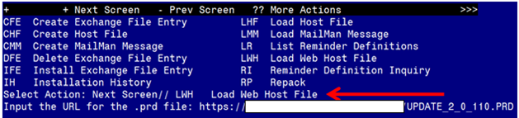

At the Select Action: prompt, enter LWH for Load Web Host File
At the Input the url for the .prd file: prompt, type the following web address:
https://REDACTED/UPDATE_2_0_110.PRD

You should see a message at the top of your screen that the file successfully loaded.
Search and locate an entry titled UPDATE_2_0_110 VA-TH DIGITAL DIVIDE ASSMNT BY SOCIAL WORK in reminder exchange.
At the Select Action prompt, enter IFE for Install Exchange File Entry
Enter the number that corresponds with your entry titled UPDATE_2_0_110 VA-TH DIGITAL DIVIDE ASSMNT BY SOCIAL WORK (in this example it is entry 122 it will vary by site). The date of the exchange file should be 07/07/2020.
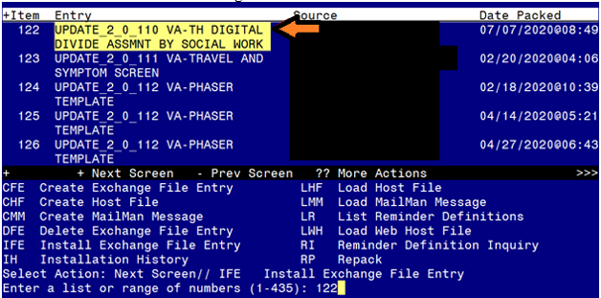
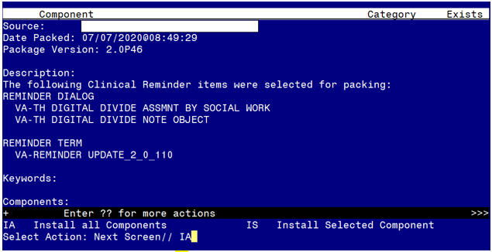
At the Select Action prompt, type IA for Install all Components and hit enter.
Select Action: Next Screen// IA Install all Components
You will see several prompts, for all new entries you will choose I to Install
For components that already exists but the packed component is different, you will choose O to Overwrite.

You will be promped to install the reminder dialog components – You will choose IA to install all even though some components may have an X to indicate they exist, the content was updated and should be installed.

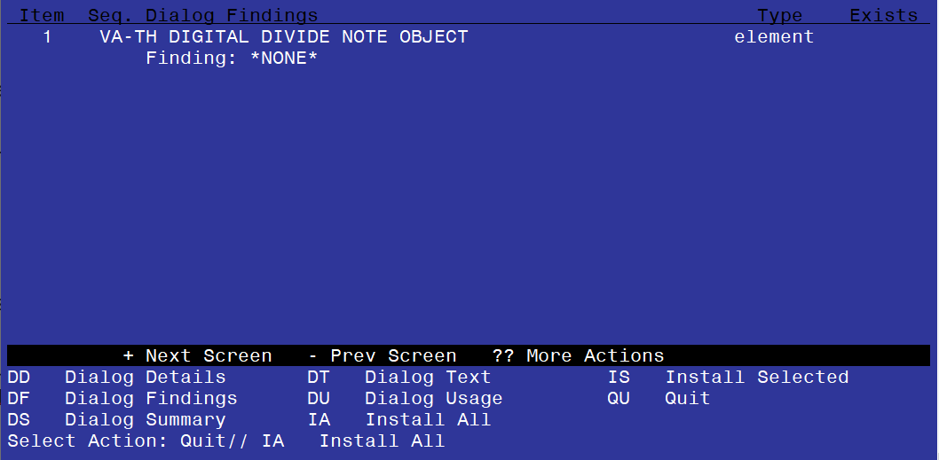
At the Select Action prompt, type IA to install the dialog – VA-TH DIGITAL DIVIDE NOTE OBJECT
Select Action: Next Screen// IA Install All
Install reminder dialog and all components with no further changes: Y// Yes
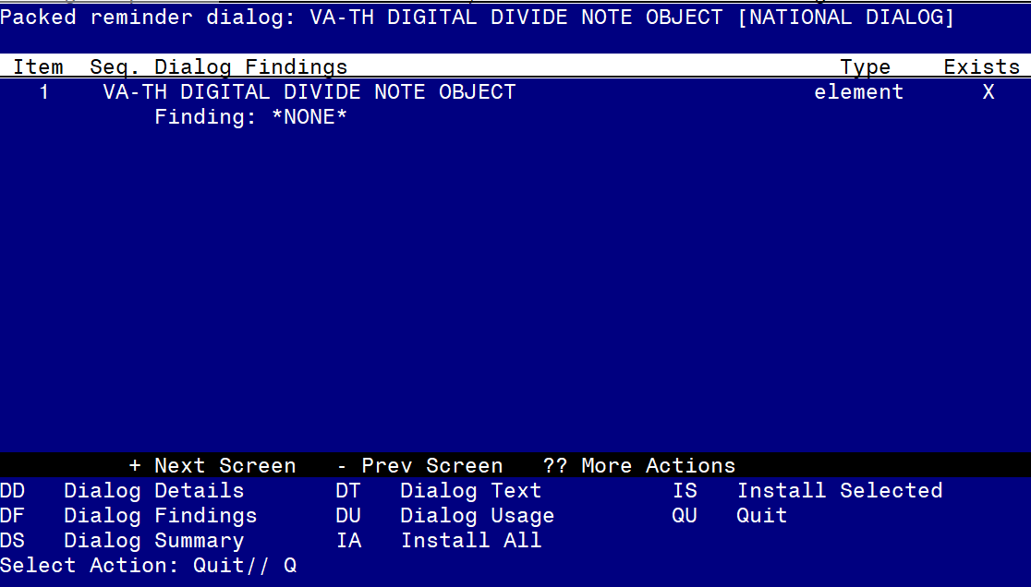When the dialog has completed installation, you will then be returned to this screen. At the Select Action prompt, type Q.

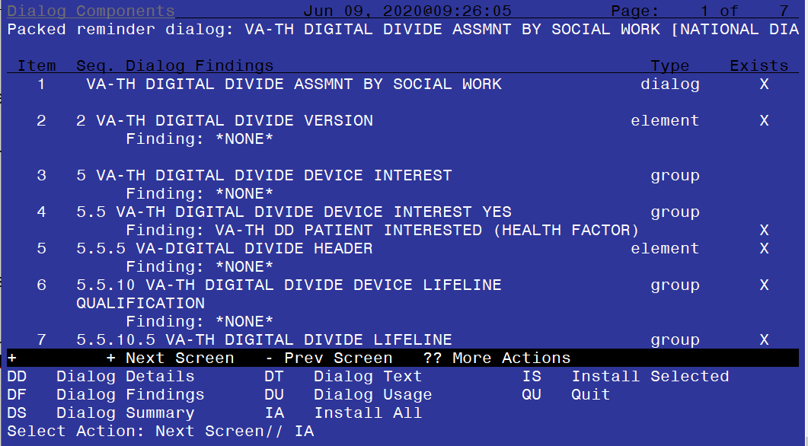
At the Select Action prompt, type IA to install the dialog – VA-TH DIGITAL DIVIDE ASSMNT BY SOCIAL WORK
Select Action: Next Screen// IA Install All
Install reminder dialog and all components with no further changes: Y// Yes

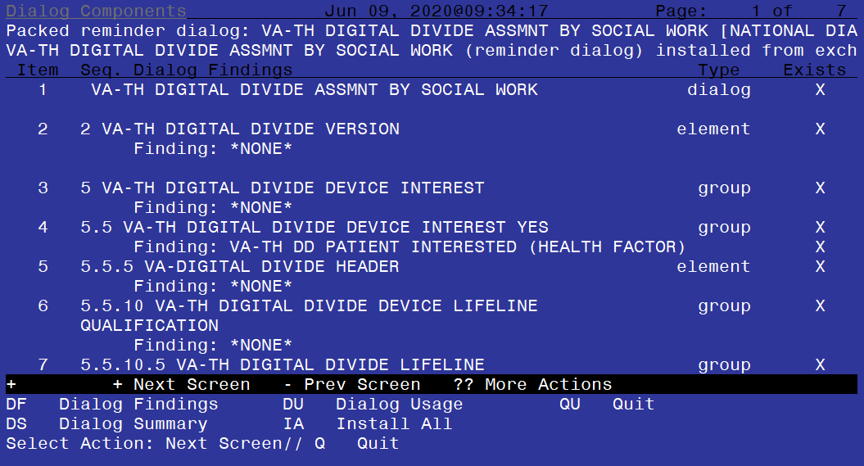
When the dialog has completed installation, you will then be returned to this screen. At the Select Action prompt, type Q.

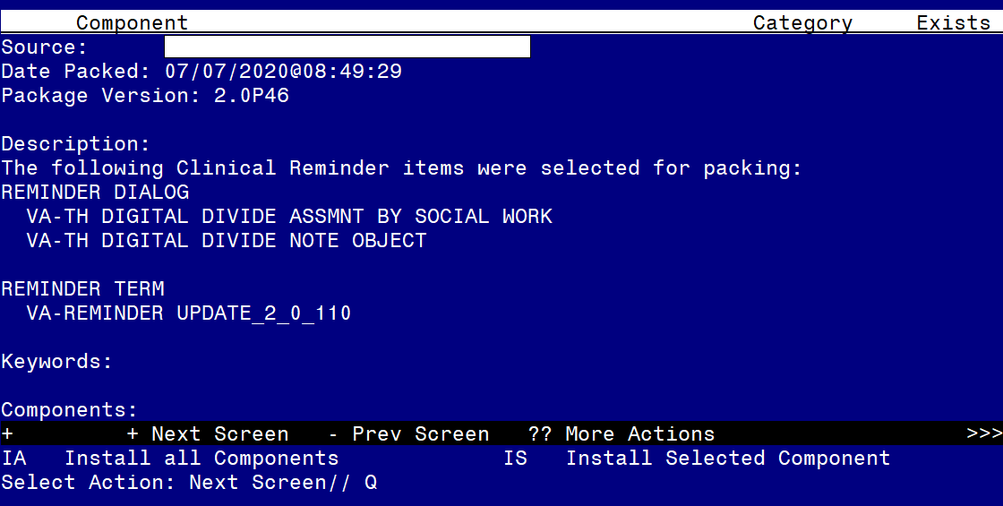
You will then be returned to this screen. At the Select Action prompt, type Q.

Install complete.

Post Installation

- Make the Dialog able to be attached to a Personal/Shared template or to a progress note title.
From the Reminders Manager Menu:
Select Reminder Managers Menu Option:
CA Add/Edit Reminder Categories
CL CPRS Lookup Categories
CS CPRS Cover Sheet Reminder List
MH Mental Health Dialogs Active
PN Progress Note Headers
RA Reminder GUI Resolution Active
DL Default Outside Location
PT Position Reminder Text at Cursor
Select CPRS Reminder Configuration Option:
Reminder Dialogs allowed as Templates may be set for the following:
1 User USR [choose from NEW PERSON]
3 Service SRV [choose from SERVICE/SECTION]
4 Division DIV [choose from INSTITUTION]
5 System SYS [NATREM.FO-SLC.MED.VA.GOV]
Enter selection: Choose the appropriate number for your site. Your site may do this by System or other levels. The example below uses SYSTEM level

Setting Reminder Dialogs allowed as Templates for System:
Select Display Sequence:

78 VA-VETERANS CHOICE NOTE
79 VA-TBI SCREENING
Select Display Sequence:
Are you adding 80 as a new Display Sequence? Yes//
Display Sequence: 80// 80
Clinical Reminder Dialog:
VA-TH DIGITAL DIVIDE ASSMNT BY SOCIAL WORK
then reminder dialog NATIONAL
OK? Yes// (Yes)

- Setup of Note title/ Associate the reminder dialog with the note title or shared template in CPRS

Check VistA for the note title DIGITAL DIVIDE ASSESSMENT BY SOCIAL WORK CONSULT RESULT. Create a new progress note title DIGITAL DIVIDE ASSESSMENT BY SOCIAL WORK CONSULT RESULT if necessary. The program office released instructions to create the title in late 2019.

- Setup of Note title (if not already completed).
The new note title is:
DIGITAL DIVIDE ASSESSMENT BY SOCIAL WORK CONSULT RESULT

The DIGITAL DIVIDE ASSESSMENT BY SOCIAL WORK CONSULT RESULT title should be created for use with the reminder dialog.

Name: DIGITAL DIVIDE ASSESSMENT BY SOCIAL WORK CONSULT RESULT
VHA Enterprise Standard Title: CONSULT
Note: Comprehensive information on Creating Document Definitions can be found beginning on page 47 of the

- Associate dialog with the note title.
  - Open Template Editor and from Shared Templates, select File “Document Titles”

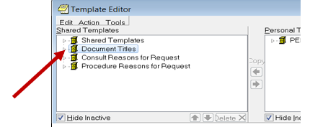

  - Click ‘triangle’ to left of Document Titles to expand.
  - Select the folder where the title DIGITAL DIVIDE ASSESSMENT BY SOCIAL WORK CONSULT RESULT will be located.
  - Select “New Template” on the top right side of the Template Editor
  - In the “Name” field enter “DIGITAL DIVIDE ASSESSMENT BY SOCIAL WORK CONSULT RESULT”.
  - Change Template type to Reminder Dialog.
  - In reminder Dialog field enter “VA-TH Digital Divide Assmnt By Social Work”
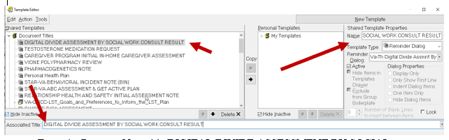
- Enter the Progress Note title DIGITAL DIVIDE ASSESSMENT BY SOCIAL WORK CONSULT RESULT in the Associated Title field. Click Apply and OK

- Test the progress note title in CPRS to see new template is attached.

- Add DIGITAL DIVIDE ASSESSMENT BY SOCIAL WORK CONSULT RESULT note title to the DIG DIVIDE CONSULT NOTE health summary type.

A TIU Object is included in this update named DIGITAL DIVIDE CONSULT RESULT NOTE. The object is used in the VIDEO DEVICE ORDER consult txml template to display the most recent DIGITAL DIVIDE ASSESSMENT BY SOCIAL WORK CONSULT RESULT note. The consult txml template is described in the DIGITABLE DIVIDE and VIDEO DEVICE CONSULT SETUP TECHNICAL GUIDE.

It is deployed in the VA-TH DIGITAL DIVIDE NOTE OBJECT element, but the element only serves as way to deliver the object. The element is not used in the reminder dialog.

The local title must be added to the health summary type named DIG DIVIDE CONSULT NOTE. Instructions are below.

- Begin on the Health Summary Coordinator’s Menu and enter red text below.
Summary Coordinator's Menu

1 Print Health Summary Menu ...
2 Build Health Summary Type Menu ...
3 Set-up Batch Print Locations
4 List Batch Health Summary Locations
5 CPRS Reports Tab 'Health Summary Types List' Menu ...

Select Health Summary Coordinator's Menu <TEST ACCOUNT> Option:

1 Create/Modify Health Summary Type
2 Delete Health Summary Type
3 Health Summary Objects Menu ...
4 Information Menu ...
5 Print Health Summary Menu ...

Select Build Health Summary Type Menu <TEST ACCOUNT> Option: 1

Select Health Summary Type:

Dig Divide Consult note

OK? YES

WARNING: You are about to edit a Health Summary Type that is being used
by a Health Summary Object. Changing the structure of this Health Summary
Type will alter how the Object will display.

Do want to continue? NO// YES
NAME: DIG DIVIDE CONSULT NOTE Replace <enter>
TITLE: DIG DIVIDE CONSULT NOTE Replace
SUPPRESS PRINT OF COMPONENTS WITHOUT DATA: yes// <enter>
SUPPRESS SENSITIVE PRINT DATA: NO SSN//<enter>
LOCK: <enter>
OWNER: <enter>

Do you wish to review the Summary Type structure before continuing? NO// YES

HEALTH SUMMARY TYPE INQUIRY

Type Name: DIG DIVIDE CONSULT NOTE
Title: DIG DIVIDE CONSULT NOTE
Owner:

SUPPRESS PRINT OF COMPONENTS WITHOUT DATA: yes
SUPPRESS SENSITIVE PRINT DATA: NO SSN

Max Hos ICD Pro CPT
Abb Ord Component Name Occ Time Loc Text Nar Mod Selection
------------------------------------------------------------------------------

Select COMPONENT: SPN PROGRESS NOTES SELECTED SPN

SUMMARY ORDER: 5// 5 <enter>
OCCURRENCE LIMIT: 1 (This will display the most recent note.)
TIME LIMIT: 7D (This will look for the note in the last 7 days.)
HEADER NAME: Selected Prog Notes// Digital Divide Note

Select new items one at a time in the sequence you want them displayed.
You may select any number of items.

Select SELECTION ITEM: DIGITAL DIVIDE ASSESSMENT BY SOCIAL WORK CONSULT RESULT
(Enter the local note title if different than title in install
guide.)

Std Title: SOCIAL WORK CONSULT
...OK? Yes// Yes
Select SELECTION ITEM: <enter>
Select COMPONENT: <enter>

Do you wish to review the Summary Type structure before continuing? NO//<enter>

The object can be viewed in the VIDEO DEVICE ORDER consult order template.

- Add VIDEO DEVICE ORDER dialog to the VAL-TH DIGITAL DIVIDE ORDER DEVICE group.

After the VIDEO DEVICE ORDER dialog has been created (refer to the DIGITAL DIVIDE and VIDEO DEVICE CONSULT SETUP TECHNICAL GUIDE), the order dialog should be embedded in this element. The element is a local class, so the text can be edited if necessary.

- Navigate to the VAL-TH DIGITAL DIVIDE ORDER DEVICE group from the dialog management menu.

NAME: VAL-TH DIGITAL DIVIDE ORDER DEVICE Replace <enter>
DISABLE: If necessary, enter “2” to disable the element to remove it from
dialog.
CLASS: LOCAL// <enter>
SPONSOR: <enter>
REVIEW DATE: <enter>
RESOLUTION TYPE: <enter>
ORDERABLE ITEM: <enter>
FINDING ITEM: Enter “Q.” and name of order dialog for the Video Device Order.

Additional findings: <enter>
Select ADDITIONAL FINDING: <enter>
DIALOG/PROGRESS NOTE TEXT: Enter “Y” to revise dialog text.
Place order for device

- Enable local elements to add local content to dialog if necessary.

The elements are deployed disabled, so they will need to be enabled if used. The elements are added to the opening window (VAL-TH DIGITAL DIVIDE DEVICE HEADER LOCAL SECTION), the option for documenting the patient is interested in a device (VAL-TH DIGITAL DIVIDE DEVICE LOCAL SECTION), and the option for documenting the patient is interested in the LifeLine program (VAL-TH DIGITAL DIVIDE DEVICE LIFELINE LOCAL SECTION).

- Navigate to reminder dialog and desired element.

REMINDER DIALOG NAME: VA-TH DIGITAL DIVIDE ASSMNT BY SOCIAL WORK [NATIONAL] *LIM
+Item Seq. Dialog Text
41 3.20.15 Element: VAL-TH DIGITAL DIVIDE DEVICE LIFELINE LOCAL SECTION (D

42 3.30 Element: VA-TH DIGITAL DIVIDE DEVICE INTEREST NO
Text: The patient is not interested in a device.
Prompts: Comment:

43 3.40 Element: VAL-TH DIGITAL DIVIDE DEVICE HEADER LOCAL SECTION (Disabled)

+ Next Screen - Prev Screen ?? More Actions >>>
ADD Add Element/Group DS Dialog Summary INQ Inquiry/Print
CO Copy Dialog DO Dialog Overview QU Quit
DD Detailed Display DT Dialog Text
DP Progress Note Text ED Edit/Delete Dialog
Select Item: Quit// 43

Select one of the following:

E Edit
C Copy and Replace current element
D Delete element from this dialog

Select Dialog Element Action: E// Edit
Dialog Element Type: E// <enter>
Used by: VA-TH DIGITAL DIVIDE DEVICE HEADER (Dialog Group)

NAME: VAL-TH DIGITAL DIVIDE DEVICE HEADER LOCAL SECTION
Replace <enter>
DISABLE: DISABLE AND DO NOT SEND MESSAGE// Enter “@” to enable the element.

