Update _2_0_114

Clinical Reminders

VA-MISC UPDATE 11

Install Guide

July 2020

Product Development
Office of Information Technology
Department of Veterans Affairs

Table of Contents
Introduction 1
Install Details 11
Install Example 17
Post Installation 24

Introduction

This update contains multiple changes to existing reminder content.

REMINDER UPDATE 114 CHANGES
Item 1: BIN and ABC STAR NOTES. Health Factors added. Ensure the following dialog components have the associated Health Factor as the finding item after install. All components are dialog groups except for the last one which is a dialog element.
Dialog component name | Finding Item – Health Factor
VA-GP STAR TARGET BEHAVIOR | VA-STAR BIN NOTE COMPLETED
VA-GP STAR CARE REFUSAL | VA-BIN CARE REJECTION OR RESISTANCE
VA-GP STAR VERBAL AGITATION | VA-BIN VERBAL AGITATION
VA-GP STAR PHYSICAL AGITATION | VA-BIN PHYSICAL AGITATION
VA-GP STAR VERBAL AGGRESSION | VA-BIN VERBAL AGGRESSION
VA-GP STAR PHYSICAL AGGRESSION | VA-BIN PHYSICAL AGGRESSION
VA-GP STAR OTHER BEHAVIOR | VA-BIN OTHER BEHAVIOR
VA-TXTZ STAR ABC ATTENDANCE | VA-STAR ABC NOTE COMPLETED

Item 2: Reminder dialog element VA-SUICIDE RISK PRINTABLE VERSION was updated to a new URL. This element contains TXML field VA-OSP SUICIDE RISK ID SITE. The new address is REDACTED. Make sure the template field has the new URL
Item 3: The following reminder terms and reminder order check group were updated with different combinations of RITUXIMAB. To ensure these terms were updated, check them for the presence of RITUXIMAB-PVVR.
VA-PNEUMOC DZ RISK – CHEMO/IMMUNOSUPP DRUGS
VA-CHEMO/IMMUNOSUPPRESSIVE DRUGS

The following reminder terms were updated to have RAVULIZUMAB-CWVZ added as a mapped item:
VA-MENINGOCOCCAL ACWY RISK IMMUNOCOMPROMISED
VA-MENINGOCOCCAL B RISK IMMUNOCOMPROMISED

Reminder Order check group VA-ANTI-CD20 DRUGS had three variations of RITUXIMAB added. The drugs added were the following:
RITUXIMAB-ABBS
RITUXIMAB-PVVR
RITUXIMAB/HYALURONIDASE

Item 4: Reminder dialog group VA-ORAL CARE GP SUPPLIES IN ROOM was removed from Reminder Dialog VA-ORAL CARE TEMPLATE. The Group was sequence 15 and has been removed
Before:
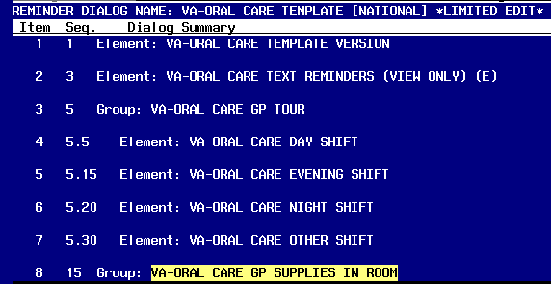
After:
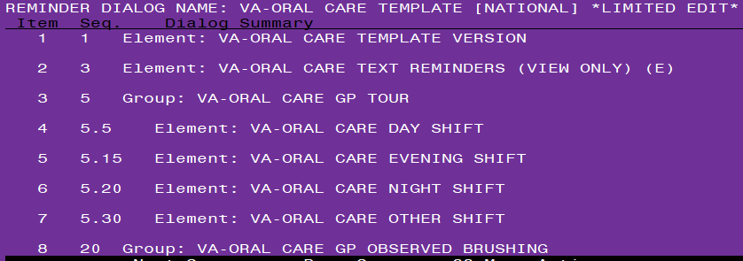

Item 5a:
Reminder dialog element VA-VCC NOTE VERSION BP changed dialog text and added a FINDING ITEM.
Before:
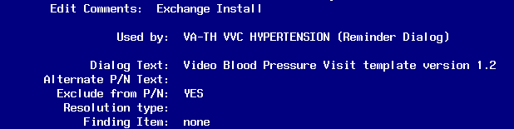
After:
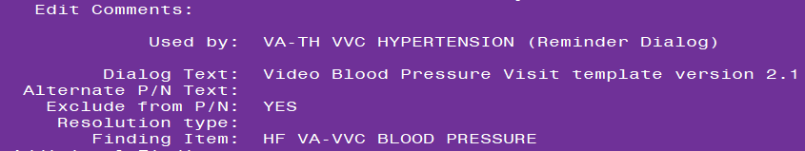

Item 5b: Reminder Dialog Group VA-GP TH VVC HYPERTENSION DISCLOSURE ABN had checkboxes suppressed. After install, ensure that checkboxes are no longer suppressed. Use INQ option in reminder dialog options to check.

Before:
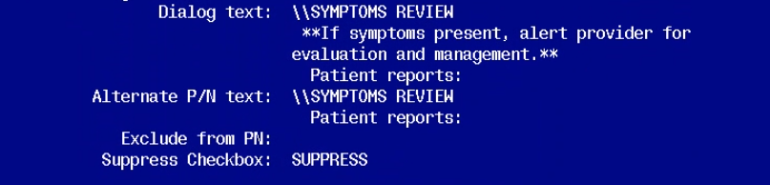

After:
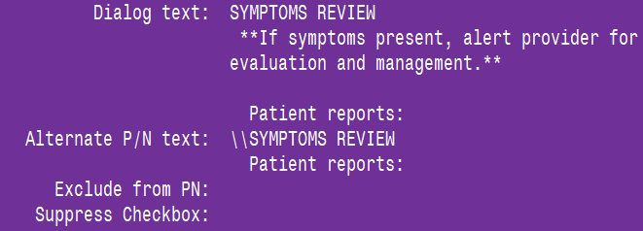
Item 5c: Reminder dialog group VA-GP TH VVC HYPERTENSION DISCLOSURE EVAL changed to suppress checkbox. Dialog Text changed from “CLINICAL EVALUATION” to “------------------” (dashed lines). Ensure these changes have taken place after install. Use INQ option in reminder dialog options to check.

Before:
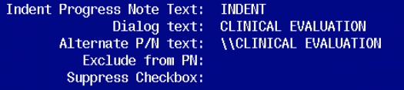

After:
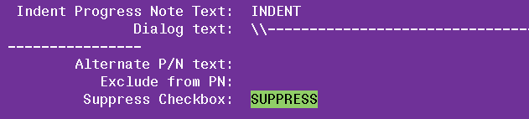

Item 5D: Reminder dialog group VA-GP TH VVC HYPERTENSION DISCLOSURE EVAL PA was changed to remove Suppress Checkbox and Dialog Text was changed from “Progress Assessment” to “Patient Progress”. Ensure these changes have taken place after install. Use INQ option in reminder dialog options to check.

Before:
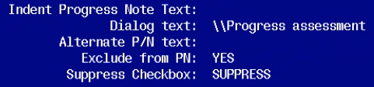
After:
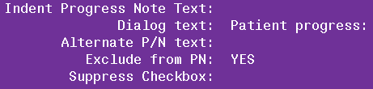

Item 5E: Reminder Dialog Group VA-GP TH VVC HYPERTENSION DISCLOSURE EVAL STRATEGY had Suppress Checkbox removed. Ensure this change has taken place after install. Use INQ option in reminder dialog options to check.

Before:
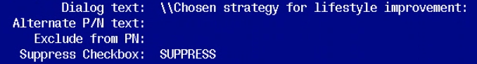
After:
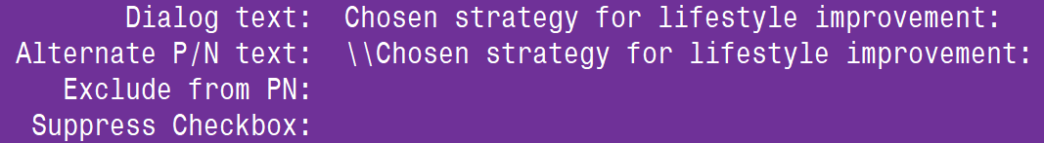

Item 5F: Reminder Dialog Group VA-GP TH VVC HYPERTENSION DISCLOSURE EVAL MOTIVATION had Suppress Checkbox removed. Ensure this change has taken place after install. Use INQ option in reminder dialog options to check.

Before:
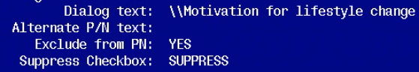
After:
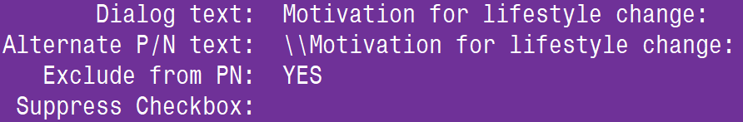

Item 5G: Reminder Dialog Group VA-GP TH VVC HYPERTENSION PLAN had Dialog Text changed from “\\CLINICAL PLAN” to “\\FOLLOW-UP ACTIONS”. Ensure this change has taken place after install. Use INQ option in reminder dialog options to check.

Before:
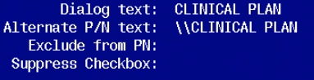

After:

Item 6: The following reminder definitions had USAGE changed to R. Check after install to make sure they have R as the USAGE entry.
VA-CRC BL ADDITIONAL TEST COMPLETE
VA-CRC BL ADDITIONAL TEST ORDERED
VA-CRC BL GAP BRANCHING
VA-CRC BL MALIGNANCY
VA-CRC BL TESTING WITHIN LAST YEAR
VA-CRC BL TISSUE SENT TO PATHOLOGY

Item 7: Dialog group VA-CSP GP PHQ2 SCORE 3-6 SUICIDE SCREEN HOPELESS CAREGIVER updated to set EXCLUDE FROM PROGRESS NOTE to YES.
Before:
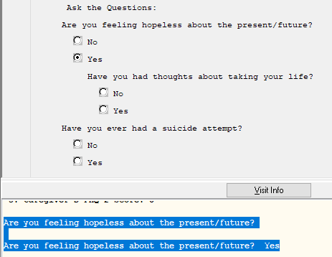
After:
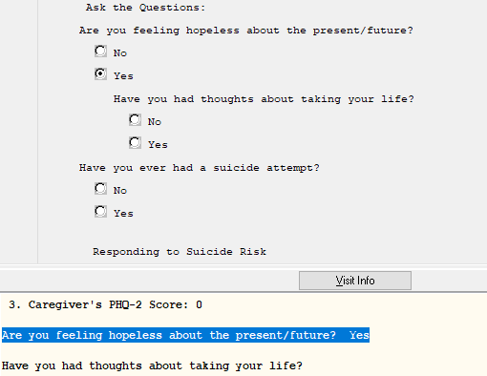
Item 8: Reminder dialog group VA-GP MCC PREGNANCY LOSS had Health Factor added as FINDING ITEM. Ensure after install that this group contains Health Factor VA-MCC PREGNANCY LOSS
Item 9: Reminder dialog group VA-GP TRAVEL SCREEN NO updated to add a box around the group. Ensure after install that this has a box around the group.
Item 10: Reminder dialog element VA-TEXT PNEUMOCOC PCV13 DETAILED GUIDANCE and VA-IM PNEUMOC VHA GUIDANCE LINKS had Dialog/Progress Note Text updated to include information about 2019 guidelines. Ensure after install that your Dialog/Progress Note Text has the following text:

VA-TEXT PNEUMOCOC PCV13 DETAILED GUIDANCE element
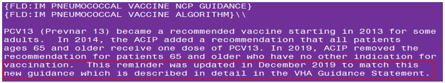
VA-IM PNEUMOC VHA GUIDANCE LINKS element
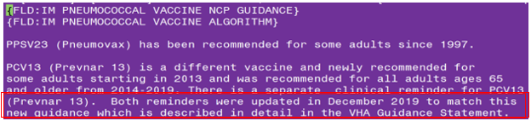
Item 11: Reminder Dialog group VA-HERPES ZOSTER DETAILED GUIDANCE has a new sequence 3 added. Ensure after install that sequence 3 has been added.
Before:
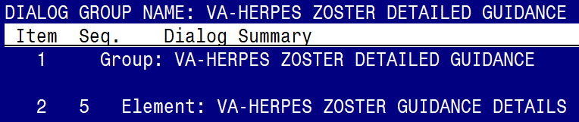
After
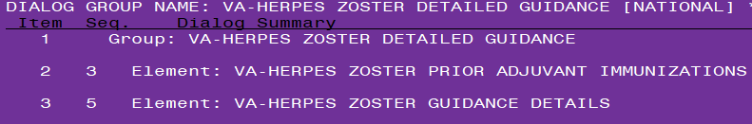
Item 12: Reminder Dialog groups VA-GP MOST RECENT METHOD ATTEMPT and VA-GP MOST LETHAL METHOD ATTEMPT had ONE OR MORE SELECTIONS to the prompt MULTIPLE SELECTION. Ensure these groups were updated to ONE OR MORE SELECTIONS by either using CPRS or looking in VistA using the INQ option for the dialog groups.
Before:
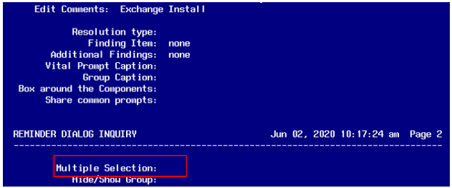
After:
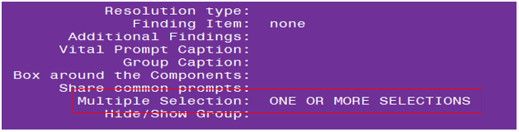
Item 13: Reminder Dialog element VA-EL JUSTIFICATION FOR CC (1) uses template field named TXML field VA-NVCC JUSTIFICATION FOR NON VA CARE V6.2. This Template Field was updated. Ensure changes have been made after install. Also the same change was made to template field VA-NVCC JUSTIFICATION FOR NON VA CARE V6.2 09012019
Before:
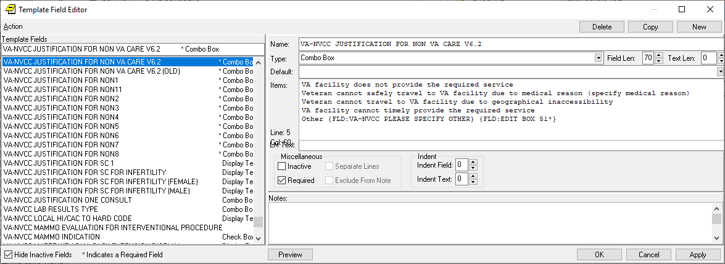

After:
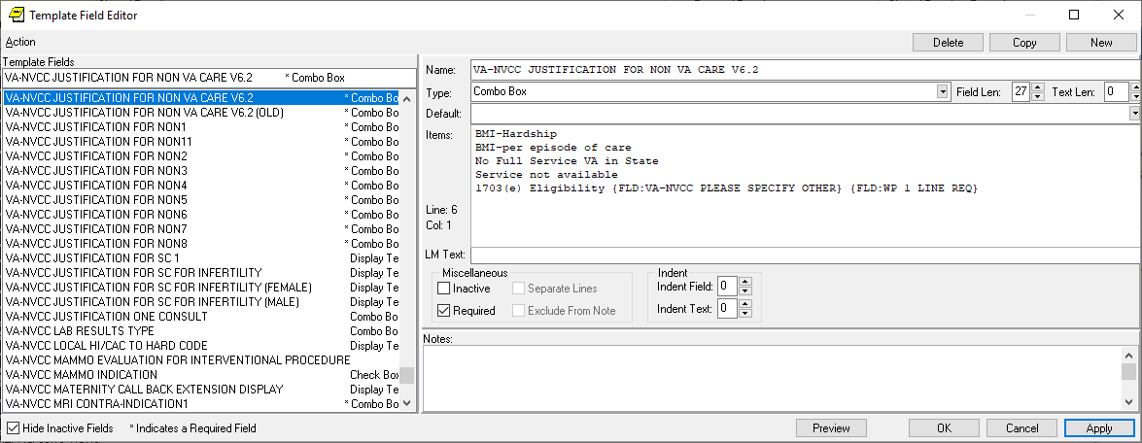
Item 14: Reminder Dialog group VA-GP SBOR EVENT STATUS. Sequence 30 in this group was changed from VA-EL SBOR EVENT STATUS OTHER to VA-EL SBOR EVENT STATUS OTHER SBOR.
Before:
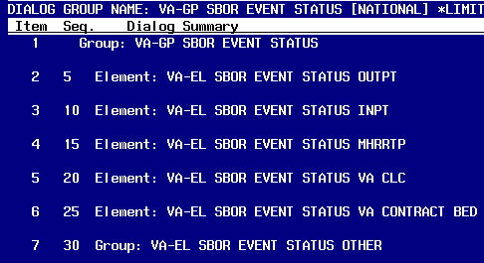

After:
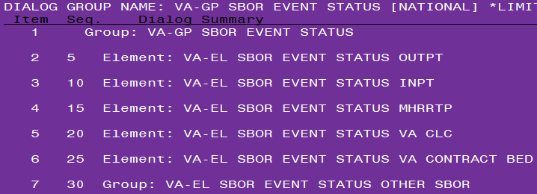

Item 15: In the VA-RELATIONSHIP HEALTH AND SAFETY ASSESSMENT dialog, there are four elements that need to be locally editable, to allow sites to add links next to the text. The following elements CLASS has been changed from “NATIONAL” to “LOCAL”.
**Note, UPDATE_2_0_52 should be installed prior to installing this MISC Update 11.
VA-EL RH&S – DISPOSITION PRINT IPV CONTENT
VA-EL RH&S – DISPOSITION PRINT RELATED FACTORS
VA-EL RH&S – DISPOSITION LOCAL IPV RESOURCES
VA-EL RH&S – DISPOSITION SAFETY PLANNING

UPDATE_2_0_114 contains 1 Reminder Exchange entry:
UPDATE_2_0_114 MISC UPDATE 11

The exchange file contains the following components:
TIU TEMPLATE FIELD
VA-NVCC JUSTIFICATION ADDITIONAL
VA-NVCC JUSTIFICATION FOR NON VA CARE V6.2
NCP HERPES ZOSTER DETAILED GUIDANCE
VA PBM HERPES ZOSTER PATIENT FAQ
CDC ZOSTER VACCINE RECOMMENDATIONS
NCP HERPES ZOSTER GUIDANCE
IM PNEUMOCOCCAL VACCINE ALGORITHM
IM PNEUMOCOCCAL VACCINE NCP GUIDANCE
IM PCV13 CDC SHARED DECISION MAKING >64
VA-CDC TRAVELERS HEALTH
VA-CDC TRAVEL HEALTH NOTICES
VA-TRAVEL SYMPTOM GUIDE
TEXT (1-60 CHARACTERS) REQ
TEXT 3 SPACES
VA*CG W-P2LINES(REQ)
VA-WORD
BLANK SP
VA-OSP SUICIDE RISK ID SITE
GEN WORD PROCESSING

HEALTH FACTORS
OUTSIDE SEROLOGY
OUTSIDE HEPATITIS B SURFACE AG POSITIVE
OUTSIDE HEPATITIS B CORE AB POSITIVE
OUTSIDE HEPATITIS B CORE AB NEGATIVE
VA-REMINDER UPDATES
VA-UPDATE_2_0_111
VA-ORAL CARE
VA-ORAL CARE REFUSED
VA-ORAL CARE EDUCATION PROVIDED
VA-ORAL CARE DENTURES/PARTIAL PLATES-NO
VA-ORAL CARE ASSIST DENTURE/PARTIAL-NO
VA-ORAL CARE ASSIST DENTURE/PARTIAL-YES
VA-ORAL CARE OBS DENTURES/PARTIAL-NO
VA-ORAL CARE OBS DENTURES/PARTIAL-YES
VA-ORAL CARE DENTURES/PARTIAL-YES
VA-ORAL CARE ASSISTED BRUSHING-NO
VA-ORAL CARE ASSISTED BRUSHING 3
VA-ORAL CARE ASSISTED BRUSHING 2
VA-ORAL CARE ASSISTED BRUSHING 1
VA-ORAL CARE OBSERVED BRUSHING-NO
VA-ORAL CARE OBSERVED BRUSHING 3
VA-ORAL CARE OBSERVED BRUSHING 2
VA-ORAL CARE OBSERVED BRUSHING 1
VA-ORAL CARE OTHER SHIFT
VA-ORAL CARE NIGHT SHIFT
VA-ORAL CARE EVENING SHIFT
VA-ORAL CARE DAY SHIFT
DOMESTIC/INTERPERSONAL VIOLENCE SCREEN
VA-IPVAP/A - SAFETY PLANNING
VA-IPVAP/A - PRINT RESOURCES PROVIDED
VA-IPVAP/A - PRINT EDUCATION PROVIDED RF
VA-IPVAP/A - PRINT EDUCATION PROVIDED
VA-SUICIDE BEHAVIOR AND OVERDOSE REPORT
VA-SBOR EVENT STATUS CONTRACT BED
VA-SBOR EVENT STATUS CLC
VA-SBOR EVENT STATUS RRTP
VA-SBOR EVENT STATUS UNK
VA-SBOR EVENT STATUS OTHER
VA-SBOR EVENT STATUS INPATIENT
VA-SBOR EVENT STATUS OUTPATIENT
VA-SUICIDE RISK ASSESSMENT [C]
VA-SUICIDE ATT LETHAL SUFFOCATION
VA-SUICIDE ATT LETHAL STABBED CUT SELF
VA-SUICIDE LETHAL ATT OVERDOSE
VA-SUICIDE ATT LETHAL JUMP IN FO AUTO/TR
VA-SUICIDE ATT LETHAL JUMPING FR HEIGHT
VA-SUICIDE ATT LETHAL INJURY BY OTHER
VA-SUICIDE ATT LETHAL POISON CHEMICAL
VA-SUICIDE LETHAL ATT HANG OTHER
VA-SUICIDE LETHAL ATT FIREARM
VA-SUICIDE ATT LETHAL AUTO OTHER
VA-SUICIDE ATT LETHAL CARBON MONOXIDE
VA-SUICIDE ATT LETHAL DROWNING
VA-SUICIDE ATT LETHAL OTHER NOT PROVIDED
VA-SUICIDE ATT LETHAL OTHER METHOD
VA-SUICIDE ATTEMPT SUFFOCATION
VA-SUICIDE ATTEMPT STABBED CUT SELF
VA-SUICIDE ATTEMPT OVERDOSE
VA-SUICIDE ATTEMPT JUMP IN FO AUTO/TRAIN
VA-SUICIDE ATTEMPT JUMPING FROM HEIGHT
VA-SUICIDE ATTEMPT INJURY BY OTHER
VA-SUICIDE ATTEMPT POISON CHEMICAL
VA-SUICIDE ATT HANG OTHER
VA-SUICIDE ATT FIREARM
VA-SUICIDE ATTEMPT AUTO OTHER
VA-SUICIDE ATTEMPT CARBON MONOXIDE
VA-SUICIDE ATTEMPT DROWNING
VA-SUICIDE ATTEMPT OTHER NOT PROVIDED
VA-SUICIDE ATTEMPT OTHER METHOD
VA-TRAVEL SCREEN [C]
VA-TRAVEL MEASLES POX ZOSTER NO
VA-TRAVEL MEASLES POX ZOSTER YES
VA-TRAVEL MDRO UNKNOWN
VA-TRAVEL MDRO NO
VA-TRAVEL MDRO YES
VA-TRAVEL IMMUNOCOMPROMISED NO
VA-TRAVEL IMMUNOCOMPROMISED YES
VA-TRAVEL RASH YES
VA-TRAVEL PHOTOPHOBIA YES
VA-TRAVEL SYMPTOM NONE
VA-TRAVEL COUGH YES
VA-TRAVEL HEADACHE YES
VA-TRAVEL EYE PROBLEMS YES
VA-TRAVEL MUSCLE PAIN YES
VA-TRAVEL BLEEDING YES
VA-TRAVEL DIARRHEA YES
VA-TRAVEL FEVER YES
VA-TRAVEL 21 DAYS NO
VA-MCC DELIVERY INFORMATION (C)
VA-MCC PREGNANCY LOSS
VA-VIDEO CONNECT
VA-VVC BLOOD PRESSURE
VA-STAR NOTES
VA-STAR ABC NOTE COMPLETED
VA-CHALLENGING BEHAVIORS
VA-OTHER CHALLENGING BEHAVIOR
VA-DIFFICULTY SLEEPING
VA-INAPPROPRIATE DRESSING OR DISROBING
VA-SMEARING OF FECES
VA-INAPPROPRIATE URINATING OR DEFECATING
VA-TAKING OTHER'S BELONGINGS
VA-HIDING OR HOARDING THINGS
VA-REFUSE MEDICATIONS OR TREATMENTS
VA-EATING NONFOOD ITEMS
VA-REFUSE TO EAT OR DRINK
VA-EXCESSIVE EATING OR DRINKING
VA-BIN OTHER BEHAVIOR
VA-SELF HARM BEHAVIORS
VA-MAKING PHYSICAL SEXUAL ADVANCES
VA-THROWING THINGS
VA-GRABBING ONTO PEOPLE
VA-AGGRESSIVE SPITTING
VA-BITING
VA-PUSHING
VA-HITTING
VA-BIN PHYSICAL AGGRESSION
VA-MAKING VERBAL SEXUAL ADVANCES
VA-CURSING
VA-MAKING NOISES
VA-SCREAMING
VA-BIN VERBAL AGGRESSION
VA-AIMLESS WANDERING
VA-PACING
VA-GENERAL RESTLESSNESS
VA-BIN PHYSICAL AGITATION
VA-COMPLAINING
VA-REPETITIVE SENTENCES
VA-CRYING
VA-DISRUPTIVE SOUNDS
VA-CONSTANT REQUEST FOR HELP
VA-BIN VERBAL AGITATION
VA-NOT COMPLETING ADLS
VA-NOT FOLLOWING DIRECTIONS
VA-BIN CARE REJECTION OR RESISTANCE
VA-STAR BIN NOTE COMPLETED
VA-CRC HF CATEGORY
VA-CRC GAP ORDER CTC
VA-CRC GAP ORDER DCBE
VA-CRC MALIGNANCY CONFIRMED BY PATH
VA-CRC DIAGNOSTIC RECORD PRIOR
VA-CRC RECORD COLONOSCOPY
VA-CRC RECORD SIGMOID
VA-CRC RECORD CT COLONOGRAPHY
VA-CRC TISSUE SENT TO PATHO

REMINDER SPONSOR
VA National Center for Health Promotion and Disease Prevention (NCP)
VHA ONCOLOGY
National Center for Health Promotion and Disease Prevention (NCP)
Office of Nursing Service
Office of Mental Health Services
Mental Health Services
WOMEN VETERANS HEALTH PROGRAM
VHA Office of Mental Health and Suicide Prevention
VHA GI Field Advisory Committee

REMINDER TAXONOMY
VA-COMPLEMENT DEFICIENCY
VA-ASPLENIA
VA-HIV INFECTION
VA-PNEUMOC DZ RISK - CHEMOTHERAPY
VA-IMMUNOCOMPROMISED
VA-CRC ADDITIONAL TESTS
VA-CRC DIAGNOSTIC COLONOSCOPY
VA-CRC CT COLONOGRAPHY
VA-CRC COLONOSCOPY AND SIGMOIDOSCOPY

REMINDER TERM
VA-HEPATITIS B CORE ANTIBODY (IGG/TOTAL)
VA-HEPATITIS B SURFACE ANTIBODY
VA-ANTI-CD20 DRUGS
VA-HIV SEROLOGY
VA-HEPATITIS B TREATMENT DRUGS
VA-OUTSIDE HEPATITIS B SURFACE AG POSITIVE
VA-OUTSIDE HEPATITIS B CORE AB POSITIVE
VA-OUTSIDE HEPATITIS B CORE AB NEGATIVE
VA-HEPATITIS B SURFACE ANTIGEN
VA-REMINDER UPDATE_2_0_111
VA-MENINGOCOCCAL B RISK IMMUNOCOMPROMISED
VA-MENINGOCOCCAL ACWY RISK IMMUNOCOMPROMISED
VA-CHEMO/IMMUNOSUPPRESSIVE DRUGS
VA-PNEUMOC DZ RISK - CHEMO/IMMUNOSUPP DRUGS
VA-CRC ADDITIONAL TESTS
VA-CRC GAP ORDER CTC
VA-CRC GAP ORDER DCBE
VA-CRC MALIGNANCY CONFIRMED BY PATH
VA-CRC GAP TRIGGERS
VA-CRC BL MALIGNANCY
VA-CRC BL ADDITIONAL TEST ORDERED
VA-CRC TISSUE SENT TO PATHO
VA-CRC VETERANS CHOICE SCREEN
VA-AGE <40!>74
VA-CRC COLONOSCOPY COMPLETED
VA-CRC BL ADDITIONAL TEST COMPLETE
VA-CRC BL TISSUE SENT TO PATHOLOGY

REMINDER DEFINITION
VA-OC HBV SCREEN FOR ANTI-CD20 TREATMENT
VA-IMMUNOCOMPROMISED OBJECT
VA-CRC BL MALIGNANCY
VA-CRC BL ADDITIONAL TEST ORDERED
VA-CRC BL TISSUE SENT TO PATHOLOGY
VA-CRC BL TESTING WITHIN LAST YEAR
VA-CRC BL ADDITIONAL TEST COMPLETE
VA-CRC BL GAP BRANCHING

REMINDER DIALOG
VA-ORAL CARE TEMPLATE
VA-REMINDER UPDATE 114 ITEMS

REMINDER ORDER CHECK RULES
VA-HBV / ANTI-CD20 THERAPY

REMINDER ORDER CHECK ITEMS GROUP
VA-ANTI-CD20 DRUGS

HEALTH SUMMARY TYPE
RZV IMMUNIZATIONS
VA-IMMUNOCOMPROMISED

HEALTH SUMMARY OBJECTS
RECOMBINANT ZOSTER IMM (TIU)
VA-IMMUNOCOMPROMISED (TIU)

TIU DOCUMENT DEFINITION
RECOMBINANT ZOSTER IMM
VA-IMMUNOCOMPROMISED

Install Details
This update will be installed by using LWH functionality within Reminder Exchange.

The file will be installed using Reminder Exchange, programmer access is not required.

Installation:
=============
This update can be loaded with users on the system. Installation will take between 30 minutes to one hour.

Install Example

To Load the Web Host File. Navigate to Reminder exchange in Vista
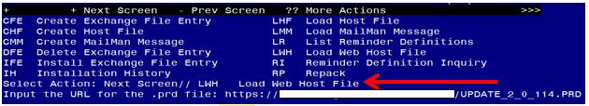
At the Select Action: prompt, enter LWH for Load Web Host File
At the Input the url for the .prd file: prompt, type the following web address:
https://REDACTED /UPDATE_2_0_114.PRD
You should see a message at the top of your screen that the file loaded successfully

You should see a message at the top of your screen that the file loaded successfully
If you are unable to load web host file, you will use vista mail to install the exchange file and use the LMM load Mailman Message Option. The subject of the email will be UPDATE 114
You will see a message similar to this one.

Install the exchange file:
Search and locate an entry titled UPDATE_2_0_114 MISC UPDATE 11 in reminder exchange.
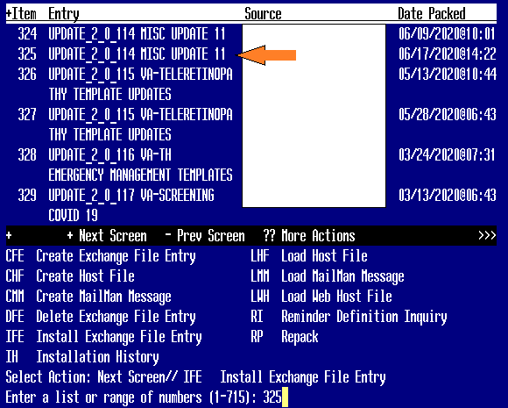
At the Select Action prompt, enter IFE for Install Exchange File Entry
Enter the number that corresponds with your entry. (in this example it is entry 325, it will vary by site.) Make sure you are using exchange file dated 06/17/2020.At the Select Action prompt, type IA to install all components.

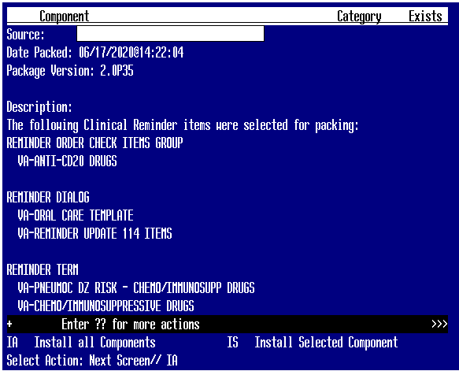
For Items that don’t exist, use the INSTALL action
For Reminder terms that exist but are different, use the MERGE action to avoid changing your sites mappings to the terms
For Other items (Definitions, Health Summary items, TXML items, Taxonomies, etc) that exist, but are different, use the OVERWRITE action
Normally we have site use MERGE action with terms. For reminder term VA-CHEMO/IMMUNOSUPPRESSIVE DRUGS, use the OVERWRITE action. If you accidentally use MERGE, you will receive an error. Go back and reinstall and use OVERWRITE.
At this point, you will begin installing the dialogs in the exchange file.
You will then be prompted to install the FIRST reminder dialog:
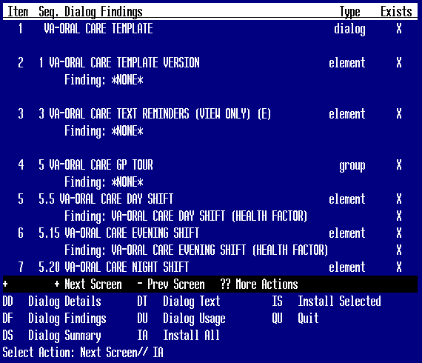
At the Select Action prompt, type IA to install the dialog – VA-ORAL CARE TEMPLATE
Select Action: Next Screen// IA Install All
Install reminder dialog and all components with no further changes: Y// Yes

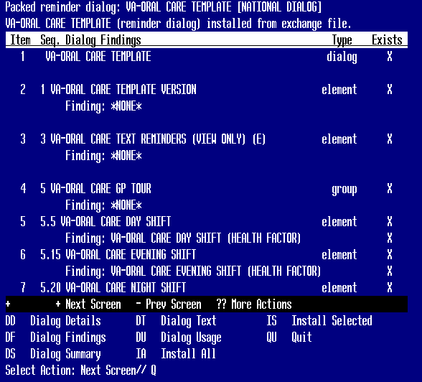

After the dialog installs, you will be returned to this prompt, at the Select Action prompt, type Q to quit.

You will be prompted to install the NEXT reminder dialog component
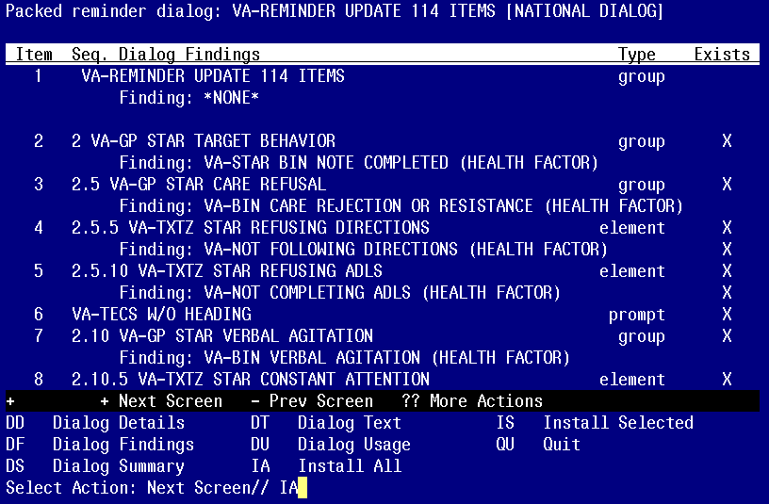
At the Select Action prompt, type IA to install the dialog – VA-UPDATE 114 ITEMS
Select Action: Next Screen// IA Install All
Install reminder dialog and all components with no further changes: Y// Yes

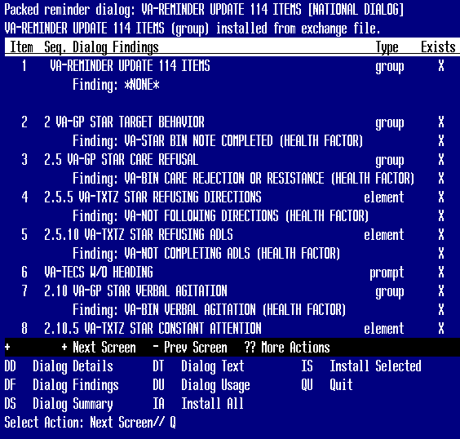
After the dialog installs, you will be returned to this prompt, at the Select Action prompt, type Q to quit.

You will be returned to this screen.
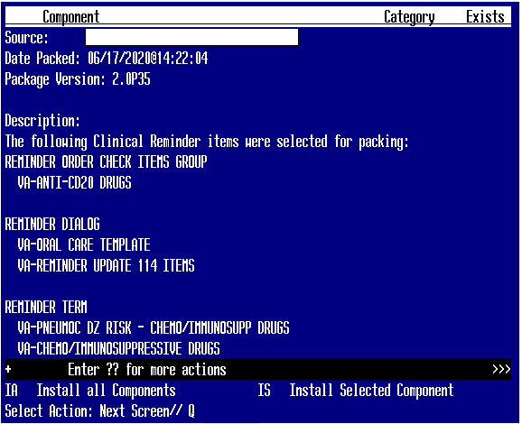
At the Select Action prompt, type Q to quit

Install Completed

Post Installation

Verify that all changes have taken place by doing comparison to what you see with the screenshots/items listed as changes at the beginning of this document.

