Update _2_0_119A

Clinical Reminders

VA-PTSD SCREENING UPDATE
Install Guide

January 2021

Product Development
Office of Information Technology
Department of Veterans Affairs

Table of Contents
Introduction 1
Install Details 2
Install Example 3
Post Installation 6

Introduction

DESCRIPTION:
With the release of reminder update 119, the instrument used in screening for PTSD was changed from PC-PTSD-5+I9 to PC-PTSD-5. Along with this, the result group was also changed from PXRM PC-PTSD-5+I9 RESULT GROUP to PXRM PTSD RESULT GROUP. Within this new group, the positive sequence Result Element had a condition of I SCORE>2 which implies that a score of 3 is positive. This was also transferred to the corresponding progress note with verbiage that a score of 3 was positive. In MHA, the result displayed as the score of 3 being negative which was inconsistent. In Accordance to VA guidelines, a PTSD screening score of 4 or more constitutes a positive screen. In this update, we have created new Result Elements and a Result Group and added this new result group to dialog element VA-MH PC-PTSD+I9 SCREEN. This update corrects the scoring and progress note text. This is an emergency install.

UPDATE_2_0_119A contains 1 Reminder Exchange entry:
UPDATE_2_0_119A VA-PTSD SCREENING UPDATE

The exchange file contains the following components:

MH TESTS AND SURVEYS
PC-PTSD-5

HEALTH FACTORS
VA-REMINDER UPDATES
VA-UPDATE_2_0_119A

REMINDER SPONSOR
Office of MH and Suicide Prevention
Office of Mental Health Services

REMINDER TERM
VA-REMINDER UPDATE_2_0_119A

REMINDER DIALOG
VA-MH PC-PTSD+I9 SCREEN

Install Details

This update is being distributed as a web host file. The address for the host file is: https://Redacted /UPDATE_2_0_119A.PRD

The file will be installed using Reminder Exchange, programmer access is not required.

Installation:
=============
This update can be loaded with users on the system. Installation will take less than 10 minutes.

Install Example
To Load the Web Host File. Navigate to Reminder exchange in Vista
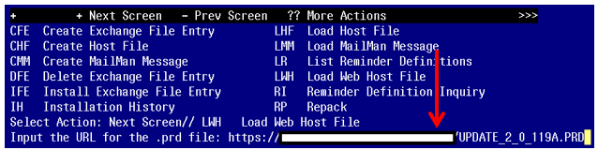

At the Select Action: prompt, enter LWH for Load Web Host File
At the Input the url for the .prd file: prompt, type the following web address:
https://Redacted /UPDATE_2_0_119A.PRD

You should see a message at the top of your screen that the file successfully loaded.

Search and locate an entry titled UPDATE_2_0_119A VA-PTSD SCREENING UPDATE in reminder exchange.
At the Select Action prompt, enter IFE for Install Exchange File Entry
Enter the number that corresponds with your entry UPDATE_2_0_119A VA-PTSD SCREENING UPDATE (in this example it is entry143 it will vary by site). The date of the exchange file should be 01/15/2021.
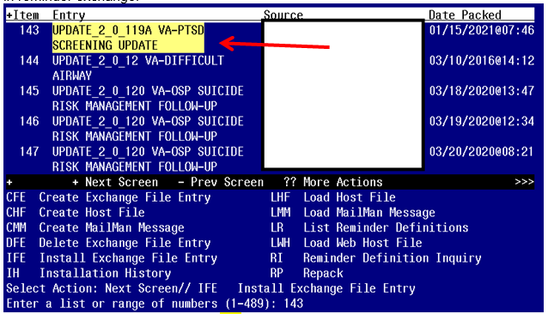

At the Select Action prompt, type IA for Install all Components and hit enter.
Select Action: Next Screen// IA Install all Components

For items that do not exist, use INSTALL action

You will be promped to install the reminder dialog component

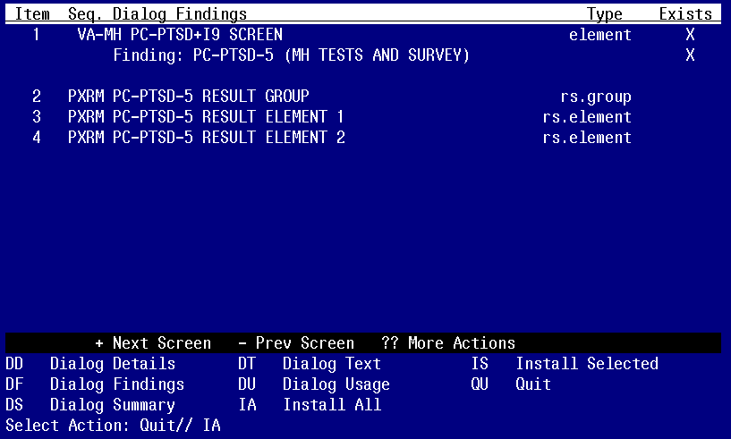
At the Select Action prompt, type IA to install the dialog – VA-MH PC-PTSD+I9 SCREEN
Select Action: Next Screen// IA Install All
Install reminder dialog and all components with no further changes: Y// Yes

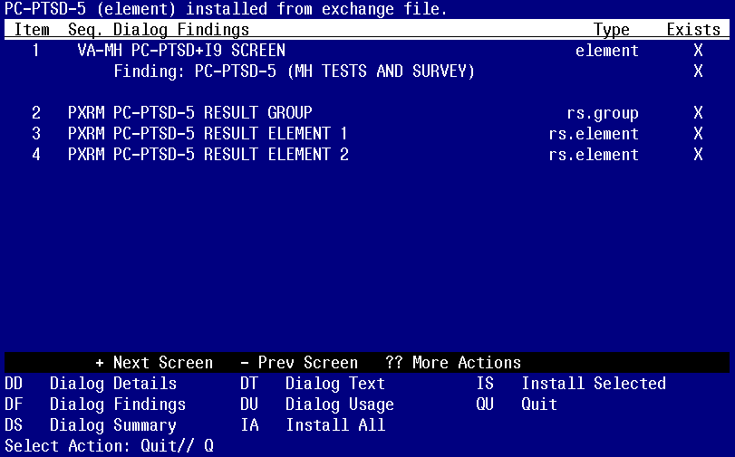

After completing this dialog install, you will type Q.

You will then be returned to this screen
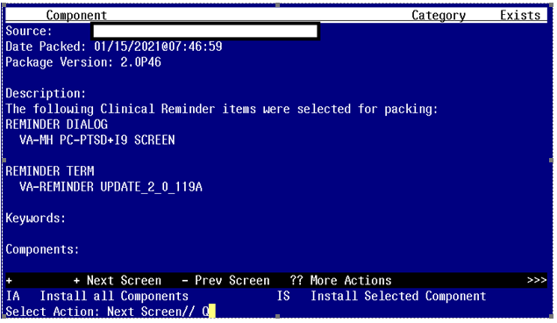

At the Select Action prompt, type Q.

Install complete.

Post Installation

- Navigate to dialog elements. Use INQ option and select dialog element VA-MH PC-PTSD+I9 SCREEN and print this to screen. Ensure that the Result Group entry has changed to PXRM PC-PTSD-5 RESULT GROUP
