Update _2_0_119

Clinical Reminders

MENTAL HEALTH REMINDER UPDATES 7.0

Install Guide

October 2020

Product Development
Office of Information Technology
Department of Veterans Affairs

Table of Contents
Introduction 1
Pre-Install 2
Install Details 6
Install Example 6
Post Installation 15

Introduction
Starting January 1, 2021, performance measures will be updated to include the following changes:
- Depression screening will use PHQ-2 instead of PHQ-2+I9
- PTSD screening will use PC PTSD instead of PC-PTSD-5+I9
- Primary suicide screening will be a new stand-alone clinical reminder/dialog pair that will use Mental Health instrument C-SSRS.
- Alcohol screening will continue to use the AUDC as the screening tool, but the instrument will now “flex” based on the patient sex, that is, different questions will be asked. Formerly sites had the choice to link the screening and follow-up combined dialog to the alcohol screening reminder. The screening reminder will have its own dialog and the follow up for positive alcohol will have its own dialog, there will no longer be a combined dialog.
- Follow up for positive alcohol reminder has been simplified to remove distinctions for Alcohol Use Dependency (AUD) and Substance Use Disorder (SUD) clinic visits as part of the branching logic for the dialog. This reminder will be due for any patient who scores 5 or greater on the AUDC tool

Other changes included in this Update:

Reminder Taxonomy VA-DEMENTIA DIAGNOSIS was updated to include A81.00, A81.01, A81.09, A81.2, A81.89, F01.50, F01.51, F02.80, F02.81, F03.90, F03.91, F10.27 F19.97, G23.1, G30.0, G30.8, G31.01, G31.09, G31.83, G90.3
When installing the update and are prompted, choose OVERWRITE for VA-DEMENTIA DIAGNOSIS taxonomy.

Reminder Location List VA-MH NO SHOW APPT CLINICS LL had the following telephone stop codes added: 527,528,530,542,545,546,579 and 584

Six reminder definitions and their associated dialog are being distributed with this update VA-ALCOHOL USE SCREEN (AUDIT-C)
VA-ALCOHOL AUDIT-C POSITIVE F/U EVAL
VA-DEPRESSION SCREENING
VA-PTSD SCREENING
VA-PRIMARY SUICIDE SCREEN
VA-FOLLOW-UP POS PTSD/DEP COMBINATION

UPDATE_2_0_119 contains 1 Reminder Exchange entry:
UPDATE_2_0_119 MH UPDATES 7.0

The exchange file contains the following components:

REMINDER DIALOG LINK TYPE
VA-ALCOHOL POSITIVE WARM HANDOFF CHECK
VA-CSSRS RN WARM HANDOFF CHECK
VA-PTSD POSITIVE WARM HANDOFF CHECK
VA-DEPRESSION POSITIVE WARM HANDOFF CHECK

TIU TEMPLATE FIELD
VA-SUD CPG
BLANK TEXT FIELD FOR DIALOGS
VA-URL MANAGE AUD TX IN PRIMARY CARE
VA-PTSD CPG
VA-PTSD PCL INFO
BLANK SPACE1
VA-URL PHQ9
VA-DEP CPG

EDUCATION TOPICS
MEDICAL PROBLEMS OF ALCOHOL (SCREENING)
ALCOHOL USE AND MEDICAL PROBLEMS

HEALTH FACTORS
VA-REMINDER UPDATES
VA-UPDATE_2_0_119
MENTAL HEALTH
VA-WARM HANDOFF ALCOHOL POSITIVE
VA-NURSE/LPN-PATIENT COG IMPAIRMENT
ALCOHOL USE
REFUSED ALCOHOL USE SCREENING
SEVERE CHRONIC COGNITIVE IMPAIRMENT
UNABLE TO SCREEN - ACUTE ILLNESS
REMINDER FACTORS
LIFE EXPECTANCY < 6 MONTHS
ALCOHOL - ADVISE ON SAFE LIMITS
REFER FOR ALCOHOL TREATMENT
ALCOHOL - ADVISE TO ABSTAIN
ALCOHOL USE WITHIN SAFE LIMITS
VA-ALCOHOL ABSTAIN OTHER ADVICE
REFUSED REFERRAL TO SUBSTANCE ABUSE
VA-ALCOHOL OTHER
VA-ALCOHOL REFER TO SUD PROGRAM
VA-ALCOHOL REFER TO PCMHI
VA-ALCOHOL TREAT IN PRIMARY CARE
VA-ALCOHOL SELF HELP/AA MEETINGS
NON-DRINKER (NO ALCOHOL FOR >1 YR)
VA-ALCOHOL USE AND MEDICAL PROBLEMS
ALCOHOL - PRIOR TREATMENT
ALCOHOL COUNSELING - PT. RESPONSE
ALCOHOL - RESPONSE TO COUNSELING
ALCOHOL - ADDL ASSESSMENT OF USE
ALCOHOL - ASSESS USE
ALCOHOL - NO PRIOR TREATMENT
VA-WARM HANDOFF PTSD/DEP POSITIVE
REFUSED PTSD SCREEN
DEP/PTSD/SI ASSESSMENT COMPLETE
PTSD ASSESSMENT COMPLETE
DEPRESSION ASSESS COMPLETE
VA-SUICIDE RISK EVALUATION TYPE [C]
VA-SUICIDE RISK UPDATE EVALUATION
VA-SUICIDE RISK NEW EVALUATION
VA-CSSRS RN COGNITIVE IMPAIRMENT
VA-CSSRS DECLINED
REFUSED DEPRESSION SCREENING

REMINDER SPONSOR
Mental Health Services
Office of Public Health and Environmental Hazards
National Clinical Practice Guideline Council
Office of Patient Care Services
Mental Health and Behavioral Science Strategic Group
Office of Quality & Performance
NATIONAL CENTER FOR HEALTH PROMOTION AND DISEASE PREVENTION (NCP)
Office of Mental Health Services

REMINDER TAXONOMY
VA-TERMINAL CANCER PATIENTS
VA-AUD DIAGNOSIS
VA-DEMENTIA DIAGNOSIS
VA-PTSD DX OUTPT VISIT
VA-DEPRESSION DX OUTPT VISIT

REMINDER LOCATION LIST
VA-MH NO SHOW APPT CLINICS LL
VA-SUD CLINICS

REMINDER TERM
VA-REMINDER UPDATE_2_0_119
VA-USER CLASS FOR COGNITIVE IMPAIRMENT
VA-BL NURSE/LPN COG IMPAIRMENT
VA-MH ACUTE ILLNESS
VA-POS ALCOHOL SCREEN
VA-COGNITIVE IMPAIRMENT
VA-REFUSED ALCOHOL SCREENING
VA-LIFE EXPECTANCY < 6 MONTHS
VA-ALCOHOL USE SCREEN
VA-ALC USE INTERVENTIONS
VA-BL AUDIT-C >7
VA-SEX
VA-AUD DIAGNOSIS
VA-SUD CLINIC VISIT
VA-ALCOHOL NONE PAST 1YR
VA-ALC MEDICAL PROBLEMS
VA-ALCOHOL USE INFORMATION
VA-PC-PTSD NEGATIVE
VA-DEMENTIA DIAGNOSIS
VA-VETERAN PATIENT
VA-PTSD DIAGNOSIS
VA-SUICIDE SCREEN POSITIVE PTSD
VA-SUICIDE SCREEN NEGATIVE PTSD
VA-PTSD/DEPRESSION ASSESSMENT COMPLETE
VA-REFUSED PTSD SCREEN
VA-PTSD SCREEN POSITIVE
VA-PTSD SCREEN NEGATIVE
VA-PTSD SCREEN
VA-BL C-SSRS DONE TODAY
VA-C-SSRS DONE TODAY POSITIVE QUESTION 8
VA-C-SSRS DONE TODAY POSITIVE QUESTION 5
VA-C-SSRS DONE TODAY POSITIVE QUESTION 4
VA-C-SSRS DONE TODAY POSITIVE QUESTION 3
VA-BL C-SSRS DONE TODAY POSITIVE
VA-USER CLASS NURSE
VA-CSSRS DECLINED
VA-CSSRS ACUTE ILLNESS
VA-PHQ-2 NEGATIVE
VA-SUICIDE SCREEN POSITIVE DEPRESSION
VA-SUICIDE SCREEN NEGATIVE DEPRESSION
VA-REFUSED DEPRESSION SCREENING
VA-DEPRESSION SCREEN POSITIVE
VA-DEPRESSION SCREEN NEGATIVE
VA-DEPRESSION DIAGNOSIS

REMINDER DEFINITION
VA-BL NURSE/LPN COG IMPAIRMENT
VA-BL C-SSRS DONE TODAY POSITIVE
VA-ALCOHOL USE SCREEN (AUDIT-C)
VA-ALCOHOL AUDIT-C POSITIVE F/U EVAL
VA-PTSD SCREENING
VA-PRIMARY SUICIDE SCREEN
VA-DEPRESSION SCREENING
VA-FOLLOW-UP POS PTSD/DEP COMBINATION

HEALTH SUMMARY COMPONENT
MHA Score
PCE HEALTH FACTORS SELECTED

HEALTH SUMMARY TYPE
OB AUDC
VA-CSRE DONE TODAY
PC-PTSD PCL+I9
PHQ2+I9

HEALTH SUMMARY OBJECTS
AUDC (TIU)
VA-CSRE DONE TODAY (TIU)
PC-PTSD PCL+I9 (TIU)
PHQ2+I9 (TIU)

TIU DOCUMENT DEFINITION
AUDIT-C
VA-CSRE DONE TODAY
PC-PTSD PCL+I9
PHQ2+I9

REMINDER DIALOG
VA-ALCOHOL USE SCREENING (AUDIT-C)
VA-AUD-C POS BRIEF ALCOHOL COUNSELING
VA-PRIMARY SUICIDE SCREEN C-SSRS
VA-FOLLOW-UP POS PTSD/DEP COMBINATION
VA-PTSD SCREENING
VA-DEPRESSION SCREEN

Pre-Install

- Sites may want to check for quick order(s) in the VA-FOLLOW-UP POS PTSD/DEP COMBINATION dialog and have those available when installing this dialog. Even though the name of the elements leads one to think this is only for PTSD, this should be a generic consult to MH for either a depression and/or a PTSD issue. Below are the elements you can check for Quick Orders.
VA-PTSD SCREEN POS MH EMERGENT EVAL
VA-PTSD SCREEN POS MH NON-EMERGENT EVAL
- Sites may want to check for quick order(s) in the VA-AUD-C POS BRIEF ALCOHOL COUNSELING reminder dialog and have available when installing this dialog. Below is the element you can check for Quick Orders.
VA-ALC REFER TO SPECIALTY SUD PROG
- Reminder update 37 (UPDATE_2_0_37), update 53 (UPDATE_2_0_53), update 63 (UPDATE_2_0_63) should be considered a prerequisite to Update 119.

Install Details

This update is being distributed as a web host file. The address for the host file is: https://REDACTED /UPDATE_2_0_119.PRD

The file will be installed using Reminder Exchange, programmer access is not required.

Installation:
=============
This update can be loaded with users on the system. Installation will take less than 20 minutes.

Install Example
To Load the exchange file, use LWH. The URL is https://REDACTED /UPDATE_2_0_119.PRD

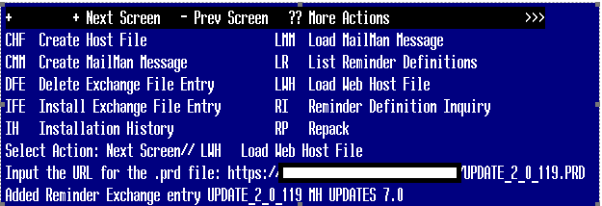

If you use LWH and it works, you will see something similar to this message. Make sure the file was loaded successfully.

Most components will be the same and will be skipped. Here are general rules for prompts to which you will have to respond.
If a component exists, but is different, use OVERWRITE action
If a component is new, use INSTALL action
For Reminder Terms below, use OVERWRITE action

VA-DEPRESSION SCREEN NEGATIVE
VA-DEPRESSION SCREEN POSITIVE
VA-PTSD SCREEN
VA-PTSD SCREEN NEGATIVE
VA-PTSD SCREEN POSITIVE
VA-SUICIDE SCREEN NEGATIVE PTSD
VA-SUICIDE SCREEN POSITIVE PTSD
VA-PC-PTSD NEGATIVE
VA-SUICIDE SCREEN NEGATIVE DEPRESSION
VA-SUICIDE SCREEN POSITIVE DEPRESSION

Search and locate an entry titled UPDATE_2_0_119 MH UPDATES 7.0 in reminder exchange. If you were a test site, you may have more than 1 entry with this name. Be sure and choose the entry with date of 11/11/2020
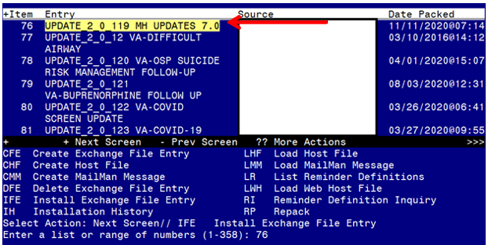
At the Select Action prompt, enter IFE for Install Exchange File Entry
Enter the number that corresponds with your entry titled UPDATE_2_0_119 MH UPDATES 7.0 (in this example it is entry 76, it will vary by site) that is dated 11/11/2020.

At the Select Action prompt, type IA for Install all Components and hit enter.
You will see several prompts:
For all new entries you will choose I to Install
For reminder definitions, Taxonomies, TIU Template fields, Health Summary Type, Reminder Location List entries that exist, but the packed component is different, use OVERWRITE action.
For Reminder Terms, use MERGE action except for the ones below: For these, use OVERWRITE action.
VA-DEPRESSION SCREEN NEGATIVE
VA-DEPRESSION SCREEN POSITIVE
VA-PTSD SCREEN
VA-PTSD SCREEN NEGATIVE
VA-PTSD SCREEN POSITIVE
VA-SUICIDE SCREEN NEGATIVE PTSD
VA-SUICIDE SCREEN POSITIVE PTSD
VA-PC-PTSD NEGATIVE
VA-SUICIDE SCREEN NEGATIVE DEPRESSION
VA-SUICIDE SCREEN POSITIVE DEPRESSION

Dialog installation may not necessarily appear in the order listed in the install guide

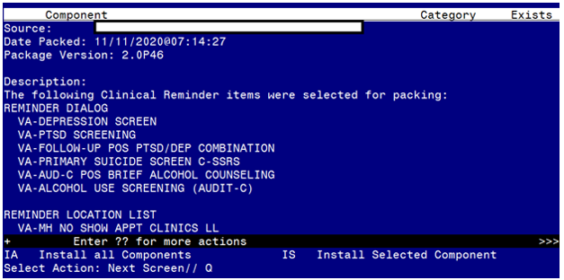

You will be promped to install the first reminder dialog component:
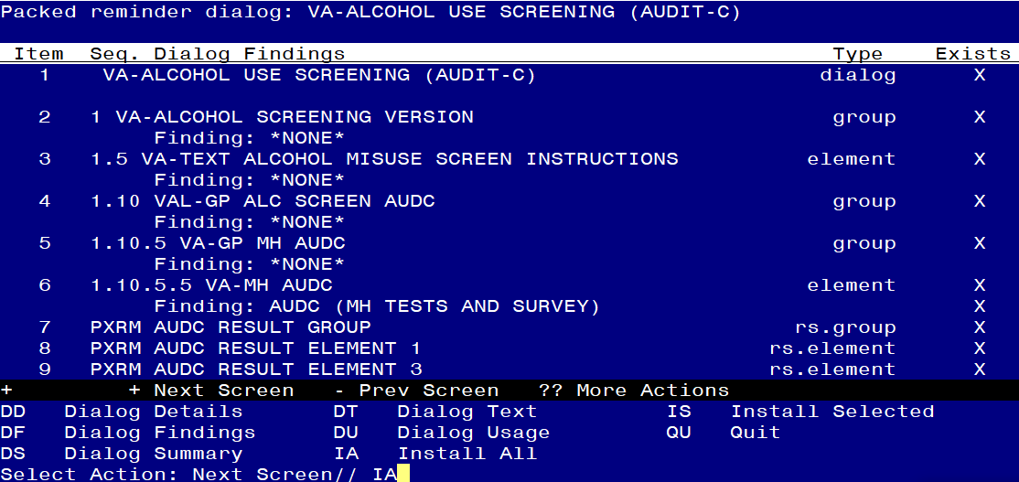

At the Select Action prompt, type IA to install the dialog – VA-ALCOHOL USE SCREEN (AUDIT-C)
Select Action: Next Screen// IA Install All
Install reminder dialog and all components with no further changes: Y// YES

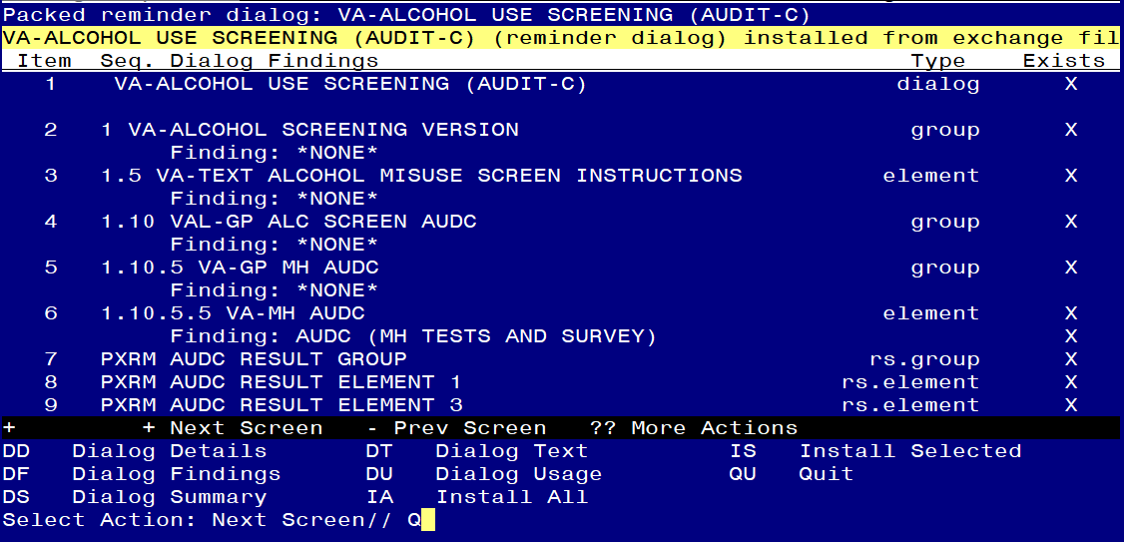

When the dialog has completed installation, you will then be returned to this screen. At the Select Action prompt, type Q.

You will be promped to install the next reminder dialog component:
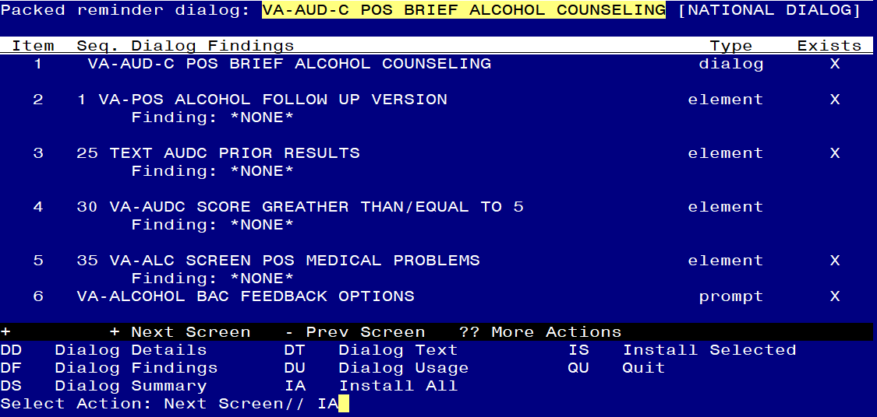

At the Select Action prompt, type IA to install the dialog – VA-AUD-C POS BRIEF ALCOHOL COUNSELING
Select Action: Next Screen// IA Install All
Install reminder dialog and all components with no further changes: Y// YES

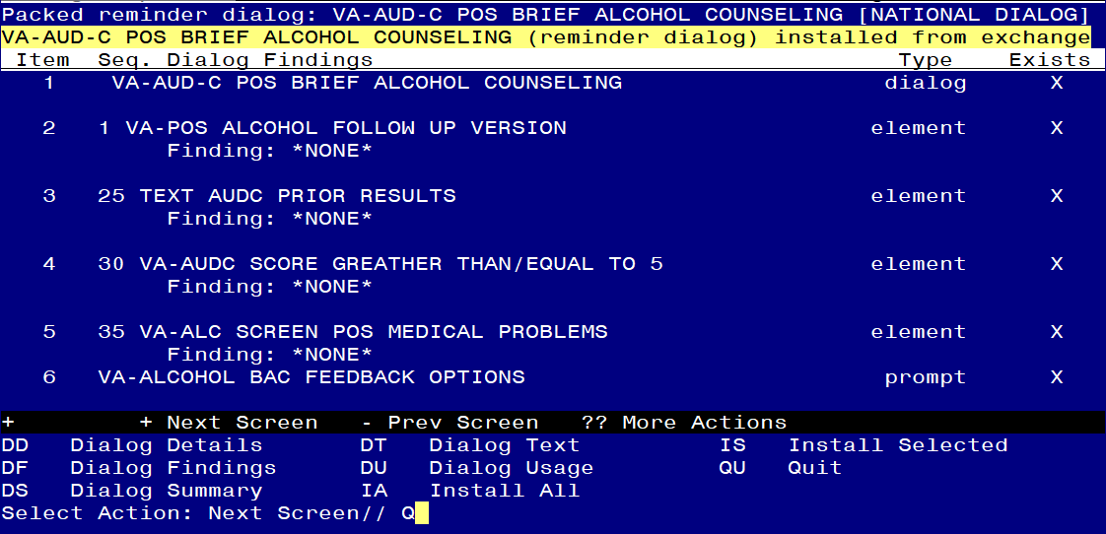
When the dialog has completed installation, you will then be returned to this screen. At the Select Action prompt, type Q.

You will be promped to install the next reminder dialog component: 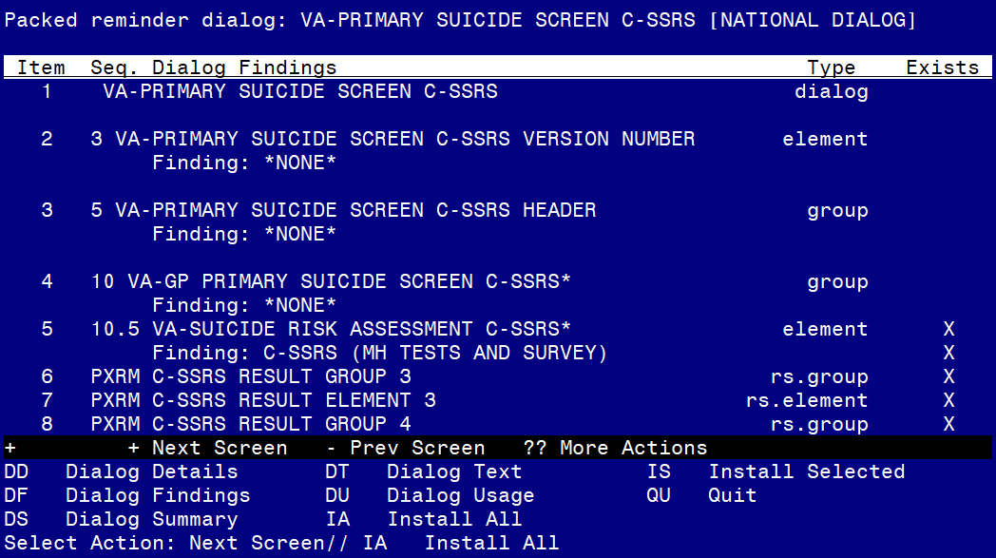
At the Select Action prompt, type IA to install the dialog – VA-PRIMARY SUICIDE SCREEN C-SSRS
Select Action: Next Screen// IA Install All
Install reminder dialog and all components with no further changes: Y// YES
You will see these prompts:
Reminder Dialog VA-PRIMA
RY SUICIDE SCREEN C-SSRS is not linked to a reminder.
Select Reminder to Link: VA-PRIMARY SUICIDE SCREEN// HIT ENTER TO LINK REMINDER

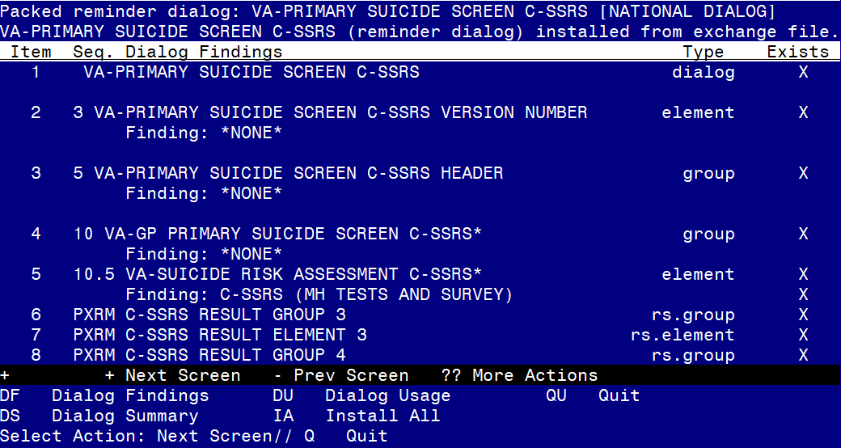
When the dialog has completed installation, you will then be returned to this screen. At the Select Action prompt, type Q.
You will be promped to install the next reminder dialog component:
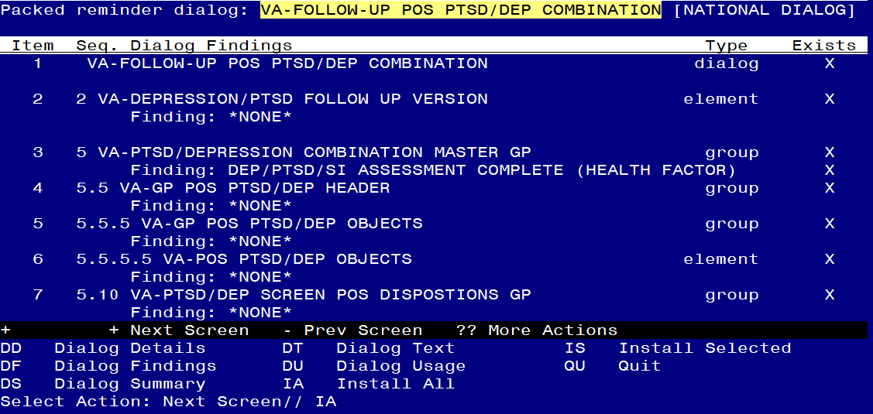
At the Select Action prompt, type IA to install the dialog – VA-FOLLOW-UP POS PTSD/DEP COMBINATION
Select Action: Next Screen// IA Install All
Install reminder dialog and all components with no further changes: Y// YES

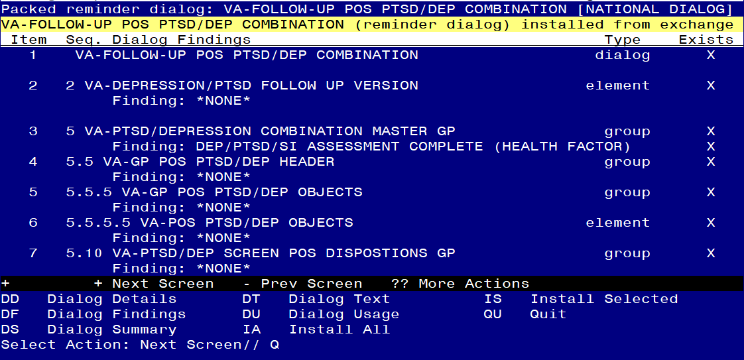
When the dialog has completed installation, you will then be returned to this screen. At the Select Action prompt, type Q.

You will be promped to install the next reminder dialog component:
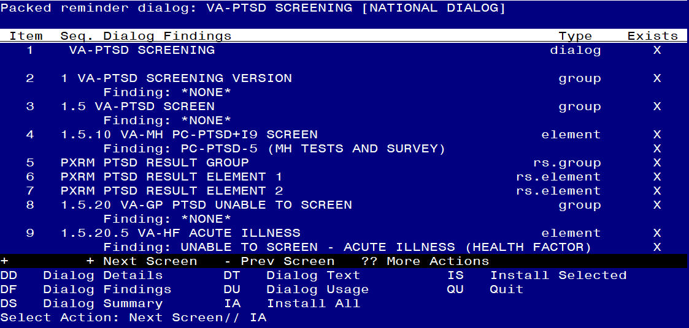

At the Select Action prompt, type IA to install the dialog – VA-PTSD SCREENING
Select Action: Next Screen// IA Install All
Install reminder dialog and all components with no further changes: Y// YES

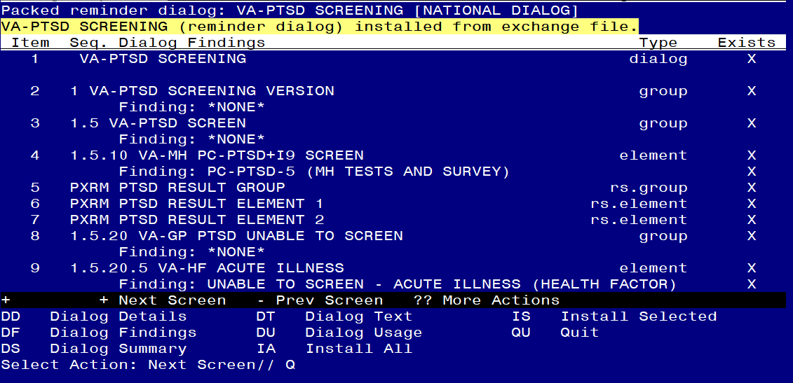
When the dialog has completed installation, you will then be returned to this screen. At the Select Action prompt, type Q.

You will be promped to install the last reminder dialog component:
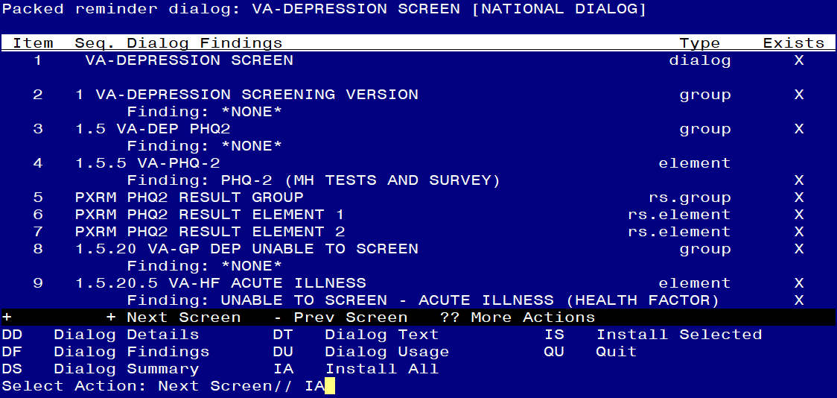

At the Select Action prompt, type IA to install the dialog – VA-DEPRESSION SCREENING
Select Action: Next Screen// IA Install All
Install reminder dialog and all components with no further changes: Y// YES

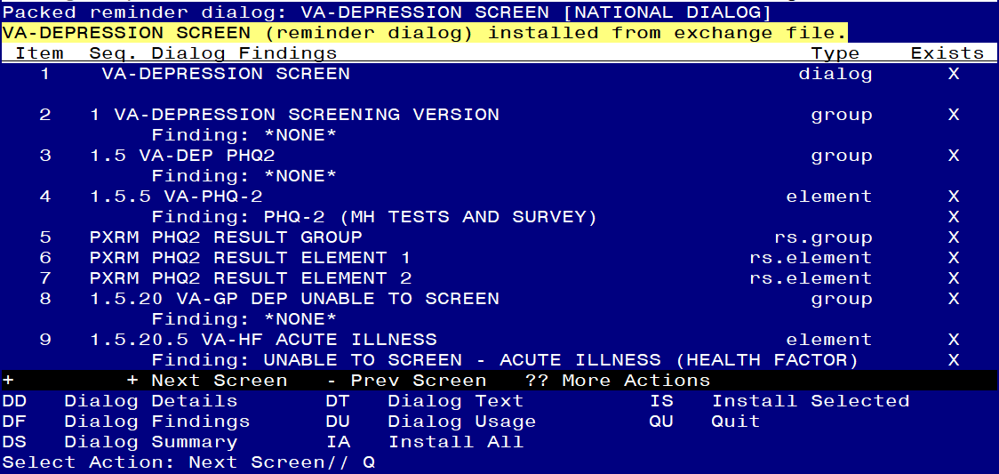
When the dialog has completed installation, you will then be returned to this screen. At the Select Action prompt, type Q.

This will complete the Dialog Install section.

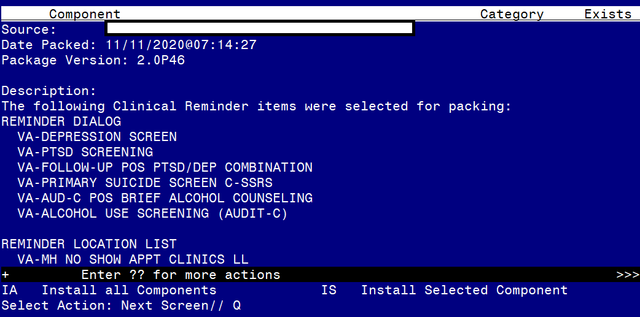

Type Q to exit the installation

Post Installation
- Reminder Term VA-USER CLASS NURSE has two mapped items, both are CF.VA-ASU USER CLASS. Make sure you have your exact RN and LPN user class names in the CF parameter field. If you have more than 2 user classes that represent RN and LPN, you will have to add a new instance of the computed finding VA-ASU USER CLASS, this is done by using quotes: “CF.VA-ASU USER CLASS”. This term is used in branching logic to display the warm handoff option in the primary suicide screen reminder dialog, if you have additional user classes that may complete the primary suicide screen and should have this option in the dialog, you can add them to this term.
- Ensure the new VA-PRIMARY SUICIDE SCREEN reminder (print name is “Suicide Screen”) is added to your coversheet for users.
- Add your local Quick Orders back into the following elements from Pre-Install
  - VA-PTSD SCREEN POS MH EMERGENT EVAL
  - VA-PTSD SCREEN POS MH NON-EMERGENT EVAL
  - VA-ALC REFER TO SPECIALTY SUD PROG

Install complete.

