Update_2_0_121

Clinical Reminders

VA-Buprenorphine Follow Up

Install Guide

August 2020

Product Development
Office of Information Technology
Department of Veterans Affairs

Table of Contents
Introduction 1
Pre-Install 2
Install Details 3
Install Example 3
Post Installation 6

Introduction
The dramatic rise in opioid prescribing has been accompanied by parallel increases in nonmedical opioid use, overdose deaths, opioid use disorders (OUD) and treatment initiations for OUD. One initiative to address this problem in the Veteran Affairs (VA) healthcare system is the Stepped Care for Opioid Use Disorder (OUD) Train-the-Trainer (SCOUTT) initiative, which aims to improve access to OUD treatment across primary care, pain management, mental health, and other health care settings. The OUD Buprenorphine Follow Up template is designed to guide and support documentation of buprenorphine treatment for OUD and ICD-10 opioid dependence. This is the third of three templates released: OUD assessment, Buprenorphine initiation and Buprenorphine follow up.

UPDATE_2_0_121 contains 1 Reminder Exchange entry:
UPDATE_2_0_121 VA-MH OUD BUPRENORPHINE FOLLOW UP

The exchange file contains the following components:
MH TESTS AND SURVEYS
COWS

TIU TEMPLATE FIELD
GEN WORD PROCESSING
VA-MH OUD PROG TOWARD GOAL
VA-MH OUD 100-300 MG
EBOX40
VA-MH FILM/TAB
WP-2LINES
IC/BLANK LINE 74 CHARACTERS T DIALOG USE
VA-MH OUD APPT
BLANK SPACE1
YES/NO
DATE
VA-MH OUD OTHER NO INDENT
WP FREE TEXT
VA-MH OUD WITHDRAWAL SYMPTOMS
VA-MH OUD NONE
VA-MH OUD BUPE SE
VA-MH OUD DIAGNOSIS

HEALTH FACTORS
VA-REMINDER UPDATES
VA-UPDATE_2_0_121
VA-NALOXONE
VA-PATIENT DECLINED NALOXONE
VA-MH OUD FOLLOW UP OFFER NALOXONE
VA-MH OUD BUPE FOLLOW UP NEEDS ADJUST
VA-MH OUD BUPE FOLLOW UP STABLE
VA-MH OUD BUPE FOLLOW UP ASSESSMENT PLAN
VA-MH OUD BUPE FOLLOW UP VIEW UDAS
VA-MH OUD BUPE FOLLOW UP OTHER SUBSTANCE
VA-MH OUD BUPE FOLLOW UP TEMPLATE

REMINDER SPONSOR
MENTAL HEALTH SERVICES
MENTAL HEALTH SERVICES AND WOMEN VETERANS HEALTH PROGRAM

REMINDER TERM
VA-REMINDER UPDATE_2_0_121

REMINDER DIALOG
VA-MH OUD BUPRENORPHINE FOLLOW UP

HEALTH SUMMARY COMPONENT
LAB CUMULATIVE SELECTED 1

HEALTH SUMMARY TYPE
VA-UDAS/BUPE OBJECT

HEALTH SUMMARY OBJECTS
VA-UDAS/BUPE OBJECT (TIU)

TIU DOCUMENT DEFINITION
VA-UDAS/BUPE OBJECT

Pre-Install
- Make sure you have installed Update_2_0_88 Opioid Use Disorder Buprenorphine Initiation and Update_2_0_72 VA-Opioid Use Disorder Assessment prior to installing this Update.

Also, before you install this update, use the action INQ (Inquiry/Print) to print and save the existing dialog for the following items. This will ensure the local modifications to these items are easier to complete when you address the Post-Install steps.

- In Reminder Dialog Manager > Reminder Dialogs > Change your view to Dialog Elements.
  - Use the action INQ (Inquiry/Print) to print and save the existing content for the following element: VAL-MH OUD PDMP LINK. If you previously added a hyperlink TXML field to this element, you’ll have it saved for re-adding it during the Post-Install steps.

- In Reminder Dialog Manager > Reminder Dialogs > Change your view to Dialog Elements.
  - Use the action INQ (Inquiry/Print) to print and save the existing content for the following element: VAL-MH OUD ASSESS NALOXONE ORDERED. If you previously added a Naloxone quick order to this element, you’ll have it saved for re-adding it during the Post-Install steps.

Install Details

This update is being distributed as a web host file. The address for the host file is: https://REDACTED/UPDATE_2_0_121.PRD

The file will be installed using Reminder Exchange, programmer access is not required.

Installation:
=============
This update can be loaded with users on the system. Installation will take less than 10 minutes.

Install Example
To Load the Web Host File. Navigate to Reminder exchange in Vista
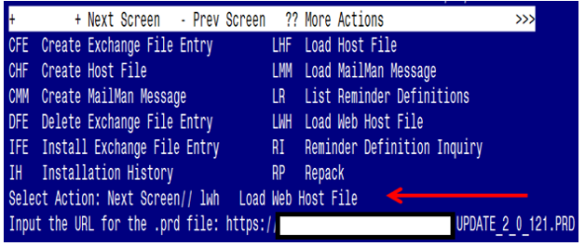

At the Select Action: prompt, enter LWH for Load Web Host File
At the Input the url for the .prd file: prompt, type the following web address:
https://REDACTED/UPDATE_2_0_121.PRD

You should see a message at the top of your screen that the file successfully loaded.

Search and locate an entry titled UPDATE_2_0_121 BUPRENORPHINE FOLLOW UP in reminder exchange

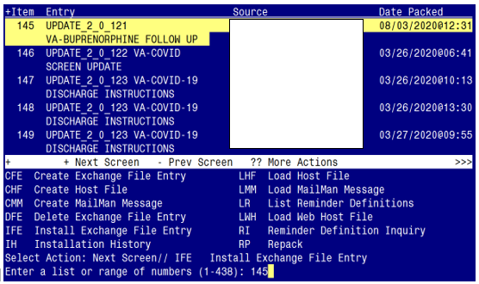

At the Select Action prompt, enter IFE for Install Exchange File Entry
Enter the number that corresponds with your entry titled
UPDATE_2_0_121 VA-BUPRENORPHINE FOLLOW UP
(in this example it is entry 145, it will vary by site). The date of the exchange file is 08/03/2020.

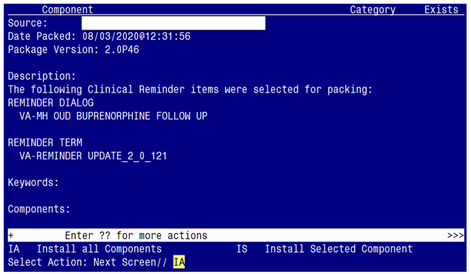

At the Select Action prompt, type IA for Install all Components and hit enter.
Select Action: Next Screen// IA Install all Components

During the installation, you will see several prompts:
Install all new components, Skip all existing components
You will be promped to install the dialog component:

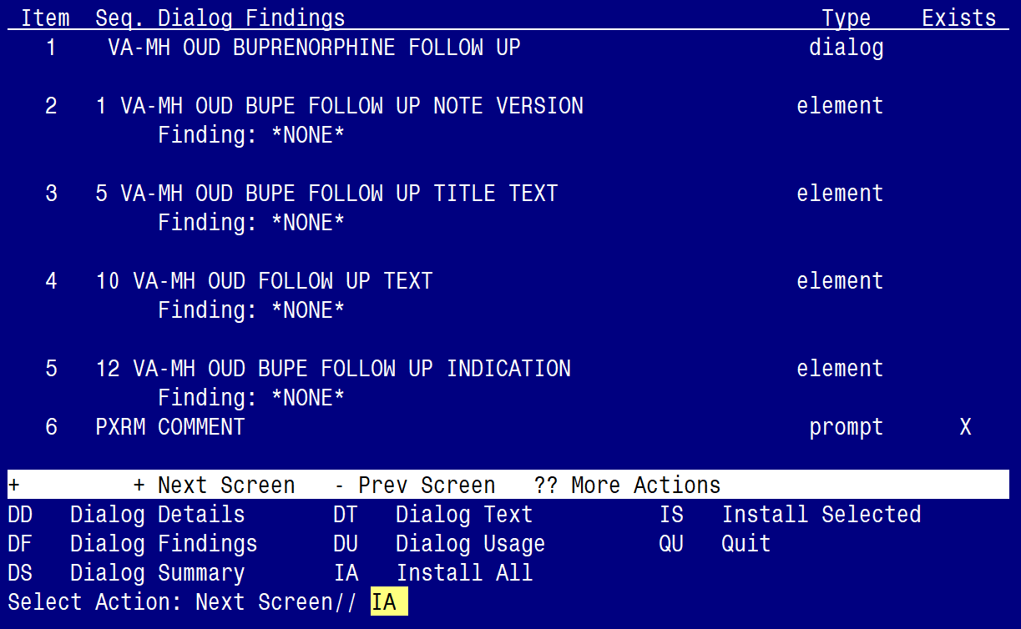

At the Select Action prompt, type IA to install the dialog – VA-MH OUD BUPRENORPHINE FOLLOW UP
Select Action: Next Screen// IA Install All
Install reminder dialog and all components with no further changes: Y// ES

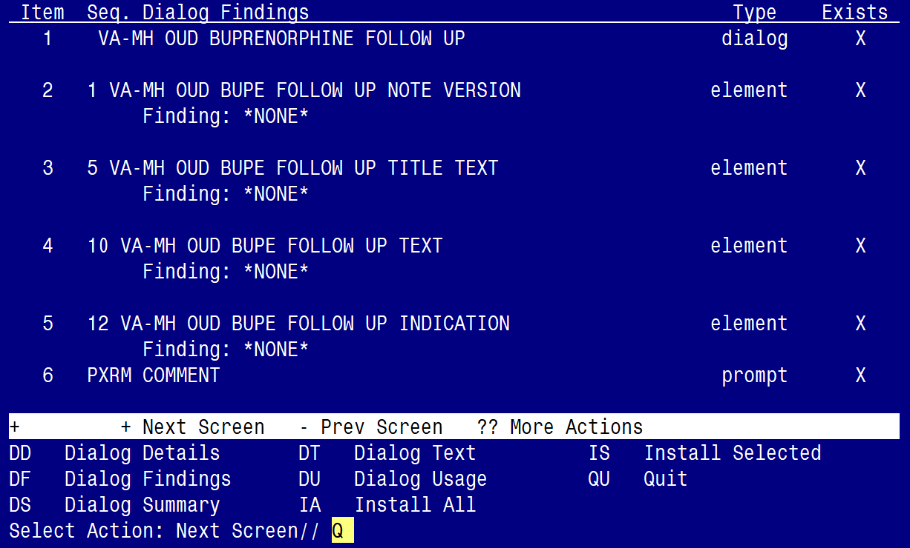

When the dialog has completed installation, you will then be returned to this screen. At the Select Action prompt, type Q.

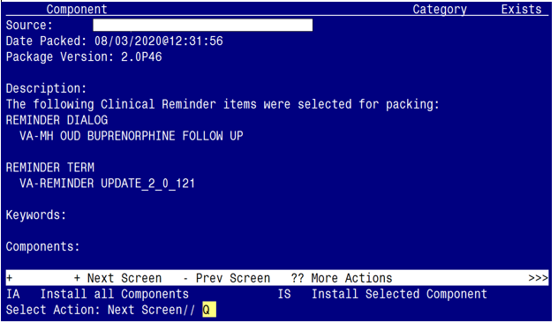

You will be returned to this screen. Type Q to quit.
Install Completed

Post Installation

- Make the Dialog templates available to be attached to a Personal or Shared template or to be able to attach the dialog to a progress note title.
From the Reminders Manager Menu:
Select Reminder Managers Menu Option: CP CPRS Reminder Configuration
CA Add/Edit Reminder Categories
CL CPRS Lookup Categories
CS CPRS Cover Sheet Reminder List
MH Mental Health Dialogs Active
PN Progress Note Headers
RA Reminder GUI Resolution Active
TIU TIU Template Reminder Dialog Parameter
DL Default Outside Location
PT Position Reminder Text at Cursor
Select CPRS Reminder Configuration Option: TIU TIU Template Reminder Dialog
Parameter
Reminder Dialogs allowed as Templates may be set for the following:
1 User USR [choose from NEW PERSON]
3 Service SRV [choose from SERVICE/SECTION]
4 Division DIV [choose from INSTITUTION]
5 System SYS [NATREM.FO-SLC.MED.VA.GOV]
Enter selection: 5 Choose the appropriate number for your site. Your site may do
this by System or other levels. The example below uses SYSTEM level
Setting Reminder Dialogs allowed as Templates for System:
Select Display Sequence: ?

148 VA-VETERANS CHOICE NOTE
149 VA-TBI SCREENING
151 VACO TRANSPLANT REFERRAL (D)
When you type a question mark above, you will see the list of #’s (with dialogs) that
are already taken. Choose a number NOT on this list. For this example, looking
above I see the number 150 is not present, so I will use 150.

Select Display Sequence: 150
Are you adding 150 as a new Display Sequence? Yes// Y YES
Display Sequence: 150// <Enter>
Clinical Reminder Dialog: VA-MH OUD BUPRENOPRHINE FOLLOW UP <Enter>
OK? Yes// <Enter> (Yes)

- Setup of Note title
The new note title that needs to be created is:
OPIOID DEPENDENCE/OUD BUPRENORPHINE FOLLOW UP
This note title is to be mapped to the following VHA Enterprise Standard Title:
MENTAL HEALTH NOTE

Comprehensive information on Creating Document Definitions can be found beginning on page 47 of the TIU/ASU Implementation Guide

- Associate the reminder dialog with the note title in CPRS
To do this, go to Template Editor, then Document Titles, select the appropriate folder (if applicable), and choose New Template (top right-hand corner).
Type in the following information:
Name: OPIOID DEPENDENCE/OUD BUPRENORPHINE FOLLOW UP
Template Type: Reminder Dialog
Reminder Dialog: VA-MH OUD BUPRENORPHINE FOLLOW UP
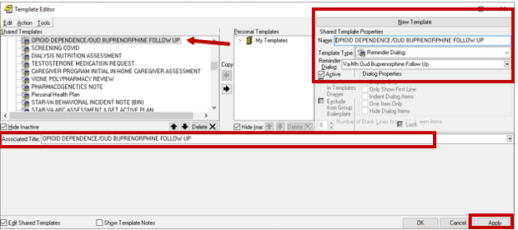

Next, type in the Associated Title, which in this case is OPIOID DEPENDENCE/OUD BUPRENORPHINE FOLLOW UP and hit Apply.

- Add the dialog to a shared template in CPRS.
To do this, go to Template Editor, then Shared Templates, select the appropriate folder (if applicable), and choose New Template (top right-hand corner).
Type in the following information:
Name: OPIOID DEPENDENCE/OUD BUPRENORPHINE FOLLOW UP
Template Type: Reminder Dialog
Reminder Dialog: VA-MH OUD BUPRENORPHINE FOLLOW UP

Hit Apply.

- Add your local PDMP hyperlink txml field

Using the menu Reminder Dialog Management, Reminder Dialogs, change your view to Elements. Search for and edit the following element. VAL-MH OUD PDMP LINK. Insert your local existing txml template field. (Refer to the saved Inquiry from the Pre-Install steps)

If one does not exist, you will need to create a txml template field hyperlink to your state’s PDMP (prescription drug monitoring program) website. Look up your state’s PDMP website here.

Note: VAL-MH OUD PDMP LINK is a local element. If you choose, you can SUPPRESS the checkbox in this element. By default, the ‘suppress checkbox’ is NOT set to “yes”.

- Using the menu Reminder Dialog Management, Reminder Dialogs, change your view to Elements.
- Search for and edit the following element VAL-MH OUD ASSESS NALOXONE ORDERED.
- Add your local quick order (or local order menu) for NALOXONE as a Finding Item. The drug from national drug file is DR. NALOXONE HCL 4MG/SPRAY SOLN NASAL SPRAY. (Refer to the saved Inquiry from the Pre-Install steps)

- Using the menu Reminder Dialog Management, Reminder Dialogs, change your view to Elements.
- Search for and edit the following element: VAL-MH OUD BUPE FOLLOW UP MEDS 2 MG TABS DISCHARGE
- Add your local quick order (or local order menu) for BUPRENORPHINE 2MG/NALOXONE .5 MG TAB as a Finding Item.
- You may have this same order currently mapped to element VAL-MH OUD BUPE INITIATION MEDS 2 MG TABS DISCHARGE. If so, refer to this element for the name of the quick order.

- Using the menu Reminder Dialog Management, Reminder Dialogs, change your view to Elements.
- Search for and edit the following element: VAL-MH OUD BUPE FOLLOW UP MEDS 8 MG TABS DISCHARGE
- Add your local quick order (or local order menu) for BUPRENORPHINE 8MG/NALOXONE 2 MG TAB as a Finding Item.
- You may have this same order currently mapped to element VAL-MH OUD BUPE INITIATION MEDS 8 MG TABS DISCHARGE. If so, refer to this element for the name of the quick order.

- Using the menu Reminder Dialog Management, Reminder Dialogs, change your view to Elements.
- Search for and edit the following element: VAL-MH OUD BUPE FOLLOW UP MEDS 2 MG FILM DISCHARGE
- Add your local quick order (or local order menu) for BUPRENORPHINE 2 MG/NALOXONE .5 MG FILM as a Finding Item.
- Some sites do not carry the film. Check with your Pharmacy ADPAC to see if your site has the film. If not, then you can disable this element, or you may also add your local non formulary drug request to this group.
- You may have this same order currently mapped to element VAL-MH OUD BUPE INITIATION MEDS 2 MG FILM DISCHARGE. If so, refer to this element for the name of the quick order.

- Using the menu Reminder Dialog Management, Reminder Dialogs, change your view to Elements.
- Search for and edit the following element: VAL-MH OUD BUPE FOLLOW UP MEDS 8 MG FILM DISCHARGE
- Add your local quick order (or local order menu) for BUPRENORPHINE 8 MG/NALOXONE 2 MG FILM as a Finding Item.
- Some sites do not carry the film. Check with your Pharmacy ADPAC to see if your site has the film. If not, then you can disable this element, or you may also add your local non formulary drug request to this group.
- You may have this same order currently mapped to element VAL-MH OUD BUPE INITIATION MEDS 8 MG FILM DISCHARGE. If so, refer to this element for the name of the quick order.

- Using the menu Reminder Dialog Management, Reminder Dialogs, change your view to Groups.
- Search for and edit the following group: VAL-MH OUD BUPE FOLLOW UP ORDER LABS UDAS
- Add your local quick order (or local order menu), for both the UDAS lab test and the BUPRENORPHINE CONFIRMATION test, to the Finding Item field. Some sites have one order for both, others have two separate orders.
- Check with your Lab Information Manager or Lab ADPAC to identify the quick orders. If your site has two separate orders, you can build an order menu to include both test orders and map the order menu to the Finding Item.

- Using the menu Reminder Dialog Management, Reminder Dialogs, change your view to Elements.
- Search for and edit the following element: VAL-MH OUD BUPE FOLLOW UP ORDER LABS HCG
- Add your local quick order (or local order menu), for QUALITATIVE URINE HCG, as a Finding Item.
- Check with your Lab Information Manager or Lab ADPAC to identify the quick order.
- You may have this same order currently mapped to element VAL-MH OUD BUPE INITIATION ORDER LABS HCG. If so, refer to this element for the name of the quick order.

- Using the menu Reminder Dialog Management, Reminder Dialogs, change your view to elements.
- Search for and edit the following element: VAL-MH OUD BUPE FOLLOW UP REFER ADDICTIONS
- Add your local quick order (or local order menu), for REFERRALS FOR SPECIALTY ADDICTIONS TREATMENT, as a Finding Item.
- Check with your Social Work service or PCMHI team or SCOUTT team (for SCOUTT sites) to identify the quick order. Your site may have additional referrals they want to add. It is a local group, so you can add additional elements and customize to fit the needs of your site.
- You may have this same order currently mapped to element VAL-MH OUD ASSESS2 PLAN OFFER REFERRAL. If so, refer to this element for the name of the quick order.

- Using the menu Reminder Dialog Management, Reminder Dialogs, change your view to Elements.
- Search for and edit the following element: VAL-MH OUD BUPE FOLLOW UP REFER MENTAL HEALTH
- Add your local quick order (or local order menu), for REFERAL TO MENTAL HEALTH, as a Finding Item.
- Check with your Mental Health service, PCMHI team or SCOUTT team (for SCOUTT sites) to identify the quick order. Your site may have additional referrals they want to add. It is a local group, so you can add additional elements and customize to fit the needs of your site.
- You may have this same order currently mapped to element VAL-MH OUD ASSESS2 PLAN OFFER REFERRAL. If so, refer to this element for the name of the quick order.

- Using the menu Reminder Dialog Management, Reminder Dialogs, change your view to Elements.
- Search for and edit the following element: VAL-MH OUD ACTIVE MEDICATIONS FOLLOW UP
- Replace the ‘placeholder’ text and add your local ACTIVE OUTPATIENT MEDICATIONS data object.

- Using the menu Health Summary Maintenance, add lab tests to the Health Summary type VA-UDAS/BUPE OBJECT
- Add your local UDAS lab test and the BUPRENORPHINE CONFIRMATION test to the health summary type called VA-UDAS/BUPE OBJECT. Some sites have one test for both, others have two separate tests.
- Check with your Lab Information Manager or Lab ADPAC to identify the lab tests.
- Below are step by step instructions for adding lab tests to the health summary type.
- If you receive a message that you are unable to edit, ensure you have the GMTSMGR key in your VistA profile.
- If you have more than seven (7) lab tests to add, you may need to add the SCL2 component in order to add additional lab tests.

Step 1 - In VistA, go to the HEALTH SUMMARY MAINTENANCE Menu and select Option 6 – Create/Modify Health Summary Type.

Step 2 – Type VA-UDAS/BUPE OBJECT HS type

Step 3 – Type Y for yes to continue:

Step 4 – Press ENTER until you see “Select COMPONENT”, then type “SCL1”

Step 5 – Type “E” to Edit component parameters

Step 6– Press ENTER until you see “Select SELECTION ITEM”

Step 7– Enter the following Lab Tests for the VA-UDAS/BUPE OBJECT HS type

Step 8– Select “N” to the ‘resequencing’ and ‘review’ question

Step 9– Finished.

- The following group and element are set to DISABLED, as prescribing of this medication (SUBLOCADE) is limited at most sites. Only ‘enable’ and set up these two items after confirming with your local stakeholders. If your site chooses to ‘enable’, search for and enable the following two items:

ELEMENT: VAL-MH OUD BUPE FOLLOW MEDS SUBLOCADE

GROUP: VAL-GP MH OUD BUPE FOLLOW UP MEDS SUBLOCADE INJECTABLE
DISCHARGE

Create a quick order for your local Orderable Item: BUPRENORPHINE INJ, SOLN, SA (N/F)
and add the quick order as a Finding Item.
- OPTIONAL: Add local reminder dialog groups and elements, if needed.

If your staff would like to insert local groups and elements from other dialogs (e.g. patient education) into this template, you can use the local reminder dialog group VAL-GP BUPE FOLLOW UP PLACEHOLDER using the reminder dialog editor.

- This dialog group is ‘disabled’ by default, so if you decide to use it, you will need to enable it.
- This dialog group will also appear at the end of the template, so if you use it and add other group and elements to it, the content will appear at the end of the template.

- OPTIONAL: This template includes two sections for the Clinical Opioid Withdrawal Scale (COWS) and the Prescription Drug Management Program (PDMP). These two sections are programmed as a local group and element and can be ‘disabled’, should your site choose not to include them in the template. Check with your local stakeholders to determine whether to disable either (or both) items … otherwise, leave them as ‘enabled’. The group and element names are as follows:

- VAL-MH OUD BUPE FOLLOW UP WITHDRAWAL ASSESSMENT COWS
- VAL-MH OUD BUPE FOLLOW UP PDMP

