Update _2_0_132

Clinical Reminders

COVID-19 INPATIENT PROVIDER TEMPLATES

Install Guide

June 2020

Product Development
Office of Information Technology
Department of Veterans Affairs

Table of Contents
Introduction 1
Install Details 1
Install Example 3
Post Installation 10

Introduction

DESCRIPTION:

Attached to this communication are a CPRS COVID-19 templated Admission H&P and a COVID-19 Inpatient Progress Note, to be used in the care of known or suspected COVID-19 patients. They have been developed in collaboration with clinical hospital medicine leadership to achieve two primary goals: to ensure all sites have access to the same CPRS tools and to document several important COVID-specific health factors considered integral to patient management across the outpatient-inpatient-post-acute care continuum.

UPDATE_2_0_132 contains 1 Reminder Exchange entry:
UPDATE_2_0_132 COVID-19 INPATIENT PROVIDER TEMPLATES

The exchange file contains the following components:

GMRV VITAL TYPE
PULSE OXIMETRY
RESPIRATION
BLOOD PRESSURE
PULSE
TEMPERATURE

TIU TEMPLATE FIELD
1 VA-WORD
2 VA-SOFA SCORE
3 TEXT (1-30 CHAR)

HEALTH FACTORS
4 VA-REMINDER UPDATES
5 VA-UPDATE_2_0_132
6 VA-COVID-19
7 VA-COVID-19 ROS OTHER
8 VA-COVID-19 ROS GI
9 VA-COVID-19 ROS CV
10 VA-COVID-19 ROS RESP
11 VA-COVID-19 ROS ENT
12 VA-COVID-19 ROS GENERAL
13 VA-COVID-19 DATE OF SYMPTON ONSET
14 VA-COVID-19 MED HX HOMELESSNESS
15 VA-COVID-19 MED HX OBESITY
16 VA-COVID-19 MED HX BREASTFEEDING
17 VA-COVID-19 MED HX OTHER
18 VA-COVID-19 MED HX CANCER
19 VA-COVID-19 MED HX HTN
20 VA-COVID-19 MED HX PREGNANCY
21 VA-COVID-19 MED HX IMMUNOCOMPROMISED
22 VA-COVID-19 MED HX LIVER DISEASE
23 VA-COVID-19 MED HX CKD
24 VA-COVID-19 MED HX DIABETES
25 VA-COVID-19 MED HX HEART DISEASE
26 VA-COVID-19 MED HX LUNG DISEASE
27 VA-COVID-19 MED HX AGE
28 VA-COVID-19 INPATIENT SOFA SCORE
29 VA-ADMISSION FAMILY POA

REMINDER COMPUTED FINDINGS
VA-SEX

REMINDER TERM
30 VA-REMINDER UPDATE_2_0_132
31 VA-SEX MALE

REMINDER DIALOG
32 VA-COVID-19 INPATIENT ADMISSION H&P
33 VA-COVID-19 INPATIENT PROVIDER

HEALTH SUMMARY COMPONENT
LAB TESTS SELECTED
VITAL SIGNS SELECTED

HEALTH SUMMARY TYPE
34 INFLUENZA LAB RESULTS
35 COVID19 LAB RESULTS
36 VA-RECENT VITALS

HEALTH SUMMARY OBJECTS
37 INFLUENZA LAB RESULTS (TIU)
38 COVID19 LAB RESULTS (TIU)
39 VA-RECENT VITALS (TIU)

TIU DOCUMENT DEFINITION
40 INFLUENZA LAB RESULTS
41 COVID19 LAB RESULTS
42 VA-RECENT VITALS

Install Details

This update is being distributed as a web host file. The address for the host file is: https://Redacted/UPDATE_2_0_132.PRD

The file will be installed using Reminder Exchange, programmer access is not required.

This update is also being distributed as a vista mailman message. The mailman message will be titled UPDATE 132.

Installation:
=============
This update can be loaded with users on the system. Installation will take less than 10 minutes.

Install Example

To Load the Web Host File. Navigate to Reminder exchange in Vista
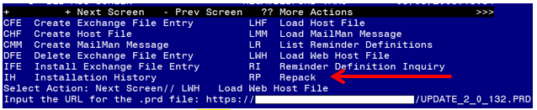
At the Select Action: prompt, enter LWH for Load Web Host File
At the Input the url for the .prd file: prompt, type the following web address:
https://Redacted/UPDATE_2_0_132.PRD

You should see a message at the top of your screen that the file loaded successfully.

If you are unable to load web host file, you will use vista mail to install the exchange file and use the LMM load Mailman Message Option. The subject of the email will be UPDATE 132. You will see a message similar to this one.
Search and locate an entry titled UPDATE_2_0_132 COVID-19 INPATIENT PROVIDER TEMPLATES in reminder exchange.
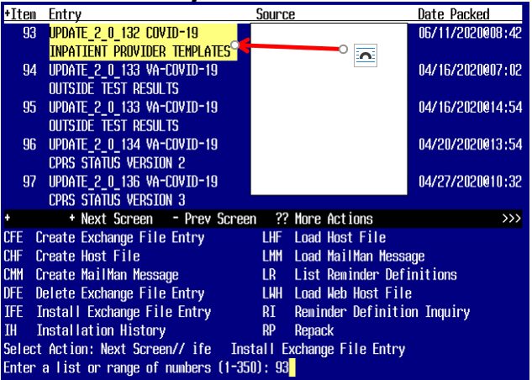
At the Select Action prompt, enter IFE for Install Exchange File Entry
Enter the number that corresponds with your entry UPDATE_2_0_132 COVID-19 INPATIENT PROVIDER TEMPLATES (in this example it is entry 93 it will vary by site). The date of the exchange file should be 06/11/2020.
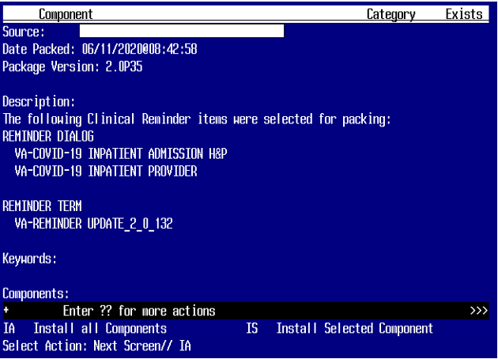
At the Select Action prompt, type IA for Install all Components and hit enter.
Select Action: Next Screen// IA Install all Components
You will see several prompts, for all new entries you will choose I to Install

For Health Summary Type named COVID19 LAB RESULTS, use SKIP action so you do not lose your mappings in the SLT Health Summary Component

For components that already exists but the packed component is different, use OVERWRITE action.

For components that are new use INSTALL action

You will be promped to install the reminder first dialog component – VA-COVID-19 INPATIENT ADMISSION H&P

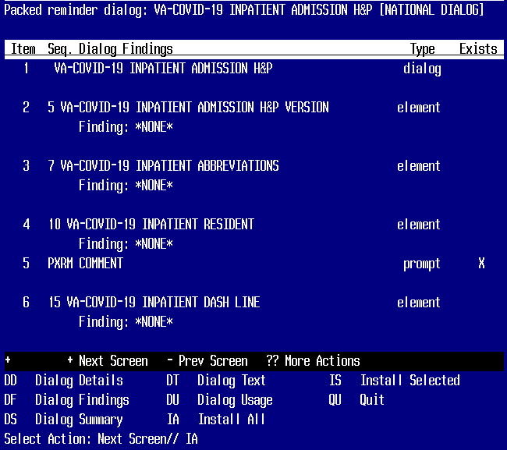
–
At the Select Action prompt, type IA to install the dialog – VA-COVID-19 INPATIENT ADMISSION H&P
Select Action: Next Screen// IA Install All
Install reminder dialog and all components with no further changes: Y// Yes
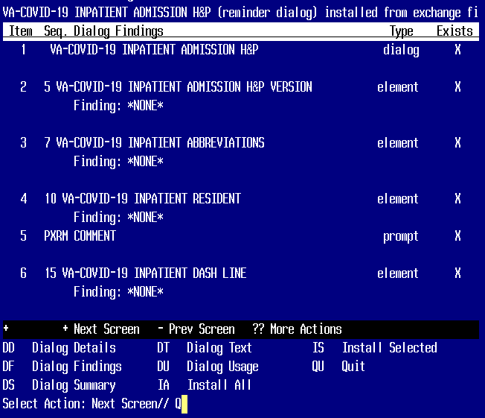

After completing this dialog install, you will type Q.

You will then be promped to install the reminder second dialog component – VA-COVID-19 INPATIENT PROVIDER

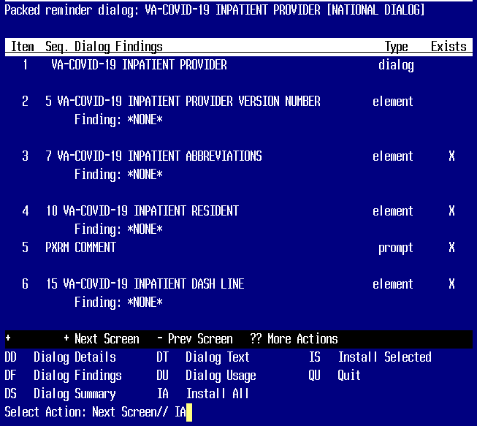
At the Select Action prompt, type IA to install the dialog – VA-COVID-19 INPATIENT PROVIDER
Select Action: Next Screen// IA Install All
Install reminder dialog and all components with no further changes: Y// Yes

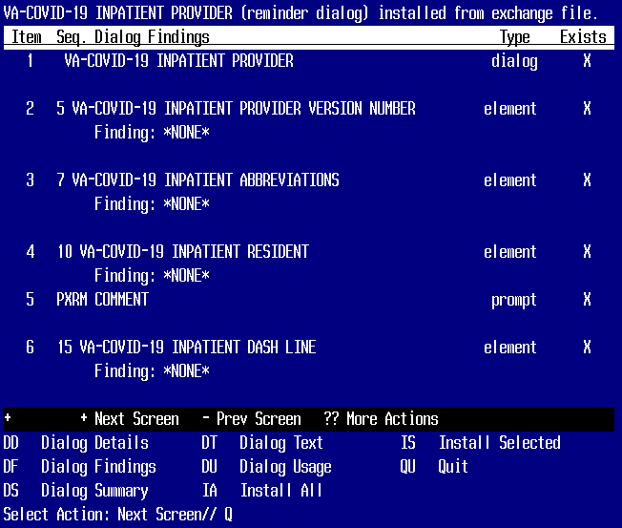
After completing this dialog install, you will type Q.

You will then be brought back to this screen where you will type Q for quit

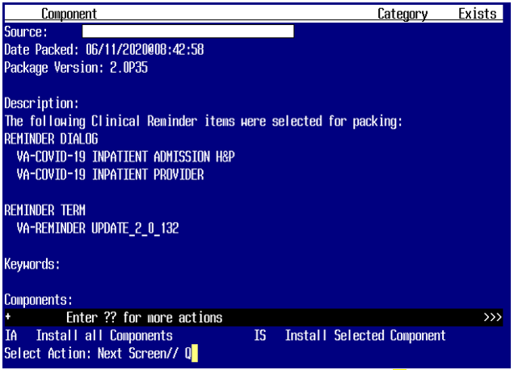
You will then be returned to this screen. At the Select Action prompt, type Q.

Install complete.

Post Installation

- For reminder dialog VA-COVID-19 INPATIENT PROVIDER, you will need make some insertions:
  - Dialog element VAL-COVID-19 INPATIENT MEDICATIONS will need to have your object for active medications added
  - Dialog element VAL-COVID-19 INPATIENT LABS will need to have your lab objects for CBC, BMP, LFT, Troponin, BNP, PT/PTT/INR, D-dimer, Pro-calcitonin, CRP, LDH, Ferritin, CPK, Arterial blood gas
  - Dialog element VAL-COVID-19 INPATIENT CONSULTANT CONTACT INFO will need to have your local information placed for consultant contacts for Pulmonary/Critical Care, Nephrology, Palliative Care and Infectious Disease
  - Dialog Element VAL-COVID-19 INPATIENT MEDICATIONS PN will need to have your object for active medications added into the Alternate Progress Note Text
- For reminder dialog VA-COVID-19 INPATIENT ADMISSION H&P, you will need to make some insertions:
  - Dialog element VAL-COVID-19 INPATIENT CONSULTANT CONTACT INFO ADMIT, will need to have your local information placed for consultant contacts for Pulmonary/Critical Care, Nephrology, Palliative Care and Infectious Disease
  - Dialog element VAL-COVID-19 DISPLAY ONLY will need to have your local objects for PROBLEM LIST, MEDICATIONS and ALLERGIES added
  - Dialog element VAL-COVID-19 INPATIENT IMAGES will need to have your local object for chest X-ray added
  - Dialog Element VAL-COVID-19 INPATIENT VIEW ALLERGIES will need to have your object for patient allergies added to the Progress Note Text
  - Dialog Element VAL-COVID-19 INPATIENT PROBLEM LIST will need to have your object for Problem List added to Progress Note Text
  - Dialog Element VAL-COVID-19 INPATIENT ACTIVE OUTPATIENT MEDS will need to have your local object for Active Medications added into the Dialog Text.

- Make the Dialog able to be attached to a Personal/Shared template or to a progress note title.

From the Reminders Manager Menu:
Select Reminder Managers Menu Option: CP CPRS Reminder Configuration
CA Add/Edit Reminder Categories
CL CPRS Lookup Categories
CS CPRS Cover Sheet Reminder List
MH Mental Health Dialogs Active
PN Progress Note Headers
RA Reminder GUI Resolution Active
TIU TIU Template Reminder Dialog Parameter
DL Default Outside Location
PT Position Reminder Text at Cursor
Select CPRS Reminder Configuration Option: TIU TIU Template Reminder Dialog Parameter
Reminder Dialogs allowed as Templates may be set for the following:
1 User USR [choose from NEW PERSON]
3 Service SRV [choose from SERVICE/SECTION]
4 Division DIV [choose from INSTITUTION]
5 System SYS [NATREM.FO-SLC.MED.VA.GOV]
Enter selection: 5 Choose the appropriate number for your site. Your site may do this by System or other levels. The example below uses SYSTEM level

Setting Reminder Dialogs allowed as Templates for System:
Select Display Sequence: ?

148 VA-VETERANS CHOICE NOTE
149 VA-TBI SCREENING
When you type a question mark above, you will see the list of #’s (with dialogs) that are already taken. Choose a number NOT on this list. For this example, looking above I see the number 150 is not present, so I will use 150.
Select Display Sequence: 150
Are you adding 150 as a new Display Sequence? Yes// Y YES
Display Sequence: 150// <Enter> 150
Clinical Reminder Dialog: VA-COVID-19 INPATIENT ADMISSION H&P
then <enter> reminder dialog NATIONAL
OK? Yes// <Enter> (Yes)

Repeat this process for Clinical Reminder Dialog VA-COVID-19 INPATIENT PROVIDER

- Setup of Note title/ Associate the reminder dialog with the note title or shared template in CPRS
You will need to create two new note titles for these templates. The note titles needed are:
COVID-19 ADMISSION H&P NOTE
COVID-19 INPATIENT PROGRESS NOTE
The note title should be mapped to the following VHA Enterprise Standard Title:
INFECTIOUS DISEASE INPATIENT NOTE

Note: Comprehensive information on Creating Document Definitions can be found beginning on page 47 of the TIU/ASU Implementation Guide

- Associate the new reminder dialogs with the note titles in CPRS
To do this, go to Template Editor, then Document Titles, select the appropriate folder (if applicable), and choose New Template (top right-hand corner).

Type in the following information:
Name: COVID-19 ADMISSION H&P NOTE
Template Type: Reminder Dialog
Reminder Dialog: VA-COVID-19 INPATIENT ADMISSION H&P

Next, type in the Associated Title, which in this case is COVID-19 ADMISSION H&P NOTE and hit Apply.

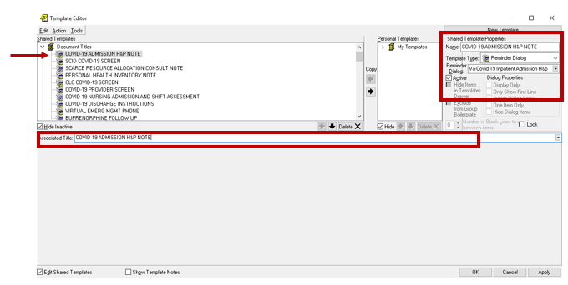

- Associate the new reminder dialogs with the note titles in CPRS
To do this, go to Template Editor, then Document Titles, select the appropriate folder (if applicable), and choose New Template (top right-hand corner).

Type in the following information:
Name: COVID-19 INPATIENT PROVIDER
Template Type: Reminder Dialog
Reminder Dialog: VA-COVID-19 INPATIENT PROVIDER

Next, type in the Associated Title, which in this case is COVID-19 INPATIENT PROGRESS NOTE and hit Apply.

