Update _2_0_139

Clinical Reminders

VA-COVID-19 TEMPLATE UPDATES
Install Guide

May 2020

Product Development
Office of Information Technology
Department of Veterans Affairs

Table of Contents
Introduction 1
Pre-Install 4
Install Details 5
Install Example 5
Post Installation 12

Introduction

DESCRIPTION:

Based on feedback from the field, input from subject matter experts, and correlation with current CDC guidelines this update contains changes to the following COVID-19 reminder dialogs:
VA-COVID-19 TELEPHONE FOLLOW-UP
VA-COVID-19 PROVIDER FOLLOW-UP
VA-COVID-19 DISCHARGE INSTRUCTIONS
VA-COVID-19 SCI COVID SCREEN MND

UPDATE_2_0_139 contains 1 Reminder Exchange entry:
UPDATE_2_0_139 VA-COVID-19 TEMPLATE UPDATES

The exchange file contains the following components:
TIU TEMPLATE FIELD
HYPERLINK COVID-19 PREVENT SPREAD
HYPERLINK COVID-19 PATIENT EDU
HYPERLINK COVID-19 CARE AT HOME
HYPERLINK COVID-19 DISP NONHOSP PT
HYPERLINK COVID-19 HOW TO PROTECT SELF
VA-COVID TEST RESULTS PHONE INFORMATION
WORD PROC 70X5
VA-CDC ENDING ISOLATION
VA-CDC IF YOU ARE SICK
VA-WORD
ADDITIONAL INFO (DISP ONLY)
VA-PPE TYPE
TEXT (1-10 CHAR) REQ
VA-COVID 19 CDC SYMPTOMS
VA-COVID SYMPTOM TEXT
OTHER NON-VA
OTHER TEXT

HEALTH FACTORS
VA-REMINDER UPDATES
VA-UPDATE_2_0_139
VA-SCI/D PQD
VA-SCI/D PQD-MOTOR NEURON DISORDER
VA-COVID-19
VA-COVID-19 DC SUSPECTED FALSE NEGATIVE
VA-COVID-19 DC TEST POSITIVE
VA-COVID-19 DC TEST NEGATIVE
VA-COVID-19 DC TEST PENDING RESULTS
VA-COVID-19 DC NOT SUSPECTED, NO TEST
VA-COVID-19 DC NOT SUSPECTED
VA-HOME MONITORING BLOOD PRESSURE
VA-HOME MONITORING PULSE OX
VA-HOME MONITORING TEMP
VA-COVID-19 FOLLOW UP PC
VA-COVID-19 PLAN OTHER FOLLOW UP
VA-COVID-19 PLAN SECURE MESSAGE
VA-COVID-19 PLAN ANNIE AP FOLLOW UP
VA-COVID-19 PLAN CONTINUE CALLS
VA-COVID-19 PLAN PROVIDE PREVENTION INFO
VA-COVID-19 PLAN CONTACT VA NURSE LINE
VA-COVID-19 PATIENT WORSENING
VA-COVID-19 REFER RELEASE ISOLATION ST
VA-COVID-19 PATIENT STABLE
VA-COVID-19 MED HX IMMUNOCOMPROMISED
VA-COVID-19 STABLE RELEASE ISOLATION
VA-COVID-19 REFER RELEASE ISOLATION IM
VA-COVID-19 PATIENT IMPROVING
VA-COVID-19 IMPROVE RELEASE ISOLATION
VA-COVID-19 UNABLE TO CARE FOR SELF HOME
VA-COVID-19 CAN CARE FOR SELF AT HOME
VA-TRAVEL SCREEN [C]
VA-TRAVEL DIARRHEA NO
VA-TRAVEL DIARRHEA YES
VA-TRAVEL FLU NO
VA-TRAVEL FLU YES
VA-TRAVEL COUGH NO
VA-TRAVEL COUGH YES
VA-TRAVEL FEVER NO
VA-TRAVEL FEVER YES
VA-COVID-19 OUTSIDE PCR SPEC COLLECTED
VA-COVID-19 PCR LAB OUTSIDE NEGATIVE
VA-COVID-19 PCR LAB OUTSIDE POSITIVE
VA-COVID-19 UNABLE TO LEAVE MESSAGE
VA-COVID-19 UNABLE TO REACH PATIENT
VA-COVID-19 TRANSPORTATION NEVER
VA-COVID-19 TRANSPORTATION WEEKLY
VA-COVID-19 TRANSPORTATION 2-3/WEEK
VA-COVID-19 TRANSPORTATION DAILY
VA-COVID-19 LEFT HOUSE NEVER
VA-COVID-19 LEFT HOUSE WEEKLY
VA-COVID-19 LEFT HOUSE 2-3/WEEK
VA-COVID-19 LEFT HOUSE DAILY
VA-COVID-19 RESIDENTIAL LIVING
VA-COVID-19 HOUSEHOLD CONTACT
VA-COVID-19 HEALTH CARE WORKER
VA-COVID-19 PLAN ADMISSION
VA-COVID-19 PLAN TRANSFER
VA-COVID-19 PLAN REMAIN HOME
VA-COVID-19 PLAN DISCHARGE HOME
VA-COVID-19 PLAN REFERRAL
VA-COVID-19 SUSPECTED SEVERE
VA-COVID-19 SUSPECTED MILD
VA-COVID-19 SUSPECTED MODERATE
VA-COVID-19 SUSPECTED
VA-COVID-19 SCREENED LOW SUSPICION
VA-COVID-19 FE COUGH DURING INTERVIEW
VA-COVID-19 FE LOOKS ILL
VA COVID-19 FE NO RESPIRATORY DIFFICULTY
VA-COVID-19 FE CYANOSIS
VA-COVID-19 FE ACCESSORY MUSC RESP
VA-COVID-19 FE RESP DISTRESS
VA-COVID-19 FE ALERT
VA-COVID-19 ROS OTHER
VA-COVID-19 ROS GI
VA-COVID-19 ROS CV
VA-COVID-19 ROS RESP
VA-COVID-19 ROS ENT
VA-COVID-19 ROS GENERAL
VA-COVID-19 MED HX HOMELESSNESS
VA-COVID-19 MED HX OBESITY
VA-COVID-19 MED HX BREASTFEEDING
VA-COVID-19 MED HX OTHER
VA-COVID-19 MED HX CANCER
VA-COVID-19 MED HX HTN
VA-COVID-19 MED HX PREGNANCY
VA-COVID-19 MED HX LIVER DISEASE
VA-COVID-19 MED HX ESRD
VA-COVID-19 MED HX DIABETES
VA-COVID-19 MED HX HEART DISEASE
VA-COVID-19 MED HX LUNG DISEASE
VA-COVID-19 MED HX AGE
VA-COVID-19 VISIT TYPE PHONE
VA-COVID-19 VISIT TYPE F2F

REMINDER TAXONOMY
VA-IMMUNOCOMPROMISED

REMINDER TERM
VA-REMINDER UPDATE_2_0_139
VA-BL IMMUNOCOMPROMISED
VA-SEX MALE
REMINDER DIALOG
VA-COVID-19 SCI COVID SCREEN MND
VA-COVID-19 DISCHARGE INSTRUCTIONS
VA-COVID-19 TELEPHONE FOLLOW-UP
VA-COVID-19 PROVIDER FOLLOW-UP

HEALTH SUMMARY TYPE
COVID19 LAB RESULTS

HEALTH SUMMARY OBJECTS
COVID19 LAB RESULTS (TIU)

TIU DOCUMENT DEFINITION
COVID19 LAB RESULTS

Pre-Install
Using the Vista menu Reminder Dialog Manager, Reminder Dialog, change your view to GROUP and choose inquire/print for the following reminder dialog groups:
VAL-COVID-19 PREVENTION LOCAL INFORMATION,
VAL-COVID-19 POSITIVE LOCAL INFORMATION,
VAL-COVID 19 RESULTS NEGATIVE LOCAL INFORMATION
VAL-COVID-19 PENDING LOCAL INFORMATION
VAL-GP COVID ASSESSMENT LAB TESTS
VAL-GP COVID ASSESSMENT COVID MILD
VAL-GP COVID ASSESSMENT ESC OF CARE F2F NON ED
VAL-GP COVID ASSESSMENT ESC OF CARE VIRTUAL
VA-GP COVID ASSESSMENT ESC OF CARE F2F NON ED URGENT
VA-GP COVID ASSESSMENT ESC OF CARE VIRTUAL URGENT
VAL-COVID PLAN REFERRAL
VAL-COVID PLAN TRANSFER
VAL-COVID PLAN ADMISSION
VAL-GP COVID-19 FOLLOW UP CALL
VAL-GP COVID-19 FOLLOW-UP PLAN EDUCATION

Change your view to Elements
VAL-COVID-19 FOLLOW-UP PLAN ED NURSE HOTLINE
VAL-COVID-19 FOLLOW-UP PLAN ANNIE
VAL-COVID-19 DIRECTIONS TO PACT
VAL-TH VVC TELEPHONE TRIAGE CONTACT PHONE OBJECT
VAL-COVID PATIENT INFORMATION
VAL-TH VVC TELEPHONE TRIAGE PATIENT LOCATION HOME
VAL-COVID ALLERGY AND MEDICATIONS
VAL-COVID FOCUSED EXAM TEMP
VAL-COVID PLAN DISCHARGE HOME FOLLOW UP

Save this info for the post install, it will make adding information back post -install easier if your site has made local edits. Not all sites will have made local edits to these dialog groups.
If you have made significant local edits to these dialog groups, you can also create a local dialog group that contains each of these items as sequences in that group and then create a reminder exchange file to back this group up. After installing, you can install that exchange file after installation of this update. Embedded below are instructions to do this.

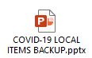

***If you create a local dialog group for backup of these components, do not include the group VAL-GP COVID ASSESSMENT LAB TESTS, for this group, you will need to inquire and save this specific group pre-install and re-do any local changes post install. ***

Install Details

This update is being distributed as a mailman message. you will have a vista mail message with subject of UPDATE 139.

Installation:
=============
This update can be loaded with users on the system. Installation will take less than 30 minutes.

Install Example
To load the mailman message. Navigate to reminder exchange in Vista, choose load mailman message, you should load the mailman message labeled UPDATE 139.
You should see a message at the top of your screen that the file successfully loaded.

Search and locate an entry titled UPDATE_2_0_139 VA-COVID-19 TEMPLATE UPDATES in reminder exchange.
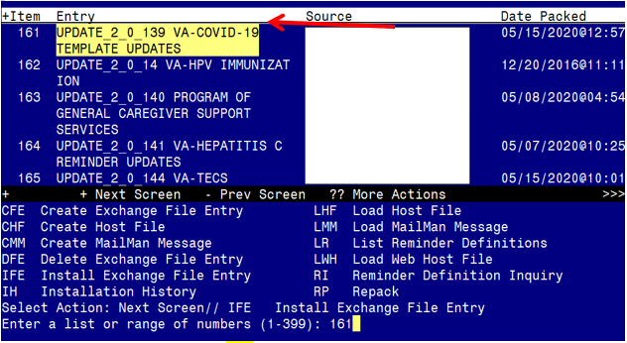
At the Select Action prompt, enter IFE for Install Exchange File Entry
Enter the number that corresponds with your entry UPDATE_2_0_139 VA-COVID-19 TEMPLATE UPDATES (in this example it is entry 161 it will vary by site). The date of the exchange file should be 05/15/2020.
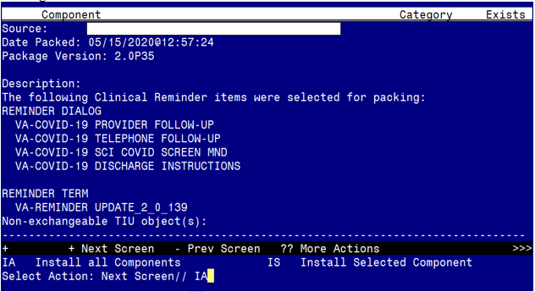
At the Select Action prompt, type IA for Install all Components and hit enter.
Select Action: Next Screen// IA Install all Components

You will see several prompts, for all new entries you will choose I to Install
For components that already exists but the packed component is different, you will choose S to Skip.
You will be promped to install the FIRST reminder dialog component – You will choose to install all even though some components may have an X to indicate that they exist.

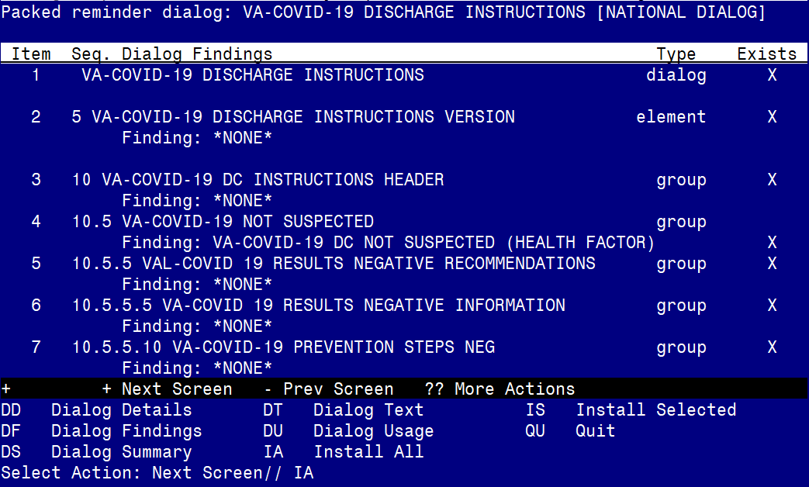

At the Select Action prompt, type IA to install the dialog – VA-COVID-19 DISCHARGE INSTRUCTIONS
Select Action: Next Screen// IA Install All
Install reminder dialog and all components with no further changes: Y// Yes

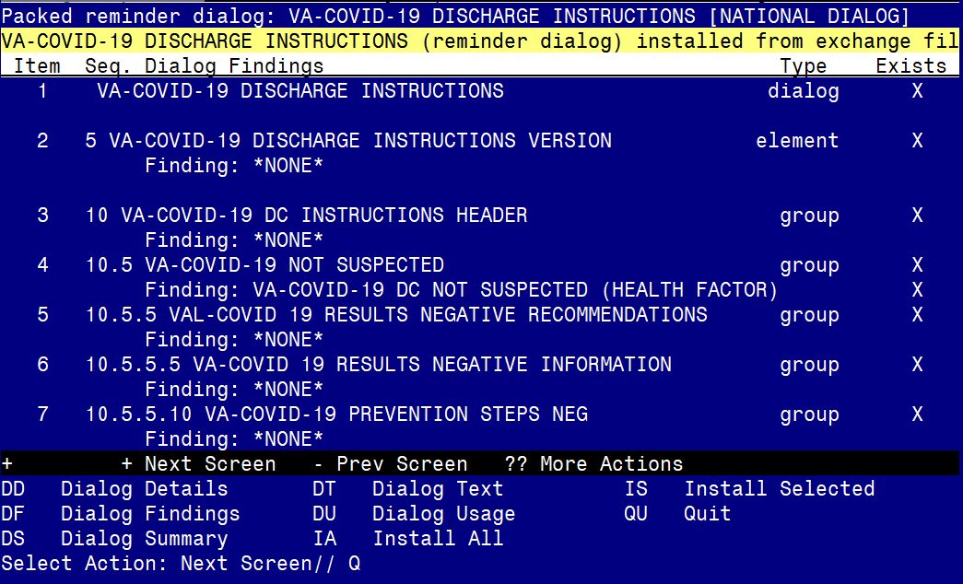

After completing this dialog install, you will type Q.

You will be promped to install the SECOND reminder dialog component – You will choose to install all even though some components may have an X to indicate that they exist.
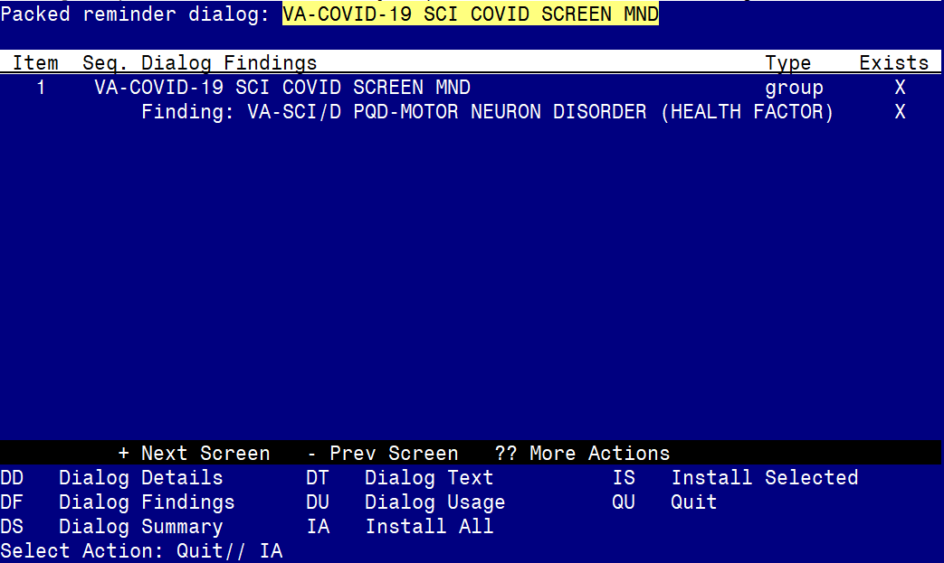

At the Select Action prompt, type IA to install the dialog – VA-COVID-19 SCI COVID SCREEN MND
Select Action: Next Screen// IA Install All
Install reminder dialog and all components with no further changes: Y// Yes
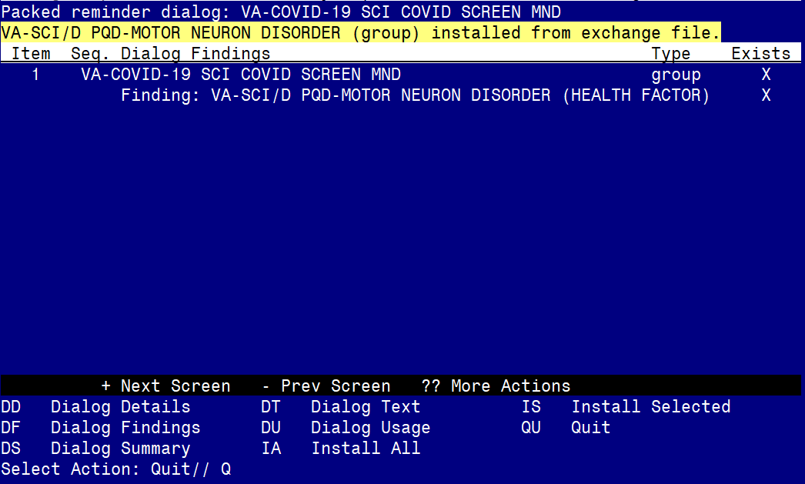

After completing this dialog install, you will type Q.
You will be promped to install the THIRD reminder dialog component – You will choose to install all even though some components may have an X to indicate that they exist.
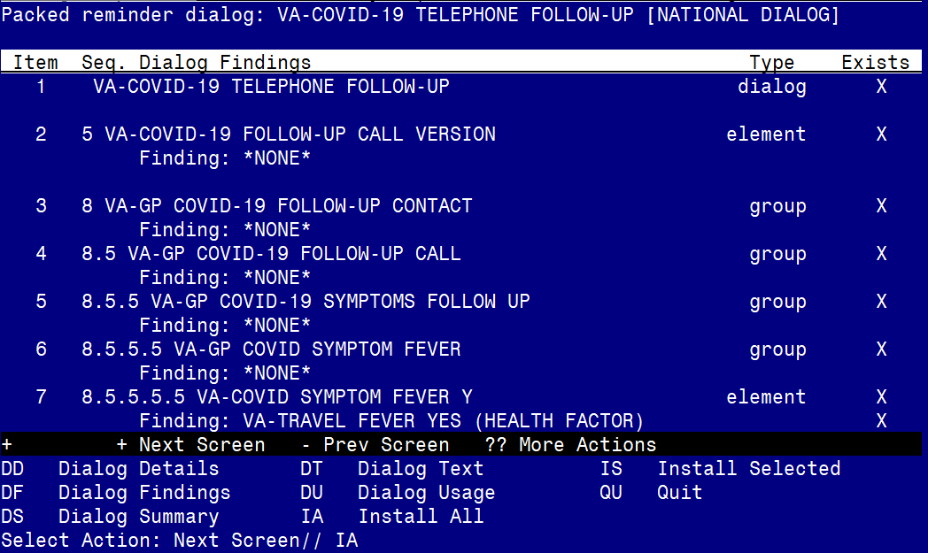

At the Select Action prompt, type IA to install the dialog – VA-COVID-19 TELEPHONE FOLLOW-UP
Select Action: Next Screen// IA Install All
Install reminder dialog and all components with no further changes: Y// Yes

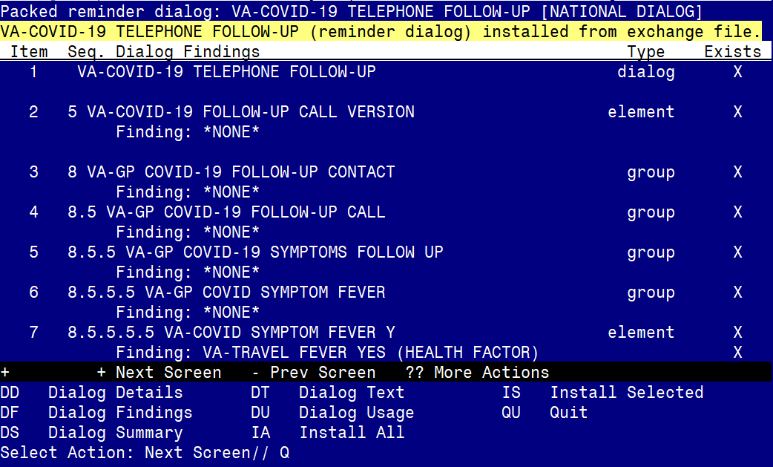

After completing this dialog install, you will type Q.
You will be promped to install the LAST reminder dialog component – You will choose to install all even though some components may have an X to indicate that they exist.
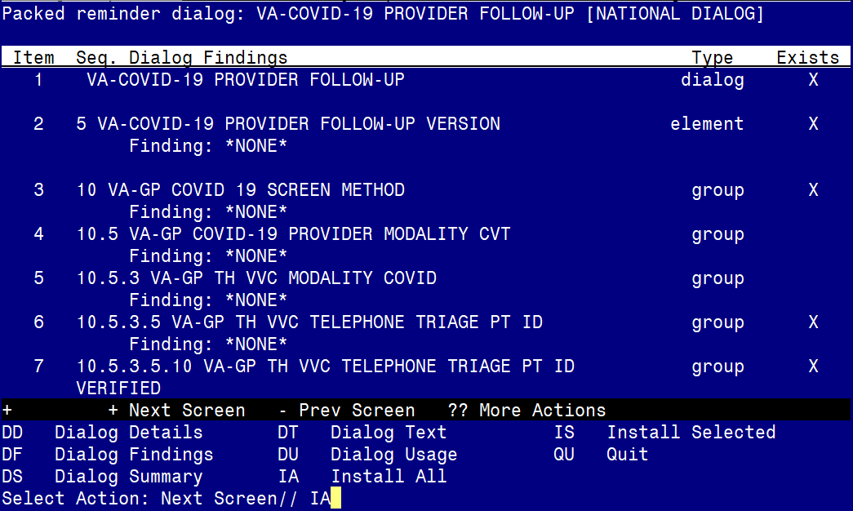

At the Select Action prompt, type IA to install the dialog – VA-COVID-19 PROVIDER FOLLOW-UP
Select Action: Next Screen// IA Install All
Install reminder dialog and all components with no further changes: Y// Yes

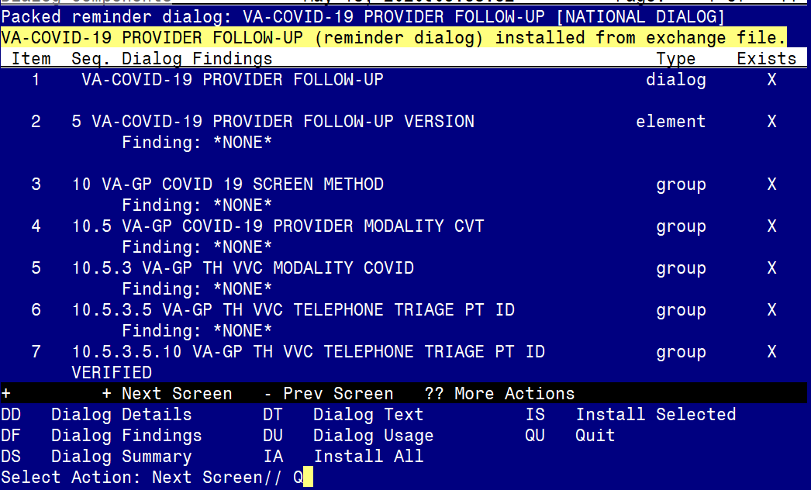

After completing this dialog install, you will type Q.

You will then be prompted to install the health summary components.
You will see several prompts, for all new entries you will choose I to Install
For components that already exists but the packed component is different, you will choose S to Skip.

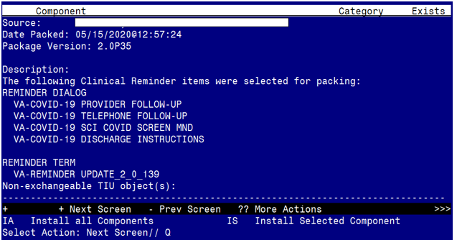
You will then be returned to this screen. At the Select Action prompt, type Q.

Install complete.

Post Installation

- Open the COVID-19 Telephone Follow Up Template and confirm the version is 2.2
- Open the COVID-19 Discharge Template and confirm the version is 2.2
- Open the COVID-19 Provider Screen Template and confirm the version is 2.2
- Add local content to reminder dialog groups and elements if needed. (Optional)
Review the pre-install for these items and edit to make any local changes. If you had made changes to the below items before, you will need to re-do any local modifications to the following groups. If you made a backup of these prior to installation, you can install selected the reminder dialog group from your backup file and this will restore your local changes to the following items:

Groups:
VAL-COVID-19 PREVENTION LOCAL INFORMATION,
VAL-COVID-19 POSITIVE LOCAL INFORMATION,
VAL-COVID 19 RESULTS NEGATIVE LOCAL INFORMATION
VAL-COVID-19 PENDING LOCAL INFORMATION
VAL-GP COVID ASSESSMENT COVID MILD
VAL-GP COVID ASSESSMENT ESC OF CARE F2F NON ED
VAL-GP COVID ASSESSMENT ESC OF CARE VIRTUAL
VA-GP COVID ASSESSMENT ESC OF CARE F2F NON ED URGENT
VA-GP COVID ASSESSMENT ESC OF CARE VIRTUAL URGENT
VAL-COVID PLAN REFERRAL
VAL-COVID PLAN TRANSFER
VAL-COVID PLAN ADMISSION
VAL-GP COVID-19 FOLLOW UP CALL
VAL-GP COVID-19 FOLLOW-UP PLAN EDUCATION
Change your view to Elements
VAL-COVID-19 FOLLOW-UP PLAN ED NURSE HOTLINE
VAL-COVID-19 FOLLOW-UP PLAN ANNIE
VAL-COVID-19 DIRECTIONS TO PACT
VAL-TH VVC TELEPHONE TRIAGE CONTACT PHONE OBJECT
VAL-COVID PATIENT INFORMATION
VAL-TH VVC TELEPHONE TRIAGE PATIENT LOCATION HOME
VAL-COVID ALLERGY AND MEDICATIONS
VAL-COVID FOCUSED EXAM TEMP
VAL-COVID PLAN DISCHARGE HOME FOLLOW UP

For this dialog group VAL-GP COVID ASSESSMENT LAB TESTS
Review your pre-install inquiry and re-do any local modifications.

In the plan section for the positive test results, there is a new group VAL-GP COVID-19 FOLLOW-UP PLAN EDUCATION POS. If you added local content to this group: VAL-GP COVID-19 FOLLOW-UP PLAN EDUCATION, you will also need to add the same local content to this new dialog group.

