Update _2_0_141

Clinical Reminders

VA-Hepatitis C Reminder Updates
Install Guide

May 2020

Product Development
Office of Information Technology
Department of Veterans Affairs

Table of Contents
Introduction 1
Pre-Install 3
Install Details 3
Install Example 3
Post Installation 7

Introduction

DESCRIPTION:

VA recommends a Hepatitis C virus (HCV) testing for all patients ages 18-79 and anyone at risk for infection, including patients born between 1945-1965.

The update in this release changes the testing reminder to include all patients ages 18-79 even if no risk is identified. Patients ages 80 and older are included if they have an identified risk or if serology was done without a viral load (testing is incomplete).

Since screening for risk is no longer part of the decision making when considering whether a person should have an initial screening serology done, the VA-HEPATITIS C RISK SCREEN reminder is being inactivated.

UPDATE_2_0_141 contains 1 Reminder Exchange entry:
UPDATE_2_0_141 VA-Hepatitis C Reminder Updates

The exchange file contains the following components:
TIU TEMPLATE FIELD
BLANK SPACE1
VA-HEP C NCP GUIDANCE STATEMENT

HEALTH FACTORS
VA-REMINDER UPDATES
VA-UPDATE_2_0_141
HEPATITIS C
PREVIOUS NEGATIVE HCV RNA
PREVIOUS POSITIVE HCV RNA
DECLINED HEP C TESTING
HEP C TESTING DEFERRED
HEP C TESTING NOT INDICATED
REMINDER FACTORS
LIFE EXPECTANCY < 6 MONTHS
PREVIOUS POSITIVE ANTI-HCV
PREVIOUS NEGATIVE ANTI-HCV
PREV NEGATIVE TEST FOR HEP C
PREV POSITIVE TEST FOR HEP C
HEP C RISK
HCV RISK: INCARCERATION
HCV RISK: BORN TO HCV+ MOTHER
HCV RISK: HX OF ALCOHOL HEP/ABUSE/DEPEND
HCV RISK: UNEXPL LIVER DZ/ABN LIVER FX
HCV RISK: HEMOPHILIA/CLOTTING FACTOR
HCV RISK: HIV INFECTION
HCV RISK: SEXUAL HCV EXPOSURE
HCV RISK: 20/> LIFETIME SEXUAL PARTNERS
HCV RISK: INTRANASAL DRUG USER
HCV RISK: TATTOO/PIERCING
HCV RISK: NEEDLE\MUCOSAL EXPOSURE
HCV RISK: VIETNAM-ERA VETERAN
HCV RISK: HEMODIALYSIS
HCV RISK: BLOOD/ORGAN TX PRIOR TO 1992
HCV RISK: INTRAVENOUS DRUG USE
RISK FACTOR FOR HEPATITIS C
DECLINED HEP C RISK SCREEN
NO RISK FACTORS FOR HEP C

REMINDER SPONSOR
VHA ONCOLOGY
Women Veterans Health Program
National Center for Health Promotion and Disease
Prevention (NCP)
Mental Health Services
Office of Public Health and Environmental Hazards

REMINDER TAXONOMY
VA-TERMINAL CANCER PATIENTS
VA-DRUG ABUSE FOR HCV TESTING
VA-HIV INFECTION
VA-ALCOHOL ABUSE
VA-HEPATITIS C SEROPOSITIVE

REMINDER TERM
VA-REMINDER UPDATE_2_0_141
VA-HEP C VIRUS ANTIBODY POSITIVE
VA-HEP C RNA
VA-HEP C TESTING DEFERRED
VA-TERMINAL CANCER PATIENT
VA-LIFE EXPECTANCY < 6 MONTHS
VA-HEP C LAB TESTS ORDERED
VA-HEP C TESTING NOT INDICATED
VA-DECLINED HEP C TESTING
VA-HEP C OUTSIDE RESULTS
VA-RISK FACTOR FOR HEPATITIS C
VA-HEP C VIRUS ANTIBODY NEGATIVE
VA-HEPATITIS C SEROPOSITIVE
VA-DECLINED HEP C RISK SCREEN
VA-NO RISK FACTORS FOR HEP C

REMINDER DEFINITION
VA-HEPATITIS C TESTING
VA-HEPATITIS C RISK SCREEN

REMINDER DIALOG
VA-HEPATITIS C TESTING
VA-HEPATITIS C RISK SCREEN

Pre-Install

- Do a reminder inquiry for the reminder definition VA-HEPATITIS C TESTING and save this as a reference for post installation. If you follow the install guide instructions closely, no mapping should be necessary post-install.

- Check the dialog elements VA-HEP C TESTING ORDER HCV RNA and VA-HEP C TESTING ORDER ANTI-HCV for a quick order finding item for the Hep C lab tests and record those entries so it can be re-entered after installation.

Install Details

This update is being distributed as a mailman message. you will have a vista mail message with subject of UPDATE 141.

Installation:
=============
This update can be loaded with users on the system. Installation will take less than 10 minutes.

Install Example
To load the mailman message. Navigate to reminder exchange in Vista, choose load mailman message, you should load the mailman message labeled UPDATE 141.

You should see a message at the top of your screen that the file successfully loaded.

Search and locate an entry titled UPDATE_2_0_141 VA-HEPATITIS C REMINDER UPDATES in 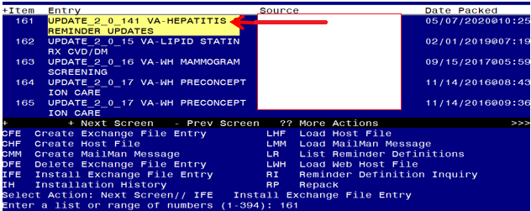 reminder exchange.

At the Select Action prompt, enter IFE for Install Exchange File Entry
Enter the number that corresponds with your entry UPDATE_2_0_141 VA-HEPATITIS C REMINDER UPDATES (in this example it is entry 161 it will vary by site). The date of the exchange file should be 05/07/2020.
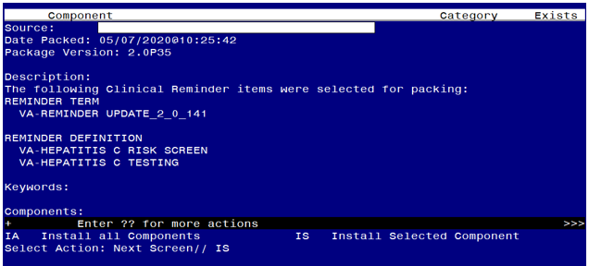

You should NOT CHOOSE TO INSTALL ALL, instead, you will install only selected components.
The components that you need to install are the following:
REMINDER DEFINITION
61 VA-HEPATITIS C TESTING X
62 VA-HEPATITIS C RISK SCREEN X
REMINDER DIALOG
63 VA-HEPATITIS C TESTING X
Review your exchange file and confirm the numbers (61-63) match the example above
At the Select Action prompt, type IS for Install SELECTED Components
Select Action: Next Screen// Select Action: Quit// IS Install Selected Component
Select Component(s): (1-64): 61-63

REMINDER DEFINITION entry named VA-HEPATITIS C TESTING already exists
but the packed component is different, what do you want to do?
Select one of the following:
C Create a new entry by copying to a new name
O Overwrite the current entry
U Update
Q Quit the install
S Skip, do not install this entry
Enter response: O// verwrite the current entry
Are you sure you want to overwrite? N// YES
REMINDER DEFINITION entry named VA-HEPATITIS C RISK SCREEN already
exists but the packed component is different, what do you want to do?
Select one of the following:
C Create a new entry by copying to a new name
O Overwrite the current entry
U Update
Q Quit the install
S Skip, do not install this entry
Enter response: O// verwrite the current entry
Are you sure you want to overwrite? N// YES

You will be promped to install the reminder dialog component – You will choose to install all even though some components may have an X to indicate that they exist.
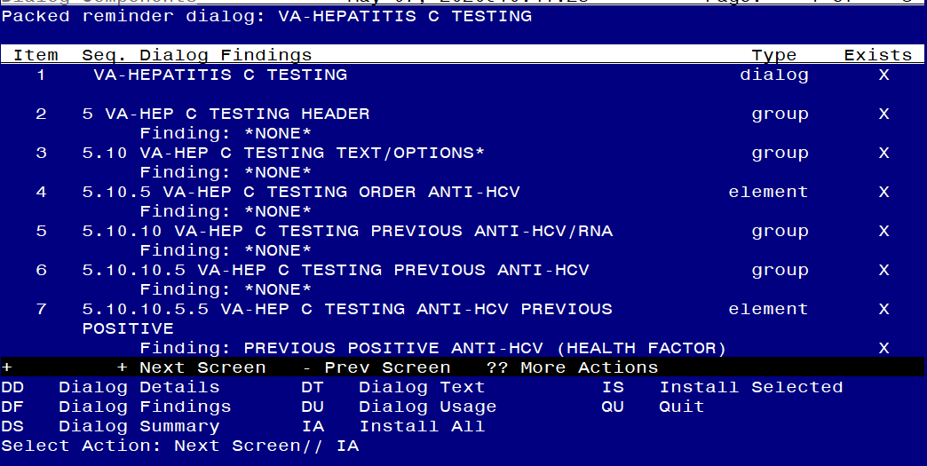
At the Select Action prompt, type IA to install the dialog – VA-HEPATITIS C TESTING Select Action: Next Screen// IA Install All
Install reminder dialog and all components with no further changes: Y// Yes

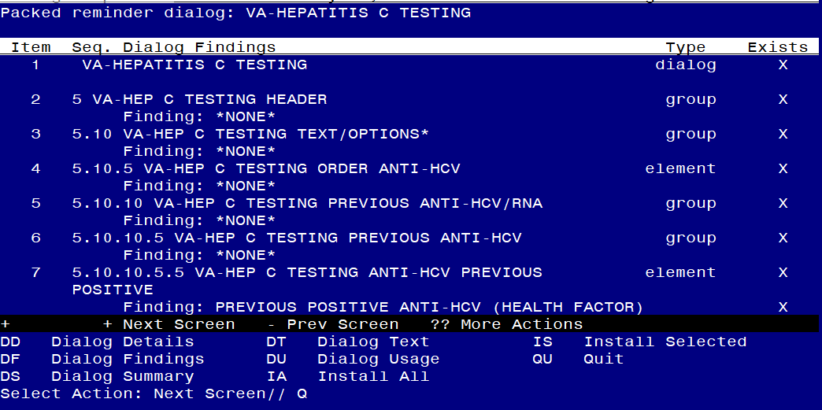

After completing this dialog install, you will type Q.

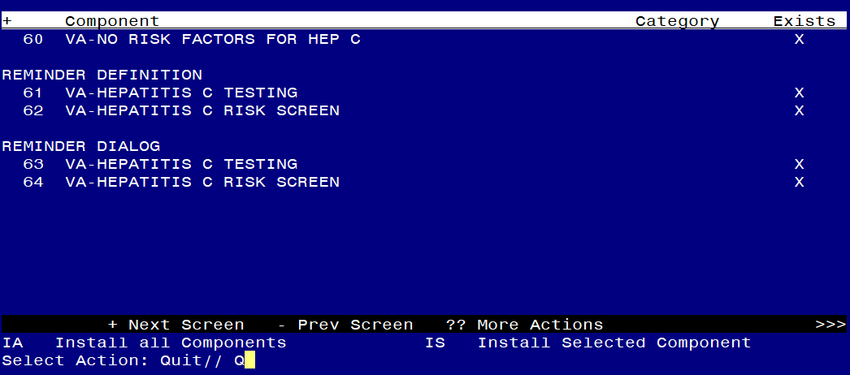
You will then be returned to this screen. At the Select Action prompt, type Q.

Install complete.

Post Installation

- Check the mapping of the reminder terms in the reminder definition VA-HEPATITIS C TESTING by comparing the reminder inquiry that was saved prior to installation with a reminder inquiry post-install. If you installed following the install guide, no mapping should be necessary.
- Review the reminder definition VA-HEPATITIS C RISK SCREEN and confirm that the definition is shows inactive and the print name starts with INACTIVE:
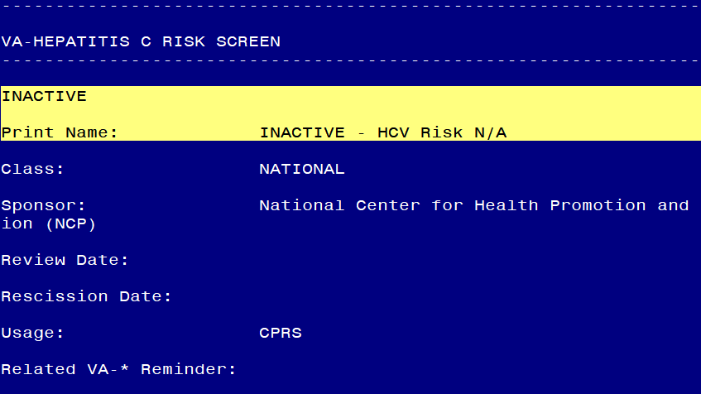

- Add the quick orders identified in the pre-install for your local Hepatitis C lab tests to dialog elements VA-HEP C TESTING ORDER ANTI-HCV and VA-HEP C TESTING ORDER HCV RNA as a finding.
- Open the reminder dialog associated with the hepatis C testing reminder and confirm that the recommendation for testing patients age 18-79 displays at the top :
