Update _2_0_143

Clinical Reminders

VA-MOVE PROGRAM TEMPLATE
Install Guide

March 2021

Product Development
Office of Information Technology
Department of Veterans Affairs

Table of Contents
Introduction 1
Install Details 5
Install Example 5
Post Installation 8

Introduction
The MOVE! Weight Management Program note template is to be used by local facility clinicians delivering the 16-session MOVE! workbook curriculum to document veteran participation in the MOVE! Program.

The template is sponsored by the National Center for Health Promotion and Disease Prevention (NCP). For questions, contact Redacted.

UPDATE_2_0_143 contains 1 Reminder Exchange entry:
UPDATE_2_0_143 VA-MOVE PROGRAM TEMPLATE

The exchange file contains the following components:

GMRV VITAL TYPE
WEIGHT

TIU TEMPLATE FIELD
IC/BLANK LINE 74 CHARACTERS T DIALOG USE
VA-MOVE GOAL STATUS
WP 1 LINE
TIME SPENT 15-90
TEXT (1-50 CHAR)
NUMBER 1-50

HEALTH FACTORS
VA-REMINDER UPDATES
VA-UPDATE_2_0_143
VA-MOVE WEIGHT MANAGEMENT
VA-MOVE SESSION MAINTAIN-GOAL SETTING
VA-MOVE SESSION MAINTAIN-TOOLKIT
VA-MOVE SESSION MAINTAIN-OTHER
VA-MOVE SESSION MAINTAIN-MOTIVATED
VA-MOVE SESSION MAINTAIN-BODY IMAGE
VA-MOVE SESSION MAINTAIN-WEIGHT
VA-MOVE SESSION-MAINTAIN PROGRESS
VA-MOVE SESSION FINE TUNE-MEDS
VA-MOVE SESSION FINE TUNE-MOTIVATION
VA-MOVE SESSION FINE TUNE-OTHER
VA-MOVE SESSION FINE TUNE-CHR COND
VA-MOVE SESSION FINE TUNE-FINE TUNE
VA-MOVE SESSION FINE TUNE-HOW ACTIVE
VA-MOVE SESSION-FINE TUNE ACTIVITY
VA-MOVE SESSION STRESS-SUPPORT
VA-MOVE SESSION STRESS-TECHNIQUES
VA-MOVE SESSION STRESS-OTHER
VA-MOVE SESSION STRESS-MINDFULNESS
VA-MOVE SESSION STRESS-TRACKING
VA-MOVE SESSION STRESS-MANAGE
VA-MOVE SESSION-STRESS
VA-MOVE SESSION DINING OUT-SOCIAL EATING
VA-MOVE SESSION DINING OUT-TAKEOUT
VA-MOVE SESSION DINING OUT-OTHER
VA-MOVE SESSION DINING OUT-FAST FOOD
VA-MOVE SESSION DINING OUT-RESTAURANT
VA-MOVE SESSION DINING OUT-PLAN
VA-MOVE SESSION-DINING OUT
VA-MOVE SESSION SLIPS-OTHER
VA-MOVE SESSION SLIPS-RELAPSE
VA-MOVE SESSION SLIPS-PLAN
VA-MOVE SESSION SLIPS-HANDLE SLIPS
VA-MOVE SESSION SLIPS-RECOGNIZE
VA-MOVE SESSION-SLIPS
VA-MOVE SESSION FOOD-FAD DIETS
VA-MOVE SESSION FOOD-SUBSTITUTIONS
VA-MOVE SESSION FOOD-OTHER
VA-MOVE SESSION FOOD-FAT
VA-MOVE SESSION FOOD-PROTEIN
VA-MOVE SESSION FOOD-CARBS
VA-MOVE SESSION-FOOD FINESSE
VA-MOVE SESSION TRIGGERS-BUST TRIGGERS
VA-MOVE SESSION TRIGGERS-ENVIRONMENT
VA-MOVE SESSION TRIGGERS-OTHER
VA-MOVE SESSION TRIGGERS-CRAVINGS
VA-MOVE SESSION TRIGGERS-RESPONDING
VA-MOVE SESSION TRIGGERS-CUES
VA-MOVE SESSION-TRIGGERS/CUES
VA-MOVE SESSION INC ACTIV-ALL TOGETHER
VA-MOVE SESSION INC ACTIV-FLEXIBILITY
VA-MOVE SESSION INC ACTIV-OTHER
VA-MOVE SESSION INC ACTIV-STRENGTH
VA-MOVE SESSION INC ACTIV-CARDIO
VA-MOVE SESSION INC ACTIV-CHECK IN
VA-MOVE SESSION-PUMP UP ACTIVITY
VA-MOVE SESSION CHALLENGES-OTHER
VA-MOVE SESSION CHALLENGES-PLATEAUS
VA-MOVE SESSION CHALLENGES-PROB SOLVING
VA-MOVE SESSION CHALLENGES-COMMON
VA-MOVE SESSION-CHALLENGES
VA-MOVE SESSION PLAN-BARRIERS
VA-MOVE SESSION PLAN-COOKING HLTHY
VA-MOVE SESSION PLAN-OTHER
VA-MOVE SESSION PLAN-FOOD LABELS
VA-MOVE SESSION PLAN-SHOPPING
VA-MOVE SESSION PLAN-MEALS
VA-MOVE SESSION-PLAN/SHOP/COOK
VA-MOVE SESSION TAKE CHARGE-TRIGGERS
VA-MOVE SESSION TAKE CHARGE-OTHER
VA-MOVE SESSION TAKE CHARGE-RETHINKING
VA-MOVE SESSION TAKE CHARGE-THOUGHTS
VA-MOVE SESSION TAKE CHARGE-AWARENESS
VA-MOVE SESSION-TAKE CHARGE
VA-MOVE SESSION FITNESS-BARRIERS
VA-MOVE SESSION FITNESS-CURRENT ACTIVITY
VA-MOVE SESSION FITNESS-OTHER
VA-MOVE SESSION FITNESS-INTENSITY
VA-MOVE SESSION FITNESS-HOW ACTIVE
VA-MOVE SESSION FITNESS-PHY ACTIVITY
VA-MOVE SESSION-FIT FOR LIFE
VA-MOVE SESSION EAT WISELY-BARRIERS
VA-MOVE SESSION EAT WISELY-SIZE IT UP
VA-MOVE SESSION EAT WISELY-OTHER
VA-MOVE SESSION EAT WISELY-LIQ CALORIES
VA-MOVE SESSION EAT WISELY-FOOD GRPS
VA-MOVE SESSION EAT WISELY-HLTHY PLATE
VA-MOVE SESSION-EAT WISELY
VA-MOVE SESSION BALANCE-BURNING CALORIES
VA-MOVE SESSION BALANCE-FEWER CALORIES
VA-MOVE SESSION BALANCE-OTHER
VA-MOVE SESSION BALANCE-TARIK STORY
VA-MOVE SESSION BALANCE-CALORIE GOAL
VA-MOVE SESSION BALANCE-ENERGY
VA-MOVE SESSION-TIP THE BALANCE
VA-MOVE SESSION TRACKING-REWARDS
VA-MOVE SESSION TRACKING-BARRIERS
VA-MOVE SESSION TRACKING-OTHER
VA-MOVE SESSION TRACKING-FOOD/ACTIVITY
VA-MOVE SESSION TRACKING-SARAH STORY
VA-MOVE SESSION TRACKING-WHAT YOU DO
VA-MOVE SESSION-TRACKING
VA-MOVE SESSION WELCOME-CONFIDENCE
VA-MOVE SESSION WELCOME-GOAL SETTING
VA-MOVE SESSION WELCOME-OTHER
VA-MOVE SESSION WELCOME-BALANCE
VA-MOVE SESSION WELCOME-REASONS
VA-MOVE SESSION WELCOME-MOVE
VA-MOVE SESSION-WELCOME
VA-MOVE SESSION GOAL 2
VA-MOVE SESSION GOAL 1
VA-MOVE SMART GOAL REVIEW
VA-MOVE SESSION-MOVEMENT ACTIVITY
VA-MOVE FOOD/ACTIVITY LOG REVIEWED
VA-MOVE EDUCATION-OTHER
VA-MOVE EDUCATION-WORKBOOK
VA-MOVE DELIVERY METHOD-VIDEO
VA-MOVE DELIVERY METHOD-PHONE
VA-MOVE DELIVERY METHOD-IN PERSON
VA-MOVE STARTING WEIGHT (lbs)
VA-MOVE STARTING DATE
VA-MOVE PARTICIPATION-OTHER
VA-MOVE PARTICIPATION-PASSIVE
VA-MOVE PARTICIPATION-ACTIVE
VA-MOVE ASSESSMENT-IND
VA-MOVE ASSESSMENT-GRP

REMINDER SPONSOR
NATIONAL CENTER FOR HEALTH PROMOTION AND DISEASE PREVENTION (NCP)
OFFICE OF TELEHEALTH SERVICES STORE AND FORWARD TELEHEALTH

REMINDER TERM
VA-REMINDER UPDATE_2_0_143
VA-BL MOVE! SMART GOAL 2
VA-BL MOVE! SMART GOAL 1
VA-BL MOVE! STARTING WEIGHT
VA-BL MOVE! STARTING DATE

HEALTH SUMMARY COMPONENT
PCE HEALTH FACTORS SELECTED
VITAL SIGNS SELECTED

HEALTH SUMMARY TYPE
VA- MOVE! SMART GOAL 2
VA- MOVE! SMART GOAL 1
VA- MOVE! STARTING WEIGHT
VA- MOVE! STARTING DATE
WEIGHT-LAST 3

HEALTH SUMMARY OBJECTS
VA- MOVE! SMART GOAL 2 (TIU)
VA- MOVE! SMART GOAL 1 (TIU)
VA- MOVE! STARTING WEIGHT (TIU)
VA- MOVE! STARTING DATE (TIU)
WEIGHT-LAST 3 (TIU)

TIU DOCUMENT DEFINTION
VA- MOVE! SMART GOAL 2
VA- MOVE! SMART GOAL 1
VA- MOVE! STARTING WEIGHT
VA- MOVE! STARTING DATE
WEIGHT-LAST 3
PATIENT HEIGHT

REMINDER DIALOG
VA-MOVE! WEIGHT MANAGEMENT PROGRAM

Install Details

This update is being distributed as a web host file. The address for the host file is: https://REDACTED/UPDATE_2_0_143.PRD
The file will be installed using Reminder Exchange, programmer access is not required.

Installation:
=============
This update can be loaded with users on the system. Installation will take less than 15 minutes.

Install Example
To Load the Web Host File. Navigate to Reminder exchange in Vista

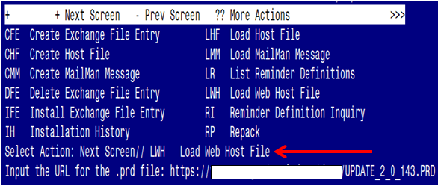

At the Select Action: prompt, enter LWH for Load Web Host File
At the Input the url for the .prd file: prompt, type the following web
address:
https:// REDACTED /UPDATE_2_0_143.PRD
You should see a message at the top of your screen that the file successfully loaded.

Search and locate an entry titled UPDATE_2_0_143 VA-MOVE PROGRAM TEMPLATE in reminder exchange.

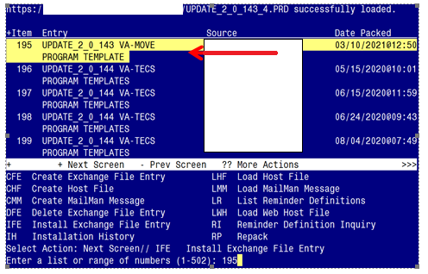

At the Select Action prompt, enter IFE for Install Exchange File Entry
Enter the number that corresponds with your entry UPDATE_2_0_143 VA-MOVE PROGRAM TEMPLATE (in this example it is entry 195. It will vary by site). The date of the exchange file should be 03/10/2021@12:50.

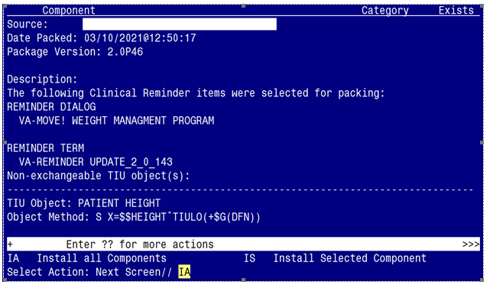

At the Select Action prompt, type IA for Install all Components and hit enter.
Select Action: Next Screen// IA Install all Components
You will see several prompts, for all new entries you will choose I to Install
For components that already exists but the packed component is different, choose S to Skip.
You will be promped to install the reminder dialog component (VA-MOVE! WEIGHT MANAGEMENT PROGRAM)

- You will choose to install all even though some components may have an X to indicate that they exist.

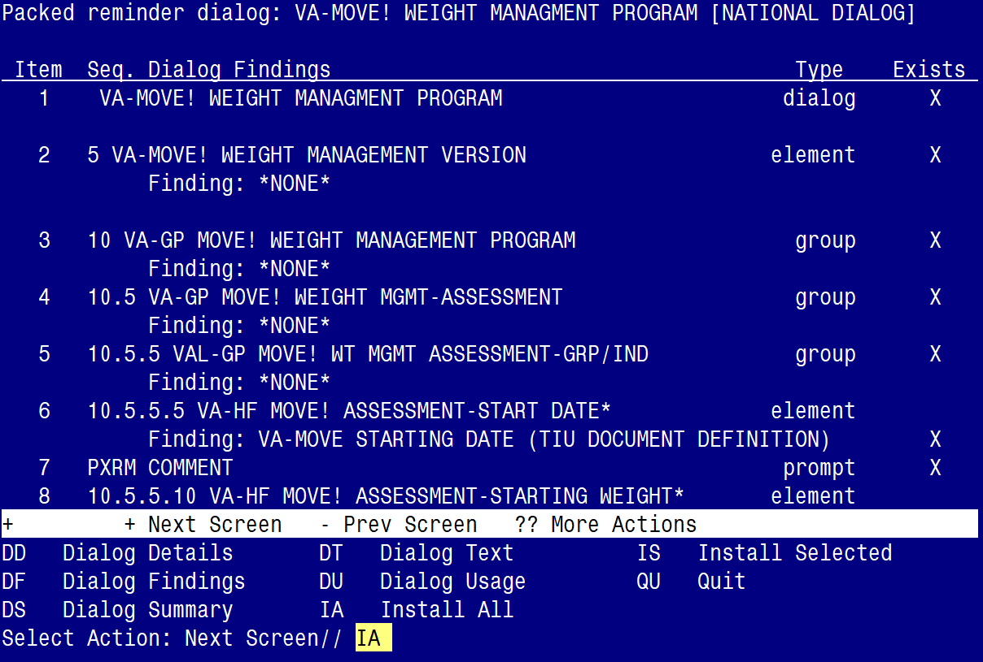

At the Select Action prompt, type IA to install the dialog – VA-MOVE! WEIGHT MANAGEMENT PROGRAM
Select Action: Next Screen// IA Install All
Install reminder dialog and all components with no further changes: Y// Yes

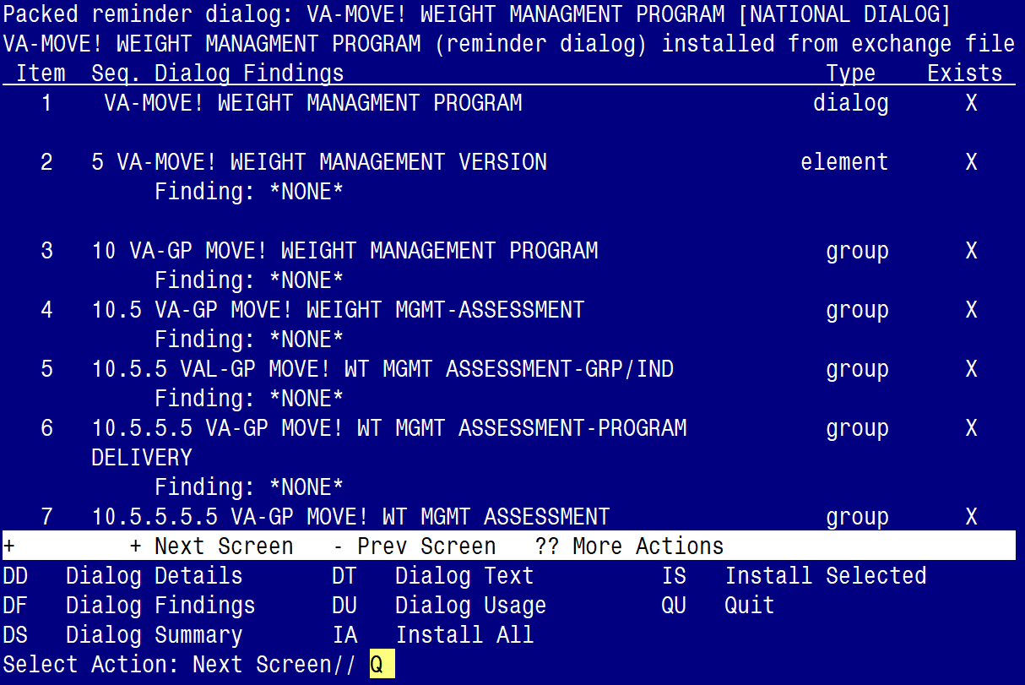

After completing this dialog install, you will type Q.
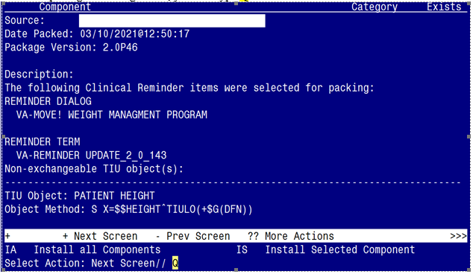

You will then be returned to this screen. At the Select Action prompt, type Q.

Install complete.

Post Installation

- Make the Dialogs able to be attached to a Personal/Shared template or to a progress note title.

From the Reminders Manager Menu:
Select Reminder Managers Menu Option: CP CPRS Reminder Configuration
CA Add/Edit Reminder Categories
CL CPRS Lookup Categories
CS CPRS Cover Sheet Reminder List
MH Mental Health Dialogs Active
PN Progress Note Headers
RA Reminder GUI Resolution Active
TIU TIU Template Reminder Dialog Parameter
DL Default Outside Location
PT Position Reminder Text at Cursor
Select CPRS Reminder Configuration Option: TIU TIU Template Reminder Dialog Parameter
Reminder Dialogs allowed as Templates may be set for the following:
1 User USR [choose from NEW PERSON]
3 Service SRV [choose from SERVICE/SECTION]
4 Division DIV [choose from INSTITUTION]
5 System SYS [NATREM.FO-SLC.MED.VA.GOV]
Enter selection: 5 Choose the appropriate number for your site. Your site may do this by System or other levels. The example below uses SYSTEM level
Setting Reminder Dialogs allowed as Templates for System:
Select Display Sequence: ?

148 VA-VETERANS CHOICE NOTE
149 VA-TBI SCREENING
When you type a question mark above, you will see the list of #’s (with dialogs) that are already taken. Choose a number NOT on this list. For this example, looking above I see the number 150 is not present, so I will use 150.
Select Display Sequence: 150
Are you adding 150 as a new Display Sequence? Yes// Y YES
Display Sequence: 150// <Enter> 150
Clinical Reminder Dialog: VA-MOVE! WEIGHT MANAGEMENT PROGRAM
then <enter> reminder dialog NATIONAL
OK? Yes// <Enter> (Yes)
- Associate the new reminder dialogs with a shared template in CPRS
To do this, go to Template Editor, then Shared Templates, select the appropriate folder (if applicable), and choose New Template (top right-hand corner).

Type in the following information:
Name: MOVE! COMPREHENSIVE LIFESTYLE INTERVENTION
Template Type: Reminder Dialog
Reminder Dialog: VA-MOVE! WEIGHT MANAGEMENT PROGRAM

Next, select Apply.

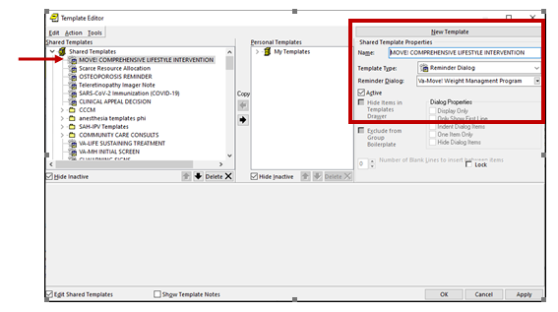

- Setup of specific Note title
The new note title that need to be created is:
MOVE! COMPREHENSIVE LIFESTYLE INTERVENTION
VHA Enterprise Standard Title: MOVE NOTE

Note: Comprehensive information on Creating Document Definitions can be found beginning on page 47 of the TIU/ASU Implementation Guide

- Associate the reminder dialog with the note title in CPRS
To do this, go to Template Editor, then Document Titles, select the appropriate folder (if applicable), and choose New Template (top right-hand corner).

- Type in the following information:
Name: MOVE! COMPREHENSIVE LIFESTYLE INTERVENTION
Template Type: Reminder Dialog
Reminder Dialog: VA-MOVE! WEIGHT MANAGEMENT PROGRAM

Next, type in the Associated Title, which in this case is MOVE! COMPREHENSIVE LIFESTYLE INTERVENTION and click APPLY.

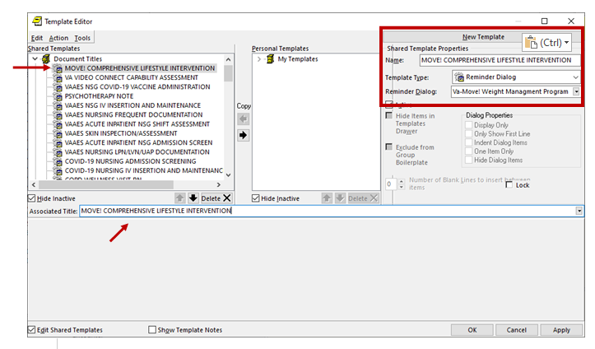

- Confirm the PATIENT HEIGHT and WEIGHT-LAST 3 objects are embedded in GROUP: VAL-GP MOVE! WT MGMT ASSESSMENT – GRP/IND.

NAME: VAL-GP MOVE! WT MGMT ASSESSMENT-GRP/IND Replace
DISABLE:
CLASS: LOCAL//

GROUP HEADER DIALOG TEXT:
BMI Assessment:\\
Height: |PATIENT HEIGHT|
\\|WEIGHT-LAST 3|
\\
Edit? NO//

- Add local dialog groups and elements, if needed – OPTIONAL

If your MOVE staff would like to insert local groups and elements from other dialogs into this template, you add them to the local reminder dialog group VAL-GP MOVE! WEIGHT PLACEHOLDER. Adding to this dialog group will place the local content at the end of the dialog template.

