Update _2_0_146

Clinical Reminders

VA-EYE CARE AT-RISK SCREEN

Install Guide

August 2020

Product Development
Office of Information Technology
Department of Veterans Affairs

Table of Contents
Introduction 1
Install Details 4
Install Example 4
Post Installation 8

Introduction

DESCRIPTION:

VA-Eye Care At-Risk Screen reminders are used for the TeleEye Screening program (formerly TeleRetinal Imaging) to identify and monitor patients known to be at risk for Diabetic Retinopathy, Macular Degeneration (AMD) and/or Glaucoma.

The Eye Care At-Risk Screen Nursing reminder is used by Primary Care nursing to request a TeleEye Screening exam or Comprehensive Eye Exam (by the Eye Clinic) for patients identified to be at-risk for Diabetic Retinopathy, Macular Degeneration (AMD) and/or Glaucoma.

The Eye Care At-Risk Screen Provider reminder is a secondary reminder that populates to the Primary Care provider when ‘Declined/Refused’ is selected on the primary Nursing reminder or if the nurse indicated that the diabetes diagnosis is not correct for the patient. This secondary reminder allows the Primary Care provider to deliver additional education and encouragement to patients known to be at-risk for these select eye conditions who refused/declined initial referral for eye care.

- Group criteria:
  - At-Risk Diabetic Retinopathy group criteria: Type I and II diabetics who have not been seen for eye assessment within the last 1-2 years. The reminder populates for patients who meet this criterion and shows a DUE NOW status indicating referral to Tele-Eye Screening (TeleRetina) is necessary. Once assessed, the reminder is processed for 1 to 2 years determined by the provider.
  - At-Risk Macular Degeneration (AMD) group criteria: must be age 60 years or older, have not been seen for eye assessment within the last 2 years (identified by query of clinical stop codes 718, 407, 408), and have at least one of the ICD9/10 codes listed in the attachment (Macular Degeneration ICD Taxonomy). The reminder populates for patients who meet this criterion and shows a DUE NOW status indicating referral to Tele-Eye Screening (TeleRetina) is necessary. Once assessed, the reminder is processed for 1 to 2 years determined by the provider.
  - At-Risk Glaucoma group criteria: must be age 60 years or older (African American ethnicity 40 years and older), have not been seen for eye assessment within the last 2 years (identified by query of clinical stop codes 718, 407, 408), and have at least one of the ICD9/10 codes listed in the attachment (Glaucoma ICD Taxonomy). The reminder populates for patients who meet this criterion and shows a DUE NOW status indicating referral to Tele-Eye Screening (TeleRetina) is necessary. Once assessed, the reminder is processed for 1 to 2 years determined by the provider.
  - Exclusions for eye screening: for all groups above (a,b,c) this reminder has logic to indicate to the viewer that patients with identified exclusions should not receive eye screening, and instead be referred for a direct in-person comprehensive eye exam.

UPDATE_2_0_146 contains 1 Reminder Exchange entry:
UPDATE_2_0_146 VA-EYE CARE AT-RISK SCREEN

The exchange file contains the following components:

HEALTH FACTORS
VA-REMINDER UPDATES
VA-UPDATE_2_0_146
INCORRECT DIAGNOSES
VA-INCORRECT DIABETES DIAGNOSIS-PROVIDER
VA-EYE CARE AT-RISK SCREEN
VA-OUTSIDE DIAB EYE UNK AT-RISK SCRN
VA-OUTSIDE DIAB EYE ABN AT-RISK SCRN
VA-OUTSIDE DIAB EYE NORMAL AT-RISK SCRN
VA-OUTSIDE EYE AT-RISK SCREEN
VA-COMP EYE EXAM SCHEDULED
VA-REFUSED PROV AT-RISK SCREEN
VA-TRI CATEGORY-DM EYE EXAM
VA-TRI EYE EXAM SCHEDULED
VA-INCORRECT DIABETES DIAGNOSIS
VA-TRI EYE EXAM FUTURE
VA-REFUSED NURS AT-RISK SCREEN
VA-TRI DM RETINOP EXAM UNABLE TO ASSESS
VA-TRR CATEGORY-DM EYE EXAM
VA-TRR DM RETINOP EXAM UNABLE TO ASSESS
VA-TRI DM RETINOP EXAM NORMAL
VA-TRR DM RETINOPATHY EXAM NORMAL
VA-TRI DM RETINOP EXAM ABNORMAL
VA-TRR DM RETINOPATHY EXAM ABNORMAL
VA-TRI MACULA EXAM UNABLE TO ASSESS
VA-TRR MACULA EXAM UNABLE TO ASSESS
VA-TRI MACULA EXAM NORMAL
VA-TRR MACULA EXAM NORMAL
VA-TRI MACULA EXAM ABNORMAL
VA-TRR MACULA EXAM ABNORMAL
VA-TELE EYE GLAUC EXAM UNABLE TO ASSESS
VA-TELE EYE GLAUCOMA EXAM NORMAL
VA-TELE EYE GLAUCOMA EXAM ABNORMAL

REMINDER SPONSOR
Office of Telehealth Services Store and Forward Telehealth
Office of Patient Care Services

REMINDER TAXONOMY
VA-DIABETES HEDIS
VA-DIABETES
VA-GLAUCOMA RISK FACTORS
VA-AMD RISK FACTORS
VA-ABNORMAL BMI
VA-CAD
TOBACCO USE CODES

REMINDER LOCATION LIST
VA-AT RISK AMD/GLAUCOMA

REMINDER TERM
VA-REMINDER UPDATE_2_0_146
VA-BL TELE EYE DIABETIC PT
VA-BL TELE EYE INCORRECT DIABETIC DX
VA-BL TELE EYE GLAUCOMA PT
VA-BL TELE EYE AMD PT
VA-AMD RISK FACTORS
TELE EYE SCREEN ORDERS
TELE EYE RETINOPATHY EXAM-UNABLE TO ASSESS
TELE EYE RETINOPATHY EXAM-NORMAL
TELE EYE RETINOPATHY EXAM-ABNORMAL
TELE EYE MACULA EXAM-UNABLE TO ASSESS
TELE EYE MACULA EXAM-NORMAL
TELE EYE MACULA EXAM-ABNORMAL
TELE EYE GLAUCOMA EXAM-UNABLE TO ASSESS
TELE EYE GLAUCOMA EXAM-NORMAL
TELE EYE GLAUCOMA EXAM-ABNORMAL
VA-OUTSIDE EYE AT-RISK SCREEN

REMINDER DEFINITION
VA-DIABETES OBJECT
VA-BL TELE-EYE SCREEN-GLAUCOMA
VA-OBJ GLAUCOMA RISK FACTORS
VA-OBJ AMD RISK FACTORS
VA-EYE CARE AT-RISK SCREEN (PROV)
VA-EYE CARE AT-RISK SCREEN (NURSE)

REMINDER DIALOG
VA-EYE CARE AT-RISK SCREEN (PROV)
VA-EYE CARE AT-RISK SCREEN (NURSING)

HEALTH SUMMARY TYPE
VA-DIABETES OBJECT
VA-GLAUCOMA RISK FACTORS
VA-AMD RISK FACTORS

HEALTH SUMMARY OBJECTS
VA-DIABETES OBJECT (TIU)
VA-GLAUCOMA RISK FACTORS (TIU)
VA-AMD RISK FACTORS (TIU)

TIU DOCUMENT DEFINITION
VA-DIABETES OBJECT
VA-GLAUCOMA RISK FACTORS
VA-AMD RISK FACTORS

Install Details

This update is being distributed as a web host file. The address for the host file is: https://Redacted /UPDATE_2_0_146.PRD

The file will be installed using Reminder Exchange, programmer access is not required.

Installation:
=============
This update can be loaded with users on the system. Installation will take less than 30 minutes.

Install Example

To Load the Web Host File. Navigate to Reminder exchange in Vista
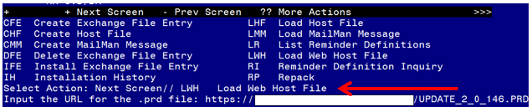

At the Select Action: prompt, enter LWH for Load Web Host File
At the Input the url for the .prd file: prompt, type the following web address:
https://Redacted /UPDATE_2_0_146.PRD

You should see a message at the top of your screen that the file loaded successfully

Search and locate an entry titled UPDATE_2_0_146 VA-EYE CARE AT-RISK SCREEN
in reminder exchange.
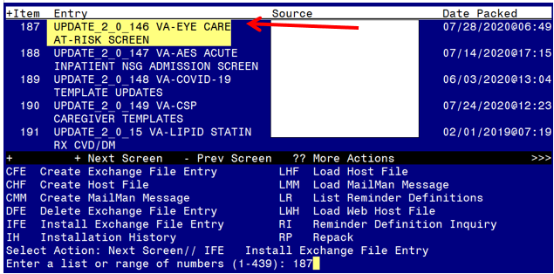

At the Select Action prompt, enter IFE for Install Exchange File Entry
Enter the number that corresponds with your entry UPDATE_2_0_146 VA-EYE CARE AT-RISK SCREEN (in this example it is entry 187 it will vary by site). The date of the exchange file should be 07/28/2020.

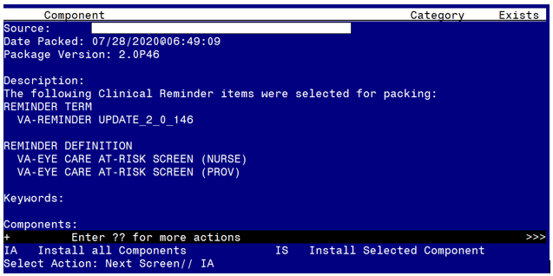

At the Select Action prompt, type IA for Install all Components and hit enter.
Select Action: Next Screen// IA Install all Components
You will see several prompts, for all new entries you will choose I to Install

For components that already exists but the packed component is different, you will choose S to Skip.

You will be promped to install the reminder first dialog component – VA-EYE CARE AT-RISK SCREEN (PROV)

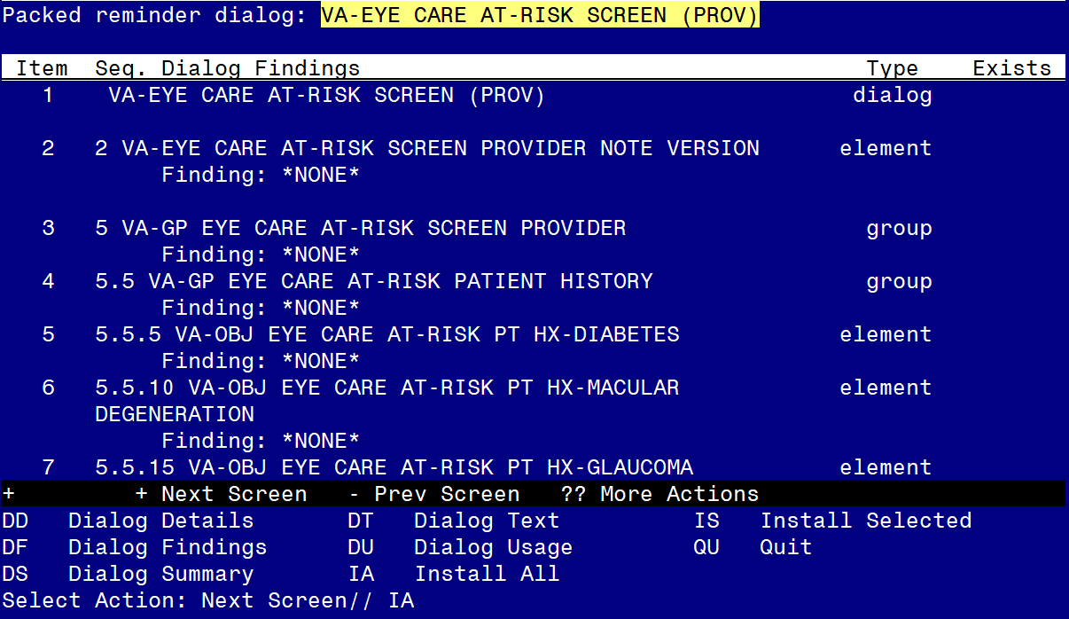

At the Select Action prompt, type IA to install the dialog – VA-EYE CARE AT-RISK SCREEN (PROV)
Select Action: Next Screen// IA Install All
Install reminder dialog and all components with no further changes: Y// Yes
At the end of the dialog install, you will see this prompt, hit enter to link the dialog to the reminder definition:
Select Reminder to Link: VA-EYE CARE AT-RISK SCREEN (PROV)//

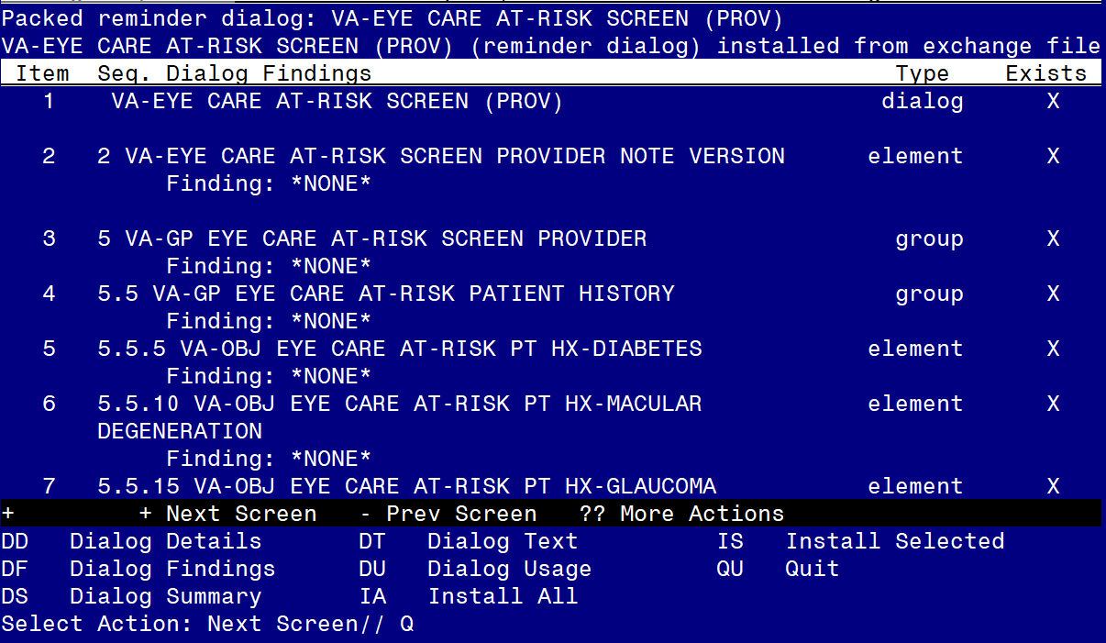

After completing this dialog install, you will type Q.
You will then be promped to install the reminder second dialog component – VA-EYE CARE AT-RISK SCREEN

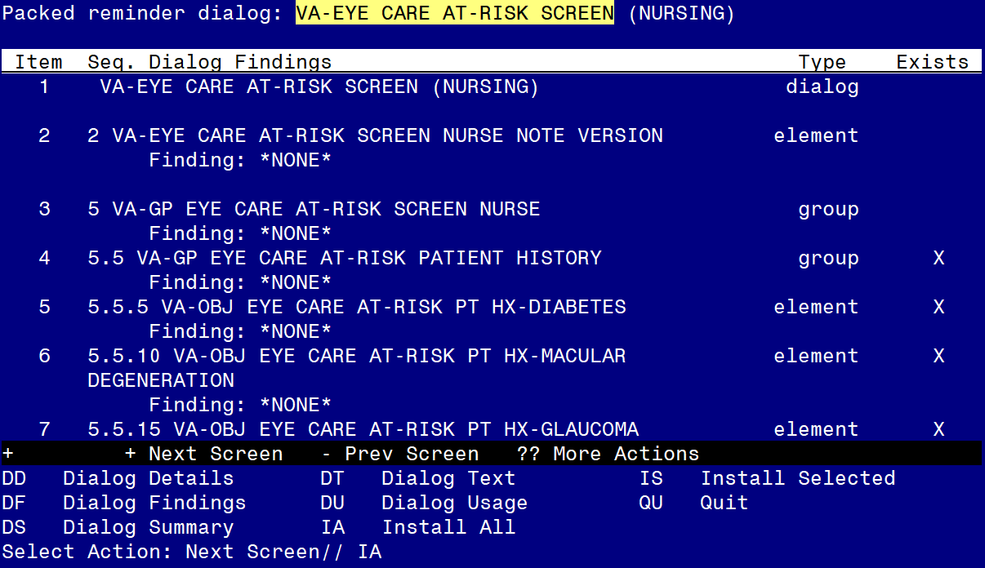

At the Select Action prompt, type IA to install the dialog – VA-EYE CARE AT-RISK SCREEN
Select Action: Next Screen// IA Install All
Install reminder dialog and all components with no further changes: Y// Yes
At the end of the dialog install, you will see this prompt, hit enter to link the dialog to the reminder definition:
Select Reminder to Link: VA-EYE CARE AT-RISK SCREEN (NURSE)//

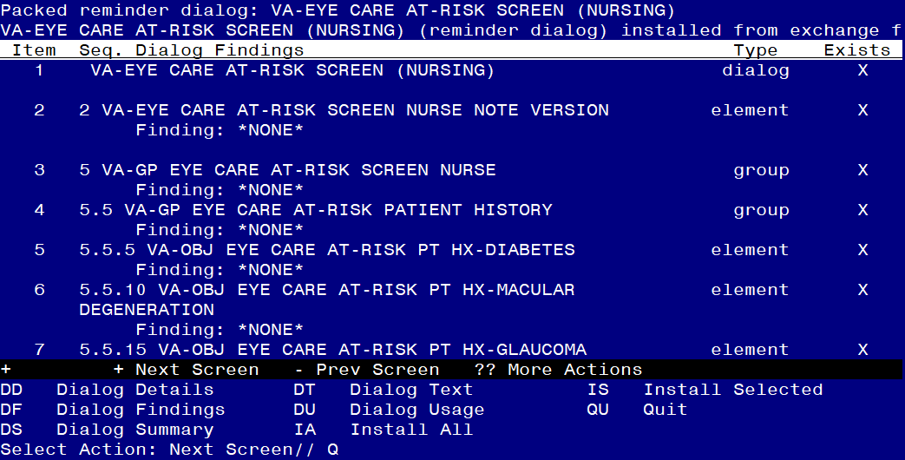

After completing this dialog install, you will type Q.
You will then be prompted to install the health summary components.
for all new entries you will choose I to Install
For components that already exists but the packed component is different, you will choose S to Skip.
You will then be brought back to this screen where you will type Q for quit

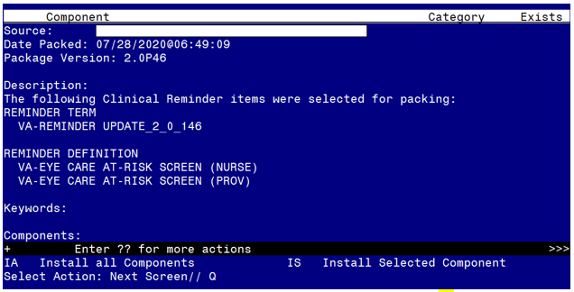
You will then be returned to this screen. At the Select Action prompt, type Q.

Install complete.

Post Installation

- Edit Reminder Term TELE EYE SCREEN ORDERS
  - Add any local health factors that your facility uses to indicate the patient has had Tele-Eye Screening.
  - Add local orderable items (OI) for Tele-Eye Screening.

- Add orders as an additional finding item to the following reminder dialog elements.
    - Element VAL-OI EYE CARE AT-RISK RETINAL IMAGE CONSULT
      - Add local quick order for Retinal Image Consult
    - Element VAL-OI EYE CARE AT-RISK EYE GLASS CONSULT
      - Add local quick order/process for scheduling an eye clinic appointment for glasses
    - Element VAL-OI EYE CARE AT-RISK COMP EYE EXAM CONSULT
      - Add local quick order/process for scheduling an eye clinic appointment

- The following reminder terms can be edited to add local findings that have the same meaning. (optional)
Add any local finding to the following reminder terms
  - Tele Eye Glaucoma Exam-Abnormal
  - Tele Eye Glaucoma Exam-Normal
  - Tele Eye Glaucoma Exam-Unable to Assess
  - Tele Eye Macula Exam-Abnormal
  - Tele Eye Macula Exam-Normal
  - Tele Eye Macula Exam-Unable to Assess
  - Tele Eye Retinopathy Exam-Abnormal
  - Tele Eye Retinopathy Exam-Normal
  - Tele Eye Retinopathy Exam-Unable to Assess
  - Tele Eye Screen Orders
  - VA-Life Expectancy < 6 Months
  - VA-Outside Eye At-Risk Factor

- Add the new reminder definitions to your cover sheet and assign to the appropriate users at your facility.

