Update _2_0_148

Clinical Reminders

VA-COVID 19 TEMPLATE UPDATES

Install Guide

June 2020

Product Development
Office of Information Technology
Department of Veterans Affairs

Table of Contents
Introduction 1
Install Details 3
Install Example 3
Post Installation 7

Introduction

DESCRIPTION:

- The offices of Infectious Disease, Surgery, GI, Population Health, Emergency Medicine, and Nursing have worked together to provide the following changes to the Screening COVID note template – in reflection of the current recommendations for VA national needs (as of 06/03/20).
  - The screen question for diarrhea was changed to include nausea and vomiting. If yes is chosen, the list of symptoms displays to choose which one.
  - A new screen question was added asking about headache, loss of taste or loss of smell. If yes is chosen, the list of symptoms displays to choose which one.

- Based on feedback from the field, the COVID-19 return to work template was updated to include the following changes:
  - A local element was included for sites to add site specific information in the letter header area
  - Changed “tense” to be had not has for the status question.
  - Added new status option of Patient Tested Negative with date tested and a text field for comments (optional)
  - Changed the provider signature area to be local so that sites could either add a free text or dropdown field.

A new reminder dialog group named VA-UPDATE 148 COVID SCREEN UPDATE is included in this update, it contains only the reminder dialog elements and groups that changed in the COVID-19 screening template. This new dialog group was created so that when you install the exchange file, any local edits you had previously made to the local components in the screening template would not be impacted.

When you install it will update the COVID-19 screen template in multiple places including ED, Nursing Admission and SCI Screen as well as anywhere you have the COVID-19 screening template embedded.

UPDATE_2_0_148 contains 1 Reminder Exchange entry:
UPDATE_2_0_148 VA-COVID-19 TEMPLATE UPDATES

The exchange file contains the following components:

TIU TEMPLATE FIELDS
BLANK SPACE1
VA COVID COMMENT
COVID-19 CDC RISK ASSESSMENT
VA COVID SITE NAME
DATE (*)
VA COVID PROVIDER

HEALTH FACTORS
VA-REMINDER UPDATES
VA-UPDATE_2_0_148
VA-COVID-19
VA-COVID-19 RETURN TO WORK
VA-NO HEADACHE LOSS OF TASTE OR SMELL
VA-SYMPTOM LOSS OF SMELL
VA-SYMPTOM LOSS OF TASTE
VA-SYMPTOM HEADACHE
VA-SCI/D COVID SCREEN
VA-SCI/D COVID SCREEN ADDL SYMPTOM
VA-SCI/D COVID SCREEN NO ADDL SYMPTOM
VA-SCI/D COVID SCREEN OTHER SYMPTOM
VA-SCI/D COVID SCREEN CONJUNCTIVITIS
VA-SCI/D COVID SCREEN NAUSEA
VA-SCI/D COVID SCREEN LOSS SMELL
VA-SCI/D COVID SCREEN LOSS TASTE
VA-SCI/D COVID SCREEN MYALGIA
VA-SCI/D COVID SCREEN SORE THROAT
VA-COVID-19 OUTSIDE PCR SPEC COLLECTED
VA-COVID-19 PCR LAB OUTSIDE NEGATIVE
VA-COVID-19 PCR LAB OUTSIDE POSITIVE
VA-NO NAUSEA VOMITING OR DIARRHEA
VA-SYMPTOM VOMITING
VA-SYMPTOM NAUSEA
VA-TRAVEL SCREEN [C]
VA-TRAVEL DIARRHEA YES
VA-COVID SCREEN NEGATIVE
VA-COVID SCREEN POSITIVE
VA-TRAVEL FLU NO
VA-TRAVEL FLU YES
VA-TRAVEL COUGH NO
VA-TRAVEL COUGH YES
VA-TRAVEL FEVER NO
VA-TRAVEL FEVER YES
VA-COVID-19 NO PRIOR DIAGNOSIS
VA-COVID-19 NOT WAITING FOR LABS
VA-COVID-19 WAITING FOR LABS

REMINDER TERM
VA-REMINDER UPDATE_2_0_148

REMINDER DIALOG
VA-COVID-19 RETURN TO WORK
VA-UPDATE 148 COVID SCREEN UPDATE

Install Details

This update is being distributed as a web host file. The address for the host file is: https://Redacted/UPDATE_2_0_148.PRD

The file will be installed using Reminder Exchange, programmer access is not required.

If your site is unable to use LWH, you will have a vista mail message with subject of UPDATE 148.

Installation:
=============
This update can be loaded with users on the system. Installation will take less than 10 minutes.

Install Example
To Load the Web Host File. Navigate to Reminder exchange in Vista
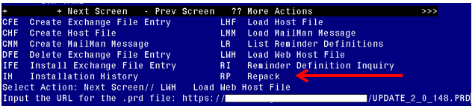
At the Select Action: prompt, enter LWH for Load Web Host File
At the Input the url for the .prd file: prompt, type the following web address:
https://Redacted /UPDATE_2_0_148.PRD

You should see a message at the top of your screen that the file successfully loaded.

Search and locate an entry titled UPDATE_2_0_148 VA-COVID TEMPLATE UPDATES in reminder exchange.
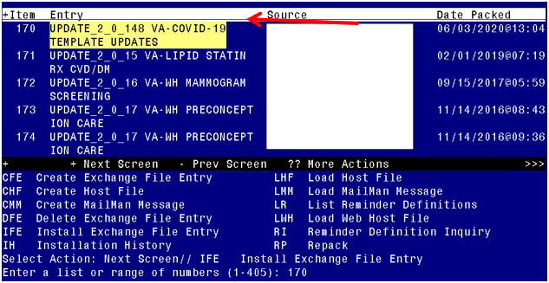
At the Select Action prompt, enter IFE for Install Exchange File Entry
Enter the number that corresponds with your entry UPDATE_2_0_148 VA-COVID TEMPLATE UPDATES (in this example it is entry 170 it will vary by site). The date of the exchange file should be 06/03/2020.
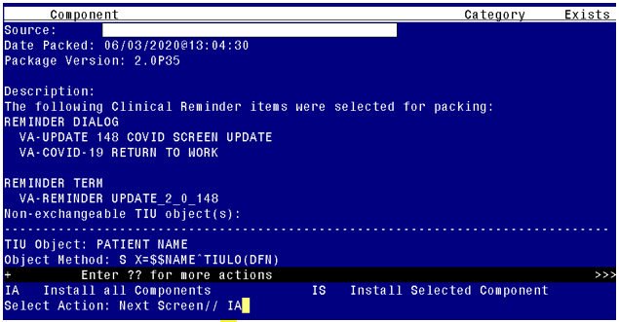
At the Select Action prompt, type IA for Install all Components and hit enter.
Select Action: Next Screen// IA Install all Components
You will see several prompts, for all new entries you will choose I to Install
For components that already exists but the packed component is different, you will choose S to Skip.

You will be promped to install the FIRST reminder dialog component – You will choose to install all even though the components have an X to indicate that they exist. These components have been updated and should be installed.
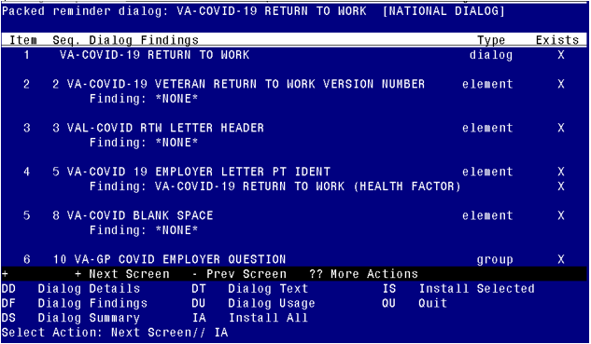
At the Select Action prompt, type IA to install the dialog – VA-COVID-19 RETURN TO WORK
Select Action: Next Screen// IA Install All
Install reminder dialog and all components with no further changes: Y// Yes
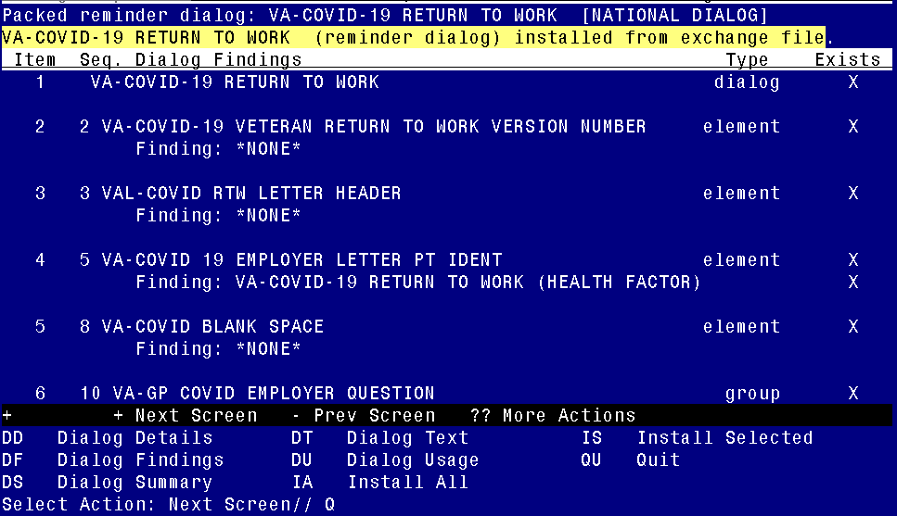

After completing this dialog install, you will type Q.

You will be promped to install the SECOND reminder dialog component – You will choose to install all even though the components have an X to indicate that they exist. These components have been updated and should be installed. 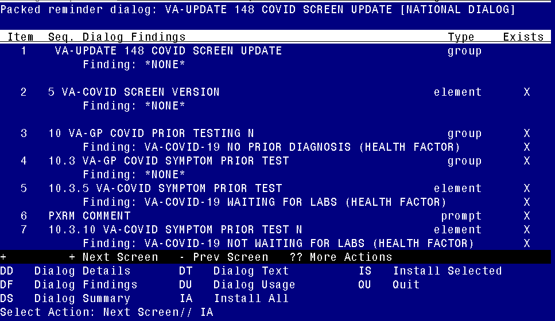
At the Select Action prompt, type IA to install the dialog – VA-UPDATE 148 COVID SCREEN UPDATE
Select Action: Next Screen// IA Install All
Install reminder dialog and all components with no further changes: Y// Yes
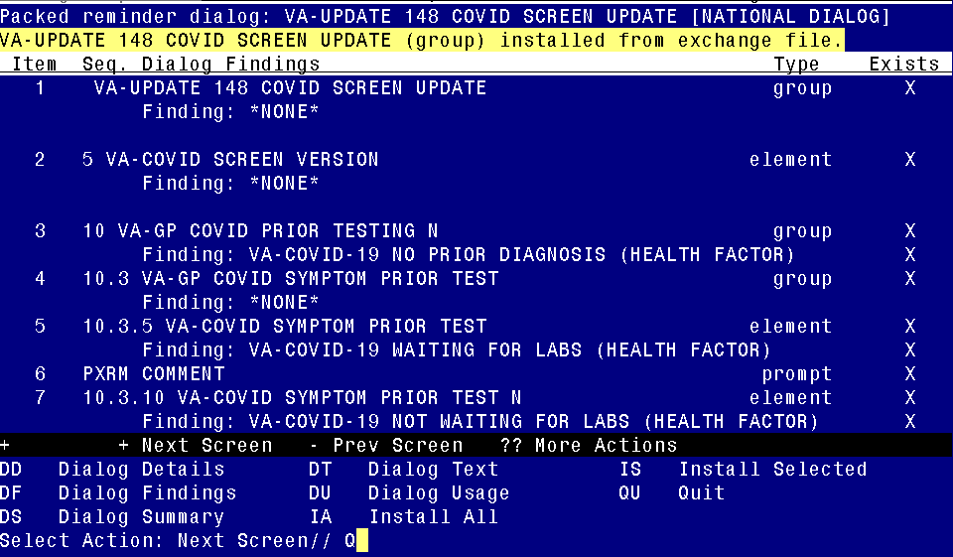

After completing this dialog install, you will type Q.

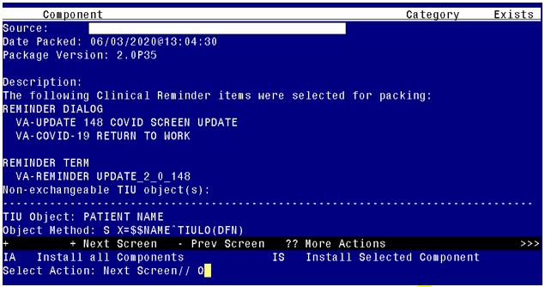

You will then be returned to this screen. At the Select Action prompt, type Q.

Install complete.

Post Installation

- Open the COVID-19 screening template and confirm that the version number is 4.1 and that you see the updated symptom questions if the patient has not been diagnosed with COVID-19.
- Open the COVID-19 return to work template and confirm that the version displays as 2.1.
- Optional - The reminder dialog element VAL-COVID RTW LETTER HEADER is a local class, you can edit this reminder dialog element and add your facility information to the dialog text if needed. Add this information before the date. If you have your facility information included in the document definition parameter, then you do not need to make any edits to this element.
- Optional – The reminder dialog element VAL-COVID-19 RTW PROVIDER SIGNATURE is a local class, you can edit this reminder dialog element and add a local txml field for the provider to type into or a local txml field for the provider to choose their name from a list for inclusion in the letter text if needed.

