Update _2_0_158

Clinical Reminders

VA-TELE URGENT CARE
Install Guide

November 2020

Product Development
Office of Information Technology
Department of Veterans Affairs

Table of Contents
Introduction 1
Install Details 2
Install Example 2
Post Installation 5

Introduction
This template will be used for Tele Urgent Care clinics that provide on demand virtual urgent care to Veterans who are referred and who self-refer for virtual urgent care. It will also be used for triage consultation which is a type of e-consult service provided to RNs in the call centers. The providers will be experienced in triage and urgent care and their setting may be urgent care clinics, EDs or they may be teleworking. The template will be completed by MDs, DOs, NPs and PAs with an urgent care skillset for all patients seen in the Tele Urgent Care clinic. Data is being collected from the health factors and used to track our visit characteristics and outcomes on a dashboard. We are using the data to improve our emergent and urgent care of at home Veterans or other non-VA settings including nursing facilities.

Per the National Program Office for Emergency Medicine, Specialty Care Services, this template is mandatory for use at all VA sites with Emergency and Urgent Care departments. For clinical questions, contact (Redacted).

UPDATE_2_0_158 contains 1 Reminder Exchange entry:
UPDATE_2_0_158 VA-TELE URGENT CARE NOTE

The exchange file contains the following components:

TIU TEMPLATE FIELD
BLANK TEXT FIELD FOR DIALOGS
WORD PROCESSING 10-2-02

HEALTH FACTORS
VA-REMINDER UPDATES
VA-UPDATE_2_0_158
TELE URGENT CARE
TELE URGENT TYPE PHONE HF
TELE URGENT TYPE VIDEO HF
TELE URGENT PLAN NEAREST ER HF
TELE URGENT PLAN URGENT CARE HF
TELE URGENT PLAN LESS THAN 72 HRS HF
TELE URGENT PLAN PACT HF
TELE URGENT PLAN TELE URGENT HF
TELE URGENT RFR OTHER HF
TELE URGENT RFR EYE HF
TELE URGENT RFR CV HF
TELE URGENT RFR NEURO HF
TELE URGENT RFR URINARY HF
TELE URGENT RFR GI HF
TELE URGENT RFR SKIN HF
TELE URGENT RFR ENT HF
TELE URGENT RFR MUSCULO HF
TELE URGENT TYPE CHART/CONSULT
TELE URGENT REFERRAL SOURCE OTHER
TELE URGENT VETERAN SELF REFERRAL
TELE URGENT CCC RN REFERRAL

REMINDER SPONSOR
Office of Emergency Medicine

REMINDER TERM
VA-REMINDER UPDATE_2_0_158

REMINDER DIALOG
VA-TELE URGENT CARE NOTE

TIU DOCUMENT DEFINITION
ACTIVE MEDS COMBINED
ALLERGIES/ADR

Install Details

This update is being distributed as a web host file. The address for the host file is: https://Redacted /UPDATE_2_0_158.PRD

Installation:
=============
This update can be loaded with users on the system. Installation will take less than 15 minutes.

Install Example
To Load the Web Host File. Navigate to Reminder Exchange in Vista.

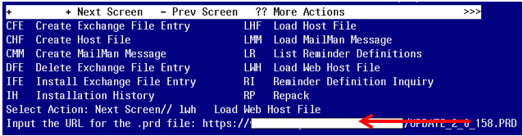

At the Select Action: prompt, enter LWH for Load Web Host File
At the Input the url for the .prd file: prompt, type the following web address:
https://Redacted /UPDATE_2_0_158.PRD

You should see a message at the top of your screen that the file successfully loaded.

Search and locate an entry titled UPDATE_2_0_158 VA-TELE URGENT CARE NOTE in reminder exchange.

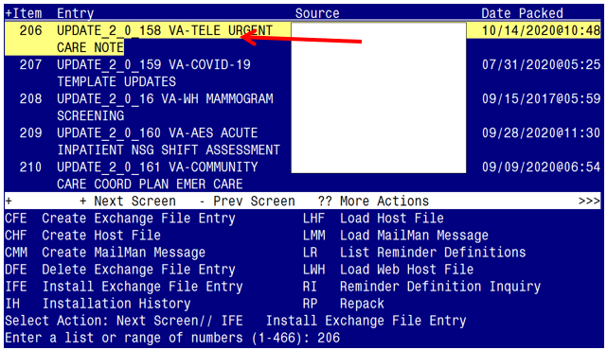

At the Select Action prompt, enter IFE for Install Exchange File Entry Enter the number that corresponds with your entry UPDATE_2_0_158 VA-TELE URGENT CARE NOTE (in this example it is entry 206. It will vary by site). The date of the exchange file should be 10/14/2020.

At the Select Action prompt, type IA for Install all Components and hit enter.
Select Action: Next Screen// IA Install all Components
You will see several prompts, for all new entries you will choose I to Install
You will be promped to install the reminder dialog component (VA-TELE URGENT CARE NOTE)
- You will choose to install all even though some components may have an X to indicate that they exist.
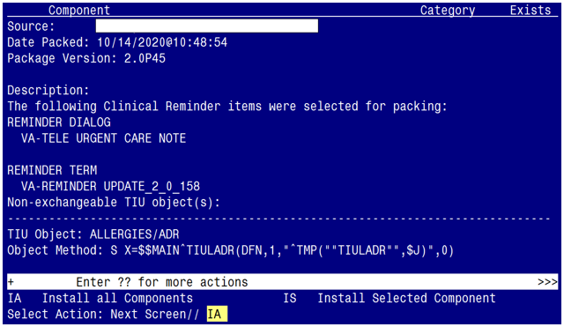

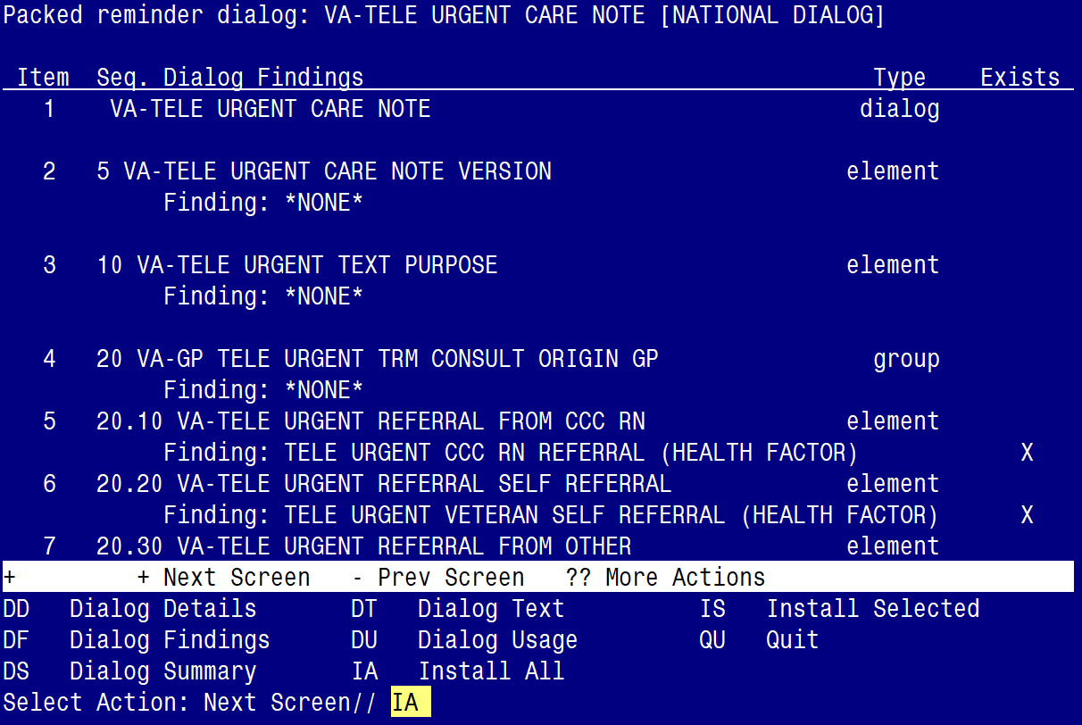

At the Select Action prompt, type IA to install the dialog – VA-TELE URGENT CARE NOTE
Select Action: Next Screen// IA Install All
Install reminder dialog and all components with no further changes: Y// Yes

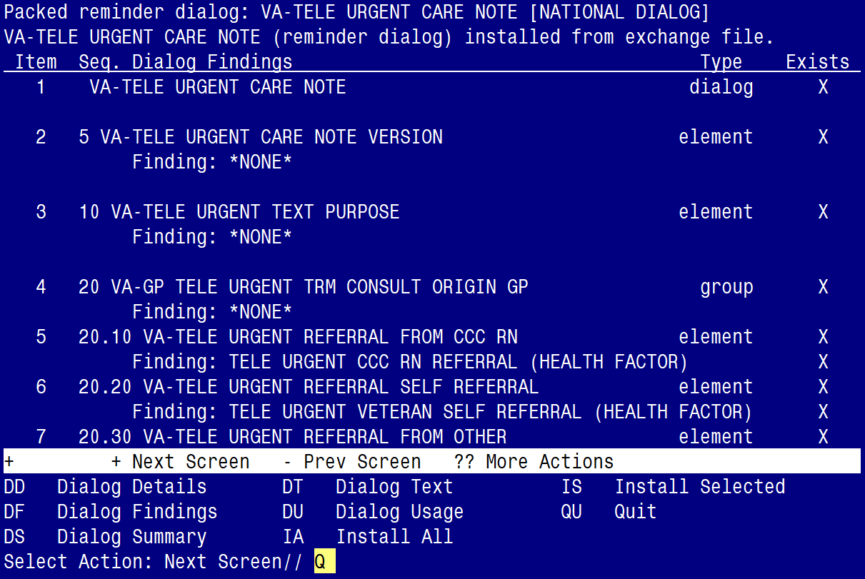

After completing this dialog install, you will type Q.
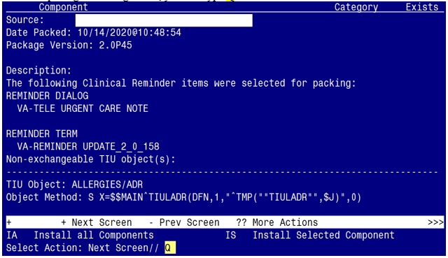

You will then be returned to this screen. At the Select Action prompt, type Q.

Install complete.

Post Installation

- Make the Dialogs able to be attached to a Personal/Shared template or to a progress note title.

From the Reminders Manager Menu:
Select Reminder Managers Menu Option: CP CPRS Reminder Configuration
CA Add/Edit Reminder Categories
CL CPRS Lookup Categories
CS CPRS Cover Sheet Reminder List
MH Mental Health Dialogs Active
PN Progress Note Headers
RA Reminder GUI Resolution Active
TIU TIU Template Reminder Dialog Parameter
DL Default Outside Location
PT Position Reminder Text at Cursor
Select CPRS Reminder Configuration Option: TIU TIU Template Reminder Dialog Parameter
Reminder Dialogs allowed as Templates may be set for the following:
1 User USR [choose from NEW PERSON]
3 Service SRV [choose from SERVICE/SECTION]
4 Division DIV [choose from INSTITUTION]
5 System SYS [SYSTEM]
Enter selection: 5 Choose the appropriate number for your site. Your site may do this by System or other levels. The example below uses SYSTEM level

Setting Reminder Dialogs allowed as Templates for System:
Select Display Sequence: ?

148 VA-VETERANS CHOICE NOTE
149 VA-TBI SCREENING
When you type a question mark above, you will see the list of #’s (with dialogs) that are already taken. Choose a number NOT on this list. For this example, looking above I see the number 150 is not present, so I will use 150.
Select Display Sequence: 150
Are you adding 150 as a new Display Sequence? Yes// Y YES
Display Sequence: 150// <Enter> 150
Clinical Reminder Dialog: VA-TELE URGENT CARE NOTE
then <enter> reminder dialog NATIONAL
OK? Yes// <Enter> (Yes)
- Setup of specific Note title
The new note title that needs to be created is:

TELE URGENT CARE PROVIDER

VHA Enterprise Standard Title: TELEHEALTH NOTE

Note: Comprehensive information on Creating Document Definitions can be found beginning on page 47 of the TIU/ASU Implementation Guide

- Associate the reminder dialogs with the note titles in CPRS
To do this, go to Template Editor, then Document Titles, select the appropriate folder (if applicable), and choose New Template (top right-hand corner).

- Type in the following information:
Name: TELE URGENT CARE PROVIDER
Template Type: Reminder Dialog
Reminder Dialog: VA-TELE URGENT CARE NOTE

Next, type in the Associated Title, which in this case is TELE URGENT CARE PROVIDER and
click APPLY.

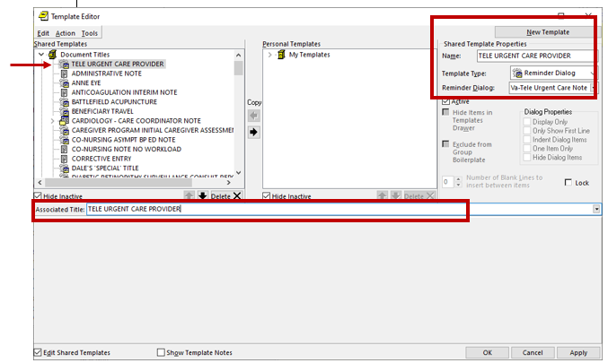

- Add/Edit ELEMENTS and GROUPS to include local data objects.

  - In the ELEMENT: VAL-TELE URGENT ALLERGIES
- Add your local data object for ALLERGIES/HDR

  - In the ELEMENT: VAL-TELE URGENT ACTIVE MEDS
- Add your local data object for ACTIVE MEDS COMBINED

  - In the ELEMENT: VAL-TELE URGENT PROBLEM LIST
- Add your local data object for ACTIVE PROBLEMS

  - In the ELEMENT: VAL-TELE URGENT DEMOGRAPHICS
- Add your local data object for VETERAN’S CURRENT ADDRESS
- Add your local data object for VETERAN’S PHONE NUMBER
- Add your local data object for VETERAN’S EMERGENCY CONTACT

- Optional: Edit/Disable GROUP and ELEMENTS, if your site decides to do so:

  - GROUP: VAL-GP TELE URGENT DISCHARGE INSTR CARE
- This group can be disabled if your site/staff chooses NOT to include this group in the template

  - ELEMENT: VAL-TELE URGENT DISCHARGE INSTR
- This is a local element and the text can be edited, if your site chooses to do so, or the element can be disabled if your site/staff chooses not to have this option available for selection.

  - In the ELEMENT: VAL-TELE URGENT UNDERSTAND CARE PLAN
- This is a local element and the text can be edited, if your site chooses to do so, or the element can be disabled if your site/staff chooses not to have this option available for selection.

This GROUP/ELEMENTS appears in the template as follows (see screenshot):

