Update _2_0_159

Clinical Reminders

VA-COVID-19 TEMPLATE UPDATES
Install Guide

August 2020

Product Development
Office of Information Technology
Department of Veterans Affairs

Table of Contents
Introduction 1
Install Details 6
Install Example 6
Post Installation 9

Introduction

DESCRIPTION:

- Based on feedback from the field, input from subject matter experts, and correlation with current CDC guidelines this update contains changes to the following COVID-19 reminder dialogs. The version number on all four of these templates has been updated:
VA-COVID-19 TELEPHONE FOLLOW-UP
VA-COVID-19 PROVIDER FOLLOW-UP
VA-COVID-19 DISCHARGE INSTRUCTIONS
VA-COVID-19 RETURN TO WORK

- The alternate dialog text was updates in the COVID-19 screening template to remove the word “they”. The version of the screening templates did not change as this change is not in the dialog text seen by the user completing the COVID-19 screening template.

- The txml field VA-PPE TYPE used in the provider follow up template has been updated, this field is locally editable so you can add local items if appropriate post install.

Additional Information:
Discharge template and instructions in provider screen discharge section – one of these choices is required:
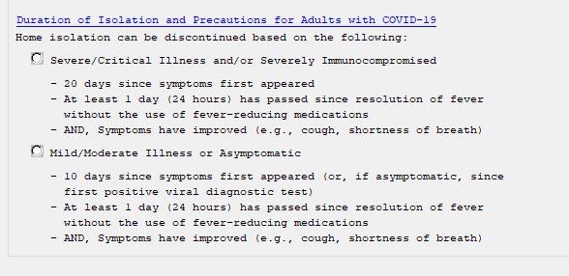

Return to Work template – one section only updated – added a new option for severe illness
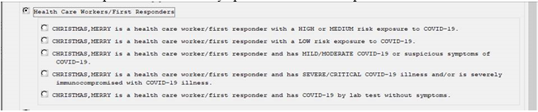
Mild moderate:
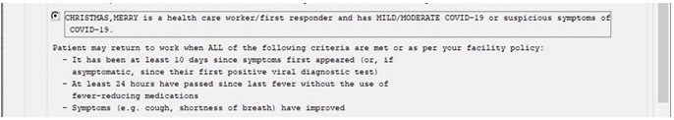
Severe:
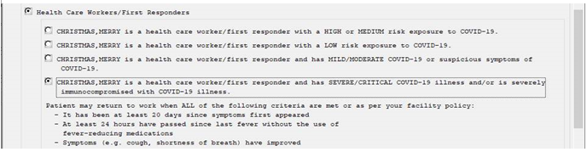

Telephone follow up note, care disposition section updated, added asymptomatic, updated recovered criteria for improving and stable options:
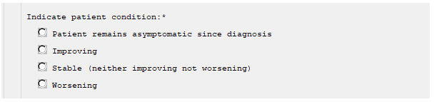

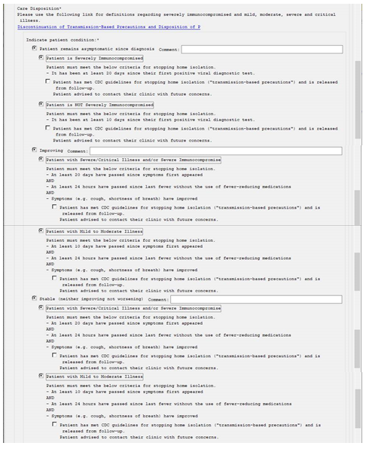

VA-PPE TYPE txml field used in Provider Follow-Up Template was updated:

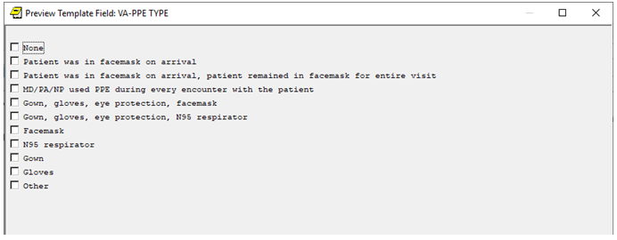

Alternate progress note text updated in COVID-19 Screening questions used in multiple templates:
Negative screen example:
Coronavirus Disease 2019 (COVID-19) Screen
The patient reports no COVID-19 diagnosis.
The patient reports not waiting for the results of a COVID-19 lab test.
The patient reports no fever.
The patient reports no new or worsening cough or shortness of breath.
The patient reports no cold or flu-like symptoms.
The patient reports no new onset of diarrhea, nausea or vomiting.
The patient reports no new onset of headache, loss of taste or loss of
smell.
The patient reports no exposure to someone with COVID-19 within the past
2 weeks.

UPDATE_2_0_159 contains 1 Reminder Exchange entry:
UPDATE_2_0_159 VA-COVID-19 TEMPLATE UPDATES

The exchange file contains the following components:
TIU TEMPLATE FIELD
VA-CDC DISPOSITION
VA-CDC DURATION ISOLATION
VA-WORD
VA-PPE TYPE

HEALTH FACTORS
VA-REMINDER UPDATES
VA-UPDATE_2_0_159
VA-COVID-19
VA-COVID-19 ASYMPTOMATIC RELEASE ISOLAT
VA-COVID-19 ASYMPTOMATIC
VA-COVID-19 PATIENT WORSENING
VA-COVID-19 STABLE RELEASE ISOLATION
VA-COVID-19 PATIENT STABLE
VA-COVID-19 IMPROVE RELEASE ISOLATION
VA-COVID-19 PATIENT IMPROVING
VA-COVID-19 UNABLE TO CARE FOR SELF HOME
VA-COVID-19 CAN CARE FOR SELF AT HOME
VA-TRAVEL SCREEN [C]
VA-COVID-19 PRIOR DIAGNOSIS
VA-EXPOSURE TO COVID NO
VA-EXPOSURE TO COVID YES
VA-NO HEADACHE LOSS OF TASTE OR SMELL
VA-SYMPTOM LOSS OF SMELL
VA-SYMPTOM LOSS OF TASTE
VA-SYMPTOM HEADACHE
VA-COVID-19 NOT WAITING FOR LABS
VA-COVID-19 WAITING FOR LABS
VA-NO NAUSEA VOMITING OR DIARRHEA
VA-SYMPTOM VOMITING
VA-SYMPTOM NAUSEA
VA-TRAVEL DIARRHEA YES
VA-COVID SCREEN NEGATIVE
VA-COVID SCREEN POSITIVE
VA-TRAVEL FLU NO
VA-TRAVEL FLU YES
VA-TRAVEL COUGH NO
VA-TRAVEL COUGH YES
VA-TRAVEL FEVER NO
VA-TRAVEL FEVER YES
VA-COVID-19 NO PRIOR DIAGNOSIS

REMINDER TERM
VA-REMINDER UPDATE_2_0_159

REMINDER DIALOG
VA-COVID-19 UPDATE AUG 2020

Install Details

This update is being distributed as a web host file. The address for the host file is: https://REDACTED/UPDATE_2_0_159.PRD

The file will be installed using Reminder Exchange, programmer access is not required. Installation should take less than 10 minutes.

Install Example
To Load the Web Host File. Navigate to Reminder exchange in Vista

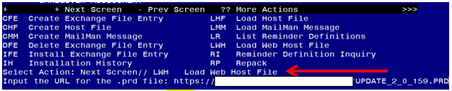
At the Select Action: prompt, enter LWH for Load Web Host File
At the Input the url for the .prd file: prompt, type the following web address:
https://REDACTED/UPDATE_2_0_159.PRD

You should see a message at the top of your screen that the file loaded successfully

Search and locate an entry titled UPDATE_2_0_159 VA-COVID-19 TEMPLATE UPDATES in reminder exchange.
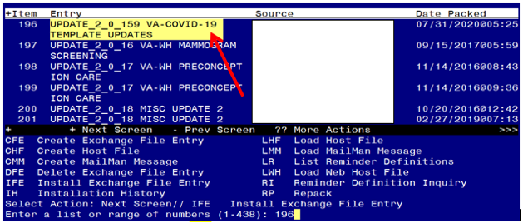

At the Select Action prompt, enter IFE for Install Exchange File Entry
Enter the number that corresponds with your entry UPDATE_2_0_159 VA-COVID-19 TEMPLATE UPDATES (in this example it is entry 196 it will vary by site). The date of the exchange file should be 07/31/2020.

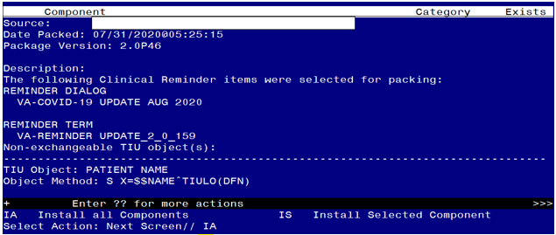
At the Select Action prompt, type IA for Install all Components and hit enter.
Select Action: Next Screen// IA Install all Components
You will see several prompts, for all new entries you will choose I to Install
For this prompt, you will OVERWRITE:
TIU TEMPLATE FIELD entry named VA-PPE TYPE already exists but the
packed component is different, what do you want to do?
Select one of the following:
C Create a new entry by copying to a new name
O Overwrite the current entry
U Update
Q Quit the install
S Skip, do not install this entry
Enter response: O//verwrite the current entry
Are you sure you want to overwrite? N// Y

You will be promped to install the reminder dialog component – You will choose to install all even though some components may have an X to indicate that they exist.

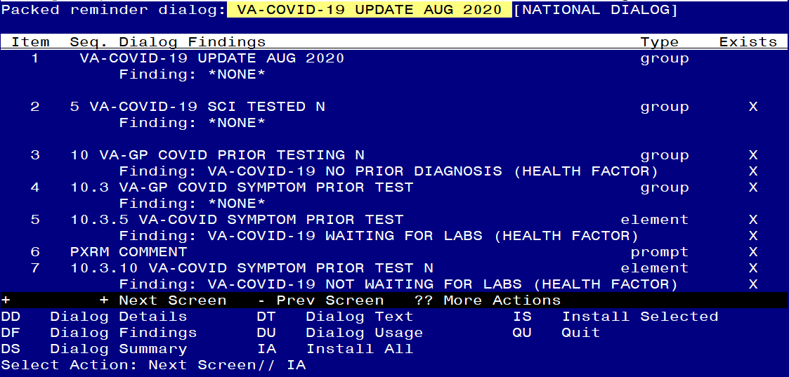

At the Select Action prompt, type IA to install the dialog – VA-COVID-19 UPDATE AUG 2020
Select Action: Next Screen// IA Install All
Install reminder dialog and all components with no further changes: Y// Yes

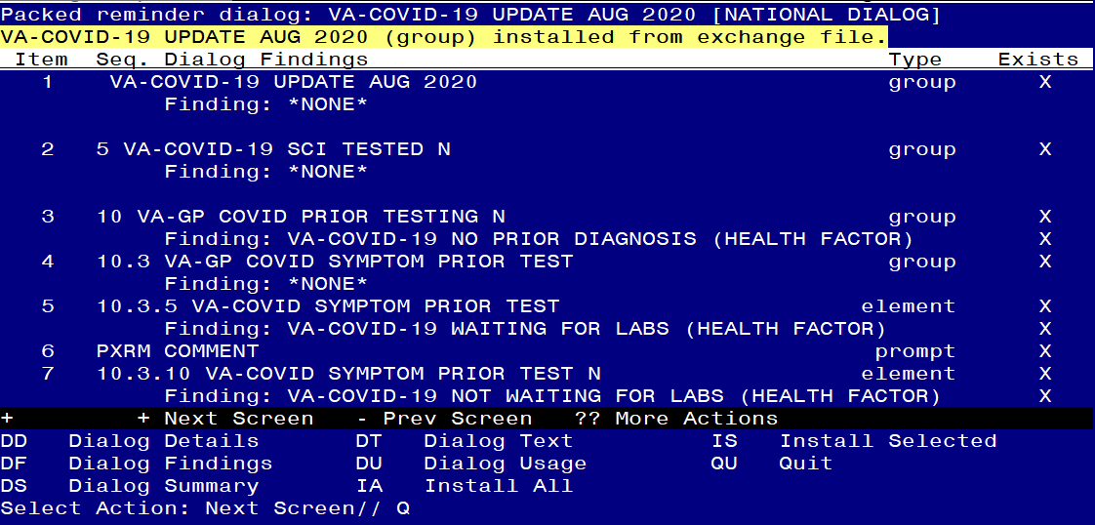

After completing this dialog install, you will type Q.

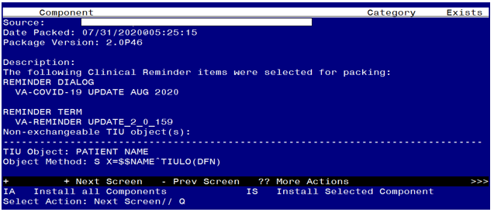

You will then be returned to this screen. At the Select Action prompt, type Q.

Install complete.

Post Installation

- Open the COVID-19 Telephone Follow Up Template and confirm the version is 4.1
- Open the COVID-19 Discharge Template and confirm the version is 3.1
- Open the COVID-19 Provider Screen Template and confirm the version is 3.1
- Open the COVID-19 Return To Work Template and confirm the version is 3.1
- Update txml field VA-PPE TYPE (Optional)
The txml template field VA-PPE TYPE can be edited using the Edit Template Fields option in CPRS to add additional local items if needed.

