Update _2_0_160

Clinical Reminders

VA-AES ACUTE INPATIENT NSG SHIFT ASSESSMENT BUNDLE

Install Guide

August 2020

Product Development
Office of Information Technology
Department of Veterans Affairs

Table of Contents
Introduction 1
Pre-Install 35
Install Details 36
Install Example 36
Post Installation Of the Bundle 42
Post Installation Of Skin Inspection/Assessment Only 53

Introduction
This release contains a bundle of the following four reminder dialogs:
- VA-AES ACUTE INPATIENT NSG SHIFT ASSESSMENT
- VA-AES NSG FREQUENT DOCUMENTATION
- VA-AES NSG IV NSG INSERT AND MAINTAIN
- VAAES SKIN INSPECTION/ASSESSMENT

The purpose of this bundle is to implement standardized nursing shift assessment templated notes within all inpatient acute settings including med-surg, telemetry, intermediate care*, and acute rehabilitation. The implementation and use of these templated notes is supported by The VA Approved Acute Enterprise Standard (VAAES) Acute Inpatient/Rehabilitation Nursing Admission Screening, Assessment, and Standard Operating Procedure (SOP). Local modification is prohibited (including health factors) unless approved following the process outlined within the SOP.

The VA-AES ACUTE INPATIENT NSG SHIFT ASSESSMENT, VA-AES NSG FREQUENT DOCUMENTATION, VA-AES NSG IV INSERT AND MAINTAIN, and VAAES SKIN INSPECTION/ASSESSMENT content is based on the Acute Care Delivery (ACD) Essential Data Set (EDS) and has been vetted across RAPID, IPEC, Behavioral Health, Infection Control/Prevention, Skin/Wound, Safe Patient Handling, National Falls Workgroup (NCPS), and multiple other consulting stakeholders. The assessment includes scales/tools that have been vetted by the ACD council and are mandated for use as outlined in the VAAES Acute Inpatient/Rehabilitation Nursing Admission Screening, Assessment, and Standards of Care SOP.

The VA-AES ACUTE INPATIENT NSG SHIFT ASSESSMENT, VA-AES NSG FREQUENT DOCUMENTATION, VA-AES NSG IV INSERT AND MAINTAIN, VAAES SKIN INSPECTION/ASSESSMENT dialogs contains national health factors that were developed to promote uniformity of data, and facilitation of reports to meet directives, policies, and regulatory metrics that support the characteristics of a high reliability organization. These national health factors are standardized and must be loaded without modification. A complete list of health factors and the corresponding text within these templates can be found under the Important Links section at the end of this section.

Description: (Facilities needing to install VAAES SKIN INSPECTION/ASSESSMENT only for CLC and Outpatient areas see post installation for VAAES SKIN INSPECTION/ASSESSMENT Only)
The VA-VANOD SKIN INITIAL ASSESSMENT and VA-VANOD SKIN REASSESSMENT Dialogs were originally developed by the Office of Nursing Service (ONS) and released to the field in 2007 through the Computerized Patient Record System (CPRS). The new VAAES SKIN INSPECTION/ASSESSMENT template was designed in collaboration with the ONS Pressure Injury Prevention and Management Field Advisory Committee. The content is being updated to align with the latest evidenced based practice guidelines, as well as development of an audit tool and multiple trainings through TMS. An update of nationally published guidelines aimed at preventing pressure ulcers/injury was developed by this VA workgroup resulting in a VHA Handbook 1180.02 in 2011 to a directive (VHA Directive 1352 Prevention and Management of Pressure Injuries, 3/21/ 2019). The Office of Nursing Informatics (ONI) strives to build national templates centered around reduced documentation burden, increased evidence-based awareness at point of care, and to support the ability to facilitate the creation of near real time reports on nursing sensitive indictors. These quality indicators provide valuable data to further support the best possible patient care outcomes.
The purpose of the national template is to preserve the ability to collect pertinent data for quality-driven healthcare. The content will not be altered. A yearly review will be conducted by the Office of Nursing Informatics and the Office of Nursing Service to optimize core content and bring new evidence-based knowledge to our clinicians at point of care.
The updated VAAES SKIN INSPECTION/ASSESSMENT note is being released as part of the VAAES ACUTE INPATIENT NSG SHIFT ASSESSMENT Bundle. Due to size and volume of content within the VAAES SKIN INSPECTION/ASSESSMENT dialog, the content was not embedded within the VA-AES INPATIENT ACUTE NSG SHIFT ASSESSMENT. Facilities are given the option to embed the VAAES SKIN INSPECTION/ASSESSMENT to avoid impacting performance of the VAAES ACUTE INPATIENT NSG SHIFT ASSESSMENT,

A local dialog group VAL-GP NSG SHIFT INTEGUMENTARY EMBEDDED, which is disabled within the VA-AES INPATIENT ACUTE NSG SHIFT ASSESSMENT dialog, is available for sites who wish to embed the VAAES Skin Inspection/Assessment content within the VAAES Inpatient Acute Nsg Shift Assessment. Nursing leadership needs to approve. If your site opts to embed the skin assessment content into the shift assessment, you must thoroughly test dialog load times. If load time is greater than 30 seconds, do not embed the Skin Inspection/Assessment dialog. In addition, performance on all acute inpatient units computers on wheels (COWS) and network connectivity must be verified during testing to ensure that embedding the content has no adverse effect on template performance prior to installing in production. If performance is adversely impacted (load time greater than 30 seconds), use the stand alone VAAES SKIN INSPECTION/ASSESSMENT note or consider having users invoke the template from Shared Templates.

Below is a list of updated revisions to the new VAAES Skin Inspection/Assessment template:
- The name of the template changed to the VAAES SKIN INSPECTION/ASSESSMENT for use in the electronic health record documentation system
- There is no longer a VANOD SKIN ASSESSMENT and VANOD SKIN RE-ASSESSMENT. These have been combined into one template which will be the VAAES SKIN INSPECTION/ASSESSMENT
- Template Includes the terminology and language to be consistent with Directive 1352: Prevention and Management of Pressure Injuries (example: skin inspection)
- A new section was added to address the issue of patient, resident, caregiver etc. refusal for skin inspection/assessment
- A list of reasons included for staff inability to inspect/assess skin within 24 hours of admission, daily or as required by policy
- Revised and edited definitions and language to be consistent with current evidenced-based practice
- Updated the term Pressure Ulcer to Pressure Ulcer/Injury to be consistent with practice across service lines and national pressure ulcer advisory panel recommendations (example: CLC still uses term Pressure Ulcer)
- Updated the term Pressure Ulcer/Injury staging to include the new 2016 National Pressure Ulcer Advisory Panel staging terminology
- Links included for staff access to educational and clinical resources
- Major risk factors included and removed the term “Special Populations”
- Intervention Section updated
- Add location text box under rash
- Remove “required” field for Braden Scale
- Remove “required” field for intervention, risk sections,
- Add ONS SharePoint Link to homepage ONS SharePoint- PowerPoint, Video File, Scales & Tools, SOP
- Add location and description to mucosal membrane
- Add reference text “Skin assessment must be completed by Registered Nurse Only”
- Removed extra wound description box
- Correct any spelling errors – Management - Abnormality
- Can add link for PI/PU Staging System PDF (https://npiap.com/page/PressureInjuryStages)
- Added a HF to the interventions section, pressure redistribution measures, individualized repositioning while out of bed to chair/wheelchair
  - HF: INDIVIDUALIZED REPOSITIONING
  - Category: PRESSURE ULCER-PRESSURE REDUCING
- Removed flap /incision section of the VAAES SKIN INSPECTION/ASSESSMENT note.
- All caps on the verbiage for RN assessment only?
- Update verbiage under Skin Inspection > Skin Color > “Usual for ethnicity”
- Add verbiage under PI > peri-wound > “Usual for ethnicity”
  - HF: PI PERI WOUND USUAL FOR ETHNICITY
Category: SKIN ASSESSMENT

* Special Instruction for Intensive Care Units/Intermediate Care areas currently using Clinical Information Systems (CIS) products:
- The VAAES ACUTE INPATIENT NSG SHIFT ASSESSMENT note is not mandated for ICU documentation. If the ICU is not using a CIS product, this note can be used for shift assessment pending nursing leadership review and decision.
- ICUs and Intermediate Care Units currently documenting the shift assessment using a CIS product may continue in the CIS and do not need to implement the VAAES ACUTE INPATIENT NSG SHIFT ASSESSMENT NOTE.
The updated VAAES Skin Inspection/Assessment must be used by ICU/Intermediate Care areas as a stand-alone note. It is not necessary and highly discouraged to duplicate documentation in the CIS product.
The VAAES ACUTE INPATIENT NSG SHIFT ASSESSMENT template must be implemented in the production environment by all inpatient acute (med-surg, telemetry, *intermediate care, and acute rehabilitation settings) per the date on the release email.
The template and Health Factors may not be changed or revised at the local level except for local elements identified in post-install instructions. Requests to add elements to the note must go through the approval process outlined in the Redacted.

Important Links:
REDACTED

For questions or feedback on the template please utilize the REDACTED. For training questions please refer to the REDACTED

UPDATE_2_0_160 contains 1 Reminder Exchange entry:
TIU TEMPLATE FIELD
VA-NSG ADMIT EMAIL
VA VANOD ONS SHAREPOINT LINK
VA VANOD ACTIVITIES FOR PRESSURE INJURY IN CLC
VA VANOD FLOW FOR SPINAL CORD
VA VANOD FLOW FOR INPATIENT MENTAL HEALTH
VA VANOD FLOW FOR HBPC PRESSURE INJURIES
VA VANOD FLOW FOR ACUTE PRESSURE INJURIES
VA VANOD PREVENTING PRESSURE ULCER IN HOSPITAL
VA VANOD VHA DIRECTIVE 1352
BLANK TEXT FIELD FOR DIALOGS
TEXT (1-20 CHAR)
TEXT (6 CHAR)
WORD 1 LINE
TEXT (1-30 CHAR) REQ
TEXT (1-20 CHAR) REQ
VANOD PU DESCRIPTIONS
VA*W-P2LINES
WORD PROCESS (REQUIRED)
VA-WORD
BLANK WP MAND 2 LINE
TEXT (1-60 CHAR)
VA VANOD PRESSURE INJURY RISK FACTORS
WORD 2 LINE
VANOD PI/PU STAGING SYSTEM PDF
VA VANOD PI/PU STAGING SYSTEM
VA VANOD EVOLUTION/DETERIORATION IN PRESSURE
ULCER STAGE
VA-NSG PAIN 2
EDIT 25
VA-NSG CPOT MUSC TENSE 2
VA-NSG CPOT VOCAL 2
VA-NSG CPOT BODY MVMT 2
VA-NSG CPOT FACIAL 2
VA-NSG PAINAD 5
VA-NSG PAINAD 4
VA-NSG PAINAD 3
VA-NSG PAINAD 2
VA-NSG PAINAD 1
VA-GEN WORD PROCESSING
GEN WORD PROCESSING
VA-WORD 1 LINE
VA-NSG MEALS LESS THAN REASON
VA-NSG MEALS LESS THAN
VA-PERCENTAGE MEALS
VA-WORD 2 LINES
EDIT 50
VA-NSG ADAPT UTENSILS
VA-NEWS SUPPLEMENTAL 02 CONFIRM
VA-NEWS AVPU CONFIRM
VA-EDIT 50
VA-WEBLINK BCAM
VA-NSG BCAM 4
VA-NSG BCAM 3
VA-NSG BCAM 2
VA-NSG BCAM 1
VA-NSG 1-4
VA-NSG DATE/TIME
VA-NSG BEFAST 5
VA-NSG BEFAST 4
VA-NSG BEFAST INST
VA-NSG BEFAST 3
VA-NSG BEFAST 2
VA-NSG BEFAST 1
VA-NSG ORIENTATION
VA-NSG PUPILS
VA-NSG MM
VA-EDIT 12+
VA-NSG POS TOL
VA-NSG ONS WEBLINK
VA-NURSE Q&A EMAIL
EDIT 12+
VA-NSG SUB LOC
VA-NSG SUBQ STAT
VA-NSG SUBQ SIZE
VA-NSG SUBQ DRESSING
VA-NSG LINE COUNT INFO
VA-NSG MIDLINE AID
VA-EDIT 20
BLANK TEXT
TEXT (1-40 CHAR)
VA-NSG FLAP PULSE
VA-NSG FLAP COLOR
VA-NSG FLAP TEXT
VA-NSG FLAP CAP
VA-NSG FLAP TEMP
VA-NSG FIM
VA-NSG REASSESSMENT
VA-NSG DRAIN SITE COND
VA-NSG DRAIN DRESSING COND
VA-NSG DRAIN DRESSING
VA-NSG DRAIN STATUS
VA-NSG DRAIN Q DESC
VA-NSG DRAIN DESC
VA-NSG EMOT SUPP
VA-NSG EQ OPP
VA-NSG EQ UTILIZE
VA-WEBLINK RN LIBRARY
VA-NSG ED UNDERSTAND
VA-NSG PROVIDED TO
VA-NSG ED METHOD
VA-NSG ED TOPICS
VA-NSG GU COLOR CHAR
VA-NSG GU VOID DIFF
VA-NSG GU ELIM 2
VA-NSG GU COLLECT
VA-NSG GU EVAL
VA-NSG GU TOLERANCE
VA-NSG GU LOCATION
VA-NSG OSTOMY MGMT
VA-NSG STOMA TISSUE
VA-NSG STOMA DESC
VA-NSG OSTOMY SITE
VA-NSG UROSTOMY TYPE
WORD 65
YES/NO
EDIT 45(NOT REQUIRED)
VA-NSG URINE CBI OUT
VA-NSG URINE CBI CONT/INT
VA-NSG SKIN NEPH
VA-NSG DRESSING
VA-NSG L/R
VA-NSG YES/NO
VA-NSG URINE CATH SITE
VA-NSG FLATUS 2
VA-NSG BM AMT
VA-NSG BM COLOR 2
VA-NSG BM DESC
VA-NSG ABD PALP 2
VA-NSG ABD DESC 2
VA-NSG ELIMINATION
VA-NSG BOWEL MGMT EVAL
VA-NSG BOWEL MGMT TOL
VA-NSG BOWEL MGMT LOC
VA-NSG GI MOTILITY
VA-NSG GI BRISTOL
VA-NSG TUBE DRAIN CONS
VA-NSG TUBE DRAIN COLOR
VA-NSG TUBE NONSUCTION
VA-NSG TUBE SUCTION
VA-NSG TUBE STAB METH
VA-NSG TUBE STAT LOC
VA-NSG GI TUBE
VA-NSG OSTOMY TYPE
VA-NSG GI SYMPTOMS
VA-NSG BS
VA-NSG CT DRAINAGE
VA-NSG CT DSG
VA-NSG CHEST TUBE STATUS
VA-NSG CHEST TUBE TYPE
VA-NSG TRACH CARE
VA-NSG SKIN
VA-NSG DRAINAGE
VA-NSG DRSG
VA-NSG SUCTION BEDSIDE
VA-NSG SPARE AIRWAY
VA-NSG SAFETY TXT
EDIT 20
VA-NSG TRACH 2
VA-NSG STOMA
VA-NSG SUCTION METHOD 2
VA-NSG ORAL TYPE
VA-NSG NASAL TYPE
VA-NSG COUGH ASST
VA-NSG CHEST PHYSIO
EDIT 25+
VA-NSG SPUTUM CONSISTENCY
EDIT 20+
VA-NSG SPUTUM COLOR
VA-NSG SPUTUM AMT
VA-NSG COUGH
VA-NSG BREATH SOUNDS
VA-NSG LUNG SOUNDS EXPLANATION
VA-NSG BREATH AUSC
VA-NSG LATERALITY
VA-NSG HR
NURRN
VA-NSG HEART SOUNDS
VA-NSG CAP REF
VA-NSG SENSATION
VA-NSG TONE AB
VA-NSG TONE
VA-NSG TEMP AB
VA-NSG TEMP
VA-NSG SENSATION AB
VA-NSG UE STRENGTH AB
VA-NSG UE STRENGTH
VA-NSG GRIP STRENGTH AB
VA-NSG GRIP STRENGTH
VA-NSG DROOP
VA-NSG LENGTH
VA-NSG SEIZ PDP
VA-NSG SEIZ PDS
VA-NSG SEIZ DESC
VA-NSG SEIZ AF
VA-NSG SEIZ EOM
VA-NSG SEIZ ONSET
VA-NSG POSTURE
VA-NSG FOLLOW
VA-NSG SPEECH CHAR
VA-NSG TIPS
VA-NSG PAIN ALLEV
VA-NSG PAIN AGG
VA-NSG PAIN NEURO
VA-NSG PAIN MS
VA-NSG PAIN SUPP3
VA-NSG PAIN SUPP2
VA-NSG PAIN SUPP1

HEALTH FACTORS (The Health Factor content will not be altered in anyway)
VA-REMINDER UPDATES
VA-UPDATE_2_0_160
SKIN ASSESSMENT
VA-VAAES SKIN INSPECTION/ASSESSMENT
VANOD SKIN REMINDER TERMS
VANOD UNABLE TO ASSESS OTHER
PATIENT REFUSAL PERSONAL
PATIENT REFUSAL END OF LIFE
PATIENT BEHAVIORALLY UNSTABLE
PATIENT MEDICALLY UNSTABLE
PATIENT OFF FLOOR
VANOD UNABLE TO ASSESS
SKIN TEMPERATURE
SKIN TURGOR
SKIN MOISTURE
SKIN COLOR
PRESSURE ULCER PROTOCOL
PRESSURE ULCER PROTOCOL NA - NO RISK
PRESSURE ULCER-REMOBILIZE
PU REMOBILIZE-OTHER
LIMIT SITTING OOB TO 2 HR PERIODS
ROM EXERCISES
ENCOURAGE ACTIVITY AS TOLERATED
REPOSITION IN CHAIR
PRESSURE ULCER-PRESSURE REDUCING
PU PRESSURE REDUCING-OTHER
TURN TO SIDE LESS THAN 30 DEGREES
TURN AND REPOSITION Q2H
FREQUENT POSITION CHANGES
SPECIALTY BED/SURFACE
ELEVATE HEELS
HEEL/ELBOW PADS
WHEELCHAIR CUSHION
INDIVIDUALIZED REPOSITIONING
PRESSURE ULCER-NUTRITION
PU NUTRITION-OTHER
TUBE FEEDINGS AS ORDERED
MONITOR FLUID/FOOD INTAKE
OFFER LIQUIDS Q2H WHEN TURNING
PROVIDE/ENCOURAGE ORAL CARE AS NEEDED
OFFER ORDERED SUPPLEMENTS
ENCOURAGE MEALS AND ASSIST AS NEEDED
TRAY SET UP AND ASSISTANCE
ENCOURAGE EATING AND ASSIST WITH MEALS
PRESSURE ULCER-MOISTURE
PU MOISTURE-OTHER
INSTRUCT PT/FAMILY TO REQUEST ASSISTANCE
SCHEDULED TOILETING
OFFER BEDPAN/URINAL
PROTECTIVE BARRIER OINTMENT
FECAL COLLECTOR
CONDOM CATHETER
MAINTAIN CLEAN DRY SKIN
NO MORE THAN 1 LINEN LAYER
PRESSURE ULCER-FRICTION/SHEAR
PU FRICTION/SHEAR-OTHER
ELEVATE HOB FOR MEALS
HOB BELOW 30 DEGREES WHEN NOT EATING
USE BED TRAPEZE OR PULL SHEET
WHEN HOB ELEVATED RAISE KNEE
PRESSURE ULCER-EDUCATION
PU EDUCATION-OTHER
EDUCATION MATERIALS ON ULCER PREVENTION
EDUCATE IMPORTANCE OF CHANGING POSITION
PROVIDE EDUCATION REGARDING TX PLAN
PROVIDE EDUCATION ON CAUSE/PREVENTION
PRESSURE ULCER PROTOCOL - NO CHANGE
SKIN - EDUCATION
SKIN REDUCE FRICTION AND SHEAR
SKIN MANAGE NUTRITION
SKIN MANAGE MOISTURE
SKIN - MAXIMAL REMOBILIZATION
SKIN - PRESSURE-REDISTRIBUTION MEASURES
PRESSURE ULCER PROTOCOL INITIATED
PRESSURE ULCER REASSESSMENT
NEW PRESSURE ULCER
PRESSURE ULCER REASSESS - CHANGE
PRESSURE ULCER STAGE
SUSPECTED DEEP TISSUE INJURY
UNABLE TO STAGE (PU)
STAGE IV
STAGE III
STAGE II
STAGE I
UNABLE TO STAGE (PU) #5
UNABLE TO STAGE (PU) #4
UNABLE TO STAGE (PU) #3
UNABLE TO STAGE (PU) #2
MUCOSAL MEM PI #5
MUCOSAL MEM PI #4
MUCOSAL MEM PI #3
MUCOSAL MEM PI #2
STAGE IV #5
STAGE IV #4
STAGE IV #3
STAGE IV #2
STAGE III #5
STAGE III #4
STAGE III #3
STAGE III #2
STAGE II #5
STAGE II #4
STAGE II #3
STAGE II #2
STAGE I #5
STAGE I #4
STAGE I #3
STAGE I #2
SUSPECTED DEEP TISSUE INJURY #5
SUSPECTED DEEP TISSUE INJURY #4
SUSPECTED DEEP TISSUE INJURY #3
SUSPECTED DEEP TISSUE INJURY #2
MUCOSAL MEM PI
OTHER WOUND LOCATION
OTHER WOUND PERI WOUND OTHER
OTHER WOUND PERI WOUND SKIN TEMP
OTHER WOUND PERI WOUND EDEMA
OTHER WOUND PERI WOUND FLUCTUANCE
OTHER WOUND PERI WOUND INDURATION
OTHER WOUND PERI WOUND CREPITUS
OTHER WOUND PERI WOUND MACERATION
OTHER WOUND PERI WOUND ERYTHEMA
OTHER WOUND TISSUE TYPE OTHER
OTHER WOUND GRANULATION TISSUE
OTHER WOUND ESCHAR/SLOUGH
OTHER WOUND NECROTIC TISSUE
OTHER WOUND DRAINAGE APPEARANCE OTHER
OTHER WOUND DRAINAGE VISCOUS
OTHER WOUND DRAINAGE SERO-PURULENT
OTHER WOUND DRAINAGE SEROUS
OTHER WOUND DRAINAGE SEROSANGUINEOUS
OTHER WOUND DRAINAGE PURULENT
OTHER WOUND DRAINAGE SANGUINEOUS
OTHER WOUND DRAINAGE COLOR OTHER
OTHER WOUND DRAINAGE COLOR GREEN
OTHER WOUND DRAINAGE COLOR TAN
OTHER WOUND DRAINAGE COLOR COLORLESS
OTHER WOUND DRAINAGE AMOUNT SCANT
OTHER WOUND DRAINAGE AMOUNT HEAVY
OTHER WOUND DRAINAGE AMOUNT MODERATE
OTHER WOUND DRAINAGE AMOUNT SMALL
OTHER WOUND WOUND DRAINAGE
OTHER WOUND DRAINAGE AMOUNT NONE
OTHER WOUND UNDERMINING
OTHER WOUND TUNNELING
OTHER WOUND CLOCKFACE POSITION
SKIN INTEGRITY - WOUND
SKIN HIGH RISK FACTORS
MED DEVICE PI UNSTAGEABLE
PI PERI WOUND USUAL FOR ETHNICITY
PI PERI WOUND OTHER
PI PERI WOUND SKIN TEMP
PI PERI WOUND EDEMA
PI PERI WOUND FLUCTUANCE
PI PERI WOUND INDURATION
PI PERI WOUND CREPITUS
PI PERI WOUND MACERATION
PI PERI WOUND ERYTHEMA
PI TISSUE TYPE OTHER
PI GRANULATION TISSUE
PI ESCHAR/SLOUGH
PI NECROTIC TISSUE
MED DEVICE PI MUCOSAL MEMBRANE
MED DEVICE PI STAGE 4
DRAINAGE APPEARANCE OTHER
DRAINAGE APPEARANCE VISCOUS
DRAINAGE APPEARANCE SERO-PURULENT
DRAINAGE APPEARANCE SEROUS
DRAINAGE APPEARANCE SEROSANGUINEOUS
DRAINAGE APPEARANCE PURULENT
DRAINAGE APPEARANCE SANGUINEOUS
DRAINAGE COLOR OTHER
DRAINAGE COLOR GREEN
DRAINAGE COLOR TAN
DRAINAGE COLOR COLORLESS
DRAINAGE AMOUNT SCANT
DRAINAGE AMOUNT HEAVY
DRAINAGE AMOUNT MODERATE
DRAINAGE AMOUNT SMALL
WOUND DRAINAGE
DRAINAGE AMOUNT NONE
PRESENCE OF OTHER
PRESENCE OF TENDON
PRESENCE OF CARTILAGE
PRESENCE OF BONE
VANOD UNDERMINING
VANOD TUNNELING
WOUND CLOCKFACE POSITION
MED DEVICE PI STAGE 3
MED DEVICE PI STAGE 2
MED DEVICE PI STAGE 1
MED DEVICE PI DEEP TISSUE
SKIN PROBLEM - TEAR
SKIN PROBLEM - SCRATCHES
SKIN INTEGRITY - HEMATOMA
SKIN INTEGRITY - FISSURE
SKIN PROBLEM - ERYTHEMIA NONBLANCHABLE
SKIN PROBLEM - CHAFING
SKIN PROBLEM - OTHER
SKIN PROBLEM - RASH
SKIN INTEGRITY - MASD
SKIN INTEGRITY - MACERATION
SKIN INTEGRITY - EXCORIATION
SKIN INTEGRITY - ERYTHEMA
SKIN INTEGRITY - DENUDED
SKIN PROBLEMS - BURN
SKIN PROBLEM - BRUISING
SKIN INTEGRITY - BLISTER
SKIN INTEGRITY - BITE WOUND
SKIN INTEGRITY - ABRASION/LACERATION
SKIN PROBLEMS - NONE
SKIN HIGH RISK OTHER
OTHER SCI
POTENTIAL COMPROMISED NUTRITION
NEUROPATHY
MEDICAL DEVICE
MALNUTRITION DIAGNOSIS
VASCULAR SURGERY OR VASCULAR DISEASE
PREVIOUS HISTORY
AMPUTEE
AGE OVER 75
NO SPINAL CORD INJURY
NO SKIN PATCHES
SKIN PATCHES
VANOD SKIN REASSESSMENT
PRESSURE ULCER
VANOD SKIN INITIAL
VA-VAAES PAIN
VA-VAAES PAIN ASSESS CPOT
VA-VAAES PAIN ASSESS PAINAD
VA-VAAES PAIN INT PRIMARY OTHER
VA-VAAES PAIN INT PRIMARY THERAPEUTIC
VA-VAAES PAIN INT PRIMARY POSITION
VA-VAAES PAIN INT PRIMARY HEAT
VA-VAAES PAIN INT PRIMARY COLD
VA-VAAES PAIN INT PRIMARY MED
VA-VAAES CARDIO
VA-VAAES CARDIO RHY OTHER
VA-VAAES CARDIO RHY VENTRICULAR
VA-VAAES CARDIO RHY JUNCTIONAL
VA-VAAES CARDIO RHY SVT
VA-VAAES CARDIO RHY A FLUTTER
VA-VAAES CARDIO RHY A FIB
VA-VAAES CARDIO RHY SINUS TACH
VA-VAAES CARDIO RHY SINUS BRADY
VA-VAAES CARDIO RHY NSR
VA-ORAL CARE
VA-ORAL CARE REFUSED
VA-ORAL CARE EDUCATION PROVIDED
VA-ORAL CARE DENTURES/PARTIAL PLATES-NO
VA-ORAL CARE ASSIST DENTURE/PARTIAL-NO
VA-ORAL CARE ASSIST DENTURE/PARTIAL-YES
VA-ORAL CARE OBS DENTURES/PARTIAL-NO
VA-ORAL CARE OBS DENTURES/PARTIAL-YES
VA-ORAL CARE DENTURES/PARTIAL-YES
VA-ORAL CARE ASSISTED BRUSHING-NO
VA-ORAL CARE ASSISTED BRUSHING 3
VA-ORAL CARE ASSISTED BRUSHING 2
VA-ORAL CARE ASSISTED BRUSHING 1
VA-ORAL CARE OBSERVED BRUSHING-NO
VA-ORAL CARE OBSERVED BRUSHING 3
VA-ORAL CARE OBSERVED BRUSHING 2
VA-ORAL CARE OBSERVED BRUSHING 1
VA-VAAES RESP
VA-VAAES RESP SUP VB OCM TEETH CHLOR
VA-VAAES RESP SUP VB OCM DEN CARE
VA-VAAES RESP SUP VB OCM ROUT ORAL
VA-VAAES RESP SUP VB OCM TEETH BRUSH
VA-VAAES RESP SUP VB OCM ORAL SUC
VA-VAAES RESP SUP VB OCM DEEP SUC
VA-VAAES RESP SUP VB OC CONTRA
VA-VAAES RESP SUP VB OC NO
VA-VAAES RESP SUP VB OC YES
VA-VAAES ADL
VA-VAAES ADL HYG PC EAT TOT ASST
VA-VAAES ADL HYG PC EAT ASST
VA-VAAES ADL HYG PC PERI COMM
VA-VAAES ADL HYG PC PERI PT DEC
VA-VAAES ADL HYG PC PERI TOT ASST
VA-VAAES ADL HYG PC PERI ASST
VA-VAAES ADL HYG PC PERI INDEPEND
VA-VAAES ADL HYG PC PERI CLSN PRDT
VA-VAAES ADL HYG PC PERI SOAP
VA-VAAES ADL HYG PC PERI INDWELLING
VA-VAAES ADL HYG PC PERI
VA-VAAES ADL ASSESS
AVPU
AVPU ALERT
AVPU VOICE
AVPU PAIN
AVPU UNRESPONSIVE
VA-VAAES RESP SUP O2
VA-VAAES FREQ
VA-VAAES FREQ ASSESS NEWS
VA-VAAES MOB
VA-VAAES MOB GS 1 LYING IN BED
VA-VAAES MOB GS 2 TURNED SELF
VA-VAAES MOB GS 3 SAT AT EDGE
VA-VAAES MOB GS 4 TRANSFERRED
VA-VAAES MOB GS 5 STANDING
VA-VAAES MOB GS 6 WALK 10 STEPS
VA-VAAES MOB GS 7 WALK 25 FT
VA-VAAES MOB GS 8 WALK 250
VA-VAAES MOB FREQUENCY ACHIEVED
VA-VAAES MOB TOL COMMENTS
VA-VAAES MOB TOL FATIGUE PREVENTS
VA-VAAES MOB TOL FATIGUE
VA-VAAES MOB TOL TIRED
VA-VAAES MOB TOL WELL
VA-VAAES MOB TOL
VA-VAAES NEURO
VA-VAAES NEURO BCAM NEGATIVE
VA-VAAES NEURO BCAM POSITIVE
VA-VAAES NEURO BCAM
VA-VAAES NEURO ABS TOTAL SCORE
VA-VAAES NEURO ABS
VA-VAAES NEURO RASS UNAROUSABLE
VA-VAAES NEURO RASS DEEP SEDATION
VA-VAAES NEURO RASS MOD SEDATION
VA-VAAES NEURO RASS LIGHT SEDATION
VA-VAAES NEURO RASS DROWSY
VA-VAAES NEURO RASS ALERT/CALM
VA-VAAES NEURO RASS RESTLESS
VA-VAAES NEURO RASS AGITATED
VA-VAAES NEURO RASS VERY AGITATED
VA-VAAES NEURO RASS COMBATIVE
VA-VAAES NEURO RASS
VA-VAAES URO
VA-VAAES URO CATH ISC CG SF MAINTAIN
VA-VAAES URO CATH ISC CAREGIVER
VA-VAAES URO CATH ISC PT SF MAINTAIN
VA-VAAES URO CATH ISC PT OTHER
VA-VAAES URO CATH ISC PT TOT ASSIST
VA-VAAES URO CATH ISC PT ASSIST
VA-VAAES URO CATH ISC PT IND
VA-VAAES URO CATH ISC PATIENT
VA-VAAES URO CATH ISC STAFF SF MAINTAIN
VA-VAAES URO CATH ISC RED RUBBER
VA-VAAES URO CATH ISC TIEMAN
VA-VAAES URO CATH ISC COUDE
VA-VAAES URO CATH ISC REG
VA-VAAES URO CATH ISC URETHRAL
VA-VAAES URO CATH ISC OTHER
VA-VAAES URO CATH ISC STAFF
VA-VAAES URO CATH ISC
VA-VAAES SUP NEURO CIWA
VA-VAAES NEURO BEFAST
VA-VAAES NEURO GLASGOW MOTOR 1
VA-VAAES NEURO GLASGOW MOTOR 2
VA-VAAES NEURO GLASGOW MOTOR 3
VA-VAAES NEURO GLASGOW MOTOR 4
VA-VAAES NEURO GLASGOW MOTOR 5
VA-VAAES NEURO GLASGOW MOTOR 6
VA-VAAES NEURO GLASGOW VERBAL 1
VA-VAAES NEURO GLASGOW VERBAL 2
VA-VAAES NEURO GLASGOW VERBAL 3
VA-VAAES NEURO GLASGOW VERBAL 4
VA-VAAES NEURO GLASGOW VERBAL 5
VA-VAAES NEURO GLASGOW EYE 1
VA-VAAES NEURO GLASGOW EYE 2
VA-VAAES NEURO GLASGOW EYE 3
VA-VAAES NEURO GLASGOW EYE 4
VA-VAAES NEURO GLASGOW
VA-VAAES NEURO AVPU
VA-VAAES NEURO AVPU UNRESPONSIVE
VA-VAAES NEURO AVPU PAIN
VA-VAAES NEURO AVPU VOICE
VA-VAAES NEURO AVPU ALERT
VA-VAAES NEURO CHECK
VA-VAAES SUP NEURO COWS
VA-VAAES RESP SUP INC SPIRO
VA-VAAES URO BLADDER SCAN CATH YES
VA-VAAES URO BLADDER SCAN DISTENTION
VA-VAAES URO BLADDER SCAN
VA-VAAES NEURO NIH SCORE
VA-VAAES NEURO NIH COMPLETE
VA-VAAES GEN INFO-ACUTE REHAB
VA-VAAES FA DETAILED REPOSITION
VA-VAAES GEN INFO
VA-VAAES NSG FREQUENT ASSESSMENT DOC
VA-VAAES LINE
VA-VAAES LINE ASSESS SUBQ POA YES
VA-VAAES LINE ASSESS SUBQ POA NO
VA-VAAES LINE SUBQ POA NO
VA-VAAES LINE SUBQ POA YES
VA-VAAES INTRAOSSEOUS
VA-VAAES LINE SUBQ
VA-VAAES LINE ASSESS MID D/C
VA-VAAES MIDLINE D/C
VA-VAAES LINE ASSESS MIDLINE POA YES
VA-VAAES MIDLINE INSERTION
VA-VAAES MIDLINE POA YES
VA-VAAES MIDLINE TYPE
VA-VAAES MIDLINE LOCATION
VA-VAAES MIDLINE PATIENT ID TIMEOUT
VA-VAAES MIDLINE INSERTION PREP
VA-VAAES MIDLINE OTHER
VA-VAAES MIDLINE NO VASCULAR ACCESS
VA-VAAES MIDLINE ANTIBIOTICS
VA-VAAES MIDLINE D/C LOCATION
VA-VAAES MIDLINE D/C REASON
VA-VAAES MIDLINE D/C OTHER
VA-VAAES MIDLINE D/C OCC DRESS
VA-VAAES MIDLINE D/C NO RES
VA-VAAES MIDLINE D/C CATH INT
VA-VAAES MIDLINE PATENT
VA-VAAES MIDLINE LEAKING SITE
VA-VAAES MIDLINE SIGNS INF
VA-VAAES MIDLINE SECURE DEVICE
VA-VAAES MIDLINE ANTI-MIC DC
VA-VAAES MIDLINE DRSG CHANGE
VA-VAAES MIDLINE ASSESS
VA-VAAES LINE ASSESS MIDLINE POA NO
VA-VAAES MIDLINE POA NO
VA-VAAES LINE ASSESS CL #2 D/C
VA-VAAES CENTRAL LINE #2 D/C
VA-VAAES CENTRAL LINE #2 INSERT BEDSIDE
VA-VAAES LINE ASSESS CL #2 INSERT PROC
VA-VAAES CENTRAL LINE #2 INSERT PROC
VA-VAAES CENTRAL LINE #1 ACCESS TYPE
VA-VAAES CENTRAL LINE #1 LOCATION
VA-VAAES CENTRAL LINE #2 D/C LOC
VA-VAAES CENTRAL LINE #2 D/C REASON
VA-VAAES CENTRAL LINE #2 D/C OTHER
VA-VAAES CENTRAL LINE #2 D/C OCC DRESS
VA-VAAES CENTRAL LINE #2 D/C NO RES
VA-VAAES CENTRAL LINE #2 D/C CATH INT
VA-VAAES CENTRAL LINE #2 EDU HANDOUT
VA-VAAES CENTRAL LINE #2 PROC EXPLAINED
VA-VAAES CENTRAL LINE #2 INFORM CONSENT
VA-VAAES CENTRAL LINE #2 INSERTION PREP
VA-VAAES CENTRAL LINE #2 PT ID TIMEOUT
VA-VAAES CENTRAL LINE #2 TEMP DIALYSIS
VA-VAAES CENTRAL LINE #2 TUNNELED
VA-VAAES CENTRAL LINE #2 NON-TUNNELED
VA-VAAES CENTRAL LINE #2 LUMEN OTHER
VA-VAAES CENTRAL LINE #2 INTRODUCER
VA-VAAES CENTRAL LINE #2 TRIPLE LUMEN
VA-VAAES CENTRAL LINE #2 DOUBLE LUMEN
VA-VAAES CENTRAL LINE #2 SINGLE LUMEN
VA-VAAES CENTRAL LINE #2 ACCESS TYPE
VA-VAAES CENTRAL LINE #2 OTHER
VA-VAAES CENTRAL LINE #2 PARENTERAL NUTR
VA-VAAES CENTRAL LINE #2 DIALYSIS
VA-VAAES CENTRAL LINE #2 NO VAS ACCESS
VA-VAAES CENTRAL LINE #2 HOME ANTIBIOTIC
VA-VAAES CENTRAL LINE #2 HEMODYNAMIC MON
VA-VAAES CENTRAL LINE #2 MEDICATION
VA-VAAES CENTRAL LINE #2 LOCATION
VA-VAAES CENTRAL LINE #2 PATENT
VA-VAAES CENTRAL LINE #2 LEAKING SITE
VA-VAAES CENTRAL LINE #2 SIGNS INF
VA-VAAES CENTRAL LINE #2 SECURE DEVICE
VA-VAAES CENTRAL LINE #2 ANTI-MIC DS
VA-VAAES CENTRAL LINE #2 DRSG CHANGE
VA-VAAES CENTRAL LINE #2 ASSESS
VA-VAAES LINE ASSESS CL POA #2 YES
VA-VAAES LINE ASSESS CL POA #2 NO
VA-VAAES CENTRAL LINE #1 POA NO
VA-VAAES CENTRAL LINE #2 POA YES
VA-VAAES CENTRAL LINE #2 POA NO
VA-VAAES LINE ASSESS CL #1 D/C
VA-VAAES CENTRAL LINE #1 D/C
VA-VAAES CENTRAL LINE #1 INSERT BEDSIDE
VA-VAAES LINE ASSESS CL #1 INSERT PROC
VA-VAAES CENTRAL LINE #1 INSERT PROC
VA-VAAES CENTRAL LINE #1 D/C LOC
VA-VAAES CENTRAL LINE #1 D/C REASON
VA-VAAES CENTRAL LINE #1 D/C OTHER
VA-VAAES CENTRAL LINE #1 D/C OCC DRESS
VA-VAAES CENTRAL LINE #1 D/C NO RES
VA-VAAES CENTRAL LINE #1 D/C CATH INT
VA-VAAES CENTRAL LINE #1 PATENT
VA-VAAES CENTRAL LINE #1 LEAKING SITE
VA-VAAES CENTRAL LINE #1 SIGNS INF
VA-VAAES CENTRAL LINE #1 SECURE DEVICE
VA-VAAES CENTRAL LINE #1 ANTI-MIC DS
VA-VAAES CENTRAL LINE #1 DRSG CHANGE
VA-VAAES CENTRAL LINE #1 ASSESS
VA-VAAES CENTRAL LINE #1 EDU HANDOUT
VA-VAAES CENTRAL LINE #1 PROC EXPLAINED
VA-VAAES CENTRAL LINE #1 INFORM CONSENT
VA-VAAES CENTRAL LINE #1 INSERTION PREP
VA-VAAES CENTRAL LINE #1 PT ID TIMEOUT
VA-VAAES CENTRAL LINE #1 TUNNELED
VA-VAAES CENTRAL LINE #1 TEMP DIALYSIS
VA-VAAES CENTRAL LINE #1 NON-TUNNELED
VA-VAAES CENTRAL LINE #1 LUMEN OTHER
VA-VAAES CENTRAL LINE #1 INTRODUCER
VA-VAAES CENTRAL LINE #1 TRIPLE LUMEN
VA-VAAES CENTRAL LINE #1 DOUBLE LUMEN
VA-VAAES CENTRAL LINE #1 SINGLE LUMEN
VA-VAAES CENTRAL LINE #1 OTHER
VA-VAAES CENTRAL LINE #1 PARENTERAL NUTR
VA-VAAES CENTRAL LINE #1 DIALYSIS
VA-VAAES CENTRAL LINE #1 NO VAS ACCESS
VA-VAAES CENTRAL LINE #1 HOME ANTIBIOTIC
VA-VAAES CENTRAL LINE #1 HEMODYNAMIC MON
VA-VAAES CENTRAL LINE #1 MEDICATION
VA-VAAES LINE ASSESS CL POA #1 YES
VA-VAAES LINE ASSESS CL POA #1 NO
VA-VAAES CENTRAL LINE #1 POA YES
VA-VAAES LINE ASSESS PORT INSERT PROC
VA-VAAES LINE ASSESS PORT POA YES
VA-VAAES PORT INSERT PROC
VA-VAAES PORT POA YES
VA-VAAES PORT DEACCESSED
VA-VAAES PORT ACCESSED
VA-VAAES PORT LOCATION
VA-VAAES PORT LEAKING SITE
VA-VAAES PORT SIGNS INF
VA-VAAES PORT SECURE DEVICE
VA-VAAES PORT ANTI-MIC DS
VA-VAAES PORT DRSG CHANGED
VA-VAAES PORT PATENT
VA-VAAES PORT DOUBLE LUMEN
VA-VAAES PORT SINGLE LUMEN
VA-VAAES PORT OTHER
VA-VAAES PORT PARENTERAL NUTRITION
VA-VAAES PORT NO VASCULAR ACCESS
VA-VAAES PORT HOME ANTIBIOTICS
VA-VAAES PORT VESICANT/IRRITANT
VA-VAAES PORT CHEMOTHERAPY
VA-VAAES PORT ANTIBIOTICS
VA-VAAES LINE ASSESS PORT POA NO
VA-VAAES PORT POA NO
VA-VAAES PICC INSERTION
VA-VAAES LINE ASSESS PICC D/C
VA-VAAES PICC D/C
VA-VAAES LINE ASSESS PICC POA YES
VA-VAAES PICC POA YES
VA-VAAES PICC TYPE POA
VA-VAAES PICC LOCATION POA
VA-VAAES PICC TYPE
VA-VAAES PICC LOCATION
VA-VAAES PICC LOT NUMBER
VA-VAAES PICC TIP CONFIRM PLACEMENT
VA-VAAES PICC CONFIRM METHOD OTHER
VA-VAAES PICC TIP CONFIRM DEVICE
VA-VAAES PICC RADIOGRAPHIC
VA-VAAES PICC EDUCATIONAL HANDOUT
VA-VAAES PICC INSERTION PREP
VA-VAAES PICC PROCEDURE EXPLAINED
VA-VAAES PICC PATIENT ID TIMEOUT
VA-VAAES PICC INFORMED CONSENT
VA-VAAES PICC SIZE
VA-VAAES PICC OTHER
VA-VAAES PICC PARENTERAL NUTRITION
VA-VAAES PICC NO VASCULAR ACCESS
VA-VAAES PICC HOME ANTIBIOTICS
VA-VAAES PICC VESICANT/IRRITANT
VA-VAAES PICC CHEMOTHERAPY
VA-VAAES PICC ANTIBIOTICS
VA-VAAES PICC D/C WITH PICC
VA-VAAES PICC D/C LOCATION
VA-VAAES PICC D/C REASON
VA-VAAES PICC D/C OTHER
VA-VAAES PICC D/C OCC DRESS
VA-VAAES PICC D/C NO RES
VA-VAAES PICC D/C CATH INT
VA-VAAES PICC PATENT
VA-VAAES PICC LEAKING SITE
VA-VAAES PICC SIGNS INF
VA-VAAES PICC SECURE DEVICE
VA-VAAES PICC ANTI-MIC DS
VA-VAAES PICC DRSG CHANGED
VA-VAAES PICC ASSESSMENT
VA-VAAES LINE ASSESS PICC POA NO
VA-VAAES PICC POA NO
VA-VAAES LINE ASSESS PERI #3 INSERT
VA-VAAES PERIPHERAL IV 3 INSERT
VA-VAAES LINE ASSESS PERI #3 D/C
VA-VAAES PERIPHERAL IV 3 D/C
VA-VAAES PERIPHERAL IV 3 LOCATION POA- Y
VA-VAAES LINE ASSESS PERI POA #3 YES
VA-VAAES PERIPHERAL IV 3 GAUGE POA
VA-VAAES PERIPHERAL IV 3 LOCATION POA
VA-VAAES PERIPHERAL IV 3 GAUGE
VA-VAAES PERIPHERAL IV 3 LOCATION
VA-VAAES PERIPHERAL IV 3 D/C LOCATION
VA-VAAES PERIPHERAL IV 3 LEAK SITE
VA-VAAES PERIPHERAL IV 3 SIGNS INF
VA-VAAES PERIPHERAL IV 3 PATENT
VA-VAAES PERIPHERAL IV 3 SECURE DEV
VA-VAAES PERIPHERAL IV 3 ANTI-MIC DS
VA-VAAES PERIPHERAL IV 3 DRSG CHANGE
VA-VAAES PERIPHERAL IV 3 ASSESS
VA-VAAES PERIPHERAL IV 3 WARM PACK APPLY
VA-VAAES PERIPHERAL IV 3 VEIN FINDER
VA-VAAES PERIPHERAL IV 3 ULTRASOUND
VA-VAAES LINE ASSESS PERI #2 INSERT
VA-VAAES PERIPHERAL IV 2 INSERT
VA-VAAES LINE ASSESS PERI #2 D/C
VA-VAAES PERIPHERAL IV 2 D/C
VA-VAAES PERIPHERAL IV 2 LOCATION POA- Y
VA-VAAES LINE ASSESS PERI POA #2 YES
VA-VAAES PERIPHERAL IV 2 GAUGE POA
VA-VAAES PERIPHERAL IV 2 LOCATION POA
VA-VAAES PERIPHERAL IV 1 GAUGE
VA-VAAES PERIPHERAL IV 2 LOCATION
VA-VAAES PERIPHERAL IV 2 D/C LOCATION
VA-VAAES PERIPHERAL IV 2 PATENT
VA-VAAES PERIPHERAL IV 2 LEAK SITE
VA-VAAES PERIPHERAL IV 2 SIGNS INF
VA-VAAES PERIPHERAL IV 2 SECURE DEV
VA-VAAES PERIPHERAL IV 2 ANTI-MIC DS
VA-VAAES PERIPHERAL IV 2 DRSG CHANGE
VA-VAAES PERIPHERAL IV 2 ASSESS
VA-VAAES PERIPHERAL IV 2 GAUGE
VA-VAAES PERIPHERAL IV 2 WARM PACK APPLY
VA-VAAES PERIPHERAL IV 2 VEIN FINDER
VA-VAAES PERIPHERAL IV 2 ULTRASOUND
VA-VAAES LINE ASSESS PERI #1 INSERT
VA-VAAES PERIPHERAL IV 1 INSERT
VA-VAAES LINE ASSESS PERI #1 D/C
VA-VAAES PERIPHERAL IV 1 D/C
VA-VAAES PERIPHERAL IV 1 LOCATION POA- Y
VA-VAAES LINE ASSESS PERI POA #1 YES
VA-VAAES PERIPHERAL IV 1 GAUGE POA
VA-VAAES PERIPHERAL IV 1 LOCATION POA
VA-VAAES PERIPHERAL IV 1 LOCATION
VA-VAAES PERIPHERAL IV 1 D/C LOCATION
VA-VAAES PERIPHERAL IV 1 PATENT
VA-VAAES PERIPHERAL IV 1 LEAK SITE
VA-VAAES PERIPHERAL IV 1 SIGNS INF
VA-VAAES PERIPHERAL IV 1 SECURE DEV
VA-VAAES PERIPHERAL IV 1 ANTI-MIC DS
VA-VAAES PERIPHERAL IV 1 DRSG CHANGE
VA-VAAES PERIPHERAL IV 1 ASSESS
VA-VAAES PERIPHERAL IV 1 WARM PACK APPLY
VA-VAAES PERIPHERAL IV 1 VEIN FINDER
VA-VAAES PERIPHERAL IV 1 ULTRASOUND
VA-VAAES LINE ASSESS PERI POA #1 NO
VA-VAAES PERIPHERAL IV 1 LOCATION POA- N
VA-VAAES NSG INSERT & MAINTAIN
VA-VAAES INCISION/FLAP
VA-VAAES INCISION/FLAP FLAP #4 IN PLACE
VA-VAAES INCISION/FLAP #4 ASSESSED
VA-VAAES INCISION/FLAP FLAP #3 IN PLACE
VA-VAAES INCISION/FLAP #3 ASSESSED
VA-VAAES INCISION/FLAP FLAP #2 IN PLACE
VA-VAAES INCISION/FLAP #2 ASSESSED
VA-VAAES INCISION/FLAP FLAP #1 IN PLACE
VA-VAAES INCISION/FLAP #1 ASSESSED
VA-VAAES INCISION & FLAP ASSESS
VA-VAAES FIM ASSESS
VA-VAAES ACUTE INPT NSG REASSESSMENT
VA-VAAES SKIN & WOUND EMBEDDED
VA-VAAES DRAIN
VA-VAAES LINES DRAIN #3 DC
VA-VAAES LINES DRAIN #3 TYPE OTHER
VA-VAAES LINES DRAIN #3 TYPE T TUBE
VA-VAAES LINES DRAIN #3 TYPE RED RUBBER
VA-VAAES LINES DRAIN #3 TYPE PENROSE
VA-VAAES LINES DRAIN #3 TYPE BULB
VA-VAAES LINES DRAIN #3 TYPE ACCORDIAN
VA-VAAES LINES DRAIN #3 LOC
VA-VAAES LINES DRAIN #3 DRAIN GRAVITY
VA-VAAES LINES DRAIN #3 DRAIN SUCTION
VA-VAAES LINES DRAIN #3
VA-VAAES LINES DRAIN #2 DC
VA-VAAES LINES DRAIN #2 TYPE OTHER
VA-VAAES LINES DRAIN #2 TYPE T TUBE
VA-VAAES LINES DRAIN #2 TYPE RED RUBBER
VA-VAAES LINES DRAIN #2 TYPE PENROSE
VA-VAAES LINES DRAIN #2 TYPE BULB
VA-VAAES LINES DRAIN #2 TYPE ACCORDIAN
VA-VAAES LINES DRAIN #2 LOC
VA-VAAES LINES DRAIN #2 DRAIN GRAVITY
VA-VAAES LINES DRAIN #2 DRAIN SUCTION
VA-VAAES LINES DRAIN #2
VA-VAAES LINES DRAIN #1 DC
VA-VAAES LINES DRAIN #1 TYPE OTHER
VA-VAAES LINES DRAIN #1 TYPE T TUBE
VA-VAAES LINES DRAIN #1 TYPE RED RUBBER
VA-VAAES LINES DRAIN #1 TYPE PENROSE
VA-VAAES LINES DRAIN #1 TYPE BULB
VA-VAAES LINES DRAIN #1 TYPE ACCORDIAN
VA-VAAES LINES DRAIN #1 LOC
VA-VAAES LINES DRAIN #1 DRAIN GRAVITY
VA-VAAES LINES DRAIN #1 DRAIN SUCTION
VA-VAAES LINES DRAIN #1
VA-VAAES LINES DRAIN ASSESS
VA-VAAES MOB PT OT REHAB
VA-VAAES MOB GAIT OTHER
VA-VAAES MOB GAIT UNABLE TO AMBULATE
VA-VAAES MOB GAIT WIDE BASED
VA-VAAES MOB GAIT SHUFFLING
VA-VAAES MOB GAIT UNSTEADY
VA-VAAES MOB GAIT STEADY
VA-VAAES MOB GOAL DISCUSSED
VA-VAAES MOB GS
VA-VAAES MOB MS MOD ASST EQ SLING AMB
VA-VAAES MOB MS MOD ASST EQ SLING LIMB
VA-VAAES MOB MS MOD ASST EQ SLING TURN
VA-VAAES MOB MS MOD ASST EQ SLING REPO
VA-VAAES MOB MS MOD ASST EQ SLING SEAT
VA-VAAES MOB MS MOD ASST EQ SLING
VA-VAAES MOB MS MOD ASST EQ SLING OTHER
VA-VAAES MOB MS MOD ASST EQ TOT ASST EQ
VA-VAAES MOB MS MOD ASST EQ STAND ASST
VA-VAAES MOB MS MOD ASST EQ
VA-VAAES MOB MS MOD ASST UNABLE SIT SURF
VA-VAAES MOB MS MOD ASST UNABLE EXTEND
VA-VAAES MOB MS MOD ASST PART OR NON
VA-VAAES MOB MS MOD ASST ABLE SIT IND
VA-VAAES MOB MS MOD ASST
VA-VAAES MOB MS INDEP EQ ORTHO DEV OTHER
VA-VAAES MOB MS INDEP EQ ORTHO DEV TYPE
VA-VAAES MOB MS INDEP EQ ORTHO DEV W ACT
VA-VAAES MOB MS INDEP EQ ORTHO DEV ALL
VA-VAAES MOB MS INDEP EQ
VA-VAAES MOB MS INDEP EQ WC MAN
VA-VAAES MOB MS INDEP EQ WC PWR
VA-VAAES MOB MS INDEP EQ WC
VA-VAAES MOB MS INDEP EQ WALKER
VA-VAAES MOB MS INDEP EQ CRUTCHES
VA-VAAES MOB MS INDEP EQ CANE
VA-VAAES MOB MS INDEP EQ PROSTH LIMB
VA-VAAES MOB MS INDEP STEADY BAL
VA-VAAES MOB MS INDEP STAND STEP
VA-VAAES MOB MS INDEP
VA-VAAES MOB MS TOT ASST EQ PROG TILT
VA-VAAES MOB MS TOT ASST EQ FRICTION
VA-VAAES MOB MS TOT ASST EQ LIFT
VA-VAAES MOB MS TOT ASST EQ SLING OTHER
VA-VAAES MOB MS TOT ASST EQ SLING AMBU
VA-VAAES MOB MS TOT ASST EQ SLING LIMB
VA-VAAES MOB MS TOT ASST EQ SLING TURN
VA-VAAES MOB MS TOT ASST EQ SLING REPO
VA-VAAES MOB MS TOT ASST EQ SLING SEAT
VA-VAAES MOB MS TOT ASST EQ SLING
VA-VAAES MOB MS TOT ASST EQ
VA-VAAES MOB MS TOT ASST UNABLE SIT IND
VA-VAAES MOB MS TOT ASST BEDREST
VA-VAAES MOB MS TOT ASST
VA-VAAES MOB MS MIN ASST EQ CRUTCHES
VA-VAAES MOB MS MIN ASST EQ SUP
VA-VAAES MOB MS MIN ASST EQ OTHER
VA-VAAES MOB MS MIN ASST EQ CANE
VA-VAAES MOB MS MIN ASST EQ WALKER
VA-VAAES MOB MS MIN ASST EQ NO PWR STAND
VA-VAAES MOB MS MIN ASST EQ AMB SLING
VA-VAAES MOB MS MIN ASST EQ
VA-VAAES MOB MS MIN ASST UNABLE STEP IND
VA-VAAES MOB MS MIN ASST STANDS
VA-VAAES MOB MS MIN ASST
VA-VAAES MOB ASSESS
VA-VAAES LINE ASSESS
VA-VAAES PSYCH
VA-VAAES PSYCH ASSESS
VA-VAAES EQUIP
VA-VAAES EQUIP ASSESS
VA-VAAES EDUCATION NEEDS
VA-VAAES EDU LRN STYLE-VIDEO
VA-VAAES EDU LRN STYLE-VERBAL
VA-VAAES EDU LRN STYLE-PRINTED MAT
VA-VAAES EDU LRN STYLE-OTHER
VA-VAAES EDU LRN STYLE-NONE
VA-VAAES EDU LRN STYLE-DEMO
VA-VAAES EDU LRN STYLE-CAREGIVER
VA-VAAES EDU BARRIER SOCIO
VA-VAAES EDU BARRIER SENSORY
VA-VAAES EDU BARRIER PHYSICAL
VA-VAAES EDU BARRIER COMM
VA-VAAES EDU BARRIER LIT
VA-VAAES EDU BARRIER EMOTIONAL
VA-VAAES EDU BARRIER DESIRE
VA-VAAES EDU BARRIER CUL/REL
VA-VAAES EDU BARRIER COG
VA-VAAES EDU
VA-VAAES ADULT ED ASSESS UTILIZED
VA-VAAES EDU BARRIER UNABLE TO ASSESS
VA-VAAES EDU ASSESS DECLINE
VA-VAAES EDU ASSESS
VA-VAAES INT
VA-VAAES INT ASSESS
VA-VAAES URO ADD OST PT PERF TOT ASST
VA-VAAES URO ADD OST PT PERF OTHER
VA-VAAES URO ADD OST PT PERF ASSIST
VA-VAAES URO ADD OST PT PERF IND
VA-VAAES URO OST STOMA EST
VA-VAAES URO OST STOMA NEW
VA-VAAES URO ADD OST
VA-VAAES URO ADD DIA TEMP DIALYSIS CATH
VA-VAAES URO ADD DIA PERITONEAL CATH
VA-VAAES URO ADD DIA AV FISTULA
VA-VAAES URO ADD DIA TUNNELED CATH
VA-VAAES URO ADD
VA-VAAES URO BLADDER IRRIGATION
VA-VAAES URO CATH NEPH
VA-VAAES URO CATH STENT ASSESS
VA-VAAES URO CATH EXT FEMALE DEVICE
VA-VAAES URO CATH EXT MALE DEVICE
VA-VAAES URO CATH IND DISCONTINUE
VA-VAAES URO CATH IND INDICATE CONT
ONS AA GENITOURINARY
ONS AA URINARY CATHETER ON ADMISSION
VA-VAAES URO CATH IND FOLEY CARE
VA-VAAES URO CATH IND ASSESSED
VA-VAAES URO CATH IND URO SURGERY
VA-VAAES URO CATH IND URO OBSTRUCTION
VA-VAAES URO CATH IND URO IRRIGATION
VA-VAAES URO CATH IND URO IMMOBILE
VA-VAAES URO CATH IND URO PERIOP
VA-VAAES URO CATH IND URO NEURO BLADDER
VA-VAAES URO CATH IND URO INCONT
VA-VAAES URO CATH IND URO EPI/SPI/PM
VA-VAAES URO CATH IND URO CRIT ILL
VA-VAAES URO CATH IND URO COMFORT
VA-VAAES URO CATH IND URO RET
VA-VAAES URO CATH IND SUPRAPUBIC
VA-VAAES URO CATH IND URETHRAL 2 WAY IRR
VA-VAAES URO CATH IND URETHRAL 3 WAY IRR
VA-VAAES URO CATH IND URETHRAL TIEMAN
VA-VAAES URO CATH IND URETHRAL COUDE
VA-VAAES URO CATH IND URETHRAL REG
VA-VAAES URO CATH IND URETHRAL
VA-VAAES URO CATH IND STER FLD LUBE
VA-VAAES URO CATH IND STER FLD CLEANING
VA-VAAES URO CATH IND STER FLD DRAPE
VA-VAAES URO CATH IND STER FLD GLOVES
VA-VAAES URO CATH IND STER FLD HW
VA-VAAES URO CATH IND STER FLD MAINT
VA-VAAES URO CATH INDWELL INSERT
VA-VAAES URO CATH INDWELL
VA-VAAES URO ASSESS
VA-VAAES GASTRO
VA-VAAES GASTRO BOWEL PROGRAM EVAL
VA-VAAES GASTRO BOWEL MGMT TOLERANCE
VA-VAAES GASTRO BOWEL MGMT LOC
VA-VAAES GASTRO GI MOT INT
VA-VAAES GASTRO RECT EMPTY INT
VA-VAAES GASTRO BOWEL MGMT TOTAL ASSIST
VA-VAAES GASTRO BOWEL MGMT ASSIST
VA-VAAES GASTRO BOWEL MGMT IND
VA-VAAES GASTRO BOWEL MGMT
VA-VAAES GASTRO SUP FMS TUBE
VA-VAAES GASTRO SUP EXT ANAL PCH
VA-VAAES GASTRO SUP FMS
VA-VAAES GASTRO SUP TUBE GI TUBE
VA-VAAES GASTRO SUP OST PT PERF OTHER
VA-VAAES GASTRO SUP OST PT PERF ASST DEV
VA-VAAES GASTRO SUP OST PT PERF TOT ASST
VA-VAAES GASTRO SUP OST PT PERF ASSIST
VA-VAAES GASTRO SUP OST PT PERF IND
VA-VAAES GASTRO SUP OST STOMA EST
VA-VAAES GASTRO SUP OST STOMA NEW
VA-VAAES GASTRO SUP OST OSTOMY
VA-VAAES GASTRO LAST BM
VA-VAAES GASTRO ASSESS
VA-VAAES RESP PAT OTHER
VA-VAAES RESP PAT TACHYPNEA
VA-VAAES RESP PAT SHALLOW
VA-VAAES RESP PAT IRREGULAR
VA-VAAES RESP PAT APNEA
VA-VAAES RESP PAT REGULAR
VA-VAAES RESP RESPIRATIONS OTHER
VA-VAAES RESP RESPIRATIONS RETRACTING
VA-VAAES RESP RESPIRATIONS PURSED LIPS
VA-VAAES RESP RESPIRATIONS NASAL FLARE
VA-VAAES RESP RESPIRATIONS LABORED
VA-VAAES RESP RESPIRATIONS ACC MUSC
VA-VAAES RESP RESPIRATIONS ABDOMINAL
VA-VAAES RESP RESPIRATIONS UNLABORED
VA-VAAES RESP SUP NASAL/UPPER AIRWAY
VA-VAAES RESP SUP CT#3
VA-VAAES RESP SUP CT #2
VA-VAAES RESP SUP CT #1
VA-VAAES RESP SUP VENT PRESS SUP
VA-VAAES RESP SUP VB UNPLAN DISC NO
VA-VAAES RESP SUP VB UNPLAN DISC YES
VA-VAAES RESP SUP VB WEARN R UNABLE
VA-VAAES RESP SUP VB WEAN R NEW ADMIT
VA-VAAES RESP SUP VB WEAN PLAN NO
VA-VAAES RESP SUP VB WEAN PLAN YES
VA-VAAES RESP SUP VB DVT CONT
VA-VAAES RESP SUP VB DVT NO
VA-VAAES RESP SUP VB DVT YES
VA-VAAES RESP SUP VB PEP ULCER CONT
VA-VAAES RESP SUP VB PEP ULCER NO
VA-VAAES RESP SUP VB PEP ULCER YES
VA-VAAES RESP SUP VB HOB FLAT PER PT
VA-VAAES RESP SUP VB HOB CONT
VA-VAAES RESP SUP VB HOB 80-90 DEG
VA-VAAES RESP SUP VB HOB 45-80 DEG
VA-VAAES RESP SUP VB HOB 30-45 DEG
VA-VAAES RESP SUP VB HOB <30 DEG
VA-VAAES RESP SUP VENT BUNDLE
VA-VAAES RESP SUP VENT PEEP
VA-VAAES RESP SUP VENT RATE
VA-VAAES RESP SUP VENT FIO2
VA-VAAES RESP SUP VENT TIDAL VOL
VA-VAAES RESP SUP VENT MODE
VA-VAAES RESP SUP VENT
VA-VAAES RESP SUP TRACH
VA-VAAES RESP SUP LARYN
VA-VAAES RESP SUP SUC TOL MOD
VA-VAAES RESP SUP SUC TOL OTHER
VA-VAAES RESP SUP SUC TOL REQ ASSIST
VA-VAAES RESP SUP SUC TOL SPON RECOVER
VA-VAAES RESP SUP SUC TOL SEVERE
VA-VAAES RESP SUP SUC TOL MILD
VA-VAAES RESP SUP SUC TOL NO DISTRESS
VA-VAAES RESP SUP SUC METHOD PT PERFORM
VA-VAAES RESP SUP SUC METHOD TRACH
VA-VAAES RESP SUP SUC METHOD ORAL
VA-VAAES RESP SUP SUC METHOD NASAL
VA-VAAES RESP SUP SUC
VA-VAAES RESP SUP SUC/LARYN/TRACH
VA-VAAES RESP SUP BIPAP
VA-VAAES RESP SUP CPAP
VA-VAAES RESP SUP COUGH ASSIST
VA-VAAES RESP SUP CHEST PT
VA-ONS POSITIONING (C)
VA-ONS POSITION-LYING RIGHT SIDE
VA-ONS POSITION-LYING LEFT SIDE
VA-ONS POSITION-SUPINE
VA-ONS POSITION-SITTING
VA-ONS POSITION-PRONE
VA-VAAES RESP SUP O2 TRACH COLLAR
VA-VAAES RESP SUP O2 HIGH FLOW
VA-VAAES RESP SUP O2 VENTI MASK
VA-VAAES RESP SUP O2 SIMPLE MASK
VA-VAAES RESP SUP O2 PART REBREATH MASK
VA-VAAES RESP SUP O2 NRB
VA-VAAES RESP SUP O2 MASK
VA-VAAES RESP SUP O2 MEASURED
VA-VAAES RESP SUP O2 FLOW RATE
VA-VAAES RESP SYMP SOB AT REST
VA-VAAES RESP SYMP SOB LYING FLAT
VA-VAAES RESP SYMP SOB EXERTIO
VA-VAAES RESP SYMP
VA-VAAES RESP ASSESS
VA-VAAES CARDIO EPIDURAL PACING WIRES
VA-VAAES CARDIO LIFE VEST
VA-VAAES CARDIO EMB CONTRAINDICATED
VA-VAAES CARDIO EMB PT DECLINE
VA-VAAES CARDIO EMB NOT APPLIED
VA-VAAES CARDIO EMB SCD FOOT
VA-VAAES CARDIO EMB SCD THIGH HIGH
VA-VAAES CARDIO EMB SCD KNEE HIGH
VA-VAAES RESP SUP VB SEQ COM DEV YES
VA-VAAES CARDIO EMB SCD
VA-VAAES CARDIO EMB PREV THIGH HIGH
VA-VAAES CARDIO EMB PREV KNEE HIGH
VA-VAAES CARDIO EMB COMP STOCKINGS
VA-VAAES CARDIO EMB ASSESS
VA-VAAES CARDIO RHY TELE TRANS
VA-VAAES CARDIO RHY ASSESS
VA-VAAES CARDIO EDEMA DEP
VA-VAAES CARDIO EDEMA ADDITIONAL
VA-VAAES CARDIO EDEMA PITTING
VA-VAAES CARDIO EDEMA GEN
VA-VAAES CARDIO EDEMA YES
VA-VAAES CARDIO PERIPH INDIVIDUAL
VA-VAAES CARDIO PERIPH ALL 4 EXT 3+
VA-VAAES CARDIO CAP REFILL INDIVIDUAL
VA-VAAES CARDIO CAP REFILL ALL 4 EXT <3
VA-VAAES CARDIO ASSESS
VA-VAAES NEURO/EXT
VA-VAAES NEURO/EXT ADDITIONAL ASSESS
VA-VAAES NEURO/EXT ASSESS
VA-VAAES NEURO ASP
VA-VAAES NEURO-EXCL NPO
VA-VAAES NEURO-EXCL NEW TRACH
VA-VAAES NEURO-EXCL HEAD/NECK CA
VA-VAAES NEURO EXCL ENTERAL FEEDING
VA-VAAES NEURO EXCL ABNORMAL ORAL
VA-VAAES NEURO EXCL SLURRED SPEECH
VA-VAAES NEURO EXCL POOR VOICE
VA-VAAES NEURO EXCL NO WAKEFULNESS
VA-VAAES NEURO EXCL
VA-VAAES NEURO-ASP ADD ASP RISK TBI
VA-VAAES NEURO-ASP ADD ASP RISK STROKE
VA-VAAES NEURO-ASP ADD ASP RISK
VA-VAAES NEURO-ASP OTHER
VA-VAAES NEURO-ASP WEAKABSENT GAG REFLEX
VA-VAAES NEURO-ASP WET SOUNDING VOICE
VA-VAAES NEURO-ASP WEAK COUGH
VA-VAAES NEURO-ASP DIFFICULT SWALLOWING
VA-VAAES NEURO-ASP DECREASED ABILITY
VA-VAAES NEURO-ASP COUGH
VA-VAAES NEURO-ASP NONE
VA-VAAES NEURO AB COMMENTS
VA-VAAES NEURO AB UNCOOPERATIVE
VA-VAAES NEURO AB IMPULSIVE
VA-VAAES NEURO AB COMBATIVE
VA-VAAES NEURO AB CALM
VA-VAAES NEURO AB COOPERATIVE
VA-VAAES NEURO AB
VA-VAAES NEURO SPEECH LANG CONSULT
VA-VAAES NEURO SWALLOW SCREEN Q3
VA-VAAES NEURO SWALLOW SCREEN Q2
VA-VAAES NEURO BEDSIDE SWALLOW SCREEN
VA-VAAES NEURO FACIAL SYM ASSESS
VA-VAAES NEURO SZE ASSESS
VA-VAAES NEURO POSTURE
VA-VAAES NEURO ASSESS
VA-VAAES ID RISK
VA-VAAES ID ISO-EDUCATION
VA-VAAES ID ISO-OTHER
VA-VAAES ID ISO-PROTECTIVE
VA-VAAES ID ISO-DROPLET
VA-VAAES ID ISO-CONTACT PLUS
VA-VAAES ID ISO-CONTACT
VA-VAAES ID ISO-AIRBORNE
VA-VAAES ENVIRON SAFETY MGMT
VA-VAAES ENVIRON SAFETY SOC OTHER
VA-VAAES ENVIRON SAFETY PT SPECIFIC
VA-VAAES ENVIRON PSA NUR
VA-VAAES ENVIRON PSA UAP
VA-VAAES ENVIRON THERA COMP TYPE OTHER
VA-VAAES ENVIRON PSA
VA-VAAES ENVIRON THERA COMP TYPE TELECA
VA-VAAES ENVIRON THERA COMP TYPE NUR
VA-VAAES ENVIRON THERA COMP TYPE UAP
VA-VAAES ENVIRON THERA COMP OTHER
VA-VAAES ENVIRON THERA COMP GEN SAFETY
VA-VAAES ENVIRON THERA COMP ELOPMENT
VA-VAAES ENVIRON THERA COMP SEVERE AGI
VA-VAAES ENVIRON THERA COMP MED THER
VA-VAAES ENVIRON THERA COMP FALL
VA-VAAES ENVIRON THERA COMP MEN STATUS
VA-VAAES ENVIRON THERA COMP
VA-VAAES ENVIRON SEIZURE
VA-VAAES ENVIRON RESTRAINT
VA-VAAES ENVIRON CLOSE TO NUR STATION
VA-VAAES ENVIRON MOBILITY SUPPORT
VA-VAAES ENVIRON MAT ON FLOOR
VA-VAAES ENVIRON ROUNDING
VA-VAAES ENVIRON CAREGIVER
VA-VAAES ENVIRON SAFETY SOC
VA-VAAES ENVIRON SAFETY ASSESS
ONS PF MORSE FALL SCALE SCORE
ONS PF MORSE FALL SCALE HIGH RISK
ONS PF MORSE FALL SCALE MODERATE RISK
ONS PF MORSE FALL SCALE LOW RISK
VA-VAAES MORSE FALL TIPS
VA-VAAES FALLS TIPS REVIEWED YES
VA-VAAES FALLS TIPS INITIATED YES
VA-VAAES MORSE FALL TIPS ASSESS
VA-VAAES PAIN ASSESS UNABLE TO VERBAL
VA-VAAES PAIN PATTERN ADD INTERMIT
VA-VAAES PAIN PATTERN ADD CONSTANT
VA-VAAES PAIN SECOND DET SUDDEN
VA-VAAES PAIN ADD DET GRADUAL
VA-VAAES PAIN ADD DETAILED
VA-VAAES PAIN ASSESS ADD OTHER
VA-VAAES PAIN ASSESS ADD UNABLE DESC
VA-VAAES PAIN ASSESS ADD NEURO
VA-VAAES PAIN ASSESS ADD MUS/SKE
VA-VAAES PAIN ASSESS ADD CHRONIC
VA-VAAES PAIN ASSESS ADD ACUTE
VA-VAAES PAIN ASSESS ADD
VA-VAAES PAIN PATTERN PRIMARY INTERMIT
VA-VAAES PAIN PATTERN PRIMARY CONSTANT
VA-VAAES PAIN PRIMARY DET SUDDEN
VA-VAAES PAIN PRIMARY DET GRADUAL
VA-VAAES PAIN PRIMARY DETAILED
VA-VAAES PAIN ASSESS PRIMARY OTHER
VA-VAAES PAIN ASSESS PRIMARY UNABLE DESC
VA-VAAES PAIN ASSESS PRIMARY NEURO
VA-VAAES PAIN ASSESS PRIMARY MUS/SKE
VA-VAAES PAIN ASSESS PRIMARY CHRONIC
VA-VAAES PAIN ASSESS PRIMARY ACUTE
VA-VAAES PAIN ASSESS PRIMARY
VA-VAAES PAIN ASSESS DVPRS SUB STRESS
VA-VAAES PAIN ASSESS DVPRS SUB MOOD
VA-VAAES PAIN ASSESS DVPRS SUB SLEEP
VA-VAAES PAIN ASSESS DVPRS SUP ACT
VA-VAAES PAIN ASSESS DVPRS SUP
VA-VAAES PAIN ASSESS DVPRS
VA-VAAES PAIN ASSESS
VA-VAAES ACUTE INPT NSG SHIFT ASSESSMENT

REMINDER SPONSOR
Office of Nursing Service
Mental Health Services
VHA ONCOLOGY
Office of Patient Care Services

REMINDER TERM
VA-REMINDER UPDATE_2_0_160
VA-VANOD SKIN INSPECTION ONLY
VA-NEWS AVPU N/A
VA-NEWS TEMPERATURE N/A
VA-NEWS SUPPLEMENTAL O2
VA-NEWS PULSE N/A
VA-NEWS SYSTOLIC BLOOD PRESSURE N/A
VA-NEWS O2 SATS N/A
VA-NEWS RESPIRATORY N/A
VA-NEWS AVPU U
VA-NEWS AVPU P
VA-NEWS AVPU V
VA-NEWS AVPU A
VA-NEWS BLOOD PRESSURE 3
VA-NEWS BLOOD PRESSURE 2
VA-NEWS BLOOD PRESSURE 1
VA-NEWS BLOOD PRESSURE 0
VA-NEWS TEMPERATURE SCORE 3
VA-NEWS TEMPERATURE SCORE 2
VA-NEWS TEMPERATURE SCORE 1
VA-NEWS TEMPERATURE SCORE 0
VA-NEWS O2 SATS SCORE 3
VA-NEWS O2 SATS SCORE 2
VA-NEWS O2 SATS SCORE 0
VA-NEWS PULSE SCORE 3
VA-NEWS PULSE SCORE 2
VA-NEWS PULSE SCORE 1
VA-NEWS PULSE SCORE 0
VA-NEWS O2 SATS SCORE 1
VA-NEWS RESPIRATORY SCORE 3
VA-NEWS RESPIRATORY SCORE 2
VA-NEWS RESPIRATORY SCORE 1
VA-NEWS RESPIRATORY SCORE 0
VA-VAAES SUBQ ON ADMIT
VA-BL NSG SUBQ ON ADMIT
VA-VAAES MIDLINE DC
VA-VAAES MIDLINE INSERT
VA-BL NSG MIDLINE INSERT
VA-VAAES MIDLINE ON ADMIT
VA-BL NSG MIDLINE ON ADMIT
VA-VAAES CENTRAL LINE#2 DC
VA-VAAES CENTRAL LINE#2 INSERT
VA-BL NSG CENTRAL LINE#2 INSERT
VA-VAAES CENTRAL LINE#2 ON ADMIT
VA-BL NSG CENTRAL LINE#2 ON ADMIT
VA-VAAES CENTRAL LINE#1 DC
VA-VAAES CENTRAL LINE#1 INSERT
VA-BL NSG CENTRAL LINE#1 INSERT
VA-VAAES CENTRAL LINE#1 ON ADMIT
VA-BL NSG CENTRAL LINE#1 ON ADMIT
VA-VAAES PORT INSERT
VA-BL NSG PORT INSERT
VA-VAAES PORT ON ADMIT
VA-BL NSG PORT ON ADMIT
VA-VAAES PICC INSERT
VA-VAAES PICC DC
VA-VAAES PICC POA
VA-BL NSG PICC POA
VA-BL NSG PICC INSERT
VA-VAAES PICC ON ADMIT
VA-BL NSG PICC ON ADMIT
VA-VAAES IV LINE#3
VA-VAAES IV LINE#3 DC
VA-VAAES IV LINE#3 POA
VA-BL NSG PIV #3 INSERT POA
VA-BL NSG PIV #3 INSERT
VA-VAAES IV LINE#2
VA-VAAES IV LINE#2 DC
VA-VAAES IV LINE#2 POA
VA-BL NSG PIV #2 INSERT POA
VA-BL NSG PIV #2 INSERT
VA-VAAES IV LINE#1
VA-VAAES IV LINE#1 DC
VA-VAAES IV LINE#1 POA
VA-BL NSG PIV #1 INSERT POA
VA-BL NSG PIV #1 INSERT
VA-VAAES PIV POA LINES
VA-BL NSG PIV LINES ON ADMIT
VA-BL NSG ADMISSION DATE

REMINDER DEFINITION
VA-NEWS AVPU U
VA-NEWS AVPU P
VA-NEWS AVPU V
VA-NEWS AVPU A
VA-BL NSG SUBQ ON ADMISSION
VA-BL NSG MIDLINE INSERT
VA-NSG MIDLINE INSERT OBJ
VA-BL NSG MIDLINE ON ADMISSION
VA-BL NSG CENTRAL LINE#2 INSERT
VA-NSG CENTRAL LINE#1 INSERT OBJ
VA-BL NSG CENTRAL LINE#2 ON ADMISSION
VA-BL NSG CENTRAL LINE#1 INSERT
VA-BL NSG CENTRAL LINE#1 ON ADMISSION
VA-BL NSG PORT INSERT
VA-NSG PORT INSERT OBJ
VA-BL NSG PORT ON ADMISSION
VA-BL NSG PICC INSERT POA
VA-NSG PICC POA OBJ
VA-BL NSG PICC INSERT
VA-NSG PICC INSERT OBJ
VA-BL NSG PICC ON ADMISSION
VA-BL NSG PIV #3 INSERT POA
VA-NSG PIV#3 POA OBJ
VA-BL NSG PIV #3 INSERT
VA-NSG PIV#3 OBJ
VA-BL NSG PIV #2 INSERT POA
VA-NSG PIV#2 POA OBJ
VA-BL NSG PIV #2 INSERT
VA-NSG PIV#2 OBJ
VA-BL NSG PIV #1 INSERT POA
VA-NSG PIV#1 POA OBJ
VA-BL NSG PIV #1 INSERT
VA-NSG PIV#1 OBJ
VA-BL NSG PIV LINES ON ADMISSION
VA-BL 24 HOURS FROM ADMISSION

HEALTH SUMMARY TYPE
VA-PU INTERVENTIONS
VA-PRESSURE ULCER
VA-VANOD BRADEN SCALE
HST CIWA 24H
HST COWS 24H
HST NSG MIDLINE
HST CENTRAL LINE 1
HST PORT LOCATION
HST PICC LOC POA
HST PICC LOC
HST PICC INDICATIONS
HST PERIPHERAL 3 POA
HST PERI 3 LOCATION/GAUGE
HST PERIPHERAL 2 POA
HST PERI 2 LOCATION/GAUGE
HST PERIPHERAL 1 POA
HST PERI 1 LOCATION/GAUGE
HST DRAIN 3 DC
HST DRAIN 3 TYPE
HST DRAIN 3
HST DRAIN 2 DC
HST DRAIN 2 TYPE
HST DRAIN 2
HST DRAIN 1 DC
HST DRAIN 1 TYPE
HST DRAIN 1
HST EDUCATION PRE
HST BARRIERS TO LEARNING
HST LAST BM
HST MORSE FALL

HEALTH SUMMARY OBJECTS
VA-PU INTERVENTIONS (TIU)
VA-PRESSURE ULCER (TIU)
VA-VANOD BRADEN SCALE
HSO CIWA 24H
HSO COWS 24H
VA-NSG MIDLINE (TIU)
HSO CENTRAL LINE 1
VA-NSG PORT (TIU)
VA-NSG PICC LOC POA (TIU)
VA-NSG PICC LOC (TIU)
VA-NSG PICC IND (TIU)
HSO PERI 3 POA
HSO PERI 3 LOC
HSO PERI 2 POA
HSO PERI 2 LOC
HSO PERI 1 POA
HSO PERI 1 LOC
HSO DRAIN 3 DC
HSO DRAIN 3 TYPE
HSO DRAIN 3
HSO DRAIN 2 DC
HSO DRAIN 2 TYPE
HSO DRAIN 2
HSO DRAIN 1 DC
HSO DRAIN 1 TYPE
HSO DRAIN 1
HSO EDUCATION PREF
HSO BARRIERS TO LEARNING
HSO LAST BM
HSO MORSE FALL

TIU DOCUMENT DEFINITION
PU INTERVENTIONS
PRESSURE ULCER
VA-VANOD BRADEN SCALE
VA-CIWA 24H SCORE
VA-COWS 24H SCORE
VA-NSG MIDLINE
VA-NSG CENT LINE 1
VA-NSG PORT
VA-NSG PICC LOC POA
VA-NSG PICC LOC
VA-NSG PICC IND
VA-NSG PERI LINE 3 POA
VA-NSG PERI LINE 3
VA-NSG PERI LINE 2 POA
VA-NSG PERI LINE 2
VA-NSG PERI LINE 1 POA
VA-NSG PERI LINE 1
VA-DRAIN 3 DC
VA-NSG DRAIN 3 TYPE
VA-NSG DRAIN 3 LOC
VA-DRAIN 2 DC
VA-NSG DRAIN 2 TYPE
VA-NSG DRAIN 2 LOC
VA-DRAIN 1 DC
VA-NSG DRAIN 1 TYPE
VA-NSG DRAIN 1 LOC
VA-ED LEARNING STYLE
VA-NSG ED BARRIERS
VA-NSG LAST BM
VA-MORSE FALL MOST RECENT
REMINDER DIALOG
VAAES SKIN INSPECTION/ASSESSMENT
VA-AES ACUTE INPATIENT NSG SHIFT ASSESSMENT
VA-AES NSG IV INSERT AND MAINTAIN
VA-AES NSG FREQUENT DOCUMENTATION

Pre-Install

- Sites may want to print out an inquiry to the VA-COVID-19 NSG ADMISSION AND SHIFT ASSESSMENT dialog or check for quick orders in the VA-COVID-19 NSG ADMISSION AND SHIFT ASSESSMENT dialog and have those available when installing this dialog. Below are the names of the elements you can check for quick orders:
OI-COVID NSG CONSULT SPEECH

- For the skin assessment template (VANOD) check for quick orders in the following elements:
VA-VANOD OI WOUND CONSULT
VA-VANOD OI SKIN RISK ORDER NUTRITION CONSULT

Install Details
This update is being distributed as a web host file. The address for the host file is:
https://Redacted /UPDATE_2_0_160.PRD

The file will be installed using Reminder Exchange, programmer access is not required.

Installation:
=============
This update can be loaded with users on the system. Installation will take between 20-30 minutes.

Install Example

To Load the Web Host File. Navigate to Reminder exchange in Vista
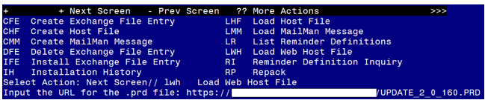

At the Select Action: prompt, enter LWH for Load Web Host File
At the Input the url for the .prd file: prompt, type the following web address:
https://Redacted /UPDATE_2_0_160.PRD

You should see a message at the top of your screen that the file loaded successfully

Search and locate an entry titled UPDATE_2_0_160 VA-AES ACUTE INPATIENT NSG SHIFT ASSESSMENT in reminder exchange.
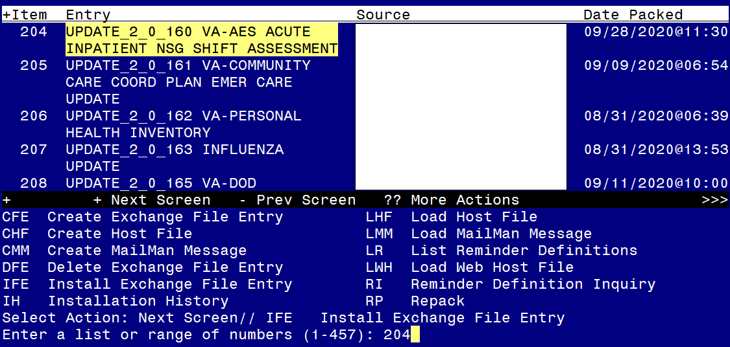
At the Select Action prompt, enter IFE for Install Exchange File Entry
Enter the number that corresponds with your entry UPDATE_2_0_160 VA-AES ACUTE INPATIENT NSG SHIFT ASSESSMENT (in this example it is entry 204 it will vary by site). The date of the exchange file should be 09/28/2020.

At the Select Action prompt, type IA for Install all Components and hit enter. Select Action: Next Screen// IA Install all Components
You will see several prompts, for all new entries you will choose I to Install.
If you are prompted to Overwrite any existing entries, you can choose O to Overwrite.

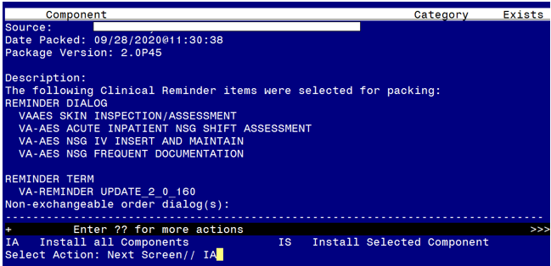
You will be prompted to install the NEXT reminder dialog component –
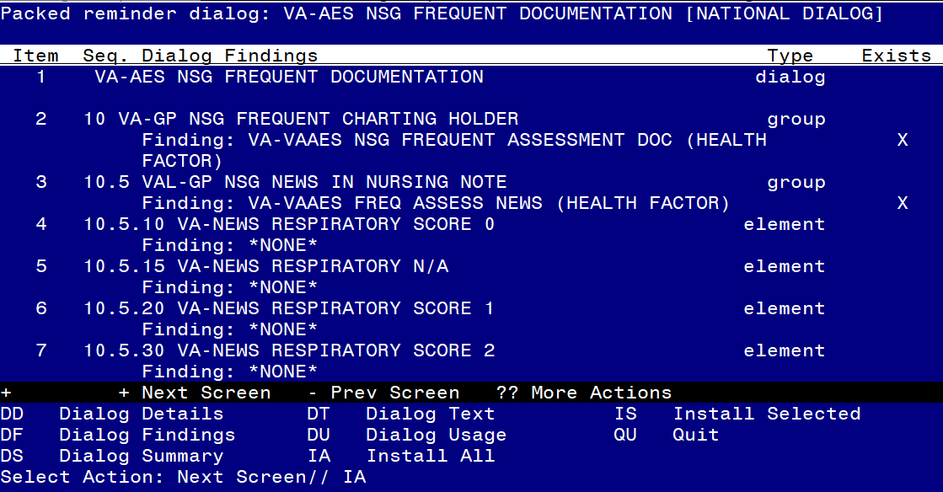
At the Select Action prompt, type IA to install the dialog – VA-AES NSG FREQUENT DOCUMENTATION
Select Action: Next Screen// IA Install All
Install reminder dialog and all components with no further changes: Y// Yes
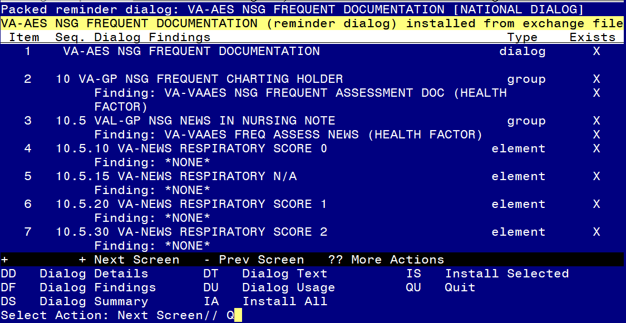

After completing this dialog install, you will type Q.

You will be prompted to install the first reminder dialog component –
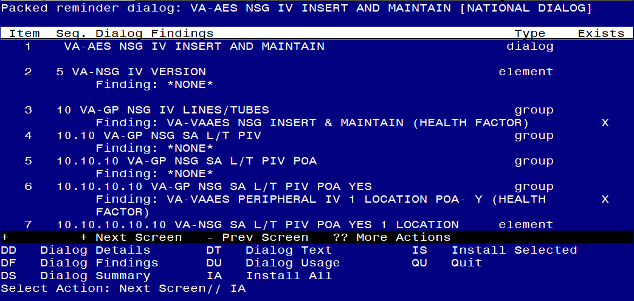
At the Select Action prompt, type IA to install the dialog – VA-AES NSG IV INSERT AND MAINTAIN
Select Action: Next Screen// IA Install All
Install reminder dialog and all components with no further changes: Y// Yes
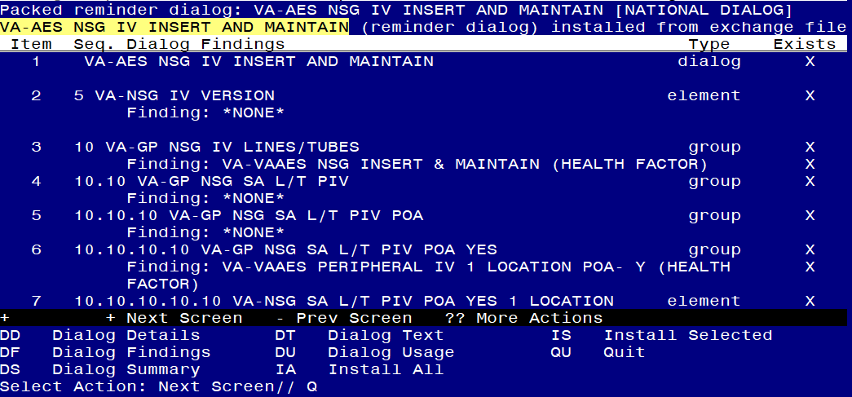

After completing this dialog install, you will type Q.

You will be prompted to install the next reminder dialog component –
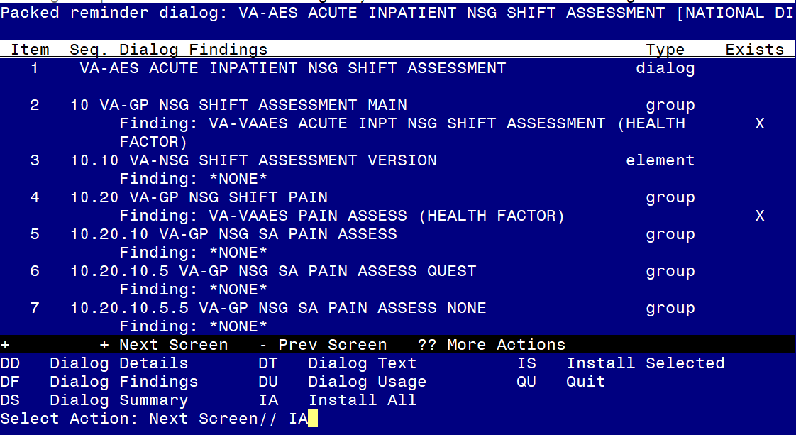
At the Select Action prompt, type IA to install the dialog – VA-AES ACUTE INPATIENT NSG SHIFT ASSESSMENT
Select Action: Next Screen// IA Install All
Install reminder dialog and all components with no further changes: Y// Yes
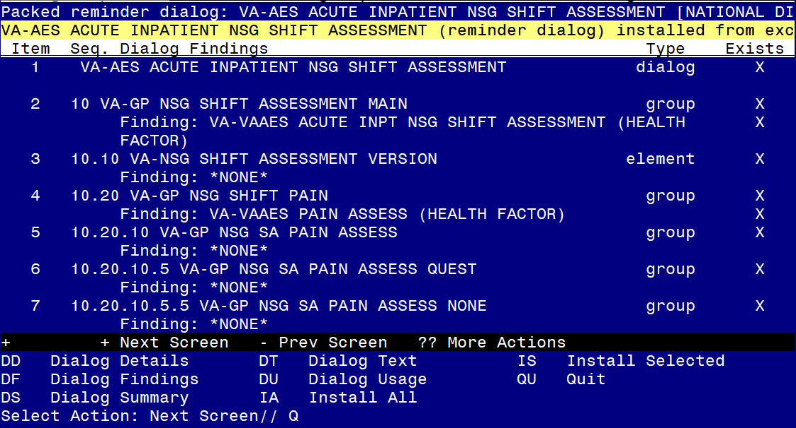

After completing this dialog install, you will type Q.

You will be prompted to install the LAST reminder first dialog component –
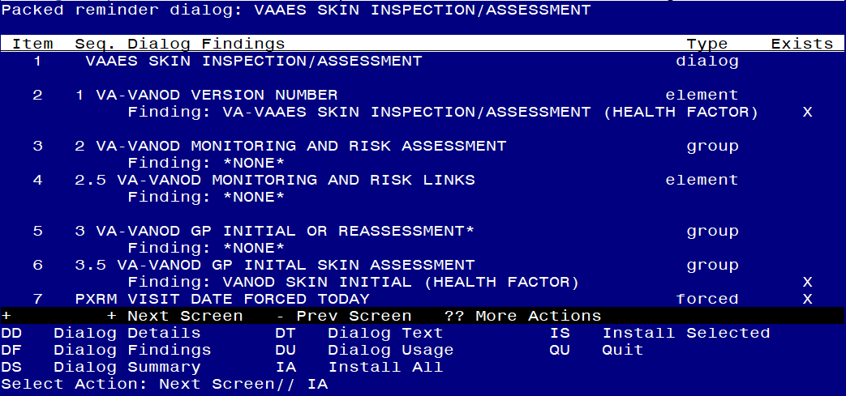
At the Select Action prompt, type IA to install the dialog –VAAES SKIN INSPECTION/ASSESSMENT
Select Action: Next Screen// IA Install All
Install reminder dialog and all components with no further changes: Y// Yes
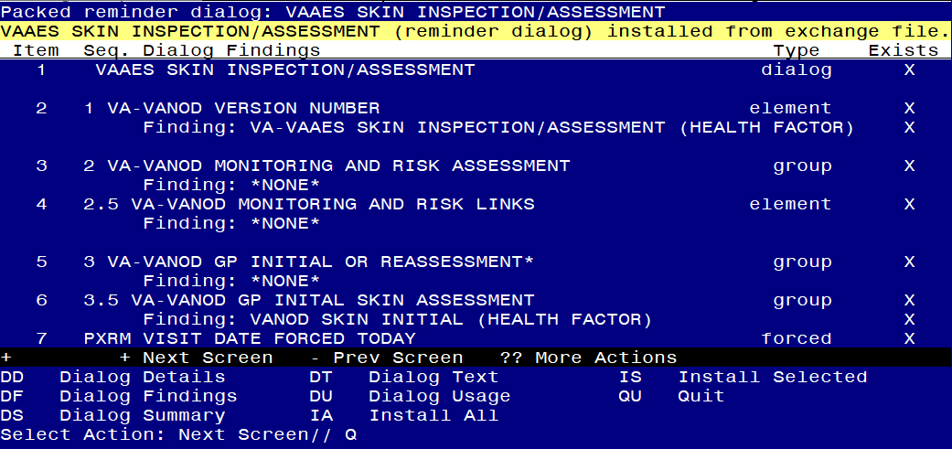
After completing this dialog install, you will type Q.

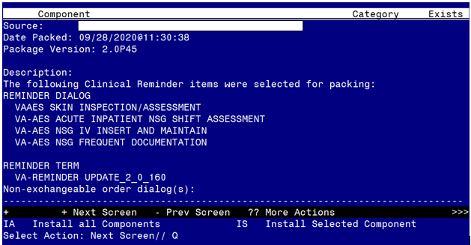
You will then be returned to this screen. At the Select Action prompt, type Q.
Install complete.

Post Installation Of the Bundle
This section contains the post-installation instructions for all four of the reminder dialogs included in this bundle. If your site does not have acute inpatient units and your facility will only be using the VAAES SKIN INSPECTION/ASSESSMENT dialog, please skip this section and refer to the Post Installation of VAAES Skin Inspection/Assessment Only section.
- TIU template field hyperlink Update Needed. Update the TIU template field VA-WEBLINK RN LIBRARY with the following hyperlink: https://www.va.gov/LIBRARY/Subject/Nursing.asp. (An OVID Login is required.) 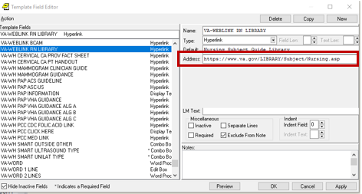
This link is located in the VA-AES ACUTE INPATIENT NSG SHIFT ASSESSMENT in the “Adult Education: If standalone note NOT being utilized Click here” under Summary of Education Provided in the template.

- Create the following local note titles:
- VAAES ACUTE INPATIENT NSG SHIFT ASSESSMENT and map it to the VHA Enterprise Standard Title of NURSING INPATIENT NOTE.
- VAAES NURSING FREQUENT DOCUMENTATION and map it to the VHA Enterprise Standard Title of NURSING INPATIENT NOTE.
- VAAES NSG IV INSERTION AND MAINTENANCE and map it to the VHA Enterprise Standard Title of NURSING NOTE.
- VAAES SKIN INSPECTION/ASSESSMENT and map it to the VHA Enterprise Standard Title of NURSING NOTE.
Note: Comprehensive information on Creating Document Definitions can be found beginning on page 47 of the TIU/ASU Implementation Guide.

- Link the dialogs to the appropriate progress note titles.
From the Reminders Manager Menu:

Select Reminder Managers Menu Option: CP CPRS Reminder Configuration

CA Add/Edit Reminder Categories
CL CPRS Lookup Categories
CS CPRS Cover Sheet Reminder List
MH Mental Health Dialogs Active
PN Progress Note Headers
RA Reminder GUI Resolution Active
TIU TIU Template Reminder Dialog Parameter
DEVL Evaluate Coversheet List on Dialog Finish
DL Default Outside Location
PT Position Reminder Text at Cursor
LINK Link Reminder Dialog to Template
TEST CPRS Coversheet Time Test
NP New Reminder Parameters
GEC GEC Status Check Active
WH WH Print Now Active

Select CPRS Reminder Configuration <TEST ACCOUNT> Option: LINK Link Reminder Dialog to Template

Select Dialog Definition: VA-AES ACUTE INPATIENT NSG SHIFT ASSESSMENT reminder dialog NATIONAL
...OK? Yes// (Yes)

Enter template name: VAAES Acute Inpatient Nsg Shift Assessment

Link template to Document Title? Y YES

Select Document Definition: VAAES ACUTE INPATIENT NSG SHIFT ASSESSMENT TITLE
Std Title: NURSING INPATIENT NOTE
Template VAAES Acute Inpatient Nsg Shift Assessment created
Template VAAES Acute Inpatient Nsg Shift Assessment added to Shared Folder.
Template VAAES Acute Inpatient Nsg Shift Assessment link to note title VAAES ACUTE INPATIENT NSG SHIFT ASSESSMENT

CA Add/Edit Reminder Categories
CL CPRS Lookup Categories
CS CPRS Cover Sheet Reminder List
MH Mental Health Dialogs Active
PN Progress Note Headers
RA Reminder GUI Resolution Active
TIU TIU Template Reminder Dialog Parameter
DEVL Evaluate Coversheet List on Dialog Finish
DL Default Outside Location
PT Position Reminder Text at Cursor
LINK Link Reminder Dialog to Template
TEST CPRS Coversheet Time Test
NP New Reminder Parameters
GEC GEC Status Check Active
WH WH Print Now Active

Select CPRS Reminder Configuration <TEST ACCOUNT> Option: LINK Link Reminder Dialog to Template

Select Dialog Definition: VA-AES NSG FREQUENT DOCUMENTATION reminder dialog NATIONAL
...OK? Yes// (Yes)

Enter template name: VAAES Nursing Frequent Documentation

Link template to Document Title? Y YES

Select Document Definition: VAAES NURSING FREQUENT DOCUMENTATION TITLE
Std Title: NURSING INPATIENT NOTE
Template VAAES Nursing Frequent Documentation created
Template VAAES Nursing Frequent Documentation added to Shared Folder.
Template VAAES Nursing Frequent Documentation link to note title VAAES NURSING FREQUENT DOCUMENTATION

CA Add/Edit Reminder Categories
CL CPRS Lookup Categories
CS CPRS Cover Sheet Reminder List
MH Mental Health Dialogs Active
PN Progress Note Headers
RA Reminder GUI Resolution Active
TIU TIU Template Reminder Dialog Parameter
DEVL Evaluate Coversheet List on Dialog Finish
DL Default Outside Location
PT Position Reminder Text at Cursor
LINK Link Reminder Dialog to Template
TEST CPRS Coversheet Time Test
NP New Reminder Parameters
GEC GEC Status Check Active
WH WH Print Now Active

Select CPRS Reminder Configuration <TEST ACCOUNT> Option: LINK Link Reminder Dialog to Template

Select Dialog Definition: VA-AES NSG IV INSERT AND MAINTAIN reminder dialog NATIONAL
...OK? Yes// (Yes)

Enter template name: VAAES Nsg IV Insertion and Maintenance

Link template to Document Title? Y YES

Select Document Definition: VAAES NSG IV INSERTION AND MAINTENANCE TITLE
Std Title: NURSING INPATIENT NOTE
Template VAAES Nsg IV Insertion and Maintenance created
Template VAAES Nsg IV Insertion and Maintenance added to Shared Folder.
Template VAAES Nsg IV Insertion and Maintenance link to note title VAAES NSG IV INSERTION AND MAINTENANCE
CA Add/Edit Reminder Categories
CL CPRS Lookup Categories
CS CPRS Cover Sheet Reminder List
MH Mental Health Dialogs Active
PN Progress Note Headers
RA Reminder GUI Resolution Active
TIU TIU Template Reminder Dialog Parameter
DEVL Evaluate Coversheet List on Dialog Finish
DL Default Outside Location
PT Position Reminder Text at Cursor
LINK Link Reminder Dialog to Template
TEST CPRS Coversheet Time Test
NP New Reminder Parameters
GEC GEC Status Check Active
WH WH Print Now Active

Select CPRS Reminder Configuration <TEST ACCOUNT> Option: LINK Link Reminder Dialog to Template

Select Dialog Definition: VAAES SKIN INSPECTION/ASSESSMENT reminder dialog NATIONAL
...OK? Yes// (Yes)

Enter template name: VAAES Skin Inspection/Assessment

Link template to Document Title? Y YES

Select Document Definition: VAAES SKIN INSPECTION/ASSESSMENT TITLE
Std Title: NURSING INPATIENT NOTE
Template VAAES Skin Inspection/Assessment created
Template VAAES Skin Inspection/Assessment added to Shared Folder.
Template VAAES Skin Inspection/Assessment link to note title VAAES SKIN INSPECTION/ASSESSMENT

3. Using the option, Link Reminder Dialog to Template, link the reminder dialogs to a shared template. At the Link template to Document Title? Prompt, type “No”.

Select Reminder Managers Menu <TEST ACCOUNT> Option: CP CPRS Reminder Configuration

CA Add/Edit Reminder Categories
CL CPRS Lookup Categories
CS CPRS Cover Sheet Reminder List
MH Mental Health Dialogs Active
PN Progress Note Headers
RA Reminder GUI Resolution Active
TIU TIU Template Reminder Dialog Parameter
DEVL Evaluate Coversheet List on Dialog Finish
DL Default Outside Location
PT Position Reminder Text at Cursor
LINK Link Reminder Dialog to Template
TEST CPRS Coversheet Time Test
NP New Reminder Parameters
GEC GEC Status Check Active
WH WH Print Now Active

Select CPRS Reminder Configuration <TEST ACCOUNT> Option: LINK Link Reminder Dialog to Template

Select Dialog Definition: VA-AES ACUTE INPATIENT NSG SHIFT ASSESSMENT reminder dialog NATIONAL
...OK? Yes// (Yes)

Enter template name: VAAES Acute Inpatient Nsg Shift Assessment

Link template to Document Title? NO
Template VAAES Acute Inpatient Nsg Shift Assessment created
Template VAAES Acute Inpatient Nsg Shift Assessment added to Shared Folder.

CA Add/Edit Reminder Categories
CL CPRS Lookup Categories
CS CPRS Cover Sheet Reminder List
MH Mental Health Dialogs Active
PN Progress Note Headers
RA Reminder GUI Resolution Active
TIU TIU Template Reminder Dialog Parameter
DEVL Evaluate Coversheet List on Dialog Finish
DL Default Outside Location
PT Position Reminder Text at Cursor
LINK Link Reminder Dialog to Template
TEST CPRS Coversheet Time Test
NP New Reminder Parameters
GEC GEC Status Check Active
WH WH Print Now Active

Select CPRS Reminder Configuration <TEST ACCOUNT> Option: LINK Link Reminder Dialog to Template

Select Dialog Definition: VA-AES NSG FREQUENT DOCUMENTATION reminder dialog NATIONAL
...OK? Yes// (Yes)

Enter template name: VAAES Nursing Frequent Documentation

Link template to Document Title? NO
Template VAAES Nursing Frequent Documentation created
Template VAAES Nursing Frequent Documentation added to Shared Folder.

CA Add/Edit Reminder Categories
CL CPRS Lookup Categories
CS CPRS Cover Sheet Reminder List
MH Mental Health Dialogs Active
PN Progress Note Headers
RA Reminder GUI Resolution Active
TIU TIU Template Reminder Dialog Parameter
DEVL Evaluate Coversheet List on Dialog Finish
DL Default Outside Location
PT Position Reminder Text at Cursor
LINK Link Reminder Dialog to Template
TEST CPRS Coversheet Time Test
NP New Reminder Parameters
GEC GEC Status Check Active
WH WH Print Now Active

Select CPRS Reminder Configuration <TEST ACCOUNT> Option: LINK Link Reminder Dialog to Template

Select Dialog Definition: VA-AES NSG IV INSERT AND MAINTAIN reminder dialog NATIONAL
...OK? Yes// (Yes)

Enter template name: VAAES Nsg IV Insertion and Maintenance

Link template to Document Title? NO
Template VAAES Nsg IV Insertion and Maintenance created
Template VAAES Nsg IV Insertion and Maintenance added to Shared Folder.

CA Add/Edit Reminder Categories
CL CPRS Lookup Categories
CS CPRS Cover Sheet Reminder List
MH Mental Health Dialogs Active
PN Progress Note Headers
RA Reminder GUI Resolution Active
TIU TIU Template Reminder Dialog Parameter
DEVL Evaluate Coversheet List on Dialog Finish
DL Default Outside Location
PT Position Reminder Text at Cursor
LINK Link Reminder Dialog to Template
TEST CPRS Coversheet Time Test
NP New Reminder Parameters
GEC GEC Status Check Active
WH WH Print Now Active

Select CPRS Reminder Configuration <TEST ACCOUNT> Option: LINK Link Reminder Dialog to Template

Select Dialog Definition: VAAES SKIN INSPECTION/ASSESSMENT reminder dialog
NATIONAL
...OK? Yes// (Yes)

Enter template name: VAAES Skin Inspection/Assessment

Link template to Document Title? NO
Template VAAES Skin Inspection/Assessment created
Template VAAES Skin Inspection/Assessment added to Shared Folder.
Please Note: When using the new Link Reminder Dialog to Template option, the templates will be added to the bottom of Shared Template. Move the VAAES templates to the appropriate folder in Shared Template.

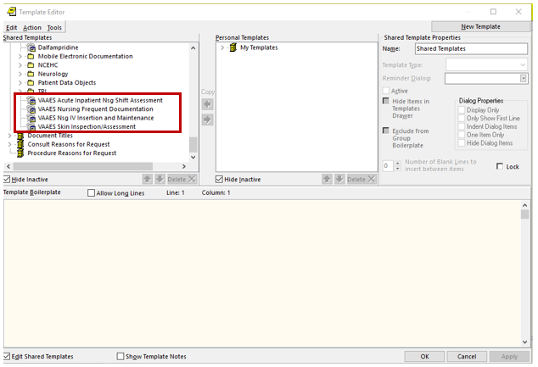

- Review local dialog elements contained within the reminder dialog. Add any quick orders/order menus to your dialogs as needed. Please note, these are local dialog elements that allow you to change the text to accurately reflect your local process or to disable, if appropriate. Using the Vista menu, reminder dialog manager, reminder dialogs, change view to Element view and search for the following elements:
  - Map your local - Speech language pathology consult quick order (or update text to reflect local process) to OI-NSG CONSULT SPEECH element.
  - Map your local Nutrition consult quick order to VAL-VANOD OI NUTRITION CONSULT and VAL-VANOD OI SKIN RISK ORDER NUTRITION
  - Map your local Wound consult quick order to VAL-VANOD OI WOUND and VAL-VANOD OI WOUND CONSULT
  - Review VAL-GP NSG SA NEURO ASPIRATION SLP CONS contains verbiage that Bedside Swallow Test to be conducted by Speech Language Pathologist (not by RN) and launches consult – adjust to different consult or alert as appropriate to reflect your local process.

- Review the Adult Education section with your clinical leadership. You can either keep the entire Adult Education section or you can disable the “Summary of Education Provided” portion of the Adult Education section. You are not able to insert your local education note but can have a stand-alone patient education note for use. If your site will be using a stand-alone education note complete the following steps:
  - Disable dialog group VAL-GP NSG SA ED STAND ALONE. This group contains standardized Education content. If your site is using a local stand-alone education note DISABLE this group.
  - Activate element VAL-NSG SA LOCAL EDUCATION NOTE. VAL-NSG SA LOCAL EDUCATION NOTE is a placeholder for sites to place instructions reflecting that a separate education note will be used. Please Note: Do not disable both VAL-NSG SA LOCAL EDUCATION NOTE and VAL-GP NSG SHIFT EDUCATION. At least one needs to remain available to reflect your current process.

- Embedding Skin Inspection/Assessment into Shift Assessment. A local dialog group VAL-GP NSG SHIFT INTEGUMENTARY EMBEDDED, which is disabled within the VA-AES INPATIENT ACUTE NSG SHIFT ASSESSMENT dialog, is available for sites who wish to embed the VAAES Skin Inspection/Assessment content within the VAAES Inpatient Acute Nsg Shift Assessment. Nursing leadership needs to approve. If your site opts to embed the skin assessment content into the shift assessment, you must thoroughly test dialog load times. If load time is greater than 30 seconds, do not embed the Skin Inspection/Assessment dialog. In addition, performance on all acute inpatient units computers on wheels (COWS) and network connectivity must be verified during testing to ensure that embedding the content has no adverse effect on template performance prior to installing in production.

To embed the Skin Inspection/Assessment into the Shift Assessment:
- Disable VAL-GP NSG SHIFT INTEGUMENTARY STAND ALONE
- Enable the local dialog group VAL-GP NSG SHIFT INTEGUMENTARY EMBEDDED and add the following items in this order below:
1 Element: VA-VANOD VERSION NUMBER
2 Group: VA-VANOD MONITORING AND RISK ASSESSMENT
3 Group: VA-VANOD GP INITIAL OR REASSESSMENT

7. Update/replace all local copies of the VANOD Skin Assessment and Reassessment templates with the new current National template in notes and shared templates.
  - To find where you have used the national reminder dialog groups within your local templates, you can use the Reminder Dialog Search Report (SEA) report under located in the reminder dialog manager, reminder dialog reports option.

Select Reminder Dialog Management <TEST ACCOUNT> Option:^sea Reminder Dialog Search Report

Search for coding system? N// O

Search for Finding Item(s) used in dialog component(s)? N// O

Search for specific Reminder Dialog component(s)? N// y YES

Select Dialog Definition: VA-VANOD GP BRADEN SKIN RISK REASSESSMENT dialog group NATIONAL
...OK? Yes// (Yes)

Select Dialog Definition: VA-VANOD GP BRADEN SKIN RISK ASSESSMENT dialog group NATIONAL
...OK? Yes// (Yes)

Select Dialog Definition:

Search for Reminder Dialog by CPRS parameter(s)? N// O

Display match criteria on the report? N// y YES
Browse or Print? B// p Print
DEVICE: HOME// ;;999 VIRTUAL TELNET

Clinical Reminders Dialogs search report.

Reminder Dialogs:

Dialog: VA-VANOD SKIN INITIAL ASSESSMENT
Match Criteria:
Dialog : VA-VANOD GP BRADEN SKIN RISK ASSESSMENT

Dialog: VA-VANOD SKIN REASSESSMENT
Match Criteria:
Dialog : VA-VANOD GP BRADEN SKIN RISK REASSESSMENT
Dialog: NUR ADMISSION ASSESSMENT
Match Criteria:
Dialog : VA-VANOD GP BRADEN SKIN RISK ASSESSMENT

This report will identify any local templates using the national reminder dialog groups from the old templates. You can edit those local templates and replace the dialog group with these items:
1 Element: VA-VANOD VERSION NUMBER
2 Group: VA-VANOD MONITORING AND RISK ASSESSMENT
3 Group: VA-VANOD GP INITIAL OR REASSESSMENT

Please Note: The VAAES SKIN INSPECTION/ASSESSMENT dialog contains branching logic that will only show the Skin Inspection and Unable to Inspect sections of the template if accessed by a user with the User Class Nursing Assistant. If a nursing assistant accesses and sees the entire template, please verify user class is set to NURSING ASSISTANT.

- Activating National Early Warning Score (NEWS) – If your site is utilizing the National Early Warning Score (NEWS) you must activate the dialog group VAL-GP NSG NEWS IN NURSING NOTE. Confirm with local nursing leadership if your site utilizes NEWS before activating. Please Note: No other local early warning system can be added to this template. Please follow the process for consideration that is documented within the SOP.

Post Installation Of Skin Inspection/Assessment Only
This section only needs to be completed by sites that do not have acute inpatient units and will be utilizing the VAAES Skin Inspection/Assessment template only. This section repeats set up of Skin Inspection/Assessment that was included within the Post Installation of the Bundle and can be skipped if you have already completed the Bundle Post Installation Bundle instructions.
- Create the following local note title: VAAES SKIN INSPECTION/ASSESSMENT and map it to the VHA Enterprise Standard Title of NURSING NOTE.
Note: Comprehensive information on Creating Document Definitions can be found beginning on page 47 of the TIU/ASU Implementation Guide.

- Link the dialogs to the appropriate progress note titles.
From the Reminders Manager Menu:

Select Reminder Managers Menu Option: CP CPRS Reminder Configuration
CA Add/Edit Reminder Categories
CL CPRS Lookup Categories
CS CPRS Cover Sheet Reminder List
MH Mental Health Dialogs Active
PN Progress Note Headers
RA Reminder GUI Resolution Active
TIU TIU Template Reminder Dialog Parameter
DEVL Evaluate Coversheet List on Dialog Finish
DL Default Outside Location
PT Position Reminder Text at Cursor
LINK Link Reminder Dialog to Template
TEST CPRS Coversheet Time Test
NP New Reminder Parameters
GEC GEC Status Check Active
WH WH Print Now Active

Select CPRS Reminder Configuration <TEST ACCOUNT> Option: LINK Link Reminder Dialog to Template

Select Dialog Definition: VAAES SKIN INSPECTION/ASSESSMENT reminder dialog NATIONAL
...OK? Yes// (Yes)

Enter template name: VAAES Skin Inspection/Assessment

Link template to Document Title? Y YES

Select Document Definition: VAAES SKIN INSPECTION/ASSESSMENT TITLE
Std Title: NURSING INPATIENT NOTE
Template VAAES Skin Inspection/Assessment created
Template VAAES Skin Inspection/Assessment added to Shared Folder.
Template VAAES Skin Inspection/Assessment link to note title VAAES SKIN INSPECTION/ASSESSMENT

3. Using the same option, Link Reminder Dialog to Template, link the reminder dialogs to a shared template. At the Link template to Document Title? Prompt, type “No”.

Select Reminder Managers Menu <TEST ACCOUNT> Option: CP CPRS Reminder Configuration

CA Add/Edit Reminder Categories
CL CPRS Lookup Categories
CS CPRS Cover Sheet Reminder List
MH Mental Health Dialogs Active
PN Progress Note Headers
RA Reminder GUI Resolution Active
TIU TIU Template Reminder Dialog Parameter
DEVL Evaluate Coversheet List on Dialog Finish
DL Default Outside Location
PT Position Reminder Text at Cursor
LINK Link Reminder Dialog to Template
TEST CPRS Coversheet Time Test
NP New Reminder Parameters
GEC GEC Status Check Active
WH WH Print Now Active

Select CPRS Reminder Configuration <TEST ACCOUNT> Option: LINK Link Reminder Dialog to Template

Select Dialog Definition: VAAES SKIN INSPECTION/ASSESSMENT reminder dialog
NATIONAL
...OK? Yes// (Yes)

Enter template name: VAAES Skin Inspection/Assessment

Link template to Document Title? NO
Template VAAES Skin Inspection/Assessment created
Template VAAES Skin Inspection/Assessment added to Shared Folder.

Please Note: When using the new Link Reminder Dialog to Template option, the templates will be added to the bottom of Shared Template. Move the VAAES templates to the appropriate folder in Shared Template.

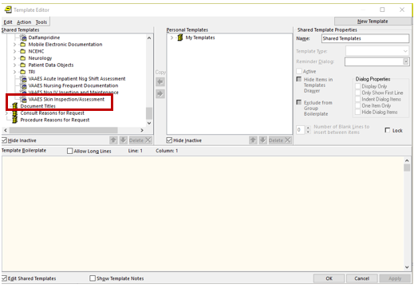

- If you were not prompted during the install to replace with your local consult order, add your local quick orders as finding items to the following elements:
  - Using the Vista menu, reminder dialog manager, reminder dialogs, change view to Element view and search for the following elements:
    - VAL-VANOD OI WOUND CONSULT and VAL-VANOD OI WOUND
      - Replace finding item ORZ CONSULTS with your local consult order for Wound
    - VAL-VANOD OI NUTRITION CONSULT and VAL-VANOD OI SKIN RISK ORDER NUTRITION
      - Replace finding item ORZ CONSULTS with your local consult order for Nutrition

- Update/replace all local copies of the VANOD Skin Assessment and Reassessment templates with the new current National template in notes and shared templates.
- To find where you have used the national reminder dialog groups within your local templates, you can use the Reminder Dialog Search Report (SEA) report under located in the reminder dialog manager, reminder dialog reports option.

Select Reminder Dialog Management <TEST ACCOUNT> Option:^sea Reminder Dialog Search Report

Search for coding system? N// O

Search for Finding Item(s) used in dialog component(s)? N// O

Search for specific Reminder Dialog component(s)? N// y YES

Select Dialog Definition: VA-VANOD GP BRADEN SKIN RISK REASSESSMENT dialog group NATIONAL
...OK? Yes// (Yes)

Select Dialog Definition: VA-VANOD GP BRADEN SKIN RISK ASSESSMENT dialog group NATIONAL
...OK? Yes// (Yes)

Select Dialog Definition:

Search for Reminder Dialog by CPRS parameter(s)? N// O

Display match criteria on the report? N// y YES
Browse or Print? B// p Print
DEVICE: HOME// ;;999 VIRTUAL TELNET

Clinical Reminders Dialogs search report.

Reminder Dialogs:

Dialog: VA-VANOD SKIN INITIAL ASSESSMENT
Match Criteria:
Dialog : VA-VANOD GP BRADEN SKIN RISK ASSESSMENT

Dialog: VA-VANOD SKIN REASSESSMENT
Match Criteria:
Dialog : VA-VANOD GP BRADEN SKIN RISK REASSESSMENT

Dialog: NUR ADMISSION ASSESSMENT
Match Criteria:
Dialog : VA-VANOD GP BRADEN SKIN RISK ASSESSMENT

This report will identify any local templates using the national reminder dialog groups from the old templates. You can edit those local templates and replace the dialog group with these items:
1 Element: VA-VANOD VERSION NUMBER
2 Group: VA-VANOD MONITORING AND RISK ASSESSMENT
3 Group: VA-VANOD GP INITIAL OR REASSESSMENT

Please Note: The VAAES SKIN INSPECTION/ASSESSMENT dialog contains branching logic that will only show the Skin Inspection and Unable to Inspect sections of the template if accessed by a user with the User Class Nursing Assistant. If a nursing assistant accesses and sees the entire template, please verify user class is set to NURSING ASSISTANT.

