Update _2_0_162

Clinical Reminders

VA-Personal Health Inventory Dialog
Install Guide

September 2020

Product Development
Office of Information Technology
Department of Veterans Affairs

Table of Contents
Introduction 1
Install Details 10
Install Example 10
Post Installation 17

Introduction
The personal health inventory is a tool used within VHA to support the whole health approach to care. This inventory allows wellbeing instructors and providers to work with Veterans in exploring the components of health and wellbeing. It is a self-exploration tool that assesses where a Veteran might want to prioritize setting goals and gaining skills and educate to support their health and wellbeing. This information is crucial to forming a therapeutic relationship with the Veteran and formulating a personal health plan for their healthcare.

UPDATE_2_0_162 contains 1 Reminder Exchange entry:
UPDATE_2_0_162 VA-PERSONAL HEALTH INVENTORY

The exchange file contains the following components:
HEALTH FACTORS
VA-REMINDER UPDATES
VA-UPDATE_2_0_162
VA-PERSONAL HEALTH INVENTORY
VA-PHI REFLECTIONS AREAS TO WORK ON
VA-PHI REFLECTIONS VISION BEST SELF
VA-PHI PROFESSIONAL CARE TO BE
VA-PHI PROFESSIONAL CARE NOW
VA-PHI POWER OF MIND TO BE
VA-PHI POWER OF MIND NOW
VA-PHI SURROUNDINGS TO BE
VA-PHI SURROUNDINGS NOW
VA-PHI SPIRIT AND SOUL TO BE
VA-PHI SPIRIT AND SOUL NOW
VA-PHI FAMILY AND FRIENDS TO BE
VA-PHI FAMILY AND FRIENDS NOW
VA-PHI PERSONAL DEVELOPMENT TO BE
VA-PHI PERSONAL DEVELOPMENT NOW
VA-PHI FOOD AND DRINK TO BE
VA-PHI FOOD AND DRINK NOW
VA-PHI RECHARGE TO BE
VA-PHI RECHARGE NOW
VA-PHI WORKING THE BODY TO BE
VA-PHI WORKING THE BODY NOW
VA-PHI DAY TO DAY LIFE WHY
VA-PHI DAY TO DAY LIFE
VA-PHI PHYSICAL WELL BEING WHY
VA-PHI PHYSICAL WELL BEING
VA-PHI MENTAL/EMOTIONAL WELL BEING WHY
VA-PHI MENTAL/EMOTIONAL WELL BEING
VA-PHP
VA-PHP MAP
REMINDER SPONSOR
Office of Patient Centered Care and Cultural Transformation

REMINDER TERM
VA-REMINDER UPDATE_2_0_162

REMINDER DIALOG
VA-PERSONAL HEALTH INVENTORY (PHI) NOTE

TIU DOCUMENT DEFINITION
PERSONAL HEALTH INVENTORY OBJ

Install Details

This update is being distributed as a web host file. The address for the host file is:

The file will be installed using Reminder Exchange, programmer access is not required.

Installation:
=============
This update can be loaded with users on the system. Installation will take less than 20 minutes.

Install Example
To Load the Web Host File. Navigate to Reminder exchange in Vista

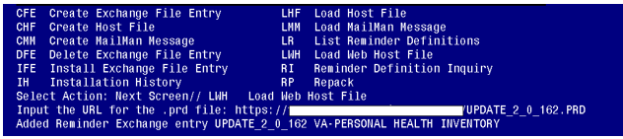

At the Select Action: prompt, enter LWH for Load Web Host File
At the Input the URL for the .prd file: prompt, type the following web address:
https://Redact/UPDATE_2_0_162.PRD

You should see a message at the top of your screen that the file successfully loaded.

Search and locate an entry titled UPDATE_2_0_162 in reminder exchange.

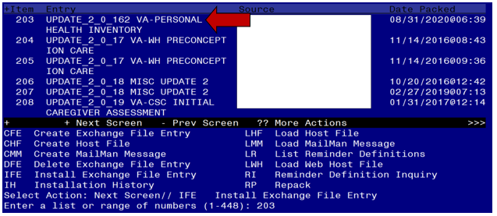
At the Select Action prompt, enter IFE for Install Exchange File Entry
Enter the number that corresponds with your entry UPDATE_2_0_162(in this example it is entry 203. It will vary by site). The date of the exchange file should be 8/31/2020.

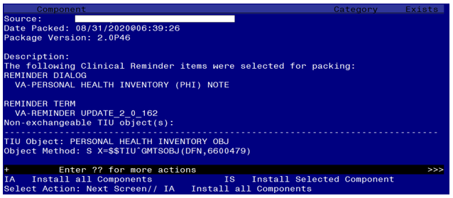

At the Select Action prompt, type IA for Install all Components and hit enter.
Select Action: Next Screen// IA Install all Components
You will see several prompts, for all new entries you will choose I to Install
For components that already exists but the packed component is different, you will choose S to Skip.

You will be promped to install the reminder dialog component (VA-PERSONAL HEALTH INVENTORY (PHI) NOTE
- You will choose to install all.

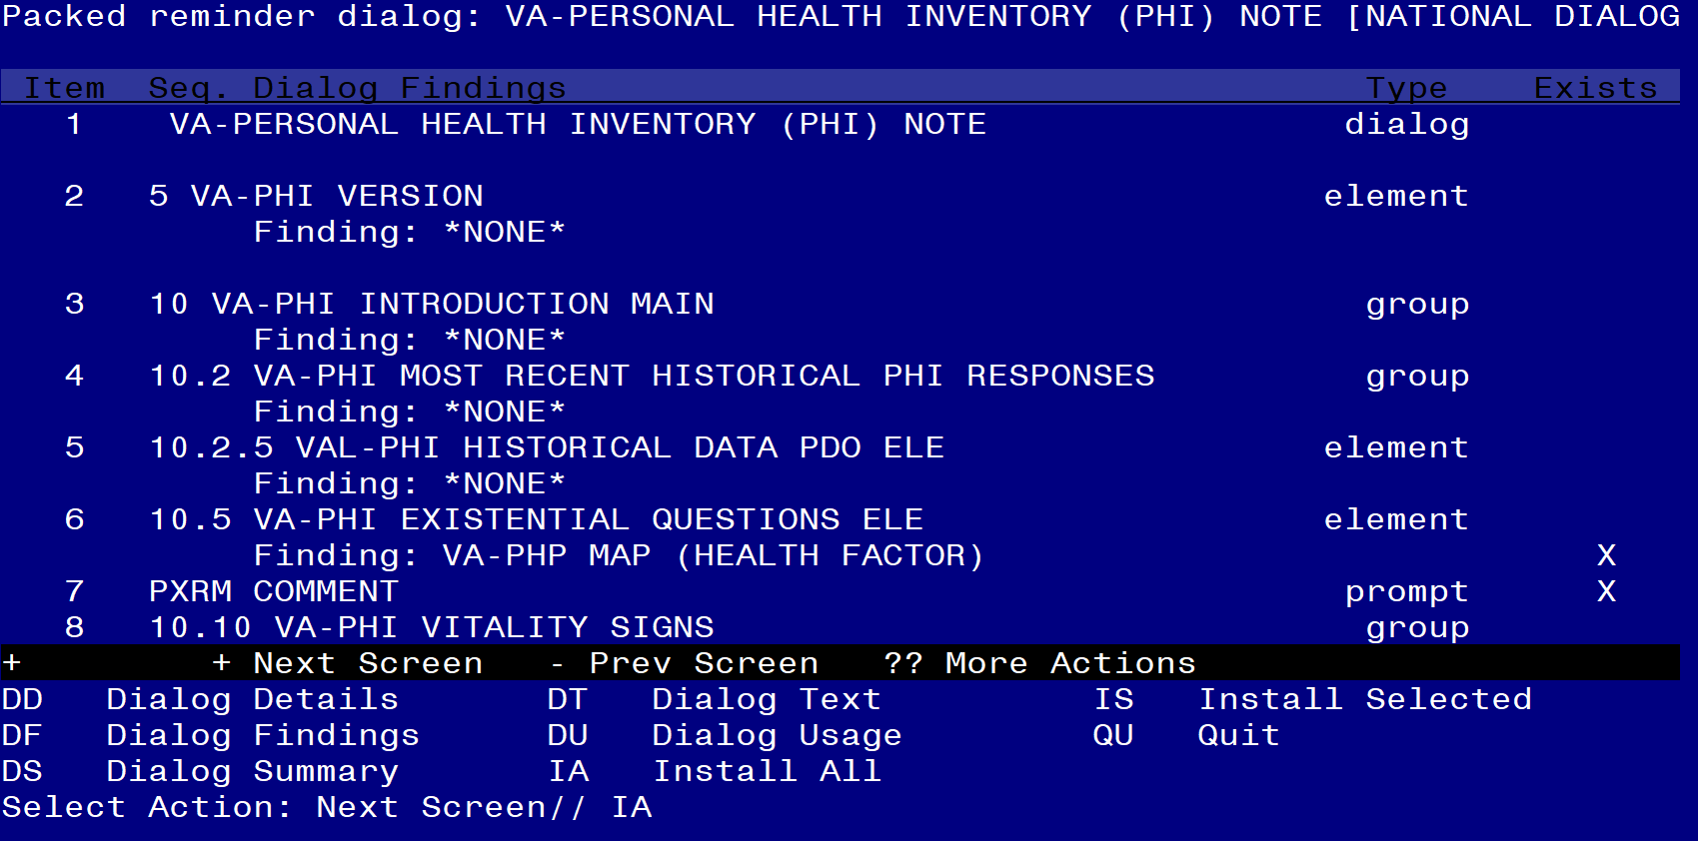

At the Select Action prompt, type IA to install the dialog – VA-PERSONAL HEALTH INVENTORY (PHI) NOTE
Select Action: Next Screen// IA Install All
Install reminder dialog and all components with no further changes: Y// Yes

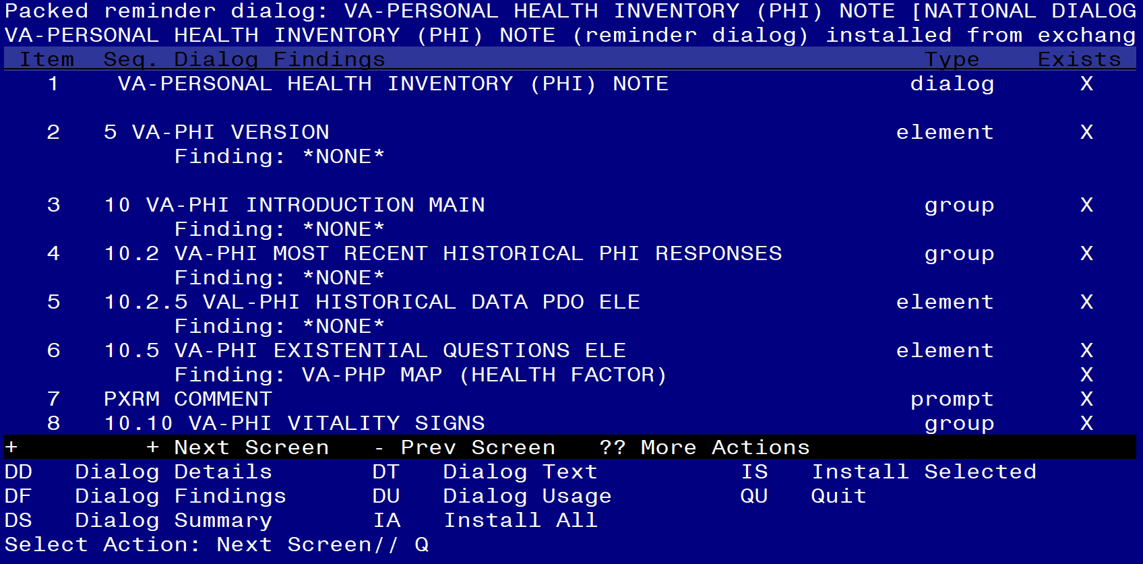

After completing this dialog install, you will type Q.
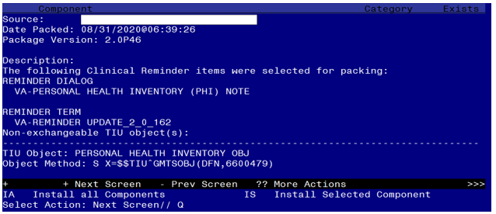

You will then be returned to this screen. At the Select Action prompt, type Q.

Install complete.

Post Installation

- Setup of specific Note title
The new note title that needs to be created is:

PERSONAL HEALTH INVENTORY NOTE

VHA Enterprise Standard Title: INTEGRATIVE HEALTH NOTE

Note: Comprehensive information on Creating Document Definitions can be found beginning on page 47 of the TIU/ASU Implementation Guide

- Make the Dialogs able to be attached to a Personal/Shared template or to a progress note title.

From the Reminders Manager Menu:
Select Reminder Managers Menu Option: CP CPRS Reminder Configuration
CA Add/Edit Reminder Categories
CL CPRS Lookup Categories
CS CPRS Cover Sheet Reminder List
MH Mental Health Dialogs Active
PN Progress Note Headers
RA Reminder GUI Resolution Active
TIU TIU Template Reminder Dialog Parameter
DL Default Outside Location
PT Position Reminder Text at Cursor
Select CPRS Reminder Configuration Option: TIU TIU Template Reminder Dialog Parameter
Reminder Dialogs allowed as Templates may be set for the following:
1 User USR [choose from NEW PERSON]
3 Service SRV [choose from SERVICE/SECTION]
4 Division DIV [choose from INSTITUTION]
5 System SYS [NATREM.FO-SLC.MED.VA.GOV]
Enter selection: 5 Choose the appropriate number for your site. Your site may do this by System or other levels. The example below uses SYSTEM level

Setting Reminder Dialogs allowed as Templates for System:
Select Display Sequence: ?

148 VA-VETERANS CHOICE NOTE
149 VA-TBI SCREENING
When you type a question mark above, you will see the list of #’s (with dialogs) that are already taken. Choose a number NOT on this list. For this example, looking above I see the number 150 is not present, so I will use 150.
Select Display Sequence: 150
Are you adding 150 as a new Display Sequence? Yes// Y YES
Display Sequence: 150// <Enter> 150
Clinical Reminder Dialog: VA-PERSONAL HEALTH INVENTORY (PHI) NOTE
then <enter> reminder dialog NATIONAL
OK? Yes// <Enter> (Yes)

- Associate the new reminder dialogs with a shared template in CPRS
To do this, go to Template Editor, then Shared Templates, select the appropriate folder (if applicable), and choose New Template (top right-hand corner).

Type in the following information:
Name: VA-PERSONAL HEALTH INVENTORY (PHI) NOTE
Template Type: Reminder Dialog
Reminder Dialog: VA-PERSONAL HEALTH INVENTORY (PHI) NOTE

Next, select Apply.

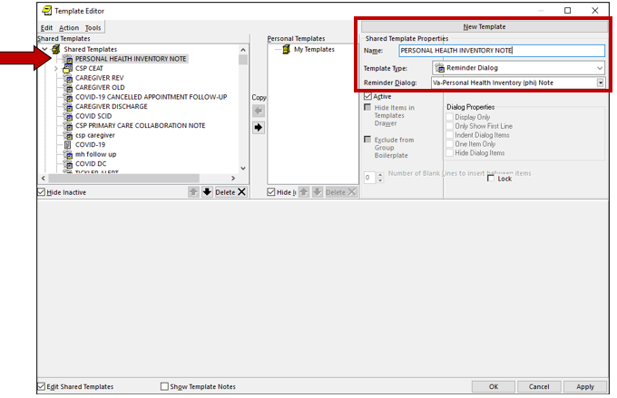

- Associate the reminder dialogs with the note titles in CPRS
To do this, go to Template Editor, then Document Titles, select the appropriate folder (if applicable), and choose New Template (top right-hand corner).

- Type in the following information:
Name: PERSONAL HEALTH INVENTORY NOTE
Template Type: Reminder Dialog
Reminder Dialog: VA-PERSONAL HEALTH INVENTORY (PHI) NOTE

Next, type in the Associated Title, which in this case is PERSONAL HEALTH INVENTORY NOTE and click APPLY.

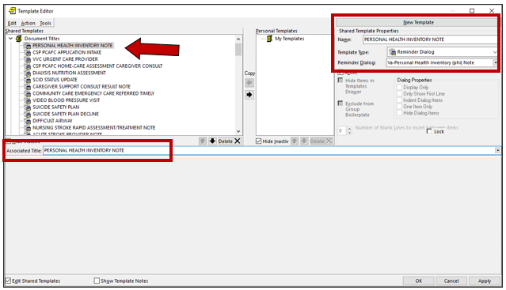

- Create PERSONAL HEALTH INVENTORY TIU Object

- Begin on the TIU Maintenance Menu

1 TIU Parameters Menu ...
2 Document Definitions (Manager) ...
3 User Class Management ...
4 TIU Template Mgmt Functions ...
5 TIU Alert Tools
6 Active Title Cleanup Report
7 TIUHL7 Message Manager
8 Title Mapping Utilities ...
9 Text Event Edit
10 Unauthorized Abbreviations (Enter/Edit)
11 List Unauthorized Abbreviations
13 Contingency Downtime Bookmark Progress Notes
Select TIU Maintenance Menu <TEST ACCOUNT> Option: 2 Document Definitions Manager)

--- Manager Document Definition Menu ---

1 Edit Document Definitions
2 Sort Document Definitions
3 Create Document Definitions
4 Create Objects
5 Create TIU/Health Summary Objects
6 Create Post-Signature Alerts

Select Document Definitions (Manager) <TEST ACCOUNT> Option: 5 Create TIU/Healt
h Summary Objects

TIU Health Summary Object Aug 31, 2020@09:18:04 Page: 1 of 30

TIU Object Name Health Summary Type
1 550 PAP RESULTS 1/NO TIME LIMIT 550 PAP RESULTS 1
2 ABDOMINAL GIRTH ABDOMINAL GIRTH
3 ACTIVE MEDICATIONS ACTIVE MEDICATIONS
4 ADMISSIONS PAST YR ADMISSIONS PAST YR
5 AH-BPR ABG;1;2Y AH-BPR ABG;1;2Y
6 AH-BPR ACTIVE PROBLEMS AH-BPR ACTIVE PROBLEMS
7 AH-BPR AUDIT-C AH-BPR AUDIT-C
8 AH-BPR CBC W/DIFF;1;2Y AH-BPR CBC W/DIFF;1;2Y
9 AH-BPR CHEST 2 VIEWS;1;2Y AH-BPR CHEST 2 VIEWS;1;2Y
10 AH-BPR CHEST CT;1;2Y AH-BPR CHEST CT;1;2Y
11 AH-BPR DEPRESSION SCREEN AH-BPR DEPRESSION SCREEN
12 AH-BPR ECHO;1;2Y AH-BPR ECHO;1;2Y
13 AH-BPR ENT CONSULT RESULTS;1;2Y AH-BPR ENT CONSULT;1;2Y
14 AH-BPR PC-PTSD PCL AH-BPR PC-PTSD PCL
Create New TIU Object Find
Detailed Display/Edit TIU Object Detailed Display/Edit HS Object
Quit
Select Action: Next Screen// CR Create New TIU Object

--- Create TIU/Health Summary Object ---

Enter a New TIU OBJECT NAME: PERSONAL HEALTH INVENTORY OBJ

Object Name: PERSONAL HEALTH INVENTORY OBJ
Is this correct? YES

Use a pre-existing Health Summary Object? NO

Checking PERSONAL HEALTH INVENTORY OBJ (TIU) with Health Summary...

Creating Health Summary Object 'PERSONAL HEALTH INVENTORY OBJ (TIU)'

Select Health Summary Type: PERSONAL HEALTH INVENTORY OBJ

Are you adding 'PERSONAL HEALTH INVENTORY OBJ' as
a new HEALTH SUMMARY TYPE (the 535th)? No// YES
NAME: PERSONAL HEALTH INVENTORY OBJ Replace <enter>
TITLE: Personal Health Inventory
SUPPRESS PRINT OF COMPONENTS WITHOUT DATA: YES
SUPPRESS SENSITIVE PRINT DATA: 2 NO SSN
LOCK: <enter>
OWNER: CLINICAL COORDINATOR

Do you wish to copy COMPONENTS from an existing Health Summary Type? YES// NO
Select COMPONENT: PROGRESS NOTES SELECTED
SUMMARY ORDER: 5// <enter>
OCCURRENCE LIMIT: 1
TIME LIMIT: <enter>
HEADER NAME: Selected Prog Notes// Last Pers Hlth Invent

No selection items chosen.

Select new items one at a time in the sequence you want them displayed.
You may select any number of items.

Select SELECTION ITEM: PERSONAL HEALTH INVENTORY NOTE
(Enter the note title created in step 1)

Searching for a TIU DOCUMENT DEFINITION TITLE
Std Title: INTEGRATIVE HEALTH NOTE
...OK? Yes// Yes
Select SELECTION ITEM: <enter>
Select COMPONENT: <enter>

Do you wish to review the Summary Type structure before continuing? NO
Please hold on while I resequence the summary order.

Do you want to overwrite the TIME LIMITS in the Health
Summary Type 'PERSONAL HEALTH INVENTORY OBJ'? NO

Print standard Health Summary Header with the Object? NO

Partial Header:
Print Report Date? NO
Print Confidentiality Banner? NO
Print Report Header? NO
Print the standard Component Header? Y// NO
Print the date a patient was deceased? NO

Print a LABEL before the Health Summary Object? NO

Suppress Components without Data? N// YES

Overwrite No Data Available Message : // No previous note

OBJECT DESCRIPTION:
Edit? NO// <enter>

Create a TIU Object named: PERSONAL HEALTH INVENTORY OBJ

Ok? YES

TIU Object created successfully.

