Update_2_0_164

Clinical Reminders

VA-MISC Update 12

Install Guide

October 2020

Product Development
Office of Information Technology
Department of Veterans Affairs

Table of Contents
Introduction 1
Install Details 4
Install Example 4
Post Installation 8

Introduction

This update contains several minor spelling and other changes to existing clinical reminder content, a full list of the changes can be found here: REDACTED

UPDATE_2_0_164 contains 1 Reminder Exchange entry:
UPDATE_2_0_164 VA-MISC UPDATE 12

The exchange file contains the following components:

TIU TEMPLATE FIELD
VA-TECS OD/OS/OU
IM VIS HBV URL
IM VIS HAV URL
IM VIS HBV DT
IM VIS HAV DT
VA-TECS BP/SG/CHL
TEXT (6 CHAR)

HEALTH FACTORS
VA-HEALTH AND WELL BEING [C]
VA-WHS - NATIVE AMERICAN HEALING
VA-WHS - FUNCTIONAL NUTRITION
VA-WHS - MAP TO THE MAP
VA-WHS - INTRODUCTION TO WHOLE HEALTH
VA-WHS - CHANGING THE CONVERSATION
VA-WHS - PERSONAL HEALTH INVENTORY
VA-WHS - PERSONAL HEALTH PLANNING
VA-WHS - AROMATHERAPY
VA-WHS - WHOLE HEALTH EDUCATION
VA-WHS - YOGA
VA-WHS - WHOLE HEALTH COACHING
VA-WHS - THERAPEUTIC OR HEALING TOUCH
VA-WHS - TAI CHI
VA-WHS - RELAXATION TECHNIQUES
VA-WHS - REIKI
VA-WHS - MINDFULNESS OTHER THAN MBSR
VA-WHS - MEDITATION
VA-WHS - MINDFULNESS BASED STRESS REDUCE
VA-WHS - INTEGRATIVE HEALTH
VA-WHS - BFA
VA-WHS - TAKING CHARGE LIFE AND HEALTH
VA-WHS - GUIDED IMAGERY
VA-WHS - QI GONG
VA-WHS - EXPRESSIVE ARTS
VA-REMINDER UPDATES
VA-UPDATE_2_0_164
VA-TECS TECHNICIAN
VA-TECS EYE MEDS-OTHER
VA-TECS EYE MEDS-ACETAZ METHAZOLAMIDE
VA-TECS EYE MEDS-PREDNISOLONE 1%
VA-TECS EYE MEDS-DICLOFENACE KETOROLAC
VA-TECS EYE MEDS-NEO POLYDEX
VA-TECS EYE MEDS-GENTAMICIN
VA-TECS EYE MEDS-POLYTRIM
VA-TECS EYE MEDS-VIGAMOX CILOXAN
VA-TECS EYE MEDS-SIMBRINZA
VA-TECS EYE MEDS-COSOPT
VA-TECS EYE MEDS-DORZALAMIDE
VA-TECS EYE MEDS-LEVOBUNOLOL TIMOLOL
VA-TECS EYE MEDS-LATANOPROST TRAVATAN
VA-TECS EYE MEDS-AREDS VITAMIN
VA-TECS EYE MEDS-LUBRICATING OINT
VA-TECS EYE MEDS-ARTIFICIAL TEARS
VA-TECS EYE MEDS-NONE
VA-BFA CATEGORY
VA-BFA COMPLICATIONS
VA-BFA ALL POINTS USED
VA-BENE ALS REASON
VA-BENE SM ALS OPEN CENTRAL LINE
VA-BENE SM ALS INTRAOUSSEOUS LINE
VA-STAR ABC CARD
VA-ABC SEVERITY EXTREME
VA-ABC SEVERITY VERY
VA-ABC SEVERITY MODERATE
VA-ABC SEVERITY MILD
VA-ABC SEVERITY NOT AT ALL
VA-TECS PROVIDER
VA-TECS EYE DM PDR RSLT
VA-TECS EYE DM CSME RSLT
VA-TECS EYE DM SEV RSLT
VA-TECS EYE DM MOD RSLT
VA-TECS EYE DM MILD RSLT
VA-TECS EYE CAT SURG HIGH RISK YES
VA-TECS EYE CAT LENS-PSEUDO YES
VA-TECS EYE PINGEUCULA
VA-TECS GLAUC PROVIDER
VA-TECS RISK IOP
VA-MCC DELIVERY INFORMATION (C)
VA-MCC DELIVERY DATE
VA-TH VVC
VA-TH VVC NO DEVICE AND/OR BROADBAND
VA-TH VVC NOT CAPABLE
VA-TH VVC CONFIRMED
VA-TH VVC TEST PENDING

REMINDER SPONSOR
NATIONAL CENTER FOR HEALTH PROMOTION AND DISEASE PREVENTION (NCP)
VA National Center for Health Promotion and Disease Prevention (NCP)
Office of Patient Care Services
Office of Telehealth Services Store and Forward Telehealth
Office of Nursing Service
WOMEN VETERANS HEALTH PROGRAM
Office of Connected Care

REMINDER TAXONOMY
VA-PNEUMOC DZ RISK - CHEMOTHERAPY
VA-IHD AND ASVD
VA-STATIN-ESRD

REMINDER LOCATION LIST
VA-TH 179 ENCOUNTERS

REMINDER TERM
VA-HEALTH AND WELL BEING
VA-CHEMO/IMMUNOSUPPRESSIVE DRUGS
VA-PNEUMOC DZ RISK - CHEMO/IMMUNOSUPP DRUGS
VA-REMINDER UPDATE_2_0_164
VA-TH VVC NOT CAPABLE
VA-TH VVC CONFIRMED
VA-TH VVC ENCOUNTERS
VA-TH VVC CAPABLE
VA-TH VVC TEST PENDING

REMINDER DEFINITION
VA-TH BL VVC CAPABLE
VA-TH VVC CAPABLE INFORMATION

REMINDER DIALOG
VA-GP MISC UPDATE 12
VA-TH VVC CAPABILITY ASSESSMENT

Install Details

This update is being distributed as a web host file. The address for the host file is: https://Redacted/UPDATE_2_0_164.PRD

The file will be installed using Reminder Exchange, programmer access is not required.

Installation:
=============
This update can be loaded with users on the system. Installation will take less than 20 minutes.

Install Example
To Load the Web Host File. Navigate to Reminder exchange in Vista
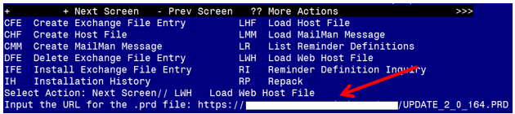

At the Select Action: prompt, enter LWH for Load Web Host File
At the Input the url for the .prd file: prompt, type the following web address:
https://Redacted /UPDATE_2_0_164.PRD

You should see a message at the top of your screen that the file successfully loaded.

Search for and locate the reminder exchange entry titled UPDATE_2_0_164 VA-MISC UPDATE 12. 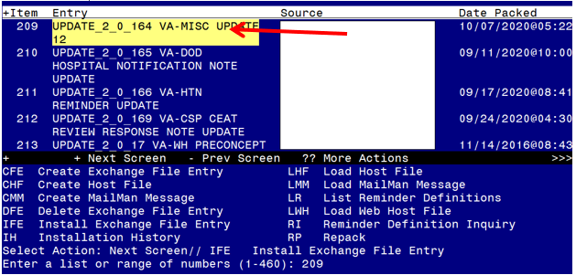

At the Select Action prompt, enter IFE for Install Exchange File Entry
Enter the number that corresponds with your entry titled UPDATE_2_0_164 VA-MISC UPDATE 12 (in this example it is entry 209, it will vary by site). The exchange file date should be 10/07/2020.

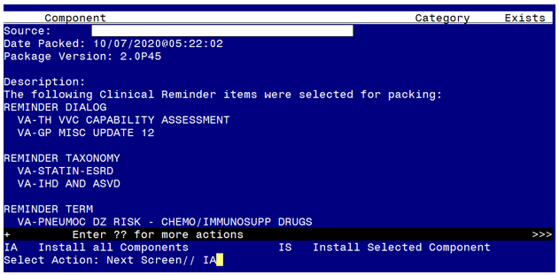

At the Select Action prompt, type IA for Install all Components and hit enter.
Select Action: Next Screen// IA Install all Components

During the installation, you will see several prompts:
You will choose I to INSTALL all new components
You will choose O to OVERWRITE all existing components that have changed
There is one exception, IF you are prompted to overwrite the reminder location list,
VA-TH 179 ENCOUNTERS, choose S to Skip.

REMINDER LOCATION LIST entry named VA-TH 179 ENCOUNTERS already exists
but the packed component is different, what do you want to do?
Select one of the following:
C Create a new entry by copying to a new name
O Overwrite the current entry
U Update
Q Quit the install
S Skip, do not install this entry
Enter response: O// Skip, do not install this entry

You will be promped to install the FIRST dialog component:
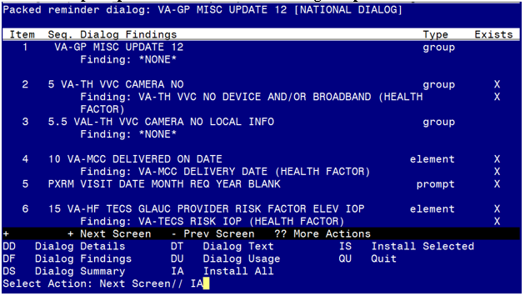

At the Select Action prompt, type IA to install the dialog – VA-GP MISC UPDATE 12
Select Action: Next Screen// IA Install All
Install reminder dialog and all components with no further changes: Y// ES

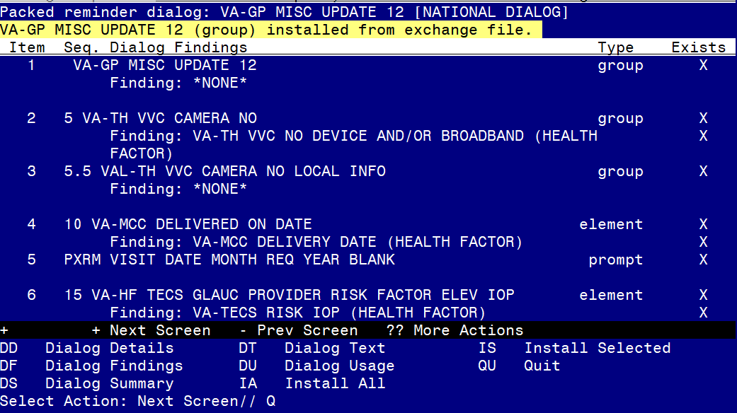
When the dialog has completed installation, you will then be returned to this screen. At the Select Action prompt, type Q.

You will be promped to install the SECOND dialog component, you do not need to install the dialog VA-TH VVC CAPABILITY ASSESSMENT, choose Q to quit:
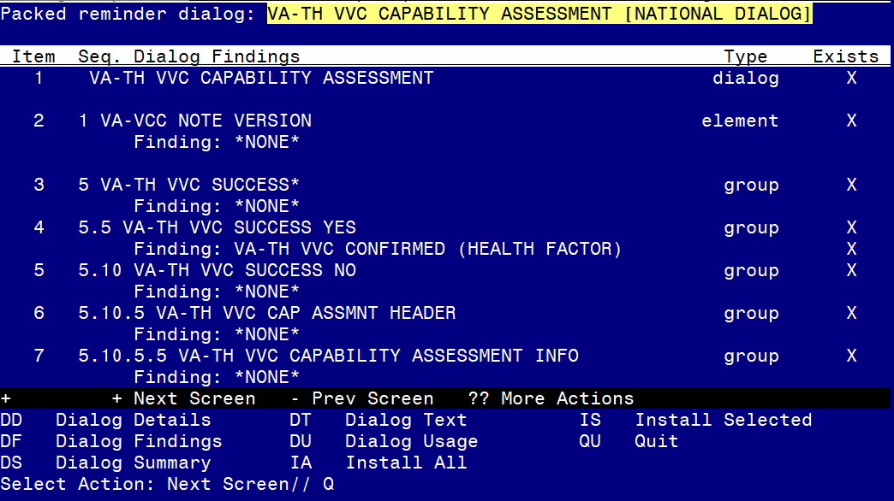

At the Select Action prompt, type Q.
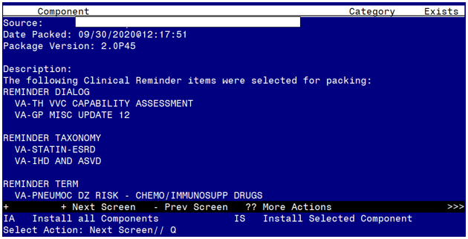

You will be returned to this screen. Type Q to quit.
Install Completed

Post Installation

- Review the items listed and confirm that they updated appropriately.
To check the reminder dialog groups and elements, you can use the INQ option in reminder dialog manager menu in Vista, in the appropriate view (group or element).

- Add your local data object for Hemoglobin A1C to the reminder dialog element VAL-TXT OBJ A1C. Using the Vista Menu- Reminder Dialog Management, Reminder Dialogs, you can change view to Element View add search for element, edit the dialog text to include your local data object for HGB A1C.

- Add your local data object for ACTIVE MEDICATIONS to the reminder dialog group VAL-GP TECS TECH-MEDICATION. Using the Vista Menu- Reminder Dialog Management, Reminder Dialogs, you can change view to Group View and search for the group, edit the dialog text to include your local data object for active medications

