Update_2_0_166

Clinical Reminders

VA-HTN Reminder Update

Install Guide

October 2020

Product Development
Office of Information Technology
Department of Veterans Affairs

Table of Contents
Introduction 1
Install Details 2
Install Example 3
Post Installation 7

Introduction

To reflect current guidelines, Subject Matter Expert opinion, EPRP requirements, and requests from the field, the national Hypertension clinical reminder(s) are being updated.
- The clinical reminder specific to a blood pressure of greater than 159 systolic or 99 diastolic is being inactivated.
- The clinical reminder for a patient with hypertension and any blood pressure greater than 139 systolic or 89 diastolic has been expanded.
- Patients with diabetes, even without a diagnosis of hypertension, will be included if their blood pressure readings are above the threshold (up to age 76).
- A new aspect of this reminder, as a reflection of new EPRP criteria, is a section to document a patient reported blood pressure. While this cannot be added to the vitals package, the documentation in the note will be reviewed for meeting EPRP measures.
- The intervention options have been expanded and include the ability to add local consults to ease referral when necessary.
- The education options have also been updated to the current recommendations.
- Although there are multiple options included to ease documentation and referral, only one selection of intervention OR education is needed to resolve the reminder.

UPDATE_2_0_166 contains 1 Reminder Exchange entry:
UPDATE_2_0_166 VA-HTN REMINDER UPDATE

The exchange file contains the following components:

TIU TEMPLATE FIELD
BLANK TEXT FIELD FOR DIALOGS

EDUCATION TOPICS
VA-HTN NUTRITION EDUCATION
VA-HTN MEDICATION ADHERENCE
VA-HTN EXERCISE

HEALTH FACTORS
VA-REMINDER UPDATES
VA-UPDATE_2_0_166
INCORRECT DIAGNOSES
INCORRECT HTN DIAGNOSIS
HYPERTENSION
HTN REFERRED TO MOVE
HTN REFERRED TO DIETICIAN
HTN REFERRED TO PACT PHARMACIST
HTN NO MED CHANGE - OTHER
HTN NO MED CHANGE - LIMITED LIFE EXP
HTN NO MED CHANGE - SIDE EFFECTS FROM RX
HTN NO MED CHANGE - NONCOMPLIANCE
HTN NO MED CHANGE - COMORBID ILLNESS
HTN NO MED CHANGE - BP CONTROLLED
HTN EVALUATION OF RESISTANT/SECONDARY
HTN REFUSAL OF MED INTERVENTION
HTN MEDICATIONS ADJUSTED
HTN NO EDUC INTERVENTION WARRANTED
HTN LIFESTYLE MODIFICATIONS RECOMMENDED
VA-INCORRECT DIABETES DIAGNOSIS
HTN SELF-RECORDED BP

REMINDER SPONSOR
Office of Quality & Performance
VHA Office of Connected Care (10P8)
Office of Patient Care Services
VHA Cardiology Services

REMINDER TAXONOMY
VA-HYPERTENSION CODES
VA-DIABETES HEDIS
VA-DIABETES HEDIS PROB LIST

REMINDER TERM
VA-REMINDER UPDATE_2_0_166
VA-HTN EDUCATIONAL INTERVENTIONS
VA-HTN MED & OTHER INTERVENTIONS
VA-HTN INCORRECT DIAGNOSIS
VA-DIABETES DX INCORRECT
VA-DIABETES DX HEDIS

REMINDER DEFINITION
VA-HTN ASSESSMENT BP >=160/100
VA-HTN ASSESSMENT BP >=140/90

REMINDER DIALOG
VA-HTN ASSESSMENT BP >=160/100
VA-HTN ASSESSMENT BP >=140/90

Install Details

This update is being distributed as a web host file. The address for the host file is: https://Redacted /UPDATE_2_0_166.PRD

The file will be installed using Reminder Exchange, programmer access is not required.

Installation:
=============
This update can be loaded with users on the system. Installation will take less than 20 minutes.

Install Example
To Load the Web Host File. Navigate to Reminder exchange in Vista
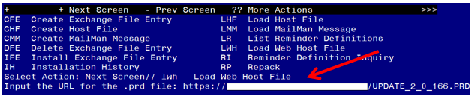

At the Select Action: prompt, enter LWH for Load Web Host File
At the Input the url for the .prd file: prompt, type the following web address:
https://Redacted /UPDATE_2_0_166.PRD

You should see a message at the top of your screen that the file successfully loaded.

Search for and locate the reminder exchange entry titled UPDATE_2_0_166 VA-HTN REMINDER UPDATE.
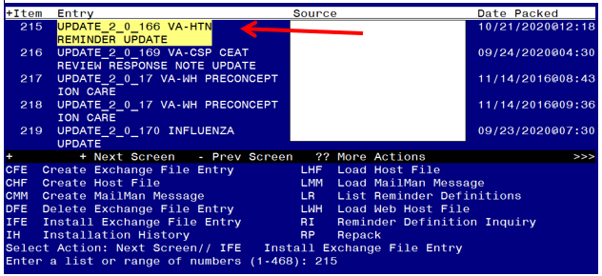

At the Select Action prompt, enter IFE for Install Exchange File Entry
Enter the number that corresponds with your entry titled UPDATE_2_0_166 VA-HTN REMINDER UPDATE (in this example it is entry 215, it will vary by site).

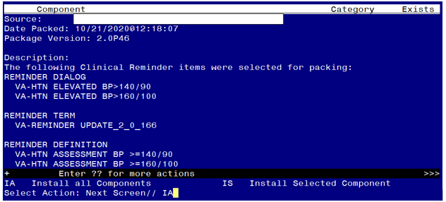

At the Select Action prompt, type IA for Install all Components and hit enter.
Select Action: Next Screen// IA Install all Components

During the installation, you will see several prompts:
Install all new components
OVERWRITE any existing components

You will be promped to install the FIRST dialog component:
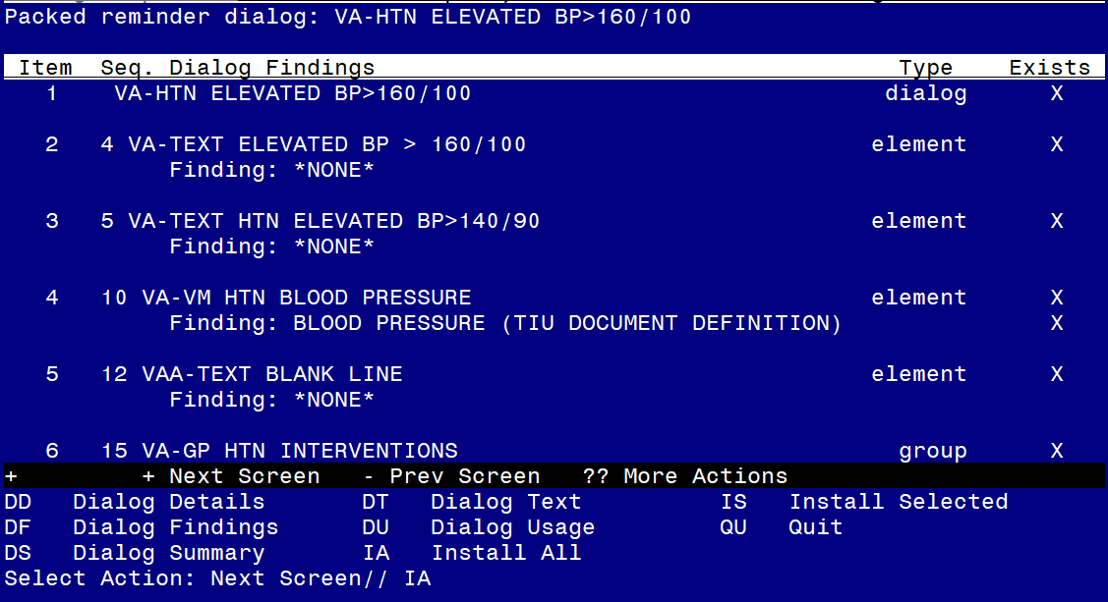

At the Select Action prompt, type IA to install the dialog – VA-HTN ELEVATED BP>160/100
Select Action: Next Screen// IA Install All
Install reminder dialog and all components with no further changes: Y// ES

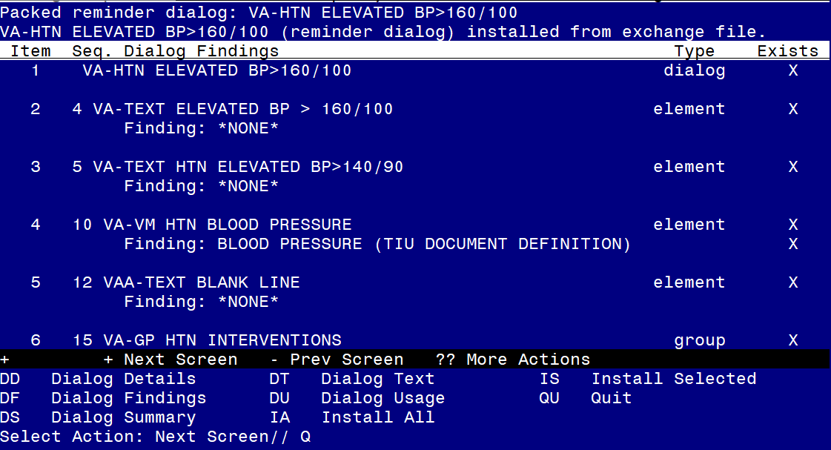

When the dialog has completed installation, you will then be returned to this screen. At the Select Action prompt, type Q.
You will be promped to install the SECOND dialog component:
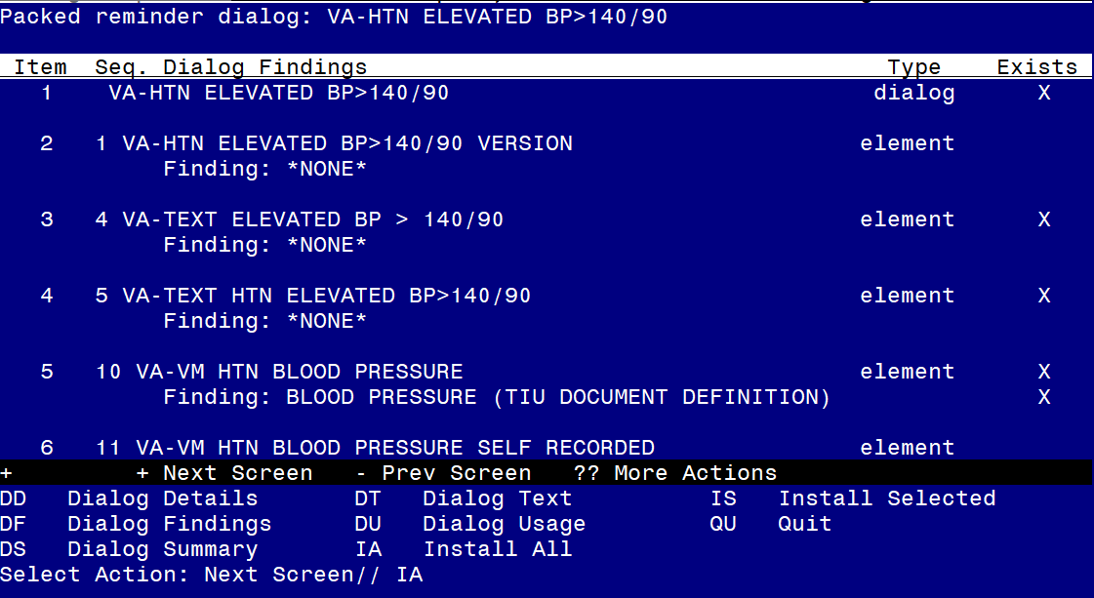
At the Select Action prompt, type IA to install the dialog – VA-HTN ELEVATED BP>140/90
Select Action: Next Screen// IA Install All
Install reminder dialog and all components with no further changes: Y// ES

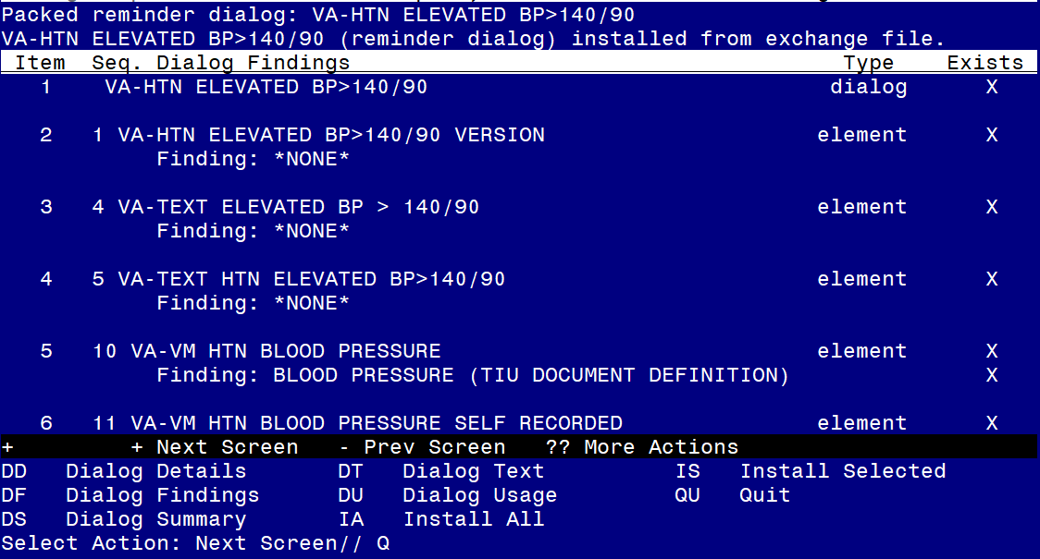

When the dialog has completed installation, you will then be returned to this screen. At the Select Action prompt, type Q.

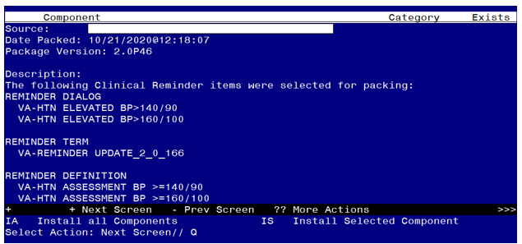

You will be returned to this screen. Type Q to quit.
Install Completed

Post Installation

- If your site is using a local reminder and is currently not using the national HTN clinical reminder and you would like to switch to this national one, you will need to add this reminder to the cover sheet for the appropriate users.

- Confirm that in CPRS when you open the national reminder with the print name HTN Assess for Elevated BP>=140/90 the version is 2.2.

- Using the Reminder Definition Manager, RI Inquire about a Reminder Definition menu, Inquire about Reminder Definition menu, choose the reminder definition VA-HTN ASSESSMENT BP >=140/90 and confirm that the reminder cohort logic at the end shows the following:
Customized PATIENT COHORT LOGIC to see if the Reminder applies to a patient:
(AGE)&((FI(2)&FI(11)&FF(1))!(FI(1)&FI(11)&FF(2)))

- Using the Reminder Definition Manager, RI Inquire about Reminder Definition menu, choose the reminder definition VA-HTN ASSESSMENT BP >=160/100 and confirm that the reminder definition is now inactive:
-----------------------------------------------------------------
VA-HTN ASSESSMENT BP >=160/100 No. XXX
-----------------------------------------------------------------

INACTIVE

Print Name: HTN Assess for Elevated BP>=160/100

- Add Consult/Referral Orders to the reminder dialog (optional)
There are three places in the template that reference referrals:

If your site has a quick order for a referral or consult to one or more of the services, using the Vista Menu- Reminder Dialog Management, Reminder Dialogs, you can change view to Element View add search for the following reminder dialog elements to add your quick order as an additional finding:
VA-HF HTN REFERRAL PACT PHARMACY
VA-HF HTN REFERRAL DIETICIAN
VA-HF HTN REFERRAL MOVE

There is an optional reminder dialog group VAL-HTN REFERRAL OTHER that is disabled. This reminder dialog group can be enabled, you can add additional local referral(s) as a finding item and edit the dialog text if appropriate for your site to offer additional referral options.

