Update _2_0_168

Clinical Reminders

VA-TD AND TDAP UPDATE
Install Guide

November 2020

Product Development
Office of Information Technology
Department of Veterans Affairs

Table of Contents
Introduction 1
Pre-Install 3
Install Details 3
Install Example 3
Post Installation 12

Introduction
DESCRIPTION:
The following changes were made to the TD/TDAP reminders:
Td
- Change print name of Td reminder to Td / Tdap
- Change informational text to indicate that either Td or Tdap can be given for 10 yr boosters and put it in general findings boxes
- Have ordering and administration options for both td and Tdap in this renamed reminder
- Turn off Td / Tdap reminder during pregnancy and for 2 months after EDD
- Update URLs
- Add option for virtual care

Tdap
- Update informational text
- Turn on Tdap reminder during pregnancy and for 2 months after EDD
  - Add FFs to provide text in Clinical maintenance
  - Add text warning in dialog if pregnant with branching logic to suppress in non-pregnant
- Update URLs
- Add option for virtual care

UPDATE_2_0_168 contains 1 Reminder Exchange entry:
UPDATE_2_0_168 VA-TD AND TDAP UPDATE

The exchange file contains the following components:
TIU TEMPLATE FIELD
NCP TD/TDAP GUIDANCE STATEMENT
BLANK TEXT FIELD FOR DIALOGS
VA-LOCATIONS
IM TD/TDAP PRECAUT WARNING
IM TD/TDAP CONTRA WARNING
IM TDAP LOT# EXP DATE
IM COMMENT COMPLICATONS
IM VIS TDAP URL
IM VIS TDAP DT
IM TDAP MANUF
IM INJECTION RIGHT/LEFT
IM TD GENERIC LOT# EXP DATE
IM VIS TD URL
IM VIS TD DT
IM TD MANUF GENERIC

HEALTH FACTORS
VA-REMINDER UPDATES
VA-UPDATE_2_0_168
IMMUNIZATION
VA-TD/TDAP EDUCATION VVC/TELEHEALTH VST
TDAP PRECAUTION
CURRENT FEBRILE ILLNESS
TDAP CONTRAINDICATION
REFUSED TDAP VACCINE
TETANUS/DIPHTHERIA PRECAUTION
TETANUS/DIPHTHERIA CONTRAINDICATION
REFUSED TD VACCINE

REMINDER SPONSOR
NATIONAL CENTER FOR HEALTH PROMOTION AND DISEASE PREVENTION (NCP)
Women Veterans Health Program
VA National Center for Health Promotion and Disease Prevention (NCP)

REMINDER TAXONOMY
VA-TDAP VACCINE (RD)
VA-IMMUNIZATION INJECTION 90471

REMINDER TERM
VA-REMINDER UPDATE_2_0_168
VA-PREGNANCY FOR TDAP
VA-TETANUS/DIPHTHERIA IMMUNIZATION
VA-TD/TDAP ORDER SUPPRESSION
VA-TDAP ORDERS
VA-TDAP DEFERRALS
VA-TDAP CONTRAINDICATION
VA-TDAP IMMUNIZATION
VA-TETANUS/DIPHTHERIA ORDERS
VA-TETANUS/DIPHTHERIA DEFERRALS
VA-TETANUS/DIPHTHERIA CONTRAINDICATION

REMINDER DEFINITION
VA-OB TD/TDAP PRIOR VACCINATIONS
VA-TETANUS/DIPHTHERIA/PERTUSSIS (TDAP)IMMUNIZATION
VA-TETANUS/DIPHTHERIA (TD) IMMUNIZATION

HEALTH SUMMARY TYPE
OB TD/TDAP IMMUNIZATIONS

HEALTH SUMMARY OBJECTS
TD/TDAP IMMUNIZATIONS (TIU)

TIU DOCUMENT DEFINITION
TD/TDAP IMMUNIZATIONS

REMINDER DIALOG
VA-TETANUS/DIPHTHERIA/PERTUSSIS (TDAP) IMMUNIZATION
VA-TETANUS/DIPHTHERIA (TD) IMMUNIZATION

Pre-Install
Print the following reminder terms for comparison post install:

VA-TETANUS/DIPHTHERIA IMMUNIZATION
VA-TETANUS/DIPHTHERIA CONTRAINDICATION
VA-TETANUS/DIPHTHERIA ORDERS
VA-TDAP IMMUNIZATION
VA-TDAP CONTRAINDICATION
VA-TDAP ORDERS
VA-TD/TDAP ORDER SUPPRESSION

Inquire into the following reminder dialog elements to identify the quick order used as a finding item, you will need to add these orders back post install:
OI TD OUTPT
OI TDAP OUTPT

Review the following txml template fields for comparison post install:
· IM TDAP LOT# EXP DATE
· IM TDAP MANUF

Install Details

This update is being distributed as a web host file. The address for the host file is: https://REDACTED /UPDATE_2_0_168.PRD

The file will be installed using Reminder Exchange, programmer access is not required.

This update can be loaded with users on the system. Installation will take less than 5 minutes.

Install Example
To Load the Web Host File. Navigate to Reminder exchange in Vista
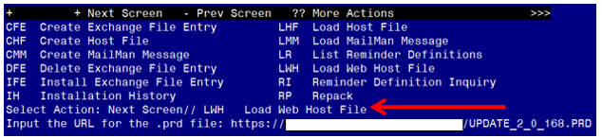

At the Select Action: prompt, enter LWH for Load Web Host File
At the Input the url for the .prd file: prompt, type the following web address:
https://REDACTED/UPDATE_2_0_168.PRD

You should see a message at the top of your screen that the file loaded successfully

Search and locate an entry titled UPDATE_2_0_169 VA-TD AND TDAP UPDATE.

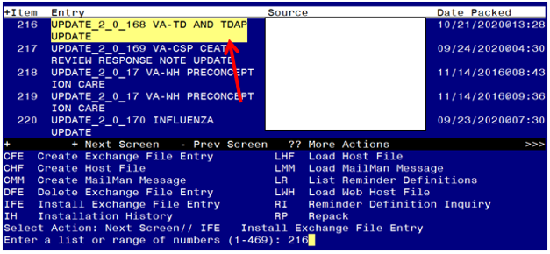

At the Select Action prompt, enter IFE for Install Exchange File Entry
Enter the number that corresponds with your entry UPDATE_2_0_168 VA-TD AND TDAP UPDATE. (in this example it is entry 216 it will vary by site). The date of the exchange file should be 10/21/2020.
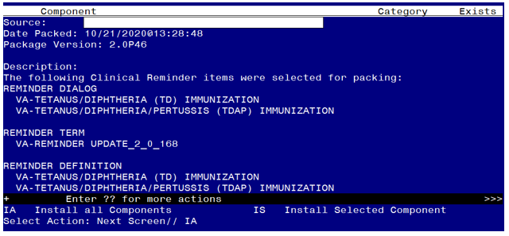

At the Select Action prompt, type IA for Install all Components and hit enter.
Select Action: Next Screen// IA Install all Components
When you are prompted to Install new items, choose I to INSTALL.
You may not see all of the prompts listed below but if you do, please answer as indicated for each prompt, if you are prompted to overwrite any item not listed below, choose S to Skip:

TIU TEMPLATE FIELD entry NCP TD/TDAP GUIDANCE STATEMENT is NEW,
what do you want to do?
Select one of the following:
C Create a new entry by copying to a new name
I Install
Q Quit the install
S Skip, do not install this entry
Enter response: I// nstall..
TIU TEMPLATE FIELD entry VA-LOCATIONS is NEW,
what do you want to do?
Select one of the following:
C Create a new entry by copying to a new name
I Install
Q Quit the install
S Skip, do not install this entry
Enter response: I// nstall..
TIU TEMPLATE FIELD entry named IM VIS TDAP DT already exists but the
packed component is different, what do you want to do?
Select one of the following:
C Create a new entry by copying to a new name
O Overwrite the current entry
U Update
Q Quit the install
S Skip, do not install this entry
Enter response: O// verwrite the current entry
Are you sure you want to overwrite? N// YES

TIU TEMPLATE FIELD entry named IM VIS TD DT already exists but the
packed component is different, what do you want to do?
Select one of the following:
C Create a new entry by copying to a new name
O Overwrite the current entry
U Update
Q Quit the install
S Skip, do not install this entry
Enter response: O// verwrite the current entry
Are you sure you want to overwrite? N// YES
HEALTH FACTORS entry VA-UPDATE_2_0_168 is NEW,
what do you want to do?
Select one of the following:
C Create a new entry by copying to a new name
I Install
Q Quit the install
S Skip, do not install this entry
Enter response: I// nstall.
HEALTH FACTORS entry VA-TD/TDAP EDUCATION VVC/TELEHEALTH VST is NEW,
what do you want to do?
Select one of the following:
C Create a new entry by copying to a new name
I Install
Q Quit the install
S Skip, do not install this entry
Enter response: I// nstall..........
REMINDER TAXONOMY entry named VA-TDAP VACCINE (RD) already exists but
the packed component is different, what do you want to do?
Select one of the following:
C Create a new entry by copying to a new name
O Overwrite the current entry
U Update
Q Quit the install
S Skip, do not install this entry
Enter response: O// verwrite the current entry
Are you sure you want to overwrite? N// YES.
REMINDER TERM entry VA-REMINDER UPDATE_2_0_168 is NEW,
what do you want to do?
Select one of the following:
C Create a new entry by copying to a new name
I Install
Q Quit the install
S Skip, do not install this entry
Enter response: I// nstall
REMINDER TERM entry VA-PREGNANCY FOR TDAP is NEW,
what do you want to do?
Select one of the following:
C Create a new entry by copying to a new name
I Install
Q Quit the install
S Skip, do not install this entry
Enter response: I// nstall

REMINDER TERM entry named VA-TETANUS/DIPHTHERIA IMMUNIZATION already
exists but the packed component is different, what do you want to do?
Select one of the following:
C Create a new entry by copying to a new name
M Merge findings
O Overwrite the current entry
U Update
Q Quit the install
S Skip, do not install this entry
Enter response: O// Merge findings
REMINDER TERM entry named VA-TD/TDAP ORDER SUPPRESSION already exists
but the packed component is different, what do you want to do?
Select one of the following:
C Create a new entry by copying to a new name
M Merge findings
O Overwrite the current entry
U Update
Q Quit the install
S Skip, do not install this entry
Enter response: O// Skip, do not install this entry.
REMINDER TERM entry named VA-TDAP DEFERRALS already exists but the
packed component is different, what do you want to do?
Select one of the following:
C Create a new entry by copying to a new name
M Merge findings
O Overwrite the current entry
U Update
Q Quit the install
S Skip, do not install this entry
Enter response: O// Merge findings
REMINDER TERM entry named VA-TDAP CONTRAINDICATION already exists but
the packed component is different, what do you want to do?
Select one of the following:
C Create a new entry by copying to a new name
M Merge findings
O Overwrite the current entry
U Update
Q Quit the install
S Skip, do not install this entry
Enter response: O// Merge findings
REMINDER TERM entry named VA-TDAP IMMUNIZATION already exists but the
packed component is different, what do you want to do?
Select one of the following:
C Create a new entry by copying to a new name
M Merge findings
O Overwrite the current entry
U Update
Q Quit the install
S Skip, do not install this entry
Enter response: O// Merge findings

REMINDER TERM entry named VA-TETANUS/DIPHTHERIA ORDERS already exists
but the packed component is different, what do you want to do?
Select one of the following:
C Create a new entry by copying to a new name
M Merge findings
O Overwrite the current entry
U Update
Q Quit the install
S Skip, do not install this entry
Enter response: O// Merge findings
REMINDER TERM entry named VA-TETANUS/DIPHTHERIA DEFERRALS already
exists but the packed component is different, what do you want to do?
Select one of the following:
C Create a new entry by copying to a new name
M Merge findings
O Overwrite the current entry
U Update
Q Quit the install
S Skip, do not install this entry

Enter response: O// Merge findings
REMINDER TERM entry named VA-TETANUS/DIPHTHERIA CONTRAINDICATION
already exists but the packed component is different, what do you
want to do?
Select one of the following:
C Create a new entry by copying to a new name
M Merge findings
O Overwrite the current entry
U Update
Q Quit the install
S Skip, do not install this entry
Enter response: O// Merge findings
REMINDER DEFINITION entry named VA-OB TD/TDAP PRIOR VACCINATIONS
already exists but the packed component is different, what do you
want to do?
Select one of the following:
C Create a new entry by copying to a new name
O Overwrite the current entry
U Update
Q Quit the install
S Skip, do not install this entry
Enter response: O// verwrite the current entry
Are you sure you want to overwrite? N// YES
REMINDER DEFINITION entry named VA-TETANUS/DIPHTHERIA/PERTUSSIS
(TDAP) IMMUNIZATION already exists but the packed component is
different, what do you want to do?
Select one of the following:
C Create a new entry by copying to a new name
O Overwrite the current entry
U Update
Q Quit the install
S Skip, do not install this entry
Enter response: O// verwrite the current entry
Are you sure you want to overwrite? N// YES
REMINDER DEFINITION entry named VA-TETANUS/DIPHTHERIA (TD)
IMMUNIZATION already exists but the packed component is different,
what do you want to do?
Select one of the following:
C Create a new entry by copying to a new name
O Overwrite the current entry
U Update
Q Quit the install
S Skip, do not install this entry
Enter response: O// verwrite the current entry
Are you sure you want to overwrite? N// YES
HEALTH SUMMARY TYPE entry named OB TD/TDAP IMMUNIZATIONS already
exists but the packed component is different, what do you want to do?
Select one of the following:
C Create a new entry by copying to a new name
O Overwrite the current entry
U Update
Q Quit the install
S Skip, do not install this entry
Enter response: O// Skip, do not install this entry..

You will be promped to install the first reminder dialog component – You will choose to install all even though some components may have an X to indicate that they exist.

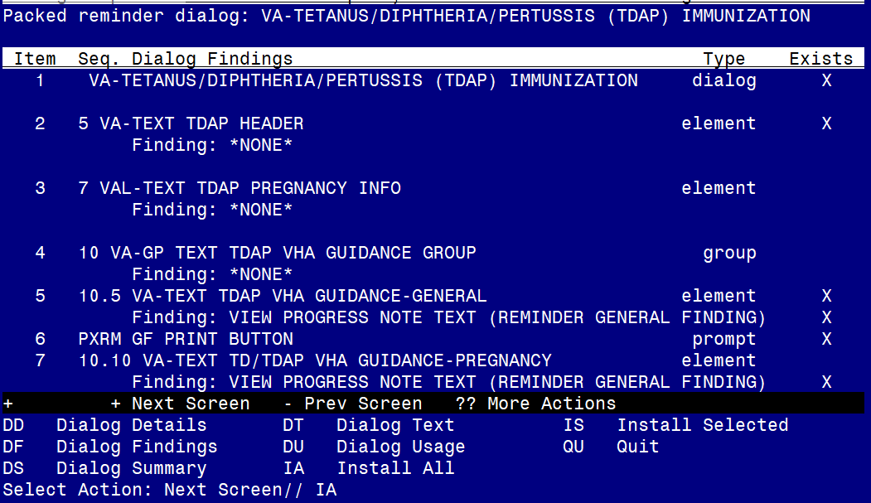

At the Select Action prompt, type IA to install the dialog – VA-TETANUS/DIPHTHERIA/PERTUSSIS (TDAP) IMMUNIZATION
Select Action: Next Screen// IA Install All
Install reminder dialog and all components with no further changes: Y// Yes

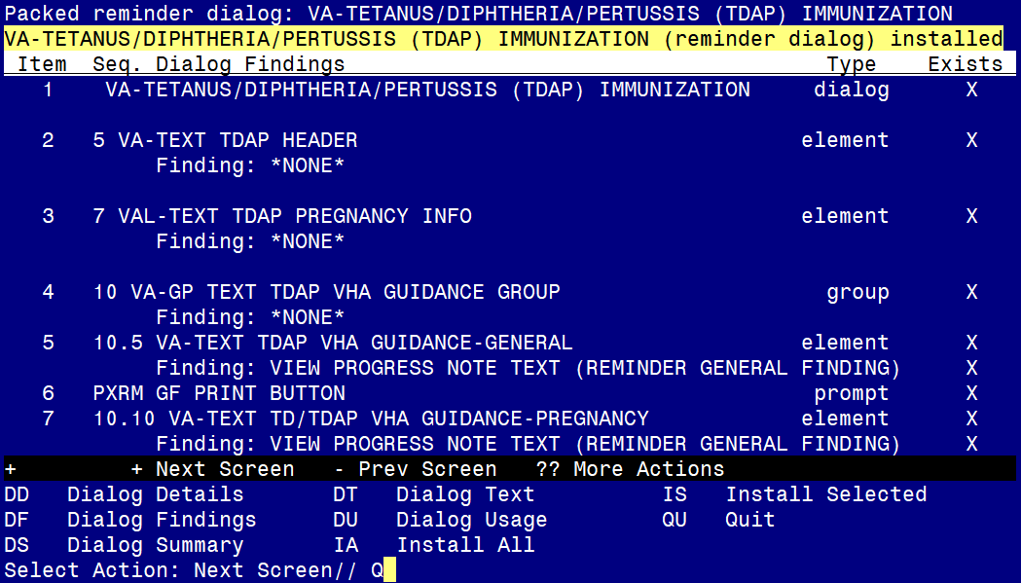
After completing this dialog install, you will type Q.
You will be promped to install the next reminder dialog component – You will choose to install all even though some components may have an X to indicate that they exist.

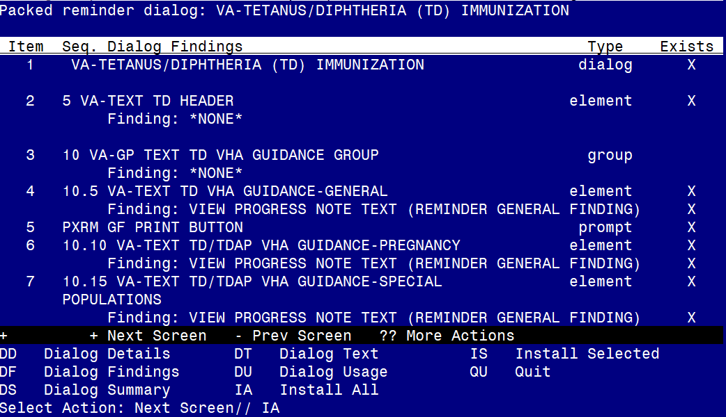
At the Select Action prompt, type IA to install the dialog – VA-TETANUS/DIPHTHERIA (TD) IMMUNIZATION
Select Action: Next Screen// IA Install All
Install reminder dialog and all components with no further changes: Y// Yes

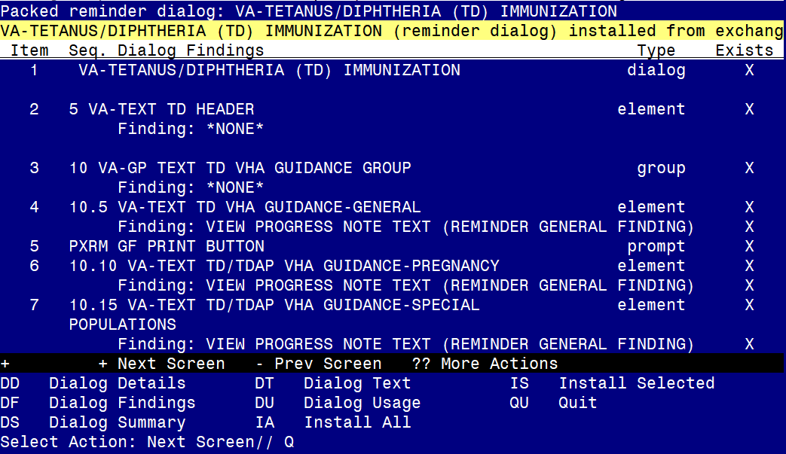

After completing this dialog install, you will type Q.

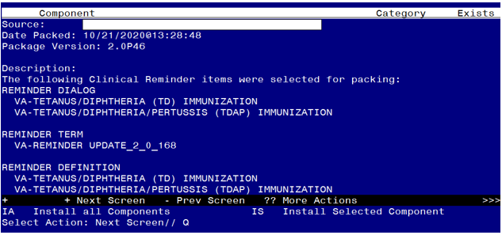

You will then be returned to this screen. At the Select Action prompt, type Q.

Install complete.

Post Installation

Compare the following reminder terms to the saved items pre-install and map any items that are no longer showing (if you followed the install instructions and did not overwrite, no changes should be needed):

VA-TETANUS/DIPHTHERIA IMMUNIZATION
VA-TETANUS/DIPHTHERIA CONTRAINDICATION
VA-TETANUS/DIPHTHERIA ORDERS
VA-TDAP IMMUNIZATION
VA-TDAP CONTRAINDICATION
VA-TDAP ORDERS
VA-TD/TDAP ORDER SUPPRESSION

Edit the following reminder dialog elements and add your local quick order as a finding item. You should have identified those quick orders in the pre-install:
OI TD OUTPT
OI TDAP OUTPT

Compare the following txml template fields to your pre-install inquiry and make changes if needed (if you followed the install instructions and did not overwrite, no changes should be needed)
· IM TDAP LOT# EXP DATE
· IM TDAP MANUF

